**Batch 2: Group 1**

**Assignment 5**

**Aim:** Create your initial product backlog: Create initial product backlog items as user stories, order your product backlog.

**Objectives:**

1. Develop a user-friendly and intuitive to-do list application accessible across various devices.
2. Prioritize features based on user needs and feedback to deliver a valuable product incrementally.
3. Implement Agile principles, particularly Scrum framework, to ensure iterative development and continuous improvement.

**Theory:**

**To-do List Application:**

A to-do list application serves as a digital tool for managing tasks, reminders, and priorities efficiently. Its primary purpose is to help users organize their daily activities, track progress, and increase productivity. By incorporating features such as task creation, prioritization, due dates, reminders, and categorization, the application aims to streamline task management processes and enhance user experience.

**Agile Principles:**

Agile methodology promotes iterative development, frequent collaboration, and customer feedback to deliver software that meets evolving requirements. By breaking down the development process into small, manageable increments, Agile teams can respond to change more effectively, minimize risks, and deliver value continuously. Embracing Agile principles fosters a culture of transparency, adaptability, and customer-centricity, enabling teams to prioritize features based on user needs and deliver incremental improvements iteratively.

**Implementation:**

1. Log in to Jira.

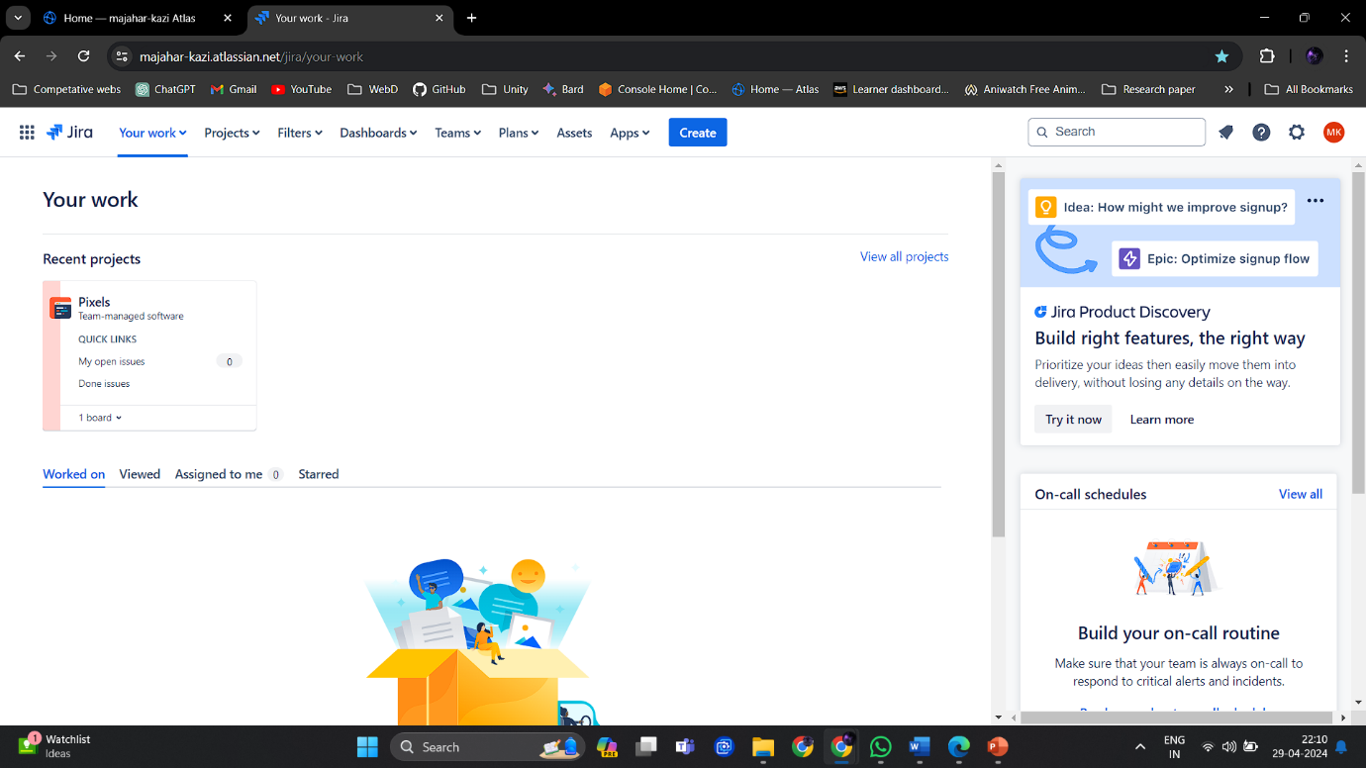

1. Select your project and go into backlog.

1. Add user stories and also describe the user stories.

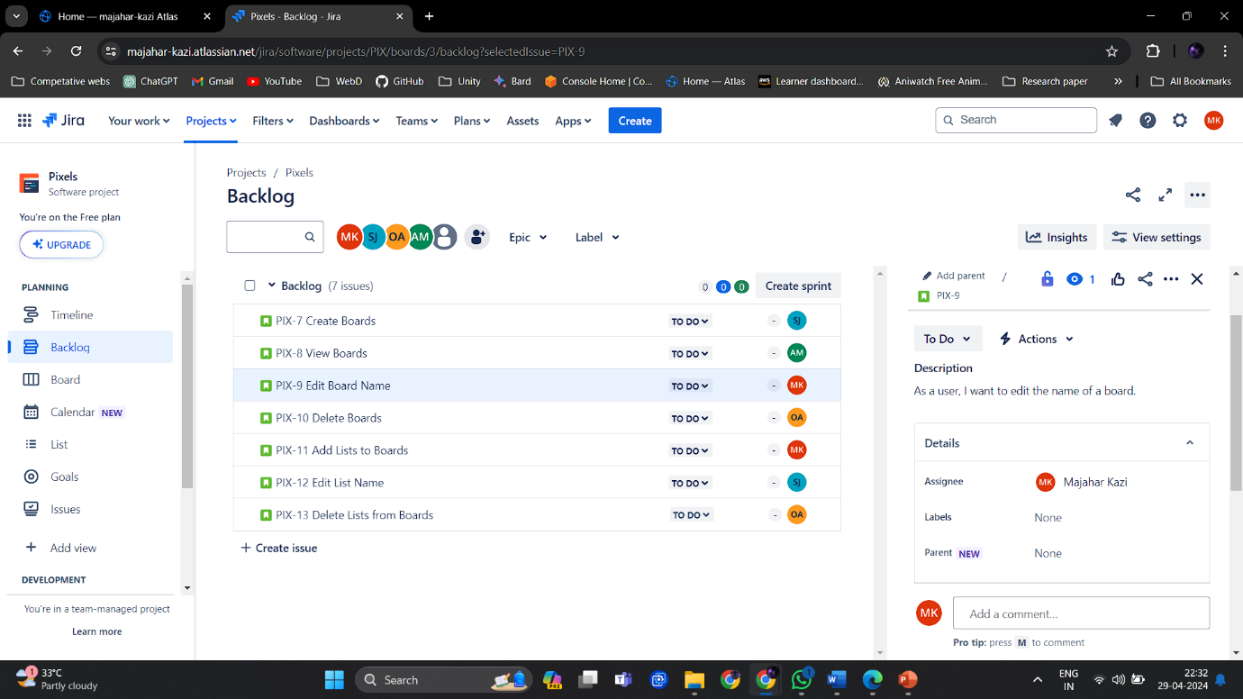

Assign user stories to discussed members.

1. Add tasks along with its description and also allocate a member behind the task.

1. Assign higher priority to tasks which are more important.

**Conclusion:**

The to-do list project aims to develop a user-centric application through iterative development cycles, guided by Agile principles. By prioritizing user stories based on feedback and delivering them incrementally, the project seeks to create a valuable product that enhances task management efficiency and user satisfaction. Through continuous iteration and adaptation, the team will refine the application to meet user needs effectively while ensuring alignment with project objectives and stakeholders' expectations.