Assignment No.8

**Title**: Various local repository operations, Branching and merging operations, resolving conflicts during merges, and managing access on repository management.

* Local repository operations:
* Exploring the concept of version control and its importance in collaborative software development.
* Learning various local repository operations such as initializing a repository, adding files, committing changes, viewing history, and reverting changes.

1.Creating a local git repository:

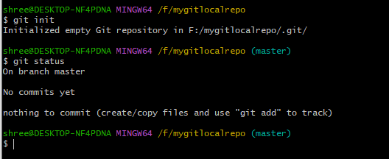

2. Creating git clone:

command clones repo located at <repo> on the local machine. The original repo can be located on the local filesystem or on a remote machine via HTTP or ssh.

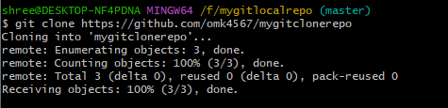

3.git config user.name <name>: it defines the author's name to be used for all commits in the current repo.

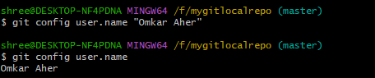

4.git add <directory> or <file>: this command stages all the changes of the <directory>or <file>into an index(staging area) for the next commit.

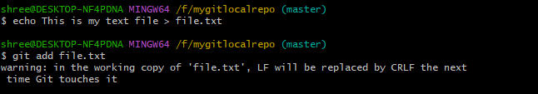

5. git status to check the status of the files of the current working directory whether they are tracked(added to staging area) or untracked(not added to staging area)

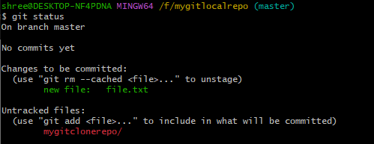

6.git commit -m "<message>": Using this command you can commit the staged snapshot(the files you have added in the staging area). Also instead of launching a text editor, use "<message>" as the commit message.

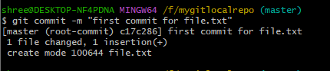

7.git log: This command displays the entire commit history using the default format. You can use this command with the customized options to see different format output.

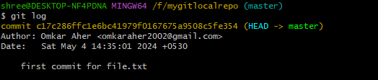

* Git Branching and Merging Operations:
* Introducing the concept of branching as a mechanism for parallel development and feature isolation.
* Examine different branching strategies such as feature branching, release branching.
* Demonstrate merging operations to integrate changes from one branch to another.

1.git branch: List all of the branches in your repo. Add <branch> as an argument to create a new branch with the name <branch>.

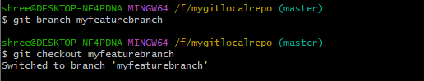

2.git checkout -b <branch>: Create and check out a new branch named <branch>. Drop the -b flag to check out an existing branch.



Git merging Operation:

git merge <branch> : Merge <branch> into the current branch.

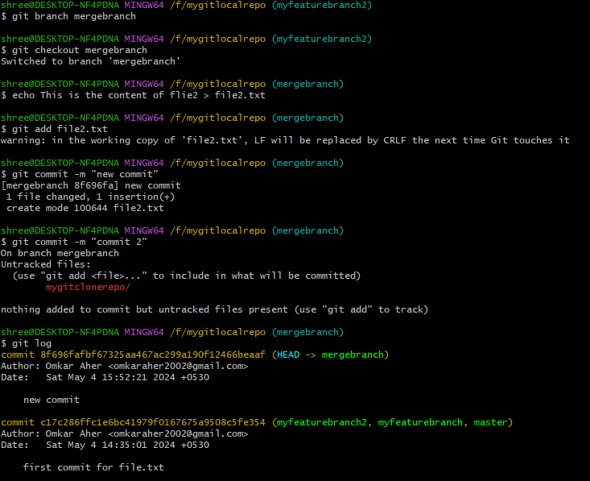

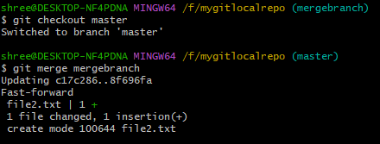

* Resolving conflicts during merges:
* Identifying common scenarios leading to conflicts during the merge process, such as overlapping changes and divergent history.
* Discuss strategies for conflict resolution, including manual conflict resolution.

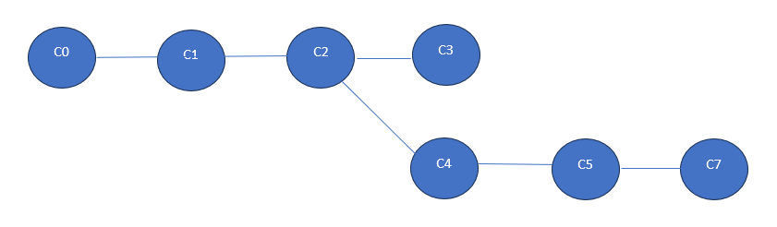

C0- Added index.html file into folder

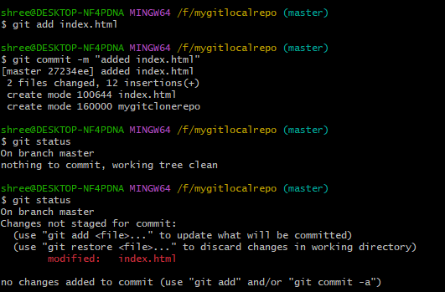

C1- Changed the title to “title1”

C2- Changed the title to “title2”

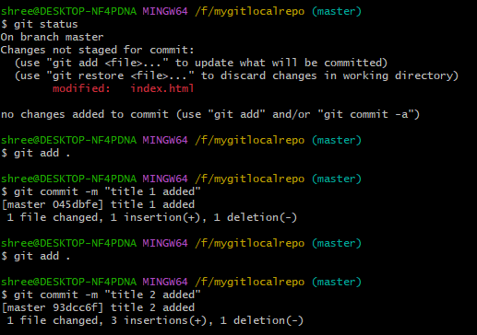

C4- Added the new branch issue1, changed the title to “title C4”

C5- Changed the title to “title C5”

C7- Changed the title to “title C7”

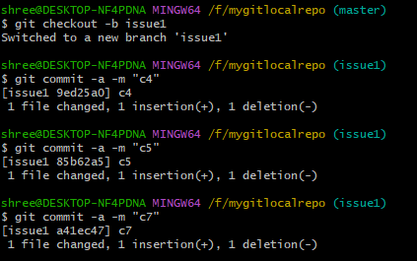

Merge conflicts-

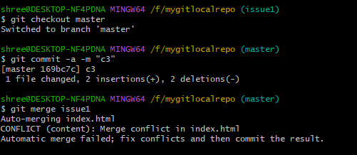

Solving conflict manually-

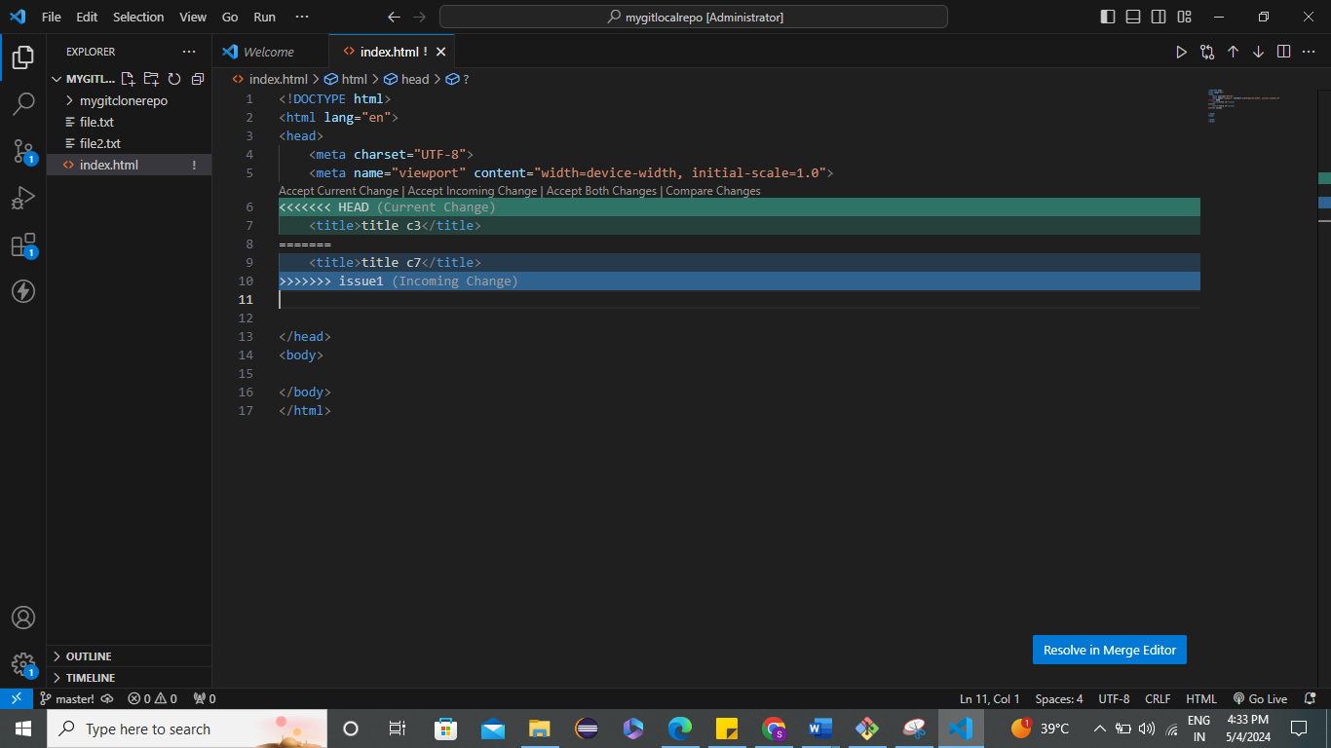

Committing the merge-

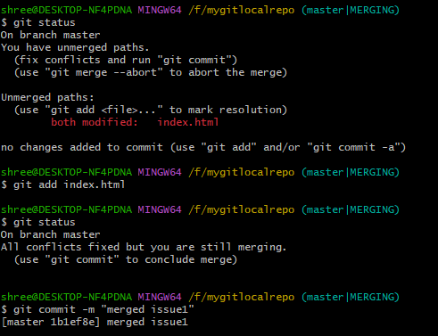

* Managing access on the repository:

