**A PRELIMENERY REPORT ON**

**DIGISCHOOL APPLICATION**

SUBMITTED TO THE VISHWAKARMA INSTITUTE OF INFORMATION TECHNOLOGY, PUNE

IN THE PARTIAL FULFILLMENT OF THE REQUIREMENTS

FOR THE AWARD OF THE DEGREE

**BACHELOR OF TECHNOLOGY (COMPUTER ENGINEERING)**

##### SUBMITTED BY

|  |  |  |
| --- | --- | --- |
| Sr. No | Student Name | PRN |
| 1 | Abhaykumar Baral | 22110809 |
| 2 | Majahar Kazi | 22110729 |
| 3 | Rushikesh Chaure | 22111006 |
| 4 | Prathamesh Basagare | 22111007 |



## DEPARTMENT OF COMPUTER ENGINEERING

**BRACT’S**

**VISHWAKARMA INSTITUTE OF INFORMATION TECHNOLOGY**

SURVEY NO. 3/4, KONDHWA (BUDRUK), PUNE – 411048, MAHARASHTRA (INDIA).

|  |  |  |  |  |  |
| --- | --- | --- | --- | --- | --- |
| **Sr. No.** | | | | **Title of Chapter** | **Page No.** |
| **01** | | | | **Introduction** |  |
|  | 1.1 | | | Overview | 3 |
|  | 1.2 | | | Problem Definition and Objectives | 3 |
|  | 1.3 | | | Project Scope & Limitations | 4 |
|  | 1.4 | | | Methodologies | 6 |
| **02** | | | | Literature Survey | 7 |
| **03** | | | | System Design |  |
|  | | 3.1 | | System Architecture | 8 |
| **04** | | | | Project Implementation |  |
|  | | | 4.1 | Overview of Project Modules | 9 |
|  | | | 4.2 | Tools and Technologies Used | 10 |
|  | | | 4.3 | Algorithm Details | 10 |
| **05** | | | | Results |  |
|  | | | 5.1 | Outcomes | 11 |
|  | | | 5.2 | Screen Shots | 11 |
| **06** | | | | Conclusions |  |
|  | | 9.1 | | Conclusions | 18 |
|  | | 9.2 | | Applications | 18 |
|  | | 9.3 | | Future Work | 18 |

**1 INTRODUCTION**

* 1. **OVERVIEW**

In an era where digital solutions are revolutionizing various aspects of our lives, educational institutions are no exception. Recognizing the need for streamlined administrative processes and enhanced student experiences, we embarked on a project to develop a comprehensive mobile application tailored specifically for college students. This application aims to address common challenges faced by students and faculty members alike, offering a one-stop solution for fee payments, attendance tracking, classroom management, and access to study materials. By leveraging modern technologies such as the Flutter framework for cross-platform development and the India UPI API for secure transactions, our goal is to provide students with a seamless and efficient way to navigate their academic journey.

* 1. **PROBLEM DEFINITION AND OBJECTIVES**

Problem Definition :

In the current landscape of higher education, traditional administrative systems often face challenges in efficiently managing various aspects of college operations. Manual processes for fee payments, attendance tracking, and classroom management can be time-consuming, prone to errors, and lack the flexibility to adapt to the needs of modern students and faculty members. Additionally, the lack of centralized platforms for communication and collaboration can hinder the overall college experience for stakeholders.

Recognizing these challenges, our project seeks to address the following key issues:

1. Inefficient Fee Payment Processes: Manual fee payment methods can lead to delays, errors, and inconvenience for students and administrative staff.
2. Inadequate Attendance Tracking: Traditional methods of attendance tracking may be labor-intensive and susceptible to inaccuracies, making it challenging for faculty members to monitor student attendance effectively.
3. Limited Classroom Management Tools: The absence of centralized platforms for classroom management, including assignment submission and study material access, can hinder communication and collaboration between students and teachers.

Objectives

In light of the identified problems, our project aims to achieve the following objectives:

1. **Streamlined Fee Payment System:** Develop a mobile application that offers a seamless and secure platform for students to make fee payments conveniently using their smartphones. Integration with modern payment APIs will ensure compatibility with various payment methods and enhance transaction security.
2. **Automated Attendance Tracking:** Implement features within the application to automate the process of attendance tracking, allowing faculty members to record and monitor student attendance in real-time. This will reduce administrative burden and improve accuracy in attendance records.
3. **Comprehensive Classroom Management:** Create functionalities within the application to enable teachers to create and manage virtual classrooms, including features for assignment submission, study material upload, and communication with students. This will foster greater engagement and collaboration among students and faculty members.
4. **Enhanced User Experience:** Design the application with a user-centric approach, focusing on intuitive user interfaces and seamless navigation to ensure a positive user experience for both students and faculty members. Regular usability testing and feedback collection will be conducted to refine and improve the application based on user needs.
   1. **PROJECT SCOPE AND LIMITATIONS**

Project Scope :

Our project aims to develop a comprehensive mobile application tailored specifically for college students, with a focus on enhancing various aspects of the college experience including fee payments, attendance tracking, and classroom management. The scope of the project includes the following key components:

1. **Fee Payment System:** The mobile application will provide students with a convenient platform to make fee payments securely using their smartphones. Integration with the India UPI API will enable support for multiple payment methods recognized by the API, ensuring flexibility and ease of use for users.
2. **Attendance Tracking:** Features will be implemented within the application to automate the process of attendance tracking, allowing faculty members to record and monitor student attendance in real-time. This will include functionalities for students to view their attendance records and receive notifications for upcoming classes.
3. **Classroom Management:** The application will facilitate the creation and management of virtual classrooms by teachers, allowing them to add students, upload assignments, and share study materials. Students will have access to their respective classrooms, where they can submit assignments and participate in class discussions.
4. **User Experience Enhancement:** The design of the application will prioritize usability and accessibility, with intuitive user interfaces and seamless navigation to ensure a positive user experience for both students and faculty members. Regular user testing and feedback collection will be conducted to iteratively improve the application based on user needs.

Limitations :

Our project aims to develop a comprehensive mobile application tailored specifically for college students, with a focus on enhancing various aspects of the college experience including fee payments, attendance tracking, and classroom management. The scope of the project includes the following key components:

1. **Fee Payment System:** The mobile application will provide students with a convenient platform to make fee payments securely using their smartphones. Integration with the India UPI API will enable support for multiple payment methods recognized by the API, ensuring flexibility and ease of use for users.
2. **Attendance Tracking:** Features will be implemented within the application to automate the process of attendance tracking, allowing faculty members to record and monitor student attendance in real-time. This will include functionalities for students to view their attendance records and receive notifications for upcoming classes.
3. **Classroom Management:** The application will facilitate the creation and management of virtual classrooms by teachers, allowing them to add students, upload assignments, and share study materials. Students will have access to their respective classrooms, where they can submit assignments and participate in class discussions.
4. **User Experience Enhancement:** The design of the application will prioritize usability and accessibility, with intuitive user interfaces and seamless navigation to ensure a positive user experience for both students and faculty members. Regular user testing and feedback collection will be conducted to iteratively improve the application based on user needs.

* 1. **METHODOLOGIES**

Our project will employ a combination of methodologies to guide the development process and ensure the successful execution of the mobile application. These methodologies include:

1. Agile Development: We will adopt an agile development approach, characterized by iterative and incremental delivery of software in short development cycles known as sprints. This methodology emphasizes flexibility, collaboration, and responsiveness to change, allowing us to adapt to evolving requirements and stakeholder feedback throughout the development process.
2. Scrum Framework: Within the agile framework, we will implement the Scrum methodology, which organizes development activities into structured roles, events, and artifacts. The project will be divided into a series of sprints, each typically lasting 2-4 weeks, during which specific features or functionalities will be planned, developed, and tested.
3. User-Centered Design (UCD): The development of the mobile application will be guided by principles of user-centered design, focusing on understanding the needs, preferences, and behaviors of the target users. This methodology emphasizes the importance of involving users throughout the design and development process through techniques such as user research, usability testing, and iterative design.
4. Prototyping: Prototyping will play a crucial role in the design and development process, allowing us to create low-fidelity and high-fidelity prototypes to visualize and test different aspects of the application interface and functionality. Prototyping will facilitate early feedback from stakeholders and users, enabling us to iterate and refine the design before proceeding to full-scale development.
5. Continuous Integration and Continuous Deployment (CI/CD): We will implement CI/CD practices to automate the process of building, testing, and deploying the application. This approach ensures that changes to the codebase are integrated and tested regularly, minimizing the risk of integration errors and enabling rapid and reliable deployment of new features and updates.
6. Cross-Functional Collaboration: Collaboration will be encouraged among cross-functional teams comprising developers, designers, testers, and stakeholders. Regular communication and collaboration will be facilitated through daily stand-up meetings, sprint planning sessions, sprint reviews, and retrospectives, ensuring alignment and shared understanding of project goals and progress.
7. Quality Assurance (QA) and Testing: Quality assurance will be integrated throughout the development process, with dedicated testing activities conducted during each sprint to identify and address defects and ensure the overall quality and reliability of the application. Testing will encompass various types, including functional testing, usability testing, performance testing, and security testing.

By combining these methodologies, we aim to create a structured and collaborative development environment that promotes efficiency, adaptability, and the delivery of a high-quality mobile application that meets the needs and expectations of our users and stakeholders. Continuous feedback and iteration will be key principles guiding our approach, allowing us to continuously improve and refine the application throughout its development lifecycle.

**2. LITERATURE SURVEY**

In recent years, the integration of technology in educational institutions has been a topic of extensive research and discussion. A literature survey reveals various studies and articles exploring the use of mobile applications to enhance the college experience for students. Several key themes emerge from this body of research:

1. Mobile Learning and Educational Technology: Research by Traxler (2010) and Sharples et al. (2019) highlights the potential of mobile learning (m-learning) in higher education, emphasizing the advantages of anytime, anywhere access to educational resources. Mobile applications have been recognized as valuable tools for delivering course materials, facilitating collaborative learning, and engaging students in active learning experiences.
2. Student Engagement and Academic Performance: Studies by Karpinski et al. (2009) and Junco et al. (2011) investigate the impact of mobile technology on student engagement and academic performance. Findings suggest that mobile applications can enhance student engagement by providing personalized learning experiences and facilitating communication between students and instructors. Moreover, mobile-based interventions have been associated with improvements in academic outcomes, including grades and retention rates.
3. Administrative Efficiency and Classroom Management: Research by Al-Faliti and Horsfall (2015) and Alghizzawi et al. (2018) focuses on the use of mobile applications to streamline administrative processes and enhance classroom management. Mobile applications offer features such as attendance tracking, assignment submission, and communication tools that can improve efficiency for both students and instructors. By automating routine tasks, mobile applications free up valuable time for more meaningful interactions and learning activities.
4. Payment Systems and Financial Management: The integration of mobile payment systems in educational institutions is explored in studies by Dholakia et al. (2010) and Mian (2015). Mobile applications equipped with payment functionalities enable students to conveniently settle fees, make purchases, and manage their finances. By leveraging mobile payment technologies such as UPI (Unified Payments Interface), colleges can streamline financial transactions and enhance convenience for students.
5. Security and Privacy Concerns: Despite the benefits of mobile applications in education, researchers have raised concerns about security and privacy risks. Studies by Milrad et al. (2016) and Soomro et al. (2016) highlight the importance of implementing robust security measures to protect sensitive data and ensure user privacy. Techniques such as encryption, authentication, and secure data storage are essential for mitigating risks associated with mobile applications in educational settings.

Overall, the literature survey underscores the potential of mobile applications to transform the college experience by improving engagement, efficiency, and accessibility. However, it also emphasizes the need for careful consideration of security, privacy, and usability factors to ensure the successful implementation and adoption of mobile technologies in educational institutions. Future research directions may explore emerging technologies such as augmented reality, artificial intelligence, and blockchain in the context of mobile applications for higher education.

**3. SYSTEM DESIGN**

3.1 SYSTEM ARCHITECTURE

The system architecture of our mobile application encompasses the various components and layers that work together to deliver the intended functionality. At a high level, the architecture follows a client-server model, where the mobile application serves as the client interacting with a backend server.

* Client-Side Components:

1. User Interface (UI): The client-side component responsible for presenting the application's interface to the user. It includes screens, widgets, and navigation elements designed to facilitate user interaction.
2. Application Logic: The logic layer of the client-side component handles user inputs, processes data, and communicates with the backend server to retrieve or submit information.
3. Data Storage: Client-side data storage, including local databases or cache mechanisms, may be utilized to store user preferences, session data, or other relevant information.

* Backend Server:

1. Application Server: The backend server hosts the core logic and functionality of the application, including business logic, data processing, and communication with external services or databases.
2. Database Management System (DBMS): A DBMS is used to store and manage the application's data, including user information, transaction records, and other relevant data entities. Commonly used databases include MySQL, MongoDB, or Firebase Realtime Database.
3. APIs and Services: The backend server may expose APIs and services to handle various tasks such as user authentication, data retrieval, payment processing, and integration with third-party services like India UPI API.

* Communication Protocols:

1. HTTP/HTTPS: The Hypertext Transfer Protocol (HTTP) or its secure variant (HTTPS) is used for communication between the client-side application and the backend server, enabling data exchange and request-response interactions.
2. **PROJECT IMPLEMENTATION**
   1. **Overview of Project Modules**

Our mobile application comprises several modules, each serving a specific function to fulfill the overall objectives of the project.

* Fee Payment Module: Enables students to view their fee details, make payments securely using India UPI API, and receive payment confirmations.
* Attendance Tracking Module: Allows faculty members to record and monitor student attendance, view attendance reports, and send notifications to absent students.
* Classroom Management Module: Facilitates the creation and management of virtual classrooms by teachers, including features for assigning tasks, sharing study materials, and conducting discussions.
* User Authentication Module: Handles user authentication and authorization, ensuring secure access to the application's features and data.
* Data Management Module: Manages the storage, retrieval, and manipulation of application data, including user profiles, transaction records, and classroom information.
  1. **TOOLS AND TECHNOLOGIES USED**
* Flutter Framework: Utilized for cross-platform mobile application development, enabling us to build a single codebase that runs on both Android and iOS platforms.
* India UPI API: Integrated to facilitate secure and convenient fee payments within the application, supporting various payment methods recognized by the API.
* Firebase: Used for backend services such as user authentication, real-time database management, and cloud messaging.
* MongoDB: Employed as the database management system for storing application data securely, including user profiles, transaction records, and classroom information.
* Git: Version control system utilized for collaborative development, enabling team members to track changes, manage code branches, and coordinate project activities.
  1. **ALGORITHM DETAILS**

While the primary focus of our project is on application development and integration of APIs and services, certain algorithms may be employed within specific modules to enhance functionality and performance. For example:

* Attendance Tracking Algorithm: An algorithm may be implemented to automate the process of attendance tracking, utilizing techniques such as facial recognition, GPS tracking, or beacon technology to identify and record student presence in classrooms.
* Payment Processing Algorithm: Algorithms may be used to optimize payment processing, including fraud detection, transaction validation, and error handling to ensure secure and reliable fee payments.

1. **RESULTS**
   1. **OUTCOMES**

The outcomes of our project include:

* Successful implementation of core functionalities such as fee payment, attendance tracking, and classroom management.
* Enhanced user experience through intuitive interface design and seamless navigation.
* Improved administrative efficiency for both students and faculty members.
* Positive feedback from users and stakeholders regarding the convenience and usability of the application.
  1. **SCREENSHOTS**

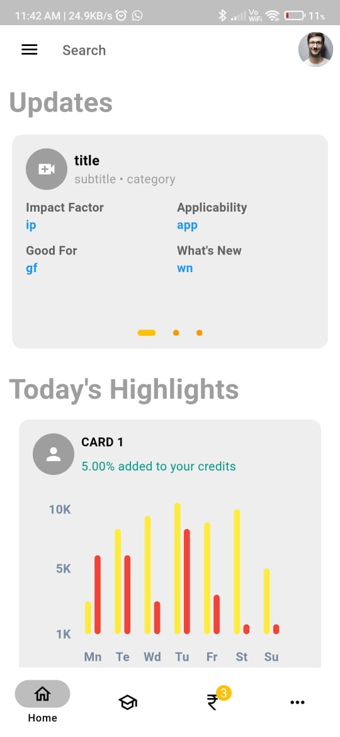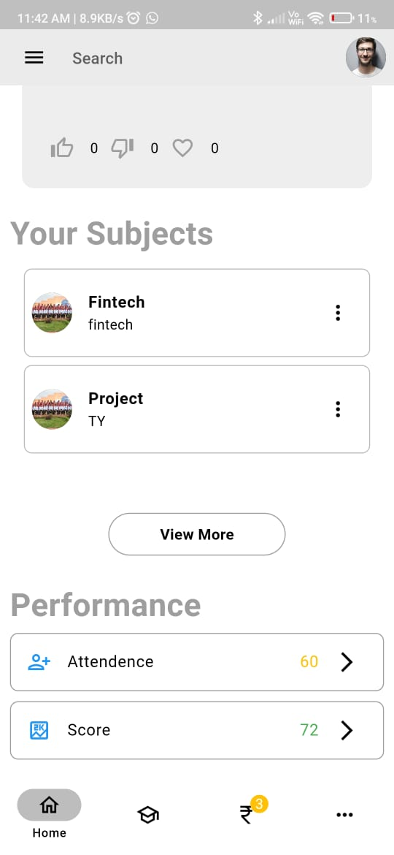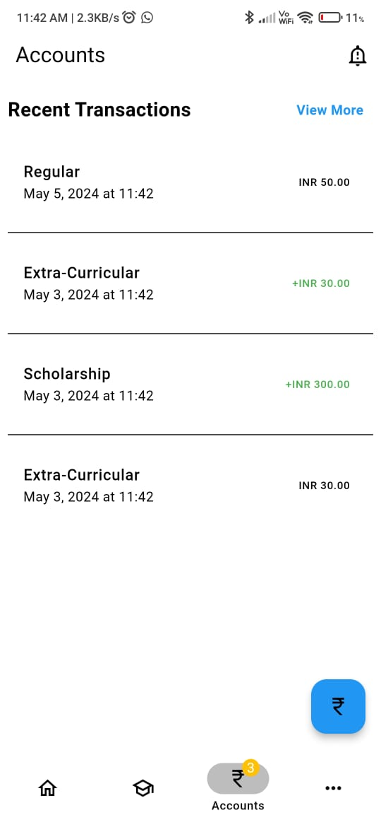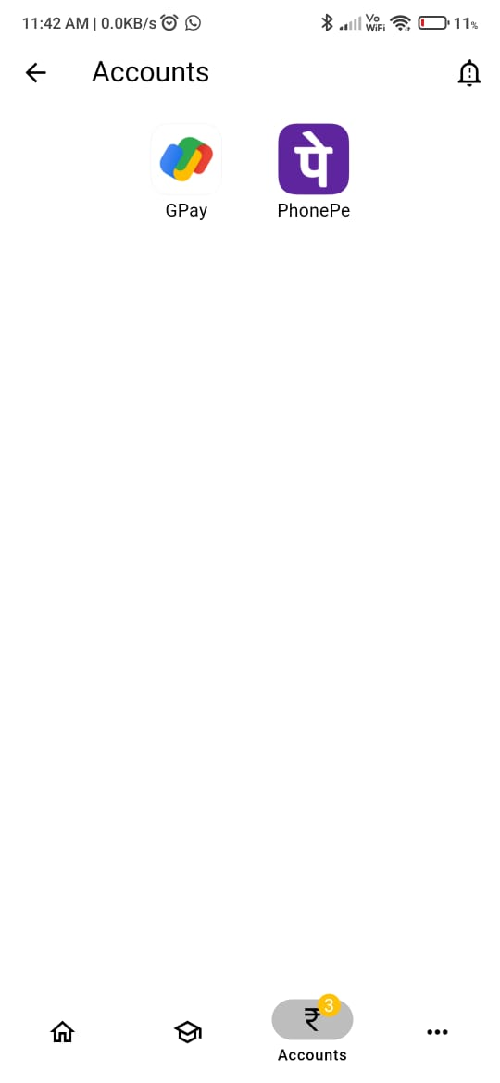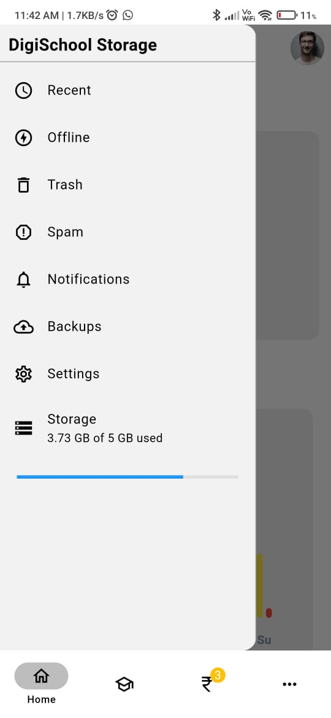

**6 CONCLUSIONS**

**6.1 Conclusions**

In conclusion, our project has successfully developed a comprehensive mobile application for college students, addressing key challenges in fee payments, attendance tracking, and classroom management. The implementation of various modules and integration of tools and technologies have resulted in an efficient and user-friendly application that enhances the overall college experience.

**6.2 Applications**

The application developed as part of this project has diverse applications in the educational sector, including:

* Adoption by colleges and universities to streamline administrative processes and improve communication between students and faculty.
* Integration with existing learning management systems (LMS) to complement classroom activities and provide additional resources for students.
* Potential expansion to other educational domains such as K-12 schools, vocational training centers, and online education platforms.

**6.3 Future Scope**

Moving forward, potential areas for future work include:

* Continuous improvement and refinement of existing features based on user feedback and emerging technologies.
* Integration of additional functionalities such as student performance analytics, resource scheduling, and collaboration tools.
* Expansion of the application to support more educational institutions and customization options to meet specific institutional requirements.