D. Y. Patil School of Engineering and Management
Kolhapur
Department of Data Science Engineering
Project Title
HealthWise AI
Hospital Management System with Report Analysis
SOFTWARE REQUIREMENTS SPECIFICATION
Submitted by
Rutvik S. Jagtap (Roll No. 18)
Vaibhav T. Lad (Roll No. 57)
Tanmay T. Salokhe (Roll No. 46)
Pranav P. Sathe (Roll No. 47)
Rahul Suryavanshi (Roll No. 51)
Under the guidance of
Prof. Ajit Patil
Academic Year: 2026 - 2027
Date: 12 October 2026
CERTIFICATE
This is to certify that the Software Requirements Specification entitled "HealthWise AI: Hospital Management System with Report Analysis" has been prepared by the following students of the Department of Data Science Engineering, D. Y. Patil School of Engineering and Management, Kolhapur, in partial fulfilment of the requirements for the degree of Bachelor of Technology in Data Science Engineering during the academic year 2026 - 2027.

Rutvik S. Jagtap (Roll No. 18)
Vaibhav T. Lad (Roll No. 57)
Tanmay T. Salokhe (Roll No. 46)
Pranav P. Sathe (Roll No. 47)
Rahul Suryavanshi (Roll No. 51)

To the best of our knowledge, the work is original and has not been submitted elsewhere for any other degree or diploma.

Prof. Ajit Patil [Head of Department]
Project Guide Head of Department

Date: 12 / 10 / 2026 Place: Kolhapur

DECLARATION
We hereby declare that this Software Requirements Specification is the result of our own work, carried out under the guidance of Prof. Ajit Patil. The requirements, diagrams and tables in this document were prepared by us for the HealthWise AI project. Where we have used ideas, standards or text from other sources, they are listed in the References (section 1.7).
We also declare that the project is meant for education and demonstration. It is not a medical device and does not diagnose disease or prescribe medicine.

Rutvik S. Jagtap (Roll No. 18) Signature: ____________
Vaibhav T. Lad (Roll No. 57) Signature: ____________
Tanmay T. Salokhe (Roll No. 46) Signature: ____________
Pranav P. Sathe (Roll No. 47) Signature: ____________
Rahul Suryavanshi (Roll No. 51) Signature: ____________

Date: 12 / 10 / 2026 Place: Kolhapur

TABLE OF CONTENTS
1. Introduction 1
1.1 Project Overview 1
1.2 Purpose of the System 1
1.3 Scope of the Project 1
1.4 Objectives 2
1.5 Intended Users 2
1.6 Definitions, Acronyms and Abbreviations 3
1.7 References 3
2. Overall Description 5
2.1 Product Perspective 5
2.2 Product Functions 5
2.3 User Classes 5
2.4 Operating Environment 6
2.5 Design and Implementation Constraints 7
2.6 Assumptions and Dependencies 7
3. Functional Requirements 8
3.1 Authentication 8
3.2 User Management 8
3.3 Report Upload and Analysis (Main Module) 9
3.4 Insights for Any Type of Report 9
3.5 Doctor Review and Clinical Notes 10
3.6 Prescriptions and Pharmacy 10
3.7 Appointments 10
3.8 History, Comparison and Trends 11
3.9 Dashboards, Notifications and Audit 11
3.10 Key Numbers and Doctor Attention List 11
4. Non-Functional Requirements 12
4.1 Performance 12
4.2 Security 12
4.3 Usability 12
4.4 Reliability 12
4.5 Availability 13
4.6 Maintainability 13
4.7 Scalability 13
4.8 Portability 13
5. External Interface Requirements 14
5.1 User Interface 14
5.2 Hardware Interface 15
5.3 Software Interface 15
5.4 Communication Interface 15
6. Use Case Requirements 16
6.1 Actors 16
6.2 Use Case Diagram 16
6.3 Use Case Descriptions 18
7. System Models 24
7.1 Context Diagram 24
7.2 DFD 25
7.3 Activity Diagram 27
7.4 Sequence Diagram 28
7.5 Class Diagram 29
7.6 ER Diagram 31
8. Data Requirements 33
8.1 Database Tables 33
8.2 Data Dictionary 33
9. System Constraints 41
10. Acceptance Criteria 42
11. Requirements Traceability Matrix 44
12. Appendices 51
Appendix A: Glossary 51
Appendix B: Sample Forms and Screens 51
Appendix C: Sample Reports 62
Appendix D: Role-Permission Matrix 62
Appendix E: Database Schema 63
Appendix F: Sample Questionnaire 65
Appendix G: References 65

1. Introduction

1.1 Project Overview
HealthWise AI is a web-based hospital management system. A hospital's staff upload a patient's medical report (a laboratory report, an X-ray report, an ECG, a discharge summary and so on) as a PDF, a photo or a text file. The system reads the file, finds the results and explains them in plain language. It then gives the treating doctor a short list of key findings, red flags and suggestions, and it prepares general tips for the patient.
Nothing reaches the patient until the doctor has reviewed it. After the review the doctor can add notes, follow-up advice and a prescription; the pharmacy dispenses the medicine and keeps the stock; the patient can follow the whole story in a timeline and compare reports over time. Five roles use the system: Admin, Doctor, Employee, Patient and Pharmacy Staff, and each role sees only what it needs.
Analysis is rule-based. The system calls a result Within, Above or Below only by comparing it with the normal range printed in the same report. An optional language model may reword the text, but it never decides anything and never sees personal details.

1.2 Purpose of the System
The system is being developed to solve the following problems of a typical hospital:
- Medical reports arrive in many layouts and formats; reading them by hand is slow and error-prone.
- Patients receive numbers they cannot understand, and doctors have little time to explain.
- Reports, notes, prescriptions and dispensing records are kept in separate places, so the patient's story is hard to follow.
- Patient information must be seen only by the right people, and there must be a record of who did what.
The purpose of this SRS is to state clearly what the system shall do, so that the development team, the guide and the testers share one understanding, and so that every requirement can be traced to a use case and a test.

1.3 Scope of the Project
Included:
- Login for five roles, forced password change and role-based access.
- Staff creation, department management and patient registration.
- Report upload (PDF, JPG, JPEG, PNG, WEBP, TXT, CSV), text reading and OCR.
- Rule-based analysis of laboratory results using the printed reference range.
- Insights for any type of medical report: key findings, red flags, suggestions for doctors and tips for patients.
- Mandatory doctor review before the patient sees an analysis; notes, advice and medical history.
- Prescriptions, pharmacy dispensing and medicine stock.
- Appointments, patient timeline, report comparison and trend charts.
- Dashboards, in-app notifications and an audit log.
Not included:
- Diagnosis or prediction of disease, and any choice of medicine by the system.
- Billing, insurance and payroll.
- Tele-consultation (video calls), ward or bed management.
- Email and SMS messages (notifications are shown inside the application).
- Exchange of data with other hospital systems (for example HL7 or FHIR).
- Native mobile apps (the web application works in a phone browser).

1.4 Objectives
- To read uploaded reports of different layouts and formats and to extract real values from each file.
- To classify each result using only the range printed in the report, so that no range is ever invented.
- To give doctors insights and suggestions for any type of report, and give patients clear tips, within seconds for a text report.
- To make sure that a doctor reviews every report before the patient sees its analysis (100% of reports).
- To connect report, review, notes, prescription and dispensing in one workflow.
- To provide role-based access so that each user sees only permitted data, and to record important actions in an audit log.
- To show the patient's history over time with comparison and trend charts.
- To keep the system verifiable: all 108 automated tests pass.

1.5 Intended Users
- Administrator: manages staff accounts and reads the audit log.
- Doctor: reviews reports, writes notes and prescriptions.
- Hospital Employee: registers patients, uploads reports, books appointments.
- Patient: views reviewed reports, tips, prescriptions and history.
- Pharmacy Staff: dispenses medicine and manages stock.
- Readers of this document: the project guide, faculty reviewers, developers and testers.

1.6 Definitions, Acronyms and Abbreviations
Term | Meaning
SRS | Software Requirements Specification
Admin | System Administrator
UI | User Interface
DB | Database
API | Application Programming Interface
REST | Representational State Transfer, a style of web API that exchanges JSON over HTTP
JWT | JSON Web Token, the signed token a user receives after logging in
RBAC | Role-Based Access Control: what a user may see or do depends on the user's role
OCR | Optical Character Recognition: reading text from a scanned page or a photo
LLM | Large Language Model: an optional AI service used only to reword text
Reference range | The normal range printed next to a result in the original report
Insight | A plain-language statement the system produces about a report: key findings, red flags, doctor suggestions and patient tips
Red flag | A statement in a report that uses urgent wording and is therefore shown to the doctor first
FR / NFR | Functional Requirement / Non-Functional Requirement
UC | Use Case
DFD | Data Flow Diagram
ER | Entity-Relationship
RTM | Requirements Traceability Matrix
HTTP / HTTPS | Hypertext Transfer Protocol / its encrypted form
PDF | Portable Document Format
SPA | Single-Page Application

1.7 References
- IEEE Std 830-1998, IEEE Recommended Practice for Software Requirements Specifications.
- ISO/IEC/IEEE 29148:2018, Systems and software engineering: Life cycle processes: Requirements engineering.
- I. Sommerville, Software Engineering, 10th ed., Pearson, 2015.
- R. S. Pressman and B. R. Maxim, Software Engineering: A Practitioner's Approach, 8th ed., McGraw-Hill, 2014.
- M. Jones, J. Bradley and N. Sakimura, JSON Web Token (JWT), RFC 7519, IETF, 2015.
- N. Provos and D. Mazieres, A Future-Adaptable Password Scheme, USENIX Annual Technical Conference, 1999 (the bcrypt algorithm).
- FastAPI documentation, https://fastapi.tiangolo.com
- SQLAlchemy 2.0 documentation, https://docs.sqlalchemy.org
- React documentation, https://react.dev
- Tesseract OCR project, https://github.com/tesseract-ocr/tesseract
- OWASP Application Security Verification Standard (ASVS), https://owasp.org/www-project-application-security-verification-standard/
- Project documents: docs/ARCHITECTURE.md, docs/PROJECT_REPORT.md and README.md in the HealthWise AI repository.

2. Overall Description
This chapter gives a high-level view of the complete system.

2.1 Product Perspective
HealthWise AI is a new, self-contained system. It replaces the manual way of keeping paper reports, reading numbers by eye and passing notes and prescriptions between desks. It is not an extension of an older software product.
The system has three tiers: a React web application in the user's browser, a FastAPI server that holds all business rules, and a relational database (SQLite or PostgreSQL). Two outside services are used and both are replaceable: the Tesseract OCR engine (to read scans) and an optional language model (to reword text). Figure 7.1 shows the system and its surroundings.

2.2 Product Functions
The major functions of the system are summarised below. Chapter 3 describes each in detail.
Function group | Summary
Accounts and access | Login, forced password change, five roles, role-based access, staff creation, activate / deactivate.
Patients and appointments | Register and search patients, book appointments with clash checks, confirm / complete / cancel.
Report upload and reading | Upload PDF, photo or text; read text or run OCR; find tests, values, units and printed ranges.
Rule-based analysis | Mark every result Within, Above, Below or Unknown using only the range printed in the report.
Any-report insights | For lab, imaging, ECG, pathology, discharge, prescription and clinical-note reports: key numbers at a glance, key findings, red flags, suggestions for doctors and tips for patients.
Doctor review | Approve, modify or ask for clarification; notes, recommendations and medical history. Patients see results only after this step.
Prescriptions and pharmacy | Doctor writes prescriptions; pharmacy dispenses in part or in full, marks medicines unavailable and keeps stock.
History and trends | Searchable patient timeline, side-by-side report comparison and trend charts.
Dashboards and audit | A dashboard for each role built from live data (for the doctor, a list of waiting reports that need attention first) and an audit log of important actions for the administrator.

2.3 User Classes
User | Responsibilities
Admin | Creates and deactivates staff accounts, manages departments, reads the audit log. Never sees clinical values.
Doctor | Reviews reports and the system's suggestions, writes notes, advice and prescriptions, sees authorised patients' history.
Hospital Employee | Registers patients, uploads reports, books appointments. Never sees clinical values.
Patient | Views own reviewed reports, tips, notes, prescriptions, appointments, timeline and trends.
Pharmacy Staff | Opens active prescriptions, dispenses medicine, records unavailable items, manages stock.

Appendix D gives the full role-permission matrix.

2.4 Operating Environment
Hardware
Item | Server (minimum) | Client (minimum)
Processor | 2 cores | Dual-core, any modern CPU
RAM | 4 GB (8 GB if OCR is used often) | 4 GB
Storage | 10 GB plus space for uploaded reports | Not needed
Internet connection | Needed only for the optional AI model and for access from other computers | Network access to the server

Software
Component | Technology
Frontend | React 18, Vite 6, Tailwind CSS 4, React Router 6, Axios, Recharts
Backend | Python 3, FastAPI, Pydantic v2, SQLAlchemy 2
Security | JWT (PyJWT) and bcrypt password hashing
Document reading | pypdf and pypdfium2 for PDFs; Pillow and Tesseract (pytesseract) for OCR
Database | SQLite for development; PostgreSQL for production
Optional AI | Any HTTP-based language model, used only to reword text
Testing | pytest (108 automated tests)
Browser | Google Chrome, Microsoft Edge, Firefox (current versions)
Operating system | Windows 10/11 or Linux (server and client); any OS with a modern browser (client)

2.5 Design and Implementation Constraints
- The system must use a relational database (SQLite for development, PostgreSQL for production).
- Only authenticated users can use the application; every private function needs a valid token.
- Passwords must not be stored as plain text.
- The application must work on current versions of Chrome, Edge and Firefox.
- Reference ranges must come only from the report; the system must not invent medical values.
- The system must not diagnose, predict disease or choose medicine; AI text must pass a safety filter.
- Scanned files can be read only if the Tesseract OCR engine is installed on the server.

2.6 Assumptions and Dependencies
- Reports contain results with numbers and units, and usually print a reference range.
- Doctors check the system's output before the patient sees it; the system supports the doctor and does not replace the doctor.
- The hospital creates all accounts; there is no public registration.
- Users have network access to the server, and the database server is available.
- Patient information entered at registration is correct.
- The optional AI model and Tesseract are separate services; the system works without the AI model.

3. Functional Requirements
The requirements are divided by module. Each requirement has a unique ID, which is used again in the use cases, acceptance criteria and the traceability matrix (chapters 6, 10 and 11).

3.1 Authentication
FR-01: The system shall allow registered users to log in with email and password.
FR-02: The system shall validate the entered credentials and show a general error message, which does not reveal which part was wrong, for invalid credentials.
FR-03: The system shall issue a signed token at login and shall refuse every private request that has no valid token.
FR-04: The system shall allow users to log out, which ends the session in the browser.
FR-05: The system shall have no public sign-up. The first administrator can be created only once, on an empty system.
FR-06: The system shall refuse login, and stop honouring old tokens, for deactivated users.
FR-07: The system shall store passwords only as bcrypt hashes and shall force a password change at first login when the password was generated by the system.
FR-08: The system shall let a logged-in user change their own password after entering the current one.

3.2 User Management
FR-09: The administrator shall be able to create doctors, employees and pharmacy staff, and the system shall show the generated password once.
FR-10: The administrator shall be able to manage departments (create and list).
FR-11: The administrator shall be able to activate or deactivate a user, but not their own account.
FR-12: Employees and the administrator shall be able to register a patient (the login account is created together with the patient) and edit only basic information.
FR-13: The system shall allow searching patients by name, patient code, phone number or email.
FR-14: The system shall limit every function to its roles and shall answer others with the message 'You do not have permission to access this information.'
FR-15: The system shall keep patient data private: a patient sees only their own data, a doctor only authorised patients, and employees and the administrator never see clinical values.
FR-16: The administrator shall be able to view a readable list of all people in the system.

3.3 Report Upload and Analysis (Main Module)
FR-17: The system shall accept PDF, JPG, JPEG, PNG and WEBP files (and optionally TXT and CSV) up to 10 MB, and shall check the real content type, not only the file name.
FR-18: The system shall read the text of text-based PDFs directly, without OCR.
FR-19: The system shall use OCR for scanned PDFs and images, and shall show a clear message when OCR is not available.
FR-20: The system shall extract test name, value, unit and reference range from the real file, whatever the layout, and shall keep the original test name.
FR-21: The system shall take reference ranges only from the report (forms a-b, below x, above x) and shall never invent a range.
FR-22: The system shall decide Within, Above, Below or Unknown by fixed rules, and Unknown when no range is printed.
FR-23: The system shall reject unreadable files and non-medical documents with a clear message, and shall save nothing in that case.
FR-24: The system shall save an accepted report as 'Waiting for doctor' and show it on the assigned doctor's dashboard.
FR-25: The system shall warn when the name printed on the report does not match the selected patient.
FR-26: A doctor shall be able to upload a report for an authorised patient; when the patient has no assigned doctor the employee must choose one.
FR-27: The system shall write explanations that do not diagnose or prescribe, pass them through a safety filter, and fall back to built-in text when no AI model is configured.
FR-28: The system shall keep original files private and give them only to authorised users.

3.4 Insights for Any Type of Report
FR-29: The system shall accept other medical documents (imaging, ECG, pathology, discharge summary, prescription, clinical note), detect their type, and reject non-medical documents such as invoices.
FR-30: For every report the system shall produce key findings (normal or worth a look, with negation such as 'no evidence of' handled), red flags for urgent wording, suggestions for the doctor and general tips for the patient.
FR-31: For laboratory reports the insights shall be grouped by body system and use only printed ranges; a value without a printed range shall not be judged.
FR-32: Doctor-only content (suggestions, red flags) shall be shown only to the doctor; patients shall see general tips only after the doctor's review; employees and administrators shall see none.
FR-33: A doctor shall be able to regenerate the insights of a report (recorded in the audit log); older reports without saved insights shall get them when opened.
FR-34: An optional AI model may improve the wording only after personal details are removed; its answer shall pass the safety filter, otherwise the rule-based text is used.

3.5 Doctor Review and Clinical Notes
FR-35: The doctor shall be able to review a report (approve, modify or ask for clarification); a comment is required for modify and clarify; the report is then marked Reviewed.
FR-36: The system shall show a report's analysis to the patient only after the doctor has reviewed it.
FR-37: The doctor shall be able to add notes (Normal, Important, Follow-up required) and recommendations (with an optional follow-up date); patients shall not be able to edit them.
FR-38: The doctor shall be able to add medical-history entries and shall see the patient's full history before reviewing.

3.6 Prescriptions and Pharmacy
FR-39: Only doctors shall create prescriptions (medicine, dosage, frequency, duration, quantity); a doctor shall see only their own prescriptions.
FR-40: Pharmacy staff shall see prescriptions (cancelled ones are hidden) with only the data they need, and shall never create or edit a prescription.
FR-41: Pharmacy staff shall be able to dispense in part or in full; the system shall not allow more than the remaining quantity, shall block cancelled or expired prescriptions, and shall lower stock for tracked medicines (earliest expiry first, never expired stock) and refuse when the stock is not enough.
FR-42: Pharmacy staff shall be able to mark a medicine as unavailable, and the system shall record it.
FR-43: Pharmacy staff shall be able to manage medicine stock, and the dashboard shall show low-stock and soon-to-expire items.
FR-44: The patient shall be able to see the status of each prescription and how much has been dispensed.

3.7 Appointments
FR-45: The system shall let the administrator, employees and patients book appointments, list them per role, and update their status (the doctor, employee and administrator may confirm, complete or cancel; a patient may only cancel); it shall refuse past times and clashes.

3.8 History, Comparison and Trends
FR-46: The system shall build a searchable patient timeline from the database (appointments, reports, analysis, reviews, notes, recommendations, prescriptions, dispensing, history) and show the source of each item.
FR-47: The system shall compare two reports of one patient (previous, latest, change) with a trend that understands the direction of each parameter.
FR-48: The system shall draw trend charts of each parameter over time.
FR-49: A patient's comparison shall use only reviewed reports.

3.9 Dashboards, Notifications and Audit
FR-50: Each role shall have a dashboard computed from the database, with honest empty states.
FR-51: The system shall show in-app notifications on the dashboards: reports waiting for review, upcoming appointments, low stock and expiring medicine. (Email and SMS are not part of this version.)
FR-52: The system shall write important actions (login, creation, upload, analysis, review, notes, prescriptions, opening a report file or a prescription, dispensing, user changes) to an audit log that only the administrator can read, in plain sentences.
FR-53: The system shall display a medical disclaimer on every page and in the health response of the API.
FR-54: The system shall upgrade an existing database automatically at start-up when new columns are added, keeping the data.

3.10 Key Numbers and Doctor Attention List
FR-55: For a laboratory report the system shall show, at the top of the report, the number of tests read, in range, outside the range and without a range, and a card for each value outside the printed range with its difference from the limit, largest first.
FR-56: For other reports (Holter, ECG, scans and so on) the system shall read the label and number pairs of the text (counts, measurements, values with a printed range) and show them as tiles; it shall mark a tile only when the report prints a range for it or when it counts events above zero, shall leave out personal fields such as age, date or phone, and shall show each number once.
FR-57: The key findings of a report shall be real sentences only: an abbreviation such as 'No.' shall not end a sentence, table rows shall not appear as sentences, and a repeated sentence shall appear once.
FR-58: The doctor's dashboard shall show how many waiting reports have urgent wording and how many values are outside the range, and a 'look at these first' list of the waiting reports with the most important values pulled out, ordered by urgent wording and then by values outside the range.

4. Non-Functional Requirements
These describe how well the system should work, rather than what functions it performs.

4.1 Performance
Target values for a normal server (2 CPU cores, 4 GB RAM):
- The system should answer normal page and list requests within 3 seconds.
- A text-based report (up to 10 MB) should be read, analysed and saved within 10 seconds.
- OCR of a scanned page may take longer; the screen shows that work is in progress and never freezes.
- Lists of people, reports and appointments are paged or limited so that screens stay fast as data grows.

4.2 Security
- Passwords shall be stored only as salted bcrypt hashes, never as plain text.
- Every private request shall carry a signed token; a deactivated user's token stops working at once.
- Access shall be role-based, and a second check shall confirm that the record belongs to the user (for example, a patient only sees their own record).
- Uploaded files shall be checked by real content type and size, stored privately and served only to authorised users.
- Personal details shall be removed before any text is sent to the optional AI model.
- Important actions shall be written to an audit log.

4.3 Usability
- The interface shall use plain words for non-technical users (for example 'Waiting for doctor' instead of status codes) and show dates as 'Today' or '2 hours ago'.
- Important tasks (upload a report, book an appointment, dispense medicine) shall need only a few clicks from the dashboard.
- Error messages shall say what went wrong and what to do next.
- Screens shall work on desktop, tablet and phone widths.

4.4 Reliability
- The system shall keep data consistent: a failed upload saves nothing, and a database change is committed or rolled back as a whole.
- The system shall never fall back to demo or invented data when something fails; it shall show a clear error.
- The database can be backed up with the standard tools of SQLite or PostgreSQL.
- Unexpected errors shall be answered with a typed, readable message and not a crash.

4.5 Availability
The system should be available during hospital working hours, with a target of 99% availability in a month for a production deployment. Planned maintenance should be announced in advance. The optional AI model and OCR engine are not required for the system to stay available: the system continues with built-in text and shows a clear message for scanned files when OCR is missing.

4.6 Maintainability
- The code shall be modular: routers (web layer), services (business rules), database models and utilities are separate.
- Supported lab parameters shall be defined in one catalogue file, so a new test can be added without changing the parser.
- A change to one module shall have minimal effect on others; 108 automated tests protect against regressions.
- Documentation shall be kept in the docs folder and in the README.

4.7 Scalability
The system should support a growing number of patients, reports and users without a change of architecture. The same code runs on SQLite for small installations and on PostgreSQL for larger ones, and the web and database tiers can be moved to separate servers. Uploaded files are kept in a configurable folder that can be moved to shared storage.

4.8 Portability
- The web application shall run on current versions of Chrome, Edge and Firefox.
- The server shall run on Windows or Linux and can be packaged with the supplied Dockerfile.
- Settings (database address, secret key, AI model, file limits) shall come from environment variables.

5. External Interface Requirements

5.1 User Interface
The user interface is a responsive web application in a calm teal theme, written for non-technical users. The main screens are listed below. Screenshots of each screen can be inserted in Appendix B.
Screen | What it shows
Login page | Email and password; first-time setup of the administrator on an empty system.
Change password | Required after a generated password is used.
Admin dashboard | People counts, recent activity, quick actions.
Staff and users | Create doctors, employees and pharmacy staff; activate or deactivate; departments.
Audit log | A day-by-day feed of who did what, in plain sentences.
Employee dashboard | Register patient, upload report and appointment shortcuts.
Register patient | Form for the patient's basic details.
Upload report | Choose patient (and doctor), choose file, see the result or a clear error.
Doctor dashboard | Look-at-these-first list with the important values, reports waiting for review, today's appointments, patients.
Report review | Key numbers at a glance, result cards with range gauges, key findings, red flags, suggestions, history, review form.
Patient details (doctor) | History, reports, notes, recommendations, prescriptions, timeline, trends.
Notes, advice and prescriptions | Cards for the doctor's notes, follow-up advice and prescriptions.
Patient dashboard and My reports | Reviewed reports in plain language, tips and status chips.
Health history and trends | Timeline, report comparison and charts.
Appointments | Cards grouped by day, with date tile, countdown chip and status.
Pharmacy dashboard | Open prescriptions, low stock, expiring medicines.
Dispensing and inventory | Dispense in part or in full, mark unavailable, stock meters, dispensing history.

Common rules for all screens: every page shows the medical disclaimer; status words are written in plain language; dates appear as Today, Tomorrow or 2 hours ago; and long lists are shown as cards or grouped rows instead of dense tables.

5.2 Hardware Interface
The system needs no special hardware. A user may take a photo of a printed report with a phone camera or use an ordinary scanner and then upload the file. No fingerprint reader, RFID reader, IoT device or GPS device is used.

5.3 Software Interface
Software | Use
SQLite / PostgreSQL | Stores all data (SQLAlchemy 2 is the access layer).
Tesseract OCR (pytesseract) | Reads text from scanned PDFs and images.
pypdf, pypdfium2, Pillow | Read PDF text, render PDF pages and prepare images.
Optional language model (HTTP API) | Rewords insights after personal details are removed; the answer is safety-filtered.
Browser | Runs the React application.

No payment gateway, email service, SMS service or map service is used in this version.

5.4 Communication Interface
- The browser and the server talk over HTTP (HTTPS in production) using a REST API with JSON, under the path /api. The API documents itself at /docs.
- Each private request carries a JWT in the Authorization header.
- File uploads use multipart form data.
- In development the Vite server forwards /api to the backend, so no cross-origin settings are needed.
- The server reaches the database and the optional AI model over TCP/IP. No email or SMS communication is used.

6. Use Case Requirements
Use cases are the link between a requirement and its test, so they are written step by step.

6.1 Actors
Actor | Who | Role in the system
Admin | Hospital administrator. | Creates staff accounts, manages departments, reads the audit log; has no access to clinical values.
Doctor | Treating doctor. | Reviews reports and insights, writes notes, advice and prescriptions.
Employee | Front-desk or records staff. | Registers patients, uploads reports, books appointments; has no access to clinical values.
Patient | Person receiving care. | Sees own reviewed reports, tips, prescriptions, appointments and history.
Pharmacy Staff | Pharmacist or assistant. | Dispenses prescribed medicine and keeps stock.
OCR engine (system actor) | Tesseract. | Reads text from scans and photos when the system asks.
AI model (system actor, optional) | External language model. | Rewords text after personal details are removed.

6.2 Use Case Diagram
Figure 6.1 shows the use case diagram. Each actor has its own coloured lane; use cases shared by all actors (login, change password, dashboard) are shown in the dashed box.
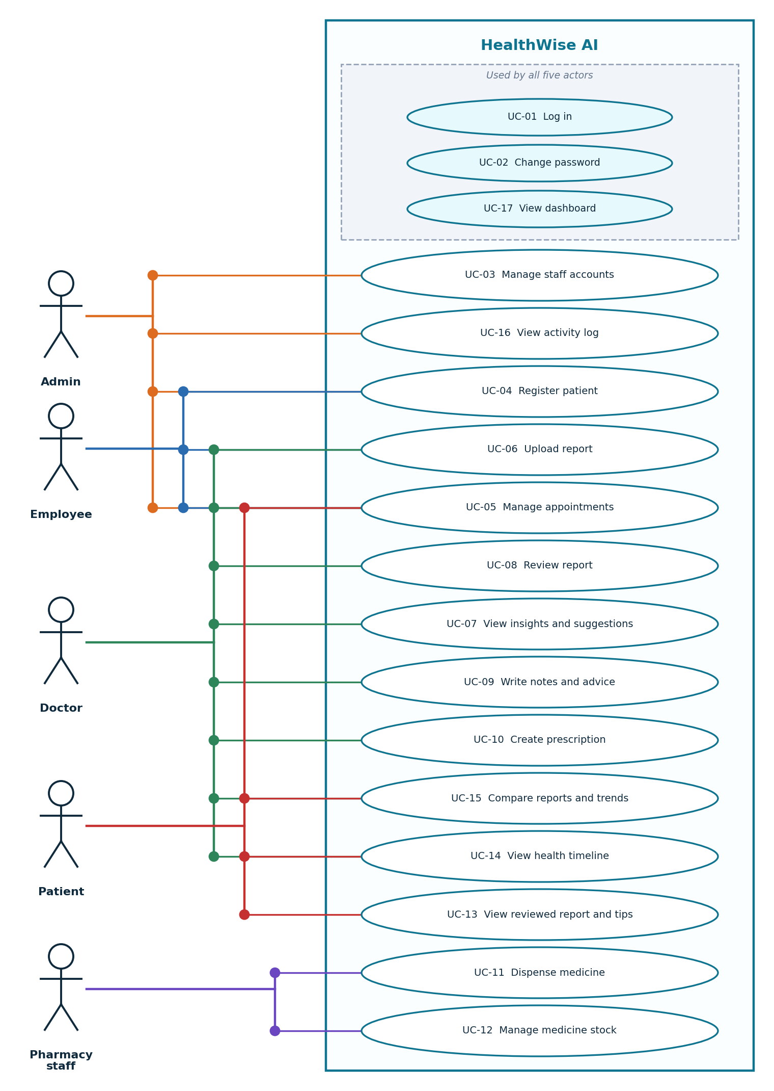
Figure 6.1 Use case diagram

6.3 Use Case Descriptions

UC-01 Login
Use Case ID | UC-01
Use Case | Login
Actor | Admin / Doctor / Employee / Patient / Pharmacy Staff
Precondition | The user has an active account.
Main Flow | Enter email, then password, then the system validates them, then the dashboard of the user's role opens.
Alternative Flow | Wrong credentials or deactivated account: a general error is shown and nothing is revealed. If the password was generated, the user is sent to Change password first.
Postcondition | The user is logged in; the login is written to the audit log.

UC-02 Change password
Use Case ID | UC-02
Use Case | Change password
Actor | All users
Precondition | The user is logged in.
Main Flow | Open Change password, then enter the current and the new password, then the system checks them and saves the new hash.
Alternative Flow | Wrong current password or a new password shorter than 8 characters: an error is shown and nothing changes.
Postcondition | The new password is active and the 'must change' flag is cleared.

UC-03 Manage staff accounts
Use Case ID | UC-03
Use Case | Manage staff accounts
Actor | Admin
Precondition | The administrator is logged in.
Main Flow | Open Staff, then choose a role, then enter name, email and role details, then the system creates the account and shows a generated password once. The administrator can also activate or deactivate people and manage departments.
Alternative Flow | Email already used: an error is shown. The administrator cannot deactivate their own account.
Postcondition | The account exists and can log in; the action is audited.

UC-04 Register patient
Use Case ID | UC-04
Use Case | Register patient
Actor | Admin / Employee
Precondition | The user is logged in.
Main Flow | Open Register patient, then fill in the basic details, then the system creates the patient's account and a patient code.
Alternative Flow | Invalid or duplicate email: an error is shown. Employees cannot enter clinical details.
Postcondition | The patient appears in the patient list and can log in.

UC-05 Manage appointments
Use Case ID | UC-05
Use Case | Manage appointments
Actor | Admin / Employee / Doctor / Patient
Precondition | The user is logged in; the patient and doctor exist.
Main Flow | Choose patient, doctor, date, time and reason, then the system checks the time is not in the past and does not clash, then saves it as Scheduled. The doctor, employee or administrator can confirm, complete or cancel it; a patient can only cancel.
Alternative Flow | Past time or clash: the system explains and does not save.
Postcondition | The appointment shows on the dashboards of the people involved.

UC-06 Upload report
Use Case ID | UC-06
Use Case | Upload report
Actor | Employee / Doctor (OCR engine)
Precondition | The user is logged in; the patient exists.
Main Flow | Open Upload report, then choose the patient (and the doctor if needed), then add the file, then the system checks type, size and content, reads the text or runs OCR, finds the results and insights, and saves the report as Waiting for doctor.
Alternative Flow | Wrong file type, too large, unreadable, or not a medical document: a clear message is shown and nothing is saved. OCR missing for a scan: a clear message. Name on the report differs from the patient: a warning.
Postcondition | The report is saved with its results and insights and shows on the doctor's dashboard.

UC-07 View insights and suggestions
Use Case ID | UC-07
Use Case | View insights and suggestions
Actor | Doctor (AI model)
Precondition | A report has been uploaded for one of the doctor's patients.
Main Flow | Open the report, then read the key numbers at a glance, the key findings, the red flags and the suggestions for the doctor. The doctor can regenerate the insights.
Alternative Flow | A report saved before insights existed: they are created when it is opened.
Postcondition | The doctor has the information needed to review; regeneration is audited.

UC-08 Review report
Use Case ID | UC-08
Use Case | Review report
Actor | Doctor
Precondition | A report is Waiting for doctor.
Main Flow | Open the report, read the values, history and insights, then choose approve, modify or clarify, then add a comment (required for modify and clarify), then save.
Alternative Flow | Comment missing for modify or clarify: the system asks for it.
Postcondition | The report is marked Reviewed; the patient can now see it.

UC-09 Write notes and advice
Use Case ID | UC-09
Use Case | Write notes and advice
Actor | Doctor
Precondition | The doctor is logged in and the patient is authorised.
Main Flow | Open the patient or report, then add a note with its priority, or a recommendation with an optional follow-up date, or a medical-history entry. A suggested tip can be turned into official advice.
Alternative Flow | Empty text: validation message.
Postcondition | The note or advice is saved under the doctor's name and shown to the patient (advice and notes).

UC-10 Create prescription
Use Case ID | UC-10
Use Case | Create prescription
Actor | Doctor
Precondition | The doctor is logged in and the patient is authorised.
Main Flow | Open New prescription, then add each medicine with dosage, frequency, duration and quantity, then save.
Alternative Flow | A missing field: validation message. Only the writing doctor may cancel it later.
Postcondition | The prescription is Active for 30 days and appears for pharmacy and the patient.

UC-11 Dispense medicine
Use Case ID | UC-11
Use Case | Dispense medicine
Actor | Pharmacy Staff
Precondition | An active prescription exists.
Main Flow | Search the prescription, then open it, then enter the quantity (part or all), or mark a medicine unavailable, then the system checks the remaining quantity and the expiry, saves the dispensing and lowers stock.
Alternative Flow | More than remaining, or the prescription is cancelled or expired: the system refuses and says why.
Postcondition | The prescription status is updated (partly or fully dispensed); stock is reduced; the action is audited.

UC-12 Manage medicine stock
Use Case ID | UC-12
Use Case | Manage medicine stock
Actor | Pharmacy Staff
Precondition | The user is logged in.
Main Flow | Open Inventory, then add or update a medicine with batch, quantity and expiry date.
Alternative Flow | Negative quantity or missing name: validation message.
Postcondition | Stock is current; low-stock and expiring items show on the dashboard.

UC-13 View reviewed report and tips
Use Case ID | UC-13
Use Case | View reviewed report and tips
Actor | Patient
Precondition | The doctor has reviewed the report.
Main Flow | Open My reports, then choose a report, then read the plain-language results, the doctor's notes and the general tips.
Alternative Flow | Report not yet reviewed: the patient is told it is waiting for the doctor and sees no analysis.
Postcondition | The patient understands the result. Opening the original file is recorded in the audit log.

UC-14 View health timeline
Use Case ID | UC-14
Use Case | View health timeline
Actor | Doctor / Patient
Precondition | The user is allowed to see the patient.
Main Flow | Open Health history, then scroll or search the timeline of appointments, reports, reviews, notes, prescriptions and dispensing.
Alternative Flow | No data yet: an honest empty message.
Postcondition | The user sees the history with the source of each item.

UC-15 Compare reports and trends
Use Case ID | UC-15
Use Case | Compare reports and trends
Actor | Doctor / Patient
Precondition | The patient has at least two reports (reviewed ones for a patient).
Main Flow | Open Compare, then choose two reports, then the system shows the change of each value and a trend chart.
Alternative Flow | Fewer than two reports: the screen explains that a second report is needed.
Postcondition | Changes and trends are displayed in plain words.

UC-16 View activity log
Use Case ID | UC-16
Use Case | View activity log
Actor | Admin
Precondition | The administrator is logged in.
Main Flow | Open Audit log, then read the day-by-day feed of who did what.
Alternative Flow | No actions yet: an empty message.
Postcondition | The administrator can see an accountable record of activity.

UC-17 View dashboard
Use Case ID | UC-17
Use Case | View dashboard
Actor | All users
Precondition | The user is logged in.
Main Flow | Open the dashboard; the system shows numbers, lists and notifications computed from the database for the user's role.
Alternative Flow | No data yet: an honest empty state is shown instead of sample numbers.
Postcondition | The user sees the current state and quick actions.

7. System Models
The diagrams below show the system from different viewpoints. All of them describe the system as it is built.

7.1 Context Diagram
The context diagram shows the whole system as one process, with the people and services that exchange data with it.
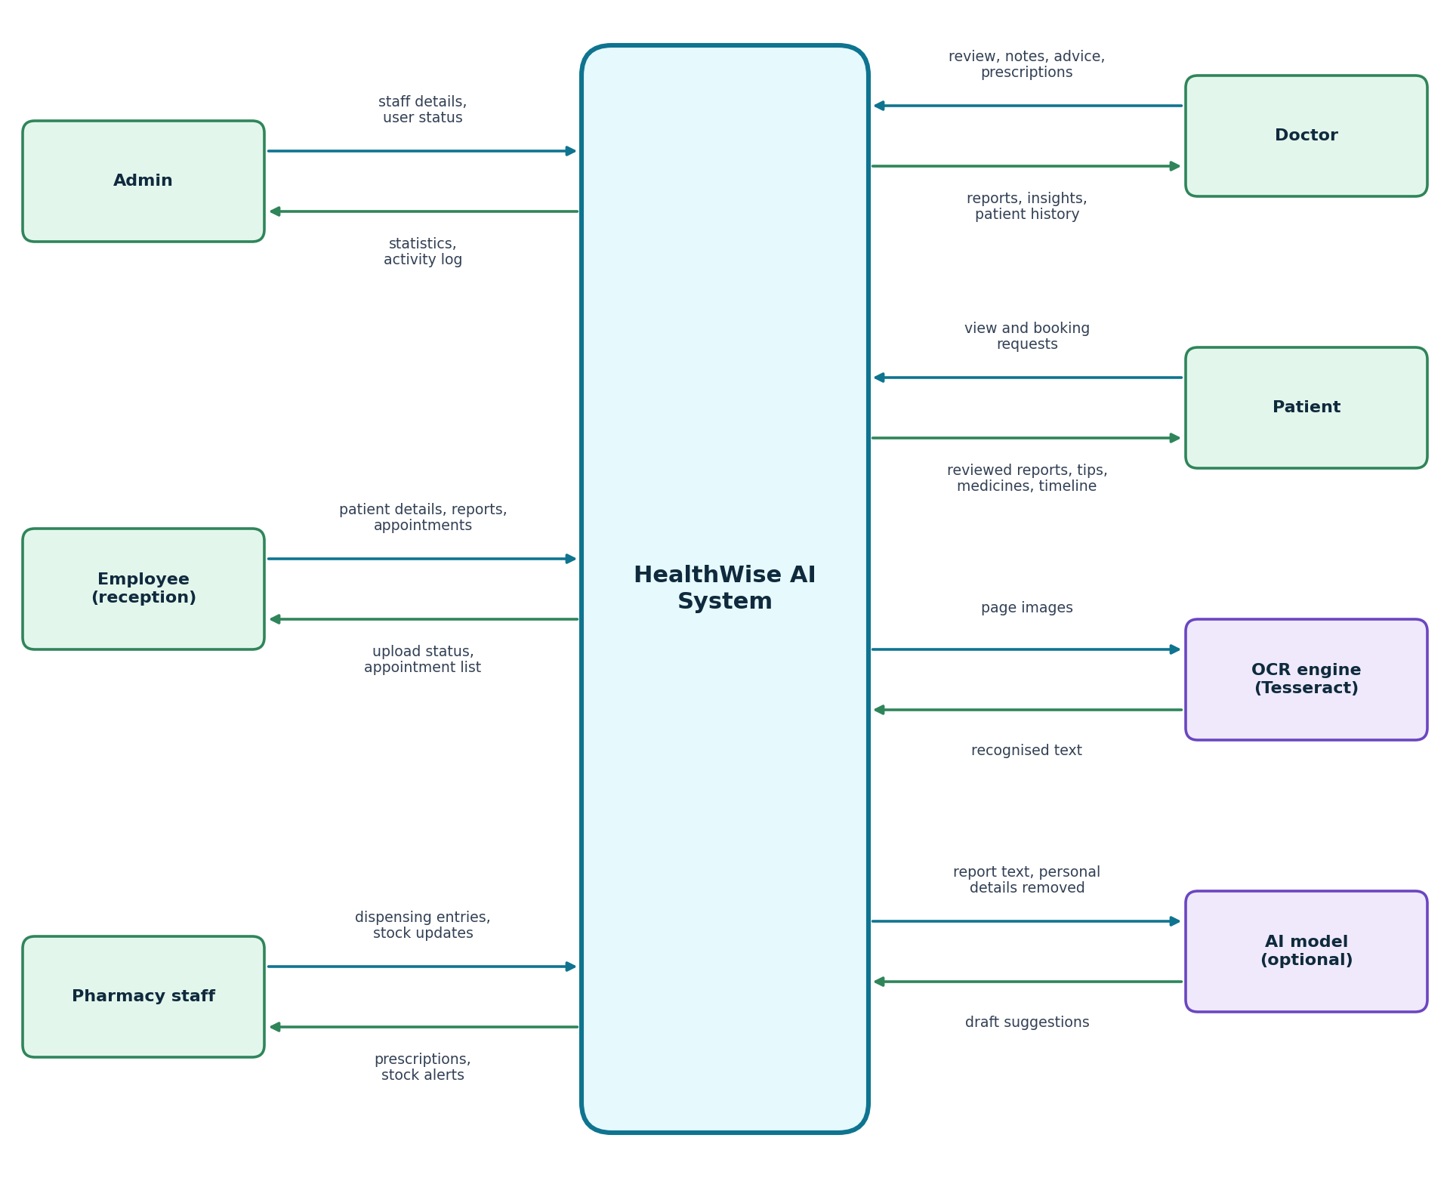
Figure 7.1 Context diagram

7.2 DFD
Level 0 splits the system into six processes and five data stores.
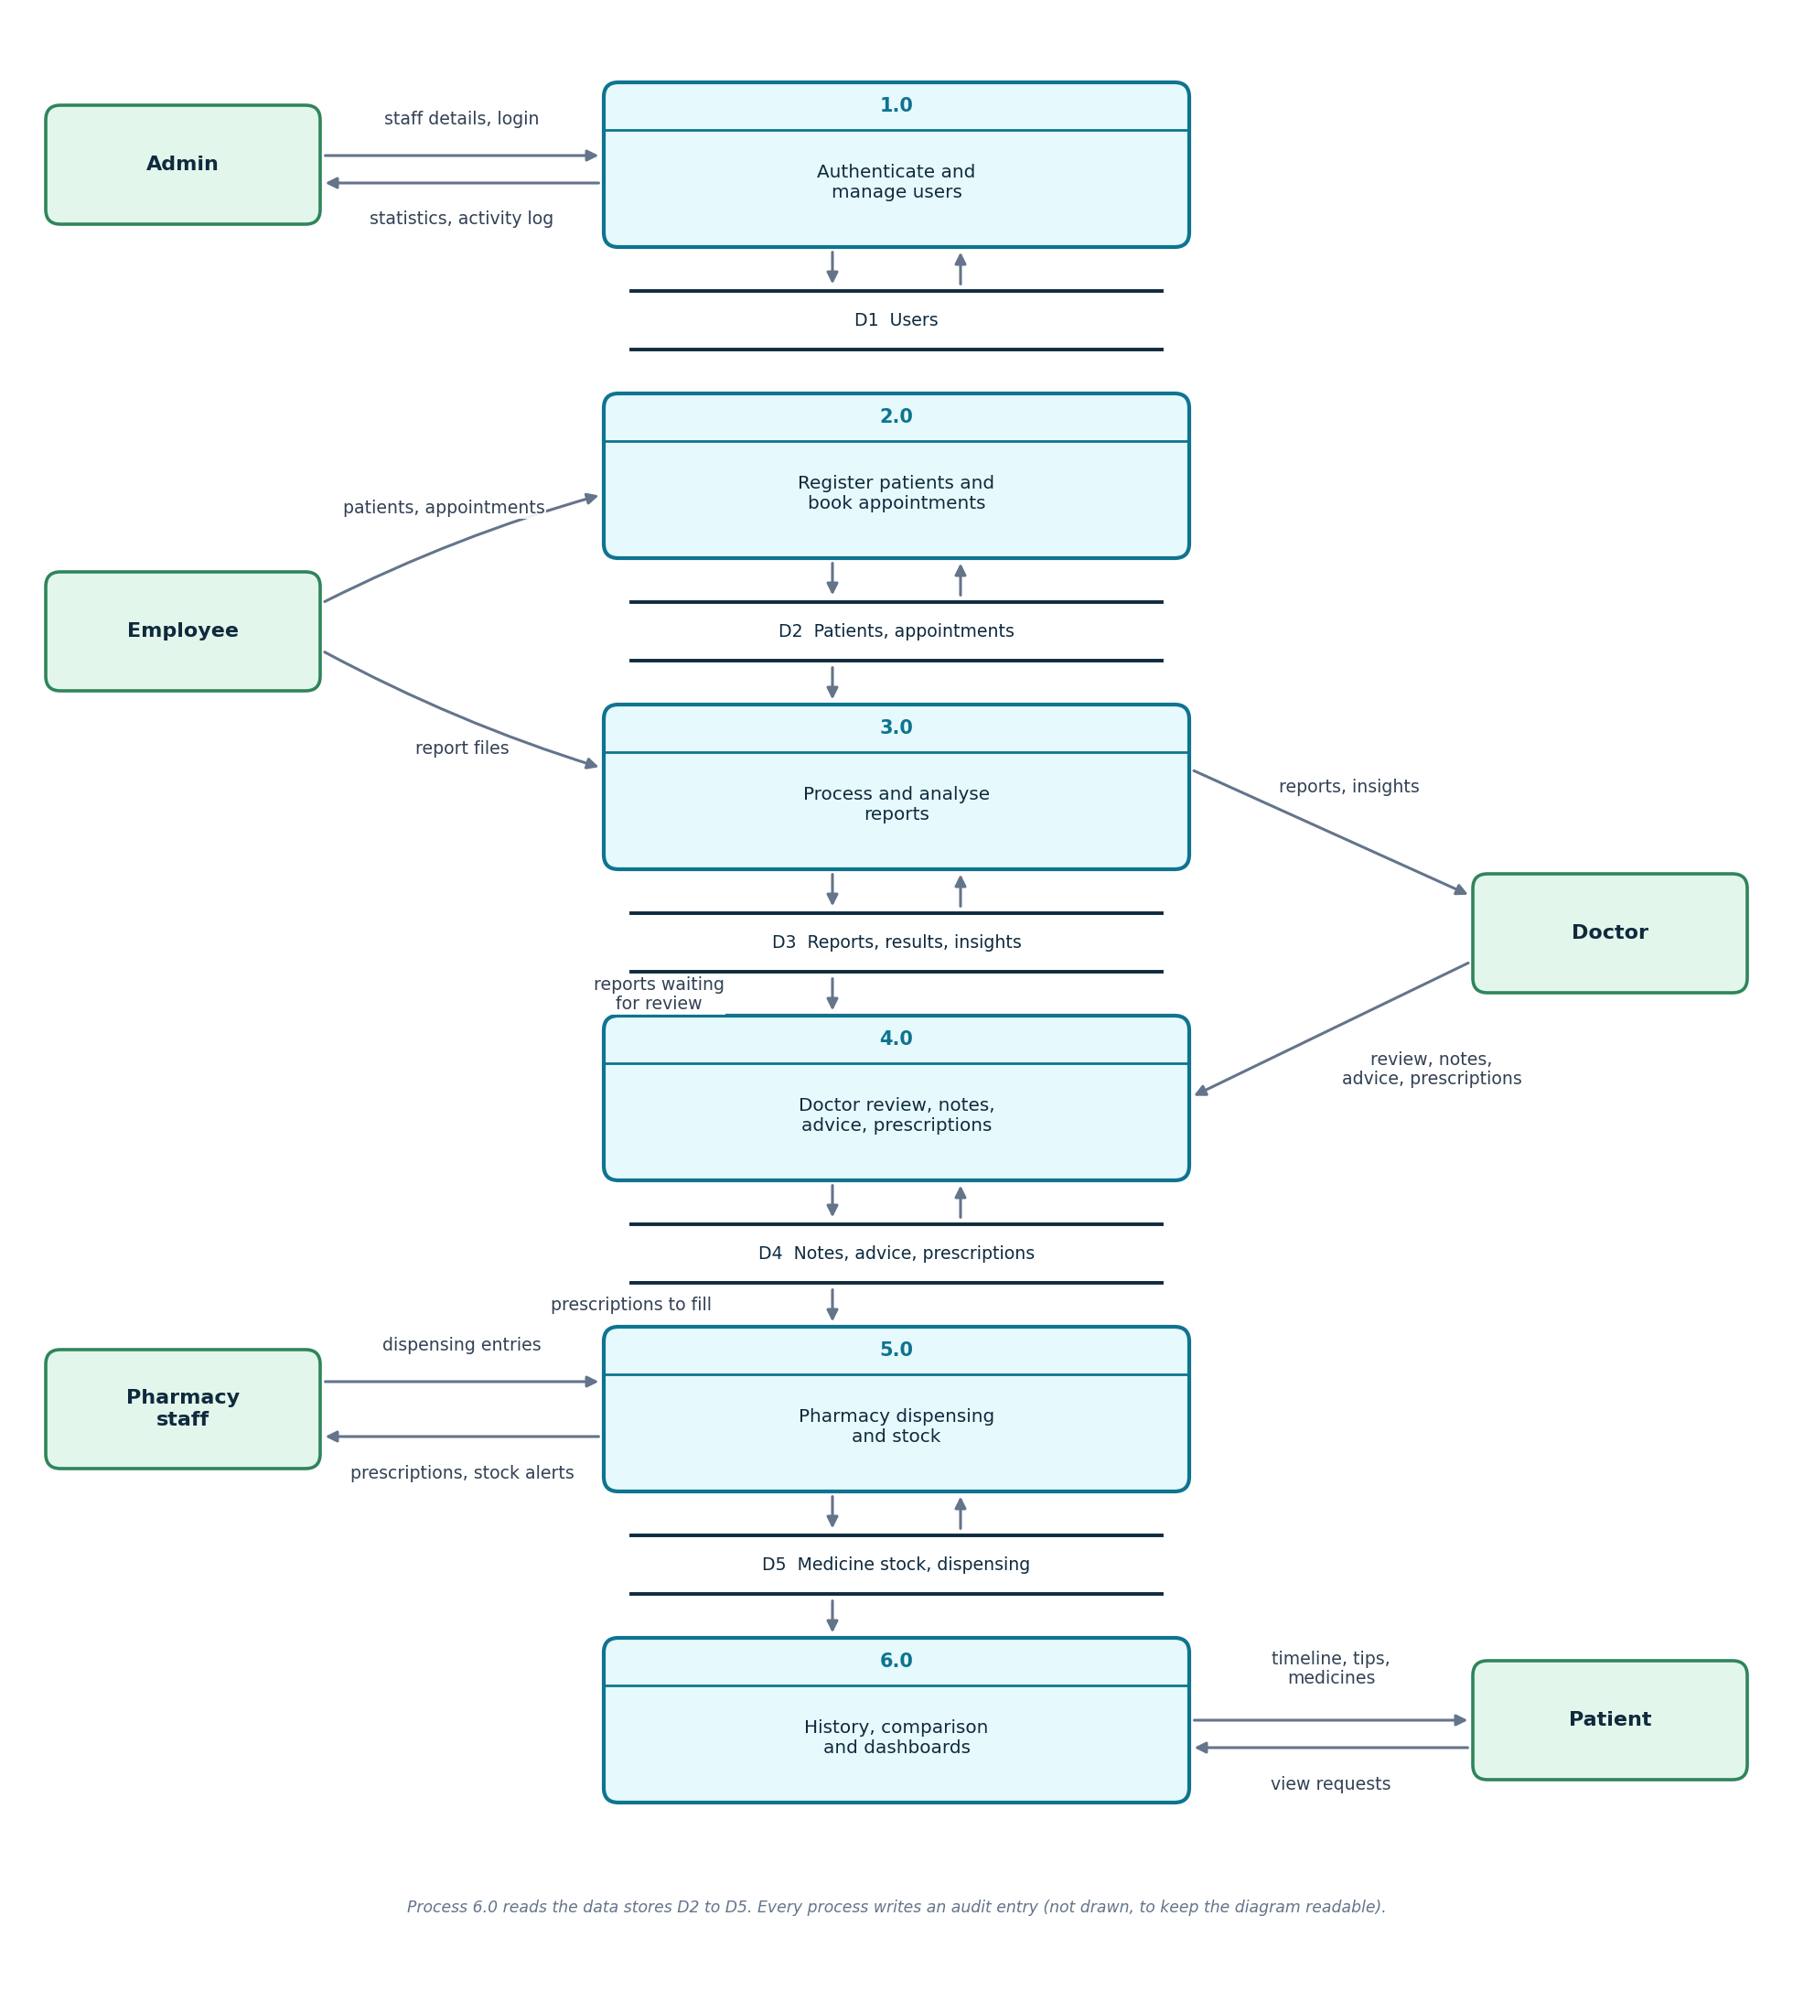
Figure 7.2 Data flow diagram, level 0
Level 1 expands process 3.0 (Report Analysis) into its six steps.
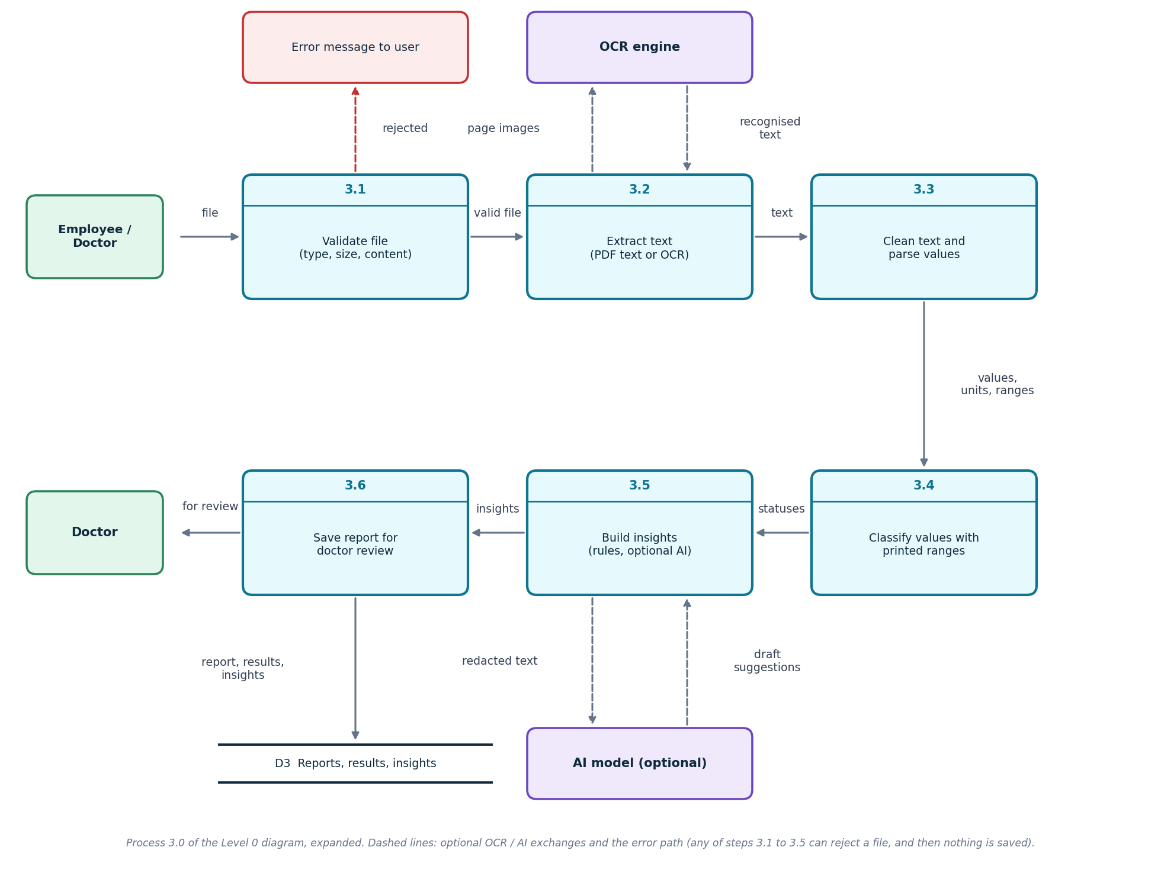
Figure 7.3 Data flow diagram, level 1 (process 3.0, Report Analysis)

7.3 Activity Diagram
The swimlane diagram follows a report from upload by the employee, through the system's checks and the doctor's review, to the patient's view and the pharmacy.
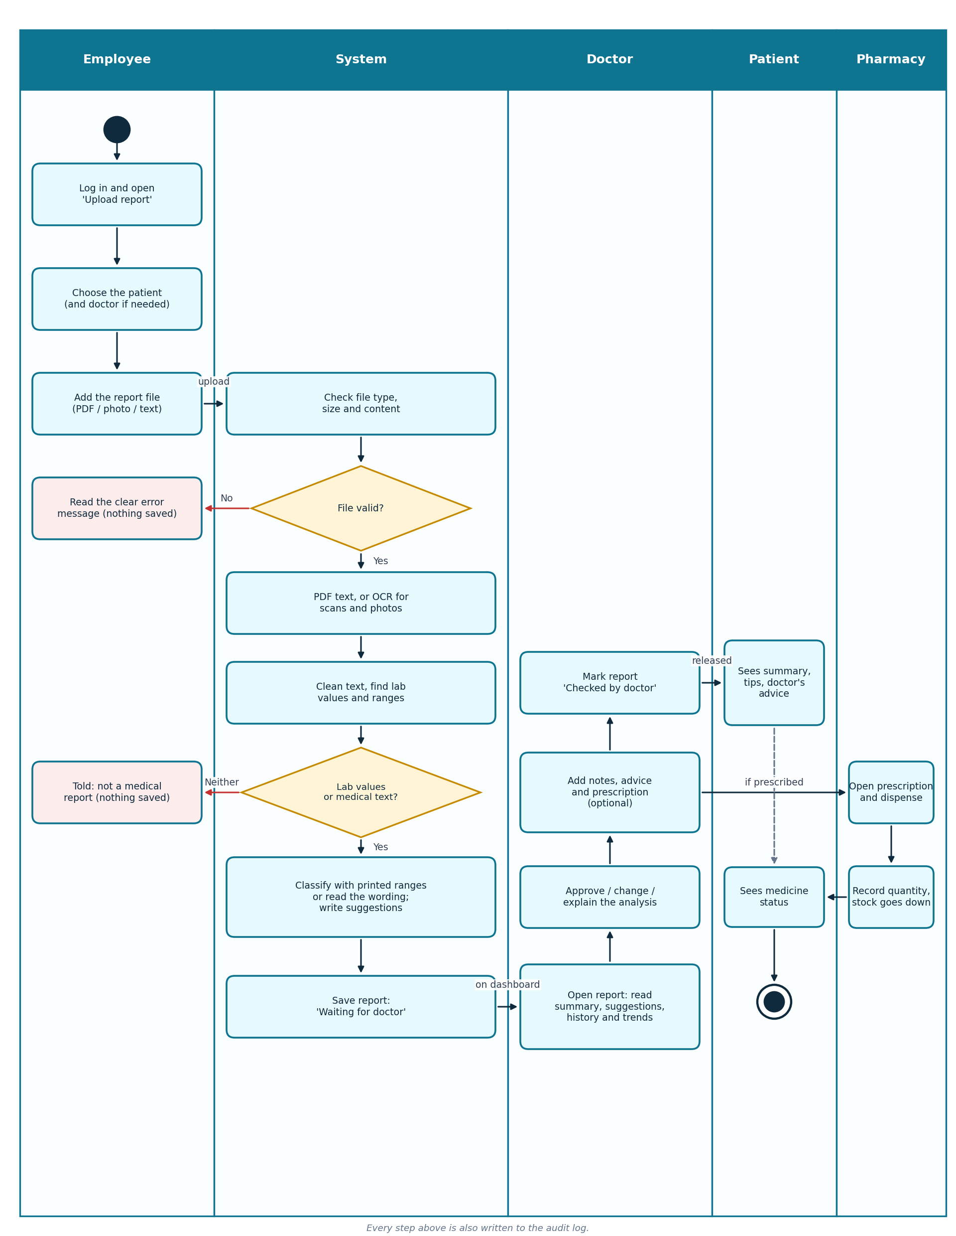
Figure 7.4 Activity diagram: report upload to dispensing

7.4 Sequence Diagram
The sequence diagram shows the messages between the browser, the server, the analysis engine and the database for the same workflow.
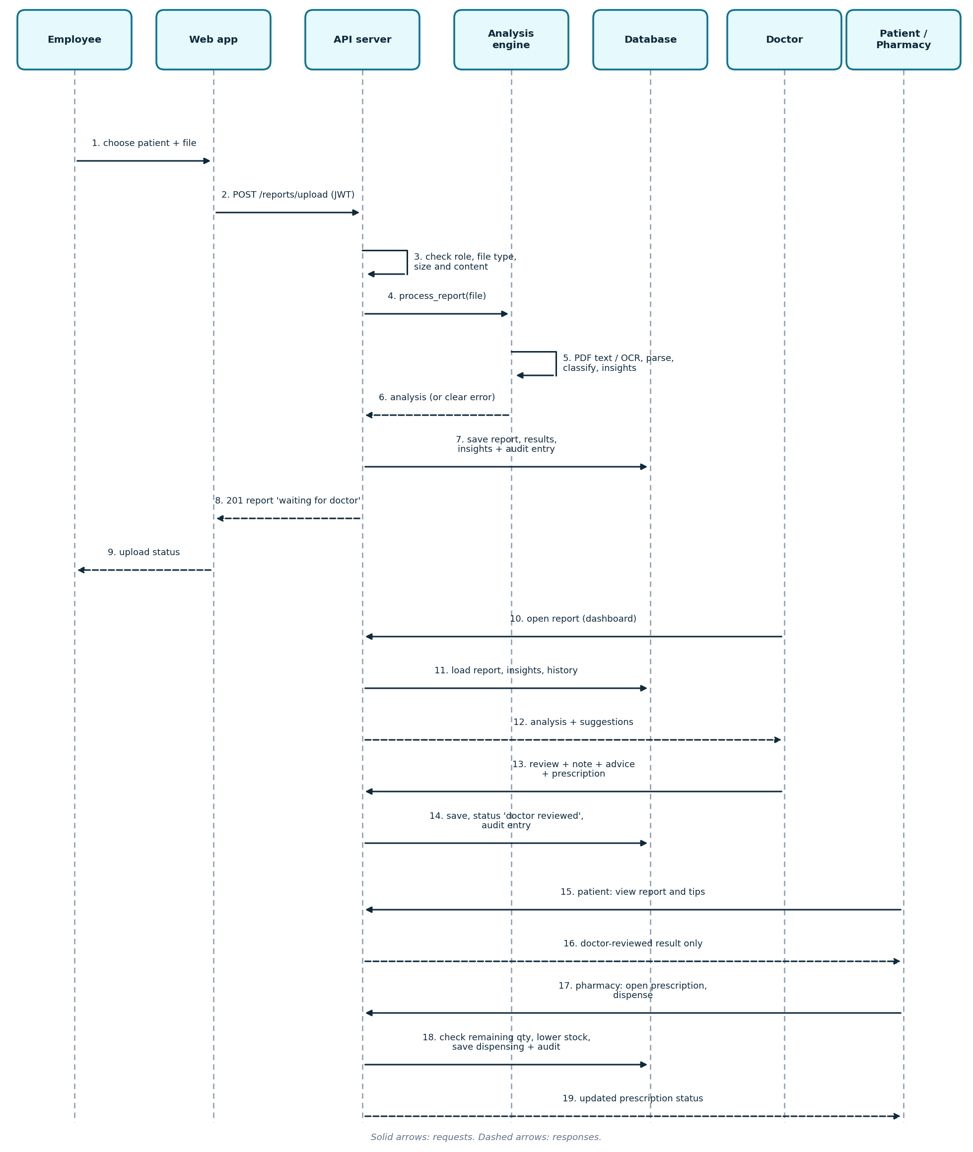
Figure 7.5 Sequence diagram: report upload, review and dispensing

7.5 Class Diagram
The classes are shown in two parts so that the text stays readable on a normal printed page. Part 1 shows the people and their roles; part 2 shows reports, prescriptions and the pharmacy.
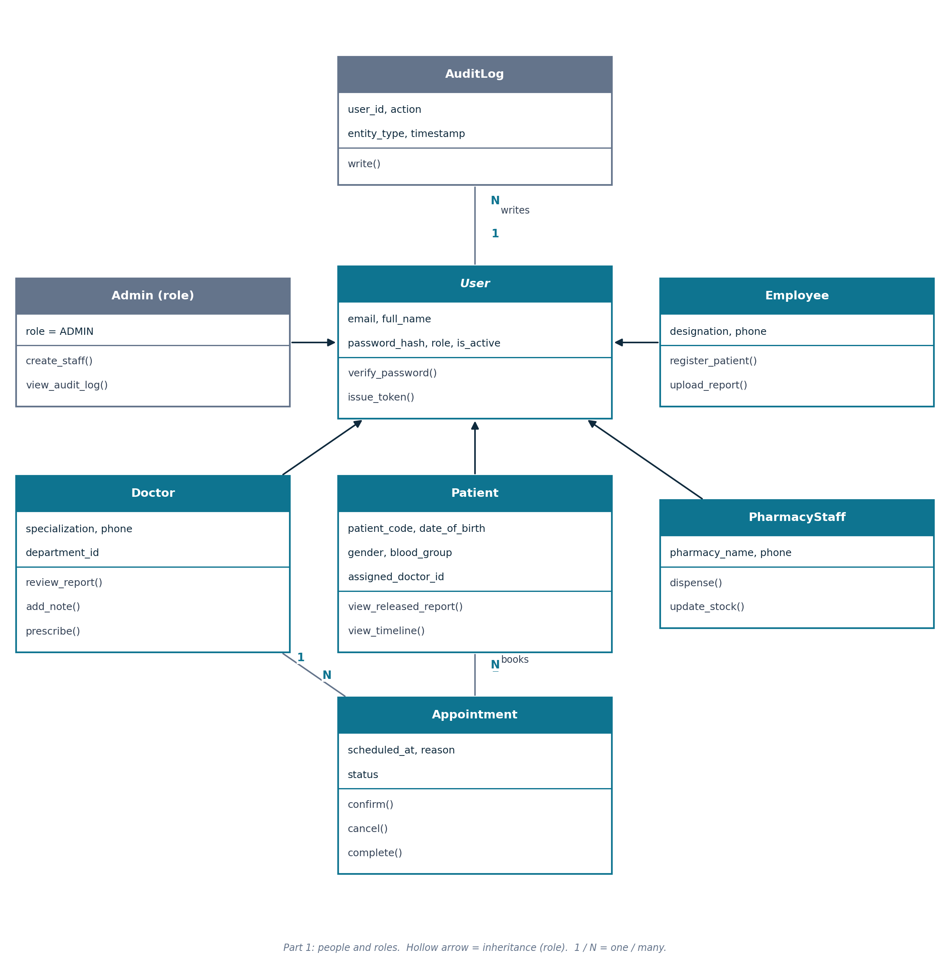
Figure 7.6 Class diagram, part 1: people and roles
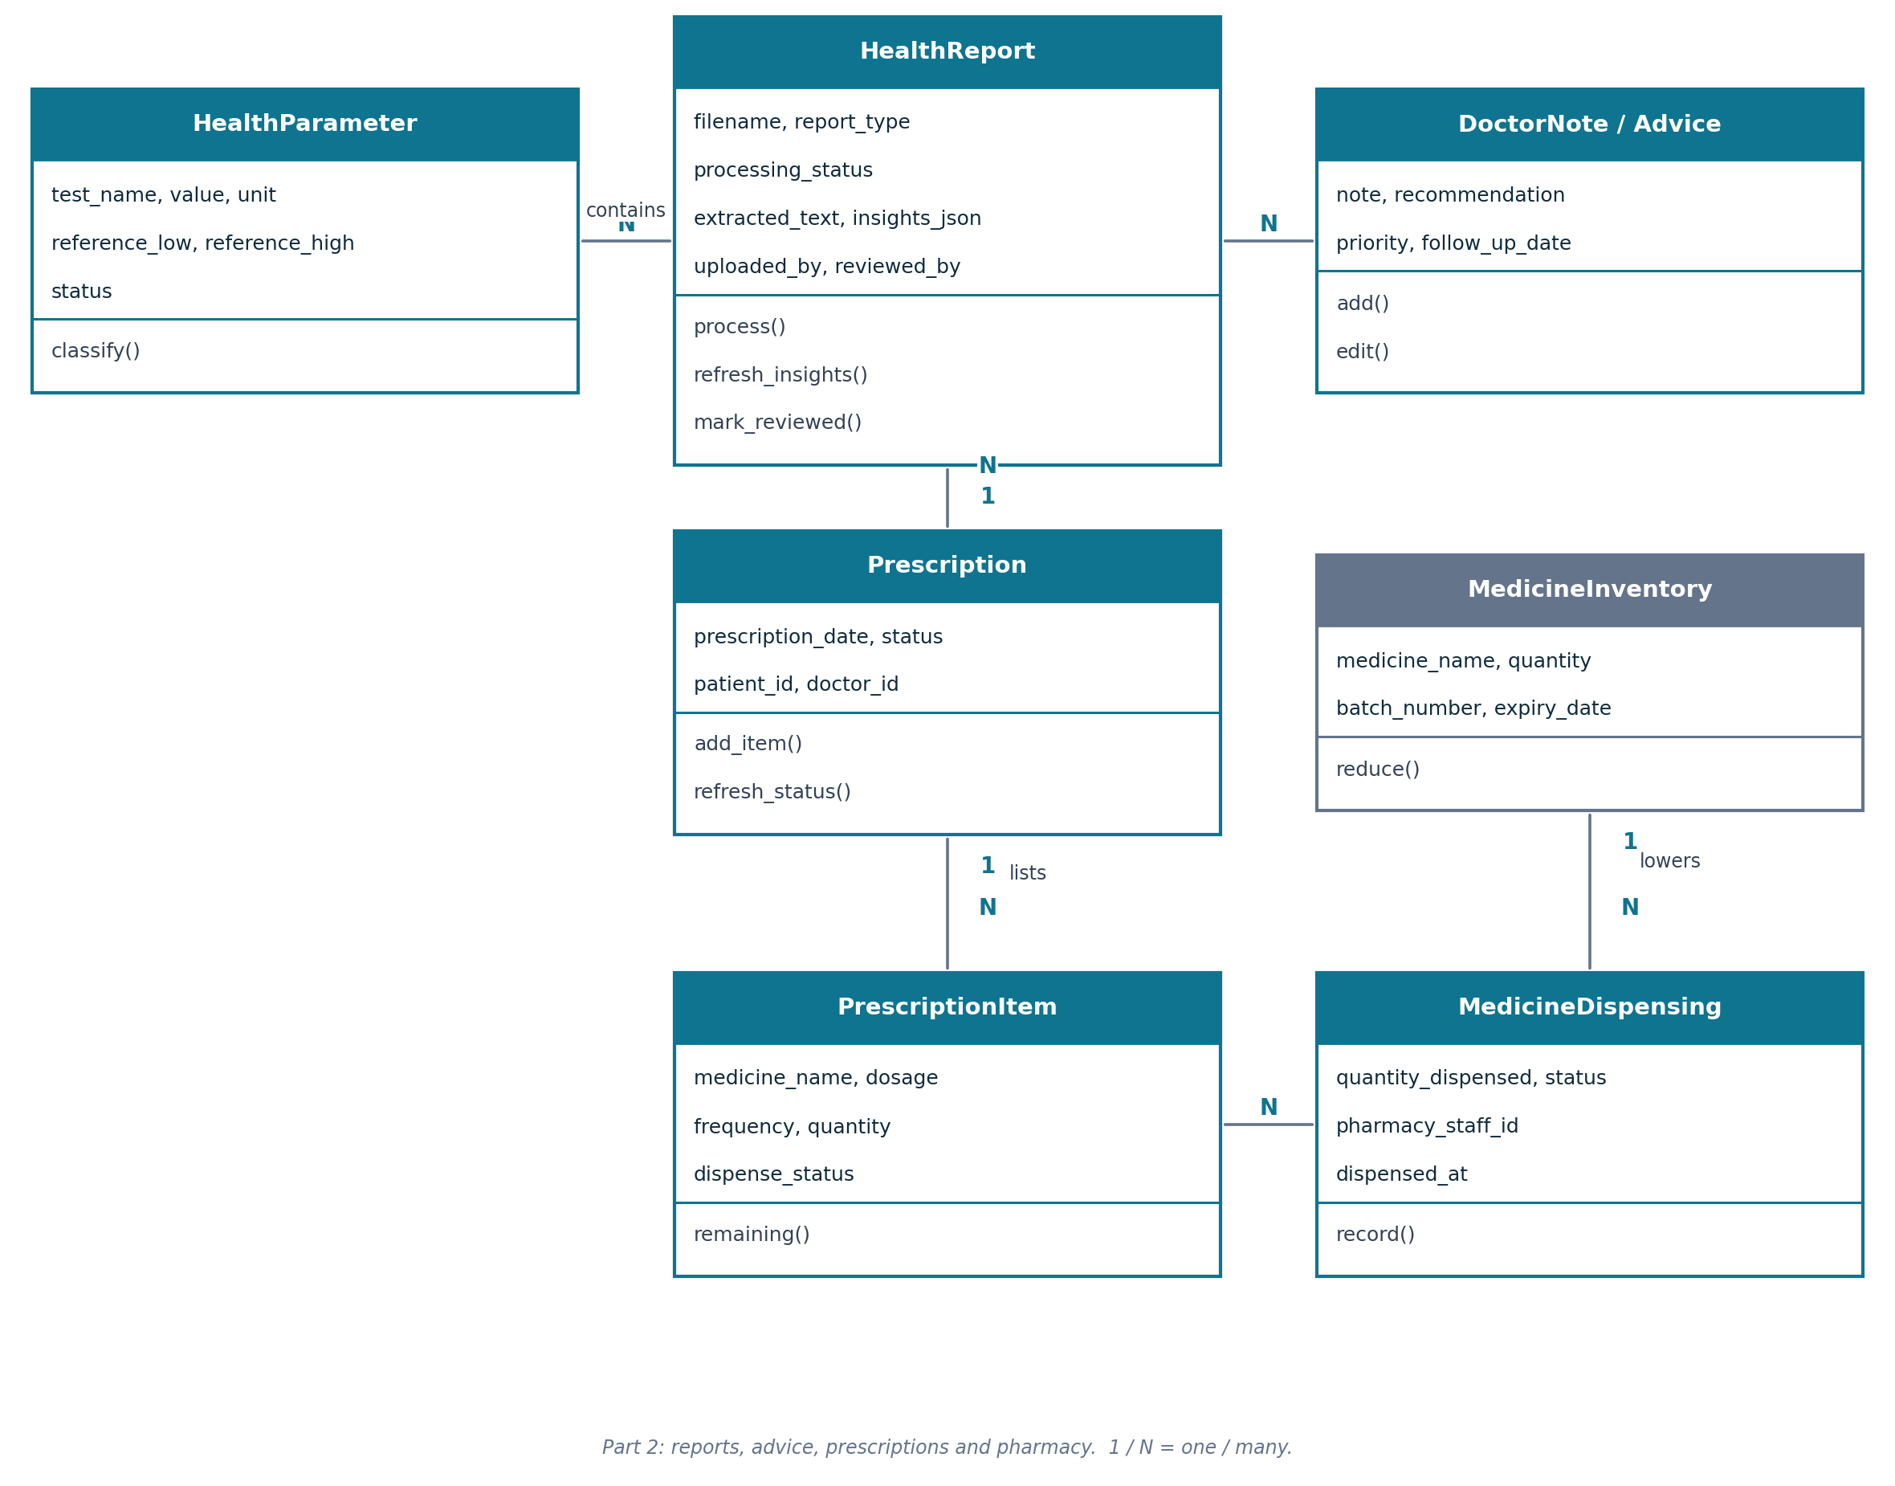
Figure 7.7 Class diagram, part 2: reports, prescriptions and pharmacy

7.6 ER Diagram
The 18 tables are shown in two parts. Only the main relationships are drawn; Chapter 8 lists every column.
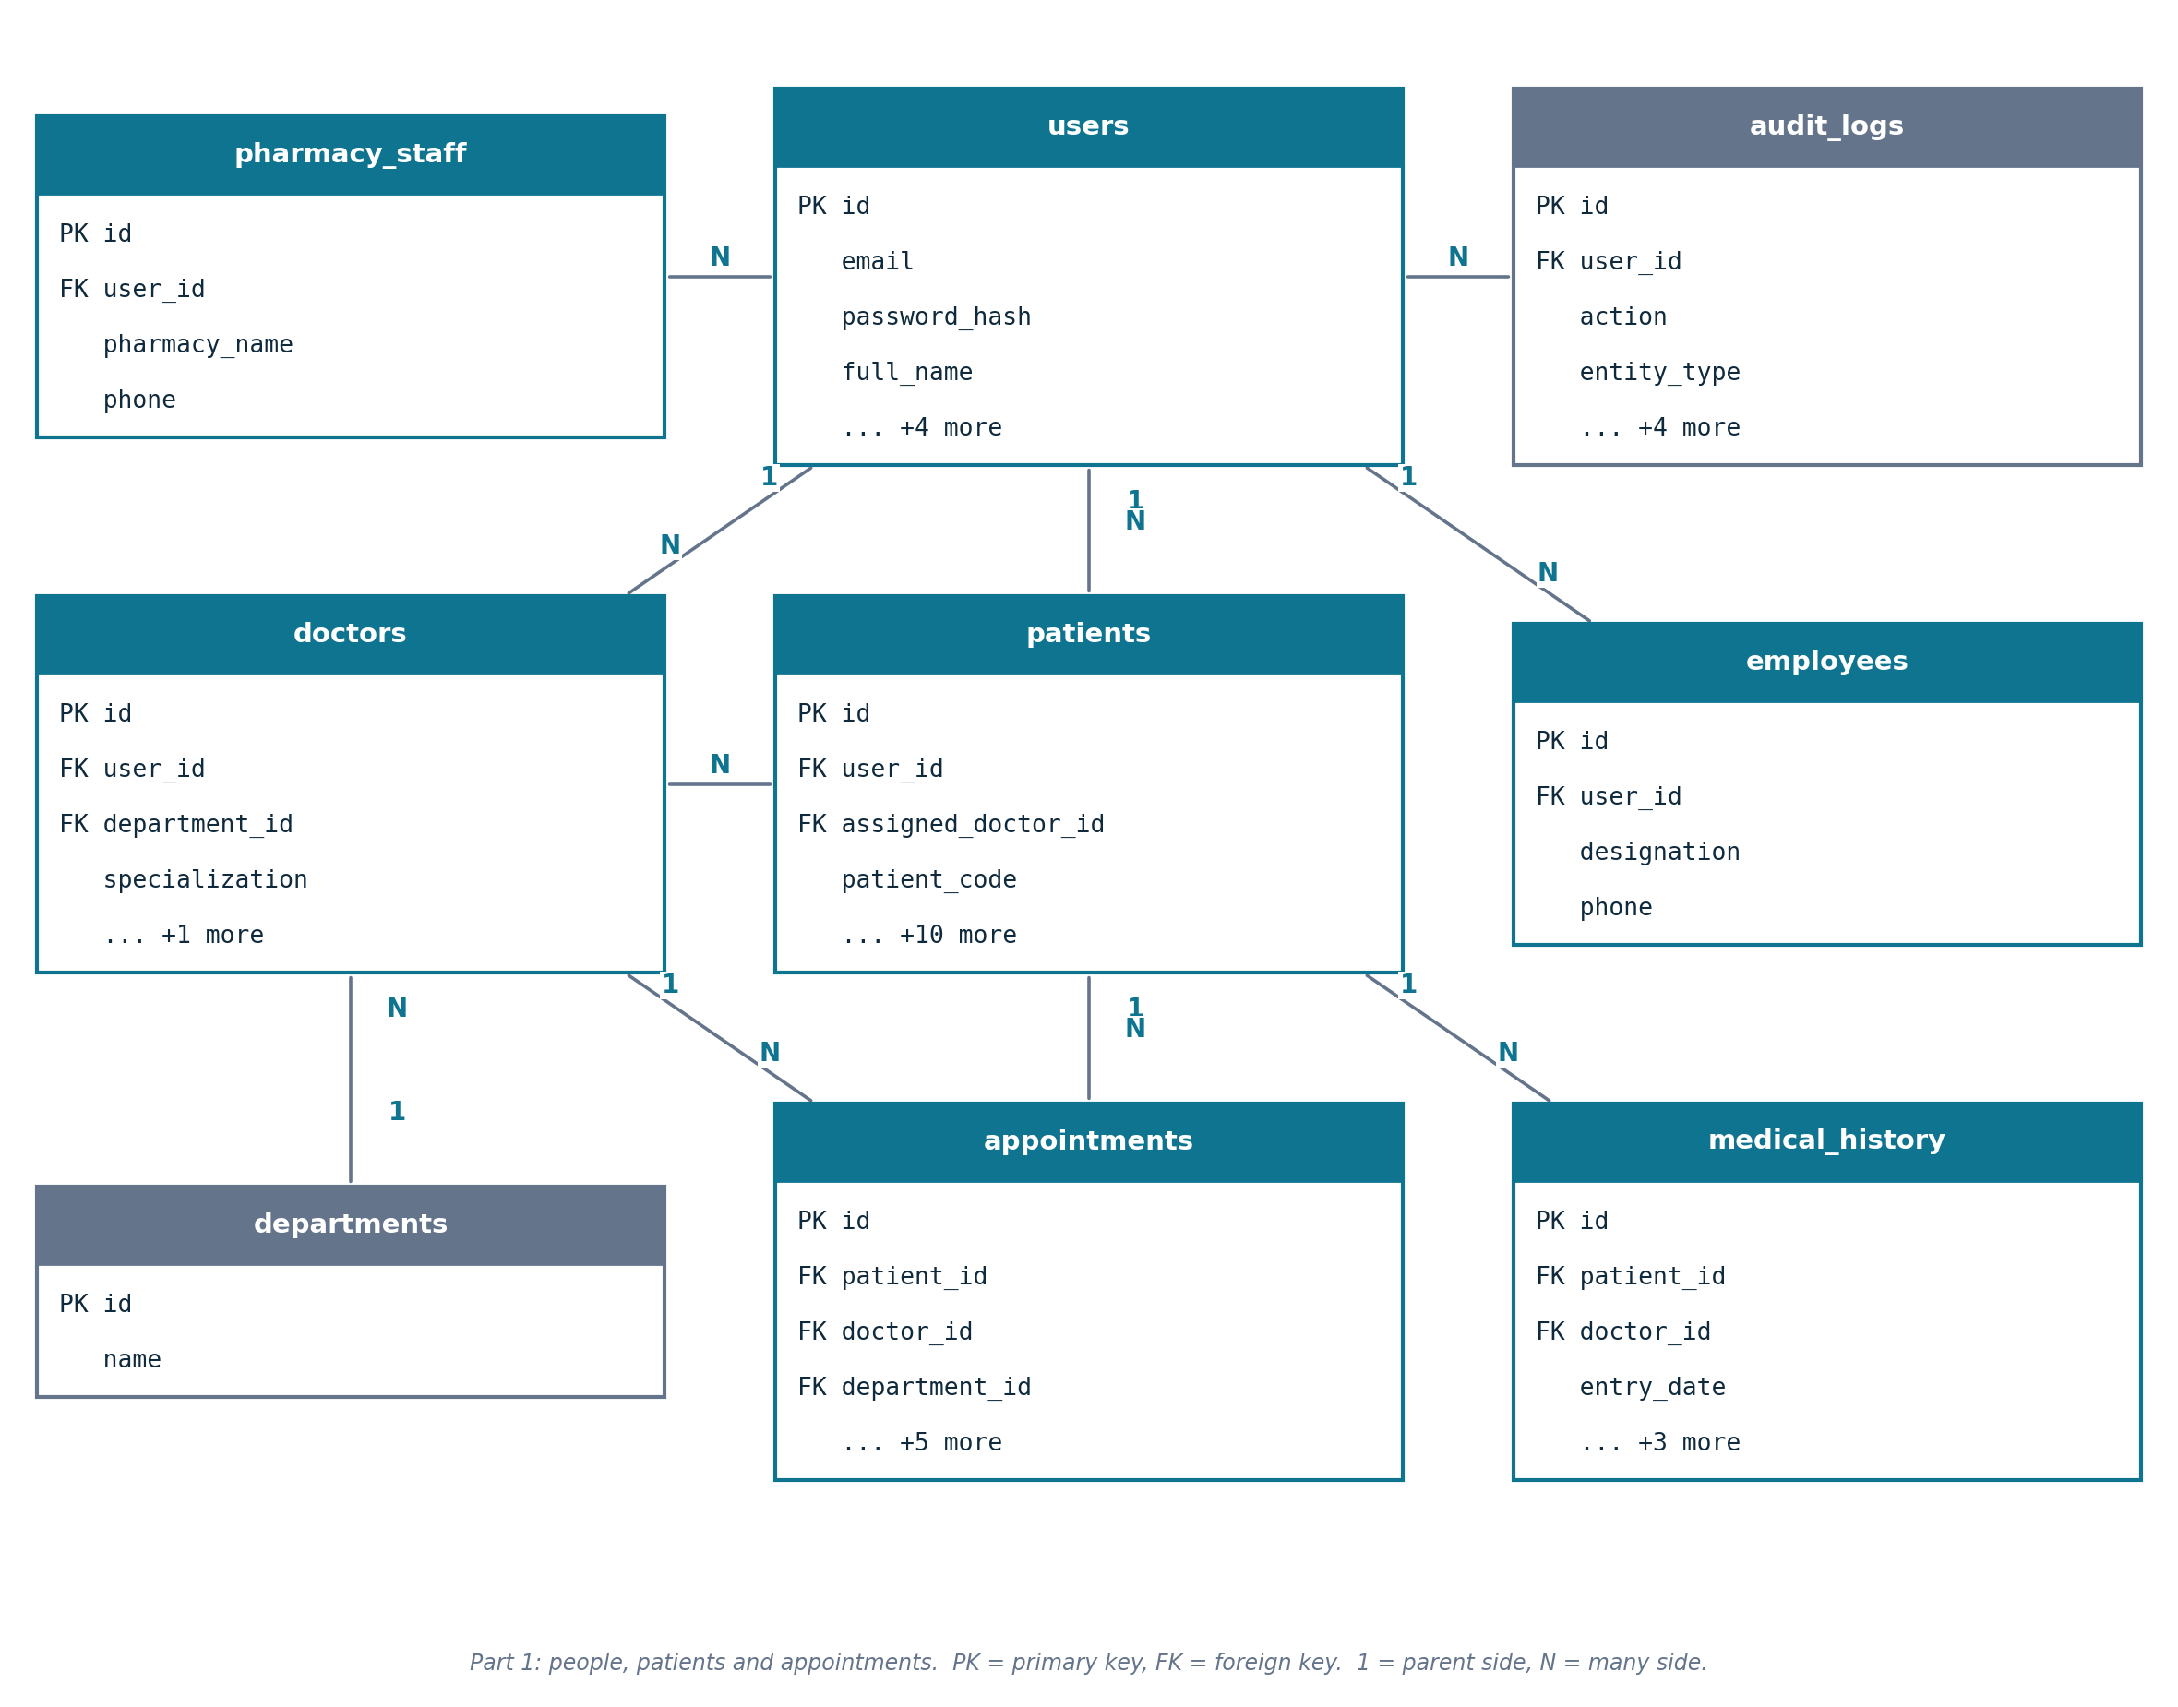
Figure 7.8 ER diagram, part 1: people, patients and appointments
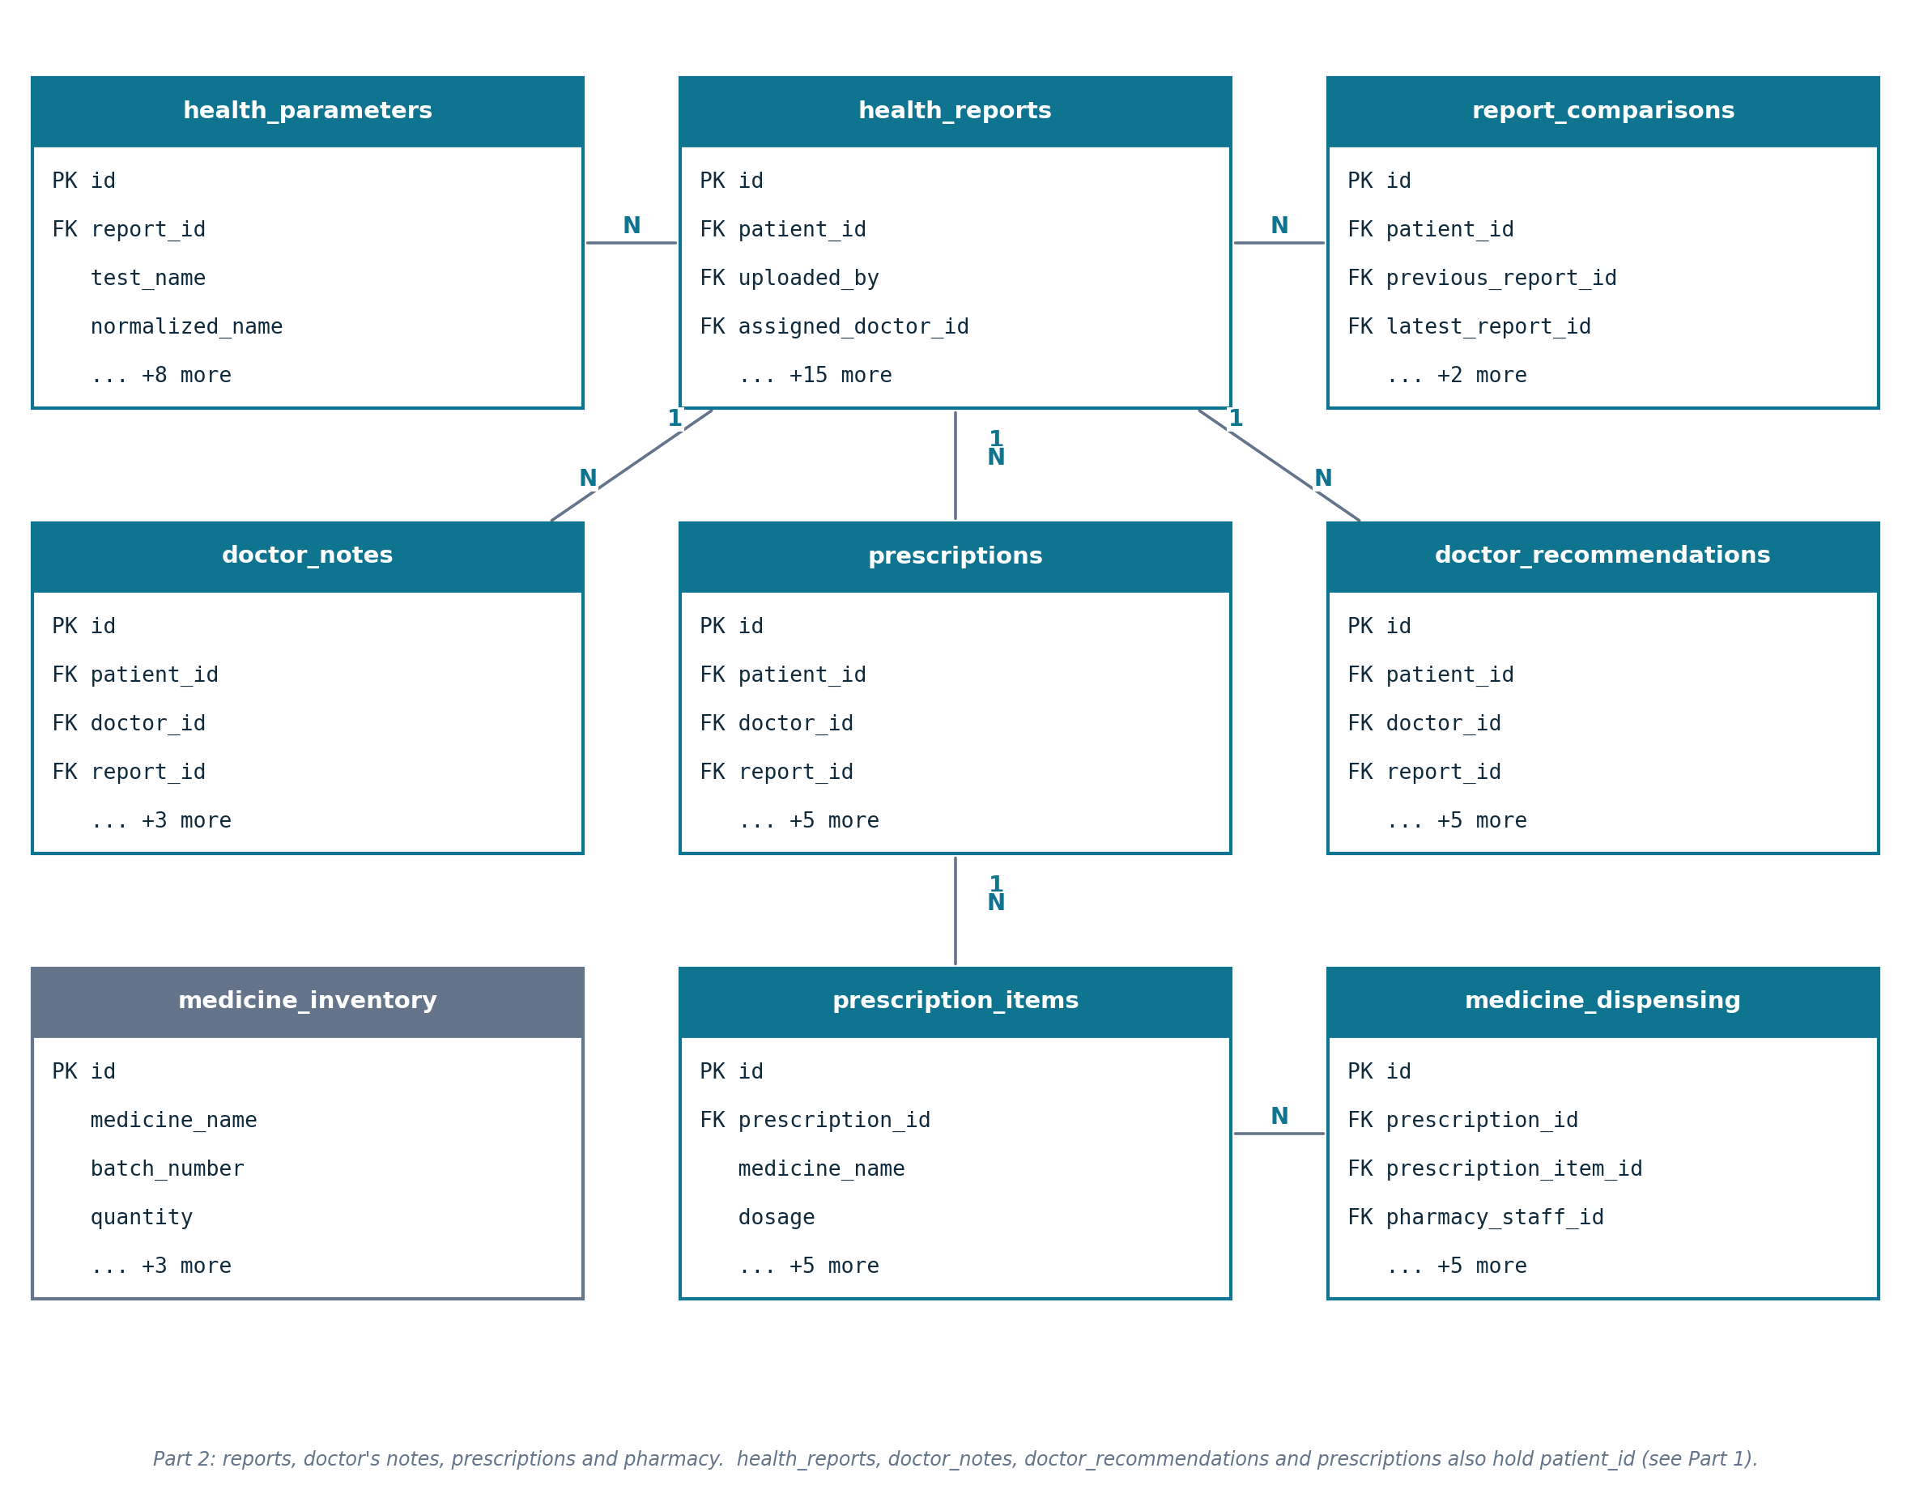
Figure 7.9 ER diagram, part 2: reports, notes, prescriptions and pharmacy

8. Data Requirements
The system stores its data in 18 relational tables. Every table has an integer primary key named id. A foreign key links a row to its parent. The table below gives a short purpose for each table; the data dictionary then lists every column.

8.1 Database Tables
Table | Purpose | Columns
departments | Hospital departments. | 2
medicine_inventory | Pharmacy stock of each medicine batch. | 7
users | Login accounts of everyone in the system, with the role. | 8
audit_logs | Record of important actions. | 8
doctors | Extra details of users with the Doctor role. | 5
employees | Extra details of users with the Employee role. | 4
pharmacy_staff | Extra details of users with the Pharmacy role. | 4
patients | Patient profile: demographics and basic history. | 14
appointments | Booked visits between a patient and a doctor. | 9
health_reports | Uploaded reports, their processing and review state, and the insights. | 19
medical_history | Medical-history entries added by a doctor. | 7
doctor_notes | Notes written by a doctor. | 7
doctor_recommendations | Follow-up advice written by a doctor. | 9
health_parameters | One row per test result found in a report. | 12
prescriptions | Prescriptions written by a doctor. | 9
report_comparisons | Saved comparisons between two reports of a patient. | 6
prescription_items | Medicines listed in a prescription. | 9
medicine_dispensing | Every handing-out (or 'unavailable' record) of a prescribed medicine. | 9

8.2 Data Dictionary
Key: PK = primary key, FK = foreign key (the parent table is named in the description), NULL = may be empty.

8.2.1 users
Field | Data Type | Key | Description
id | INTEGER | PK | Unique number of the record
email | VARCHAR(255) | Unique | Login email, unique
password_hash | VARCHAR(255) |  | Password stored as a bcrypt hash
full_name | VARCHAR(150) |  | Full name
role | VARCHAR(20) |  | ADMIN, DOCTOR, EMPLOYEE, PATIENT or PHARMACY
is_active | BOOLEAN |  | False when the account is deactivated
must_change_password | BOOLEAN |  | True until the generated password is changed
created_at | DATETIME |  | When the account was created

8.2.2 departments
Field | Data Type | Key | Description
id | INTEGER | PK | Unique number of the record
name | VARCHAR(100) | Unique | Department name

8.2.3 doctors
Field | Data Type | Key | Description
id | INTEGER | PK | Unique number of the record
user_id | INTEGER | FK | Login account (users)
department_id | INTEGER | FK | Department (departments)
specialization | VARCHAR(120) | NULL | Doctor's speciality
phone | VARCHAR(30) | NULL | Contact number

8.2.4 employees
Field | Data Type | Key | Description
id | INTEGER | PK | Unique number of the record
user_id | INTEGER | FK | Login account (users)
designation | VARCHAR(100) | NULL | Job title
phone | VARCHAR(30) | NULL | Contact number

8.2.5 pharmacy_staff
Field | Data Type | Key | Description
id | INTEGER | PK | Unique number of the record
user_id | INTEGER | FK | Login account (users)
pharmacy_name | VARCHAR(150) | NULL | Name of the pharmacy
phone | VARCHAR(30) | NULL | Contact number

8.2.6 patients
Field | Data Type | Key | Description
id | INTEGER | PK | Unique number of the record
user_id | INTEGER | FK | Login account (users)
patient_code | VARCHAR(20) | Unique | Readable patient number, unique
date_of_birth | DATE | NULL | Date of birth
gender | VARCHAR(30) | NULL | Gender
phone | VARCHAR(30) | NULL | Contact number
address | VARCHAR(300) | NULL | Home address
emergency_contact | VARCHAR(150) | NULL | Emergency contact person and number
blood_group | VARCHAR(10) | NULL | Blood group
allergies | TEXT | NULL | Known allergies
medical_history_text | TEXT | NULL | Short history written at registration
current_medications | TEXT | NULL | Medicines currently taken
assigned_doctor_id | INTEGER | FK | Doctor looking after the patient or report (doctors)
created_at | DATETIME |  | When the patient was registered

8.2.7 appointments
Field | Data Type | Key | Description
id | INTEGER | PK | Unique number of the record
patient_id | INTEGER | FK | Patient the record belongs to (patients)
doctor_id | INTEGER | FK | Doctor responsible (doctors)
department_id | INTEGER | FK | Department (departments)
scheduled_at | DATETIME |  | Date and time of the visit
reason | VARCHAR(300) | NULL | Reason for the visit
status | VARCHAR(20) |  | SCHEDULED, CONFIRMED, COMPLETED or CANCELLED
created_by | INTEGER | FK | User who created the record (users)
created_at | DATETIME |  | When the record was created

8.2.8 health_reports
Field | Data Type | Key | Description
id | INTEGER | PK | Unique number of the record
patient_id | INTEGER | FK | Patient the record belongs to (patients)
uploaded_by | INTEGER | FK | User who uploaded the file (users)
assigned_doctor_id | INTEGER | FK | Doctor looking after the patient or report (doctors)
filename | VARCHAR(255) |  | Original file name
file_path | VARCHAR(500) | NULL | Private storage path of the file
report_date | DATE | NULL | Date printed on the report
uploaded_at | DATETIME |  | When the file was uploaded
processing_status | VARCHAR(20) |  | ANALYZED (only successfully read reports are stored)
doctor_review_status | VARCHAR(20) |  | PENDING (waiting for doctor) or REVIEWED
reviewed_by | INTEGER | FK | Doctor who reviewed (doctors)
reviewed_at | DATETIME | NULL | When it was reviewed
review_decision | VARCHAR(20) | NULL | APPROVED, MODIFIED or CLARIFIED
review_comment | TEXT | NULL | Doctor's comment
extracted_text | TEXT | NULL | Text read from the file
processing_method | VARCHAR(20) | NULL | How the text was read: pdf_text, ocr or text
ai_summary | TEXT | NULL | Short plain-language summary
report_type | VARCHAR(30) | NULL | Detected type (lab, imaging, ECG ...)
insights_json | TEXT | NULL | Saved insights (findings, key numbers, red flags, suggestions, tips) as JSON

8.2.9 health_parameters
Field | Data Type | Key | Description
id | INTEGER | PK | Unique number of the record
report_id | INTEGER | FK | Report the record relates to (health_reports)
test_name | VARCHAR(200) |  | Test name as printed
normalized_name | VARCHAR(100) |  | Standard name of the test
value | FLOAT |  | Measured value in the report
unit | VARCHAR(50) | NULL | Unit of measure
reference_text | VARCHAR(120) | NULL | Reference range as printed
reference_low | FLOAT | NULL | Lower limit of the range
reference_high | FLOAT | NULL | Upper limit of the range
status | VARCHAR(20) |  | WITHIN_RANGE, ABOVE_RANGE, BELOW_RANGE or UNKNOWN
ai_explanation | TEXT | NULL | Plain-language explanation
created_at | DATETIME |  | When the record was created

8.2.10 report_comparisons
Field | Data Type | Key | Description
id | INTEGER | PK | Unique number of the record
patient_id | INTEGER | FK | Patient the record belongs to (patients)
previous_report_id | INTEGER | FK | Earlier report (health_reports)
latest_report_id | INTEGER | FK | Later report (health_reports)
result_json | TEXT |  | Comparison result as JSON
created_at | DATETIME |  | When the record was created

8.2.11 doctor_notes
Field | Data Type | Key | Description
id | INTEGER | PK | Unique number of the record
patient_id | INTEGER | FK | Patient the record belongs to (patients)
doctor_id | INTEGER | FK | Doctor responsible (doctors)
report_id | INTEGER | FK | Report the record relates to (health_reports)
note | TEXT |  | Text of the note
priority | VARCHAR(25) |  | Normal, Important or Follow-up required
created_at | DATETIME |  | When the note was written

8.2.12 doctor_recommendations
Field | Data Type | Key | Description
id | INTEGER | PK | Unique number of the record
patient_id | INTEGER | FK | Patient the record belongs to (patients)
doctor_id | INTEGER | FK | Doctor responsible (doctors)
report_id | INTEGER | FK | Report the record relates to (health_reports)
title | VARCHAR(200) |  | Short heading
recommendation | TEXT |  | Text of the advice
follow_up_date | DATE | NULL | Suggested date of the next visit
priority | VARCHAR(25) |  | Normal, Important or Follow-up required
created_at | DATETIME |  | When the record was created

8.2.13 medical_history
Field | Data Type | Key | Description
id | INTEGER | PK | Unique number of the record
patient_id | INTEGER | FK | Patient the record belongs to (patients)
doctor_id | INTEGER | FK | Doctor responsible (doctors)
entry_date | DATE |  | Date of the entry
entry_type | VARCHAR(40) |  | Kind of entry
description | TEXT |  | Free text
created_at | DATETIME |  | When the record was created

8.2.14 prescriptions
Field | Data Type | Key | Description
id | INTEGER | PK | Unique number of the record
patient_id | INTEGER | FK | Patient the record belongs to (patients)
doctor_id | INTEGER | FK | Doctor responsible (doctors)
report_id | INTEGER | FK | Report the record relates to (health_reports)
prescription_date | DATE |  | Date written (valid for 30 days)
clinical_indication | VARCHAR(300) | NULL | Why it was prescribed
status | VARCHAR(25) |  | ACTIVE, PARTIALLY_DISPENSED, DISPENSED, CANCELLED or EXPIRED
notes | TEXT | NULL | Extra notes
created_at | DATETIME |  | When the record was created

8.2.15 prescription_items
Field | Data Type | Key | Description
id | INTEGER | PK | Unique number of the record
prescription_id | INTEGER | FK | Prescription (prescriptions)
medicine_name | VARCHAR(200) |  | Name of the medicine
dosage | VARCHAR(100) |  | Dose per intake
frequency | VARCHAR(100) |  | How often
duration | VARCHAR(100) |  | For how long
quantity | INTEGER |  | Quantity prescribed
instructions | TEXT | NULL | How to take it
dispense_status | VARCHAR(25) |  | PENDING, PARTIALLY_DISPENSED, DISPENSED or UNAVAILABLE

8.2.16 medicine_inventory
Field | Data Type | Key | Description
id | INTEGER | PK | Unique number of the record
medicine_name | VARCHAR(200) |  | Name of the medicine
batch_number | VARCHAR(50) | NULL | Batch number
quantity | INTEGER |  | Units in stock
expiry_date | DATE | NULL | Expiry date
manufacturer | VARCHAR(150) | NULL | Manufacturer
unit_price | FLOAT | NULL | Price per unit

8.2.17 medicine_dispensing
Field | Data Type | Key | Description
id | INTEGER | PK | Unique number of the record
prescription_id | INTEGER | FK | Prescription (prescriptions)
prescription_item_id | INTEGER | FK | Medicine line being dispensed (prescription_items)
pharmacy_staff_id | INTEGER | FK | Pharmacy user who dispensed (pharmacy_staff)
quantity_prescribed | INTEGER |  | Quantity asked for
quantity_dispensed | INTEGER |  | Quantity handed out
dispensed_at | DATETIME |  | When it was dispensed
status | VARCHAR(25) |  | Status of the medicine line after this dispensing
notes | TEXT | NULL | Extra notes

8.2.18 audit_logs
Field | Data Type | Key | Description
id | INTEGER | PK | Unique number of the record
user_id | INTEGER | FK | Login account (users)
action | VARCHAR(50) |  | What was done
entity_type | VARCHAR(50) | NULL | Kind of record touched
entity_id | INTEGER | NULL | Number of the record touched
details | VARCHAR(300) | NULL | Readable details
ip_address | VARCHAR(60) | NULL | Address the request came from
timestamp | DATETIME |  | When it happened

9. System Constraints
The following limits apply to the project.
- Only registered users can use the system; there is no public sign-up, and the five roles are fixed.
- Uploaded files may be at most 10 MB and must be PDF, JPG, JPEG, PNG, WEBP (optionally TXT or CSV).
- Scanned reports can be read only if the Tesseract OCR engine is installed; otherwise the user gets a clear message.
- Accuracy of reading depends on the quality of the file; a poor scan may be rejected.
- Ranges come only from the report. A value without a printed range is shown as Unknown, never judged.
- The system does not diagnose, predict disease or suggest medicines; it supports the doctor, who stays responsible.
- A prescription is valid for 30 days; a prescription with undispensed medicine after that is treated as Expired.
- The system depends on the availability of the database. SQLite suits a small installation; PostgreSQL is recommended for many users.
- The optional AI model needs an internet connection; without it the system uses its built-in text.
- The project is for education and demonstration and is not certified as a medical device.
- Only authorised doctors can change clinical content; employees and administrators cannot see clinical values.

10. Acceptance Criteria
The system is accepted when all of the following can be shown. The last column links each criterion to the functional requirements of chapter 3.
Requirement | Acceptance Criteria | Related FR
Login | Valid credentials open the dashboard of the user's role. | FR-01
Login | Invalid credentials show a general error and no dashboard. | FR-02
Login | A deactivated user cannot log in and an old token stops working. | FR-06
Security | A user with no valid token is refused (HTTP 401) on every private function. | FR-03
Security | Passwords are stored only as hashes; a generated password must be changed at first login. | FR-07
Roles | A patient sees only their own data; a doctor sees only authorised patients; employees and the administrator never see clinical values. | FR-14, FR-15
Upload | A readable PDF, photo or text report is accepted and saved as 'Waiting for doctor'. | FR-17, FR-24
Upload | A non-medical or unreadable file is rejected with a clear message and nothing is saved. | FR-23, FR-29
Upload | Two different reports give different extracted values. | FR-20
Analysis | Each result is Within, Above or Below only when the report prints a range; otherwise Unknown. | FR-21, FR-22
Insights | Doctors see findings, red flags and suggestions; patients see tips only after review. | FR-30, FR-32
Insights | A normal statement such as 'no evidence of ...' is not flagged as a problem. | FR-30
Review | A report marked Reviewed becomes visible to the patient; before that, the patient sees no analysis. | FR-35, FR-36
Prescription | Only a doctor can create a prescription; pharmacy cannot edit it. | FR-39, FR-40
Dispensing | Dispensing more than the remaining quantity is refused; stock decreases by the dispensed quantity. | FR-41
Dispensing | A cancelled or expired prescription cannot be dispensed. | FR-41
Appointments | A past time or a clashing time is refused. | FR-45
History | The timeline shows the source of every item and can be searched. | FR-46
Comparison | Two reports of a patient show the change of each value and a trend. | FR-47, FR-48
Audit | Important actions appear in the audit log, readable by the administrator only. | FR-52
Quality | All 108 automated tests pass. | All
Key numbers | A lab report shows the values outside the range first; a Holter or ECG report shows its numbers as tiles, with no broken sentences. | FR-55, FR-56, FR-57
Doctor dashboard | Waiting reports are listed with the most important values and urgent wording first. | FR-58

11. Requirements Traceability Matrix
The matrix links each requirement to its use case and to the test that checks it. This gives a direct chain: SRS, use case, design, test case.
Test cases marked with a test name are automated pytest functions in the backend/tests folder (108 tests in total); they are run with the command pytest. A test case that says 'Manual test' is checked by hand.
Req. ID | Requirement | Use Case | Test Case
FR-01 | The system shall allow registered users to log in with email and password. | UC-01 | TC-01: test_login_me_and_invalid_login
FR-02 | The system shall validate the entered credentials and show a general error message, which does not reveal which part was wrong, for invalid credentials. | UC-01 | TC-02: test_login_me_and_invalid_login
FR-03 | The system shall issue a signed token at login and shall refuse every private request that has no valid token. | UC-01 | TC-03: test_private_endpoints_need_a_token
FR-04 | The system shall allow users to log out, which ends the session in the browser. | UC-01 | TC-04: Manual test: log out and press Back
FR-05 | The system shall have no public sign-up. The first administrator can be created only once, on an empty system. | UC-03 | TC-05: test_first_admin_only_once
FR-06 | The system shall refuse login, and stop honouring old tokens, for deactivated users. | UC-01, UC-03 | TC-06: test_deactivated_user_cannot_log_in
FR-07 | The system shall store passwords only as bcrypt hashes and shall force a password change at first login when the password was generated by the system. | UC-02 | TC-07a: test_passwords_are_hashed  TC-07b: test_generated_password_is_returned_once_and_must_be_changed
FR-08 | The system shall let a logged-in user change their own password after entering the current one. | UC-02 | TC-08: test_generated_password_is_returned_once_and_must_be_changed
FR-09 | The administrator shall be able to create doctors, employees and pharmacy staff, and the system shall show the generated password once. | UC-03 | TC-09: test_only_admin_manages_staff_and_audit
FR-10 | The administrator shall be able to manage departments (create and list). | UC-03 | TC-10: Fixture in conftest.py creates a department through the API
FR-11 | The administrator shall be able to activate or deactivate a user, but not their own account. | UC-03 | TC-11a: test_admin_cannot_deactivate_self  TC-11b: test_deactivated_user_cannot_log_in
FR-12 | Employees and the administrator shall be able to register a patient (the login account is created together with the patient) and edit only basic information. | UC-04 | TC-12: test_employee_cannot_change_clinical_fields
FR-13 | The system shall allow searching patients by name, patient code, phone number or email. | UC-04 | TC-13: test_patient_search
FR-14 | The system shall limit every function to its roles and shall answer others with the message 'You do not have permission to access this information.' | UC-01 | TC-14a: test_permission_message  TC-14b: test_role_matrix_on_core_endpoints
FR-15 | The system shall keep patient data private: a patient sees only their own data, a doctor only authorised patients, and employees and the administrator never see clinical values. | UC-13, UC-14 | TC-15a: test_patient_sees_only_own_records  TC-15b: test_doctor_sees_only_authorized_patients  TC-15c: test_employee_sees_basic_info_but_never_clinical_data  TC-15d: test_admin_has_no_clinical_access
FR-16 | The administrator shall be able to view a readable list of all people in the system. | UC-03 | TC-16: test_people_list_and_readable_audit_labels
FR-17 | The system shall accept PDF, JPG, JPEG, PNG and WEBP files (and optionally TXT and CSV) up to 10 MB, and shall check the real content type, not only the file name. | UC-06 | TC-17: test_unsupported_and_fake_files_rejected
FR-18 | The system shall read the text of text-based PDFs directly, without OCR. | UC-06 | TC-18: test_text_pdf_is_read_without_ocr
FR-19 | The system shall use OCR for scanned PDFs and images, and shall show a clear message when OCR is not available. | UC-06 | TC-19a: test_scanned_pdf_uses_ocr_pathway  TC-19b: test_image_uses_ocr_pathway  TC-19c: test_ocr_unavailable_error  TC-19d: test_scanned_pdf_without_ocr_gives_clear_error
FR-20 | The system shall extract test name, value, unit and reference range from the real file, whatever the layout, and shall keep the original test name. | UC-06 | TC-20a: test_extracts_value_unit_reference  TC-20b: test_real_world_layouts  TC-20c: test_different_layout_and_missing_reference
FR-21 | The system shall take reference ranges only from the report (forms a-b, below x, above x) and shall never invent a range. | UC-06 | TC-21a: test_reference_parsing  TC-21b: test_reference_none_when_absent
FR-22 | The system shall decide Within, Above, Below or Unknown by fixed rules, and Unknown when no range is printed. | UC-06 | TC-22a: test_range_classification  TC-22b: test_less_than_classification  TC-22c: test_greater_than_classification  TC-22d: test_unknown_when_no_reference
FR-23 | The system shall reject unreadable files and non-medical documents with a clear message, and shall save nothing in that case. | UC-06 | TC-23a: test_invalid_document_rejected  TC-23b: test_failed_or_invalid_upload_is_not_saved
FR-24 | The system shall save an accepted report as 'Waiting for doctor' and show it on the assigned doctor's dashboard. | UC-06, UC-17 | TC-24: test_complete_hospital_workflow
FR-25 | The system shall warn when the name printed on the report does not match the selected patient. | UC-06 | TC-25: test_name_mismatch_warning_and_report_values_come_from_each_file
FR-26 | A doctor shall be able to upload a report for an authorised patient; when the patient has no assigned doctor the employee must choose one. | UC-06 | TC-26a: test_doctor_can_upload_for_authorized_patient  TC-26b: test_doctor_must_be_chosen_when_patient_has_none
FR-27 | The system shall write explanations that do not diagnose or prescribe, pass them through a safety filter, and fall back to built-in text when no AI model is configured. | UC-06 | TC-27a: test_disclaimer_and_safety_filter  TC-27b: test_built_in_texts_never_diagnose_or_prescribe
FR-28 | The system shall keep original files private and give them only to authorised users. | UC-08, UC-13 | TC-28a: test_complete_hospital_workflow  TC-28b: test_admin_has_no_clinical_access
FR-29 | The system shall accept other medical documents (imaging, ECG, pathology, discharge summary, prescription, clinical note), detect their type, and reject non-medical documents such as invoices. | UC-06 | TC-29a: test_report_type_is_detected  TC-29b: test_all_kinds_of_files_are_accepted_and_invoice_is_not  TC-29c: test_non_medical_documents_are_still_rejected
FR-30 | For every report the system shall produce key findings (normal or worth a look, with negation such as 'no evidence of' handled), red flags for urgent wording, suggestions for the doctor and general tips for the patient. | UC-07 | TC-30a: test_statement_classification  TC-30b: test_urgent_wording_is_flagged_for_the_doctor  TC-30c: test_xray_gives_findings_and_suggestions_for_doctor_and_patient  TC-30d: test_normal_ecg_has_no_attention_items
FR-31 | For laboratory reports the insights shall be grouped by body system and use only printed ranges; a value without a printed range shall not be judged. | UC-07 | TC-31a: test_lab_insights_group_by_body_system_and_use_only_printed_ranges  TC-31b: test_value_without_printed_range_is_not_judged
FR-32 | Doctor-only content (suggestions, red flags) shall be shown only to the doctor; patients shall see general tips only after the doctor's review; employees and administrators shall see none. | UC-07, UC-13 | TC-32a: test_any_report_workflow_and_role_visibility  TC-32b: test_lab_report_insights_visible_to_doctor_and_patient_tips_after_review
FR-33 | A doctor shall be able to regenerate the insights of a report (recorded in the audit log); older reports without saved insights shall get them when opened. | UC-07 | TC-33a: test_refresh_insights_is_doctor_only  TC-33b: test_old_lab_reports_without_saved_insights_still_get_them
FR-34 | An optional AI model may improve the wording only after personal details are removed; its answer shall pass the safety filter, otherwise the rule-based text is used. | UC-07 | TC-34a: test_redaction_removes_personal_details  TC-34b: test_ai_output_is_filtered_and_personal_data_is_not_sent  TC-34c: test_bad_ai_reply_falls_back_to_rules  TC-34d: test_doctor_filter_blocks_doses_and_patient_filter_blocks_diagnosis
FR-35 | The doctor shall be able to review a report (approve, modify or ask for clarification); a comment is required for modify and clarify; the report is then marked Reviewed. | UC-08 | TC-35a: test_complete_hospital_workflow  TC-35b: test_doctor_content_validation
FR-36 | The system shall show a report's analysis to the patient only after the doctor has reviewed it. | UC-08, UC-13 | TC-36: test_unreviewed_analysis_hidden_from_patient_until_review
FR-37 | The doctor shall be able to add notes (Normal, Important, Follow-up required) and recommendations (with an optional follow-up date); patients shall not be able to edit them. | UC-09 | TC-37a: test_patient_cannot_edit_doctor_content  TC-37b: test_doctor_content_validation
FR-38 | The doctor shall be able to add medical-history entries and shall see the patient's full history before reviewing. | UC-09 | TC-38: test_doctor_sees_full_history_before_reviewing
FR-39 | Only doctors shall create prescriptions (medicine, dosage, frequency, duration, quantity); a doctor shall see only their own prescriptions. | UC-10 | TC-39: test_doctor_sees_only_their_own_prescriptions
FR-40 | Pharmacy staff shall see prescriptions (cancelled ones are hidden) with only the data they need, and shall never create or edit a prescription. | UC-11 | TC-40: test_pharmacy_sees_only_open_prescriptions_with_limited_data
FR-41 | Pharmacy staff shall be able to dispense in part or in full; the system shall not allow more than the remaining quantity, shall block cancelled or expired prescriptions, and shall lower stock for tracked medicines (earliest expiry first, never expired stock) and refuse when the stock is not enough. | UC-11 | TC-41a: test_expired_prescription_cannot_be_dispensed  TC-41b: test_inventory_and_stock_deduction
FR-42 | Pharmacy staff shall be able to mark a medicine as unavailable, and the system shall record it. | UC-11 | TC-42: test_unavailable_medicine_is_recorded
FR-43 | Pharmacy staff shall be able to manage medicine stock, and the dashboard shall show low-stock and soon-to-expire items. | UC-12 | TC-43a: test_inventory_and_stock_deduction  TC-43b: test_dashboards_have_real_numbers
FR-44 | The patient shall be able to see the status of each prescription and how much has been dispensed. | UC-13 | TC-44: test_complete_hospital_workflow
FR-45 | The system shall let the administrator, employees and patients book appointments, list them per role, and update their status (the doctor, employee and administrator may confirm, complete or cancel; a patient may only cancel); it shall refuse past times and clashes. | UC-05 | TC-45: test_appointment_flow
FR-46 | The system shall build a searchable patient timeline from the database (appointments, reports, analysis, reviews, notes, recommendations, prescriptions, dispensing, history) and show the source of each item. | UC-14 | TC-46a: test_complete_hospital_workflow  TC-46b: test_doctor_sees_full_history_before_reviewing
FR-47 | The system shall compare two reports of one patient (previous, latest, change) with a trend that understands the direction of each parameter. | UC-15 | TC-47a: test_comparison_of_two_reports  TC-47b: test_comparison_trend_logic_units
FR-48 | The system shall draw trend charts of each parameter over time. | UC-15 | TC-48: test_trend_series
FR-49 | A patient's comparison shall use only reviewed reports. | UC-15 | TC-49: test_patient_comparison_only_uses_reviewed_reports
FR-50 | Each role shall have a dashboard computed from the database, with honest empty states. | UC-17 | TC-50: test_dashboards_have_real_numbers
FR-51 | The system shall show in-app notifications on the dashboards: reports waiting for review, upcoming appointments, low stock and expiring medicine. (Email and SMS are not part of this version.) | UC-17 | TC-51: test_dashboards_have_real_numbers
FR-52 | The system shall write important actions (login, creation, upload, analysis, review, notes, prescriptions, opening a report file or a prescription, dispensing, user changes) to an audit log that only the administrator can read, in plain sentences. | UC-16 | TC-52a: test_complete_hospital_workflow  TC-52b: test_people_list_and_readable_audit_labels
FR-53 | The system shall display a medical disclaimer on every page and in the health response of the API. | UC-17 | TC-53: test_disclaimer_and_safety_filter
FR-54 | The system shall upgrade an existing database automatically at start-up when new columns are added, keeping the data. | UC-17 | TC-54: test_new_columns_are_added_to_an_existing_database
FR-55 | For a laboratory report the system shall show, at the top of the report, the number of tests read, in range, outside the range and without a range, and a card for each value outside the printed range with its difference from the limit, largest first. | UC-07 | TC-55: Manual test: open a lab report as a doctor
FR-56 | For other reports (Holter, ECG, scans and so on) the system shall read the label and number pairs of the text (counts, measurements, values with a printed range) and show them as tiles; it shall mark a tile only when the report prints a range for it or when it counts events above zero, shall leave out personal fields such as age, date or phone, and shall show each number once. | UC-07 | TC-56a: test_table_rows_become_numbers_not_broken_sentences  TC-56b: test_extract_metrics_ignores_ids_and_repeats
FR-57 | The key findings of a report shall be real sentences only: an abbreviation such as 'No.' shall not end a sentence, table rows shall not appear as sentences, and a repeated sentence shall appear once. | UC-07 | TC-57: test_table_rows_become_numbers_not_broken_sentences
FR-58 | The doctor's dashboard shall show how many waiting reports have urgent wording and how many values are outside the range, and a 'look at these first' list of the waiting reports with the most important values pulled out, ordered by urgent wording and then by values outside the range. | UC-17 | TC-58: Manual test: doctor dashboard with waiting reports

12. Appendices

Appendix A: Glossary
The terms used in this document are defined in section 1.6. Further terms:
Term | Meaning
Within / Above / Below / Unknown | The four statuses of a result: inside the printed range, higher than it, lower than it, or no range printed.
Waiting for doctor | A saved report that the doctor has not reviewed yet; the patient cannot see its analysis.
Reviewed | A report the doctor has approved, modified or clarified; it becomes visible to the patient.
Safety filter | A check that blocks diagnosis, doses and other unsafe wording in automatic text.
Audit log | A permanent record of important actions, readable by the administrator.
Patient code | A readable patient number printed on registration, for example for searching.

Appendix B: Sample Forms and Screens
The screens below were captured from the running application with demonstration data (the fictional patient Rahul Patil and demo staff accounts). The list of screens is in section 5.1.
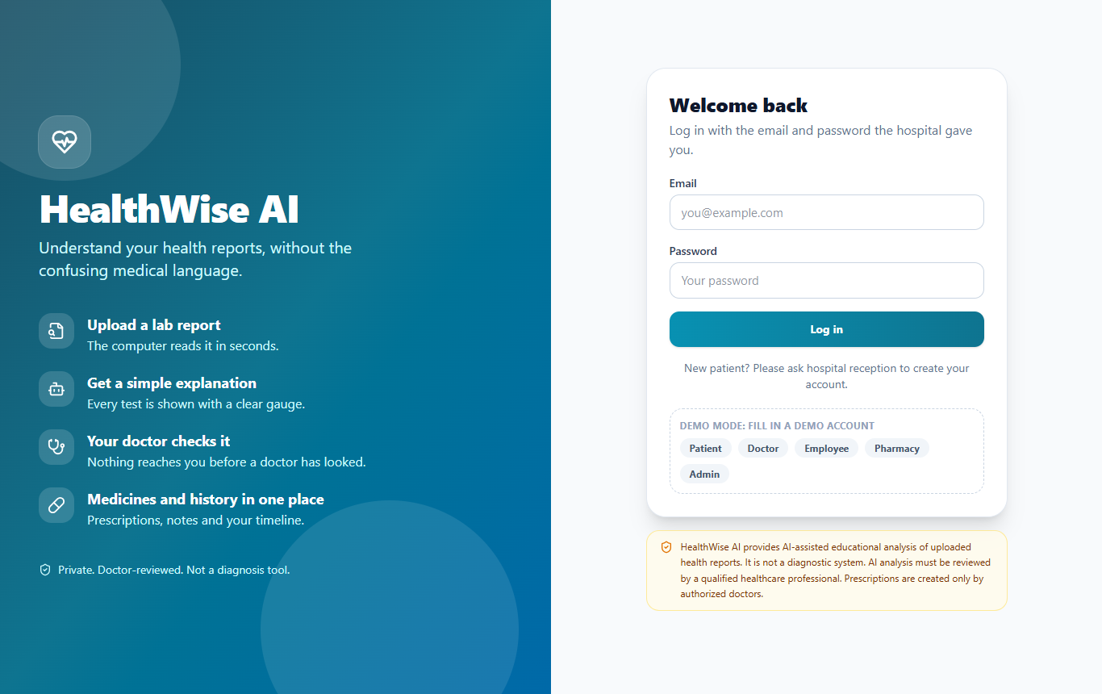
Figure B.1 Login page
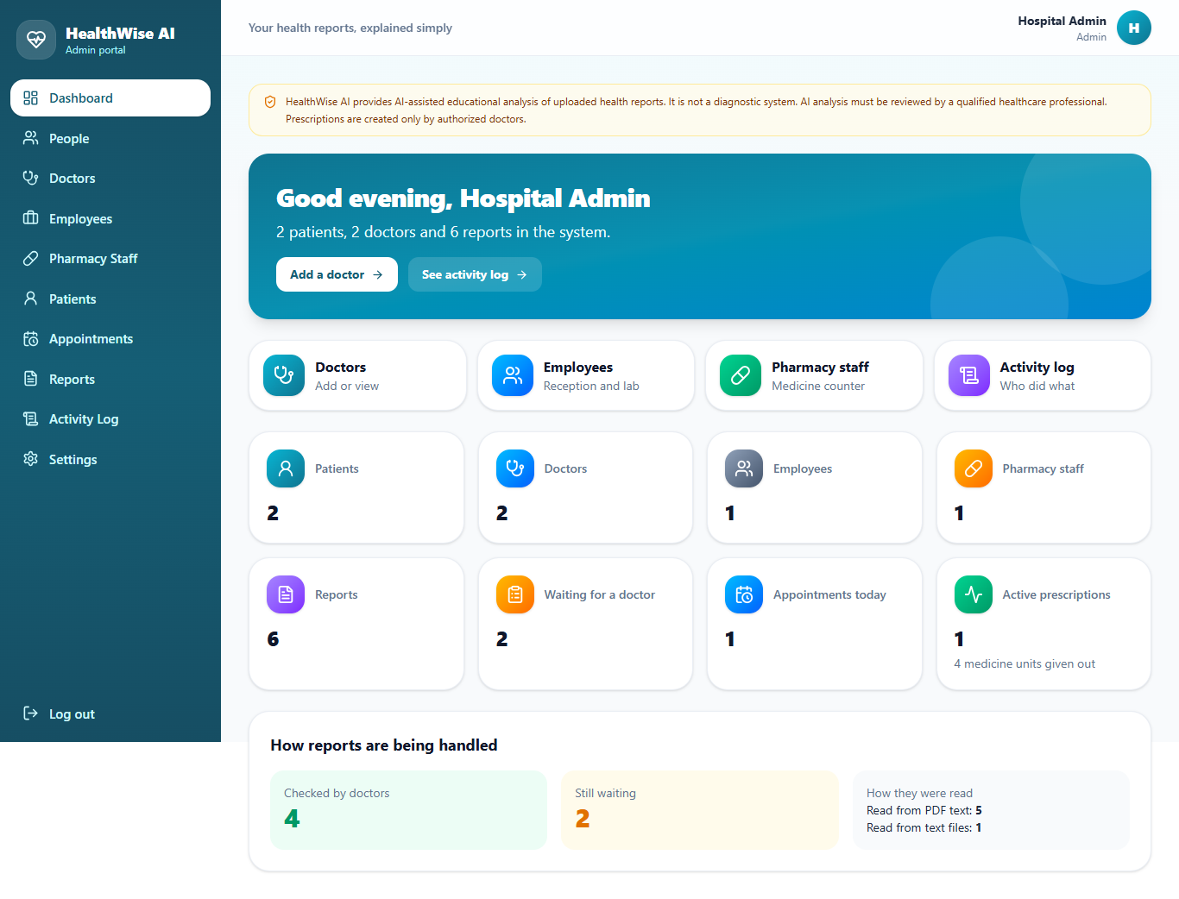
Figure B.2 Admin dashboard
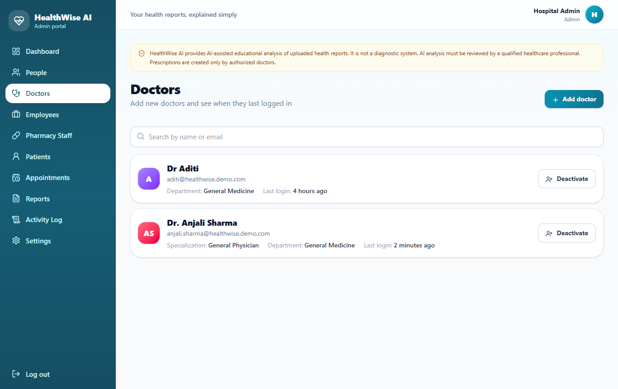
Figure B.3 Admin: doctors list (staff management)
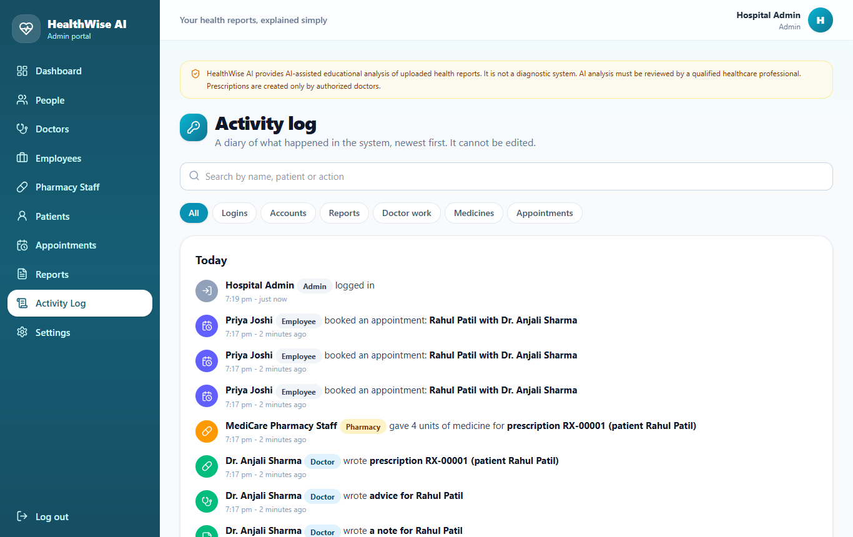
Figure B.4 Admin: audit log
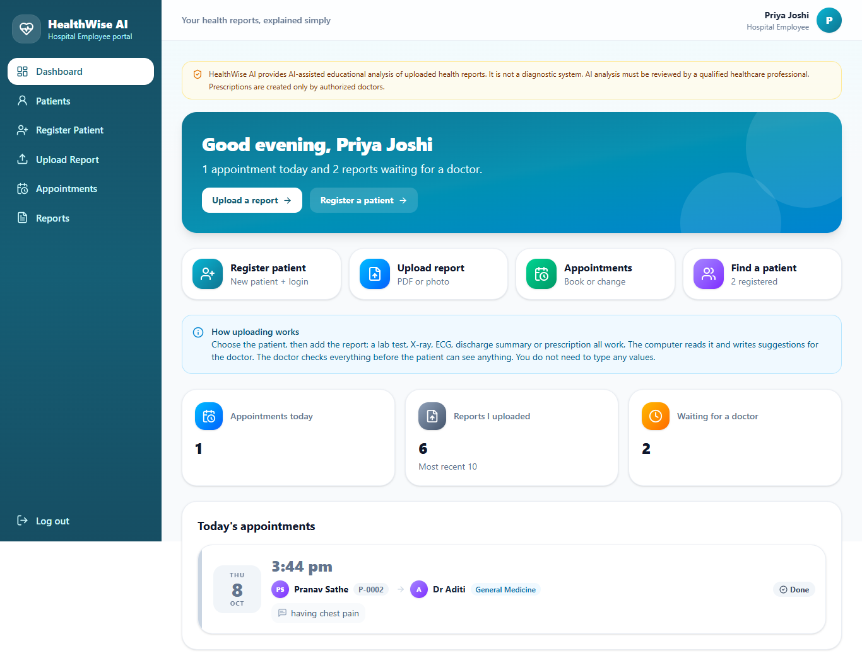
Figure B.5 Employee dashboard
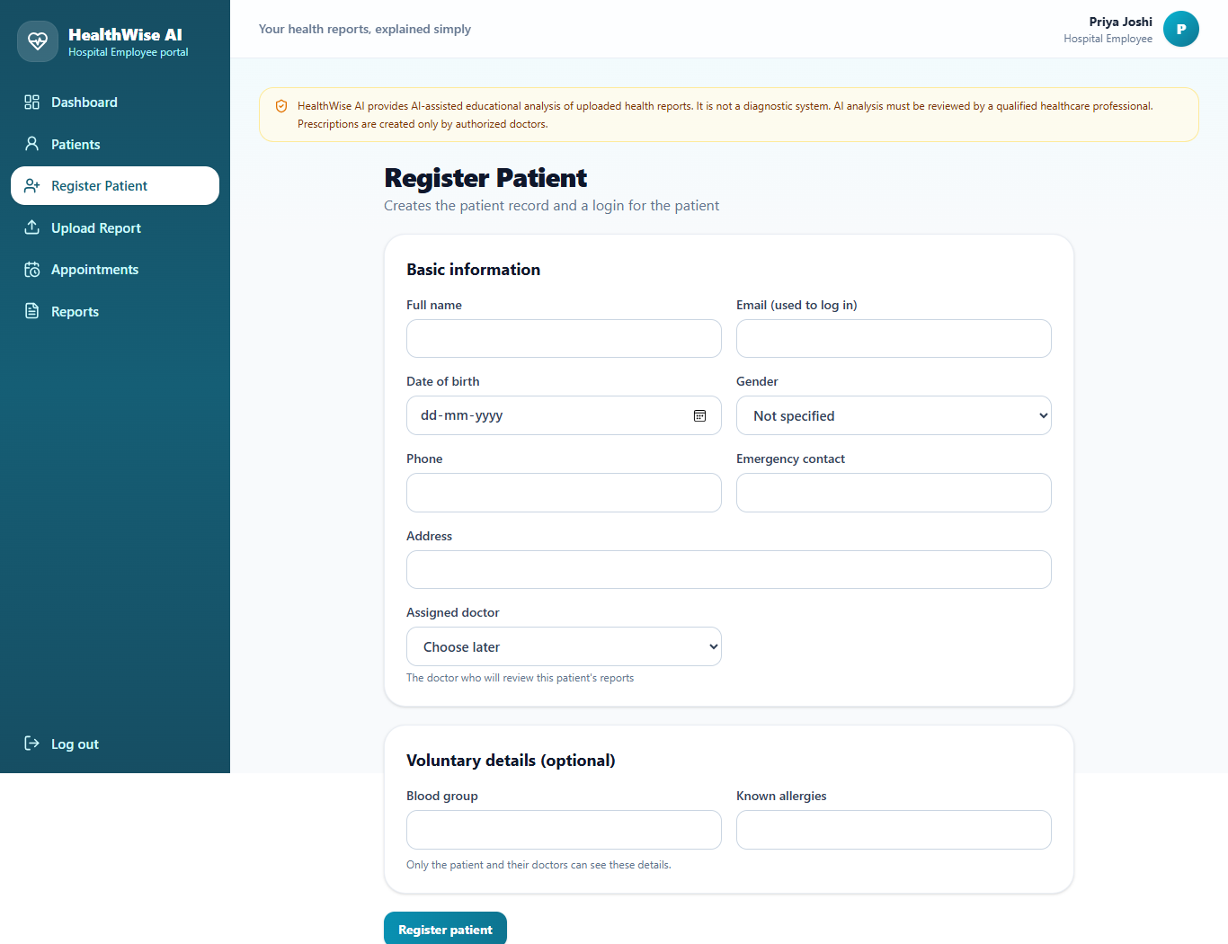
Figure B.6 Employee: register patient
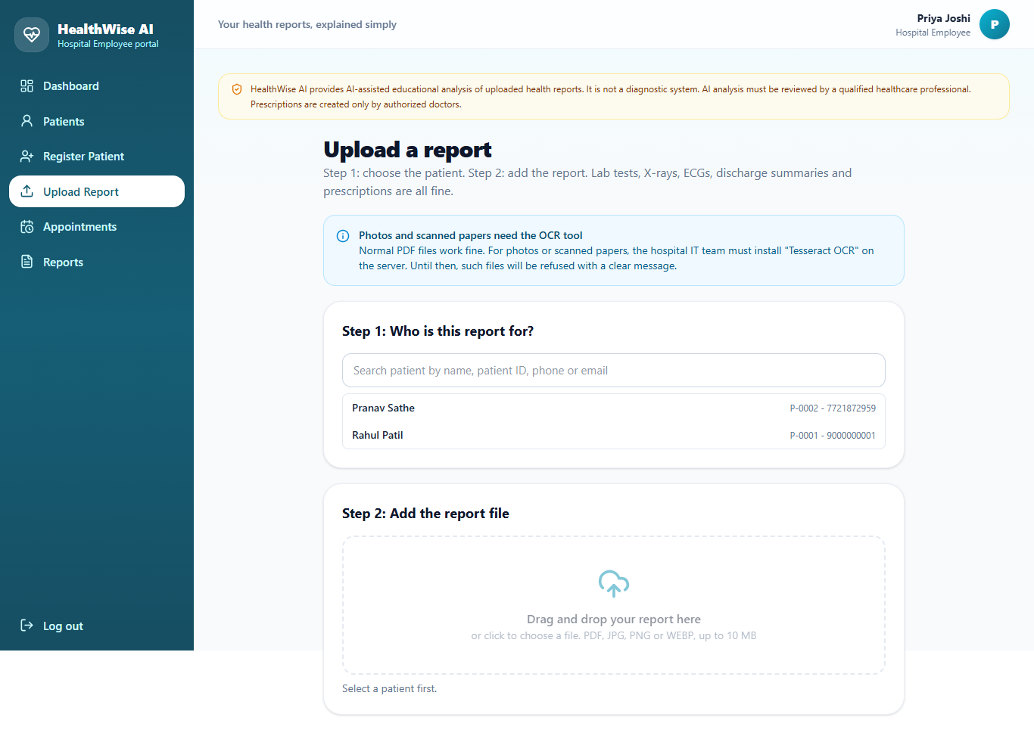
Figure B.7 Employee: upload report
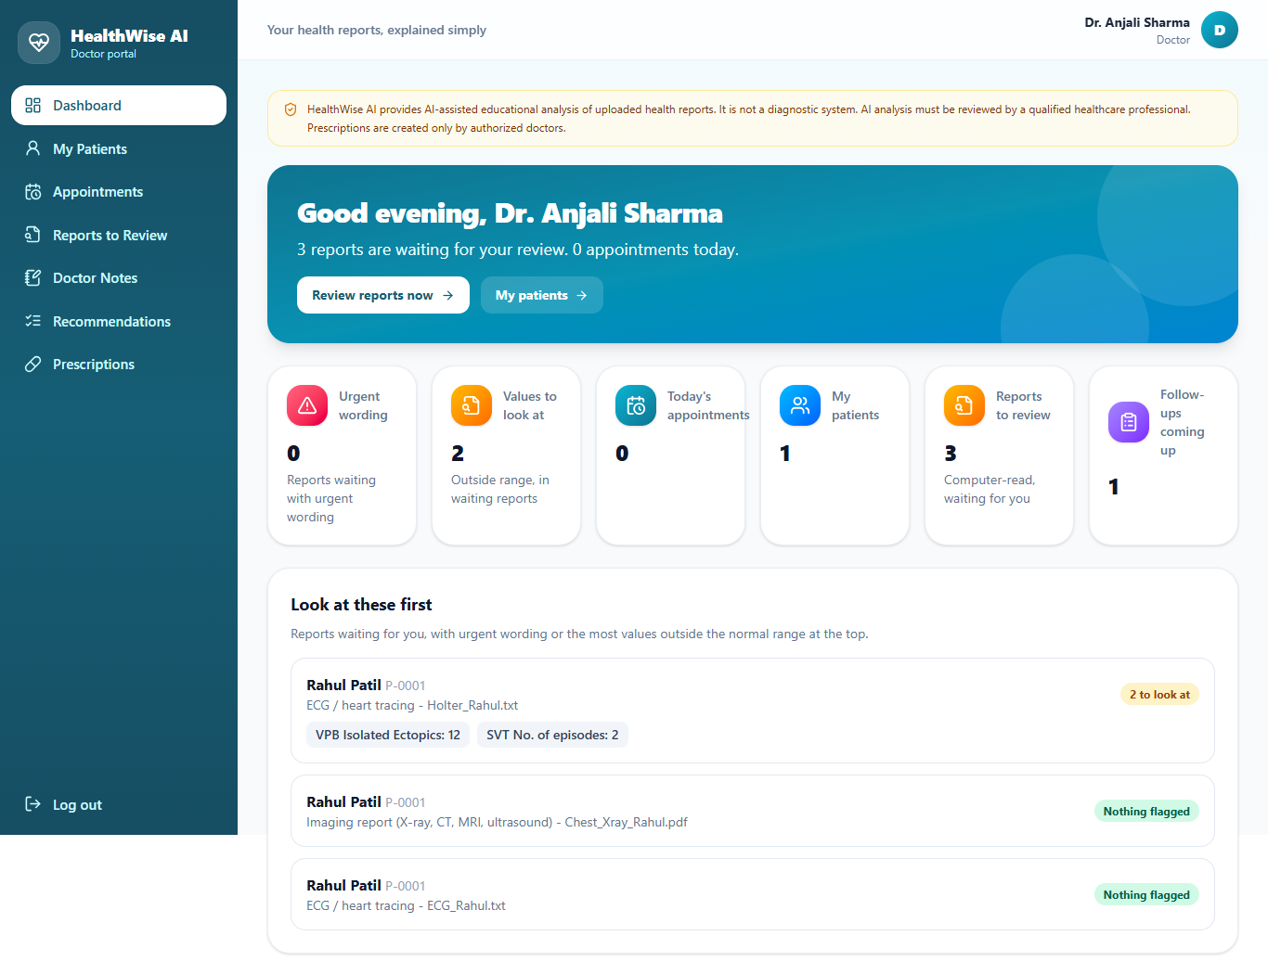
Figure B.8 Doctor dashboard
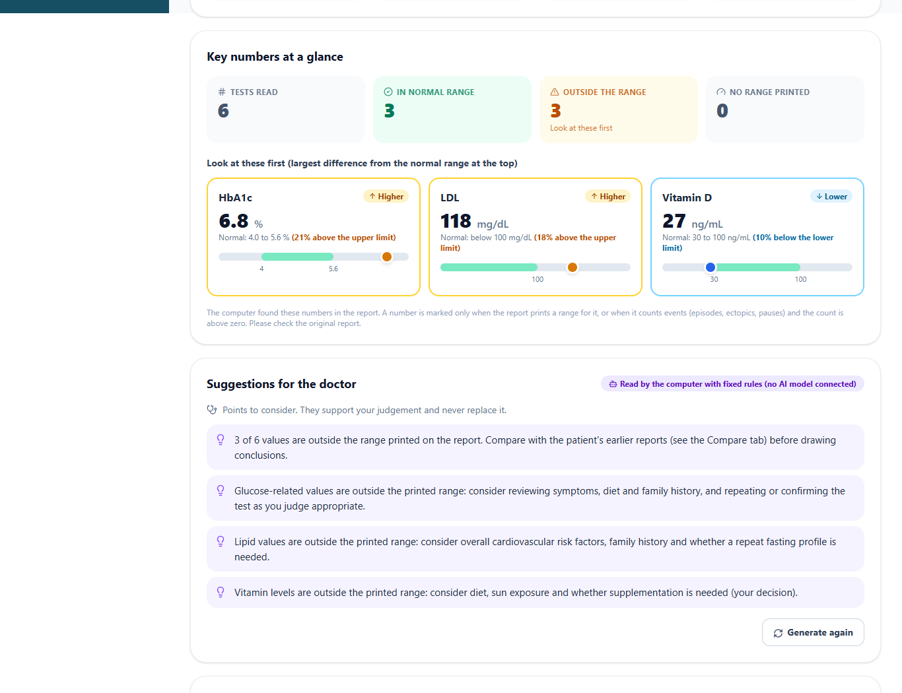
Figure B.9 Doctor: report review, key numbers of a laboratory report
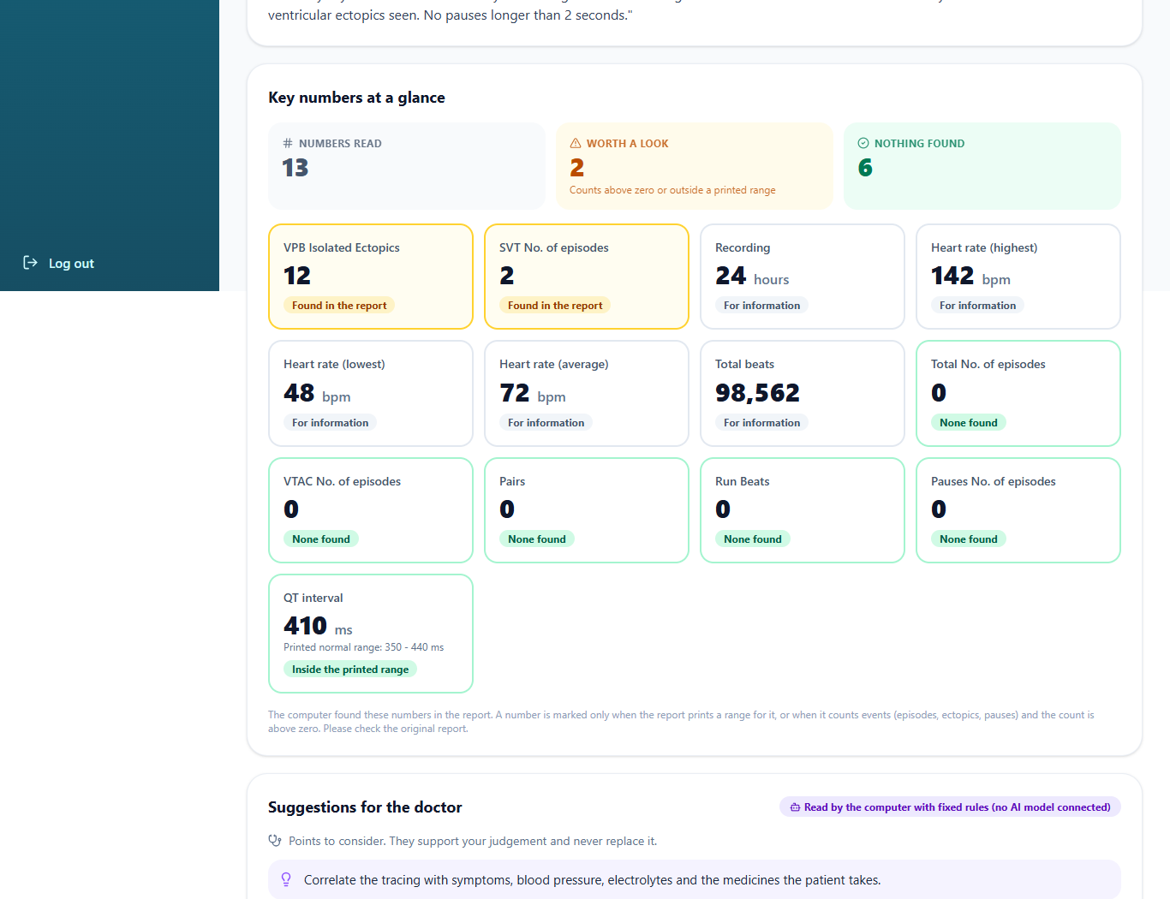
Figure B.10 Doctor: report review, key numbers of a Holter report
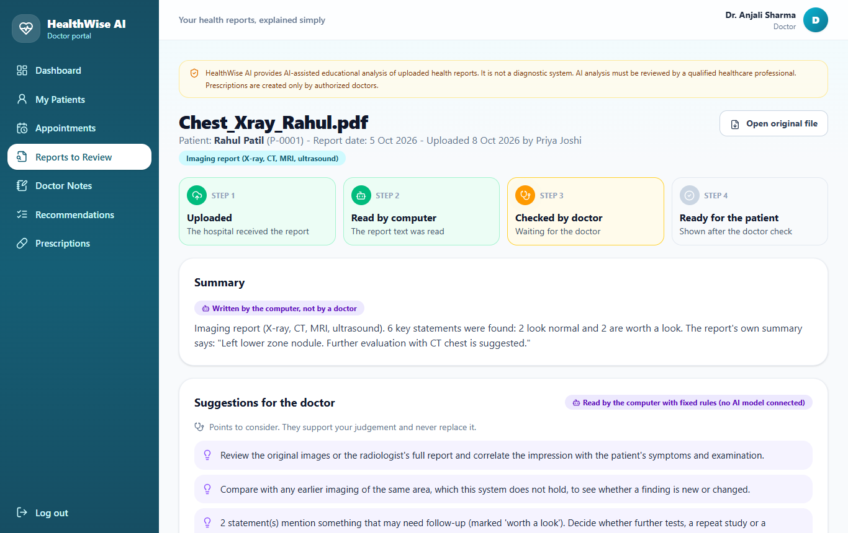
Figure B.11 Doctor: report review (chest X-ray, insights for the doctor)
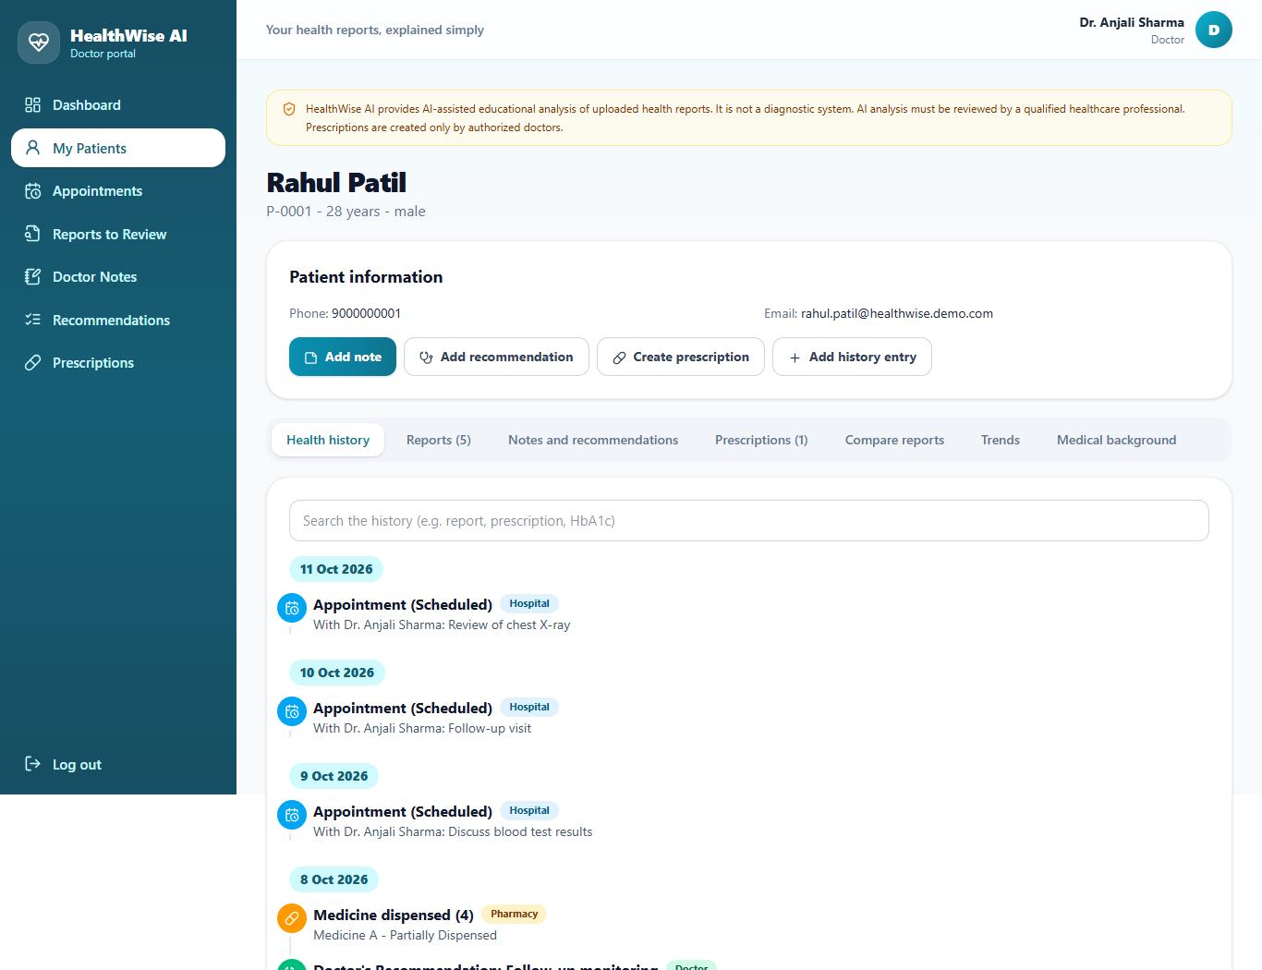
Figure B.12 Doctor: patient details
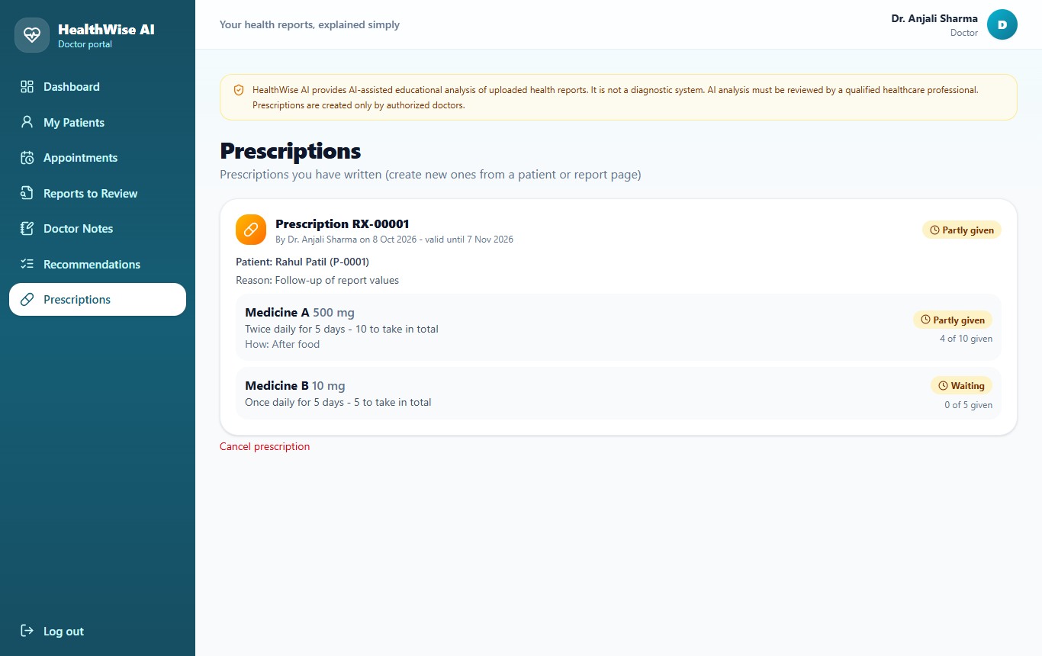
Figure B.13 Doctor: prescriptions
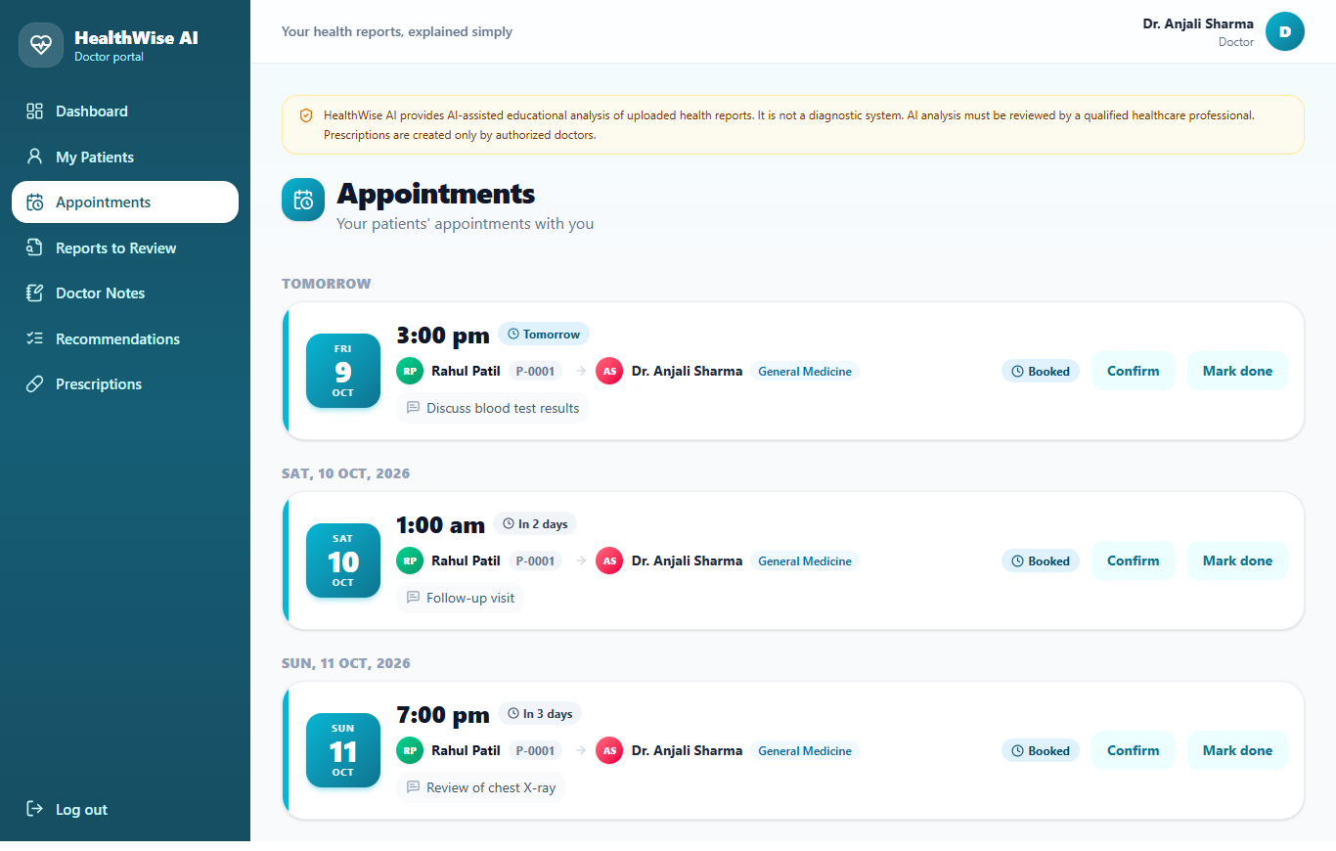
Figure B.14 Appointments
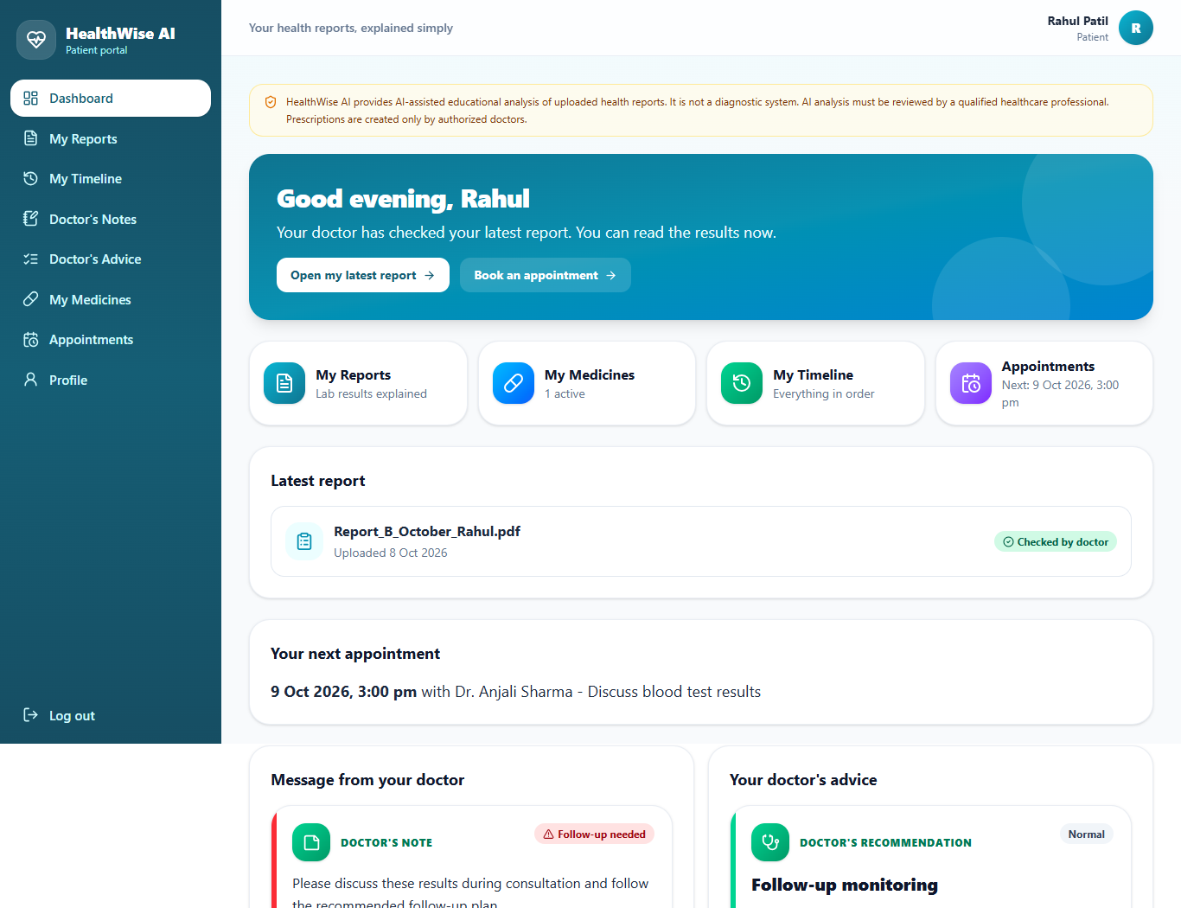
Figure B.15 Patient dashboard
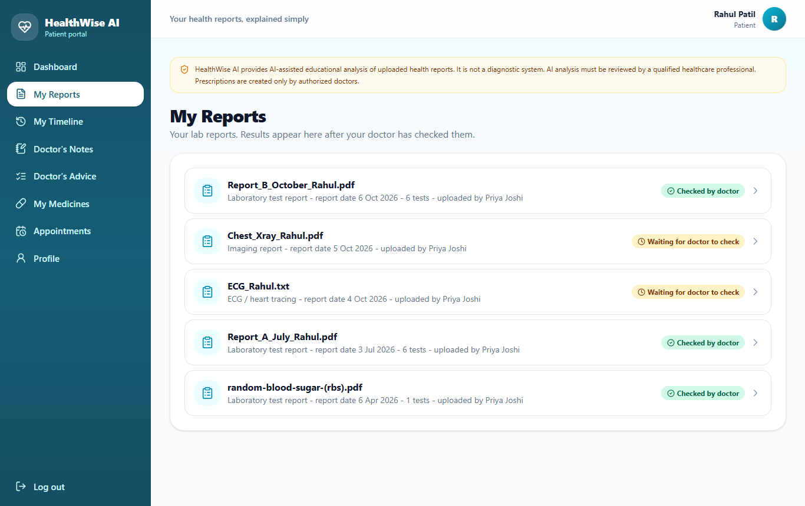
Figure B.16 Patient: my reports
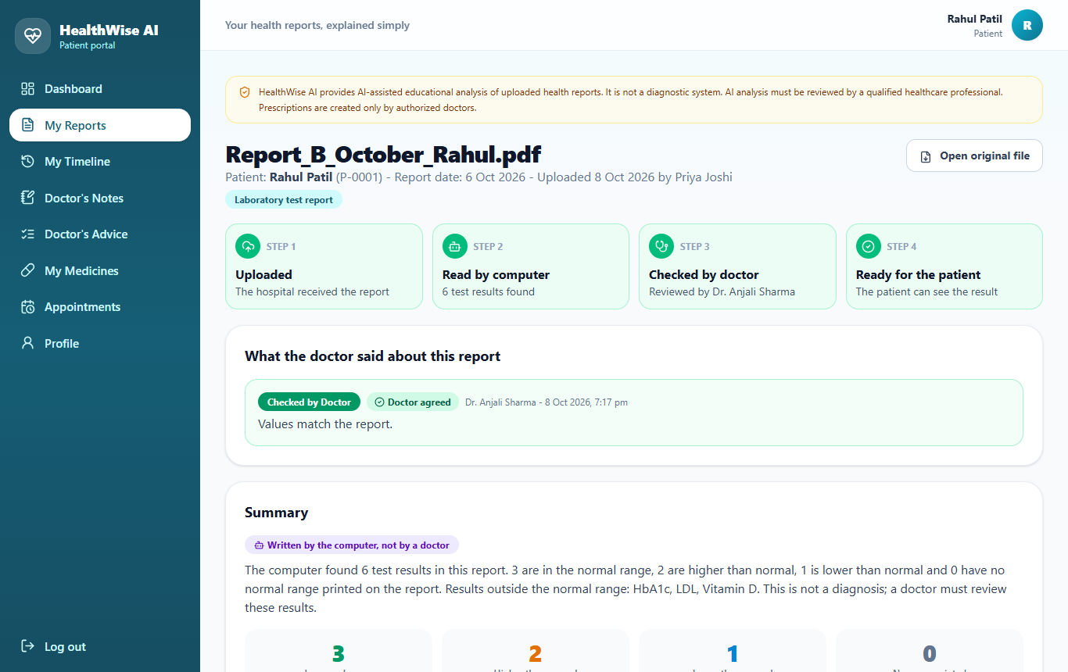
Figure B.17 Patient: reviewed report with tips
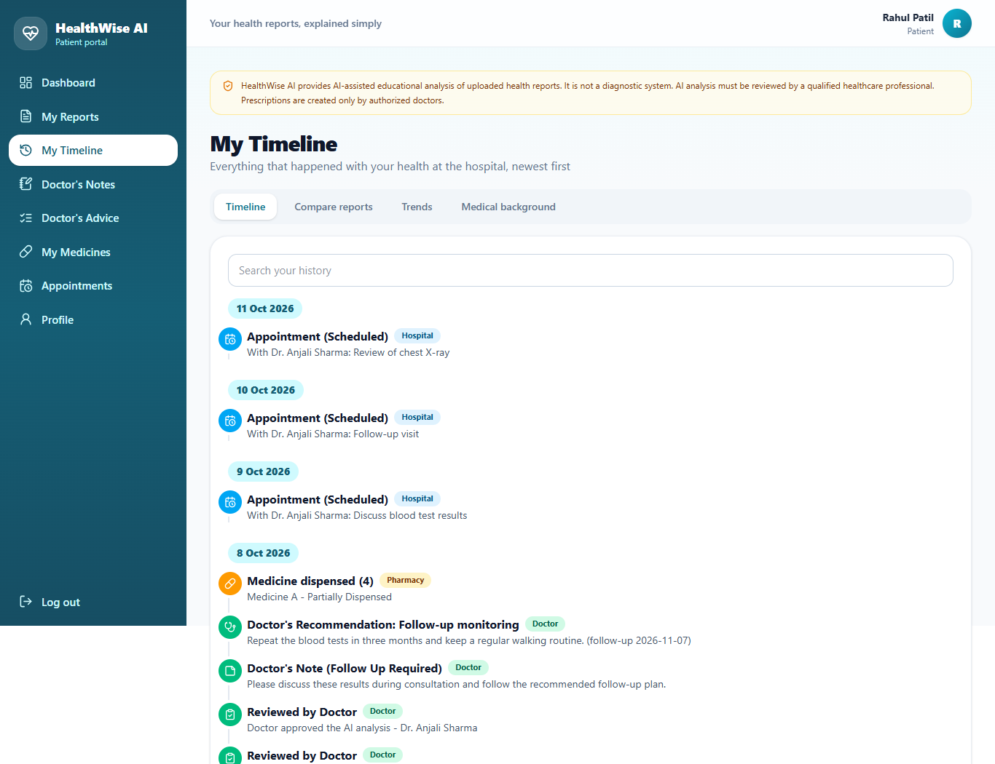
Figure B.18 Patient: health timeline
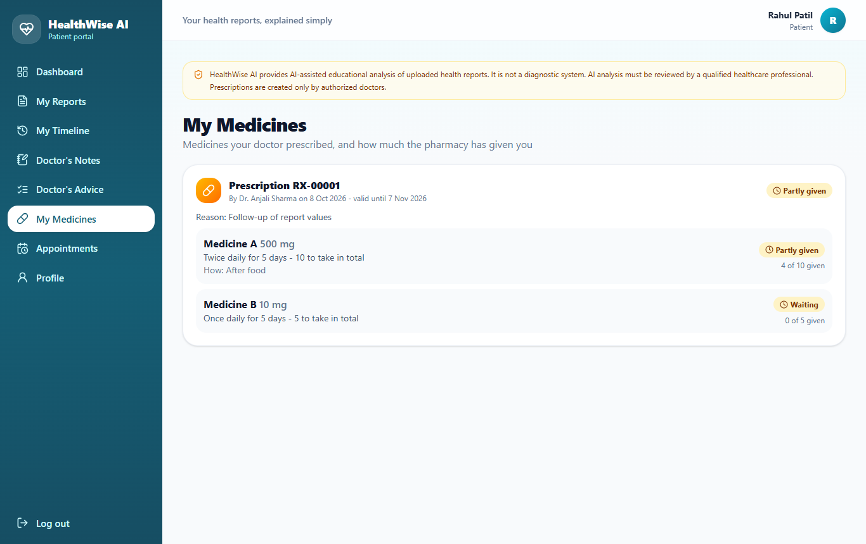
Figure B.19 Patient: my medicines
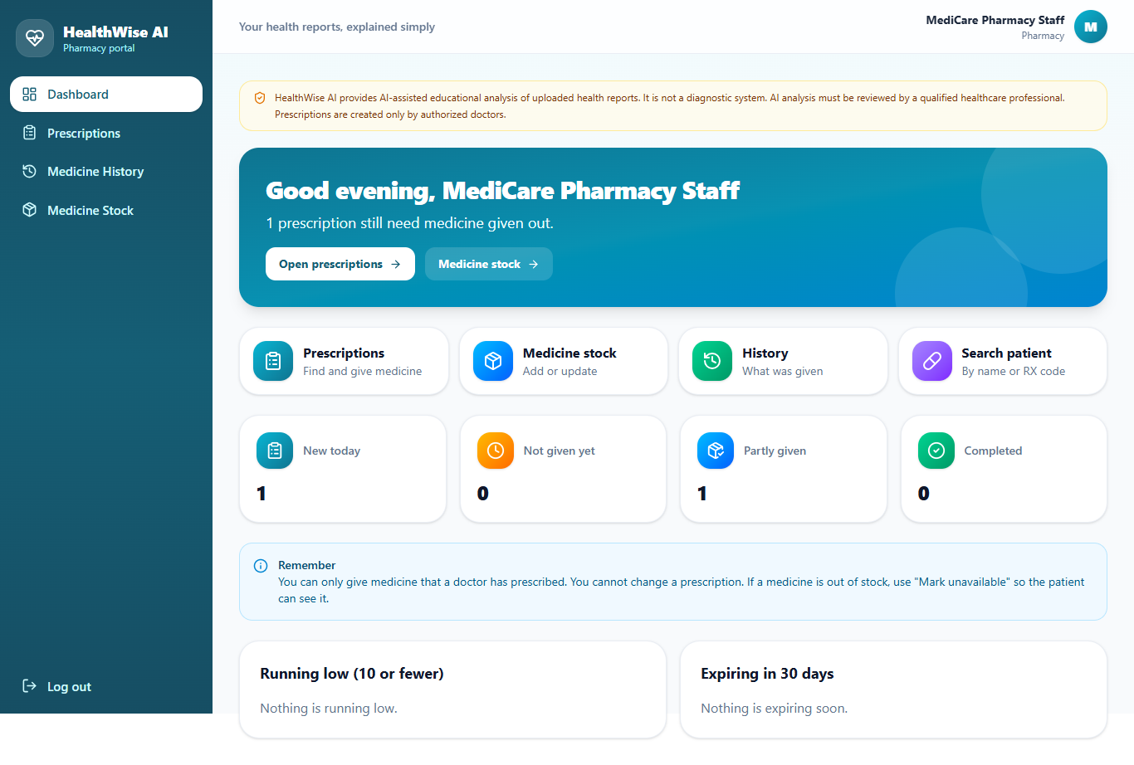
Figure B.20 Pharmacy dashboard
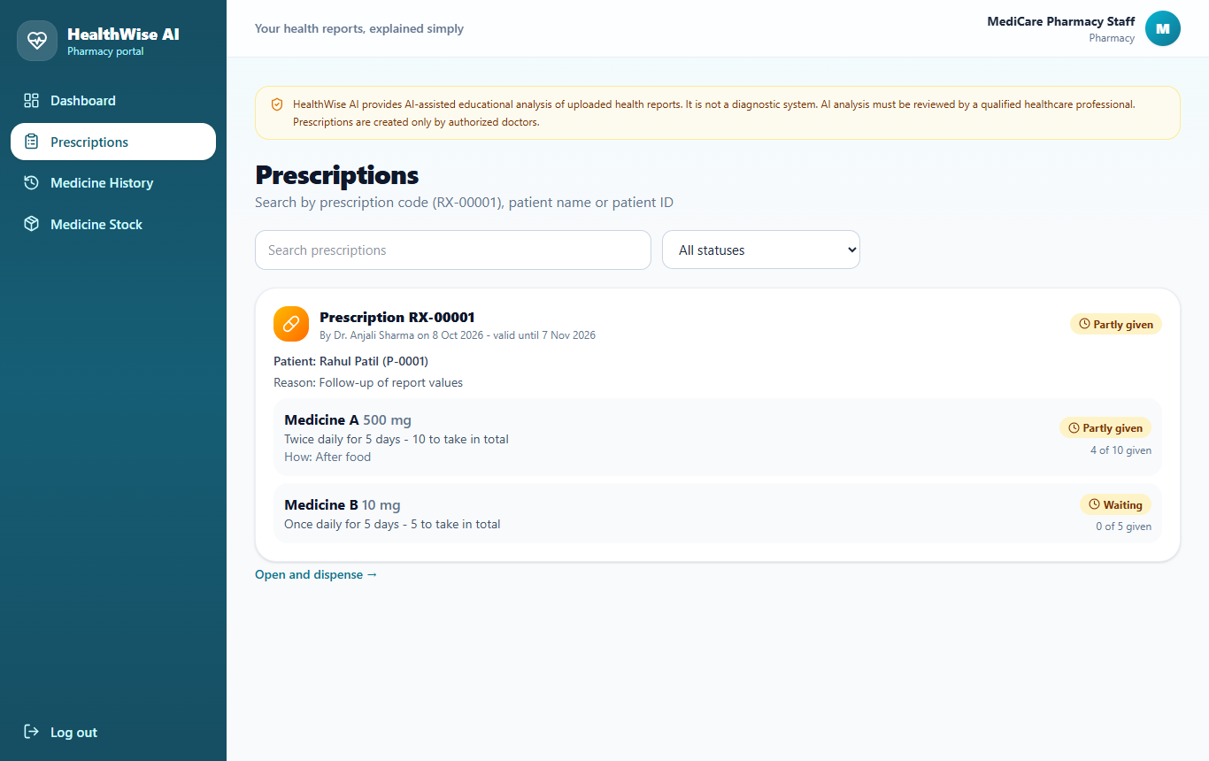
Figure B.21 Pharmacy: prescriptions to dispense
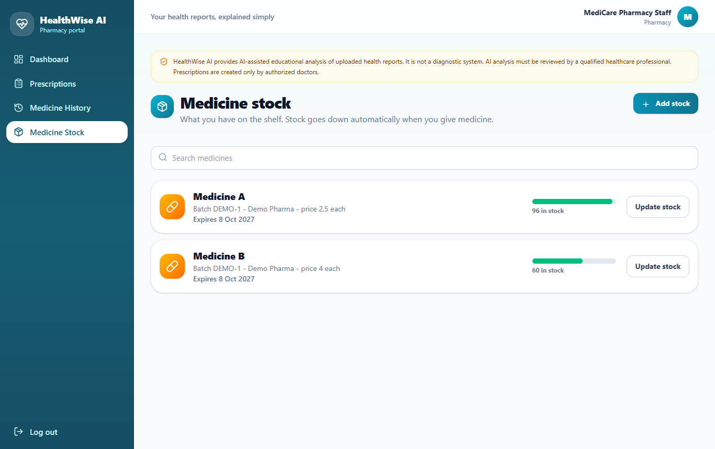
Figure B.22 Pharmacy: medicine stock

Appendix C: Sample Reports
The folder sample_reports in the project holds files for testing and for the demonstration.
File | What it shows
Report_A_July_Rahul.pdf | Text PDF, blood and metabolic panel (earlier report).
Report_B_October_Rahul.pdf | Text PDF, same patient three months later (for comparison and trends).
Report_A_scan.png | Scanned image; needs OCR.
Report_C_other_patient.txt | Different patient, different layout and values (proves values come from each file).
Chest_Xray_Rahul.pdf | Imaging report with findings and impression.
ECG_Rahul.txt | ECG report.
Discharge_Summary_Rahul.pdf | Discharge summary.
Prescription_Rahul.txt | Prescription document.
Not_a_health_report.txt | Non-medical file; must be rejected.

Appendix D: Role-Permission Matrix
Function | Admin | Doctor | Employee | Patient | Pharmacy
Manage staff and departments | Yes | - | - | - | -
Read audit log | Yes | - | - | - | -
Register patient | Yes | - | Yes | - | -
Upload report | - | Authorised patients | Yes | - | -
See clinical values and insights for doctors | - | Authorised patients | - | - | -
Review a report, write notes and advice | - | Yes | - | - | -
See own reviewed reports and tips | - | - | - | Yes | -
Create a prescription | - | Yes | - | - | -
Dispense medicine, manage stock | - | - | - | - | Yes
Book appointments | Yes | - | Yes | Yes | -
Change appointment status | Yes | Yes | Yes | Cancel only | -

Appendix E: Database Schema
Chapter 8 lists every table and column; Figures 7.8 and 7.9 show the main relationships. The foreign keys of the database are:
Table | Column | Refers to
doctors | user_id | users . id
doctors | department_id | departments . id
employees | user_id | users . id
pharmacy_staff | user_id | users . id
patients | user_id | users . id
patients | assigned_doctor_id | doctors . id
appointments | patient_id | patients . id
appointments | doctor_id | doctors . id
appointments | department_id | departments . id
appointments | created_by | users . id
health_reports | patient_id | patients . id
health_reports | uploaded_by | users . id
health_reports | assigned_doctor_id | doctors . id
health_reports | reviewed_by | doctors . id
health_parameters | report_id | health_reports . id
report_comparisons | patient_id | patients . id
report_comparisons | previous_report_id | health_reports . id
report_comparisons | latest_report_id | health_reports . id
doctor_notes | patient_id | patients . id
doctor_notes | doctor_id | doctors . id
doctor_notes | report_id | health_reports . id
doctor_recommendations | patient_id | patients . id
doctor_recommendations | doctor_id | doctors . id
doctor_recommendations | report_id | health_reports . id
medical_history | patient_id | patients . id
medical_history | doctor_id | doctors . id
prescriptions | patient_id | patients . id
prescriptions | doctor_id | doctors . id
prescriptions | report_id | health_reports . id
prescription_items | prescription_id | prescriptions . id
medicine_dispensing | prescription_id | prescriptions . id
medicine_dispensing | prescription_item_id | prescription_items . id
medicine_dispensing | pharmacy_staff_id | pharmacy_staff . id
audit_logs | user_id | users . id
The complete SQL script is in backend/schema.sql of the project.

Appendix F: Sample Questionnaire
This is a sample form for the user-acceptance survey. It has not been used yet, and no answers are reported in this document.
No. | Statement | 1 (disagree) ... 5 (agree)
1 | The screens were easy to understand without any training. | 1 2 3 4 5
2 | I could find the task I wanted from the dashboard in a few clicks. | 1 2 3 4 5
3 | The result cards and colours made the report easy to understand. | 1 2 3 4 5
4 | The suggestions for the doctor saved time when reviewing a report. | 1 2 3 4 5
5 | The tips for the patient were clear and did not frighten me. | 1 2 3 4 5
6 | Error messages told me what to do next. | 1 2 3 4 5
7 | I felt my information was kept private. | 1 2 3 4 5
8 | Overall, I would like to use this system in a hospital. | 1 2 3 4 5

Appendix G: References
See section 1.7.

