Lab 8 Documentation from Yichun Hsieh, Shunyu Chuang:

In this documentation, I am going to briefly discuss the AI we trained and the game development – Dance challenge.

For the YOLO5 model training, we use YOLO to train our computer to recognize people and objects. We use photos of ourselves to let the AI recognize us. And also, we train glasses in the end. So that if we run the code, our computer will recognize us and our glasses as both figures below.

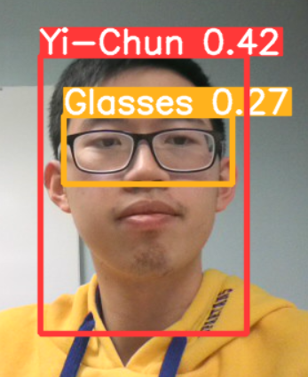

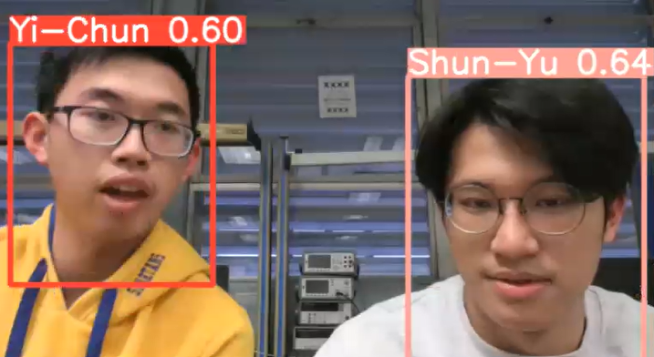

Finally, we are going to explain the game part. The game for lab 8 is about developing a dancing game. Players can use arrow keys and W A S D keys to control the little guy in the game. Then we changed the music, longer the dance period, and add PVP to the game.

The game is a turn-based system, player1 ends and changes to player2, if both people pass the same stage, the next stage requires more actions

If someone fails, the game ends. The end page will show who wins based on who has the highest score

If the match ends with the same score, a tie will be shown

GitHub link to code:

YouTube link (YOLOv5): <https://youtu.be/0G3bv2PoV6I>

YouTube link (Game): <https://youtu.be/y7R13-HKaFc>