CAPSTONE PROJECT

CHAPTER 5 - TESTING, RESULTS & EVALUATION

Student / Group Template

Project Title
Group Members
Module
Lecturer / Supervisor
Week / Stage
Submission Date
TrackWIL
Willem Basson, Dylan Shepard, Moegammad Green, Sihle Kayise
SPM622
Amanda Raganya
Week 4
29 October 2026

5.1 Introduction
State the testing and evaluation purpose.
The purpose of testing and evaluation is to check whether TrackWIL works correctly and meets the requirements of the project. Testing helps identify errors and confirm that the main features work as expected. The system was tested by checking student login, account creation, logbook entries, saving records, navigation, sign-out and the coordinator dashboard. The evaluation also considers whether TrackWIL can improve the current WIL logbook process by making it easier to submit daily records and monitor student progress.

5.2 Test Strategy
Explain test levels/types, environment, responsibilities and acceptance criteria.
The testing strategy focused mainly on functional testing to check whether the system's features work correctly. The tests were performed manually using the TrackWIL application in a web browser. The student and coordinator accounts were used to test the different dashboards and functions.
The tests included logging in, creating an account, viewing existing logbook entries, creating and saving new entries, navigating between pages, and signing out. The test plan and test-case workbook were used to organise the testing activities and record the expected and actual results.
The developer and testing contributors were responsible for checking the application's features, recording results and identifying any problems. A test was considered successful when the actual result matched the expected result. Any failed or incomplete tests should be recorded for further investigation and retesting.

5.3 Test Cases and Results
Reference the test-case workbook and summarise pass/fail results.
Functional testing was performed on the main features of TrackWIL. The student login was successful, and the student dashboard appeared and worked correctly.
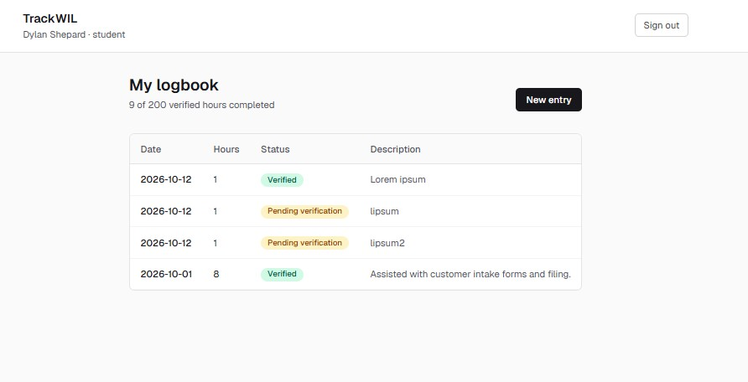
Existing logbook entries could be opened by selecting their dates.
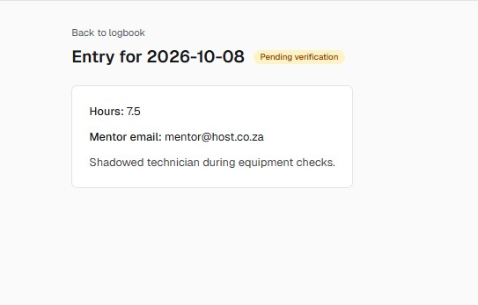
The Back to Logbook button returned the user to the logbook dashboard, while the New Entry button opened a form that could be completed.
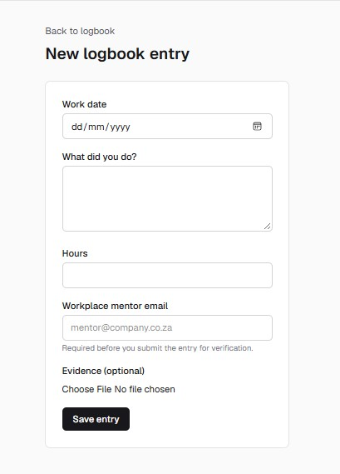
The Save Entry button successfully saved a new logbook entry, which then appeared on the logbook dashboard. Student sign-out redirected the user to the login page.
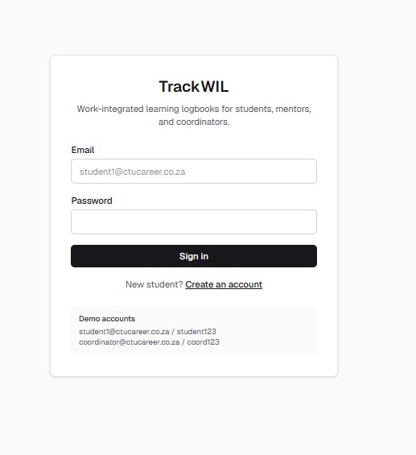
The coordinator was also able to log in successfully and view students who had uploaded their entries. Coordinator sign-out worked correctly.
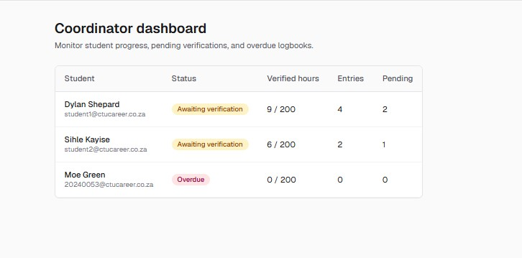
These results indicate that the tested functions worked as expected during the reported tests. The detailed test cases, including test IDs, requirement IDs, preconditions, test steps, test data, expected results, actual results, status and evidence, are recorded in the test-case workbook.
The system was tested using incorrect login details to check whether it could prevent unauthorised access for both student and coordinator logins. The expected result was that the system would display an error message and keep the user on the login page. The actual result and status should be recorded according to what happened during testing.
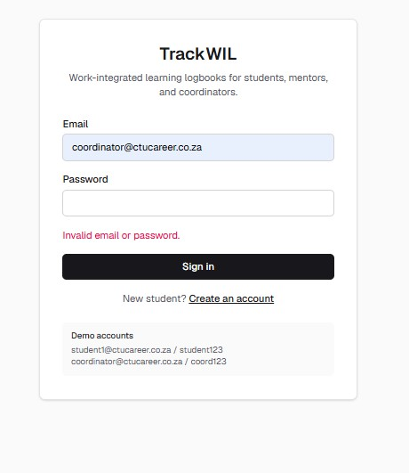
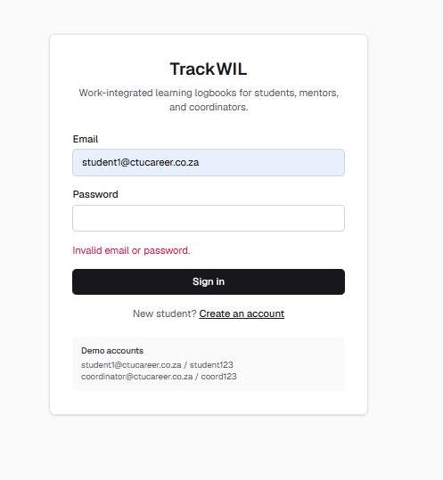

5.4 Defects and Corrections
Describe important defects, their causes, fixes and retest outcomes.
During the reported testing, the main functions tested worked as expected. No specific application defects or corrections were reported in the testing results provided. Therefore, no confirmed defect can be described as having been fixed.
Any problems discovered during further testing should be recorded in the defect log. The record should include the defect description, the steps needed to reproduce it, its severity, the correction applied and the result of retesting. This will help the development team track and resolve issues before the final demonstration.

5.5 Performance / Usability Evaluation
Evaluate relevant non-functional requirements using evidence.
The initial evaluation focused on whether the main TrackWIL features were accessible and easy to use. The student could navigate the dashboard, open existing logbook entries, create new entries, save records and sign out. The coordinator could access the coordinator dashboard and view student submissions.
These observations suggest that the tested navigation and logbook functions were usable during the tests. However, formal performance measurements, such as page-loading times, response times under heavy usage and concurrent-user performance, have not been confirmed. Further testing would be needed to evaluate these areas. Usability could also be assessed by asking students and coordinators to complete common tasks and provide feedback about their experience.

5.6 Requirements Evaluation
Compare the completed system against functional and non-functional requirements.
The tested TrackWIL features were compared with their expected behaviour to determine whether they worked correctly. The results showed that student authentication, dashboard access, viewing existing entries, creating and saving logbook entries, navigation, sign-out, coordinator authentication, viewing student submissions and account creation worked as expected during testing.
These results provide evidence that the tested functional requirements were achieved in the tested scenarios. However, further verification is needed for requirements that were not tested, including invalid login handling, required-field validation, access restrictions between user roles, document upload and verification, and data persistence after refreshing the application, where applicable.
Non-functional requirements, such as security, performance, reliability and usability, should also be evaluated against the requirements documented in Chapter 3. The requirements traceability matrix should link each requirement to its test case and result.

5.7 User / Stakeholder Feedback
Summarise feedback where applicable and explain resulting improvements.
The current evaluation is based on functional testing of the application. No formal feedback from students, lecturers, coordinators or workplace mentors has been provided in the testing information available.
To improve the evaluation, relevant stakeholders could be asked to test the application and comment on the ease of submitting daily logbook entries, viewing student progress and monitoring outstanding submissions. Their feedback could help identify confusing features and areas for improvement. Any feedback received should be recorded together with the changes made in response.

5.8 Chapter Summary
Summarise whether the system adequately solves the identified problem.
This chapter described the testing and evaluation of TrackWIL. The reported functional tests showed that the main tested features, including student and coordinator login, dashboards, logbook entry creation and saving, navigation, sign-out and account creation, worked as expected.
The results provide initial evidence that TrackWIL can support the management of WIL logbook records and help coordinators monitor student submissions. However, additional testing is needed to confirm the remaining requirements, security, performance and usability. Overall, the tested features show progress towards the project's goal of improving the WIL logbook process and reducing reliance on manually managed daily documents.

