CAPSTONE PROJECT
CHAPTER 4 - SYSTEM DESIGN & DEVELOPMENT
Student / Group Template
Project Title | ________________________________________
Group Members | ________________________________________
Module | ________________________________________
Lecturer / Supervisor | ________________________________________
Week / Stage | ________________________________________
Submission Date | ________________________________________

4.1 Introduction
Explain the purpose of the design and implementation chapter.
This chapter shows how we turned Chapter 3 requirements into a working design and what we built in the development sprint. TrackWIL replaces the PDF and email logbook with a small web-app. Students log workplace hours, the employer checks and entry through a link and does not need an account to do so. The WIL coordinator can see who is on track, who is waiting on a mentor, and who is overdue.
For week 3 we drew the architecture, UML, and database design. We built the app at the same time. The code in `05_Source_Control/trackwil` covers the three core features from the proposal.

4.2 System Architecture
Present and explain the architecture diagram, components and data flow.
TrackWIL is a Next.js application. The browser talks to a single Node.js process. That process serves the React pages, runs the business logic, and reads and writes to the JSON database. Uploaded evidence sits on disk.
Main components:
Component | Responsibility
Student area | Dashboard, new entries, evidence, sharing
Coordinator area | Table of students with status, verifying hours
Public verify | Mentor entry approval
Auth | Login, logout, signup
Verify action | Checks token, updates entry status

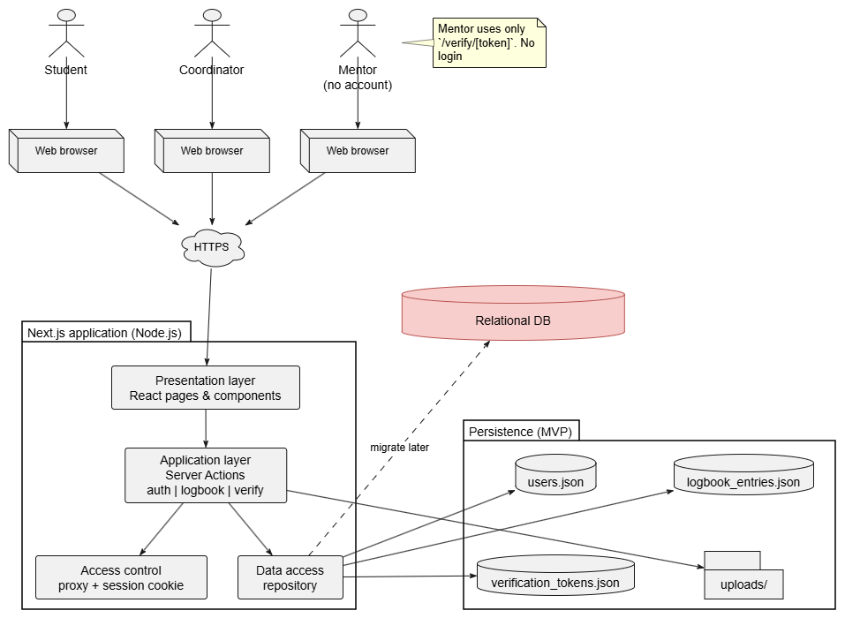
Figure 1 Architecture Diagram

4.3 UML Design
Include and explain relevant use case, class, activity and sequence diagrams.
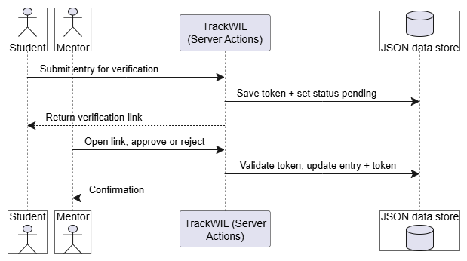
Figure 2 Sequence Diagram
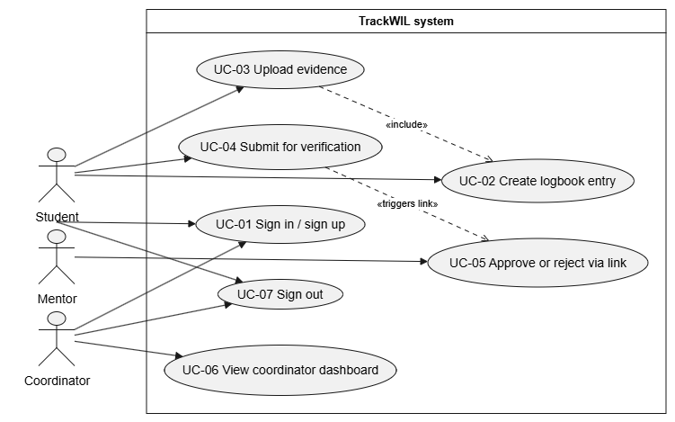
Figure 3 Use Case Diagram

The sequence diagram shows mentor verification as message between the student, the mentor, TrackWIL, and the database.
The use-case diagram has 3 actors:
- Student – signs up, logs hours, uploads evidence, and shares the entry for checking.
- Mentor – Approves/rejects a student’s entry.
- Coordinator – Monitors progress across students.

4.4 Database Design
Present ERD, entities, attributes, keys, relationships and normalisation where applicable.
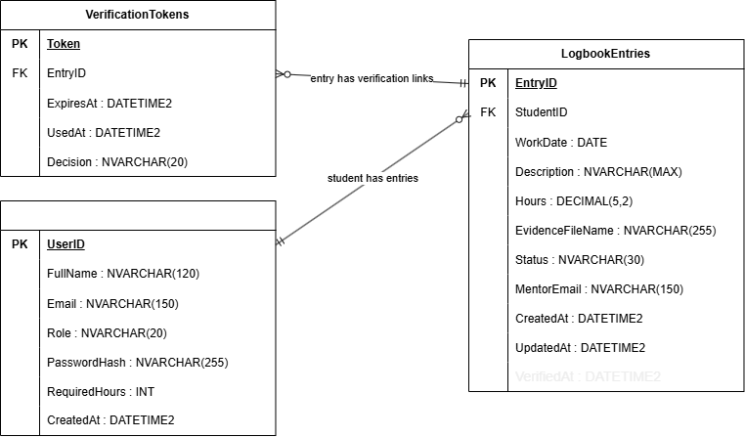
Figure 4 ERD

4.5 User Interface Design
Show wireframes or prototypes and explain usability decisions.
________________________________________________________________________________
________________________________________________________________________________
________________________________________________________________________________
________________________________________________________________________________
________________________________________________________________________________

4.6 Development Environment
List languages, frameworks, IDE, database, libraries, cloud/services and version-control tools.
- Languages: TypeScript, HTML and CSS through JSX, SQL in the schema script
- Framework: Next.js 16
- IDE: Visual Studio Code
- Database: JSON file system
- Libraries: Tailwind CSS
- Cloud services: none. Local only
- Version control: Git and GitHub (https://github.com/Noobey32/TrackWIL)

4.7 Implementation
Explain important modules/features and include selected code snippets only where they support the discussion.

Session and role routing
The cookie stores the user id. On request it loads the full user, including the role from storage. After login, a coordinator and student view different dashboards.
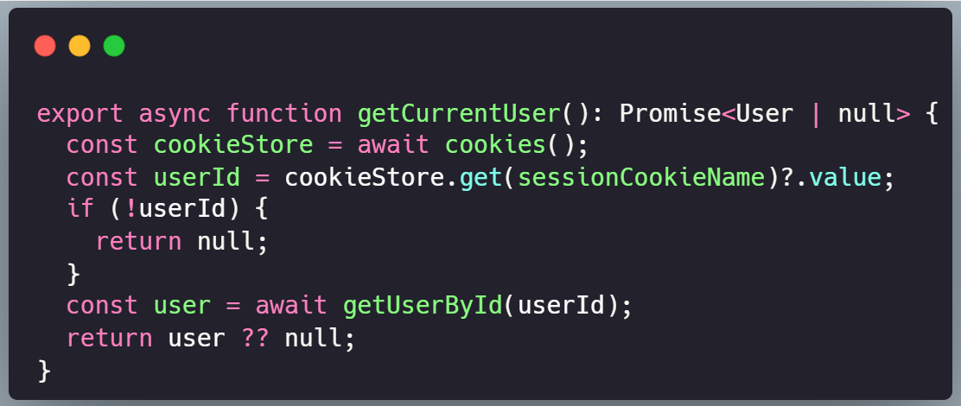

Mentor verification
Before the status changes, the action checks that the token exists, has not been used, and has not expired. That is what makes the link one-time. After the update, the view is refreshed
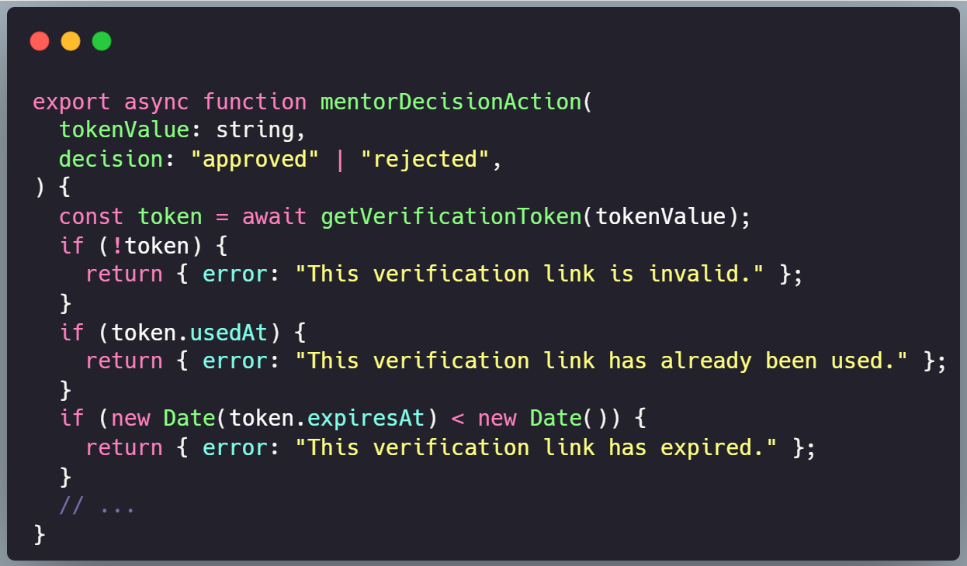

4.8 Version Control
Explain repository structure, branches, commits, pull/merge activity and team collaboration.
The capstone pack is split into numbered folders (00_ to 12_). The app is in `5_Source_Code/trackwil/`. This chapter’s diagrams, SQL, and draft live in `04_System_Design_and_Development/`. Requirements are in `03_. Project management`.

Branches
- Main: stable branch on GitHub
- app-dev: application development work
- moe/system-design: this chapter and its design files.
Branch strategy is for each member to name their branch with their name and the task (name/task), example: moe/system-design. Once they are satisfied with their work, it’s merged into main and pushed so everyone can view and work off their changes.

Team
In addition to the repository owner (Noobey32), here is the team:
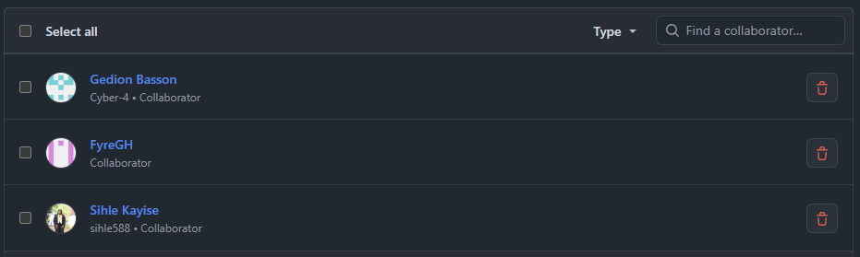

4.9 Chapter Summary
Summarise the implemented system and prepare for testing.
Core features implemented:
- Student logbook entry with optional evidence upload
- Verified hours against the required total on the student dashboard
- Submit for verification and a mentor link (7-day token)
- Mentors approve or reject on a public URL, no login
- Coordinator dashboard (status, hours, pending counts)
- Student signup with email and password checks
These features form the basis for the MVP and serve to demonstrate the potential of TrackWIL.

