**Experiment Procedure Documentation**

**Introduction:**

This document provides instructions to run the simulation

**Instructions:**

Step 1: Open the experiment by clicking on the Editor.html page.

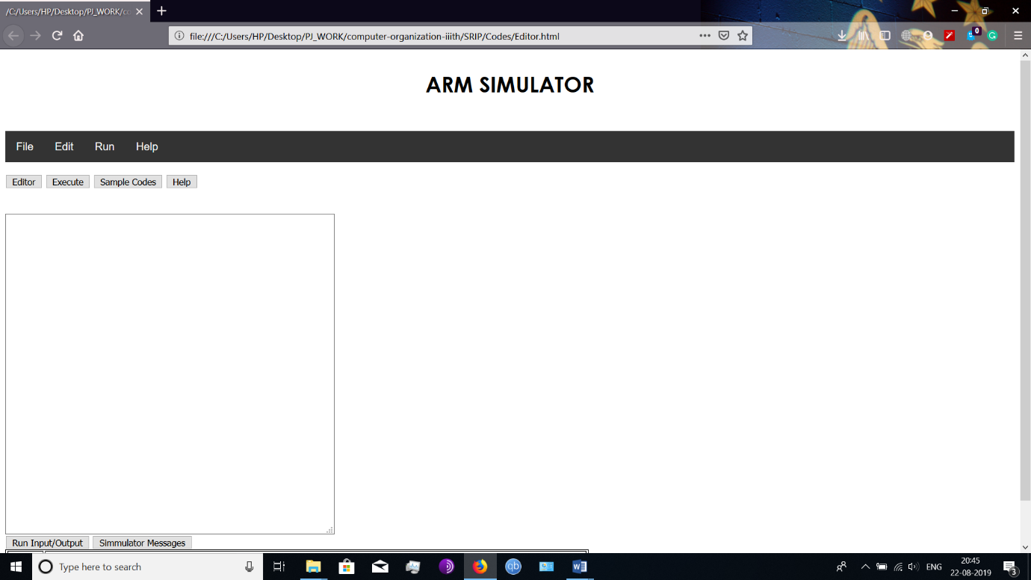

Step 2: Enter your code in the textarea provided in the page.

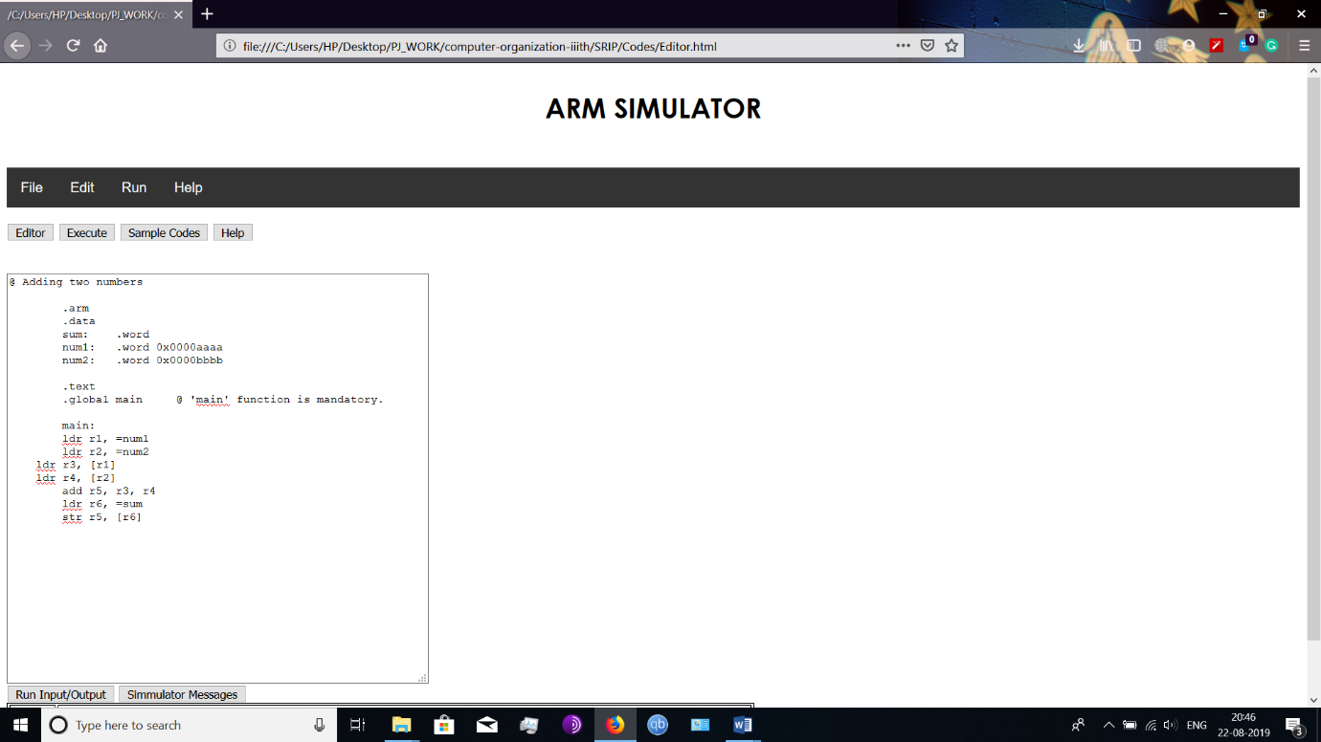

Step 3: Click on Run and then on Assemble to assemble the code

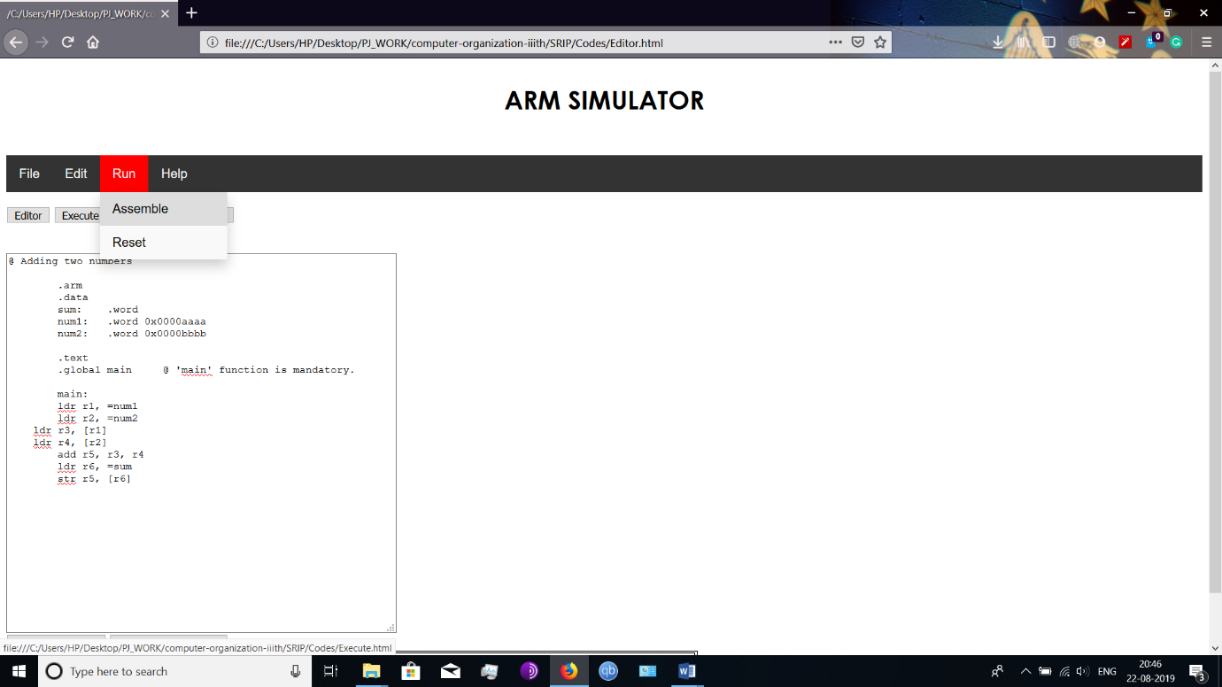

Step 4: Click on Run button and you should be given the output

