**Project report on**

E-Commerce Website For Handicrafts

A Dissertation submitted to JNTU Hyderabad in partial fulfillment of the academic requirements for the award of the degree.

**Bachelor of Technology**

**IN**

**Computer Science and Engineering**

Submitted by

P. Savan Reddy (19H51A05E4)

P. Shabarish (19H51A05H8)

N. Thomas (19H51A0550)

Under the esteemed guidance of

(Ms. P. Sravanthi)



**Department of Computer Science and Engineering**

**CMR COLLEGE OF ENGINEERING AND TECHNOLOGY**

(An Autonomous Institution under UGC & JNTUH, Approved by AICTE, Permanently Affiliated JNTUH, Accredited by NBA.)

KANDLAKOYA, MEDCHAL ROAD, HYDERABAD -501401.

2019- 2023

### CMR COLLEGE OF ENGINEERING & TECHNOLOGY

KANDLAKOYA, MEDCHAL ROAD, HYDERABAD –501401

DEPARTMENT OF COMPUTER SCIENCE AND ENGINEERING



CERTIFICATE

This is to certify that the Project report "**E-COMMERCE WEBSITE FOR HANDICRAFTS**” being submitted by **P. Savan Reddy (19H51A05E4)**, **P. Shabarish (19H51A05H8)**, **N. Thomas Reddy (19H51A0550)**, in partial fulfillment for the award of **Bachelor of Technology in** **Computer Science and Engineering** record of Bonafede work carried out his/her under my guidance and supervision.

The results embodies in this project report have not been submit any other University or Institute for the award of any Degree.

**MS. P. SRAVANTHI DR. S. SIVA SKANDA**

**Associate Professor and HOD**

**Dept. of CSE Dept. of CSE**

# ACKNOWLEDGEMENT

With great pleasure I want to take this opportunity to express my heartfelt gratitude to all the people who helped in making this project work a grand success.

I am grateful to **Ms. P. Sravanthi**, Assistant Professor, Dept of Computer Science and Engineering for his valuable suggestions and guidance during the execution of this project work.

I would like to thank **Dr. S. Siva Skanda**, Head of the Department of Computer Science and Engineering, for his moral support throughout the period of my study in CMRCET.

We are very grateful to **Dr. Vijaya Kumar Koppula**, Dean-Academic, CMR College of Engineering and Technology, for his constant support and motivation in carrying out the project work successfully.

I am highly indebted to **Dr. V A Narayana**, Principal CMRCET for giving permission to carry out this project in a successful and fruitful way.

I would like to thank the Teaching & Non- teaching staff of Department of Computer Science and Engineering for their co-operation.

Finally, I express my sincere thanks to **Mr. Ch. Gopal Reddy**, Secretary, CMR Group of Institutions, for his continuous care. I sincerely acknowledge and thank all those who gave support directly and indirectly in completion of this project work

P. Savan Reddy (19H51A05E4)

P. Shabarish (19H51A05H8)

N. Thomas (19H51A0550)

**TABLE OF CONTENTS**

**CHAPTER NO. TITLE PAGE NO.**

**LIST OF FIGURES** i

**ABSTRACT** ii

**1 INTRODUCTION** 1

1.1 Classification of handloom and handicraft 4

1.2 Internet scenario 4

1.2.1 What is E-commerce? 5

1.2.2 E-commerce in India 5

**2 BACKGROUND WORK** 7

2.1 Need for the new system 8

2.2 Detailed problem definition 8

2.2.1 Existing system 8

2.2.2 Drawbacks of existing system 8

2.2.3 Proposed system 9

2.2.4 Features of proposed system 9

2.3 Project scope 10

**3 PROPOSED SYSTEM** 11

3.1 Project plan 12

3.2 Feasible study 12

3.2.1 Technical feasibility 12

3.2.2 Economic feasibility 13

3.2.3 Operational feasibility 13

3.2.4 Behavioral feasibility 13

3.2.5 Feasibility study report 14

**4 DESIGNING** 15

4.1 Data flow diagram 16

4.1.1 Context diagram 17

4.1.2 Seller process 18

4.1.3 Customer process 19

4.2 UML diagrams 20

4.2.1 Class Diagrams 20

4.2.2 Use Case Diagram 20

4.3 Sequence diagram 21

4.2.4 Deployment diagram 22

4.2.5 ER diagram 23

**5 RESULTS AND DISCUSSION** 25

**6 SUMMARY AND CONCLUSION** 28

6.1 Conclusion 29

**7 REFERENCES** 30

**List Of Figures**

**FIGURE NO. TITLE PAGE NO.**

1.1 E-commerce growth in India 6

4.1 Context diagram 17

4.2 Seller process diagram 18

4.3 User process 19

4.4 Class diagram 20

4.5 Use case diagram 21

4.6 Sequence diagram 22

4.7 Deployment diagram 23

4.8 E-R diagram 24

5.1 User login 26

5.2 User Homepage 26

5.3 Products page 26

5.4 Cart page 27

5.5 Seller page 27

# ABSTRACT

India is a country of great cultural heritage and India’s cultural diversity provides plenty of remarkable art and craft products. Handicraft industry uses conventional manual methods instead of advanced technology for making various items. It is an unorganized, decentralized, labor intensive cottage industry. Though handicraft industry employs millions of artisans, It is still miniscule with respect to the global industry. This scenario is changing with the advent of E-commerce initiatives at government as well as at private or individual level. In this paper, an attempt has been made to highlight the role of E-commerce in the development of rural artisans in India by illustrating some efforts of Government and Non-Government agencies, Groups and Individuals in uplifting the socio-economic standard of the rural artisans through E-commerce. Strengths, Weaknesses, Opportunities and Threats/Challenges faced or to be faced by rural handicraft artisans adopting E-commerce have also been analyzed in this paper.

**CHAPTER 1**

INTRODUCTION

E-commerce stands for Electronic commerce.

The word ”electronics ” has come from word electron and a suffix- ics. An electron is a negative charge particle that move inside the atom. Electron plays an important role in the conduction of electricity. Any device that uses electricity is electronic. For example Computer, Mobile phone.

The word commerce came from the Latin word commercium, made from cum means Together and merx means merchandise. Cambridge dictionary defines Merchandise ”goods that are traded and sold in shops” and Together means ”with each other”. So Commerce means trade of goods with each other in a simple way. Cambridge dictionary defines Commerce is ”Activities involved in buying and selling things.” ECommerce can be defined simply as buying and selling things using electronic items like computer, phones.

According to Philip Kotler “E-commerce can be defined as a general term for buying and selling process that is supported by electronic means.” Electronic commerce is the use of computer networks to improve organizational performance, in a broad sense. Electronic commerce is an emerging concept that describes the process of buying and selling or exchanging of products, services, and information via computer networks including the internet. (Mourya and Gupta 2014, 23).

Electronic Commerce (e-commerce) is increasingly discussed and written about in today’s knowledge-based economies. Although there are certainly no internationally agreed-upon definitions of e-commerce, the OECD (Organization for Economic Cooperation and Development) defines e-commerce transactions as: the sale or Handicraft has made from two words: Hand + Craft. The Cambridge Dictionary defines hand as ”The part of your body at the end of your arms that has a finger and a thumb”. The Cambridge dictionary defines craft as ”to make something using a lot of skill.” The simple meaning of handicraft is something made of hand skill. The Cambridge dictionary define Handicraft ”An activity that involves making things with your hands and that needs skill and artistic ability.”

Handicraft has aesthetic value. it isn’t necessarily required that handicrafts must be used for a physical purpose. There is no clear separation exist where artistic value and utility depart. One general problem, we face in studying the handicraft sector is the term ”Handicraft” has no universally accepted definition and there is no separate product classification for handicrafts. Handicrafts refers to a wide range of items, including ”gift items”, houseware, home furnishings, products of craft industries, and fashion accessories. According to UNESCO/ITC (1997) ”Artisanal products are those produced by artisans, either completely by hand, or with the help of hand tools or even by mechanical means, as long as the direct manual contribution of the artisan remains the most substantial component of the finished product. The special nature of the finished products derives from their distinctive features, such as utilitarian, aesthetic, creative, culturally attached, decorative functional, traditional, religiously and socially symbolic and significant.” (Silver and Kundu 2013, 1).

According to Chattopadhyay (1995), When a question is asked today why Handicrafts, the answer cannot be very simple. The answer will emerge if we go down the passage of history and trace out cultural evolution to a craft-oriented society in which handicrafts still had an honored place. The concepts of arts and crafts were interchangeable. Handicrafts are always been a very basic act of human society; for crafts are an integral part of our life. In fact, they are found to be more cohesive in a human relationship than even language and can cross such barriers as the latter may create. Particularly has this been true of an ancient society of Asia, South and Central America, Africa and older countries like Greece where certain aspects of the hoary handed -down cultures still continue to exercise powerful influence that almost seems ageless. In the ancient books of east it is said that when the hands of a craftsman are engaged in his craft, it is always ceremonial. Tools are after all but an extension of the personality of the craftsman to reach beyond the range of human limitations. The craftsman thus combines within his being the tradition that embraces both the producer and the consumer within the social fabric.

Handicraft is an income-generating and production-oriented activity. It reflects the pleasure and skill of the person who carries the folkloric tradition and customs of the community, without the need for machine power but simple tools and hand. It is usually based on the knowledge and skill of the individual. It is a product made with purpose to decorate and benefit people to meet daily necessities. It reflects the character of the society with the creative ability of the individual and reveals the taste of national art. It is an art form that emerges from the known needs of people against external factors and is characterized by the structures, traditions, and cultures of the society that they are gradually creating. (Sekerci 2007, 2)

* 1. **Classification of Handloom and Handicraft**

Different parts of India are sources of various specific and original disciplines of handloom. The handloom artistry of every region is a display of a mixture of its culture and long-lasting tradition. The Handlooms and Handicrafts made in India are classified based on the product and the raw materials used. It is given as follows

(i) Handloom

1. Clothing: Saris, Dress material, Dhotis, Shirts, and Trousers.

2. Fashion Accessories: Scarves, Stoles, Gloves, Mitts, Mittens, and Handkerchiefs.

3. Made Ups: Bed linen, Table linen, Kitchen linen, and Upholstery. 4. Floor Coverings: Carpets, Mats, and Matting.

(ii) Handicraft

1. Wood: Figurines, tabletops, wall hangings, kitchenware, office, and home accessories.

2. Stone: Furniture, tabletops, utensils, decorative items, and home accessories.

3. Metal: Furniture, figurines, utensils, Jewellery, and decorative items.

4. Natural Fibre: Mats, baskets, coasters, lighting, furniture, and furnishings.

5. Papier Mache: Decorative items and home accessories.

6. Glass: Jewellery, beads, vases, utilities, decorative items, and home accessories.

7. Cane and Bamboo: Furniture, utilities, decorative items, and home accessories.

8. Clay/Ceramics: Tiles, figurines, utilities, garden accessories, and other decorative items.

9. Textile-Based soft Goods: Dolls, wall hangings, utilities, and other decorative items.

**1.2 Internet Scenario**

The beginning of the year 2019, recorded a massive increase in the number of digitally active people across India. There were approximately 213 million digitally active users in India in 2014, and this number went up to 636 million in 2019. This statistic is estimated to go up to 821 million in the year 2021. The changing technical scenarios resulted in the reduction of internet costs. With that in hand, the Digital India campaign started by the Government of India resulted in increased internet connectivity and a digitally empowered country.

**1.2.1 What is E-commerce?**

E-Commerce or Electronic Commerce is a way of buying and selling of commodities over the internet or some other dedicated online platform. Ecommerce is often used to refer to the sale of physical products online, but it can also describe any kind of commercial transaction that is facilitated through the internet. For example, one can buy a book from amazon and pay either through online transaction or by cash on delivery as provided by the seller. Whereas ebusiness refers to all aspects of operating an online business, ecommerce refers specifically to the transaction of goods and services. The history of e-commerce begins with the first ever online sale: on the August 11, 1994 a man sold a CD by the band Sting to his friend through his website NetMarket, an American retail platform. This is the first example of a consumer purchasing a product from a business through the World Wide Web—or “ecommerce” as we commonly know it today. Since then, ecommerce has evolved to make products easier to discover and purchase through online retailers and marketplaces. Independent freelancers, small businesses, and large corporations have all benefited from ecommerce, which enables them to sell their goods and services at a scale that was not possible with traditional offline

**1.2.2 E-commerce in India**

E-commerce is the cause of the complete transformation of the Indian way of doing business. New innovative ideas are developing every day to enhance the market under the influence of the e-commerce industry.

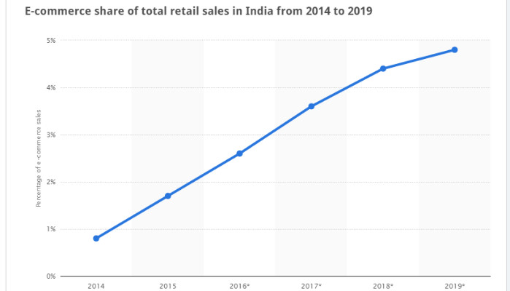

***Fig: 1.1: E-commerce growth in India***

The e-commerce market in India has grown from $3.9 billion to $38.5 billion in 2018. It is estimated to grow by up to $200 billion by the year 2026. Among the top e-commerce companies in India, we have Amazon India, Flipkart, Snapdeal, 1mg, BookMyShow, Paytm, etc. E-commerce provides means to workers to attract new customers while holding on to old ones. The ease of using e-commerce is increasing day by day. The latest technical innovations like digital payments and advertisements and government campaigns such as Digital India, Make in India, and Skill India have greatly helped in the growth of e-commerce.

**CHAPTER 2**

BACKGROUND WORK

**2.1 Need for the New System**

e-commerce werbsite for handicrafts is a dynamic and informative website through which the sellers/artists can directly access, the information they require to update different products and their prices, or to even add/delete certain products. It deals with different categorical catalogues which entail various products having handicraft materials, handmade cards, pottery products, and etc. It focuses on developing a product which the customer’s request for or order. The project serve administrator to view the details of products and their prices and maintain their database in an efficient and effective manner so that their maintenance will be easy. The services providing for administrator are approving the courses by adding fields, different questions of different artists and feedbacks, add/delete the products. The services provided to the users are to view the content of a product, related to their links and along with their prices. Users can search here different items related to different occasions/needs a customer wants.

e-commerce is a web site to give employment and take it to a new level through an efficient manner and no time wasting for searching for a required phase of the job placements techniques. The main objective of our website is to efficiently evaluate the sections of the society and identify the artists and craftsmen thoroughly through a fully developed system that not only saves lot of time but also covers all the fields required to compete a product preparation. For customers it can be of great help as there are very less platforms which provides artists help for their employment. It can be used anywhere any time as it is a web based application (user location doesn’t matter). It can be accessed at any time, any place and by anyone who wants.

**2.2 Detailed Problem Definition**

**2.2.1 Existing System**

The first problem is that there are loads of hard copied documents and records being generated. This brings us to the age-old discussion of keeping information in the form databases versus keeping the same on sheets of paper when we want to run a business. Keeping the information in the form of hard-copied documents leads to the following problems.

**2.2.2 Drawbacks of Existing System**

* **Lack of space –** It becomes a problem in itself to find space to keep the sheets of paper being generated as a result of the ongoing discussion. The documents being generated are too important to be ill-treated.
* **Filing poses a problem –** Sorting out the documents categorically is a time consuming and tedious exercise
* **Filtering is not easy –** It becomes hard to filter relevant products for the irrelevant ones if the count of the same crosses a certain manageable number.
* **Reviewing becomes time-consuming –** All the process done manually at the centers and all the records are maintained on the courses. So the maintenance of the record is very difficult in the departments and as well as it’s very difficult for the workers to check the record. The Existing system is paper based, time consuming, monotonous, less flexible and provides a very hectic working schedule. The chance of loss of records is high and also record searching is difficult. Maintenance of the system is also very difficult and takes lot of time.
* **Result Processing:** is slow due to paper work and requirement of staff

**2.2.3 Proposed System**

This Web site provides artists to apply for various craftsmen jobs available provided by administrator, also the customers to go through the website and shop for various products.

It saves time as it allows number of customers to choose from various products/ items so that they don’t have to search for them individually online, instead they can register themselves on the website from their respective available laptops or mobile. Registration will be automatically stored by the server. Administrator has a privilege to create, modify and delete the products, handicrafts. User can register, login and select the item with his/her specific id, and can see the entire catalogues

**2.2.4 Features of Proposed System**

* **Functional Capabilities:** This project aims at creating an online portal for handmade crafts. This allows registered users of the system to buy a product available in the site and access the website published for various products. There will be an admin approval page where admin can approve the changes in the prices for any product by the seller in the back end. The handloom home page should contain the title of the product and a brief description.
* **Performance Level:** The scope of this project gives immense opportunity for the customers to know the available products which are crafted by the artisans, so that they can choose the product according to their interest and can buy them efficiently. It provides effective measures so as to help the artisans providing them employment. There will be different sections/levels for artisans so that they can individually work on different skill set required for artists to crack an employment.
* **Data Structures:** The data in this project are maintained in the tabular form using MYSQL in the form of database. It provides easy access to the user. Easy category questions are maintained in the database which provides easy for the user to access and choose the category.
* **Safety:** No data loss occurs in the system. It is very much protected in such a way that it gives permission to the customers to access only when the username and password is correct.
* **Reliability:** We assure that the project is completely authenticated in order to enhance security and corruptions of database as well as the software. The person is given access only if he/she has a valid username and password.
* **Quality:** The project is developed with the help of sublime Text software which meets the requirement of the user, the project is checked whether the phases individually have served its purpose.

**2.3 Project Scope**

Handicraft reflects the culture and skill of local population and hence the country. India is one of the most sought after destinations for handicraft due to variation in culture and people who produce varied kinds of handicraft. Different places in India are famous for different handicrafts like Saharanpur for its wooden articles, the North Western state of Rajasthan for Jaipuri quilts, Gujarat for embroidered stuff, and Narsapur for lace and lace material, Punjab for Phulkari, Jodhpur for wrought iron product etc. Handicraft industry is one of the biggest employers in rural India. Near about 13 million artisans mostly women and people from weaker sections of the society get job in this industry. Many artisans work on full time and many on part time basis to produce these goods with hands.

Low initial investment, potential for export and foreign earning are few of the factors which are helping this industry to grow further. But Indian handicraft industry is highly decentralized.

Handicraft market in India is growing at a very steady pace. It is almost doubling in every five years. In the handmade products India enjoys 2% of share at global level. Because of weak market forces and fake products near about 7-10 people leave this job to explore other opportunities.

Handicraft export promotion in India is handled by the Export Promotion Council for Handicrafts (EPCH). Industry experts believe that global trade now depends upon more on ecommerce along with traditional medium for trading.

Though there is no standard definition of e-commerce but the OECD (Organization for Economic Co-operation and Development) defines e-commerce transactions – “the sale or purchase of goods or services, whether between businesses, households, individuals, governments, and other public or private organizations, conducted over computer-mediated networks. The goods and services are ordered over those networks, but the payment and the ultimate delivery of the good or service may be conducted on or off-line.”

India is one of the largest users of Internet across the world and expected to cross US in the coming years. Hence e-commerce has huge hidden and untapped opportunities for the businesses as well as local artisans. It also provides scope for the expansion to the exporters.

This is one of the most unique an important quality for any establishment. A lot of initial support and work is needed to make anything work and it can be done so in India in today’s era.

**CHAPTER 3**

PROPOSED SYSTEM

**3.1 Project Plan**

* **Requirement Gathering and analysis −** All possible requirements of the system to be developed are captured in this phase and documented in a requirement specification document. During this phase, detailed requirements of the software system to be developed are gathered from client
* **System Design −** the requirement specifications from first phase are studied in this phase and the system design is prepared. This system design helps in specifying hardware and system requirements and helps in defining the overall system architecture. Plan the programming language like PHP, CSS, database like MySQL, etc. Or other high-level technical details of the project
* **Implementation −** with inputs from the system design, the system is first developed in small programs called units, which are integrated in the next phase. Each unit is developed and tested for its functionality, which is referred to as Unit Testing. After design stage, it is built stage, that is nothing but coding the software
* **Integration and Testing −** All the units developed in the implementation phase are integrated into a system after testing of each unit. Post integration the entire system is tested for any faults and failures. In this phase, you test the software to verify that it is built as per the specifications given by the client.
* **Deployment of system −** Once the functional and non-functional testing is done; the product is deployed in the customer environment or released into the market. Deploy the application in the respective environment.
* **Maintenance −** There are some issues which come up in the client environment. To fix those issues, patches are released. Also to enhance the product some better versions are released.

**3.2 Feasible Study**

A Feasibility Study determines whether a project is worth doing. The process followed for making this determination is called a Feasibility Study. This type of study determines whether a project can and should proceed. Once it has been determined that a project is feasible, the analyst can proceed and prepare the project specifications that finalize the project specification. The following are the various types of feasibility studies that can be undertaken.

**3.2.1 Technical Feasibility**

This is concerned with specifying the equipment and the software to satisfy the user requirements. The technical needs of the system vary considerably but might include:

* The facility to produce outputs in a given time.
* Response time under certain conditions.
* Ability to process a certain volume of transactions at a specified speed.
* Facility to communicate data to a distant location.

Technical feasibility centers on the existing computer system, hardware, software etcetera and to what extent it can support the system. In examining the technical feasibility, the configuration of the system is given more importance than the actual hardware. The configuration should provide the complete picture of the system requirements, for example how many workstations are required and how these units are interconnected so that they would operate smoothly, etcetera. The result of the Technical Feasibility Study is the basis for the documents against which dealer and manufacturer can make bids. Specific hardware and software products can then be evaluated keeping in view the logical needs.

**3.2.2 Economic Feasibility**

Economic analysis is the most frequently used method for evaluating the effectiveness of a new system. More commonly known as cost/benefit analysis, the procedure is to determine the benefits and savings that are expected from a candidate system and compare them with costs. If benefits outweigh costs, then the decision is made to design and implement the system. It is not done to analyze the new system. Using a Gantt chart schedule and part chart.

We assumed that the benefit of the project is greater than the cost. So if we can develop the project easily then it is used for the evaluation of the proposed. We calculate the cost/benefit analysis and we assume that the benefit is feasible so we start developing the project. It is an analysis of the cost to be incurred in the system and benefits the derivable from the system. An economic Feasibility Study should demonstrate the net benefit of the proposed course of action in the context.

**3.2.3 Operational Feasibility**

It determines how acceptable the software is within the organization. The evaluations must then determine the general attitude and skills. Such restriction of the job will be acceptable. To the users are enough to run the proposed budget, hence the system is supposed to the feasible regarding all except of feasibility. In operational feasibility, we attempt to ensure that every user can access the system easily. We develop a menu that users can easily access and we provide shortcut keys. We show a proper error message when any mistakes are made in the program. We provide help and a guideline menu to help the user. Changes in the ways individuals are organized into groups may then be necessary and the groups may now compete for economic resources with the needs of stabilized ones by converting a number in a file in software.

**3.2.4 Behavioral Feasibility**

Normal psychology of human beings indicate that people are resistant to change and computers are known to facilitate change. Any project formulations should consider this factor also. Before the development of the Project titled "Delhi Metro", the need to study the feasibility of the successful execution of the project was felt and thus the following factors are considered for a Feasibility Study. Need Analysis. Provide the users information pertaining to the preceding requirement.

**3.2.5 Feasibility Study Report**

The result of the Feasibility Study provides us with the following facts:

* The automated system would increase the efficiency of the system.
* The automated system would increase customer's satisfaction.
* The automated system has many requirements such as Efficiency cost effectiveness, prompt service, Reliability.
* The automated system would add to the security features of the system
* The automated system should be simple to use, incorporate all necessary services and maintainable.

**CHAPTER 4**

DESIGNING

**4.1 Data Flow Diagram**

A data flow diagram (DFD) maps out the flow of information for any process or system. It uses defined symbols like rectangles, circles and arrows, plus short text labels, to show data inputs, outputs, storage points and the routes between each destination. Data flowcharts can range from simple, even hand-drawn process overviews, to in-depth, multi-level DFDs that dig progressively deeper into how the data is handled. They can be used to analyze an existing system or model a new one. Like all the best diagrams and charts, a DFD can often visually “say” things that would be hard to explain in words, and they work for both technical and nontechnical audiences, from developer to CEO. That’s why DFDs remain so popular after all these years.

DFD graphically representing the functions, or processes, which capture, manipulate, store, and distribute data between a system and its environment and between components of a system. The visual representation makes it a good communication tool between User and System designer. Structure of DFD allows to start from a broader overview and then expand it to a hierarchy of detailed diagrams. DFD has often been used due to the following reasons:

* Logical information flow of the system
* Determination of physical system construction requirements
* Simplicity of notation
* Establishment of manual and automated systems requirement

**4.1.1 Context Diagram**

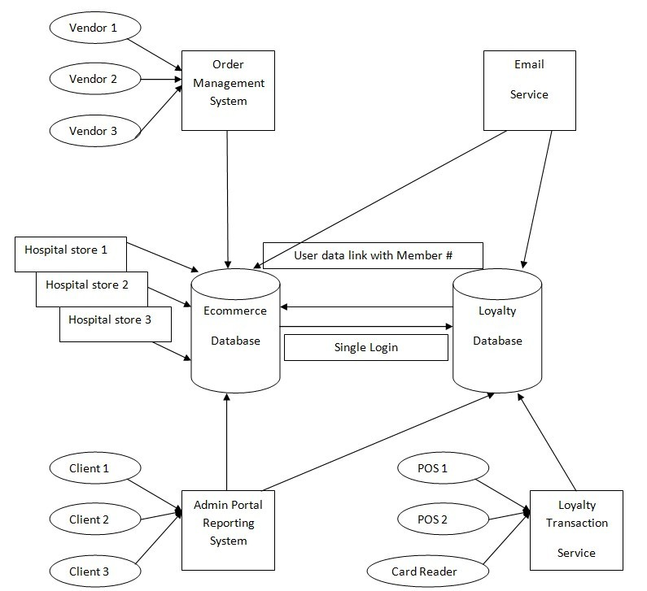

***Fig: 4.1: Context diagram***

**4.1.2 SELLER PROCESS**

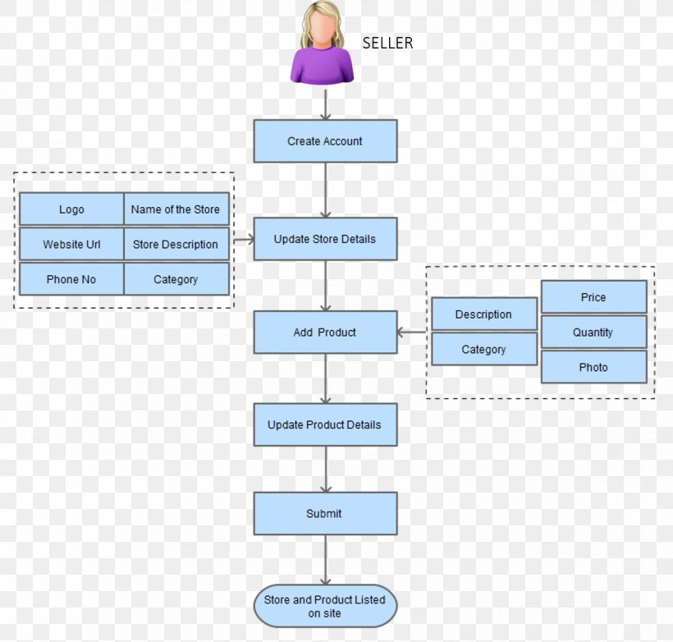

***Fig: 4.2: Seller process diagram***

**4.1.3 CUSTOMER PROCESS**

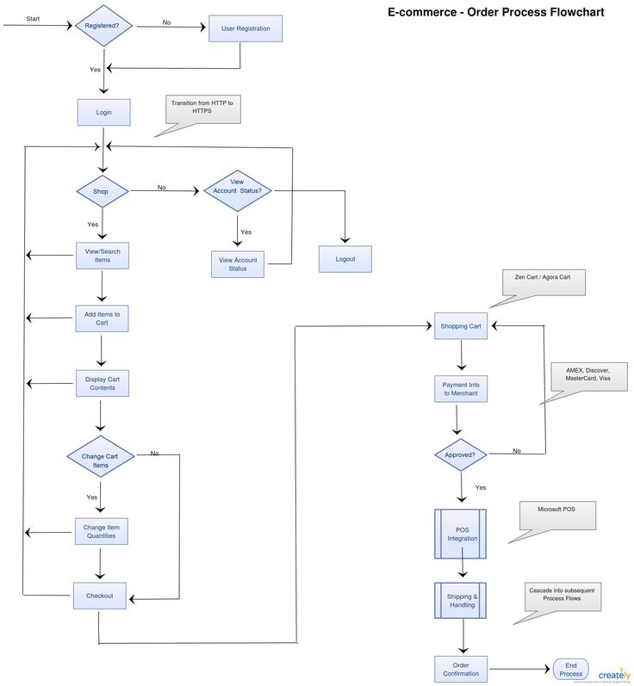

***Fig: 4.3: User process***

**4.2 UML Diagrams**

**4.2.1 Class Diagrams**

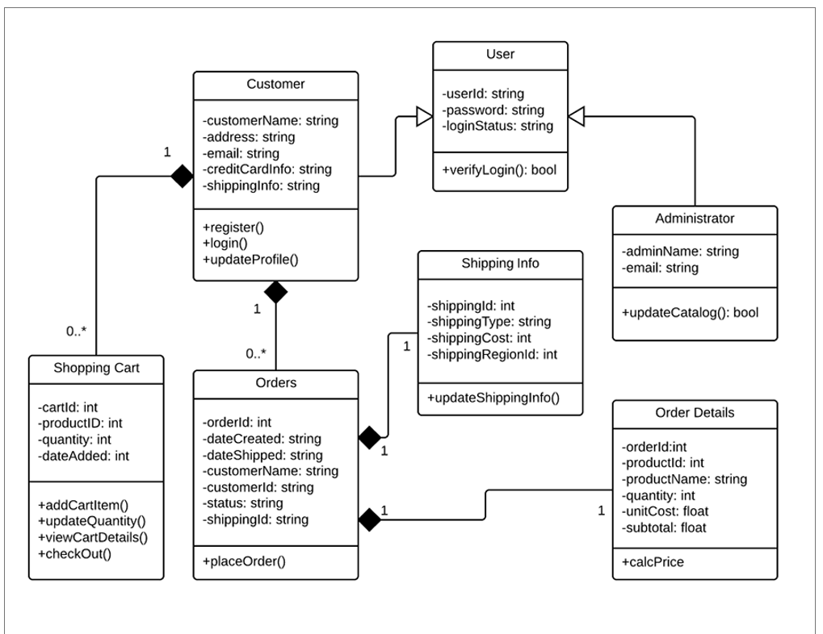

***Fig: 4.4: Class diagram***

A class diagram is at the heart of UML. It represents the core purposes of UML because it separates the design elements from the coding of the system. UML was set up as a standardized model to describe an object-oriented programming approach. Since classes are the building block of objects, class diagrams are the building blocks of UML. The diagramming components in a class diagram can represent the classes that will actually be programmed, the main objects, or the interaction between class and object. The class shape itself consists of a rectangle with three rows. The top row contains the name of the class, the middle row has the attributes of the class, and the bottom section expresses the methods or operations that the class may utilize.

**4.2.2 Use Case Diagram**

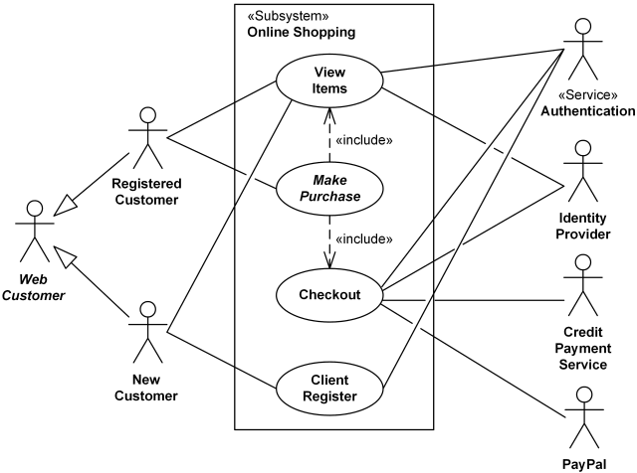

***Fig: 4.5: Use case diagram***

Use case diagrams are usually referred to as behavior diagrams used to describe a set of actions (use cases) that some system or systems (subject) should or can perform in collaboration with one or more external users of the system (actors). Each use case should provide some observable and valuable result to the actors or other stakeholders of the system. Note, that UML 2.0 to 2.4 specifications also described use case diagram as a specialization of a class diagram, and class diagram ass a structure diagram. Use case diagrams are in fact twofold - they are both behavior diagrams, because they describe behavior of the system, and they are also structure diagrams - as a special case of class diagrams where classifiers are restricted to be either actors or use cases related to each other with associations.

**4.2.3 SEQUENCE DIAGRAM**

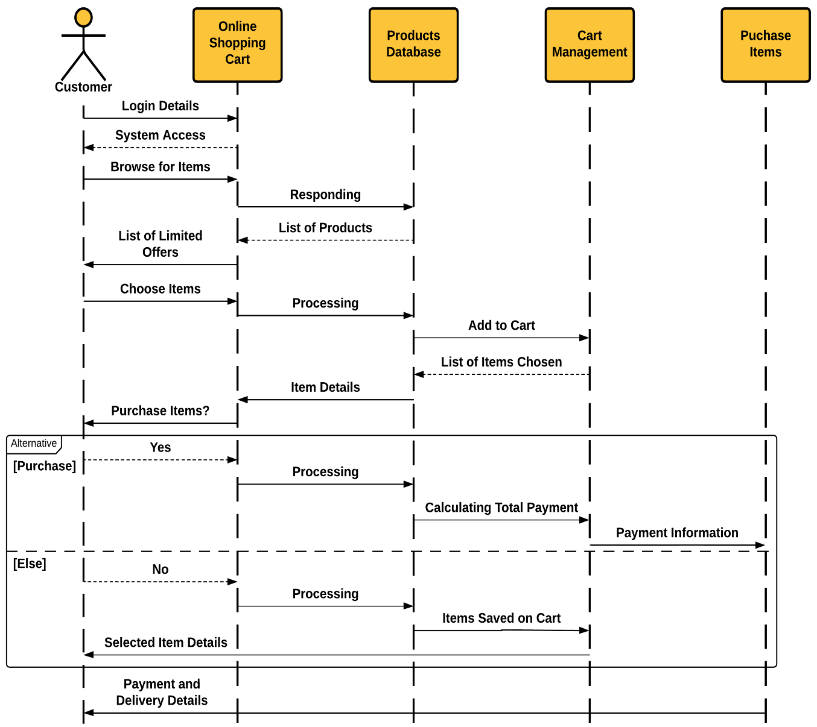

***Fig: 4.6: Sequence diagram***

UML Sequence Diagrams are interaction diagrams that detail how operations are carried out. Sequence Diagrams are time focus and they show the order of the interaction visually by using the vertical axis of the diagram to represent time what messages are sent and when.

Sequence Diagrams captures:

∙ the interaction that takes place in a collaboration that either realizes a use case or an operation (instance diagrams or generic diagrams)

∙ high-level interactions between user of the system and the system, between the system and other systems, or between subsystems (sometimes known as system sequence diagrams)

**4.2.4 DEPLOYMENT DIAGRAM**

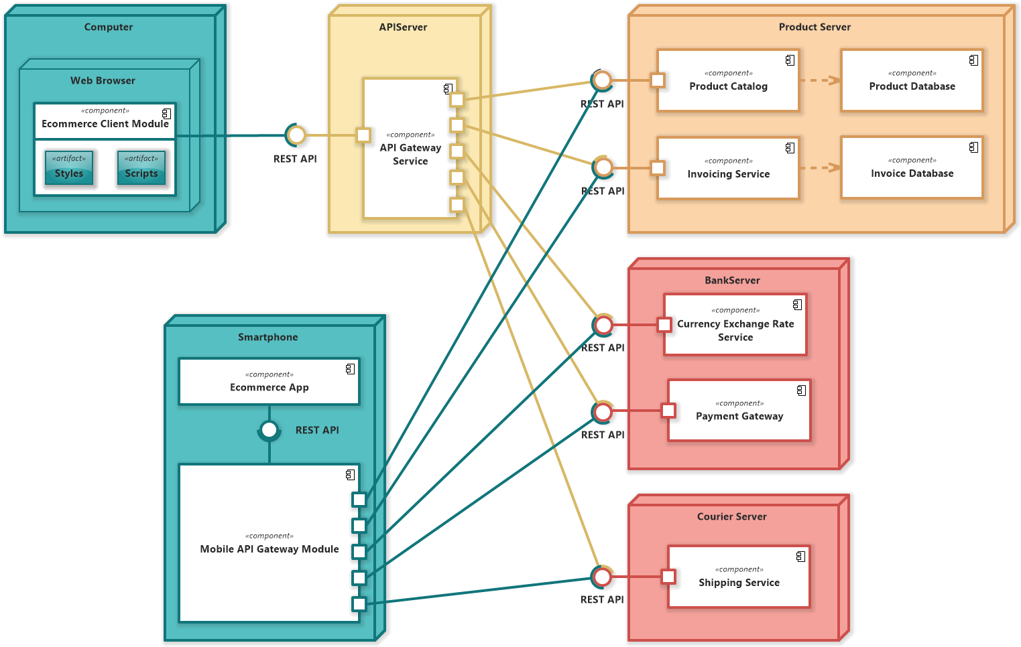

***Fig: 4.7: Deployment diagram***

Deployment diagrams are used to visualize the topology of the physical components of a system, where the software components are deployed. Deployment diagrams are used to describe the static deployment view of a system. Deployment diagrams consist of nodes and their relationships. The term Deployment itself describes the purpose of the diagram. Deployment diagrams are used for describing the hardware components, where software components are deployed. Component diagrams and deployment diagrams are closely related. Component diagrams are used to describe the components and deployment diagrams shows how they are deployed in hardware. UML is mainly designed to focus on the software artifacts of a system. However, these two diagrams are special diagrams used to focus on software and hardware components.

**4.3 E-R DIAGRAM**

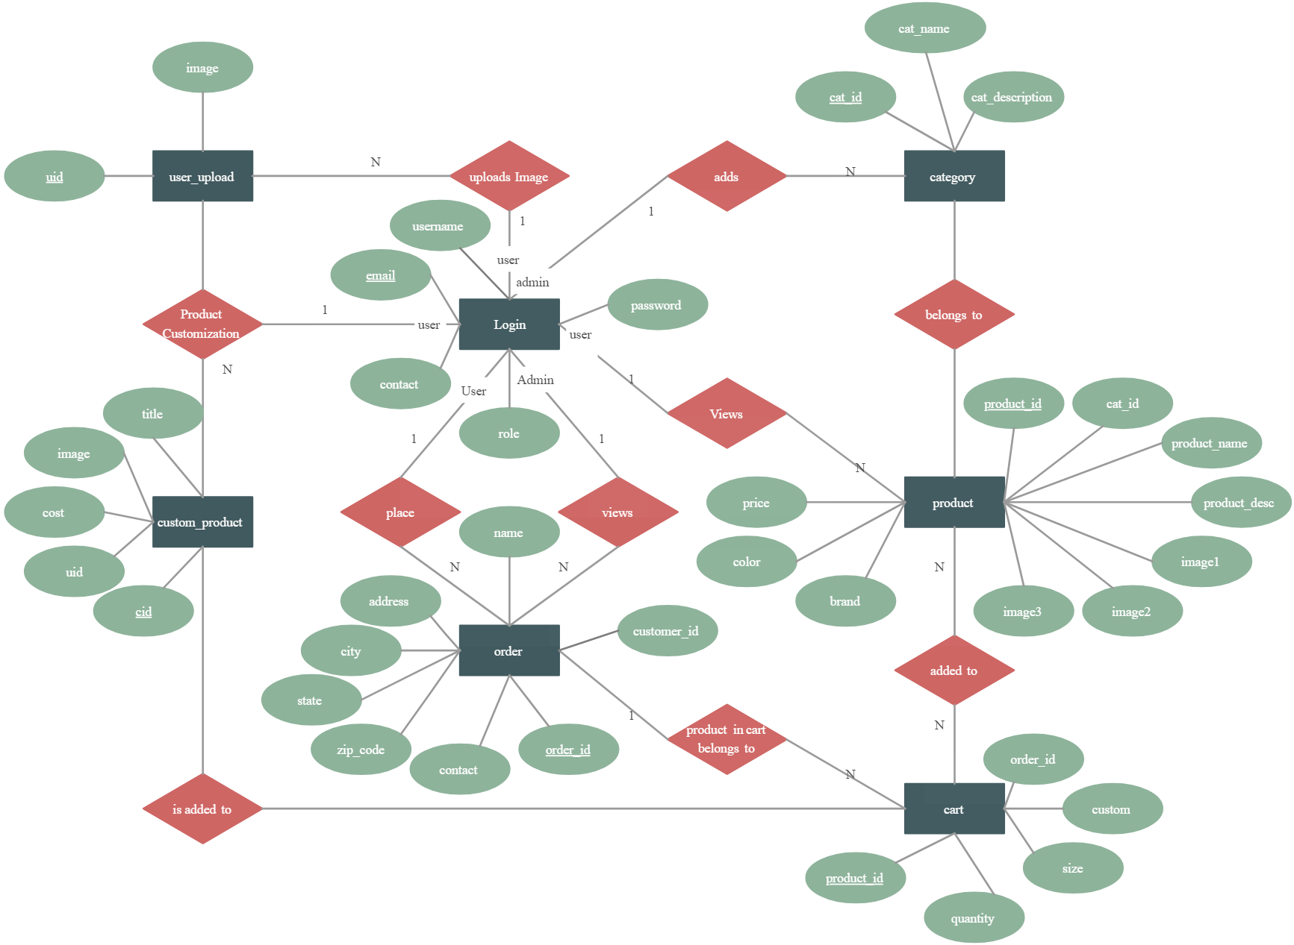

***Fig: 4.8: E-R diagram***

An Entity Relationship (ER) Diagram is a type of flowchart that illustrates how “entities” such as people, objects or concepts relate to each other within a system. ER Diagrams are most often used to design or debug relational databases in the fields of software engineering, business information systems, education and research. Also known as ERDs or ER Models, they use a defined set of symbols such as rectangles, diamonds, ovals and connecting lines to depict the interconnectedness of entities, relationships and their attributes.

**CHAPTER 5**

RESULTS AND DISCUSSION

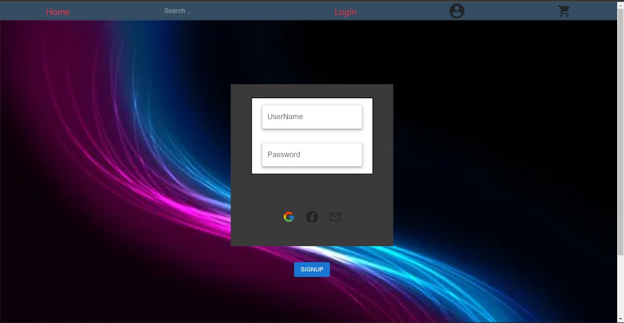

***Fig: 5.1: User login***

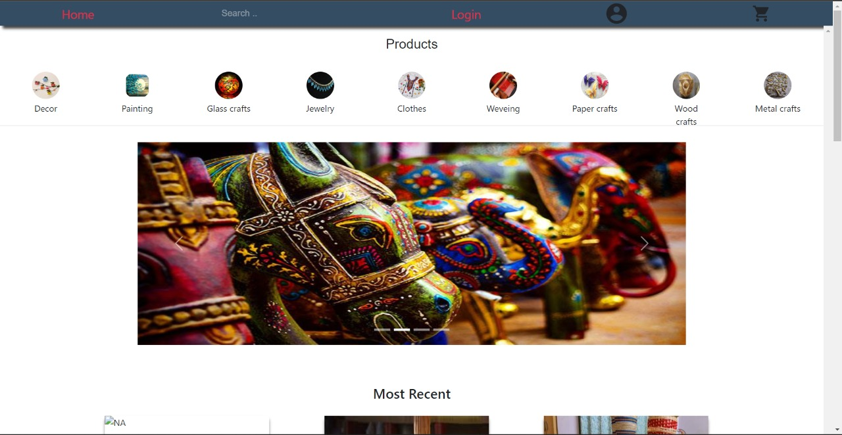

***Fig: 5.2: User Homepage***

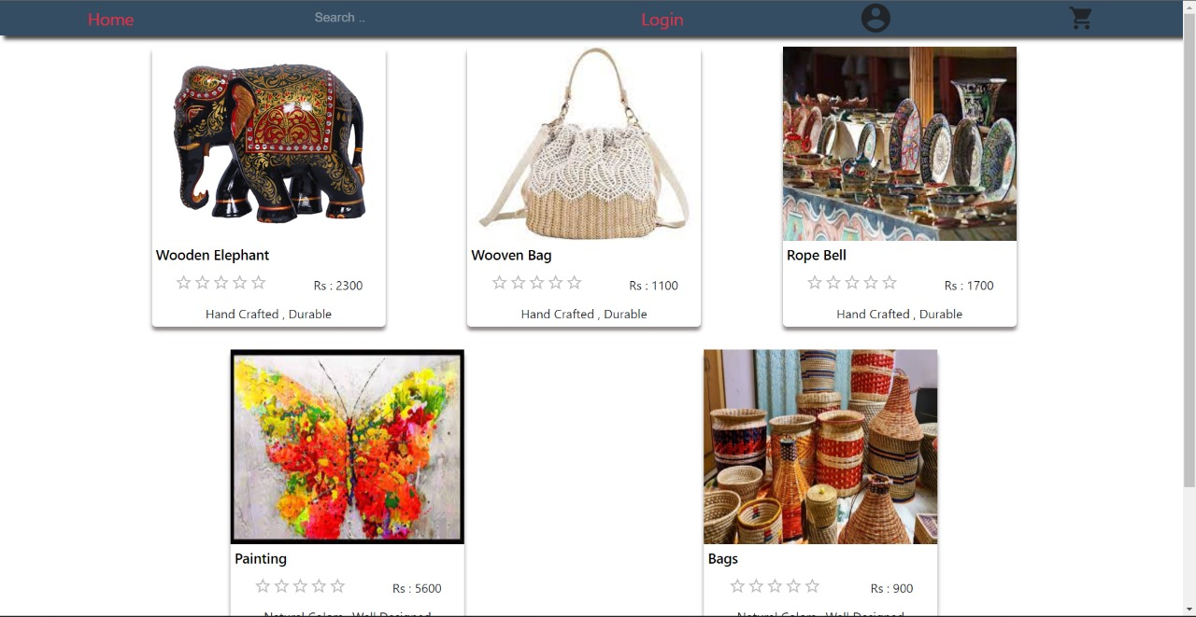

***Fig: 5.3: Products page***

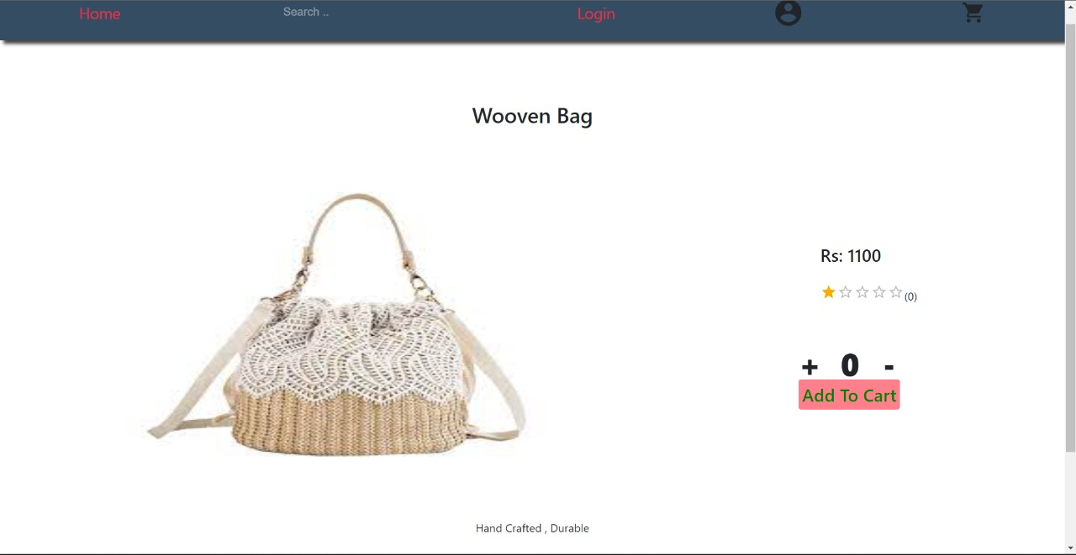

***Fig: 5.4: Cart page***

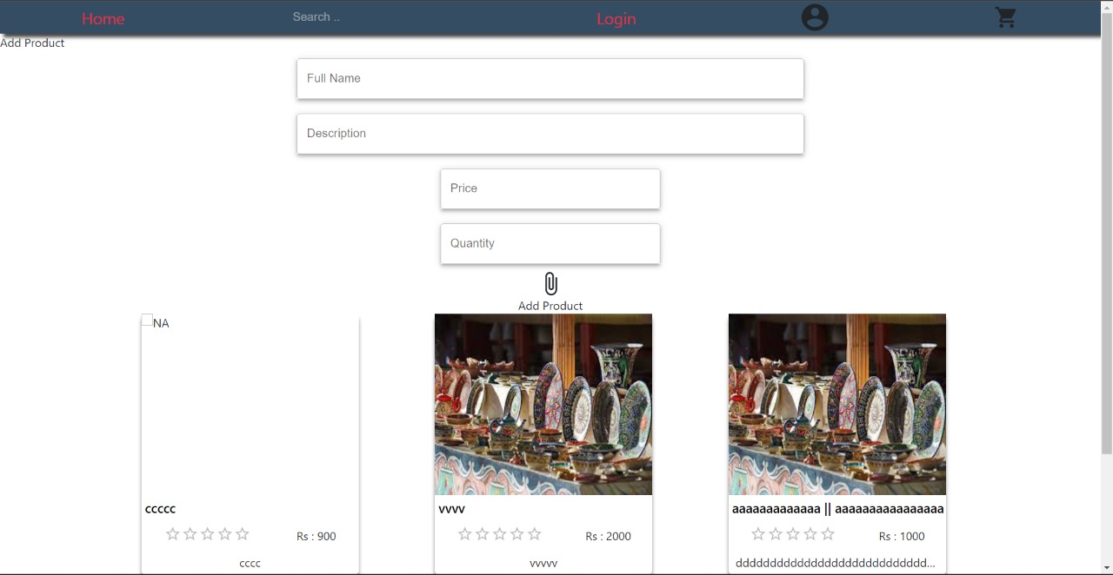

***Fig: 5.5: Seller page***

**CHAPTER 6**

CONCLUSION AND FUTURE WORK

**6.1 CONCLUSION**

The conclusion is that our website provides employment as well various products to customers and also we customize products according to the wish of the customer, we have flexibility in our process, from ordering of the product to the delivery. Also returns and refunds are easier than ever, the product is guaranteed for damage, if nay is done, one can request for a replacement or simply a refund.

Also, the products are completely handmade and no machines are used in the manufacture of the items, we have a wide range of products including handmade cards, handlooms, showcase elephants, paper dolls, clay toys, wooden chairs, jute bags, and etcetera. There might be many websites which provide the same service but we have an edge over the others because not only we provide various products but also we act as a bridge between the craftsmen who do not get recognized in the society and are under paid with the customers who want different handicrafts for special occasions or wants.

Products at reasonable and affordable prices, wide employment for artisans, and taking the entire handloom industry to just another level is a new ball game, not only it takes efforts to kindle the light of traditions and cultures in the modern era, it takes a lot more than business and professional skills in maintaining such business, it requires the understanding for a customer’s needs/wants, the specifications of a product, the craftsmen orders and designs needs/equipment requirements. Concluding altogether ARTESANIA is an online handloom portal which contains myriads of products that are handmade with embellished gems, sheets, etc with dynamic interface and admin panel on the back end.

**CHAPTER 7**

REFERENCE

1. “Feasibility Study” wikipedia.com. Retrieved on April 9, 2016, from <https://en.wikipedia.org/wiki/Feasibility_study>.

2. “JQuery Tutorials”w3schools.com. Retrieved on April 9, 2016, from <http://www.w3schools.com/php/>.

3. “Systems development Life Cycle”techtarget.com. Retrieved on April 15, 2016, from <http://searchsoftwarequality.techtarget.com/definition/systems-development-life-cycle>.

4. Henry F. Kurt, Database System Concepts, Indian Edition, 2013.

5. James Rumbaugh, Object –Oriented Modeling and Design With UML, Second Edition, 2005

. 6. Meloni, Julie C. “Sams teach yourself PHP, MySQL and Apache all in one”. Sams Publishing, 2012.

7. Roger Pressman. Software Engineering, Second Edition, 2004.

8. Software Development Process”wikipedia.com. Retrieved on April 17, 2016, from <https://en.wikipedia.org/wiki/Software_development_process>

9. Williams, Hugh E., and David Lane. “Web database applications with PHP and MySQL”. O’Reilly Media, Inc., 2004.

10. “Ecommerce definition & types of ecommerce (B2B, B2C, C2B, & C2C)” <http://www.digitsmith.com/ecommerce-definition.html>

11. “E-commerce in India: Industry Overview, Market Size & Growth| IBEF” <https://www.ibef.org/exports/handloom-industry-india.aspx>

12. “Individuals using the Internet (% of population) | Data” <https://data.worldbank.org/indicator/IT.NET.USER.ZS>

13. “Market, Captial: Business Standard in India” https://www.business-standard.com/article/news-cm/e-commerce-market-growing-at-a-rateof-about-17-in-2018-19-118121700794_1.html