PUNJAB COLLEGE OF TECHNICAL
EDUCATION, LUDHIANA

CLOUD COMPUTING
PROJECT REPORT
ON
FITNESS PHYRE: Local Gym Website
with Trial Booking and Admin Panel
SUBMITTED TO:  Ms. Chhayadeep Kaur  (Assistant Professor) | SUBMITTED BY:  Aryan  BCA 3A  2446533

TABLE OF CONTENTS
Sr. No. | Particulars
1 | Acknowledgement
2 | Abstract
3 | Introduction
4 | Technology Stack
5 | Key Features
6 | Implementation
7 | Visual Results
8 | Deployment
9 | Conclusion & Future Scope
10 | Reference Links

ACKNOWLEDGEMENT
I wish to express my sincere gratitude to everyone who contributed to the successful completion of the Fitness Phyre website project. This project gave me valuable practical experience in designing and building a complete, secure and responsive web application for a real-world local business.
I am especially thankful to Ms. Chhayadeep Kaur for the valuable guidance and support provided throughout the design and development of this project. Her feedback helped shape both the technical structure and the user experience of the website.
I would also like to acknowledge Punjab College of Technical Education for providing the academic environment and resources that made this work possible.
Finally, I thank my family and friends for their constant support and encouragement.
Aryan
BCA 3A | 2446533
November 2026

ABSTRACT
This report presents the design and development of the Fitness Phyre website, a responsive and information-focused website for a local gym with a 4.6 rating on Google. The site helps visitors learn about the gym, see its nine training programs and membership information, view photographs and reviews, and contact the gym by phone, WhatsApp, a contact form or a free trial request form.
The website is built with PHP and a MySQL database and is designed to run on an Apache web server. Pages are written in semantic HTML and CSS and adapt to desktop, tablet and mobile screens. All business details (name, address, phone number, opening hours, programs, membership plans, trainers and reviews) are kept in separate configuration files, so they can be updated without changing the page code. A password-protected admin panel lets gym staff read and manage enquiries and trial requests and upload photographs to the gallery.
A guiding principle of the project is honesty: information that the gym has not yet confirmed, such as prices, opening hours, trainer names and facilities, is not invented. The site shows neutral wording such as “Contact us for current membership plans and pricing” until real details are supplied. Key outcomes include eight public pages, two validated forms protected by CSRF tokens, a hidden honeypot field, rate limiting and duplicate detection, a secure admin panel and gallery, search-engine optimisation (sitemap, robots.txt and structured data), and an automated accessibility audit that found zero violations on nine pages.

INTRODUCTION
Project Background
A gym depends heavily on its local reputation, and most new members first look it up on their phone. A visitor wants quick answers: where is it, how can I call, which programs are offered, what does membership include, and can I try a session first? A gym without a clear website loses these visitors to competitors who answer these questions faster.
Fitness Phyre is a local gym with a 4.6 Google rating. It needed a simple and trustworthy website that presents the gym clearly, makes contact a single tap on a mobile phone, and collects enquiries and trial requests in one place where staff can follow them up. Because several business details were still to be confirmed during development, the website was designed so that each of them can be filled in later from one configuration file, and shows neutral wording until then.
Project Goals
- Build a clean, fast and fully responsive website of eight pages: Home, About, Programs, Membership, Gallery, Reviews, Contact and Book a Trial.
- Present the gym’s nine training programs with a short description and a “Suited for” note, without claiming anything the gym has not confirmed.
- Make contact effortless with click-to-call buttons, a floating WhatsApp button with a pre-filled message, Google Maps directions and an embedded map.
- Provide a contact form and a trial-request form with server-side validation and protection against spam and attacks.
- Build a password-protected admin panel to manage enquiries and trial requests and to upload and delete gallery photographs.
- Keep all business content in editable configuration files so the gym can update details without changing page code.
- Follow security, accessibility (WCAG 2.0/2.1 A and AA) and search-engine best practices.

TECHNOLOGY STACK
Component | Technology | Description
Frontend | HTML5, CSS3 | Semantic, responsive pages that adapt to desktop, tablet and mobile screens.
Client-side Scripting | JavaScript | Mobile menu, gallery lightbox viewer and form helpers.
Backend | PHP | Server-side page rendering, form handling, validation and admin logic.
Database | MySQL / MariaDB | Stores contact enquiries, trial requests, gallery records and the admin account (schema in database/schema.sql).
Web Server | Apache (.htaccess) | Serves the site, blocks access to sensitive folders and handles redirects and error pages.
Content Management | PHP config files | Editable site.php, plans.php, trainers.php and reviews.php hold all business details.
Admin Panel | PHP sessions | Password-protected panel for enquiries, trial requests and gallery management.
Security | CSRF, honeypot, rate limit | Form spam protection, login lockout, security headers and safe image uploads.
Contact Tools | tel:, WhatsApp, Google Maps | Click-to-call, WhatsApp chat with pre-filled message, directions and embedded map.
SEO | sitemap.xml, robots.txt, structured data | Helps search engines find and understand the eight public pages.
Testing | Automated checks, axe-core | Form, security and gallery checks plus an accessibility audit in Chromium.

KEY FEATURES
- Eight public pages: Home, About, Programs, Membership, Gallery, Reviews, Contact and Book a Trial, with a menu that becomes a hamburger menu on mobile.
- Programs: nine programs, each with a one-line description and “Suited for” text, so visitors can quickly find what matches their goal.
- Membership: four benefit cards and five FAQ answers. Plans and prices are read from a configuration file; until confirmed, the page shows “Contact us for current membership plans and pricing”.
- Photo gallery: photographs uploaded by staff from the admin panel and viewed in a lightbox that can be operated with the keyboard.
- Reviews: the gym’s Google rating with a “View on Google” button; individual reviews appear only if the reviewer has given permission.
- One-tap contact: “Call Now” buttons, a floating WhatsApp button with a pre-filled message, “Get Directions” and “View on Google Maps” links, and an embedded map that works with pinch-zoom on phones.
- Contact form: validates name, phone, email and message on the server and shows clear error messages.
- Book a Trial form: refuses past dates and, on success, shows “Thanks! Your trial request has been received. Our team will contact you to confirm the time.”
- Spam and abuse protection: CSRF tokens, a hidden honeypot field, rate limiting, duplicate detection, and handling of SQL-injection and script text.
- Admin panel: login with lockout after repeated failures; list of enquiries and trial requests that can be marked contacted, marked new or deleted; gallery upload and delete.
- Search-engine ready: sitemap.xml listing the eight pages, robots.txt, structured data and a friendly “Page not found” page.
- Accessible and responsive: works on laptop, tablet and phone; keyboard use, labels and colour contrast checked with an automated audit.
- Honest content: nothing unconfirmed is claimed; missing details are shown as “ask us / contact us” rather than invented.

IMPLEMENTATION
1. Project Architecture
The project is a PHP application organised into clear folders. The page files (for example about.php and membership.php) sit at the root and share common header, footer and helper code from the includes folder. The config folder holds db.php (database connection) and the editable content files site.php, plans.php, trainers.php and reviews.php. The admin folder contains the staff login, enquiries list, gallery manager and a one-time setup page. The database folder contains schema.sql, and uploaded and static images live under assets/images.
2. Configuration-Driven Content
Business details are not written into the pages. The gym’s name, address, phone and WhatsApp numbers, email, opening hours, programs, social links and Google rating are read from config/site.php; membership plans from config/plans.php; trainers from config/trainers.php; and reviews from config/reviews.php. If a value is empty, the page shows safe wording (for example “Please call to confirm timings”) or hides the section, so the site never displays made-up information. Opening hours are shown only after hours_verified is set to true.
3. Public Pages and Contact Options
- Each of the eight pages shares one responsive layout, so the design stays consistent from phone to desktop.
- Phone numbers use tel: links to open the dialler, and WhatsApp buttons open a chat with a pre-filled message.
- The Contact page includes an embedded map plus “Get Directions” and “View on Google Maps” buttons; the page still scrolls normally on a phone while the map supports pinch-zoom and + / − buttons.
- The Gallery page shows photos uploaded from the admin panel and opens them in a lightbox viewer; labelled placeholders are shown until real photographs are uploaded.
4. Forms and Spam Protection
The Contact form and the Book a Trial form are validated on the server for missing fields, invalid phone numbers and invalid email addresses, and the trial form rejects dates in the past. Each form carries a CSRF token and a hidden honeypot field that real users never fill in. A rate limit restricts how often one visitor can submit, duplicate submissions are detected, and text that looks like SQL injection or a script is handled safely. After a successful submission the visitor sees a confirmation message and the request is saved in the database for staff to review.
5. Admin Panel
Staff sign in at the admin login page. Repeated wrong passwords cause a temporary lockout, and any admin page opened while logged out redirects to the login page. The enquiries page lists contact enquiries and trial requests with options to mark each as contacted, mark it as new again, or delete it. The gallery page allows photographs to be uploaded, shown on the public Gallery page, and deleted. A one-time setup page creates the admin account and must be deleted from the server after first use.
6. Security
- Security headers and a content-security policy are sent with every page; testing found no policy violations.
- Upload rules accept only genuine images. A PHP file disguised as an image, code hidden inside a JPEG and path tricks on delete were all tested and rejected.
- Sensitive folders and files (config, includes and database/schema.sql) are blocked on the server so they show an error page and not code or a file list.
- Sessions are handled safely, and logged-out access to admin pages is refused.
7. Search Engine Optimisation and Accessibility
The site provides a sitemap.xml listing the eight pages, a robots.txt file pointing to it, structured data describing the business, and a custom “Page not found” page. For accessibility, pages use semantic headings, form labels and keyboard-friendly controls, including the gallery viewer. An automated axe audit covering WCAG 2.0/2.1 A and AA rules found 0 violations on 9 pages at desktop and phone sizes.
8. Testing
- Forms, spam checks, admin and security: 48 automated checks, all passed (validation, CSRF, honeypot, rate limit, duplicates, SQL-injection and script text, login lockout, session handling and logged-out access).
- Gallery, headers and SEO: 33 automated checks, all passed (upload rules, disguised PHP file, code hidden inside a JPEG, delete path tricks, security headers, sitemap, 404 page and structured data).
- Accessibility: automated axe audit with 0 violations on 9 pages; keyboard use of the gallery viewer checked.
- Browser: no content-security-policy violations, no broken images or scripts and no horizontal overflow.
- Limits of this testing: it used a local copy with SQLite as a stand-in database and Chromium only. Real MySQL/MariaDB, Apache .htaccess rules, real HTTPS, Firefox, Safari, Edge, real phones and map tiles are covered by the final testing checklist on the live site.

VISUAL RESULTS
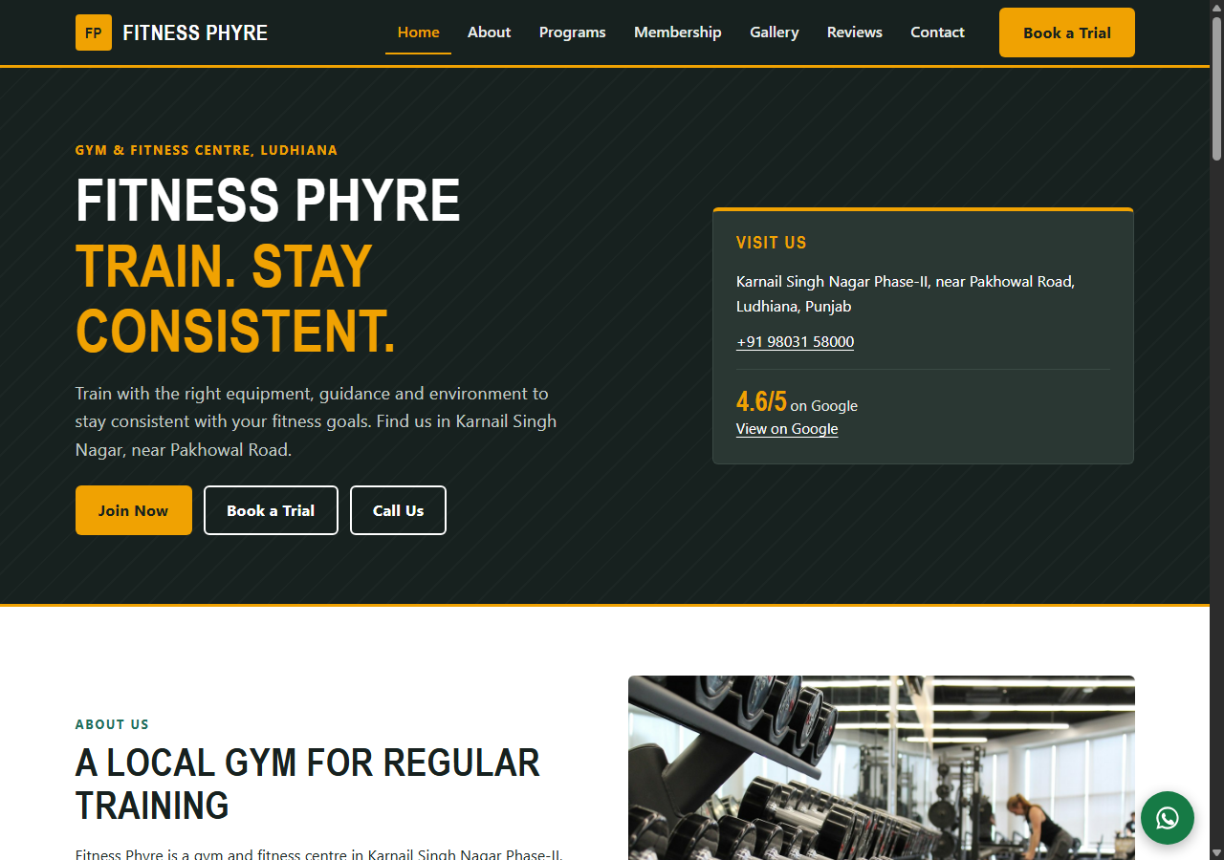
Figure 1: Home page (hero section)
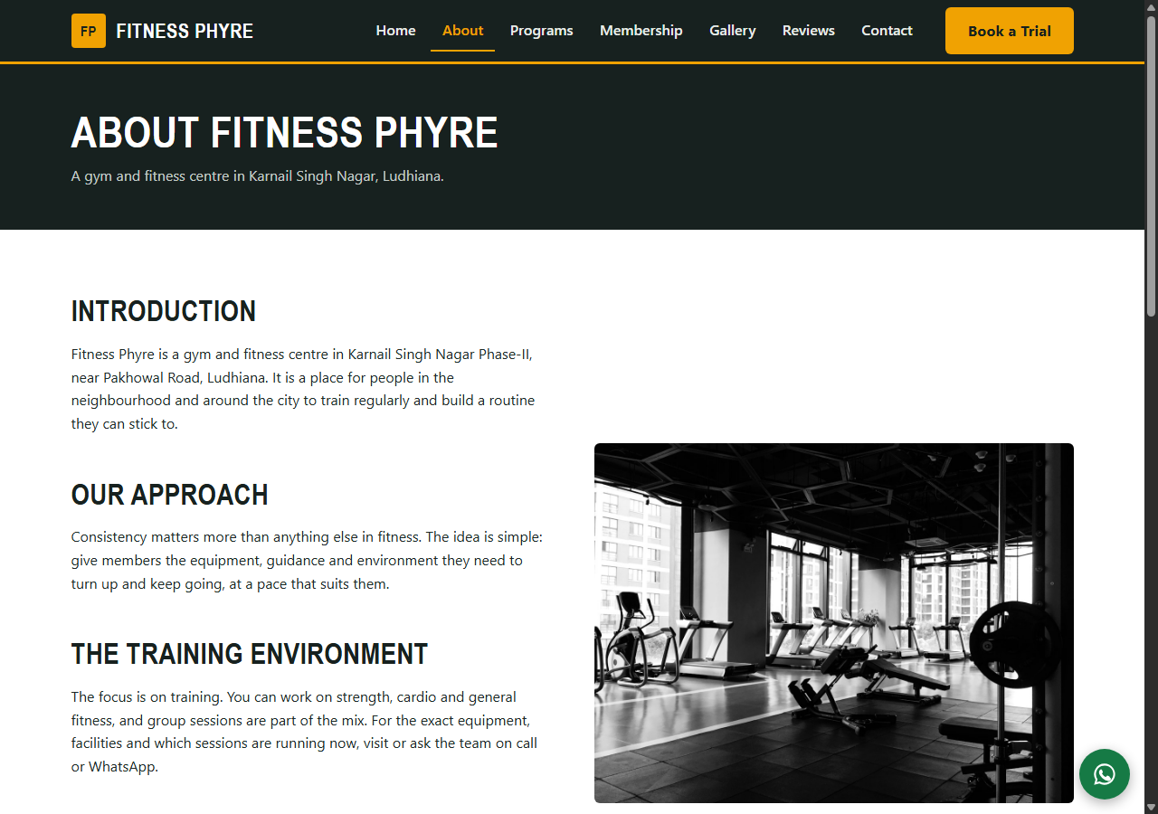
Figure 2: About page

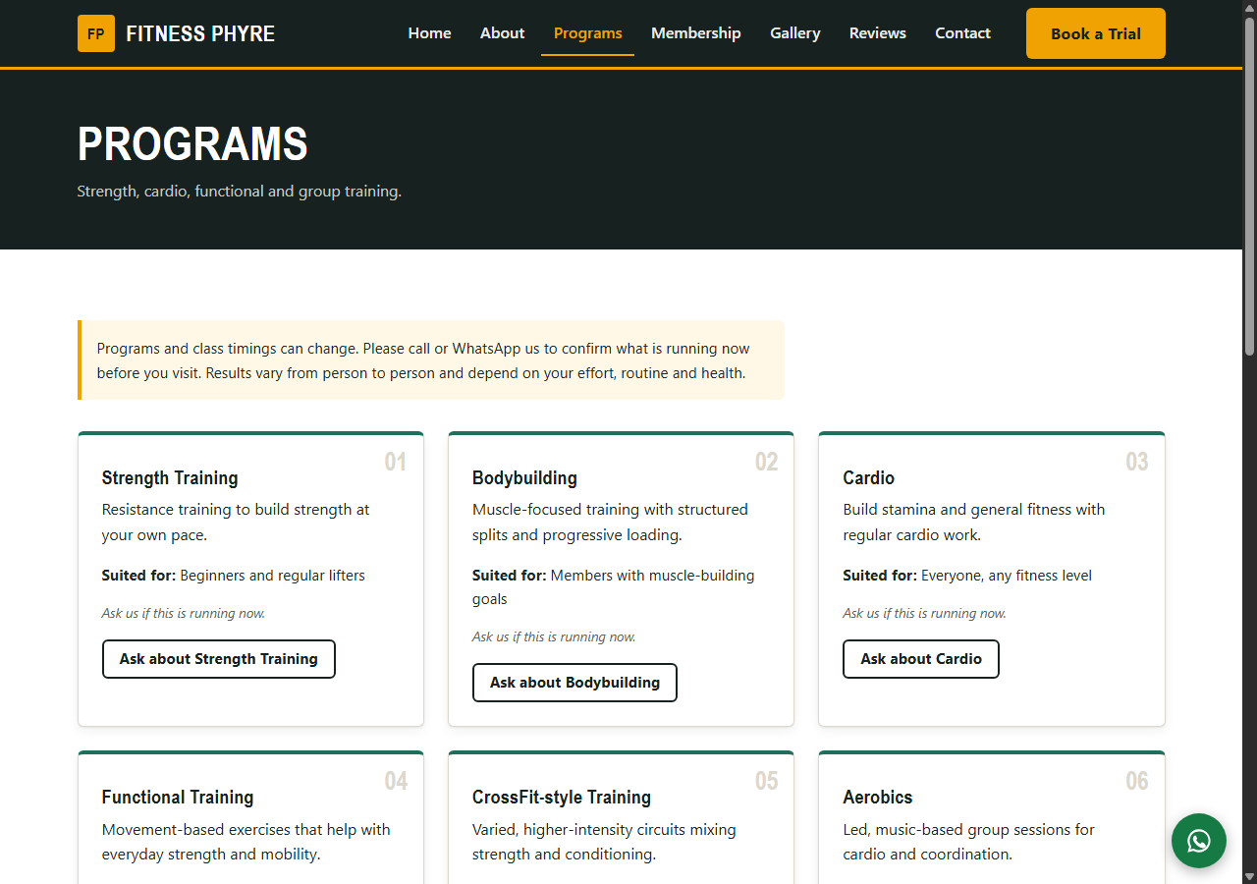
Figure 3: Programs page
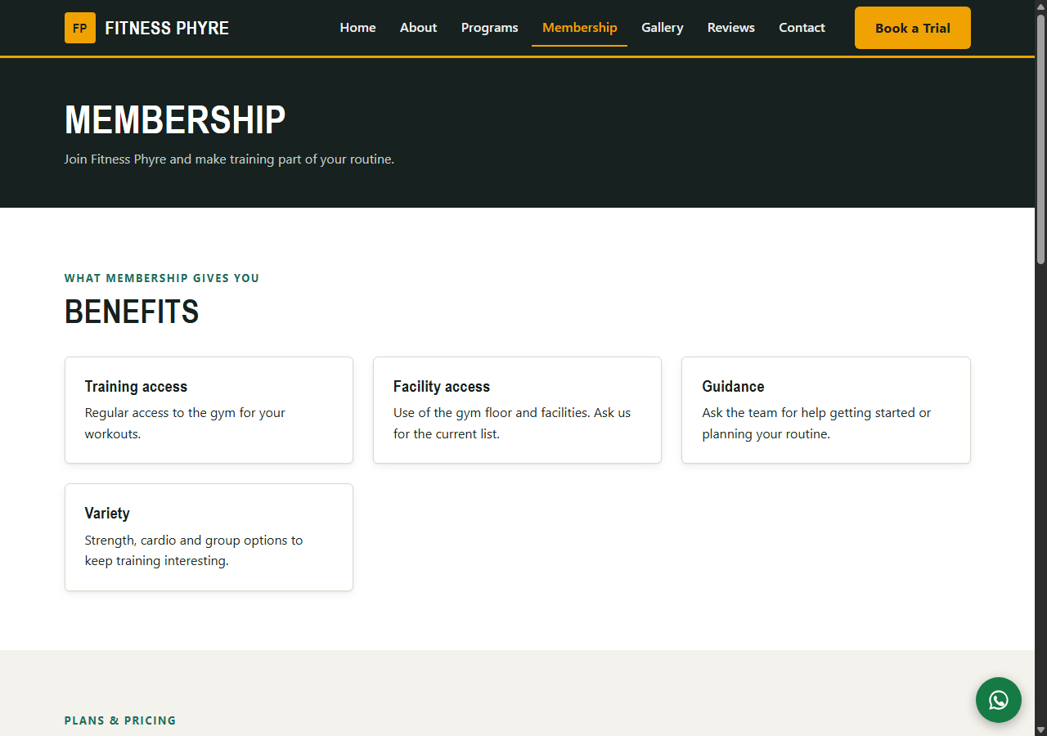
Figure 4: Membership page

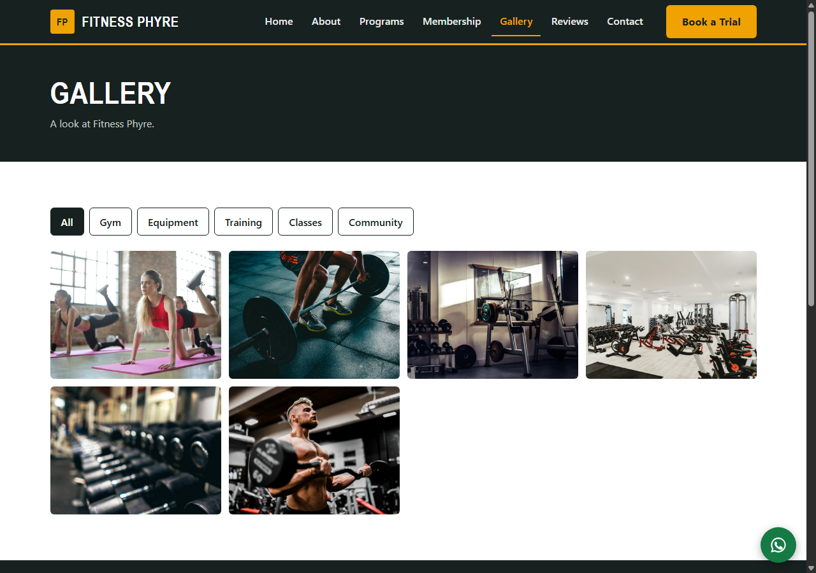
Figure 5: Gallery page with lightbox viewer
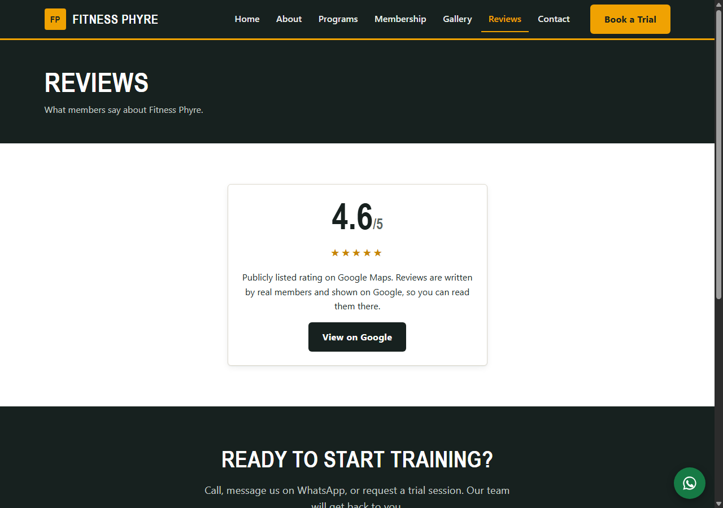
Figure 6: Reviews page

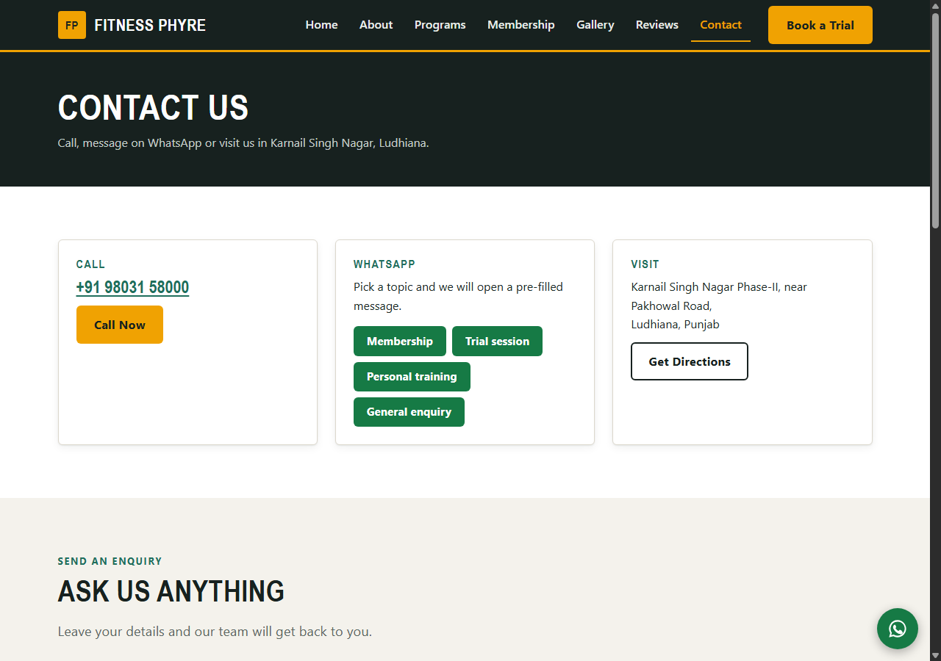
Figure 7: Contact page with map and contact form
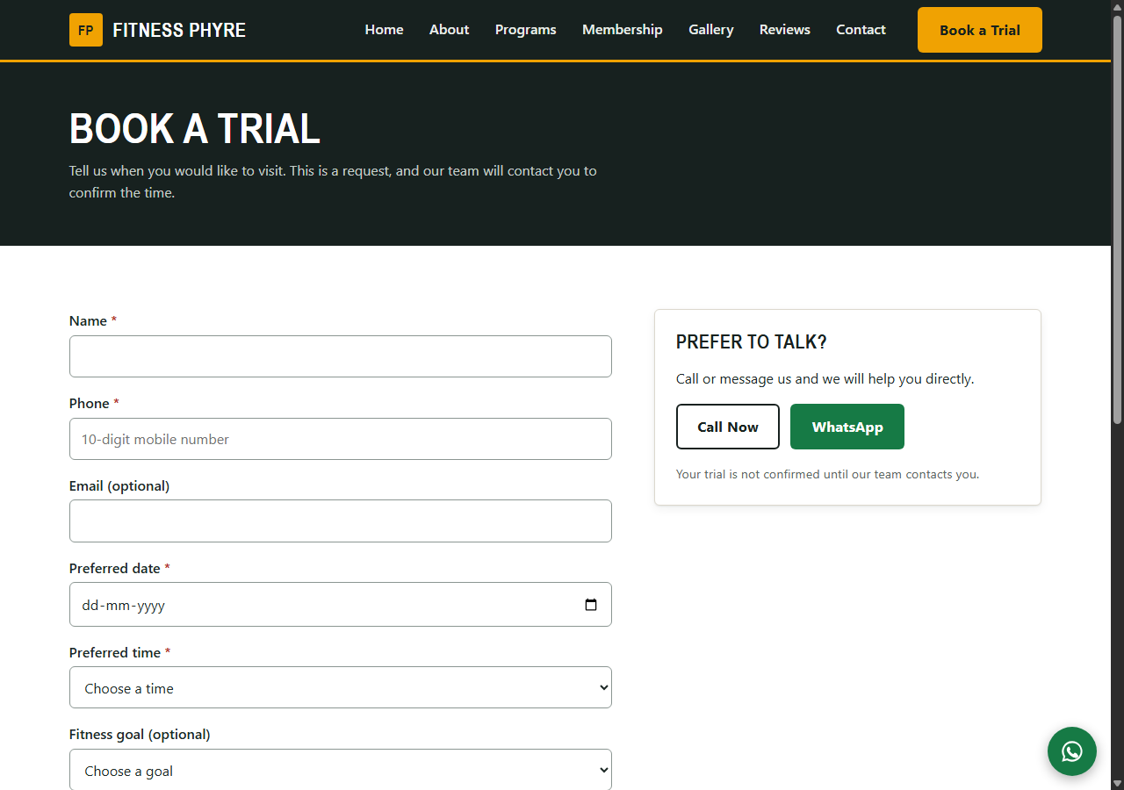
Figure 8: Book a Trial form and confirmation message

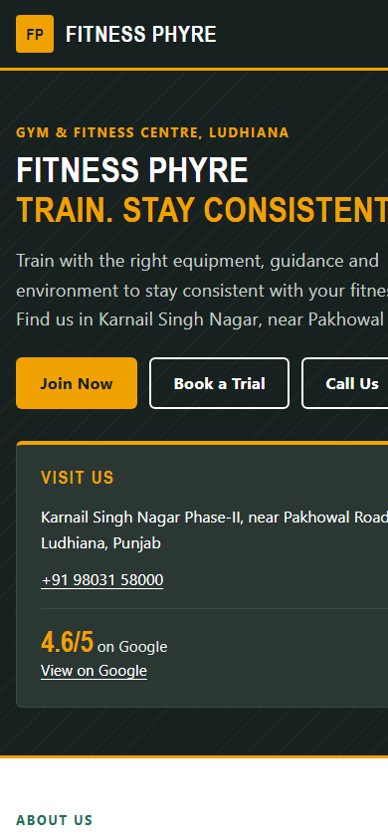
Figure 9: Mobile view of the home page
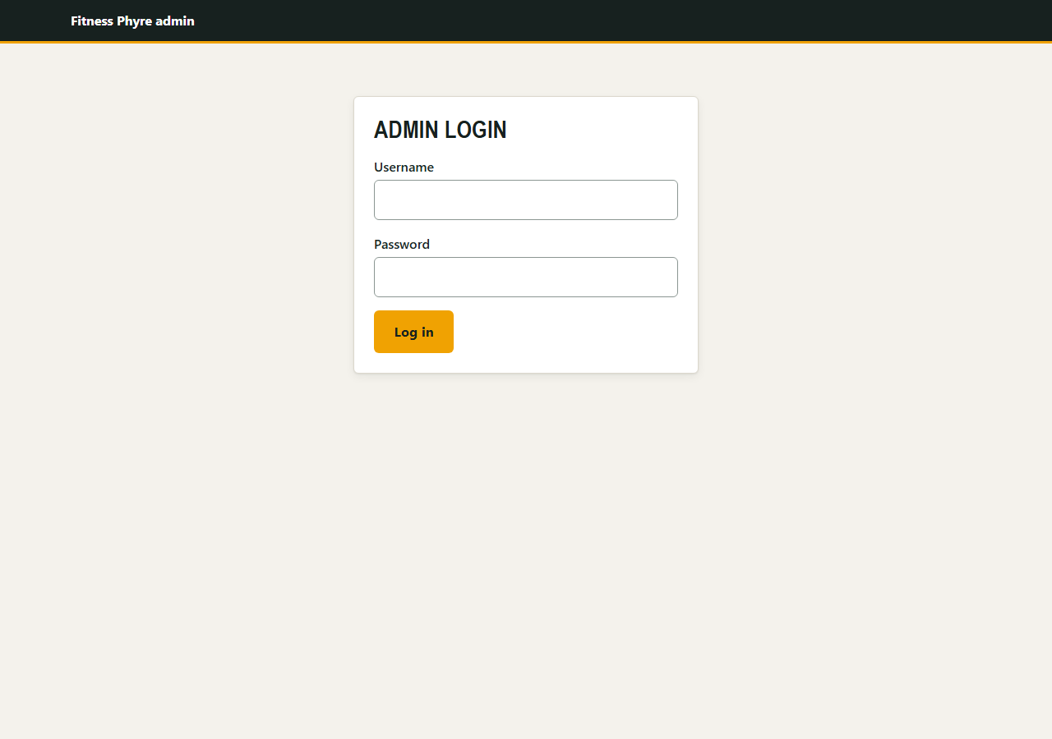
Figure 10: Admin login page

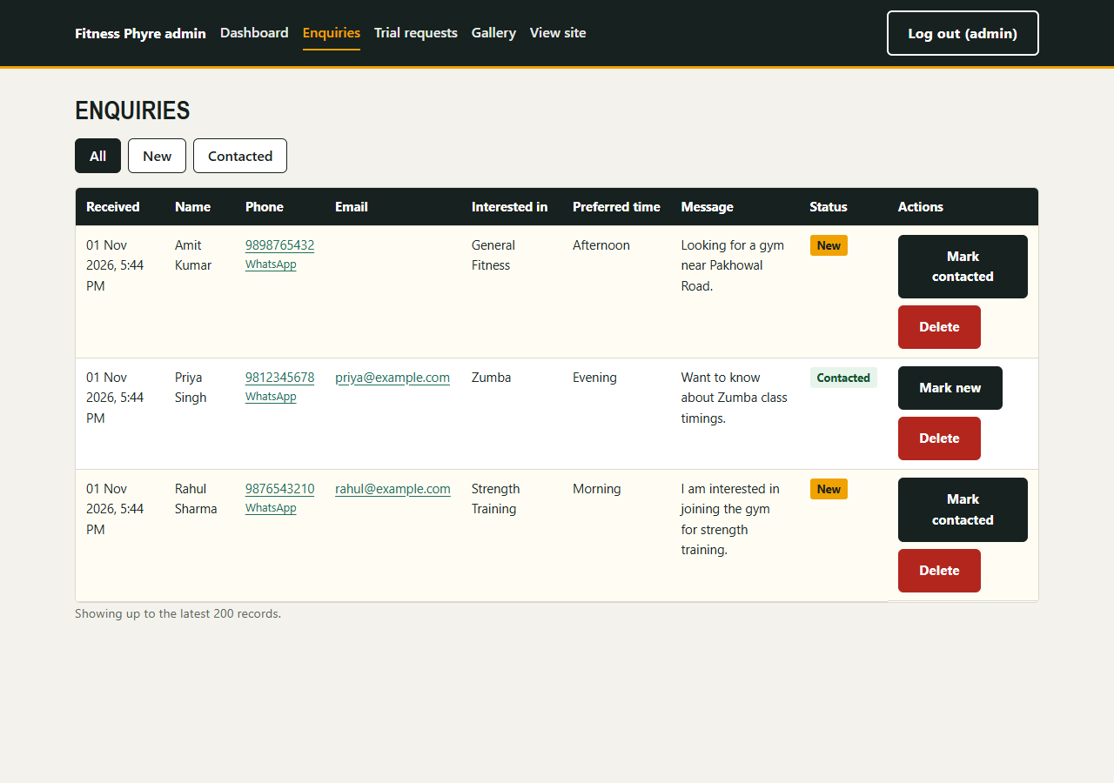
Figure 11: Admin enquiries and trial requests list
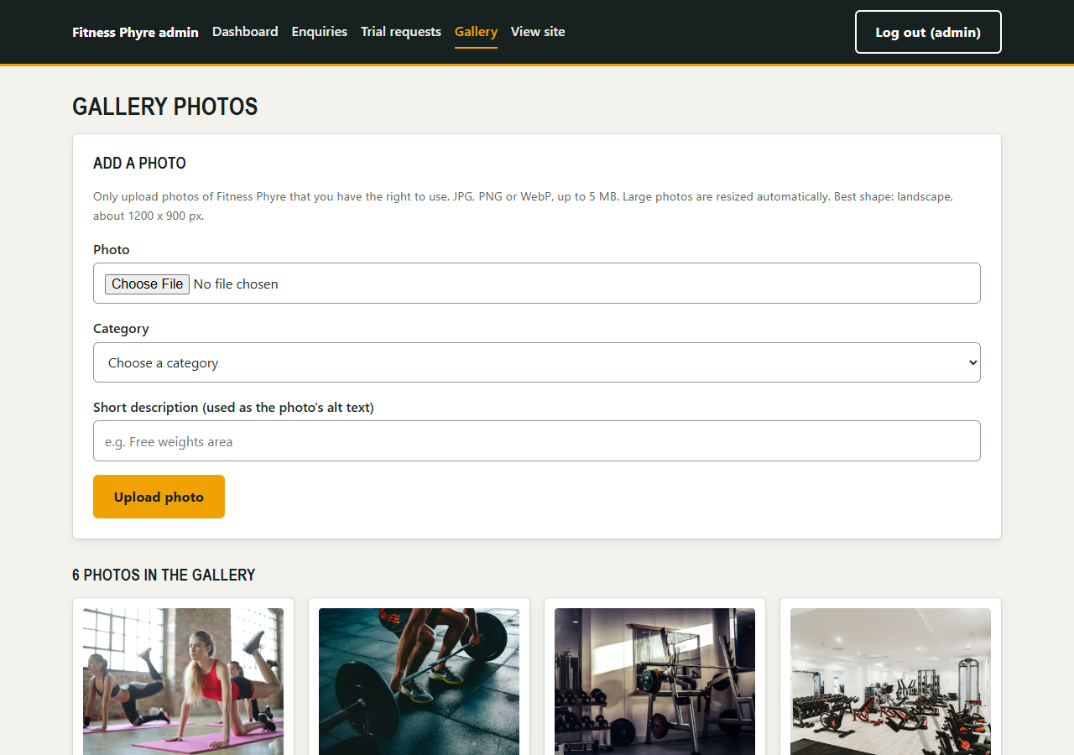
Figure 12: Admin gallery management

DEPLOYMENT
The website currently runs on a local development copy. It is designed to be deployed on standard Apache, PHP and MySQL/MariaDB web hosting using the following steps:
- Choose web hosting with Apache, PHP and MySQL/MariaDB, and create an empty database and database user.
- Import database/schema.sql into the new database and enter the connection details in config/db.php.
- Upload the project files, then open the admin setup page to create the admin account and delete admin/setup.php from the server immediately afterwards.
- Enter the confirmed business details in config/site.php and config/plans.php, set site_url to the real domain, and update the Sitemap line in robots.txt.
- Point the domain name to the hosting, enable HTTPS and make sure http:// redirects to https://.
- Run the final testing checklist on the live site (pages, buttons, map, forms, admin, security, browsers and search) and submit the sitemap to Google Search Console.
Information needed from the gym before launch
The following must be confirmed by Fitness Phyre and entered in the configuration files: official business name, full address and PIN code, working phone/WhatsApp number, business email, opening hours, membership plans and prices, programs actually running, trainer details (with permission), real photographs and logo, social media accounts, genuine reviews (with permission) and the domain name. A short privacy notice explaining how names and phone numbers collected by the forms are used should also be added.
CONCLUSION & FUTURE SCOPE
The Fitness Phyre website meets its main goals: it presents the gym clearly on all screen sizes, makes contact easy through call, WhatsApp, map and forms, protects those forms against spam and attacks, and gives staff a secure admin panel to follow up enquiries and manage the gallery. Because all business details live in configuration files and nothing unconfirmed is claimed, the site stays truthful and can be completed quickly once the gym supplies the remaining information.
Future Scope
- Completing the pre-launch information list and replacing placeholders with real gym photographs and the official logo.
- Email and WhatsApp notifications to staff when a new enquiry or trial request arrives.
- Editing opening hours, plans, trainers and reviews directly from the admin panel instead of configuration files.
- Class timetable, online membership payment and a member login area.

REFERENCE LINKS
- PHP documentation: https://www.php.net/docs.php
- MySQL documentation: https://dev.mysql.com/doc/
- Apache HTTP Server documentation: https://httpd.apache.org/docs/
- MDN Web Docs (HTML, CSS, JavaScript): https://developer.mozilla.org
- WCAG accessibility guidelines: https://www.w3.org/WAI/standards-guidelines/wcag/
- axe accessibility testing: https://www.deque.com/axe/
- OWASP web security resources: https://owasp.org
- Schema.org structured data: https://schema.org
- Google Search Console: https://search.google.com/search-console
- Google Maps: https://www.google.com/maps

