DoCC Project Report

Launching a Sustainable
Basmati Rice Brand for MVS

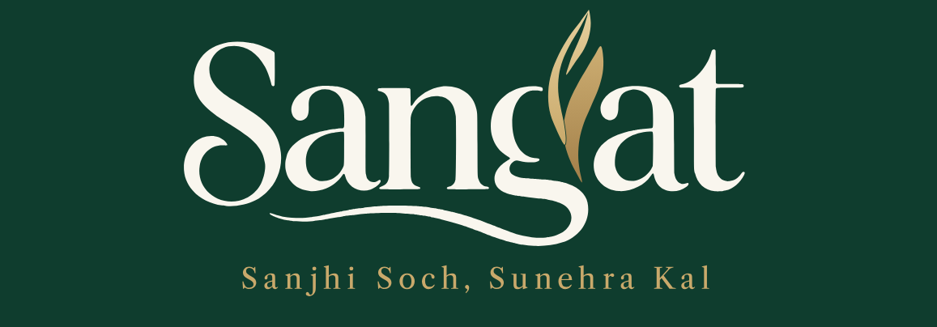

Prepared for
Manav Vikas Sansthan (MVS)
By
Ashish Satpathy and Janardhan Reddy Bogireddy
Development of Corporate Citizenship (DoCC)
S. P. Jain Institute of Management & Research, Mumbai
2026

Preface
The DoCC project offered an opportunity to work with Manav Vikas Sansthan on a question that sits between rural livelihoods, agricultural practices and the consumer market: how might an existing farmer ecosystem support a credible premium basmati rice brand?
Our work moved between field conversations and desk-based strategy. We met people in the communities where the work takes place, listened to experiences around cultivation and livelihoods, and then tried to translate what we were learning into decisions about customers, positioning, identity, packaging and a possible route to market.
The report documents the work completed, the thinking behind the recommendations and the areas that MVS would need to validate before taking the brand into a commercial pilot. It distinguishes between field observations, desk research, design concepts and proposed next steps.

Acknowledgement
We would like to thank Manav Vikas Sansthan for giving us the opportunity to engage with its work and to understand the relationships that support its programmes. We are grateful to the MVS team members who facilitated field visits, shared context and helped us understand the practical realities behind the project.
We also thank the farmers, community members and other stakeholders who gave us their time and allowed us to learn from their experiences. Their openness helped us look beyond the product brief and appreciate the people, decisions and constraints that shape agricultural livelihoods.
We are grateful to the MVS field and programme teams for sharing their time, field knowledge and operational context across the PRANA and PRERANA initiatives, and for facilitating interactions with farmers and community members. We also acknowledge the guidance provided by DoCC team and SPJIMR.

Contents
- Executive Summary
- 1. Introduction and Project Context
- 2. Organisation Profile: Manav Vikas Sansthan
- 3. Project Objectives and Scope
- 4. Methodology and Approach
- 5. Problem Diagnosis and Analysis
- 6. Market Understanding
- 7. Segmentation, Targeting & Positioning
- 8. Sangat: Brand Naming and verbal Identity
- 9. Visual identity & brand system
- 10. Packing and consumer communication
- 11. Go-to-market and marketing recommendations
- 12. Stakeholder coordination and operating model
- 13. Field Implementation, Validation and pilot
- 14. Recommendations to MVS
- 15. Conclusion

Executive Summary
This DoCC project was undertaken with Manav Vikas Sansthan (MVS) to develop an evidence-led brand and go-to-market blueprint for a proposed sustainable basmati rice brand. The project team worked across field understanding, stakeholder context, market research, segmentation, targeting and positioning, brand identity, packaging and launch recommendations.
The central challenge was not simply to create a name or attractive pack. MVS had an existing farmer ecosystem and work around cultivation practices, but a consumer-facing proposition would need to connect that work with what households expect from premium basmati: dependable aroma, texture, grain quality and cooking performance. A farming story could add meaning, but it could not compensate for an inconsistent product.
The project developed the proposed brand identity Sangat, with the tagline “Sanjhi Soch, Sunehra Kal”. The identity uses togetherness as its central idea: farmers, MVS and households connected through the food they grow and consume. The visual direction uses a forest-green, ivory and muted-gold palette, a distinctive wordmark with a golden rice-ear motif, and landscape-led packaging concepts. The packaging work explored 1 kg and 5 kg formats, a QR storytelling area and a structured back panel for statutory and product information.
The STP recommendation is to begin with existing premium branded basmati buyers, especially household grocery decision makers who value cooking quality and are open to credible information about cultivation. Occasion-led home cooks form a secondary target. Chandigarh, Mohali and Panchkula are proposed as a practical pilot geography because the project team had local access.
The recommended route is to prove the rice first and then build trust through a farming story that customers can examine. Before launch, MVS would need to confirm the product specification, batch consistency, sourcing records, applicable Sustainable Rice Platform (SRP) status and wording, packaging compliance, landed cost and channel economics. A focused pilot with household buyers and premium retailers is proposed to test cooking parity, message comprehension, paid trial, repeat purchase and contribution margin.
The project therefore leaves MVS with a strategic and creative foundation for Sangat, alongside a set of validation requirements. It does not claim that a commercial launch, consumer validation or verified product traceability has already taken place.

1. Introduction and Project Context

1.1 Background
Rice is both a staple and a product shaped by trust. For a household buying premium basmati, the decision is often tied to a familiar outcome: how the grains look, how they smell, how they cook and whether the dish turns out as expected. A new brand enters this relationship with a disadvantage. It must give the buyer a reason to move away from a product that already feels dependable.
MVS approached the project with an opportunity to connect its work with farming communities to a consumer-facing basmati brand. The existing supply chain in the Punjab region, particularly around Mohali and Fatehgarh Sahib, could potentially support the proposed brand.

1.2 Problem statement
How can MVS translate its existing engagement with farmers and sustainable cultivation work into a credible premium basmati brand, while ensuring that the product, sourcing story, operating model and customer proposition are aligned?

1.3 Why the problem matters
The project sits at the intersection of rural development and market development. A consumer brand may create a route through which farming practices and community participation become more visible. However, a brand can only contribute meaningfully if it is grounded in a functioning supply chain, consistent quality, transparent claims and a viable commercial model. Branding without these foundations risks creating expectations that the organisation may not yet be able to fulfil.

1.4 Project approach
The work combined field engagement with desk research and the development of practical brand and market recommendations. The intention was to move from understanding the ecosystem to defining a proposition that MVS could review and take forward.
Project boundary The project developed a brand and go-to-market blueprint with bounded proof-of-concept outputs. It did not establish that commercial production, retail distribution, consumer repeat purchase or SRP product verification had been completed.

2. Organisation Profile: Manav Vikas Sansthan
Manav Vikas Sansthan (MVS) is a non-profit, non-governmental organisation established in 1996, working towards the socio-economic development of rural communities. The organisation focuses on creating sustainable livelihood opportunities, promoting social equity and strengthening community institutions. It works across multiple states, including Punjab, Himachal Pradesh, Haryana, Uttarakhand and Meghalaya. Its key areas of intervention include women empowerment, sustainable agriculture, water conservation, climate resilience, education and rural development. MVS works closely with farmers, rural households and Self-Help Groups (SHGs) to enhance economic independence and community participation. Through initiatives such as Project Prerna, it empowers rural women by promoting farm-based and non-farm livelihood opportunities and strengthening women-led institutions. Overall, the organisation aims to build self-reliant, inclusive and sustainable rural communities through grassroots-driven development initiatives.

3. Project Objectives and Scope
The project goal is to launch a practical, evidence-led brand and go-to-market blueprint, supported by a bounded proof of concept that MVS could evaluate and take forward.
Workstream | Objective | Project output / status
Field research and diagnosis | Understand farmer economics, production and selling practices, constraints and the existing supply chain. | Field visits and stakeholder observations; complete supply-chain map.
STP | Identify plausible customer segments, compare needs and recommend a priority target. | Brand STP and pilot recommendation.
Brand strategy | Develop promise, messages, differentiation and tone. | Brand name, tagline, positioning and verbal identity report prepared.
Packaging | Recommend pack sizes, hierarchy, design and compliance checks. | 1 kg and 5 kg concepts developed.
GTM and channels | Compare routes to market and recommend a focused initial route. | Pilot geography, channel mix and validation approach proposed.
Marketing & Communication initiatives | Recommend sampling, retailer education and digital storytelling. | Initiatives proposed. QR based website prototype design.

3.1 Specific objectives
- Identify a customer segment for whom the proposed product and farming story are relevant.
- Define a positioning that balances premium cooking expectations with credible cultivation information.
- Create a coherent verbal and visual identity for the proposed brand.
- Develop packaging concepts that communicate the brand while leaving space for verified product and statutory information.
- Recommend a practical pilot and a sequence of validation decisions.

4. Methodology and Approach

4.1 Overall approach
The project used an exploratory, applied approach. It combined field observation and stakeholder conversations with secondary research, competitor review, strategic synthesis and design development. This was appropriate because the assignment involved an early-stage opportunity where the team first needed to understand the context and then translate that understanding into choices MVS could assess.

4.2 Field engagement
Field visits were used to observe the setting in which farmers and community members live and work, and to understand the practical realities behind cultivation and livelihoods..

4.3 Secondary research
Desk research covered competitor product propositions, published brand information, market context, SRP resources and available retail listings. Competitor pages were used to understand what brands communicate; they were not treated as independent proof of product superiority or customer preference. Market estimates and listed prices were treated as directional and time-sensitive.

4.4 Methodological limitations
- The mentioned data do not establish a statistically representative consumer sample.
- The naming exercise compared shortlisted names against criteria including memorability, relevance to the brand idea, distinctiveness and fit with the intended premium positioning. The selected name was Sangat, supported by the tagline “Sanjhi Soch, Sunehra Kal”.
- No product samples, blind cooking-test results or verified batch specifications were supplied in the STP report.
- No SRP verification documents or chain-of-custody records were supplied.
- Market size, willingness to pay, switching rate and repeat purchase remain unknown.
- Some recommendations are strategic hypotheses that require a pilot.

5. Problem Diagnosis and Analysis

5.1 The gap between a farmer ecosystem and a consumer brand
The project began with the possibility that MVS's existing work and supply-chain relationships could support a basmati brand. The challenge was to connect activities that may be managed by different participants like cultivation, aggregation, processing, quality control, packaging, distribution and retail into one consistent customer experience.
A consumer does not see this complexity at the point of purchase. The consumer sees a pack and makes a judgement about quality, price and trust. If the product is inconsistent, the story will not retain the customer. If the story is not supported by records, the brand may create a credibility risk for MVS.

5.2 Three connected requirements
Requirement | Question to resolve | Why it matters
Product reliability | Can the same quality be supplied across batches? | A poor first cooking experience can prevent repeat purchase.
Evidence and communication | Can the cultivation story be supported by farm, season and sourcing records? | Claims must match what MVS can demonstrate.
Operating viability | Can supply, processing, packaging, fulfilment and selling costs support the chosen price? | A brand may attract interest but still be commercially unsustainable.

6. Market Understanding

6.1 The switching problem
A household that already buys premium basmati has a familiar product and a known cooking outcome. Trying a new brand creates a small but meaningful risk: the rice may not perform as expected when guests are coming over or when a family meal depends on it. This makes product confidence a more immediate purchase barrier than awareness of a sustainability story.

6.2 Implication for Sangat
Sangat should not ask customers to choose between a good meal and a meaningful story. It must meet the category's expected quality cues and then give customers a reason to learn more about how the rice is grown. The farming story is a supporting source of trust and differentiation, not a substitute for product performance.

7. Segmentation, Targeting and Positioning

7.1 Segmentation logic
The house holds can be segmented by purchase behaviour and benefits sought rather than relying only on age, income or city. The five segments are
Segment | Main need | Role for Sangat
Informed Providers | Reliable aroma and texture with credible cultivation information. | Primary target hypothesis.
Assured Regulars | Consistent results across repeated home meals. | Core premium-buyer pool; difficult to win from trusted incumbents.
Gathering Hosts | Confidence for biryani, pulao, festivals and guests. | Secondary, occasion-led trial segment.
Organic Purists | A product meeting an explicit organic specification. | Not targeted unless the product separately meets that requirement.
Everyday Value Buyers | Lowest acceptable cost per kg. | Not targeted at initial premium launch.

7.2 Target selection
The primary target is household grocery decision makers who already buy premium branded basmati, prepare it at home and are open to comparing a new product. Within this group, Sangat should prioritise people who ask about origin, cultivation or traceability after assessing cooking quality.
The secondary target is home cooks who buy premium rice for biryani, pulao and hosting. Their trial may be linked to a specific occasion, although repeat frequency may be lower.

7.3 Pilot geography
Chandigarh, Mohali and Panchkula are proposed as the first pilot geography because the project had local access and could support close learning. This is a feasibility-based recommendation, not evidence that these cities represent the largest demand opportunity. Delhi NCR may be considered after quality, repeat purchase and service feasibility are demonstrated.

7.4 Positioning statement
Proposed positioning : For households that already buy premium basmati and care how their food is grown, Sangat is the premium basmati from farming communities, developed with Manav Vikas Sansthan, that delivers dependable aroma, grain and cooking results and lets you see how the rice was grown, because its SRP-aligned farming practices, farms and seasons are documented and every claim on the pack matches a record.

The positioning is conditional. Dependable quality becomes an unconditional promise only after a written specification and comparative cooking tests are completed. The SRP connection must be described in the exact form supported by Sangat's status.

8. Sangat: Brand Naming and Verbal Identity

8.1 Naming objective and approach
Our objective was to develop an identity that connects MVS’s engagement with farming communities to the expectations of premium basmati buyers. The name needed to be memorable, easy to pronounce, culturally relevant and suitable for a premium product. It also needed to leave room for the farmer story without suggesting that certification or environmental outcomes had already been established.
The naming process includes understanding the field context, generating alternatives, screening unsuitable names and comparing a shortlist. Inputs included local interactions, desk research and AI-assisted name generation. The initial pool contained twelve options: Sangat, Mehak, Sanjha, Sajora, Barkat, Harit, Saauni, Beeji, Khushhali, Dharti, Vehra and Khet Da Sona.
Screening considered the intended association, ease of use and distinctiveness of each option. Longer names such as Khushhali and Khet Da Sona were set aside, while broad associations such as Harit and Dharti offered less differentiation. The name Barkat is removed after identifying existing use by a rice business.
8.2 Shortlisted alternatives
Name | Intended association | Strategic consideration
Sangat | Togetherness and community | Connects farmers, MVS and households.
Mehak | Fragrance and food appeal | Communicates a familiar basmati benefit.
Sanjha | Sharing and collective purpose | Offers another community-oriented identity.
Sajora | Coined name with a premium sound | Tests distinctiveness without a claimed dictionary meaning.

8.3 Respondent data and method
The field research collected data for 20 respondents: 12 consumers and 8 retailers. Four name orders are rotated across the records, with each order appearing five times. This provides a balanced order structure.
8.4 Name preferences
Name | Consumers  (n = 12) | Retailers  (n = 8) | Total  (n = 20) | Share
Sangat | 7 | 5 | 12 | 60%
Mehak | 3 | 1 | 4 | 20%
Sanjha | 1 | 2 | 3 | 15%
Sajora | 1 | 0 | 1 | 5%

Sangat leads in both groups, receiving 7 of 12 consumer preferences and 5 of 8 retailer preferences. Mehak and Sanjha tie for second place overall. This supports retaining Sangat as the working name, alongside its fit with the community idea. The result does not establish purchase intent, willingness to pay or preference over established premium basmati brands.
8.5 Tagline preferences
Tagline | Preferences | Share
Sanjhi Soch, Sunehra Kal | 13 | 65%
Punjab Se, Bharose Ke Saath | 4 | 20%
Achhi Fasal, Behtar Kal | 3 | 15%

“Sanjhi Soch, Sunehra Kal” leads among consumers, with 13 of 20 preferences. Its intended meaning is “Shared thinking for a brighter tomorrow”. The line reinforces Sangat’s community association, although it does not communicate aroma, grain quality or cooking performance by itself.
These results are exploratory. The small sample and absence of recruitment details limit wider conclusions.

8.6 Personality and values
Value | Meaning in practice
Togetherness | Recognise the relationships between farmers, MVS and households.
Care | Treat people, cultivation and resources with respect; avoid pity-based storytelling.
Craft and consistency | Take product specification, cooking performance and pack quality seriously.
Honesty | Say only what the organisation can support with records and evidence.

9. Visual Identity and Brand System
The final visual is a golden rice-ear motif integrated into the wordmark, with a sweeping underline that gives the identity a distinctive signature.
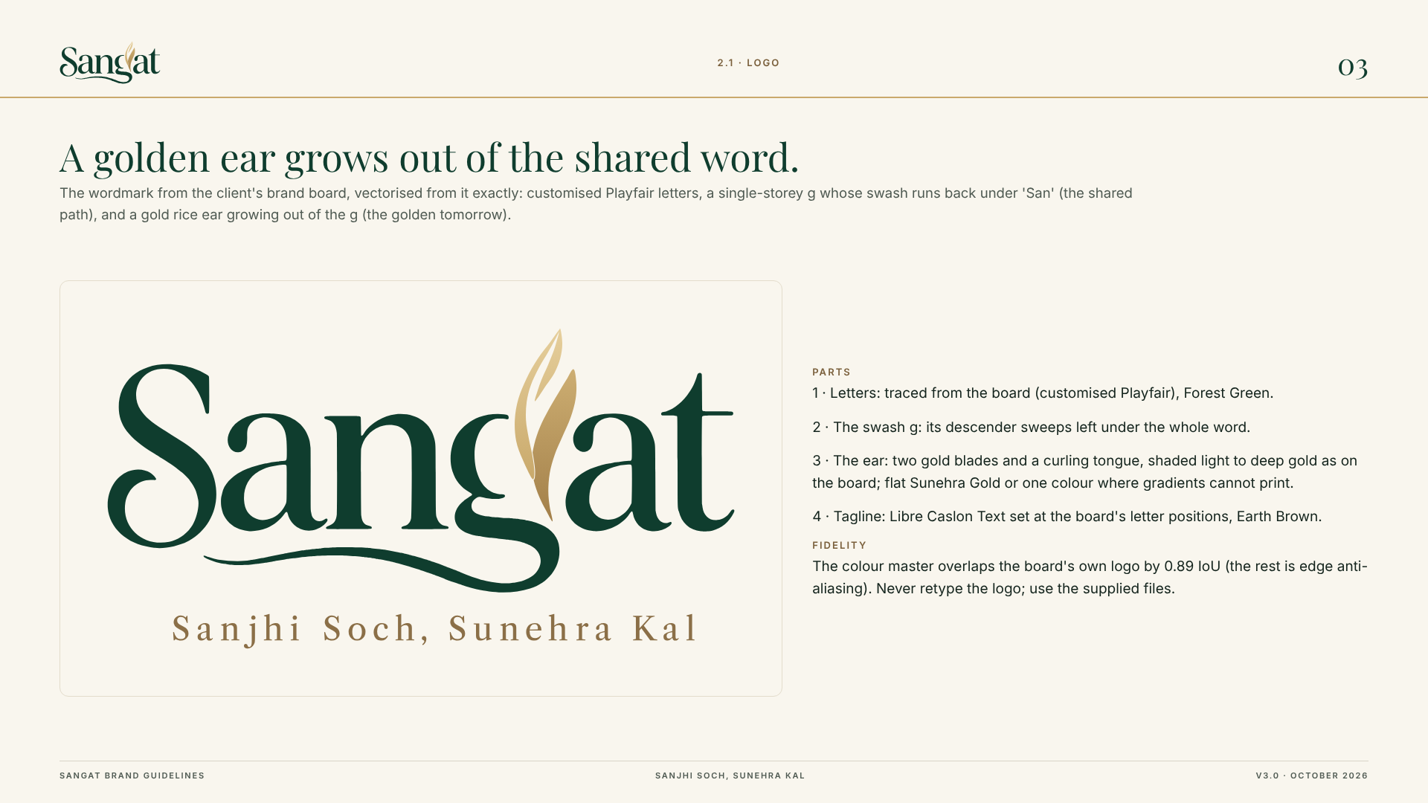

9.1 Visual principles
- Use the primary wordmark with tagline where space allows; use horizontal, stacked and symbol-only variants according to the application.
- Keep forest green as the anchor colour, ivory as the breathing space and gold as a restrained accent.
- Use a considered serif for expressive brand moments and a clean sans-serif for information and utility.
- Keep the rice-ear symbol legible at small sizes and avoid unnecessary decorative elements.
- Maintain consistent spacing, contrast and hierarchy across pack sizes and digital applications.

9.2 Brand assets and governance
This is a customised Playfair-style wordmark and a gold rice-ear detail, with versions for primary, horizontal, stacked, wordmark and symbol use. Final production files should be treated as the source of truth; the logo should not be retyped or recreated from a screenshot.
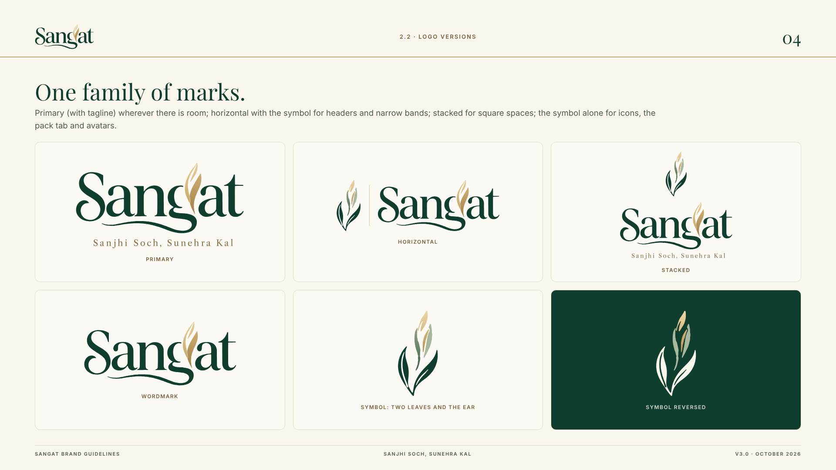

9.3 Cultural sensitivity
The name Sangat has cultural and religious associations in Punjab. The identity direction uses the broader meaning of togetherness and avoids religious iconography. This distinction should be retained in future communication. The tagline should be accompanied by a simple English explanation where audiences may not understand the phrase.

10. Packaging and Consumer Communication

10.1 Packaging concept
The packaging concept translates the identity into a premium rice pouch. The front panel gives prominence to the Sangat wordmark, tagline and product descriptor. A landscape illustration provides a visual link to cultivation, while the lower pack area carries the net quantity. The back panel combines a short brand story, a QR invitation and space for product and statutory information.
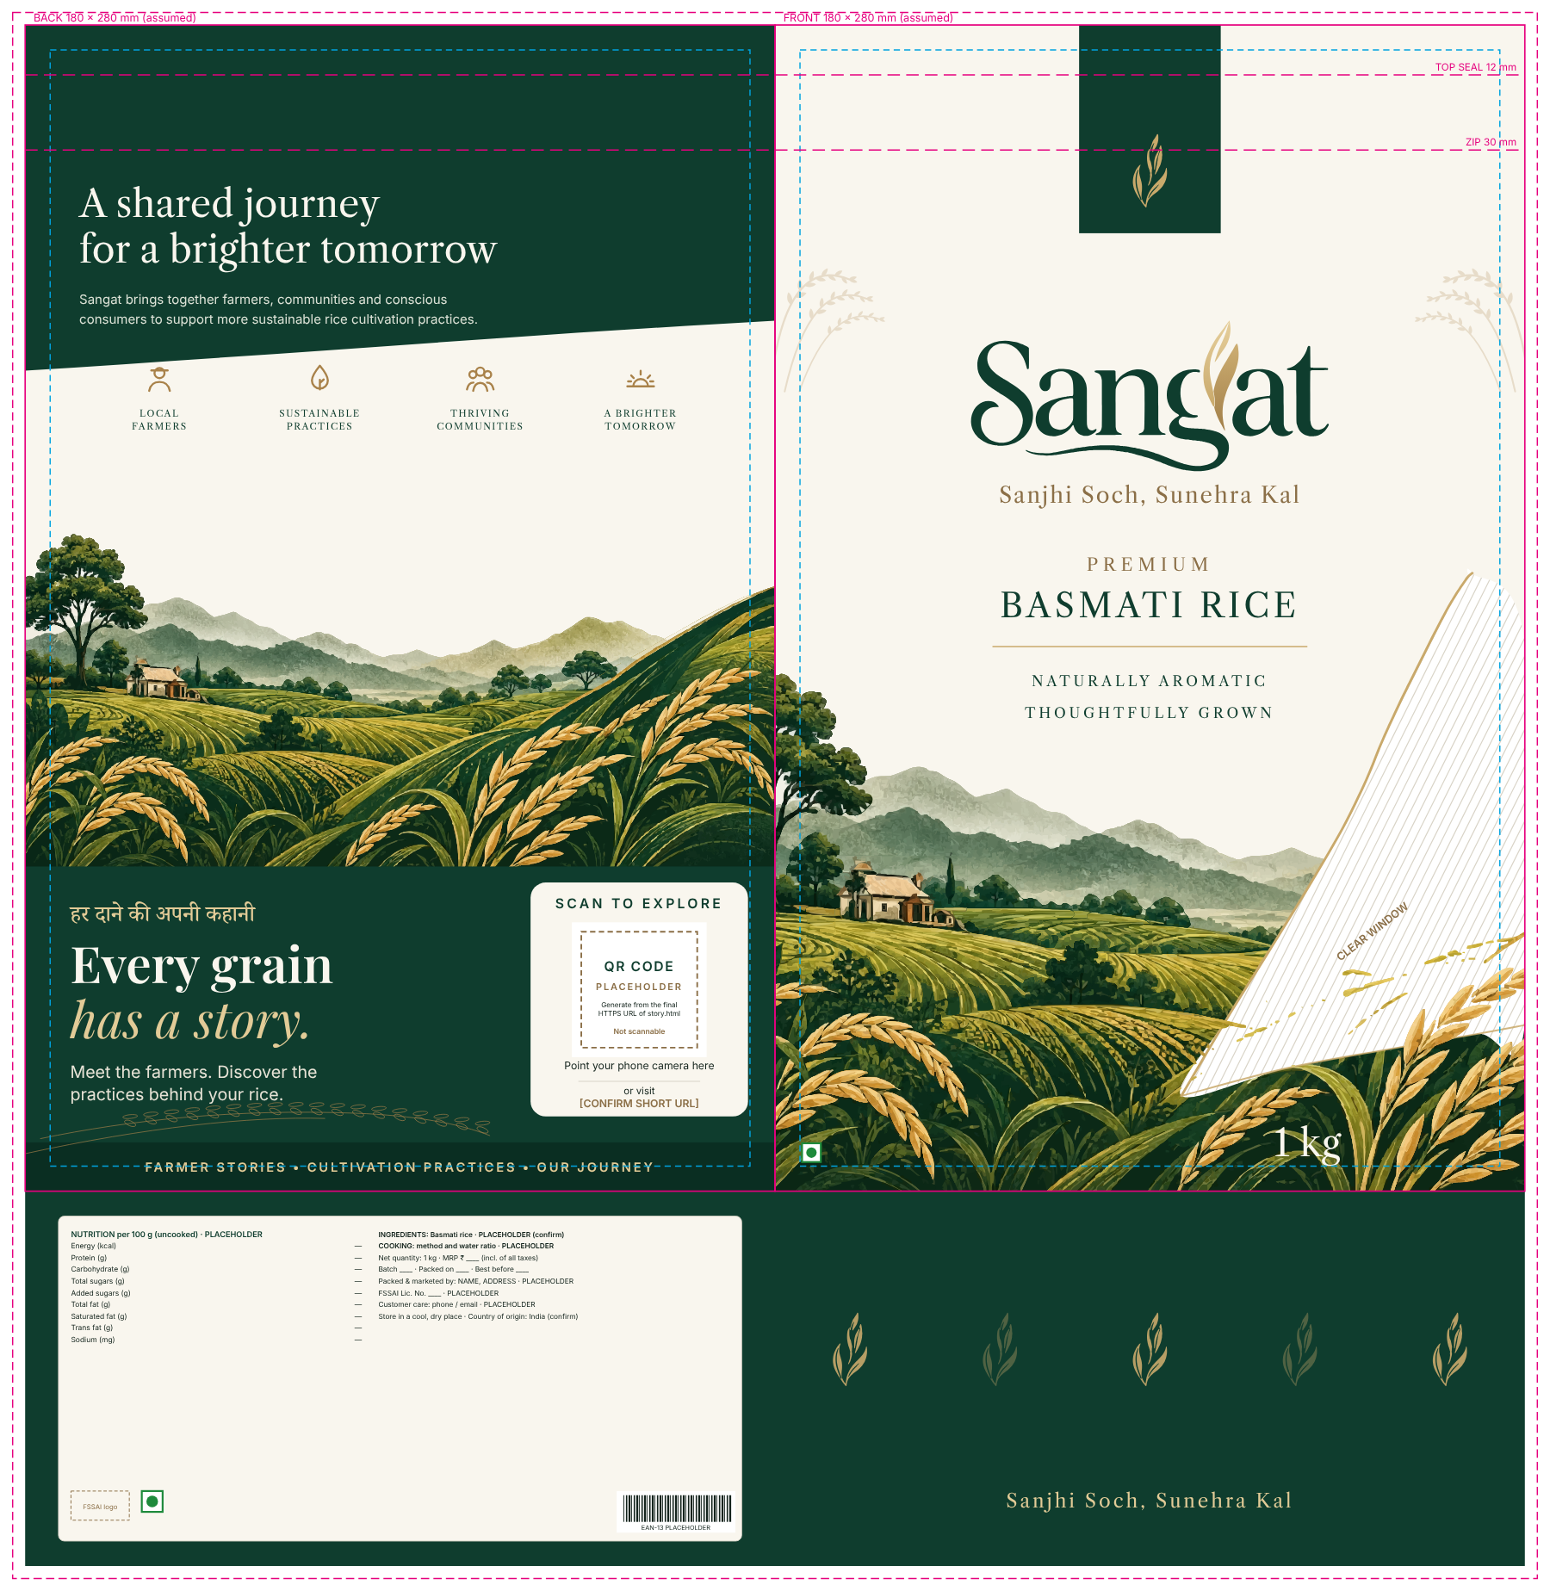

10.2 Pack architecture
The STP recommendation proposes a 1 kg trial pack and a 5 kg family pack. The same information hierarchy should be retained across both formats so that the brand is recognisable even when the pack dimensions change.

10.3 QR storytelling
The QR area is intended to invite consumers to explore farmer stories, cultivation practices and the journey behind the product. It should lead to a mobile-first page that explains what MVS does, which practices are documented and what information is available for the product or batch.
The story must match the sourcing model. A programme-level farmer story does not by itself prove that the named farmer grew the rice in the specific packet. Farm-level traceability should be promised only if the chain-of-custody records support it. The QR code shown in the concept is a placeholder and must be replaced with a tested HTTPS destination before printing.

11. Go-to-Market and Marketing Recommendations

11.1 Product
Before launch, MVS should establish a written specification covering grain length, ageing period, moisture, broken grain and purity limits, along with processing and batch controls. The same specification should be maintained across batches. Cooking guidance should be provided for the intended dishes.

11.2 Price
The price point identifies as approximately ₹180–₹220 per kg based on point-in-time retail listings. These listings vary by platform, city and pack size and must be rechecked before price fixation. The recommendation is to stay within the competitor level and offer the same quality at same price.

11.3 Place
The proposed pilot channels include selected premium grocery and modern trade outlets, e-commerce and quick-commerce listings where operationally feasible, direct ordering through the brand website or messaging, and early sampling through MVS's community networks. General trade may be explored later after the supply and distribution model is better understood.

11.4 Promotion
- Conduct small cooking demonstrations and blind sampling sessions where the rice can be compared on actual dishes.
- Equip selected retailers with a short product explanation, cooking guidance and clear answers to common questions.
- Use recipe-led content to show the product in biryani, pulao and other intended preparations.
- Use the QR story to explain documented practices and MVS's work in accessible language. Go for hoardings, banners and leaflets in popular areas.
- Keep the front-of-pack communication focused on the product; place detailed cultivation information on the back panel and digital story page.

12. Stakeholder Coordination and Operating Model
A consumer-facing brand depends on a chain of participants whose work must connect reliably. The following map is a proposed operating framework based on the project scope.
Stakeholder | Potential responsibility | Coordination requirement
Farmers | Cultivation, field records and participation in agreed practices. | Clear practice guidance, realistic timelines and record-keeping.
Farmer groups / arthyas | Aggregation, quantity coordination and primary records. | Lot identification, volumes, timing and reconciliation.
Processors / millers | Milling, grading, sorting and batch consistency. | Written specifications, sampling and batch acceptance.
Quality lead / laboratory | Testing and release checks. | Documented standards, sampling plan and corrective action.
Packaging vendor | Food-contact packaging, printing and packing. | Approved artwork, dielines, material and quality checks.
Logistics partner | Storage and movement of finished packs. | Handling, inventory visibility and service levels.
Retailers / online channels | Availability, display, customer feedback and sales. | Margin, replenishment, returns and sell-through information.
MVS | Programme coordination, evidence governance and brand oversight. | Clear ownership, claim approvals and grievance escalation.

13. Field Implementation, Validation and Pilot

13.1 What was developed during the project
- A proposed brand name and tagline: Sangat with tagline “Sanjhi Soch, Sunehra Kal”.
- A brand purpose, personality, values, tone of voice and core messages.
- A segmentation, targeting and positioning recommendation for premium household basmati.
- Visual identity and logo-system direction documented in the supplied brand guidelines.
- 1 kg and 5 kg packaging concepts, including a QR storytelling area and back-panel information architecture.

13.2 What remains to be validated
- Product specification, quality consistency and comparative cooking performance.
- Farm, season, sourcing and chain-of-custody records.
- Current SRP status, permitted terminology and artwork permissions.
- Actual customer comprehension, willingness to try, paid trial and repeat behaviour.
- Retailer acceptance, channel economics, landed cost and working-capital needs.
- Packaging compliance and production feasibility.

14. Recommendations to MVS
The recommendations below are sequenced so that MVS can reduce the largest risks before committing to a wider launch.

14.1 Immediate priorities
- Appoint one accountable brand owner and a small cross-functional working group.
- Confirm the product identity and written quality specification before finalising the pack.
- Compile farm, practice, season, aggregation and batch records; map the actual sourcing model.
- Confirm the current SRP status and approved wording with the relevant assurance body before using any label or claim.
- Complete the packaging compliance checklist and replace every placeholder before production.
- Confirm supply volumes, landed cost, fulfilment cost, retailer margin and working-capital requirement.
- Run the proposed directional pilot and record negative as well as positive feedback.
- Build the proto QR story page into deployable website for stories from batch-level traceability.

14.2 Medium-term priorities
- Develop retailer education and sampling materials that explain product quality before sustainability context.
- Track customer complaints, cooking feedback, paid trial and repeat purchase.
- Review the pilot against explicit go / adjust / stop criteria before entering additional markets.
- Explore farmer-facing feedback loops so that commercial learning is shared with participating communities.

15. Conclusion
The Sangat project began with a brand-building brief but developed into a wider question about how an organisation's relationships with farming communities might connect to a market proposition. The work showed that a credible brand cannot be created through visual identity alone. It requires a product that performs, a supply chain that can deliver consistently, records that support the story and a commercial model that works for the people involved.
Sangat provides MVS with a proposed name, verbal identity, visual direction, packaging concepts and a focused STP recommendation. The tagline “Sanjhi Soch, Sunehra Kal” expresses the idea of shared effort and a better tomorrow. The brand's next step is not simply to communicate more loudly, but to validate more carefully.
The most practical way forward is a bounded pilot in Chandigarh, Mohali and Panchkula. MVS can use the pilot to test cooking quality, message comprehension, paid trial, repeat purchase and contribution margin. If the evidence supports the proposition, the organisation can build on the foundation. If it does not, the pilot should guide what needs to change.

