CS 310 Final Project Overview
Nikolai Medvedev, Linh Ly, Peter Ha, Arya Bulusu

We built on Project 3 by adding features to analyze PDFs, including keyword extraction, language detection, and translation. We added these features as lambda functions, and they interact with S3, our database, and our Python client.

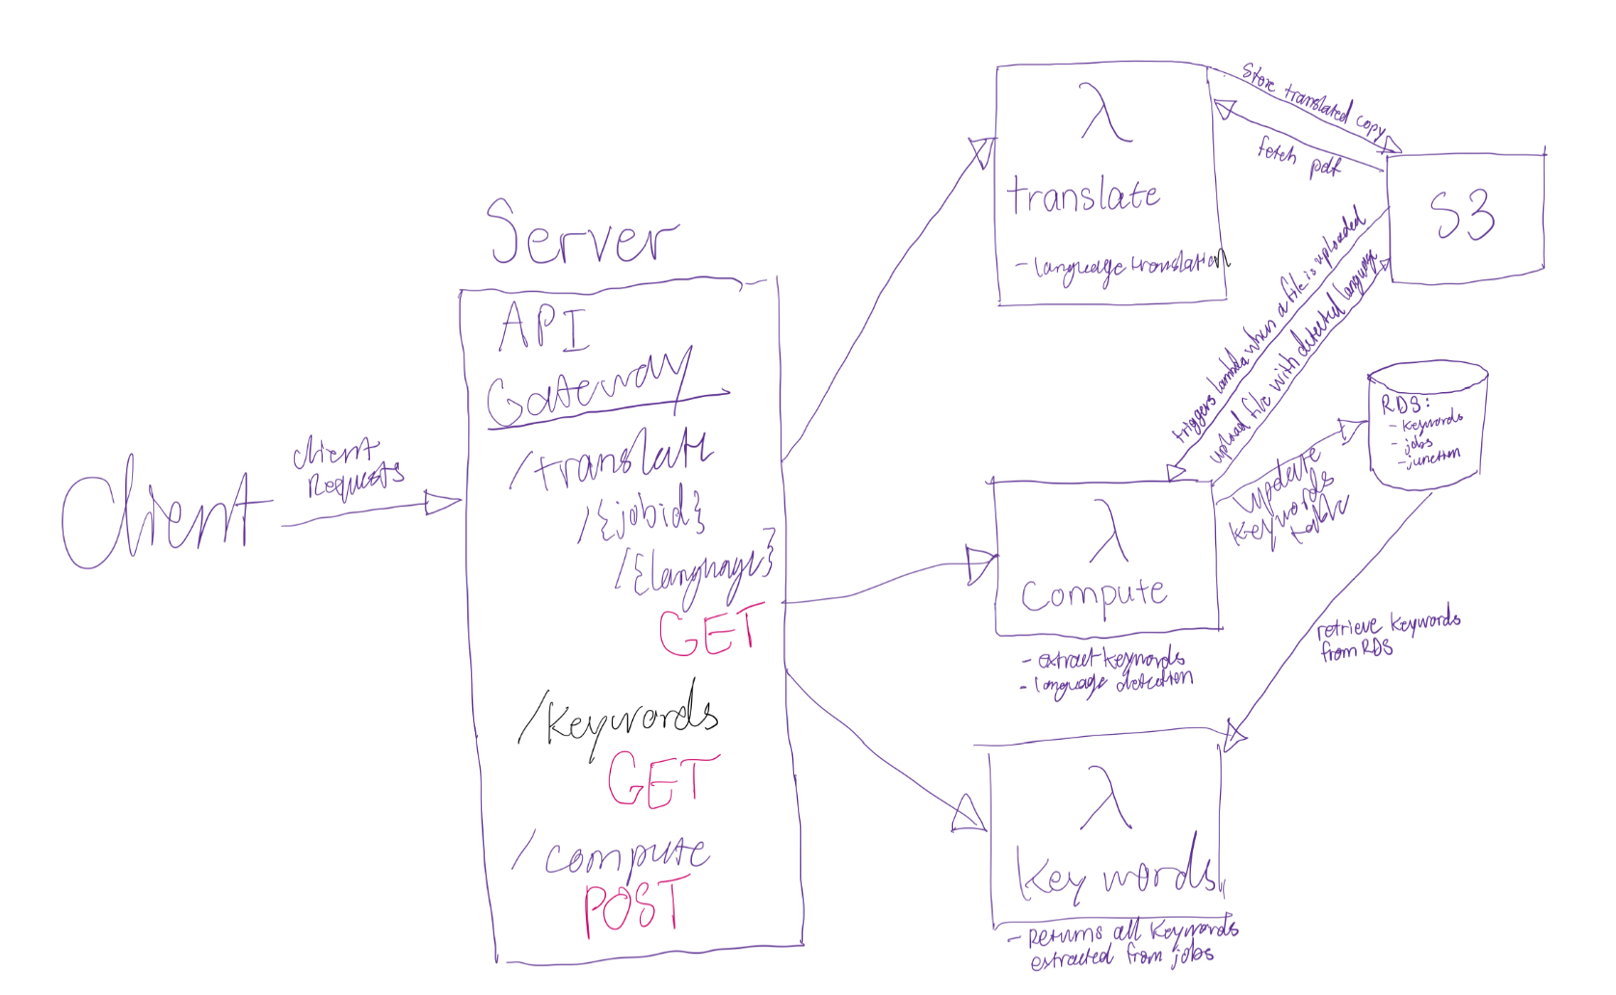

Database-
(Below is the schema for the database)
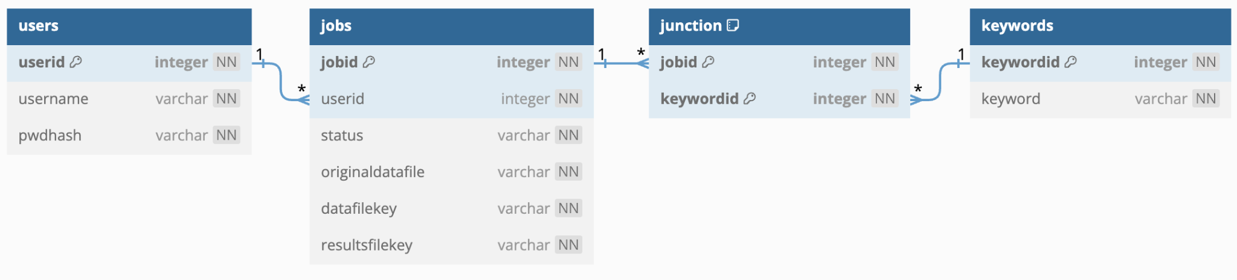
[NN means not null, the key indicates primary keys, the lines represent relationships]

We implemented two extra tables in addition to the users and jobs tables in our database used for project 03. In order to associate keywords and jobs/pdfs, we created two one-to-many relationships, essentially creating a many-to-many relationship between jobs/pdfs and keywords. While we did not implement keyword search, the clear relationships between keywords and PDFs makes it easy to add new features such as keyword search.

Language Detection-
We implemented a lambda function for language detection using the library LangDetect. In the function, we extract the text of the uploaded PDF, determine the language, and upload a txt file containing the language code to S3. This happens automatically when a PDF is uploaded to S3.

Translation
Functionality: The Translation feature is implemented through an AWS Lambda function. This function is triggered on-demand through our Python client. It is designed to take a PDF and a target language code as inputs.
Keyword Extraction
Functionality: The keyword extraction is implemented through an AWS Lambda function. This function is triggered when a file is uploaded to S3. It is designed to take all words except for stop words and calculate the frequency of each word. Then, the top 5 occurring words are saved in the keywords table. If more than one pdf is uploaded, and the same keywords are extracted, they will not be added to the keywords table since only unique keywords can be inserted.
Process:
- Client Request: Users initiate a translation request from the Python client by specifying the PDF file and the target language (e.g., 'es' for Spanish).
- Lambda Function: Upon receiving the request, the Lambda function first decodes the base64-encoded PDF file. It then utilizes AWS Translate to convert the extracted text into the desired language.
- Output Handling: The translated text is returned to the client, where it can be viewed or further processed. It’s also uploaded as a translated copy to S3 for easy download.
This feature is particularly useful for users looking to analyze PDF content in different languages, enhancing the accessibility and usability of the information contained in the documents.

