PARALLEL AND DISTRIBUTED PROGRAMMING

ASSIGNMENT 1

Group 50

Jiahao LU, You WU, Zonghao LU

12 April 2019

## Problem Formulation

The task is to compute in parallel the two-dimensional integral

The exact answer is .

## Solution Method

## Experiments

1. **Testing environment**

Host: vitsippa.it.uu.se

CPU: AMD Opteron (Bulldozer) 6282SE, 2.6 GHz, 16-core, dual socket

OS: Scientific Linux release 6.10 (Carbon)

GCC: gcc (GCC) 4.4.7 20120313 (Red Hat 4.4.7-23)

MPI: mpirun (Open MPI) 1.8.1

1. **Testing method**

Each time is tested 4 times. Except for the first result, the measured time of the rest 3 testing is averaged to get the mean value.

The speedup performance is tested for intervals, running from 1 to 32 processors. The output time is measured by MPI_Wtime() function. Only the parallelised computation time is measured.

The scalability is tested

## Results and Discussion

The tested speedup is shown as follows.

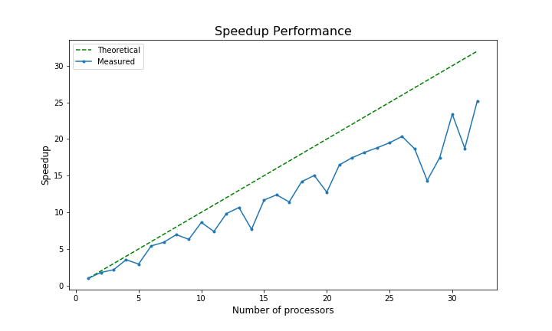

Since only the parallelised computation time is measured, the theoretical speedup should equal to the number of processors.