1.What are the two values of the Boolean data type? How do you write them?

True, False.

x = True

y = False

2. What are the three different types of Boolean operators?

And, or, not

3. Make a list of each Boolean operator's truth tables (i.e. every possible combination of Boolean values for the operator and what it evaluate ).

4. What are the values of the following expressions?

(5 > 4) and (3 == 5): False

not (5 > 4): False

(5 > 4) or (3 == 5): True

not ((5 > 4) or (3 == 5)): False

(True and True) and (True == False) : False

(not False) or (not True) : True

5. What are the six comparison operators?

1. > Greater Than  
2. < less Than  
3. >= Greater than or equal to  
4. <= less than or equal to  
5. != not equal to  
6. == precisely equal to or exactly same

6. How do you tell the difference between the equal to and assignment operators?Describe a condition and when you would use one.

X = 9 : this is assignment operator as it has single equal sign

X==9 : this is equal to or exactly equal to operator, with double equal sign.

7. Identify the three blocks in this code:

spam = 0

if spam == 10:

print('eggs')

if spam > 5:

print('bacon')

else:

print('ham')

print('spam')

print('spam')

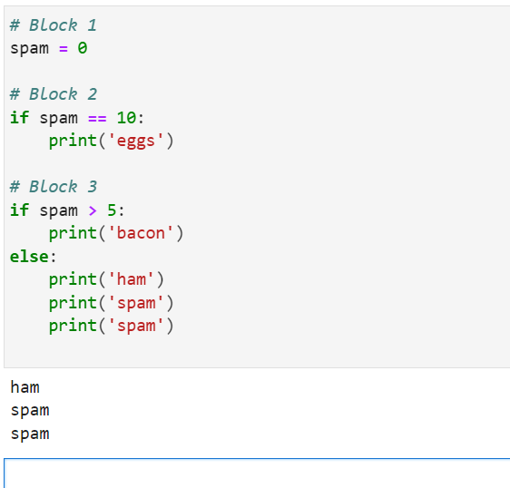

8. Write code that prints Hello if 1 is stored in spam, prints Howdy if 2 is stored in spam, and prints Greetings! if anything else is stored in spam.

spam = input("Enter the value: ")

if spam =="1":

print("Hello")

elif spam =="2":

print("Howdy")

else:

print("Greetings!")

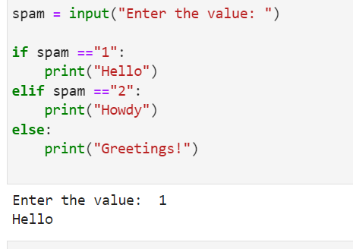

9.If your programme is stuck in an endless loop, what keys you’ll press?

Esc, Ctrl + Break (Windows), Ctrl + C (or Command + C on macOS),

10. How can you tell the difference between break and continue?

#Break:

- Flow control statement  
- Break statement will not execute the loop if condition doesn't meet.  
- it stop the loop then and there.

#Continue

- Flow control statement  
- It will execute the loop when condition meet.  
- skip the current loop or skip statement after "continue" keyword.  
- it doesn't print the met condition.  
- it skips the current loop or it skips all the statement after continue keyword

11. In a for loop, what is the difference between range(10), range(0, 10), and range(0, 10, 1)?

range(10), range(0, 10) the output for these will remain same, the difference is range(10) has not any starting index/value means by default it will count from 0, In range(0, 10) we gave the starting point/value, if we change 0 to 1, then outcome will start from 1.

Output will remain same for range(0, 10, 1) but the difference is 1 represent that when loop runs code will skip one step at every iteration.(every first or next number in this case).

12. Write a short program that prints the numbers 1 to 10 using a for loop. Then write an equivalent program that prints the numbers 1 to 10 using a while loop.

for i in range(1,11):

print(i)

=======================

i = 1

while i <=10:

print(i)

i+=1

13. If you had a function named bacon() inside a module named spam, how would you call it after importing spam?

import spam

spam.bacon()