Reading Actions from a Frozen Language Model
Lightweight action heads on Qwen3-0.6B hidden states as policies for a text-based gridworld
SC4001 Neural Networks and Deep Learning: Group Project Report
Group: Group number
Name | Matriculation number
Name 1 | Matric no.
Name 2 | Matric no.
Name 3 | Matric no.

16 November 2026
Abstract
Agents built on large language models (LLMs) usually choose actions by generating or scoring text. We ask whether a small action head, trained by behaviour cloning on the hidden states of a frozen LLM, is an effective and efficient policy for a text gridworld (BabyAI-Text), and what it gives up compared with language-grounded action selection. On a frozen Qwen3-0.6B we compare the head (P) with generation (B1) and log-probability scoring (B2) on the same model and prompt, and with a symbolic CNN agent (B3) trained on the same demonstrations, over four tasks, three training seeds and four test sets. A head reading layer 12 through learned attention pooling matches B3 on the single-object tasks (success 0.876 vs 0.867), is 2.6 times better on two-object tasks (0.588 vs 0.225), needs far fewer demonstrations, and takes 9–13 ms per decision against 41–155 ms for the zero-shot baselines, which fall below random. It loses nothing on held-out goal objects and 8% under invented object names (B3: 41% and 54%), but more than B3 under clutter. Reading the final layer instead changes nothing with real names and collapses with invented ones (0.003 vs 0.255). A replay-based failure analysis shows that B3's wrong pickups are at chance on two-object tasks, while the head's are near misses and confusions between the two named objects.
Code: the submitted ZIP (instructions for reproducing every result in README.md and Appendix A).

Contents
1 Introduction 1
2 Review of Existing Techniques 1
2.1 Language models as policies over a fixed action set 1
2.2 Frozen representations, pooling and the non-language baseline 1
3 Methods 2
3.1 Environment, tasks and test sets 2
3.2 Conditions 2
3.3 Training and model selection 3
3.4 Evaluation 3
3.5 Failure analysis 3
4 Experiments and Results 4
4.1 Choosing the layer and the pooling (validation) 4
4.2 Main results (RQ1) 4
4.3 Data efficiency and cost 4
4.4 Robustness under distribution shift (RQ3) 5
4.5 Layer and pooling on the test sets (RQ2) 6
4.6 Failure analysis 6
5 Discussion 7
5.1 The hypotheses 7
5.2 What the head trades away 7
5.3 Limitations 7
5.4 Future work 8
6 Conclusion 8
7 AI Use Statement 8
References 9
Appendix A Reproducing the results 10
Appendix B Additional results 10

1 Introduction
Large language models (LLMs) are increasingly used as agents that observe an environment and choose actions over many steps. Most act by generating text, such as a command, and are adapted by fine-tuning the whole model. This is flexible but costly: every decision needs token-by-token decoding, the text may not be a valid action, and adaptation updates billions of parameters. Over a fixed set of actions, prior work offers three ways to turn an LLM into a policy (Carta et al., 2023): generate and map free text to the nearest valid action (Huang et al., 2022); score each action name by its log-probability after the prompt (Ahn et al., 2022; Carta et al., 2023); or attach an action head that maps the LLM's internal representation to a distribution over actions in one forward pass. The first two are language-grounded: they choose through the meaning of the action and object names. A head is not; its outputs mean nothing until demonstrations teach them.
GLAM (Carta et al., 2023) fine-tuned a whole LLM with reinforcement learning in BabyAI-Text and found that a new head on the final layer learned slowly, which the authors attributed to the final layer being specialised for next-word prediction. A cheaper alternative has not been isolated: keep the LLM frozen and train only a small head on its hidden states, choosing which layer to read and how to pool its token vectors, as one would train a classifier on a frozen image backbone. Probing studies, which recover a game's state from a sequence model's intermediate activations (Li et al., 2023), suggest the information may be there.
Main question. Can a lightweight action head trained on the hidden states of a frozen LLM serve as an effective and efficient policy for a text-based gridworld, and what does it trade away compared with language-grounded action selection? We test three hypotheses:
- RQ1, H1. After behaviour cloning, the head (P) matches or exceeds generation (B1) and scoring (B2) on the same frozen LLM with one forward pass per decision, and in distribution is within the 95% interval of a non-language agent (B3) trained on the same demonstrations, so its cost must be justified by robustness.
- RQ2, H2. Intermediate layers outperform the final layer, and learned attention pooling outperforms last-token pooling, most of all when observations contain many distractors.
- RQ3, H3. Under distribution shift the head drops more than scoring when object names are replaced by invented words, but less when the number of distractors grows.
Contributions. (1) A controlled comparison of three ways of reading actions from the same frozen LLM, with the same prompt, demonstrations, seeds and episodes, against a symbolic agent that sees the same information without language pretraining. (2) A sweep of 7 layers × 3 poolings × 2 head depths showing that the pooling decides more than the layer, and that the final layer, equal to layer 12 with real names, collapses under invented ones. (3) A robustness profile under three controlled shifts that reuse the same rooms. (4) A replay-based failure analysis that measures which wrong object an agent picks up against chance, separating near misses from guessing.

2 Review of Existing Techniques

2.1 Language models as policies over a fixed action set
Generate and map. Huang et al. (2022) let a frozen LLM write free-form plan steps and mapped each to the most similar admissible action by sentence-embedding similarity (Reimers and Gurevych, 2019). It needs no training, but every decision is a full decoding pass and the text can be off-task. Scoring. SayCan (Ahn et al., 2022) scores each candidate skill by the LLM's probability of its description, combined with a learned affordance value. GLAM (Carta et al., 2023) scores BabyAI-Text actions the same way and fine-tunes Flan-T5 with PPO; its prompt template, text descriptions and held-out goals are reused here. TWOSOME (Tan et al., 2024) normalises the scores by token length so long action names are not penalised. Learning from demonstrations. LID (Li et al., 2022) initialises a policy from a pretrained language model and fine-tunes it by imitation in BabyAI and VirtualHome, finding that pretraining helps while the input format matters little; LLM4Teach (Zhou et al., 2024) distils an LLM teacher into a small student agent. Benchmarks. BALROG (Paglieri et al., 2025) evaluates zero-shot LLM and VLM agents on games including BabyAI, a reference for how far prompting alone goes. Efficiency. In vision-language-action models, replacing token generation with direct action prediction gives large speed-ups (Kim et al., 2025), a practical motivation for action heads.

2.2 Frozen representations, pooling and the non-language baseline
Training a small classifier on a frozen network is standard transfer learning in vision; for LLMs, probes on intermediate activations recover structured world state (Li et al., 2023), but which layer and which summary of a ~300-token prompt best supports acting has not been compared against language-grounded readouts of the same model. Pooling options range from the last token (the natural input to next-token prediction), to the mean over tokens, to a learned attention query that selects tokens. For the non-language comparison we follow the BabyAI baselines (Chevalier-Boisvert et al., 2019), which condition convolutions on the instruction with FiLM (Perez et al., 2018). All trained agents here use behaviour cloning, whose errors can compound once the agent leaves the expert's states; DAgger (Ross et al., 2011) addresses this by having the expert relabel the agent's own states.
Gap. No study we know of compares, on one frozen model and one prompt, a head across layers and poolings with generation and scoring and with a non-language agent, in both success and cost, and under controlled shifts that separate the use of word meaning from the use of the observation.

3 Methods

3.1 Environment, tasks and test sets
The BabyAI-Text package could not be installed on our setup, so we wrote a text wrapper over Farama MiniGrid (Chevalier-Boisvert et al., 2023) that reproduces BabyAI-Text; tests check its descriptions and prompts against code transcribed from GLAM's repository. Each episode is one 8×8 room (6×6 inside) with 8 distractor objects (keys, balls, boxes in six colours) and a 7×7 egocentric view. The agent has six actions (turn left, turn right, go forward, pick up, drop, toggle). The easy tier has go to <object> and pick up <object> (64-step limit); the hard tier has put <object> next to <object> and pick up <object>, then go to <object> (128 steps), both from GLAM's training mix. Reward on success is 1 − 0.9 t/T. The LLM conditions read GLAM's prompt: the action list, the goal, the text descriptions of the last three observations (object positions in steps relative to the agent) and the two actions between them, about 270–300 tokens. B3 reads the same window symbolically. Seeds are split into train (demonstrations), val (all selection) and test (used once); the three shifted test sets (Table 1) reuse the test seeds, so a drop comes from the shift, not from other rooms.
Table 1. Test sets. All use the test seeds; 500 episodes per task and set.
test set | what changes | what it tests
test | nothing (8 distractors, real names) | in-distribution performance
16 distractors | 16 distractors instead of 8 | clutter: longer prompts, more look-alikes
invented words | colour and object names replaced by invented words (red → dueno, ball → tism) in the goal and the descriptions; B3's grid codes are unchanged | reliance on the meaning of names
held-out goals | one named object is a yellow box, red key or green ball, never named in training (only seen as distractors) | composition of known words

3.2 Conditions
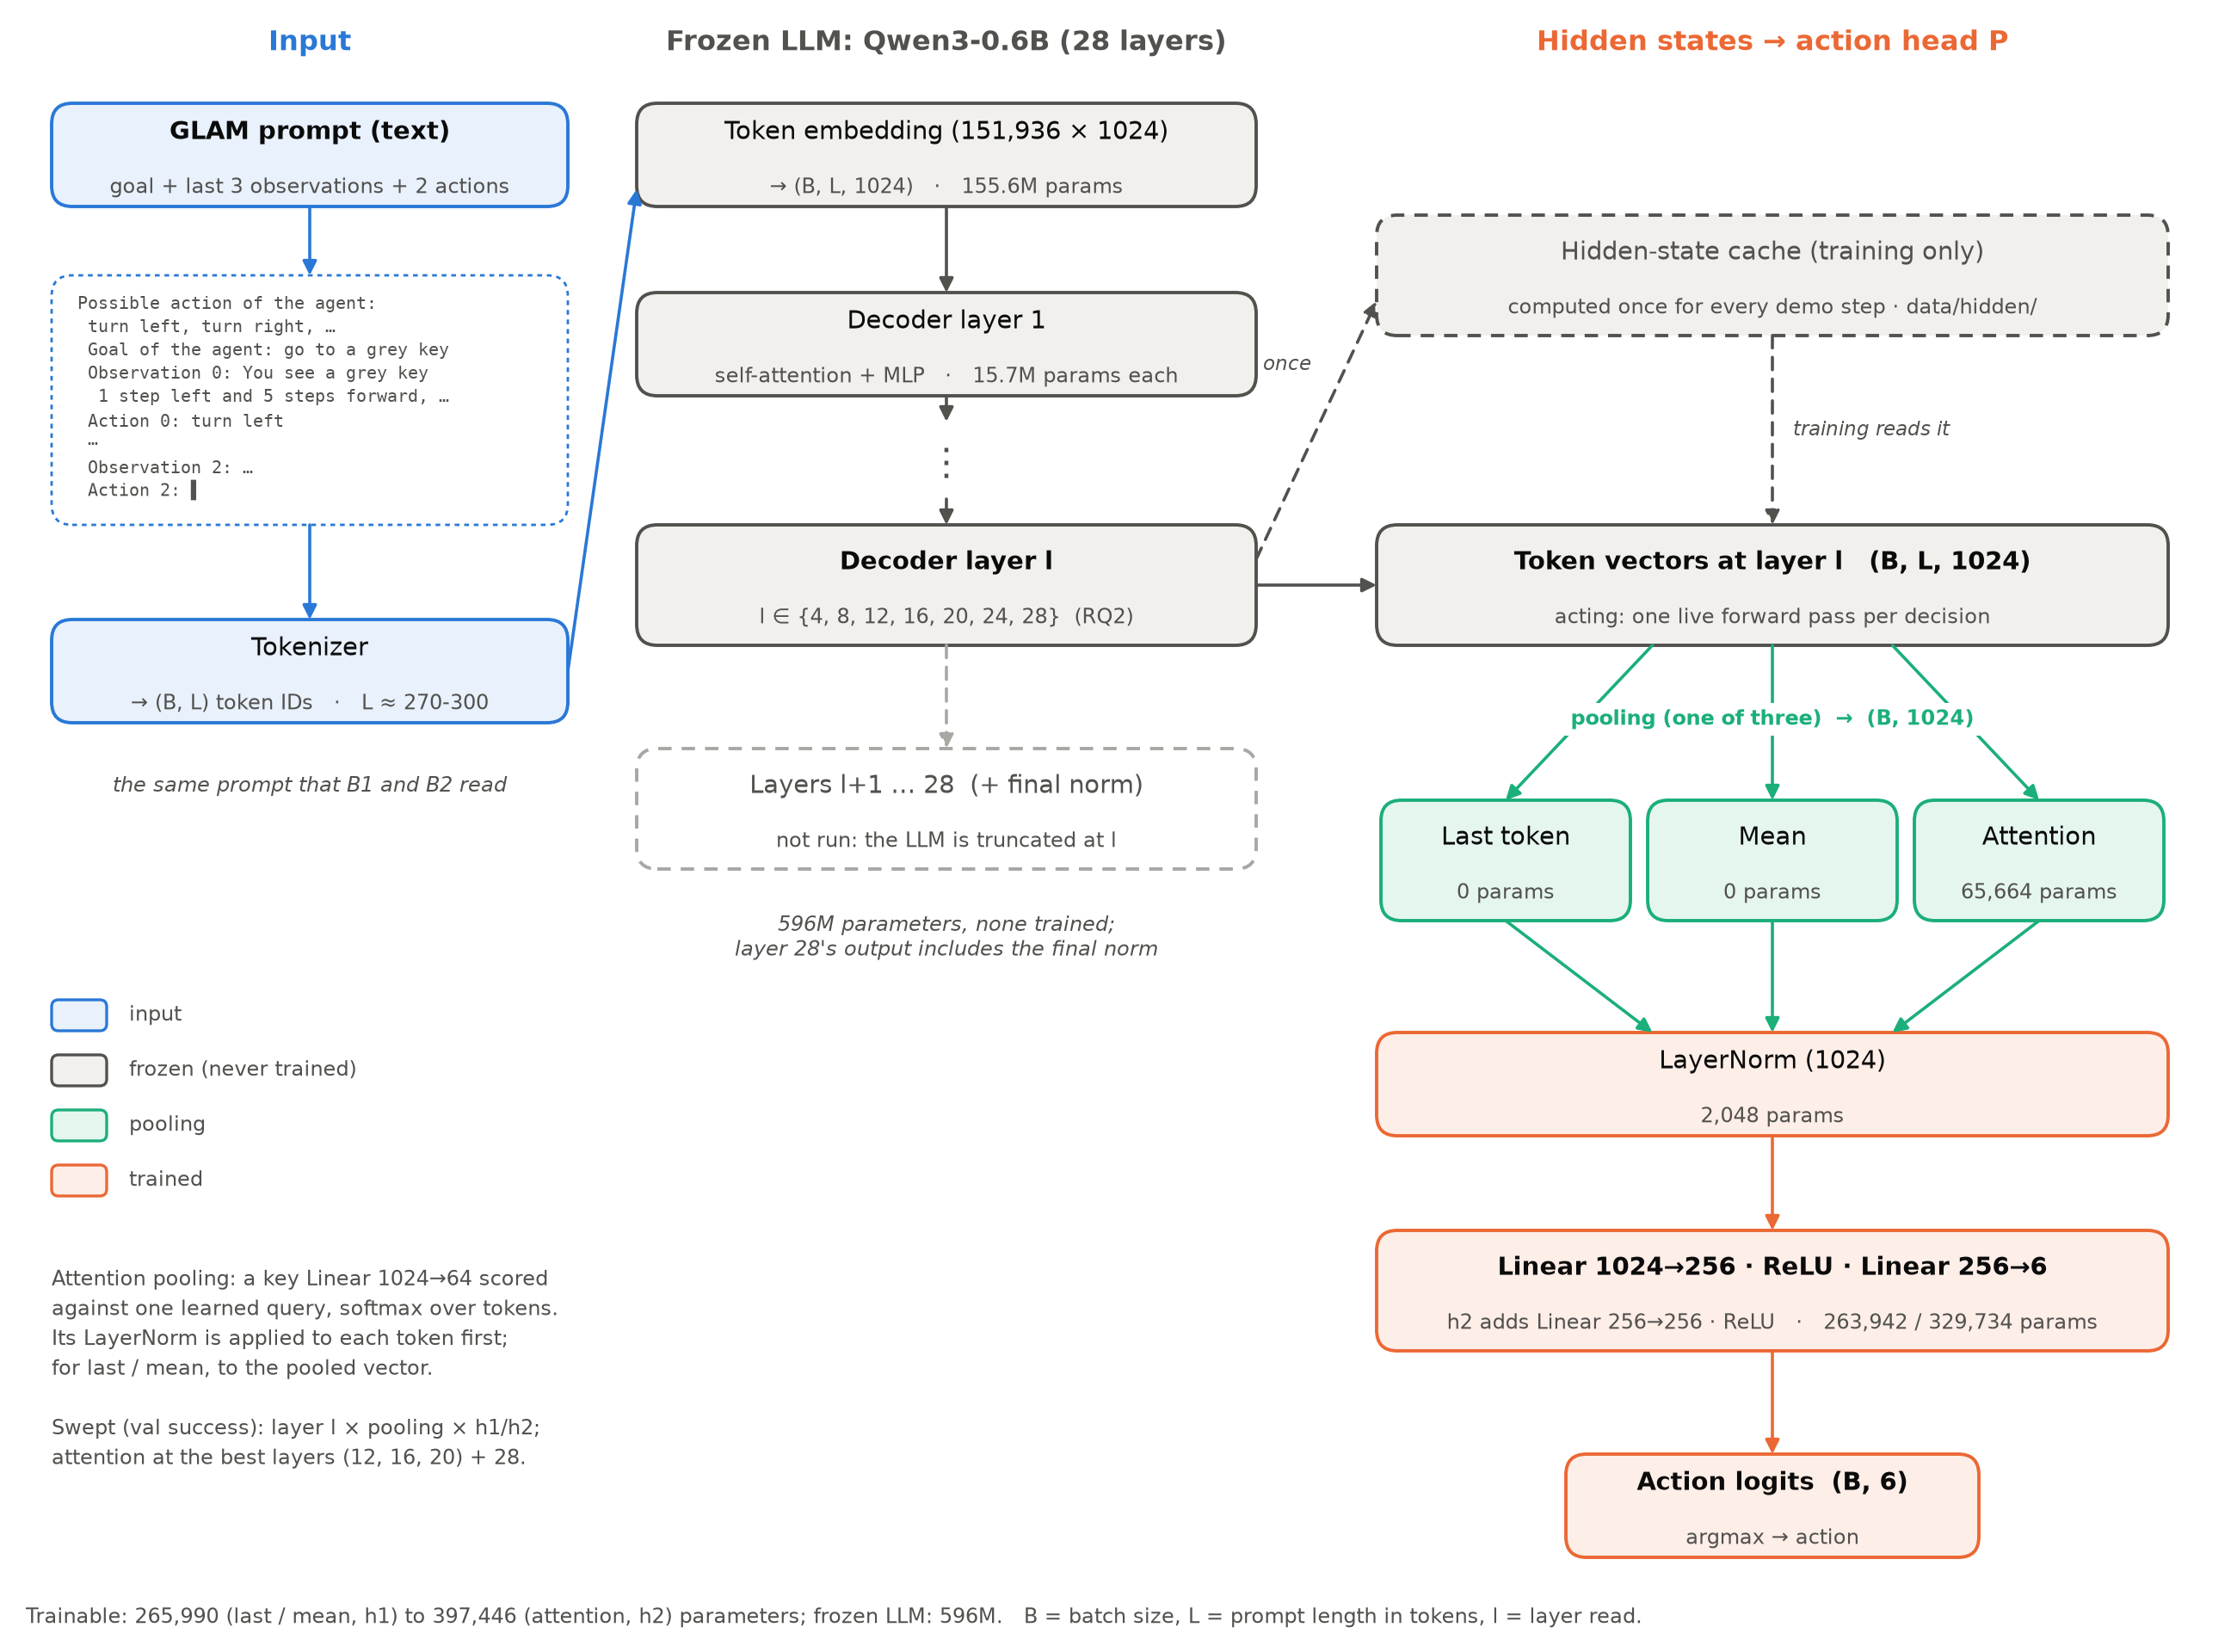
Figure 1. The action head P. The frozen LLM reads the GLAM prompt; the token vectors of layer l are pooled and passed through LayerNorm and a small MLP to six action logits. During training, hidden states come from a cache computed once per demonstration step; when acting, one forward pass stops at layer l.
All LLM conditions share one frozen Qwen3-0.6B (Qwen Team, 2025; 28 layers, width 1024, bfloat16, thinking mode off) and the same prompt. B1 (generate and map) decodes up to 8 tokens greedily; an exact action name is taken, otherwise the action whose name is nearest in all-MiniLM-L6-v2 sentence-embedding space (an invalid output). B2 (scoring) takes the action whose name has the highest mean token log-probability after the prompt (length-normalised, as in TWOSOME); the prompt is run once and its key-value cache shared by the six names. B3 (symbolic) is a frame-stacked CNN on the last three 7×7 symbolic views and the two actions between them: two 3×3 convolutions, each modulated by FiLM from a GRU over the goal's words, then an MLP (583,614 parameters; Appendix Figure A1). Its word vocabulary is fixed, so invented names become an unknown token. P (action head, Figure 1) reads the token vectors of layer l of the frozen LLM, pools them (last token, mean, or attention with one learned query over 64-dimensional keys), applies LayerNorm and an MLP with one or two hidden layers of 256 units, and outputs six logits (266k-397k trainable parameters). When acting, the LLM is run only up to layer l. Random actions give the chance floor.

3.3 Training and model selection
P and B3 are trained by behaviour cloning (cross-entropy on the expert's action) on 2000 expert demonstrations per task from MiniGrid's BabyAI bot, with 200 val demonstrations per task, in one shared training loop: batches of 32 whole episodes, AdamW, gradient clipping at 1, an initial learning rate of 3e-3 (chosen from {1e-3, 3e-3, 1e-2} by val cross-entropy, best for both models), halved after 3 epochs without a lower val cross-entropy, and early stopping after 10 (at most 200 epochs). Because the LLM is frozen, the hidden states of all 78k demonstration steps are computed once (14 min on an RTX 5080): last-token and mean vectors at layers 4, 8, ..., 28, and full token sequences only for the layers used with attention. Each run keeps the epoch with the lowest val cross-entropy and then measures greedy val success once (100 val episodes per task); configurations are compared by that success. The easy-tier sweep has two steps: last-token and mean pooling at all seven layers with one or two hidden layers (28 configurations), then attention pooling at the best layers of that sweep (12, 16 and 20, which tied) and at the final layer 28 as a control. The hard tier is not swept: it trains B3 and the configuration chosen on the easy tier unchanged, plus the final-layer attention head (control for H2) and mean pooling at layer 12. B3 and the chosen head are also trained on 100, 250, 500 and 1000 demonstrations per task. Every configuration is trained with 3 seeds. A DAgger step was planned in case of drift; it was not used, so all results are pure behaviour cloning.

3.4 Evaluation
Each condition is evaluated once on the four test sets, 500 episodes per task and set with the same seeds for every condition; test sets were used for nothing else. The primary metric is success rate. Intervals are 95%: for trained conditions a t-interval over the 3 training seeds (each seed's success averaged over the tier's tasks), for the deterministic zero-shot conditions a Wilson interval over episodes, and for differences between trained conditions a Welch interval. Latency is the policy call alone at batch size 1 on an RTX 5080 with nothing else on the GPU (median per decision). In every visited state the expert is also asked what it would do, without affecting the episode, which gives action confusion matrices on the policy's own states. B1 was run on the hard tier on the in-distribution set only: it succeeded in none of its first 1000 hard episodes, never chose pick up (which both hard tasks need) in 128,000 decisions, and matched B2's outcome in every episode compared, so its shifted-set gaps would have been differences of zeros (and about 16 GPU hours).

3.5 Failure analysis
Every failed episode of B2, B3 and the two attention heads (38,299 episodes) is replayed exactly from its recorded actions and given the first category that applies: wrong object (picked up an object the instruction does not ask for), first step only (hard tier: picked up the right object, then failed), reached, no pickup, stuck (at most 2 cells in the last 16 steps), never saw the goal, or wandered. Categories are computed from the replayed state, so they mean the same for every agent and, under invented words, refer to the real objects. Each wrong pickup is further classed as the other named object (two-object tasks), a look-alike (sharing a colour or type with a named object) or unrelated, and compared with the share a random wrong pickup would have in the same room. Agreement with the expert at each step, for failed against successful episodes, shows whether failures drift.

4 Experiments and Results

4.1 Choosing the layer and the pooling (validation)
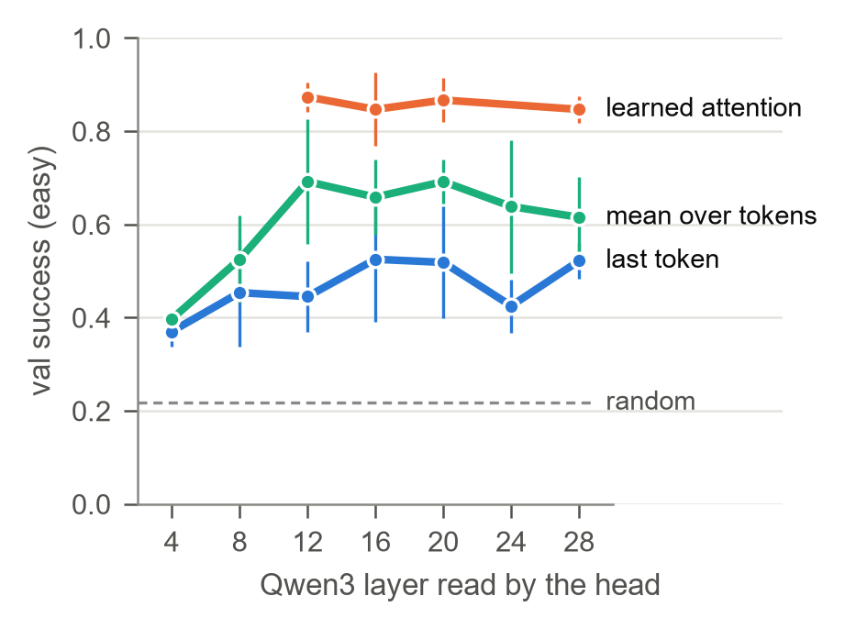 | 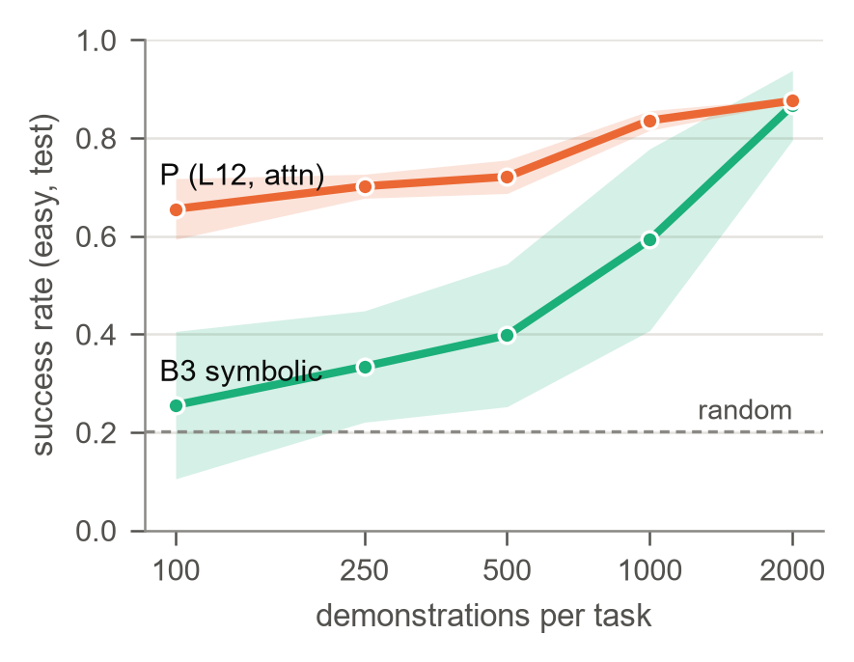
Figure 2. (a) Val success of P by layer and pooling, easy tier, one hidden layer (mean and 95% interval over 3 seeds; selection data, not test). (b) Test success against demonstrations per task, easy tier, B3 against P (layer 12, attention), with 95% bands.
Figure 2a shows that pooling decides more than the layer. Learned attention reaches 0.85–0.87 val success at all four layers where it was trained, against at most 0.695 for mean and 0.525 for last-token pooling. With fixed pooling, the middle layers are best (mean pooling: 0.69 at layers 12–20, 0.62 at layer 28, 0.40 at layer 4); with attention, layers 12–28 are within 0.03 of each other. One hidden layer is as good as two. We chose P = layer 12, attention, one hidden layer (0.873 ± 0.013), the best and also the cheapest of the tied configurations; B3 reached 0.890 ± 0.030 (random: 0.217). On the hard tier's val set, P reached 0.633, the final-layer head 0.637, B3 0.228 and mean pooling at layer 12 only 0.138 (random: 0.047).

4.2 Main results (RQ1)
Table 2. Test success rate (mean over the tier's two tasks) with 95% intervals; best per column in bold. B1 was run on the hard tier on the in-distribution set only (Section 3.4).
tier | condition | test | 16 distractors | invented words | held-out goals
easy | random | 0.202 [0.18, 0.23] | 0.233 [0.21, 0.26] | 0.202 [0.18, 0.23] | 0.218 [0.19, 0.25]
 | B1 generate | 0.062 [0.05, 0.08] | 0.065 [0.05, 0.08] | 0.062 [0.05, 0.08] | 0.063 [0.05, 0.08]
 | B2 score | 0.062 [0.05, 0.08] | 0.065 [0.05, 0.08] | 0.062 [0.05, 0.08] | 0.063 [0.05, 0.08]
 | B3 symbolic | 0.867 [0.80, 0.94] | 0.725 [0.65, 0.80] | 0.399 [0.36, 0.44] | 0.508 [0.44, 0.58]
 | P (L12, attention) | 0.876 [0.87, 0.88] | 0.691 [0.69, 0.70] | 0.808 [0.79, 0.83] | 0.879 [0.85, 0.91]
hard | random | 0.046 [0.04, 0.06] | 0.032 [0.02, 0.05] | 0.046 [0.04, 0.06] | 0.043 [0.03, 0.06]
 | B1 generate | 0.000 [0.00, 0.00] | - | - | -
 | B2 score | 0.000 [0.00, 0.00] | 0.000 [0.00, 0.00] | 0.000 [0.00, 0.00] | 0.000 [0.00, 0.00]
 | B3 symbolic | 0.225 [0.10, 0.35] | 0.157 [0.08, 0.23] | 0.165 [0.08, 0.25] | 0.189 [0.10, 0.28]
 | P (L12, attention) | 0.588 [0.54, 0.64] | 0.319 [0.30, 0.34] | 0.255 [0.20, 0.31] | 0.588 [0.55, 0.63]
 | P (L28, attention) | 0.628 [0.60, 0.65] | 0.322 [0.29, 0.36] | 0.003 [0.00, 0.01] | 0.622 [0.61, 0.64]

P against the zero-shot baselines. P is far above B1 and B2 on every set (0.876 against 0.062 on easy test). Both zero-shot methods are below random on both tiers: they succeed only on go to (0.124, where facing the object suffices) and never pick anything up (B2: no pickups; B1: 10 in 241,396 easy and none in 128,000 hard decisions), so every other task is out of reach. B1 and B2 behave almost identically: same outcome in all 5000 episodes compared and the same action in 99.5% (easy) and 99.9% (hard) of identical states; 2.1–3.7% of B1's outputs are not an action name. P against B3. In distribution on the easy tier the two are tied (difference +0.009 [−0.062, +0.081]), as H1 predicts. On the hard tier P is 2.6 times better (+0.363 [+0.225, +0.500]), and B3's seeds disagree (0.285, 0.196, 0.195). Per task, B3 is better at go to (0.950 vs 0.901) and P at pick up (0.851 vs 0.783), put next to (0.650 vs 0.343) and pick up, then go to (0.526 vs 0.107).

4.3 Data efficiency and cost
Figure 2b shows that P needs far fewer demonstrations: with 100 per task it reaches 0.655 on test, which B3 does not reach with 1000 (0.593); P leads by 0.40 [0.24, 0.56] at 100 demonstrations and the gap closes only at 2000. P's seeds also agree more closely at every count. On cost (Figure 3), P takes 9.2 ms per decision on the easy tier and 12.7 ms on the hard tier (longer prompts), against 41 ms for B2 (one prompt pass plus six scored names), 155 ms for B1 (decoding plus an embedding model) and 1.1 ms for B3, which needs no LLM. Reading layer 28 instead of 12 doubles P's latency (19.8 ms on hard). Training a head took 5.5 min per seed on the easy tier and 43 min on the hard tier, after the one-off 14-minute hidden-state cache; B3 trains in 17–43 s. P has 331,654 trainable parameters, B3 583,614.
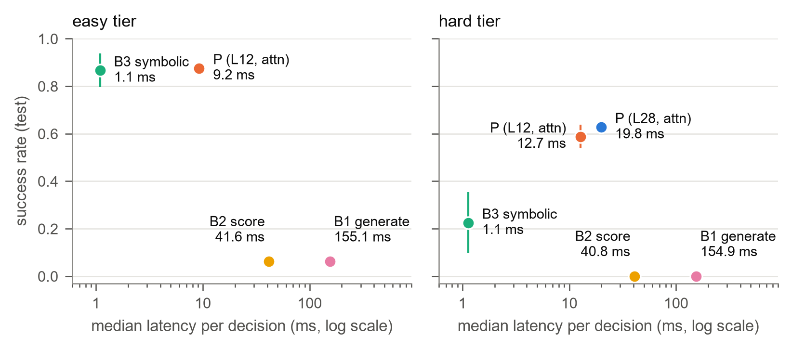
Figure 3. Test success against median latency per decision (log scale), RTX 5080, batch size 1. P is 4.5 times faster than B2 and 17 times faster than B1, and 8–12 times slower than B3.

4.4 Robustness under distribution shift (RQ3)
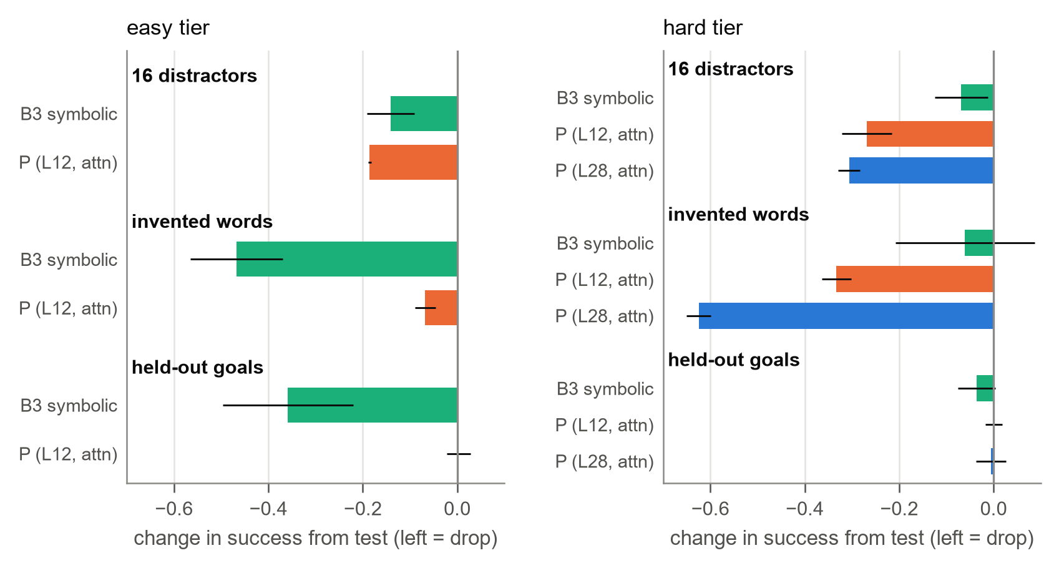
Figure 4. Change in test success from the in-distribution set to each shifted set (mean and 95% interval over 3 seeds). Bars to the left are drops. B1 and B2 (no change; they are below random) are omitted.
Figure 4 separates three kinds of robustness. Held-out goals: P loses nothing on either tier (+0.003 and 0.000), while B3 loses 0.36 (41%) on the easy tier: P composes known words into goals it was never given, B3 does not. Invented words: P loses 8% on the easy tier against 54% for B3. Under this shift the descriptions are renamed consistently with the goal ("dueno tism" in both), so P can still match the goal's words to an object's description, whereas B3 reads the goal through its own word embeddings, for which the invented words are unknown. With two invented names per instruction (hard tier), P (layer 12) loses 57%. Clutter: with 16 distractors P loses at least as much as B3 (easy: −0.185 vs −0.141, difference −0.044 [−0.095, +0.007]; hard: −46% vs −30%): its prompt grows and lists more objects, while B3's 7×7 grid stays the same size. B1 and B2 show no gap because their behaviour never depended on the names: their success is identical on the in-distribution and invented-words sets.

4.5 Layer and pooling on the test sets (RQ2)
Table 3. Test-set differences between heads, with Welch 95% intervals over seeds (bold: the interval excludes zero). The pooling heads at layer 12 were evaluated on two sets only.
comparison | test set | difference [95% interval]
hard tier, attention: layer 28 − layer 12 | test | +0.040 [−0.016, +0.096]
 | 16 distractors | +0.003 [−0.028, +0.034]
 | invented words | −0.252 [−0.305, −0.199]
 | held-out goals | +0.034 [−0.006, +0.074]
easy tier, layer 12: attention − last token | test | +0.482 [+0.418, +0.547]
 | 16 distractors | +0.441 [+0.405, +0.476]
easy tier, layer 12: attention − mean | test | +0.209 [+0.117, +0.300]
 | 16 distractors | +0.315 [+0.256, +0.374]

With real names, the final layer is no better than layer 12 on any set (Table 3), at twice the latency. With invented names it collapses: 0.003 success against 0.255 for layer 12, and in 2,627 of its 2,990 failures it turns on the spot for the last 16 steps (turn left is 75% of its actions). The same head on layer 12 still acts, so the final layer's representation of unfamiliar words is the cause, not the head. Attention pooling beats last-token pooling by 0.48 and mean pooling by 0.21 on the test set, but its advantage does not measurably grow with clutter: over mean pooling it grows by +0.107 [−0.035, +0.249], over last-token pooling it shrinks by −0.042 [−0.115, +0.032]. In relative terms attention loses least under clutter (−21% vs −36% for last token and −44% for mean).

4.6 Failure analysis
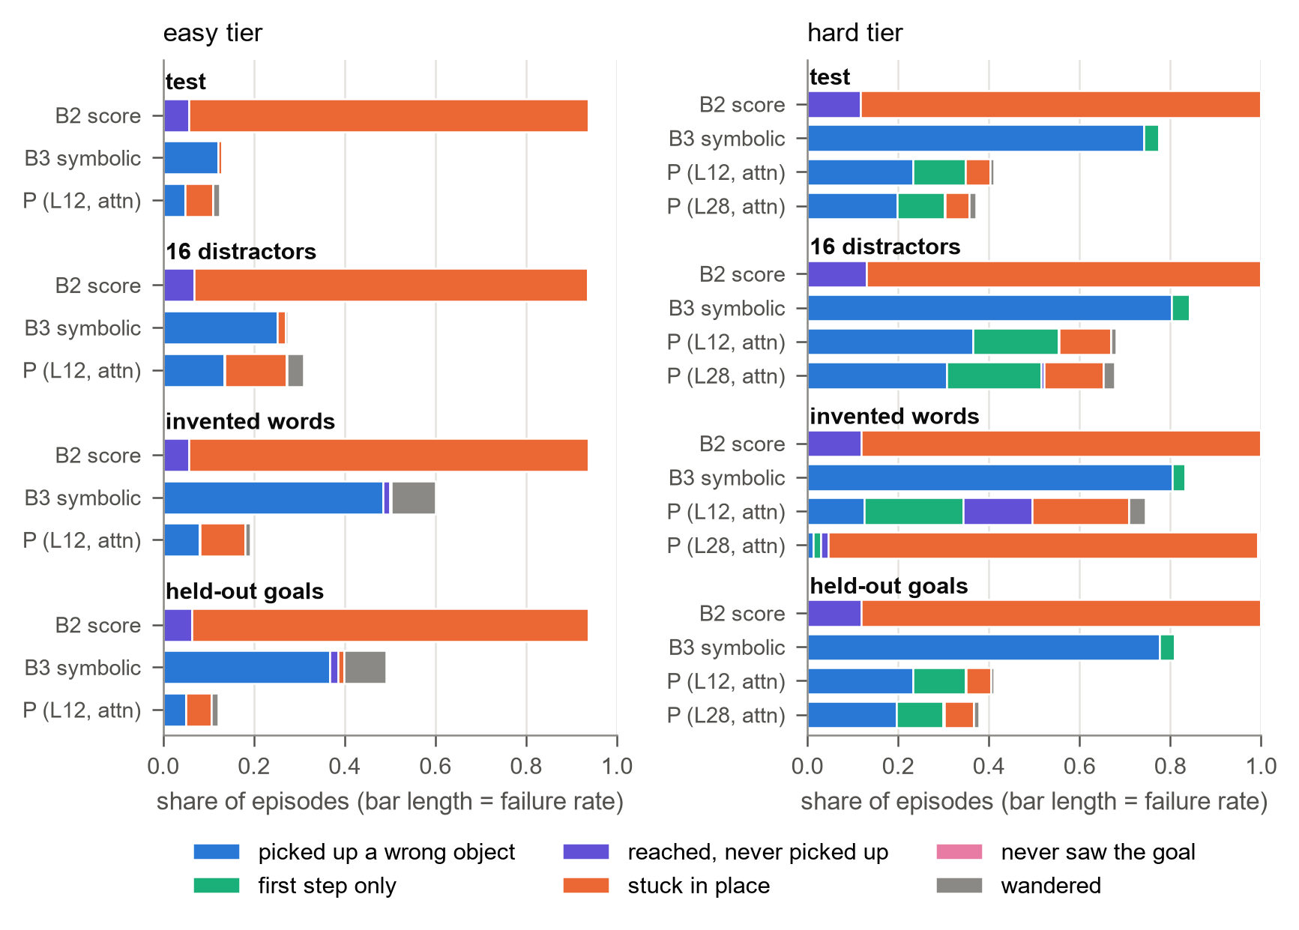
Figure 5. Share of all test episodes failing in each category (bar length = failure rate), per condition and test set. Every failure is a time-out. "Never saw the goal" occurs once in 38,299 failures.
B3 fails by picking up the wrong object (91% of its easy and 96% of its hard failures on test) and almost never gets stuck. P fails in two ways about equally on the easy tier: wrong pickups and getting stuck, almost always by walking into an object or wall (157 of 183 stuck failures); clutter mostly adds stuck failures (0.061 to 0.136 of episodes). On the hard tier, over a quarter of P's failures complete the first step and then fail to place the object or reach the second one; B3 rarely gets that far. B2 is stuck in 88% of episodes, walking into walls and objects. Table 4 shows which wrong object is picked up.
Table 4. What the first wrong pickup was, as a share of wrong-object failures; in brackets, the share a uniformly random wrong pickup would have in the same rooms.
tier, test set | condition | other named object | look-alike | unrelated
easy, test | B3 | - | 0.80 (0.44) | 0.20 (0.56)
 | P | - | 0.84 (0.45) | 0.16 (0.55)
easy, invented words | B3 | - | 0.38 (0.41) | 0.62 (0.59)
 | P | - | 0.83 (0.44) | 0.17 (0.56)
hard, test | B3 | 0.20 (0.16) | 0.57 (0.56) | 0.23 (0.28)
 | P | 0.39 (0.16) | 0.53 (0.58) | 0.07 (0.26)

On the easy tier, both agents' wrong pickups are near misses: look-alikes at almost twice the chance rate, with one attribute right. With invented words B3's wrong pickups fall to chance, while P's remain near misses, the failure-level counterpart of the gaps in Section 4.4. On the hard tier, P's characteristic error is confusing the two named objects (in put next to, picking up the target instead of the object to move) at 2.4 times chance, whereas B3's wrong pickups are at chance in every column, consistent with it not parsing two-object instructions at all. Errors arrive early: failed episodes agree with the expert in 0.79 (P) and 0.69 (B3) of first decisions but about 0.3 by step 4, against more than 0.8 for successful episodes, and 73% (P) and 83% (B3) of failures leave the expert's choice within their first 4 steps (Appendix Figure A3). These are compounding errors of the kind DAgger targets. In the agents' own states, both rarely confuse go forward (0.83–0.87 agreement), but often go forward when the expert would turn, and B3 picks up when the expert would pick up in only 9% of such hard-tier states (P: 43%; Appendix Figure A2).

5 Discussion

5.1 The hypotheses
Table 5. The hypotheses against the test results.
hypothesis | verdict | evidence
H1: P matches or exceeds B1/B2 with one pass; within B3's interval in distribution | supported; exceeds B3 on the hard tier | 0.876 vs 0.062 (easy), 0.588 vs 0 (hard); 9–13 ms vs 41/155 ms; P − B3: +0.009 (easy), +0.363 (hard)
H2a: intermediate layers beat the final layer | not with real names; strongly under invented names | L28 − L12 between +0.003 and +0.040 (n.s.); −0.252 under invented words; val: only with mean pooling
H2b: attention beats last token, most with many distractors | first part only | +0.48 on test, +0.44 with 16 distractors; gain does not grow (−0.04 [−0.12, +0.03])
H3: P drops more than B2 under invented words, less under clutter | not testable against B2; the reverse against B3 | B2 is below random with no gap; vs B3, P drops less under invented words (−8% vs −54%), more under clutter (−21% vs −16%, n.s.)

5.2 What the head trades away
The head was expected to trade the robustness of word meaning for speed. The results suggest a different picture. The language-grounded baselines on this 0.6B model do not use word meaning to act at all: they never pick anything up, and their success is unchanged when every name is replaced. What P exploits is not the meaning of names but the LLM's ability to relate words within the prompt: the goal and the descriptions share the same (possibly invented) words, and P's attention pooling can read off where the goal object is. This explains both its strength under invented and held-out names and its weakness under clutter, where the prompt is longer and lists more competing objects. B3, in contrast, must learn a fixed word-to-object mapping from demonstrations, which fails for unseen words and, apparently, for goals seen only as distractors (its failures face the held-out goal less often: 30% against 54%, though no experiment isolates this). What P gives up is therefore mostly cost and dependence on the prompt format: an LLM pass per decision (8–12 times B3's latency), sensitivity to prompt length, and, at the final layer, fragility to unfamiliar tokens. GLAM's explanation for slow final-layer heads is partly supported: a frozen final layer works as well as layer 12 in distribution, but its representation of unfamiliar words no longer supports the learned mapping.

5.3 Limitations
- One small model and one prompt. B1 and B2 may act far better with a larger LLM, few-shot examples, or the thinking mode; our zero-shot results describe Qwen3-0.6B with GLAM's prompt only.
- Three seeds. Intervals on the easy tier are about ±0.07 for B3, so small differences (P vs B3 in distribution, layers under attention pooling) can be neither shown nor ruled out.
- Untuned hard tier and partial controls. The configuration was chosen on the easy tier and carried over unchanged; the layer-28 collapse was measured on the hard tier only, and the pooling heads on two test sets.
- Pure behaviour cloning. Failures start with early mistakes that compound; DAgger was planned but not run, so all trained agents may be below what relabelling would give.
- Rule-based failure categories. They are ordered heuristics on the replayed state (e.g. "stuck" = at most 2 cells in 16 steps), not causes.

5.4 Future work
Natural next steps are DAgger relabelling for both trained agents, which targets the early compounding errors found here; probing the final layer on invented words to locate the collapse; evaluating the final-layer and pooling heads on every tier and set; and repeating the comparison with a larger LLM, where language-grounded action selection may become competitive.

6 Conclusion
A small head on a frozen 0.6B-parameter LLM is an effective and efficient policy for BabyAI-Text. With 0.33M trained parameters and one truncated forward pass per decision, it matches a symbolic agent trained on the same demonstrations on single-object tasks, is 2.6 times better on two-object tasks, reaches with 100 demonstrations per task a success the symbolic agent does not reach with 1000, and is 4.5–17 times faster than acting through the same LLM's language, which fails here. Which tokens the head attends to matters far more than which layer it reads, but the final layer fails under invented words where layer 12 does not. Against expectation, the head is more robust than the symbolic agent to new names and new goals, because it can match words within the prompt, and less robust to clutter, which lengthens that prompt.

7 AI Use Statement
We used Claude (Anthropic), through Claude Code with Claude Opus models, throughout the project: to brainstorm project directions and search for and summarise related work; to draft the project proposal and this report; to write, test and debug code (the text environment wrapper, the models, the training and evaluation pipelines, the failure analysis and the figure scripts); and to run and summarise analyses of our logged results. We checked its output by running the code's test suite (140 tests, including checks of our environment against GLAM's code), by inspecting the generated figures and episode replays, by tracing every number in this report to the logged evaluation and training outputs, and by checking each reference against the original source. The team chose the research question and hypotheses, made the design decisions recorded in our decision log (for example returning to the submitted question, adding the hard tier, keeping to behaviour cloning, and running B1 on the hard tier on the in-distribution set only), ran all training and evaluation on our own GPU, and reviewed and edited the code and the text. We remain responsible for all submitted work.

References
Ahn, M., et al. (2022). Do As I Can, Not As I Say: Grounding Language in Robotic Affordances. arXiv:2204.01691.
Carta, T., Romac, C., Wolf, T., Lamprier, S., Sigaud, O., & Oudeyer, P.-Y. (2023). Grounding Large Language Models in Interactive Environments with Online Reinforcement Learning. ICML 2023.
Chevalier-Boisvert, M., et al. (2019). BabyAI: A Platform to Study the Sample Efficiency of Grounded Language Learning. ICLR 2019.
Chevalier-Boisvert, M., et al. (2023). Minigrid & Miniworld: Modular & Customizable Reinforcement Learning Environments for Goal-Oriented Tasks. NeurIPS 2023 Datasets and Benchmarks Track.
Huang, W., Abbeel, P., Pathak, D., & Mordatch, I. (2022). Language Models as Zero-Shot Planners: Extracting Actionable Knowledge for Embodied Agents. ICML 2022.
Kim, M. J., Finn, C., & Liang, P. (2025). Fine-Tuning Vision-Language-Action Models: Optimizing Speed and Success. RSS 2025.
Li, K., Hopkins, A. K., Bau, D., Viégas, F., Pfister, H., & Wattenberg, M. (2023). Emergent World Representations: Exploring a Sequence Model Trained on a Synthetic Task. ICLR 2023.
Li, S., et al. (2022). Pre-Trained Language Models for Interactive Decision-Making. NeurIPS 2022.
Paglieri, D., et al. (2025). BALROG: Benchmarking Agentic LLM and VLM Reasoning on Games. ICLR 2025.
Perez, E., Strub, F., de Vries, H., Dumoulin, V., & Courville, A. (2018). FiLM: Visual Reasoning with a General Conditioning Layer. AAAI 2018.
Qwen Team (2025). Qwen3 Technical Report. arXiv:2505.09388.
Reimers, N., & Gurevych, I. (2019). Sentence-BERT: Sentence Embeddings using Siamese BERT-Networks. EMNLP 2019.
Ross, S., Gordon, G., & Bagnell, D. (2011). A Reduction of Imitation Learning and Structured Prediction to No-Regret Online Learning. AISTATS 2011.
Tan, W., Zhang, W., Liu, S., Zheng, L., Wang, X., & An, B. (2024). True Knowledge Comes from Practice: Aligning LLMs with Embodied Environments via Reinforcement Learning. ICLR 2024.
Zhou, Z., Hu, B., Zhao, C., Zhang, P., & Liu, B. (2024). Large Language Model as a Policy Teacher for Training Reinforcement Learning Agents. IJCAI 2024.
Reused code and models: GLAM's text description format and prompt template (github.com/flowersteam/Grounding_LLMs_with_online_RL); Farama MiniGrid's environment dynamics, BabyAI levels and expert bot; the pretrained Qwen3-0.6B and all-MiniLM-L6-v2 models from Hugging Face. Everything else (text wrapper, test sets, models P and B3, training, evaluation and analysis code) is our own.

Appendix A Reproducing the results
The submitted code has a README in every section (environment, models, training, evaluation, analysis) describing its design, public interface and limitations; every setting is in one file, config.py, and every dataset, cache, run and evaluation cell records the settings, command line and git commit that produced it.
Dependencies. Python 3.11; PyTorch with CUDA, Hugging Face Transformers, Farama MiniGrid, matplotlib. Install with conda (conda env create -f environment.yml; conda activate neurons; pip install -e ".[models]"), uv (uv sync --extra dev --extra models) or pip (pip install -r requirements.txt; pip install -e ".[models]"). Tests: python -m pytest (140 tests, about 2 minutes, no download).
Data preparation.
- python -m training.tools.collect_demos: expert demonstrations, 2000 train + 200 val episodes per task (about 40 s).
- python -m training.tools.cache_hidden: the frozen LLM's hidden states for every demonstration step (about 14 min on an RTX 5080; token sequences for attention pooling are cached by the run plan).
Training and evaluation.
- python -m training.run_plan: every training run (the sweep, the hard tier, the demonstration-count curves; --dry-run lists the commands, --summary ranks the runs by val success).
- python -m evaluation.evaluate --models random B3 P-L12-attn-h1 B2 B1 --tiers easy, then the hard tier and the control runs listed in evaluation/README.md (resumable; about 2 days on one GPU in total).
- python -m evaluation.summarise: all result tables (outputs/results/evaluation.md).
- python -m analysis.failures and python -m analysis.figures: the failure analysis and every result figure in this report (report/figures/).
All validation and test results are also collected in report/val_results.md and report/test_results.md.

Appendix B Additional results
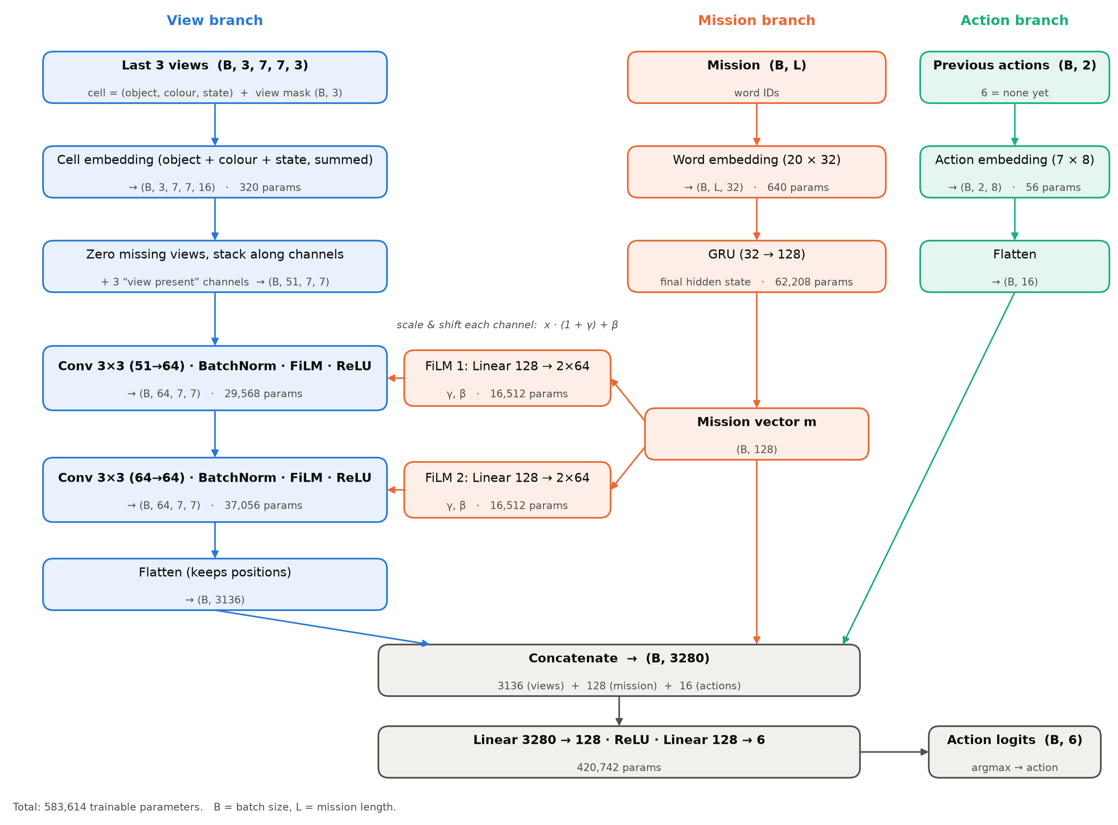
Figure A1. B3, the symbolic agent: the last three 7×7 views (frame-stacked), a GRU over the goal's words conditioning two convolutions through FiLM, and the two previous actions, concatenated into an MLP. 583,614 trainable parameters.
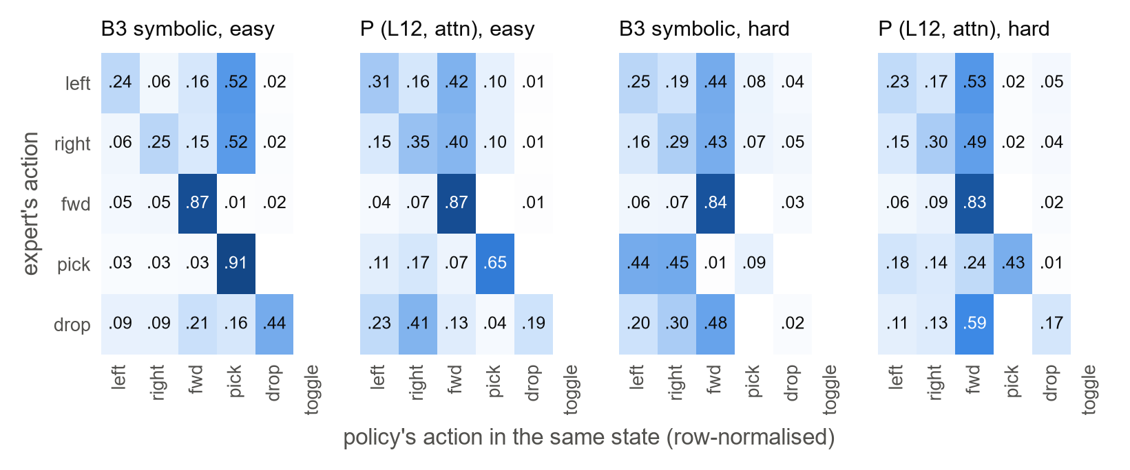
Figure A2. Action confusion on the in-distribution test set: for each action the expert would take in the policy's own state (rows), the share of the policy's actions (columns).
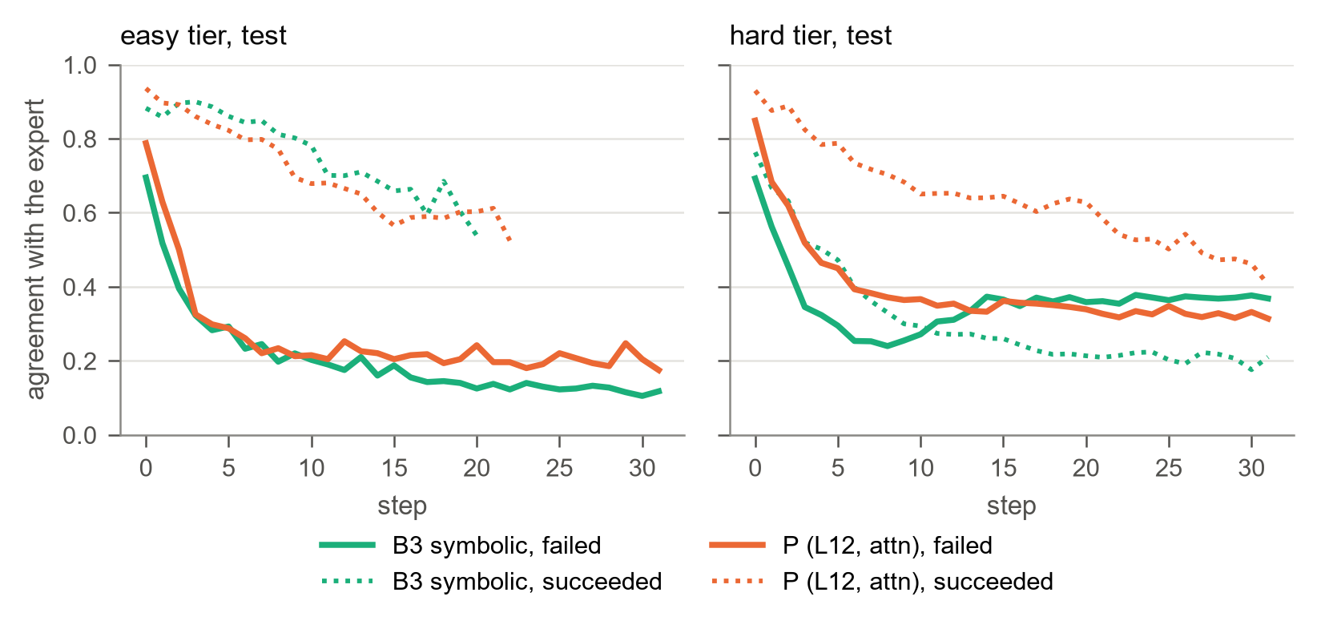
Figure A3. Agreement with the expert at each step on the in-distribution test set, for failed (solid) and successful (dotted) episodes. Steps resting on fewer than 50 decisions are not shown.
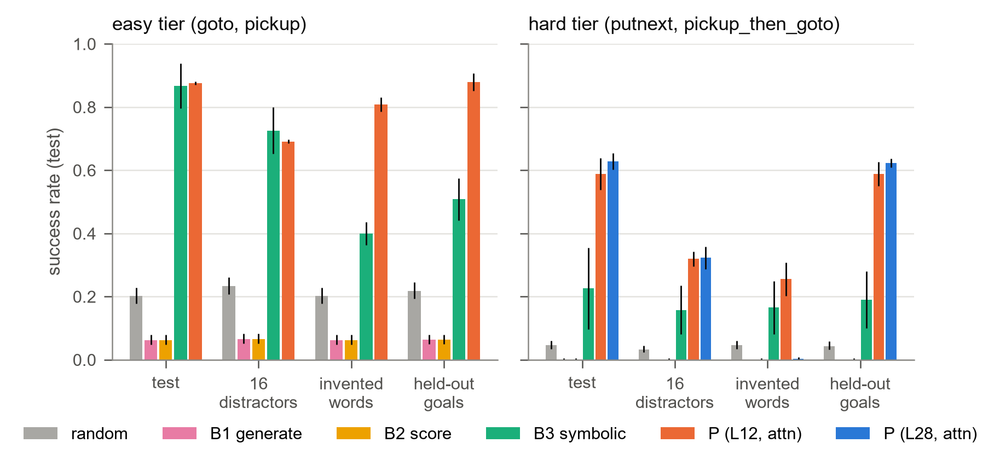
Figure A4. Test success per condition and test set with 95% intervals (the data of Table 2).
Table A1. Test success per task (mean over 3 seeds). B1 and B2 succeed only on go to (0.124–0.130).
condition | task | test | 16 distractors | invented words | held-out goals
B3 | go to | 0.950 | 0.863 | 0.632 | 0.680
B3 | pick up | 0.783 | 0.587 | 0.167 | 0.336
P (L12) | go to | 0.901 | 0.740 | 0.852 | 0.894
P (L12) | pick up | 0.851 | 0.641 | 0.764 | 0.864
B3 | put next to | 0.343 | 0.247 | 0.245 | 0.285
B3 | pick up, then go to | 0.107 | 0.067 | 0.085 | 0.094
P (L12) | put next to | 0.650 | 0.338 | 0.229 | 0.632
P (L12) | pick up, then go to | 0.526 | 0.301 | 0.281 | 0.545
P (L28) | put next to | 0.669 | 0.347 | 0.002 | 0.650
P (L28) | pick up, then go to | 0.587 | 0.298 | 0.005 | 0.595

Table A2. Val success of P by layer and pooling, easy tier, one hidden layer (mean of 3 seeds). B3: 0.890; random: 0.217.
pooling | layer 4 | 8 | 12 | 16 | 20 | 24 | 28
last token | 0.370 | 0.453 | 0.445 | 0.525 | 0.518 | 0.425 | 0.522
mean | 0.397 | 0.525 | 0.692 | 0.658 | 0.692 | 0.638 | 0.615
attention | - | - | 0.873 | 0.847 | 0.867 | - | 0.847

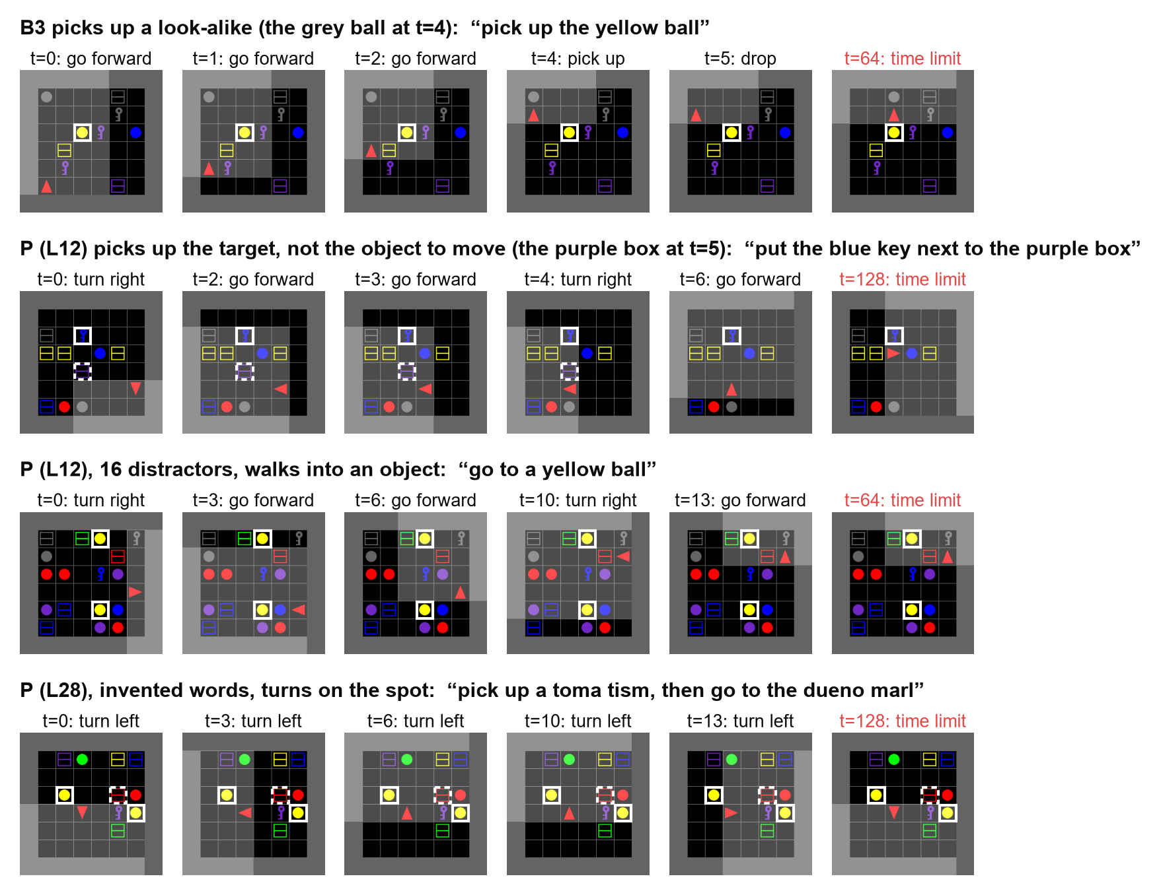
Figure A5. Four failed test episodes (room view; goal objects outlined, solid for the first named object, dashed for the second). Rows: B3 picks up a look-alike; P picks up the target instead of the object to move; P walks into an object in a cluttered room; P (L28) turns on the spot under invented words.

