Rethinking the Road Effect Zone

Michael J. Noonan, Arnaud L. J. Desbiez, Adam T. Ford

1 – Department of Biology, The University of British Columbia, Okanagan Campus.

**\*Corresponding Author**: [michael.noonan@ubc.ca](mailto:michael.noonan@ubc.ca)

**Article type:** Note

|  |  |  |
| --- | --- | --- |
|  |  |  |
| Words in the abstract: 150 |  | Number of Figures: 2 |
|  |  |  |
| Words in main text: 3,000 max |  | Number of tables: 0 |
|  |  |  |
| Number of references: 31 |  | Supplementary material: 0 |

# Abstract

Roads are important for human socio-economic growth, but they carry substantial ecological impacts that can extend far beyond their physical footprint. This relationship has given rise to the so called `Road Effect Zone’. Although the concept of the Road Effect Zone has proven useful in understanding the ecological consequences of roads, it is limited in that it only considers impacts on the focal species, and combines the impacts of roads on multiple ecological processes into a single metric. Here, we introduce a more nuanced road effect zone based on probability theory that describes the broader ecological impacts of the mortality of an animal on the landscape. We demonstrate the utility of a probabilistic representation of the road effect zone for giant anteaters living near a highway in Brazil. We then conclude with a brief discussion of how this novel metric can be employed in practice to inform species conservation.

**Keywords:** Anthropogenic impacts, GPS tracking, Home range, Space use, Road ecology

# Introduction

The ca. 64,000,000 km of roads distributed across the globe are important for human socio-economic growth (Ibisch et al. 2016). Yet, while the area that roads occupy might be small, they can carry substantial ecological impacts (Coffin 2007; Fahrig and Rytwinski 2009; Ascensão and Desbiez 2022) that can extend far beyond their physical footprint (Forman and Alexander 1998; Forman et al. 2003). From an ecological perspective, roads and roadside ecotones are considered high disturbance systems with non-natural chemical, physical, hydrological, and auditory properties (Reijnen, Foppen, and Meeuwsen 1996; Forman and Alexander 1998; Brady and Richardson 2017). Roads have been shown to alter population densities (Reijnen, Foppen, and Meeuwsen 1996; Fahrig and Rytwinski 2009; Andrasi et al. 2021), community composition (Truscott et al. 2005), evolutionary trajectories (Brown and Brown 2013; Brady and Richardson 2017), and are a serious source of non-natural mortality for many species (Desbiez, Bertassoni, and Traylor-Holzer 2020; Silva, Crane, and Savini 2020; Ascensão and Desbiez 2022). Fully understanding the ecological footprint of roads is thus of the utmost importance if we are to design well-informed ecological mitigation strategies, while still reaping the socio-economic benefits of roads.

The ecological impacts of roads are usually strongest directly on the road, and decay in intensity with increasing distance from the road. This relationship has given rise to the so called `Road Effect Zone’ (Forman and Alexander 1998; Forman 2000), which describes the distance up to which the ecological impact of a road can be measured (Fig. 1). Ecologists and conservation practitioners regularly quantify road effect zones for different species (e.g., Semlitsch et al. 2007; Eigenbrod, Hecnar, and Fahrig 2009; Andrasi et al. 2021), and these distances are often used to make conservation recommendations (e.g., Forman and Deblinger 2000; Peaden et al. 2015). Although this concept has proven useful in understanding the ecological consequences of roads, it is limited in that it only considers impacts on the focal species (e.g., reductions in densities), and combines the impacts of roads on multiple ecological processes into a single metric (e.g., increased mortality and altered habitat preference both result in decreased local population densities). Here, we introduce a more nuanced road effect zone that describes the broader ecological impacts of the mortality of an animal on the landscape. Although our focus here is on the ecological impacts of roadkilled animals, the concepts presented herein can be readily extended to other spatially explicit ecological processes.

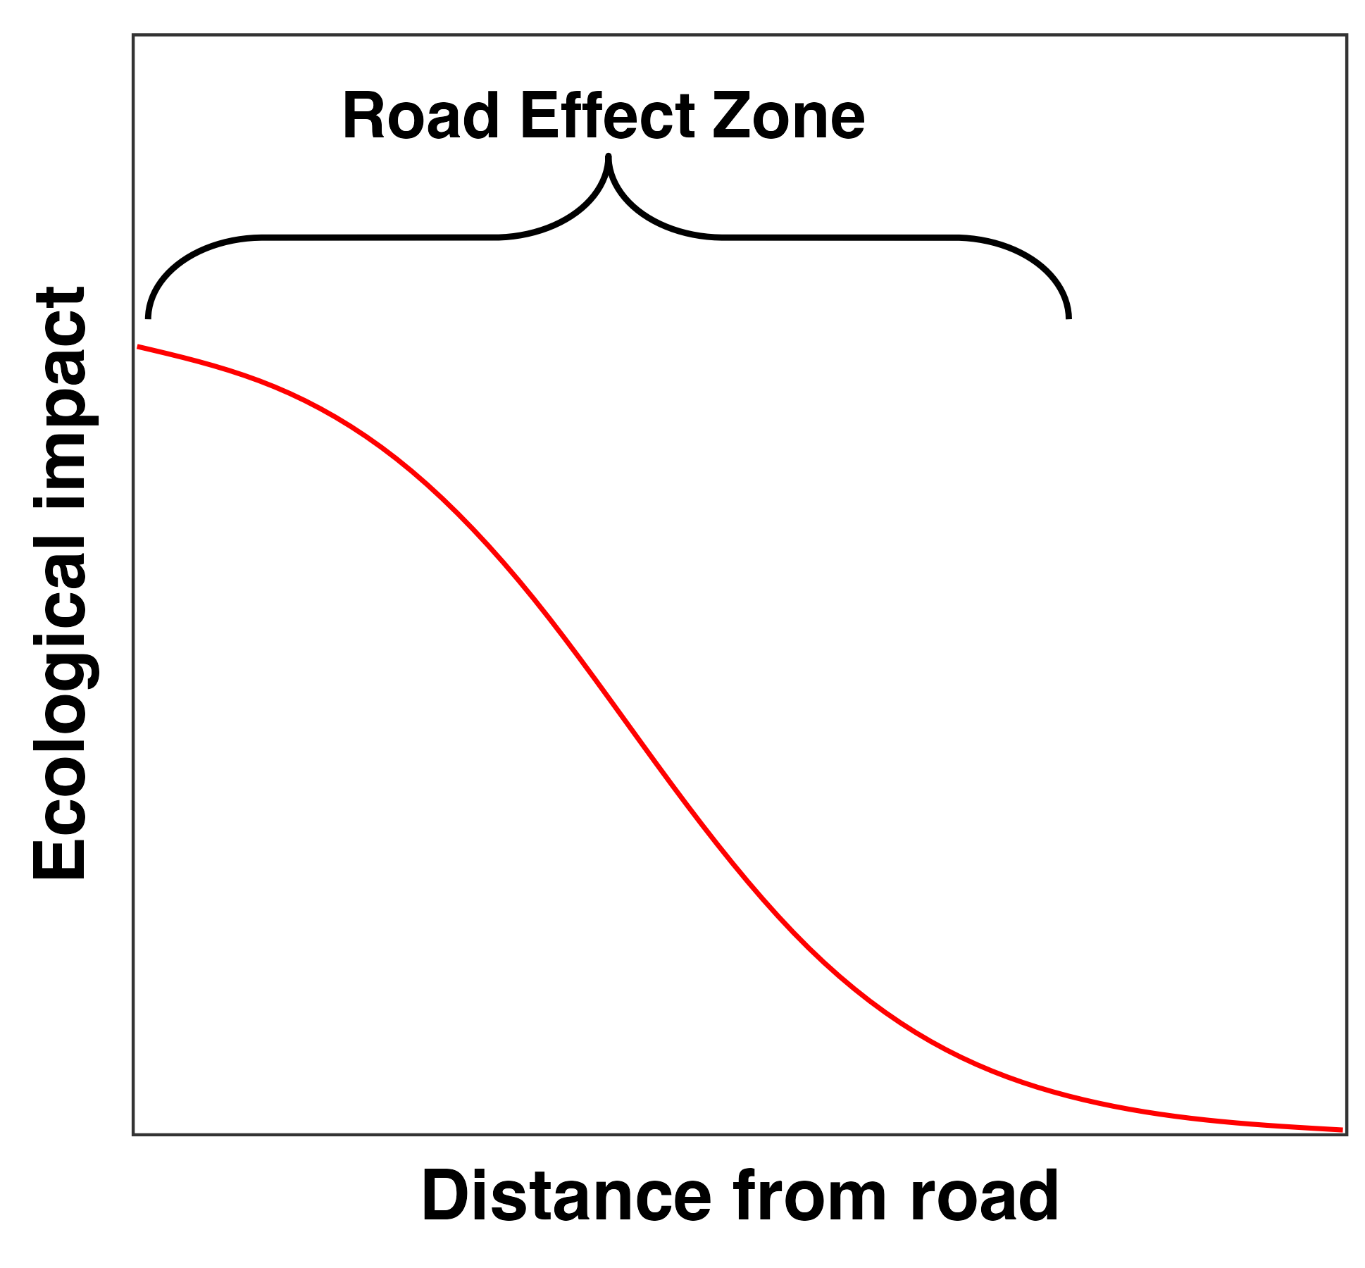

Theoretical depiction of the road effect zone as originally defined by Forman and Alexander (1998).

# The Road Effect Zone as a Joint Probability

Our purpose in this note is to demonstrate how probability theory can provide powerful tool for re-thinking the road effect zone. As noted above, our focus here is on the ecological impact of an animal being roadkilled, and so our framework begins from the concept of an animal space use and movement ecology. An individual’s home range describes the space it uses to undergo `*its normal activities of food gathering, mating, and caring for young*’ (Burt 1943). Ecologists have long recognised the utility of the home-range concept in describing patterns of space use (e.g., Kie et al. 2010), and routinely estimate home ranges from animal tracking data (see Michael J. Noonan et al. 2019). Statistically, home-range estimation results in a probability distribution function () satisfying

This PDF provides information on the locations where an animal is more, or less, likely to be found. Importantly, for the context of understanding the effects of roads on ecological processes, this PDF also represents the space over which an individual’s ecological interactions (e.g., foraging, mating, defecating, engaging in territorial defence, etc.) are expected to occur. This PDF can thus be considered to be proportional to an animal’s impact on the ecosystem, with core (i.e., high probability) areas of the PDF being more heavily impacted than tail (i.e., low probability) areas. Under the assumption that the probability of an animal being roadkilled is proportional to the amount of time it spends on the road, we can quantify by integrating over the area the falls on road surfaces

where and represent the road margins. Similarly, the probability of an animal engaging in normal ecological interactions, , is proportional to the amount of time it spends in locations other than on the road

The ecological ecological cost of a roadkilled animal not being able to engage in normal behaviour across its home range can thus be quantified via the joint probability of an animal encountering a vehicle on a road and being roadkilled and the probability of an animal engaging in ecologically relevant behaviour , or . Another way of seeing this is that quantifies the probability of an animal engaging in normal behaviour after being roadkilled. Given that both of these events can not occur, can be seen as quantifying the probability of an ecological impact. Assuming independence, this probabilistic road effect is given by the joint probability of these two events

If an animal occupies a home range that is far away from a road will be 0, resulting no road effect. Similarly, if an animal spends all of its time on roads, may be high, but will be 0, also resulting in no road effect. For animals where and , however, the road effect will be some non-zero probability with a strength that is a function of how much time an animal spends on roads relative to the rest of its home range. While this general concept is useful, we can also integrate over areas of interest to calculate the local road effect. For instance, the road effect within some distance threshold of a road can be quantified as

where and represent distance thresholds from the road edge. For example, setting to 0m and to 1m would provide the probability of a road effect within 1m of the road edge. Defining the road effect zone in this way allows is to flexibly take individual-specific forms based on each animal’s patterns of space use.

# The Road Effect Zone for Giant Anteaters

Here, we demonstrate the utility of a probabilistic representation of the road effect zone on a pair of giant anteaters (*Myrmecophaga tridactyla*) from the Brazilian Cerrado. Giant anteaters are the largest extant anteater, reaching over 2 m and weighing up to 50kg (McNab 1984) and are distributed throughout Central and South America (Gardner 2008). Giant anteater populations have suffered severe reductions and wildlife-vehicle-collisions are a major threat to their survival (Ascensão et al. 2021; Michael J. Noonan et al. 2022). Wild giant anteaters were captured between 2017 and 2018, in the vicinity of the three paved highways in the state of Mato Grosso do Sul, in the Cerrado biome, and equipped with tracking collars that obtained GPS fixes at 20-min intervals (for full details see Michael J. Noonan et al. 2022). A preliminary analysis on these data suggested that these individuals occupied fixed home ranges that regularly overlap paved highways. Following the workflow described above, we estimated the road effect zone for these two individuals in (ver. 4.2.1, R Core Team 2016). Home range areas were estimated using Autocorrelated Kernel Density Estimation (AKDE, Fleming et al. 2015) via the package (ver. 1.1.0, Calabrese, Fleming, and Gurarie 2016). The scripts required to reproduce these analyses and estimate the road effect zone from animal tracking data are openly available at <https://github.com/NoonanM/Road_Effect_Zone>.

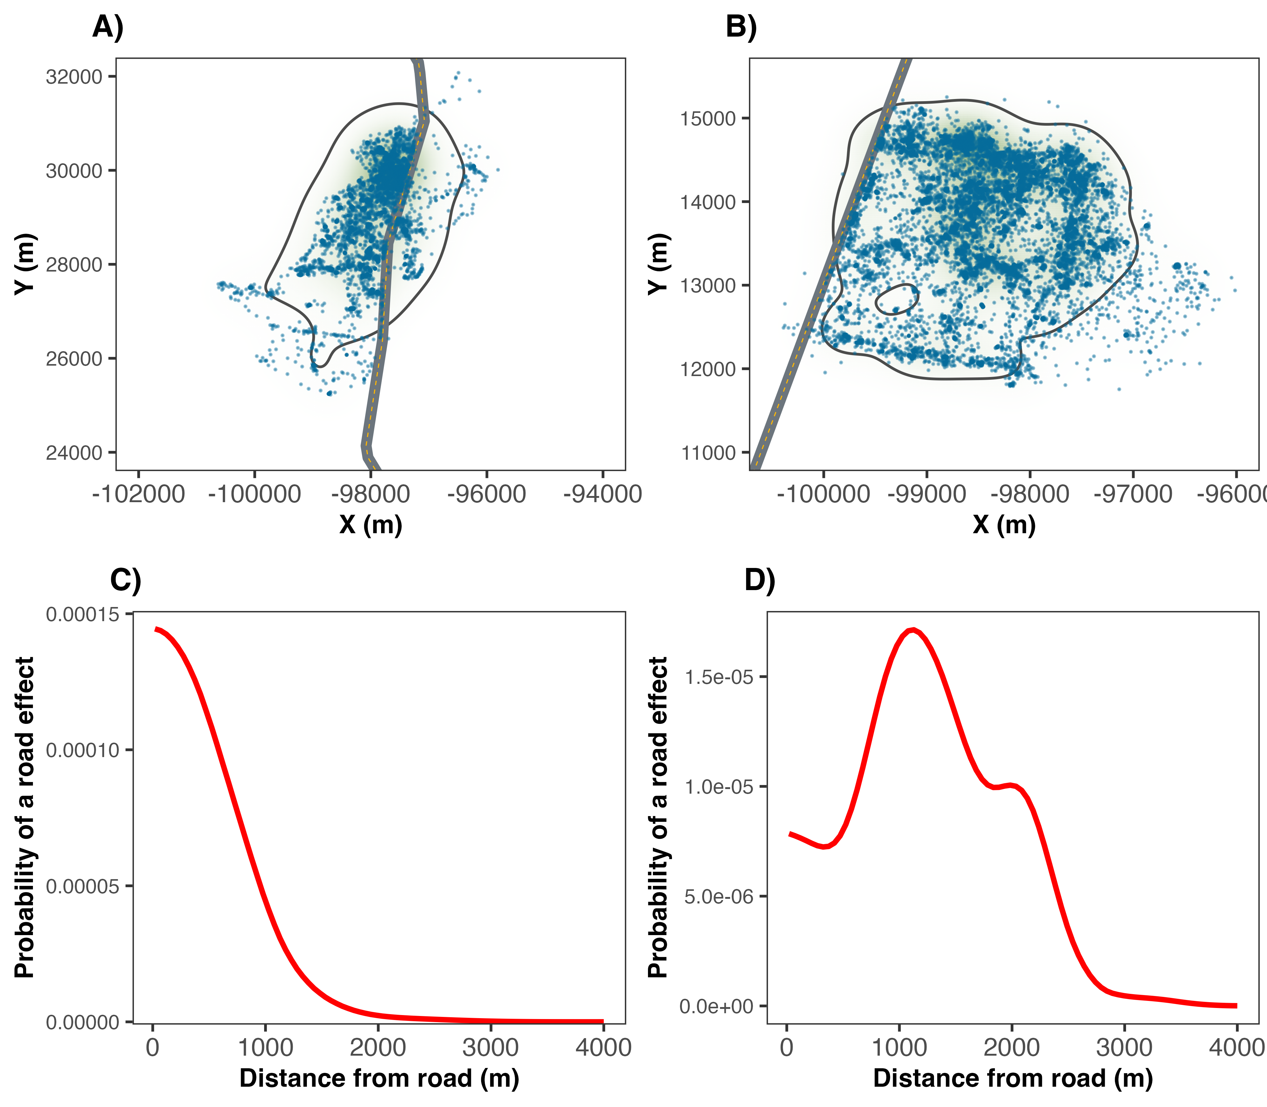

The relationship between space use and the road effect zone for two giant anteaters in the Brazilian Cerrado. Note how in panel A), the animal lives right along the roadside, so the ecological effects of a road mortality are greatest near the road, as shown in panel C). In Panel B), the animal’s home range was further from the road and while the overal road effect was weaker, it peaked between 1-2km from the road.

The two animals we estimated our road effect zones for exhibited two different patterns in space use. One animal occupied a home range that was centered on the road (Fig. 1A), whereas the other occupied the roadside and surrounding area, but spent little time on the road itself (Fig. 1B). As would be expected for the animal that lived right along the roadside, the ecological effects of a road mortality were greatest near the road (Fig. 1C). For the second animal, their home range was further from the road, resulting in a weaker overall road effect, but one that peaked in probability between 1-2km from the road (Fig. 1D). In other words, although was greater for the first giant anteater, the road has the probability to impact the ecosystem more than 2km away from the road through the loss of the second giant anteater.

# Discussion

The idea that ecological conditions will be more pristine the further one moves from away from a road has been a core concept in road ecology research since Forman and Alexander (1998) first introduced theconcept of the Road Effect Zone more than two decades ago (Reijnen, Foppen, and Meeuwsen 1996; Forman and Alexander 1998; Forman and Deblinger 2000; Semlitsch et al. 2007; Eigenbrod, Hecnar, and Fahrig 2009; Peaden et al. 2015; Brady and Richardson 2017; Andrasi et al. 2021). This traditional viewpoint is focused on quantifying the area over which roads alter physical, chemical, hydrological, and auditory properties (Reijnen, Foppen, and Meeuwsen 1996; Forman and Alexander 1998; Brady and Richardson 2017), population densities (Reijnen, Foppen, and Meeuwsen 1996; Fahrig and Rytwinski 2009; Andrasi et al. 2021), and/or community composition (Truscott et al. 2005). While this concept has proven informative for understanding the ecological footprint of roads, there is a level of nuance that is not captured.

The probabilistic framework for estimating road effect zones presented here provides an individual-based framework for scaling up to population-, or community-level effects. For instance, migratory ungulates move over vast distance between seasonal home ranges (M. Kauffman et al. 2020; M. J. Kauffman et al. 2021). The effects of these animals being roadkilled might decrease nutrient transfer (Subalusky et al. 2017), prey densities (Walton et al. 2017), or grazing pressure (Augustine and McNaughton 1998) hundreds or even thousands of kilometers away from the road. Similarly, for territorial species, the death of a roadside animal can have a cascading effect on the socio-spatial arrangement over larger distances than the conventional Road Effect Zone might capture.

In this study we have developed a probabilistic framework for estimating road effect zones from animal movement data. Conceptually, this framework describes the broader ecological impacts of the mortality of an animal on the landscape, and compliments the original concept of the Road Effect Zone first introduced by Forman and Alexander (1998). Furthermore, using movement data from giant anteaters occupying roadside habitats in Brazil, we have demonstrated how this framework can be used in practice to understand the ecological cost of a road, and help inform management. Notably, this framework builds straightforwardly off of home-range estimation and requires no specialized data collection protocols, allowing researchers to easily quantify the potential ecological impacts of roads.

# Acknowledgments

This work was supported by an NSERC Discovery Grant RGPIN-2021-02758 to MJN, as well as the Canadian Foundation for Innovation. We would like to thank the donors to the Anteaters and Highways Project especially the Foundation Segre as well as North American and European Zoos listed at <http://www.giantanteater.org/>. We would also like to thank the owners of all the ranches that allowed us to monitor animals on their property, in particular Nhuveira, Quatro Irmãos and Santa Lourdes ranches and also thank to M. Alves, D. Kluyber, C. Luba, A. Alves, as well as all of the volunteers who helped us in carrying out the fieldwork.

# References

Andrasi, Balint, Jochen AG Jaeger, Stefanie Heinicke, Kristian Metcalfe, and Kimberley J Hockings. 2021. “Quantifying the Road-Effect Zone for a Critically Endangered Primate.” *Conservation Letters* 14 (6): e12839.

Ascensão, Fernando, and Arnaud LJ Desbiez. 2022. “Assessing the Impact of Roadkill on the Persistence of Wildlife Populations: A Case Study on the Giant Anteater.” *bioRxiv*.

Ascensão, Fernando, Débora R Yogui, Mario H Alves, Amanda Carolina Alves, Fernanda Abra, and Arnaud LJ Desbiez. 2021. “Preventing Wildlife Roadkill Can Offset Mitigation Investments in Short-Medium Term.” *Biological Conservation* 253: 108902.

Augustine, David J, and Samuel J McNaughton. 1998. “Ungulate Effects on the Functional Species Composition of Plant Communities: Herbivore Selectivity and Plant Tolerance.” *The Journal of Wildlife Management*, 1165–83.

Brady, Steven P, and Jonathan L Richardson. 2017. “Road Ecology: Shifting Gears Toward Evolutionary Perspectives.” *Frontiers in Ecology and the Environment* 15 (2): 91–98.

Brown, Charles R, and Mary Bomberger Brown. 2013. “Where Has All the Road Kill Gone?” *Current Biology* 23 (6): R233–34.

Burt, William Henry. 1943. “Territoriality and Home Range Concepts as Applied to Mammals.” *Journal of Mammalogy* 24 (3): 346–52.

Calabrese, Justin M, Chris H Fleming, and Eliezer Gurarie. 2016. “Ctmm: An R Package for Analyzing Animal Relocation Data as a Continuous-Time Stochastic Process.” *Methods in Ecology and Evolution* 7 (9): 1124–32.

Coffin, Alisa W. 2007. “From Roadkill to Road Ecology: A Review of the Ecological Effects of Roads.” *Journal of Transport Geography* 15 (5): 396–406.

Desbiez, Arnaud Leonard Jean, Alessandra Bertassoni, and Kathy Traylor-Holzer. 2020. “Population Viability Analysis as a Tool for Giant Anteater Conservation.” *Perspectives in Ecology and Conservation* 18 (2): 124–31.

Eigenbrod, Felix, Stephen J Hecnar, and Lenore Fahrig. 2009. “Quantifying the Road-Effect Zone: Threshold Effects of a Motorway on Anuran Populations in Ontario, Canada.” *Ecology and Society* 14 (1).

Fahrig, Lenore, and Trina Rytwinski. 2009. “Effects of Roads on Animal Abundance: An Empirical Review and Synthesis.” *Ecology and Society* 14 (1).

Fleming, C H, W F Fagan, T Mueller, K A Olson, P Leimgruber, and J M Calabrese. 2015. “Rigorous home range estimation with movement data: a new autocorrelated kernel density estimator.” *Ecology* 96 (5): 1182–88.

Forman, Richard TT. 2000. “Estimate of the Area Affected Ecologically by the Road System in the United States.” *Conservation Biology* 14 (1): 31–35.

Forman, Richard TT, and Lauren E Alexander. 1998. “Roads and Their Major Ecological Effects.” *Annual Review of Ecology and Systematics* 29 (1): 207–31.

Forman, Richard TT, and Robert D Deblinger. 2000. “The Ecological Road-Effect Zone of a Massachusetts (USA) Suburban Highway.” *Conservation Biology* 14 (1): 36–46.

Forman, Richard TT, Daniel Sperling, John A Bissonette, Anthony P Clevenger, Carol D Cutshall, Virginia H Dale, Lenore Fahrig, et al. 2003. *Road Ecology: Science and Solutions*. Island press.

Gardner, Alfred L. 2008. *Mammals of South America, Volume 1: Marsupials, Xenarthrans, Shrews, and Bats*. Vol. 2. University of Chicago Press.

Ibisch, Pierre L, Monika T Hoffmann, Stefan Kreft, Guy Pe’er, Vassiliki Kati, Lisa Biber-Freudenberger, Dominick A DellaSala, Mariana M Vale, Peter R Hobson, and Nuria Selva. 2016. “A Global Map of Roadless Areas and Their Conservation Status.” *Science* 354 (6318): 1423–27.

Kauffman, Matthew J, Francesca Cagnacci, Simon Chamaillé-Jammes, Mark Hebblewhite, J Grant C Hopcraft, Jerod A Merkle, Thomas Mueller, et al. 2021. “Mapping Out a Future for Ungulate Migrations.” *Science* 372 (6542): 566–69.

Kauffman, Matthew, Holly Copeland, Jodi Berg, Scott Bergen, Eric Cole, Matthew Cuzzocreo, Sarah Dewey, et al. 2020. “Ungulate Migrations of the Western United States, Volume 1.” US Geological Survey.

Kie, John G, Jason Matthiopoulos, John Fieberg, Roger A Powell, Francesca Cagnacci, Michael S Mitchell, Jean-Michel Gaillard, and Paul R Moorcroft. 2010. “The home-range concept: are traditional estimators still relevant with modern telemetry technology?” *Philosophical Transactions of the Royal Society of London. Series B: Biological Sciences* 365 (1550): 2221–31.

McNab, Brian K. 1984. “Physiological Convergence Amongst Ant-Eating and Termite-Eating Mammals.” *Journal of Zoology* 203 (4): 485–510.

Noonan, Michael J, Fernando Ascensão, Débora R Yogui, and Arnaud LJ Desbiez. 2022. “Roads as Ecological Traps for Giant Anteaters.” *Animal Conservation* 25 (2): 182–94.

Noonan, Michael J., Marlee A. Tucker, Christen H. Fleming, Tom Akre, Susan C. Alberts, Abdullahi H. Ali, Jeanne Altmann, et al. 2019. “A Comprehensive Analysis of Autocorrelation and Bias in Home Range Estimation.” *Ecological Monographs* 0 (0): e01344. <https://doi.org/10.1002/ecm.1344>.

Peaden, J Mark, Tracey D Tuberville, Kurt A Buhlmann, Melia G Nafus, and Brian D Todd. 2015. “Delimiting Road-Effect Zones for Threatened Species: Implications for Mitigation Fencing.” *Wildlife Research* 42 (8): 650–59.

R Core Team. 2016. *R: A Language and Environment for Statistical Computing*.

Reijnen, Rien, Ruud Foppen, and Henk Meeuwsen. 1996. “The Effects of Traffic on the Density of Breeding Birds in Dutch Agricultural Grasslands.” *Biological Conservation* 75 (3): 255–60.

Semlitsch, Raymond D, Travis J Ryan, Kevin Hamed, Matt Chatfield, Bethany Drehman, Nicole Pekarek, Mike Spath, and Angie Watland. 2007. “Salamander Abundance Along Road Edges and Within Abandoned Logging Roads in Appalachian Forests.” *Conservation Biology* 21 (1): 159–67.

Silva, I, M Crane, and T Savini. 2020. “High Roadkill Rates in the Dong Phayayen-Khao Yai World Heritage Site: Conservation Implications of a Rising Threat to Wildlife.” *Animal Conservation* 23 (4): 466–78.

Subalusky, Amanda L, Christopher L Dutton, Emma J Rosi, and David M Post. 2017. “Annual Mass Drownings of the Serengeti Wildebeest Migration Influence Nutrient Cycling and Storage in the Mara River.” *Proceedings of the National Academy of Sciences* 114 (29): 7647–52.

Truscott, Anne-Marie, SCF Palmer, GM McGowan, JN Cape, and S Smart. 2005. “Vegetation Composition of Roadside Verges in Scotland: The Effects of Nitrogen Deposition, Disturbance and Management.” *Environmental Pollution* 136 (1): 109–18.

Walton, Zea, Jenny Mattisson, John DC Linnell, Audun Stien, and John Odden. 2017. “The Cost of Migratory Prey: Seasonal Changes in Semi-Domestic Reindeer Distribution Influences Breeding Success of Eurasian Lynx in Northern Norway.” *Oikos* 126 (5): 642–50.