**UNIVERSITY OF ENGINEERING AND TECHNOLOGY, LAHORE**



**COURSE:**

Database and Management Systems

**PROJECT REPORT:**

Course Registration System

**SUBMITTED TO:**

Ma’am Sehar Waqar

**SUBMITTED BY:**

Noor Fatima 2023-CE-17

Contents

* Introduction 2

Objectives 3

* System Design 3

1. Manage Students 3

2. Manage CLOs 3

3. Manage Rubrics 3

4. Manage Assessments 4

5. Manage Rubric Levels 4

6. Reports 4

* Database Design 4
* Challenges Faced 5
* Conclusion 5

## Introduction

The OBE Rubrics Management System is a web-based application developed using Streamlit to manage students, Course Learning Outcomes (CLOs), rubrics, assessments, rubric levels, and generate reports. The system is connected to a MySQL database where all data, including student records, CLOs, rubrics, assessments, and evaluation results, is stored and managed.

### Objectives

The primary goal of this project is to create an efficient management system for overseeing and assessing students' performance against predefined CLOs. It aims to:

* Simplify the process of managing students and their associated data.
* Provide an interface for managing CLOs, rubrics, assessments, and rubric levels.
* Generate reports for the analysis of student performance, CLO-wise results, and assessment-wise results.

## System Design

The system utilizes Streamlit for creating the user interface and MySQL for data storage. Each functionality within the application is broken down into specific modules, which are:

### 1. **Manage Students**

* **Features**:
  + Add new student records with attributes such as Student ID, Name, Registration Number, and Section.
  + Display a list of all students stored in the database.
* **Functionality**:
  + Students are added through a form where data is validated. On submission, the information is inserted into the Student table in the database.
  + An option to display all students is provided through a checkbox, which retrieves and displays the data in tabular form.

### 2. **Manage CLOs**

* **Features**:
  + Add new CLOs by specifying CLO ID and description.
  + Display a list of all CLOs.
* **Functionality**:
  + CLOs are added via a form, and once the user submits, the data is inserted into the CLO table in the MySQL database.
  + All CLOs are listed on request in a data table.

### 3. **Manage Rubrics**

* **Features**:
  + Add rubrics linked to specific CLOs, with a description and CLO ID.
  + Display all rubrics.
* **Functionality**:
  + Rubrics are added using a form, where the user can select an associated CLO from a dropdown list.
  + The rubric data is then stored in the Rubric table.
  + A checkbox allows the user to view all existing rubrics.

### 4. **Manage Assessments**

* **Features**:
  + Add assessments with a title, total marks, and associated rubric.
  + Display all assessments.
* **Functionality**:
  + Assessments are added through a form, and the data is inserted into the Assessment table.
  + An option to view all assessments is provided.

### 5. **Manage Rubric Levels**

* **Features**:
  + Add rubric levels with a description and level number.
  + Link rubric levels to specific rubrics.
  + Display all rubric levels.
* **Functionality**:
  + Rubric levels are added using a form, and the data is stored in the RubricLevel table.
  + A checkbox allows users to view all rubric levels.

### 6. **Reports**

* **Features**:
  + Generate different types of reports based on evaluations, CLOs, and assessments.
  + Available reports include:
    - Evaluation Summary: Displays student names, assessment titles, and rubric levels.
    - CLO-wise Class Result: Shows CLO-wise evaluation results.
    - Assessment-wise Class Result: Displays results based on assessments.
* **Functionality**:
  + The system allows users to select a report type. Based on the selected report, a SQL query is executed, and the data is fetched and displayed in a tabular format.

## Database Design

The system uses a MySQL database with the following tables:

1. **Student**: Contains details about the students.
   * student_id (Primary Key)
   * name
   * reg_no
   * section
2. **CLO**: Stores information about Course Learning Outcomes.
   * clo_id (Primary Key)
   * description
3. **Rubric**: Stores rubric descriptions linked to CLOs.
   * rubric_id (Primary Key)
   * description
   * clo_id (Foreign Key)
4. **Assessment**: Contains details about assessments.
   * assess_id (Primary Key)
   * title
   * total_marks
5. **RubricLevel**: Stores rubric levels, descriptions, and their link to rubrics.
   * level_id (Primary Key)
   * rubric_id (Foreign Key)
   * level
   * description
6. **Evaluation**: Stores evaluation results for students, linking students to rubrics and assessments.
   * eval_id (Primary Key)
   * student_id (Foreign Key)
   * assess_id (Foreign Key)
   * level_id (Foreign Key)

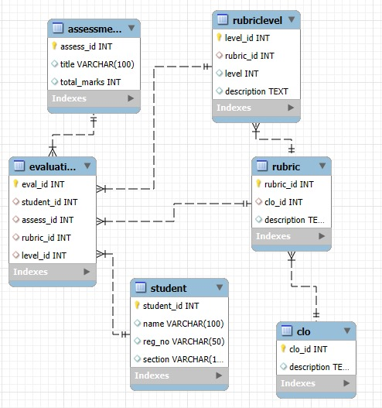

## Challenges Faced

1. **Database Connection**:
   * Handling MySQL connections efficiently and ensuring proper cleanup after each operation was crucial.
   * The system had to handle multiple database connections while avoiding connection leaks.
2. **Data Integrity**:
   * Ensuring data integrity while adding new records was addressed using unique constraints and error handling mechanisms to prevent duplicate entries.
3. **User Interface**:
   * Designing an intuitive user interface that integrates all functionalities in one place. Streamlit allowed for rapid prototyping of the UI and seamless integration with the backend.
4. **Reports**:
   * Generating dynamic reports based on user input required complex SQL queries, which were designed to pull the necessary data and display it in an organized manner.

## Conclusion

The OBE Rubrics Management System developed with Streamlit and MySQL provides a comprehensive solution for managing and evaluating student performance. By streamlining the management of students, CLOs, rubrics, assessments, and rubric levels, the system offers an efficient platform for educational institutions to track and report on student learning outcomes. Future improvements could include the addition of more interactive features, such as data visualization, advanced filtering for reports, and user role management for enhanced security.