## **UNIVERSITY OF ENGINEERING AND TECHNOLOGY, LAHORE**



**COURSE:**

Database Management System

**PROJECT REPORT:**

School Management System

**SUBMITTED TO:**

Dr. Sehar Waqar

**SUBMITTED BY:**

Noor Fatima 2023-CE-17

## ***Department of Computer Engineering***

# **School Management System**

# **App Overview Report**

## Introduction

The **School Management System** is a modular web application developed using **Streamlit**, designed to streamline school operations, manage student data, analyze performance, and plan academic activities. This report outlines the app’s functionality, interface structure, and underlying database design.

## Main Navigation Structure

The app’s interface is structured with a **sidebar-based navigation system**, allowing users to access five key sections:

1. **Dashboard**
2. **Core Modules**
3. **Analytics & Reports**
4. **Student Insights**
5. **Academic Calendar**

## Dashboard

The **Dashboard** serves as the control center for administrators, presenting an overview of key performance indicators (KPIs), recent updates, and quick access to essential modules.

## Core Modules

These are the fundamental components of the system:

* **Student Module**: Handles student registration, personal and academic records.
* **Course Module**: Manages course details, schedules, and subject mappings.
* **Marks Module**: Records assessment results and calculates performance metrics.
* **Attendance Module**: Logs and reports daily attendance for each student.
* **Fee Module**: Tracks student fee payments, outstanding balances, and payment history.

## Analytics & Reports

This section provides data-driven insights for better decision-making:

* **Reports**: Generate standard academic and financial reports.
* **Performance Analysis**: View trends in grades and academic progress.
* **Upcoming Birthdays**: Displays student birthdays within a time range.
* **Enrollment Summary**: Summarizes enrollment status and demographics.
* **Attendance Summary**: Aggregates attendance patterns for classes or individuals.
* **Fee Payment Summary**: Breaks down collected and pending payments.
* **Student Profile**: Comprehensive profile view of each student.
* **Custom Query**: Interface for executing custom SQL-based reports.

## Student Insights

This module gives detailed insights into student behavior and learning outcomes using trend analysis and visual summaries. It assists teachers in identifying students who may need academic or personal support.

## Academic Calendar

The **Academic Calendar** module lets users view and manage scheduled academic events, holidays, exam dates, and institutional activities, promoting better organization and planning.

## Design Considerations

* **Modularity**: Each functional area is implemented as a dedicated function, improving code readability and extensibility.
* **User Experience**: Clear navigation ensures ease of use for admins and staff.
* **Data Centralization**: Modules are interlinked through a consistent backend database schema.
* **Future-Proofing**: Can be expanded with authentication, SMS alerts, or mobile integration.

## App Flow (Visualized)

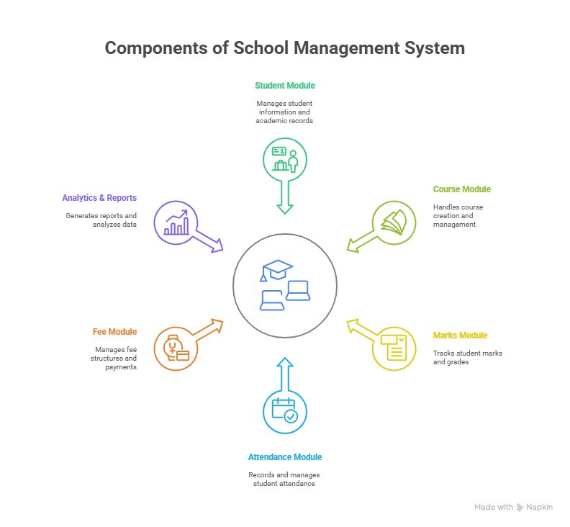This visual representation outlines the high-level structure and navigation logic of the system.

## Database Schema

The app is supported by a well-structured relational database, reverse-engineered and visualized using **MySQL Workbench**.

Insert MySQL Workbench database schema diagram here.

The database typically includes tables such as:

* student: Stores personal and academic info.
* course: Contains course and subject details.
* marks: Links students to their results.
* attendance: Logs daily attendance entries.
* fees: Tracks payment history and balances.

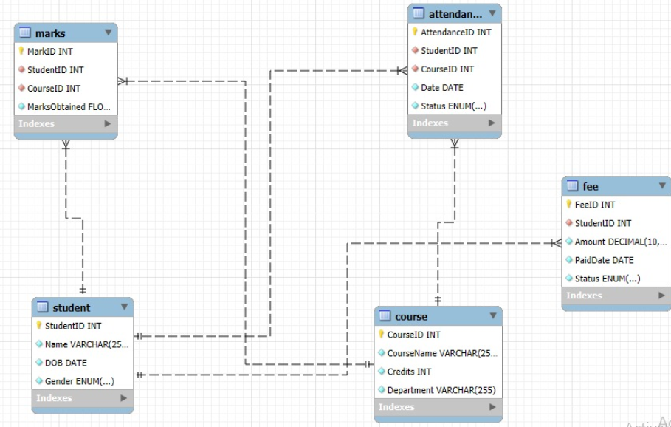

This schema ensures seamless data flow between the app’s modules and supports complex queries for analytics and reporting.

## Conclusion

The **School Management System** integrates front-end simplicity with back-end robustness. Its well-organized structure, modular design, and optimized database allow for efficient school operations, insightful analytics, and future enhancements. The system is ideal for educational institutions seeking digital transformation without heavy overhead.