Final Project Report

Health Care App



Project Supervisor
Taliah Tajammal

Submitted By

F230273EE9 (BC200401623)

Software Projects & Research Section,
Department of Computer Sciences,
Virtual University of Pakistan


CERTIFICATE

This is to certify that Noor ul Ain (BC200401623), has worked on and completed their Software Project at Software & Research Projects Section, Department of Computer Sciences, Virtual University of Pakistan in partial fulfillment of the requirement for the degree of BS in Software Engineering under my guidance and supervision.

In our opinion, it is satisfactory and up to the mark and therefore fulfills the requirements of BS in Software Engineering.

Supervisor / Internal Examiner

Taliah Tajammal
Supervisor,
Software Projects & Research Section,
Department of Computer Sciences
Virtual University of Pakistan

___________________
(Signature)

External Examiner/Subject Specialist
<<External Supervisor Name>>

___________________
(Signature)

Accepted By:

_____________
(For office use)

EXORDIUM

In the name of Allah, the Compassionate, the Merciful.

Praise be to Allah, Lord of Creation,
The Compassionate, the Merciful,
King of Judgment-day!

You alone we worship, and to You alone we pray for help,
Guide us to the straight path

The path of those who You have favored,

Not of those who have incurred Your wrath,
Nor of those who have gone astray.

DEDICATION

This Project is dedicated to the pursuit of knowledge, growth, and the relentless pursuit of excellence. May this project serve as a testament to the journey of self-discovery and academic achievement.

ACKNOWLEDGEMENT

I would like to express my sincere gratitude and appreciation to the individuals and entities who have supported and contributed to the completion of this project.
- I am deeply thankful to Supervisor Taliah Tajammal for their invaluable guidance, encouragement, and expertise throughout the duration of this project. Their mentorship has been instrumental in shaping the direction and execution of my research.
- My heartfelt thanks to my family for their unwavering support, encouragement, and understanding throughout this academic journey. Their love and belief in me have been a constant source of motivation.
- I would like to acknowledge my seniors for their encouragement, companionship, and for being a source of inspiration during challenging times. Their camaraderie has made this journey memorable and enjoyable.

To conclude, I am deeply indebted to all those mentioned above and countless others who have played a role, however small, in the realization of this project. Your support and encouragement have been indispensable, and I am truly grateful for the opportunity to undertake this endeavor.

PREFACE

This project Health Care App is a very helpful and useful tool for both the patients and the vendors like doctors, hospitals and pharmacies. App provides a variety of services to the patients at the ease of their homes. It will help patients to keep record of their appointment history. This app is very beneficial for all users.
Moreover, during the phase of learning, this project helped me to enhance my knowledge regarding the work. I had undergone many experiences related to the programming concepts, procedures, views, triggers and many other concepts, through this project I come to know the importance of online learning and role of devotion towards the work.
TABLE OF CONTENTS

CHAPTER NO. 1
gathering & Analyzing info 10

1.1 Introduction 9

1.2 purpose 9

1.3 scope 9

1.4 definitions, acronyms and abbreviations 9

1.5 Project requirements 10

1.5.1 Functional Requirements 10

1.5.2 Non-Functional Requirements 11

1.6 use cases and usage scenarios 11

1.6.1 Use Case Diagrams 11

1.6.2 Usage Scenarios 12

1.7 Development Methodology 23

1.7.1 Chosen Methodology 23

1.7.2 Reasons for Chosen Methodology 24
1.7.2 Work Plan (Gantt Chart) 24
1.7.2 Project Schedule (Submission Calendar) 25

CHAPTER NO. 2
designing the project 26

2.1 Introduction 27

2.2 purpose 27

2.3 scope 27

2.4 definitions, acronyms and abbreviations 28

2.5 Architectural Representation (Architecture Diagram) 29

2.6 Dynamic Model: Sequence Diagrams 30

2.7 Object Model/Logical Model: Class Diagram 33

2.8 Database Model (Database Diagram) 33

2.9 Graphical User Interfaces 34

Chapter no.3
DEvelopment 35
3.1 Development plan (Architecture Diagram) 36

CHAPTER 1
Gathering & Analyzing Info

CHAPTER NO. 1
gathering & Analyzing info 10

  - Introduction

This project is being proposed to give online health care solutions to the patients dealing with various diseases and detail of the medical store or medicines that should be suggested to them and that are near to them.

  - Purpose
The app additionally involves more features than just to connect patients and doctors but also the medical stores. The fundamental target is to give doctors and patients a place where they can get health care at the ease of their home and to feel safe to consult to a doctor that is most suitable for their treatment, book appointments and approach effectively for the medicines prescribed to patients and vendors like doctors, hospitals, pharmacies, mortuaries, ambulance service provides would be able to provide their services by buying subscription for the app.

  - scope
The project is about Health Care App which is a comprehensive solution designed to streamline and revolutionize the healthcare industry. The app is developed with an advanced technology stack to ensure security, privacy, and data integrity using android studio whose main language of programming will be Kotlin and firebase for backend. It provides users with an enhanced user experience through intuitive interfaces and a user-friendly platform. The functionality of the app includes Patients online consultation with doctors.
The app allows for remote monitoring and diagnosis of patients, which can help address healthcare challenges in remote areas and reduce the burden on healthcare providers. Patients can easily book appointments and consult with specialists at various hospitals and diagnostic centers using the app. The app also provides an option for home-based healthcare services, which includes home nursing, home medical equipment supply, and even foreign doctor assist. Patients can get prescription and pharmacy services. App also provides an integrated platform for patients to access various healthcare services like laboratory tests, dental services, physiotherapy, etc. Patients could get 24/7 support and emergency assistance. User’s data security and privacy will also be insured.
Doctor will able to view the profile of patient’s diagnosis recognized by app and identify the problems and can advise patient the solution in no time.

1.4 definitions, acronyms and abbreviations
- Definitions:

ERD (Entity Relationship Diagram):
An Entity-relationship diagram is likewise called an entity-relationship model, it is a graphical portrayal. ERD diagram is a data model for portraying an informational collection or database in a hypothetical model ERD is made from substance types and indicates relationships that can exists between elements. An entity may be arranged as a thing that is seen as being prepared for free presence and which can be uncommonly recognized.

Sequence Diagram:
Sequence Diagram is an association diagram that shows how cycles work with each other. The sequence diagram catches the relationship between objects concerning joint effort.

Architecture Design Diagram:
This Diagram is used to address dates as layers. It contains three layers that are application layer, database layer and business layer. It is a huge instrument as it gives an overall viewpoint on the genuine association of the item programming and its progression guide.

Class Diagram:
In class diagram, we will portray the design of the HealthCare app by showing the structure’s classes, show their traits, activities or techniques, and relationships between classes or the articles. In a class diagram classes address both the principal articles and associations. A class diagram is a construction of the framework by showing the framework’s classes, their qualities, activities, and the relationships among them.

Database Design:
Database Design is now the most widely recognized approach to make an organization data model of the database. It tends to be taken as the consistent arrangement of the base data designs to store the data and furthermore how the data or parts interrelate.

Interface Design:
It is GUI viewpoint on programming. It shows how is our Software App will look like or style and how we interact with the system.

- Acronyms and Abbreviations:

Terms | Descriptions
ERD | Entity Relationship Diagram
XML | eXtensible Markup Language

1.5 Project requirements

1.5.1 Functional Requirements

Functional requirements define a function of software system and how the system must behave when presented with specific inputs and conditions. The requirements are used to generate use cases. Each use case describes one or more functional requirements.

- Patients will be connected to hospital providers and Pharmacy’s within any geographical location.
- Each user should have access to a personalized dashboard displaying their activity history, contact list, and relevant updates.
- Patients will be connected to Ambulance services/Mortuary services within any geographical location.
- People will be able to schedule appointments with hospitals/doctors for chronic/ terminal issues like cancer, surgery etc.
- Medical equipment producers/sellers will be connected to hospitals trying to expand and help them arrange flexible payment plans.
- Local hospitals to foreign/diaspora doctors will be connected through app to facilitate performance of complex medical procedures.
- Doctors will be provided a platform to schedule their appointments on their free time so their services could be utilized.
1.5.2 Non-Functional Requirements

The Non-functional requirements that specify criteria that can be used to judge the operation of a system, rather than specific behaviors.

Non-functional requirements - can be divided into two main categories:

Execution qualities, such as security and usability, which are observable at run time. Evolution qualities, such as testability, maintainability, extensibility and scalability, which are embodied in the static structure of the software system.

- Security: The app would implement robust security measures, such as secure data transmission and storage, to protect user data and ensure privacy.
- Usability: The app would load quickly and function smoothly on a variety of devices, even on low-powered ones.
- Interface: The app would have an intuitive and user-friendly interface that allows users to easily navigate and use the platform.
- Performance: The app would maintain stable and consistent performance, even under extreme conditions or heavy usage.
- Security: The app would be able to handle a large number of users and effectively manage their data.
- Accessibility: The app would be compatible with different operating systems and devices, ensuring a seamless experience for all users.
- Scalability: The app would have a modular design and clear documentation to facilitate future development and updates.

1.6 use cases and usage scenarios
Use Cases:

- Registration/ login
- User Subscription
- View/ Update Profile Settings
- Get Services (number of people / people’s location)
- Search and Suggestion
- Add Details
- Provide details
- Keep records (Appointment / Query Handling details) `
- Personalized Dashboard
- Maintain Records (user feedback and comments)
- Keep track
- Provide urgent service

1.6.1 Use Case Diagrams

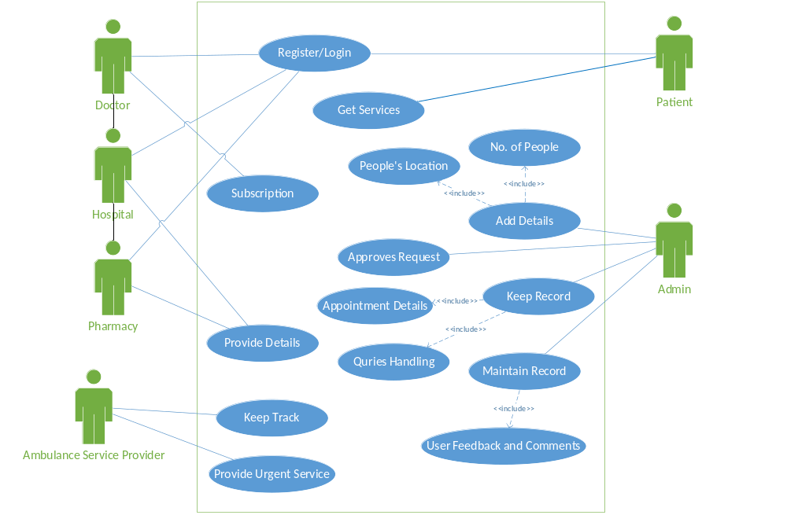

1.6.2 Usage Scenarios

Use Case Title | Registration
User Id | 1
Actions | The user i.e. patients and vendors are allowed to register themselves to the system. The actor who wants to be part of the system must register with app. The admin accepts the request. The system must facilitate that registration form is according to the selected fields fulfilling the specification needs.
Description | User will click on register button and add details. User will register by simply connecting with their Google account or just filling the fields i.e. username/ email, passwords and contact number. As a doctor or a vendor registration will be different that is direct request to the admin where through email, they will get a link of online verification or a demo test. Firstly, by giving their email/contact number.
Alternative paths | User can also visit this site without registration
Pre-conditions | The site will be open for all users for 24 hours a day and
Post-conditions | All fields must be filled.
Author | BC200401623
Exceptions | It occurs if user provide invalid data such as wrong email id or phone number etc.
Actor | Patient, Vendors.

Use Case Title | Login
User Id | 2
Actions | The user i.e. patients and vendors are allowed to login themselves to the system by simply entering their user name and password but for doctor there is an other login option i.e Login as Doctor.
Description | User in both cases as a patient or a doctor will click on login button and have to fill all the fields. User will login by simply connecting with their Google account or just filling the fields i.e. username/ email and passwords.
Alternative paths | User can also visit this site without login.
Pre-conditions | The site will be open for all users for 24 hours a day and the user must be registered.
Post-conditions | All fields must be filled.
Author | BC200401623
Exceptions | It occurs if user forget their password or invalid username/ email.
Actor | Patient, Vendors.

Use Case Title | Forgot Password
User Id | 3
Actions | The user i.e. patients and vendors are allowed to regain their passwords from system by simply entering their user email account by clicking on forgot password button.
Description | User in both cases as a patient or a doctor will click on forget password button and have to fill all the fields. User will regenerate password by simply clicking on the link sent to their email and the access will be regained after a verification.
Alternative paths | User can also regain their password by entering their phone number.
Pre-conditions | The user must be registered and receive an email.
Post-conditions | The user must have clicked on the recovery email and re-written a new password.
Author | BC200401623
Exceptions | It occurs if user forget their email password or if the email is invalid.
Actor | Patient, Vendors.

Use Case Title | Subscription
User Id | 4
Actions | The user i.e. vendors will view or choose a subscription plan for offering their services on the app by clicking on subscription button and adding details.
Description | All vendors will click on the subscription button and buy a subscription plan depending on the time period they can offer their services and by signing an official page and agreeing to the terms and condition. The app would be able to proceed.
Alternative paths | User can also regain their password by entering their phone number.
Pre-conditions | The user must be a vendor and have a plan.
Post-conditions | The user will sign agreement and have given a trial demo to very being a vendor.
Author | BC200401623
Exceptions | It occurs if user will fail to verify himself as a vendor and did not choose a plan of subscription.
Actor | Vendors.

Use Case Title | View and Update Profile
User Id | 5
Actions | The user i.e. patients or vendors can view or update their profile by just clicking on their profile tab and update their history. User can also view profile of a doctor or a vendor, a vendor can also view profile of a patient.
Description | All users will click on their profile tab and will view and update their details and can also add their previous medical history. The app will allow user to view profile of vendors and vendors like doctors can also view profile of their patient.
Alternative paths | User can also view their profile by going to the settings.
Pre-conditions | The user must click on the profile tab.
Post-conditions | The user will click on the update button after entering information.
Author | BC200401623
Exceptions | Exception could occur if the user attempts to update their profile with invalid or incorrect data.
Actor | Patients, Vendors.

Use Case Title | Get Services
User Id | 6
Actions | The user i.e. patient can search and review suggestions through the app to get services. The patients can search for a nearby doctor, hospital, pharmacy or ambulance service etc.
Description | All users can search by clicking on search tab. The suggestion results will be based on the search inquiry by the user.
Alternative paths | User can also click on the options in the app of hospitals, doctors, labs or ambulance directly.
Pre-conditions | The user must click on the search tab.
Post-conditions | The user will choose an option from a list of drop down.
Author | BC200401623
Exceptions | Exception could occur if the user attempts to search for something whose data does not exist like a hospital who has not registered through the app.
Actor | Patients, Vendors.

Use Case Title | Keep records
User Id | 7
Actions | The admin will help user for booking an appointment and providing appointment details or consult a doctor by clicking on the doctor or hospital profile according to the time slot provided which suits them. The admin will also handle quires generated by users.
Description | All users will click on their preferred doctor or hospital profile tab and then select a time slot then click on the book appointment button then confirm button. The app will allow user to consult a doctor and offer discounts to patients for making an appointment through the app.
Alternative paths | User can also review a doctor or hospital before booking a consultation.
Pre-conditions | The user must click on an option in provided time slot and choose a day for appointment.
Post-conditions | The doctor approves appointment of their patient by insuring their availability.
Author | BC200401623
Exceptions | Exception could occur if the doctor is unavailable or did not approve the request of the patient.
Actor | Patient, admin.

Use Case Title | Add Details
User Id | 8
Actions | The admin will add the details and records of different users. The details include no of people and people’s location and so that the suggestions depend on these details.
Description | All users will add their data and details including their location. The admin will help the patient to avail the nearest service depending upon the information user provided.
Alternative paths | Admin can also review location before adding user id.
Pre-conditions | The user must add their location in the app.
Post-conditions | The admin maintains the record by insuring the profile.
Author | BC200401623
Exceptions | Exception could occur if the user has not provided complete details to app.
Actor | Patient, admin.

Use Case Title | Maintain Records
User Id | 9
Actions | The patients can give their feedback and also stars to mark the excellence of the doctor. Doctors can view their patient’s comments and can also report a review if it is vague or a bad comment by the patient. Admin will handle.
Description | All patients will give feedback as an important part and based on feedbacks the ranks of the doctors or hospitals will be upgraded.
Alternative paths | The users/ patients will be provided direct support by offering live chat or email support where the user can ask questions and report issues.
Pre-conditions | The patient must have used the service of the vendor.
Post-conditions | The patient can edit or delete the feedback.
Author | BC200401623
Exceptions | Exception could occur if the user attempts to give a bad or vague feedback about a service. Strict action will be taken against bad review and patient can be blocked.
Actor | Patients, Vendors.

Use Case Title | Provide Details
User Id | 10
Actions | The pharmacy will add its details of medicines and branches all the detail will be saved by the admin through proper data security.
Description | Pharmacy will enter its detailed information about location, id and medicines availability or shortage so that the admin will be able to save and upgrade the details.
Alternative paths | Pharmacy can also provide online service.
Pre-conditions | The service will be open for all users for 24 hours a day and the pharmacy must be registered.
Post-conditions | All details must be provided.
Author | BC200401623
Exceptions | It occurs if pharmacy is not registered.
Actor | Pharmacy.

Use Case Title | Keep Track
User Id | 11
Actions | The admin will keep track of all the details provided by the pharmacy and update the data, keeping all in record so that the number of medical equipment’s and medicines can be tracked.
Description | All pharmacy branches will add their medical details so then the admin will keep track of medicines that are commonly available and if a special medicine needed through prescription.
Alternative paths | No alternative.
Pre-conditions | The user must be a patient and have used a service through app.
Post-conditions | The action will be taken by the request generated by the user.
Author | BC200401623
Exceptions | Exception will occur if the details and records are not exact as described by the pharmacy.
Actor | Admin.

Use Case Title | Provide Urgent service
User Id | 12
Actions | The user will click on emergency tab then click on the near ambulance tab that will help the ambulance to find the exact location of the patient and provide urgent service of ambulance.
Description | Ambulance will enter its detailed information about location and availability then the patient will be able to avail urgent service.
Alternative paths | Ambulance can also provide other nearby ambulance service.
Pre-conditions | The Ambulance must be near, available and registered.
Post-conditions | Location must be provided.
Author | BC200401623
Exceptions | It occurs if the ambulance is short or unavailable.
Actor | Ambulance service provider, patient.

Use Case Title | Logout
User Id | 13
Actions | The user will click the logout button which will direct the user to main page.
Description | After taking and giving of services the user will logout of the app.
Alternative paths | User can reinstall the app or clear cache data.
Pre-conditions | The user must be login.
Post-conditions | User will be on the main page.
Author | BC200401623
Exceptions | N/A
Actor | Patient, doctor and admin.

1.7 Development Methodology
1.7.1 Chosen Methodology

The adopted or chosen methodology for this project is VU Process Model which is a combination of waterfall and spiral model. VU Process Model is the combination of waterfall methodology and spiral methodology. It is also called hybrid approach of system development. It has five phases. The five phases of the VU process model are following:
- Gathering and Analyzing requirements
- Planning
- Analysis and Design
- Development
- Final Report

In the requirement phase, the system goals, services and constrains are established after discussion with user. The planning phase is synchronized effort to find all the potential to tackle each. This phase usually involves a lot of brainstorming within software development team as well as with respective client. It maximizes the quality of system and minimizes any risk and errors.

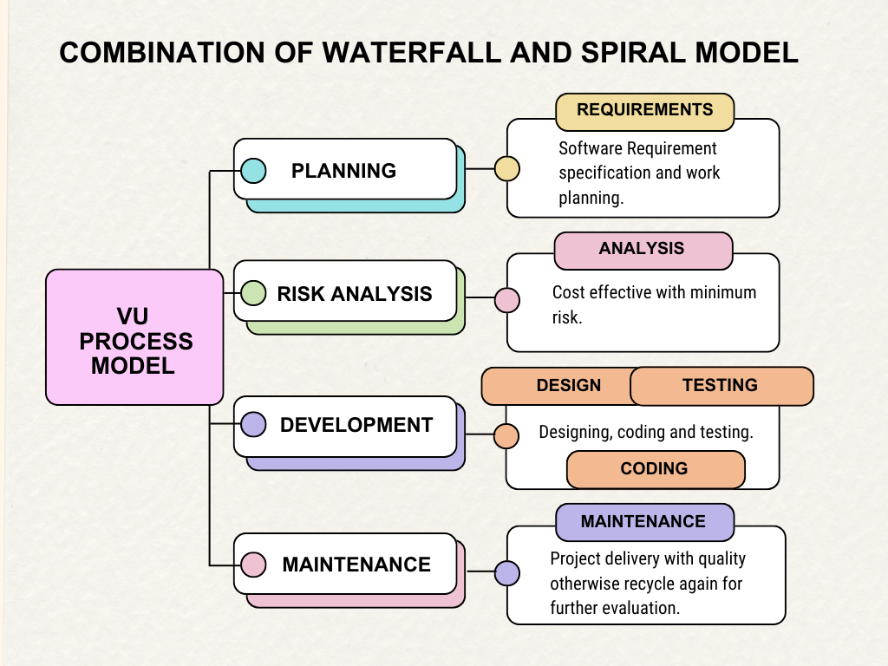

1.7.2 Reasons for Chosen Methodology
To achieve certain outcomes, one should know to improvise, VU Process Model is improvised version of SDLC which is a mix of two cycles Waterfall and Spiral Model. Clear structure, early goal, well planning comes from the waterfall and risk analysis, engineering/ development, came from spiral this mix creates a powerful yet simple way to follow. Due to its nature count of paper work in this SDLC makes things usable for both the stake holder hence lessen the chances any misdirection.
1.7.3 Work Plan (Gantt Chart)
Work plan is a document that shows all tasks involved in a project. The work plan is backbone of any project then project will be completed within time and budget. Project plan shows the tasks and responsibilities distribution. We plan the software development progress mainly. It describes the team management, standards, processes and constraints of project resources. Plan consists of following two stages:
  - Team Structure
  - Working Plan
Team Structure:
Team consisted of one student.

Gathering
Planning
Testing

BC200401623

Development
Design

Working Plan:
Working plan is given below:

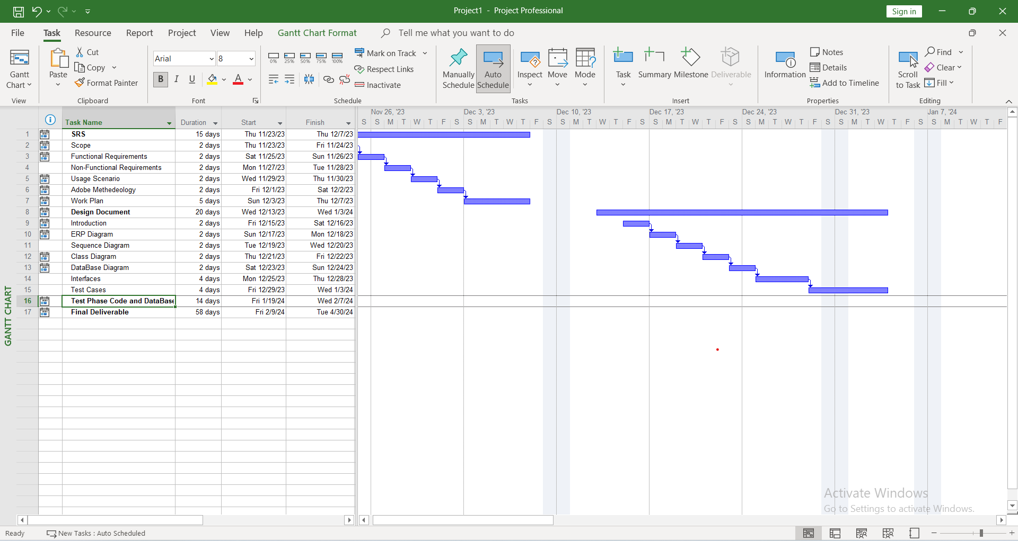

1.7.4 Project Schedule (Submission Calendar)

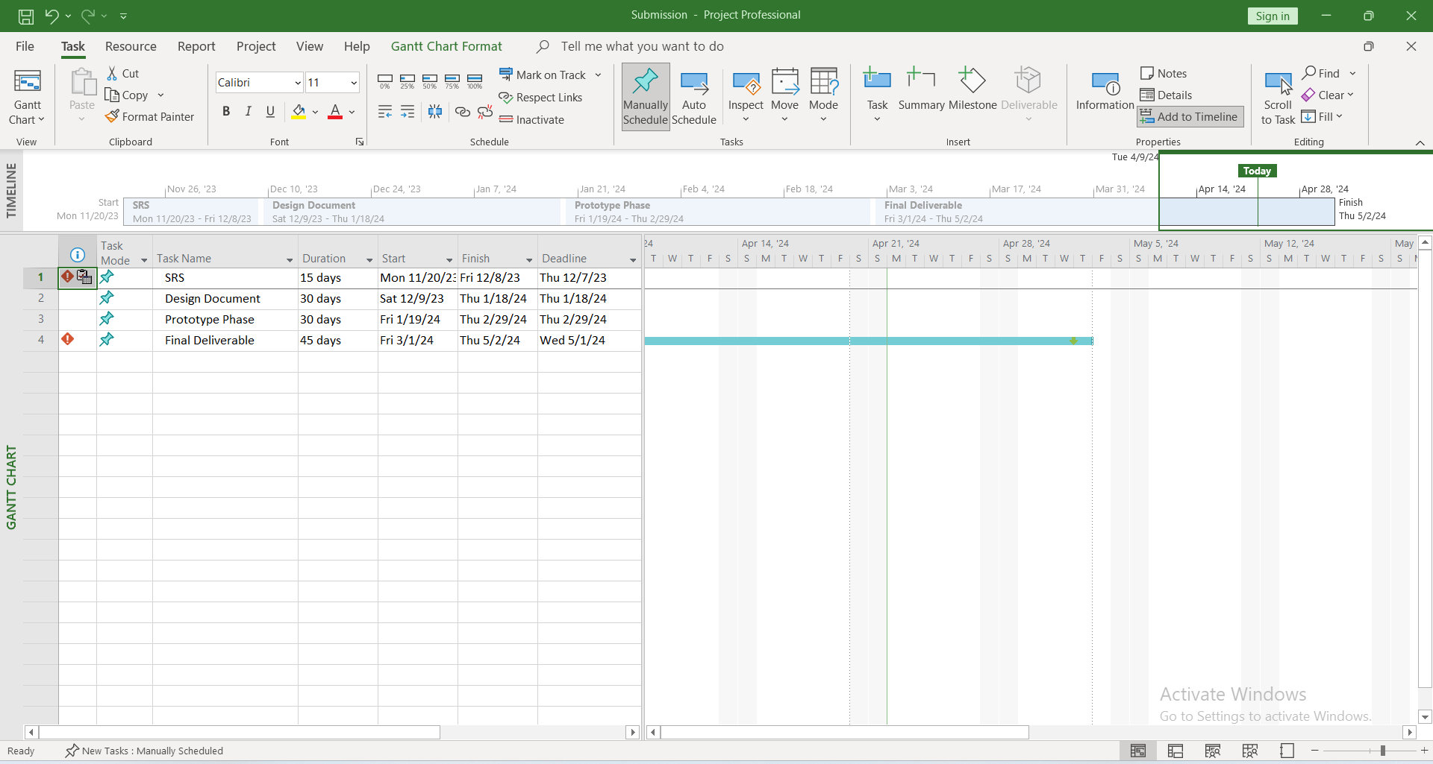

CHAPTER 2
Designing the Project

CHAPTER NO. 2
designing the project 12

2.1 Introduction
Design document presents the detailed design for Health Care App, an app that is made for patients and vendors like doctors, medical stores and hospitals to connect with each other in a very friendly manner to make a difference and for the ease of time saving and life saving strategies.
This document lays out the blueprint for development, outlining the technical decisions, architecture, and implementation roadmap for the project. The purpose of this phase is to focus on the goals of the project, provide a clear vision of what needs to be done, and define the scope of the project, thus improving feedback and implementation of the project. By utilizing this design document effectively, we can ensure a successful and efficient development process for Health Care App, delivering a high-quality software product that meets all stakeholder expectations.
2.2 purpose

This document serves as a single source of truth for the technical design of Health Care App. It aims:
- To guide developers in implementing the system efficiently and accurately.
- To facilitate communication and collaboration among stakeholders.
- To provide a baseline for evaluating the progress and success of the project.
- To serve as a reference point for future maintenance and enhancements.

2.3 scope
Scope of Project:

The project is about Health Care App which is a comprehensive solution designed to streamline and revolutionize the healthcare industry. The app is developed with an advanced technology stack to ensure security, privacy, and data integrity using android studio whose main language of programming will be flutter. It provides users with an enhanced user experience through intuitive interfaces and a user-friendly platform. The functionality of the app includes Patients online consultation with doctors.

The app allows for remote monitoring and diagnosis of patients, which can help address healthcare challenges in remote areas and reduce the burden on healthcare providers. Patients can easily book appointments and consult with specialists at various hospitals and diagnostic centers using the app. The app also provides an option for home-based healthcare services, which includes home nursing, home medical equipment supply, and even foreign doctor assist. Patients can get prescription and pharmacy services. App also provides an integrated platform for patients to access various healthcare services like laboratory tests, dental services, physiotherapy, etc. Patients could get 24/7 support and emergency assistance. User’s data security and privacy will also be insured.
Doctor will able to view the profile of patient’s diagnosis recognized by app and identify the problems and can advise patient the solution in no time.

2.4 definitions, acronyms and abbreviations
- Definitions:

ERD (Entity Relationship Diagram):
An Entity-relationship diagram is likewise called an entity-relationship model, it is a graphical portrayal. ERD diagram is a data model for portraying an informational collection or database in a hypothetical model ERD is made from substance types and indicates relationships that can exists between elements. An entity may be arranged as a thing that is seen as being prepared for free presence and which can be uncommonly recognized.

Sequence Diagram:
Sequence Diagram is an association diagram that shows how cycles work with each other. The sequence diagram catches the relationship between objects concerning joint effort.

Architecture Design Diagram:
This Diagram is used to address dates as layers. It contains three layers that are application layer, database layer and business layer. It is a huge instrument as it gives an overall viewpoint on the genuine association of the item programming and its progression guide.

Class Diagram:
In class diagram, we will portray the design of the HealthCare app by showing the structure’s classes, show their traits, activities or techniques, and relationships between classes or the articles. In a class diagram classes address both the principal articles and associations. A class diagram is a construction of the framework by showing the framework’s classes, their qualities, activities, and the relationships among them.

Database Design:
Database Design is now the most widely recognized approach to make an organization data model of the database. It tends to be taken as the consistent arrangement of the base data designs to store the data and furthermore how the data or parts interrelate.

Interface Design:
It is GUI viewpoint on programming. It shows how is our Software App will look like or style and how we interact with the system.

- Acronyms and Abbreviations:

Terms | Descriptions
ERD | Entity Relationship Diagram

2.5 Architectural Representation (Architecture Diagram)

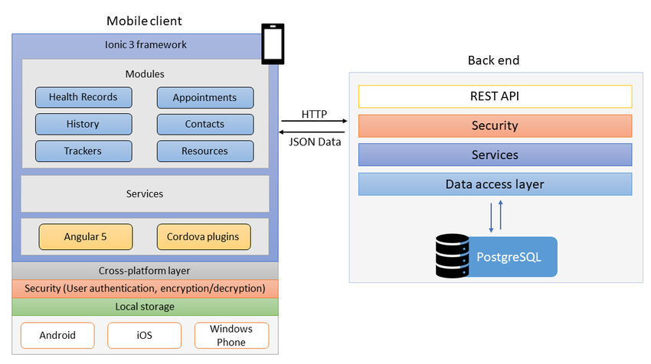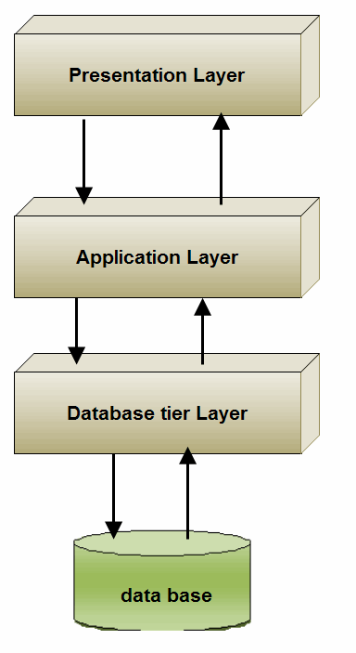

2.6 Dynamic Model: Sequence Diagrams

Doctor Sequence Diagram
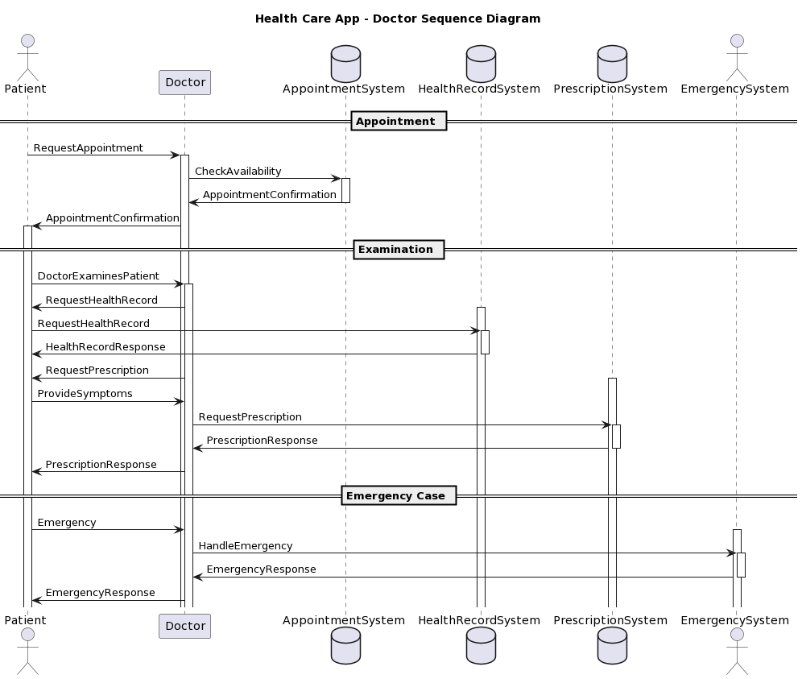
Vendors Sequence Diagram
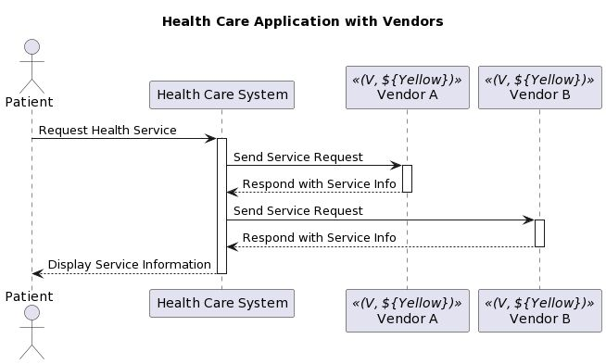
Patients Sequence Diagram
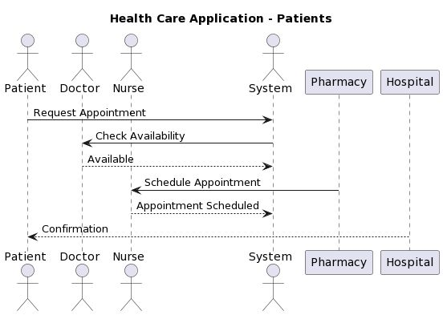 Hospitals Sequence Diagram 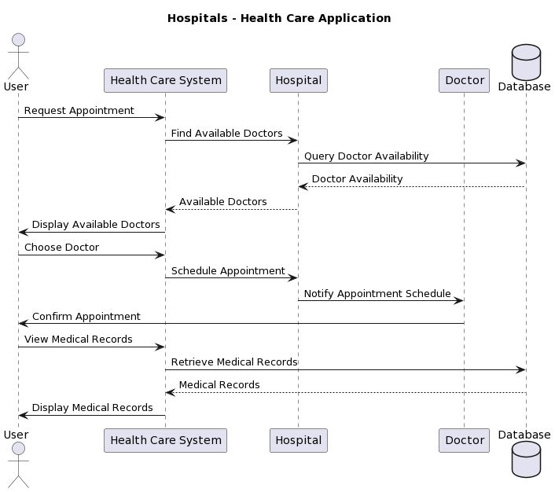

Pharmacy Sequence Diagram
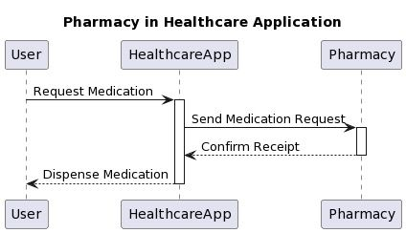

Appointment Sequence Diagram
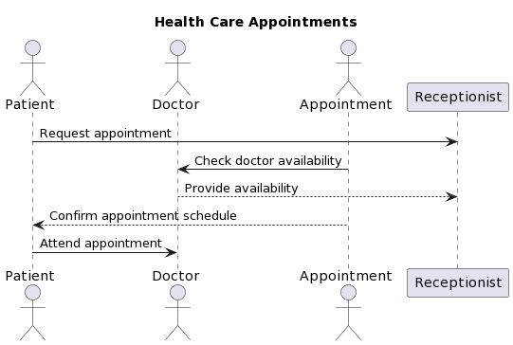
2.7 Object Model/Logical Model: Class Diagram

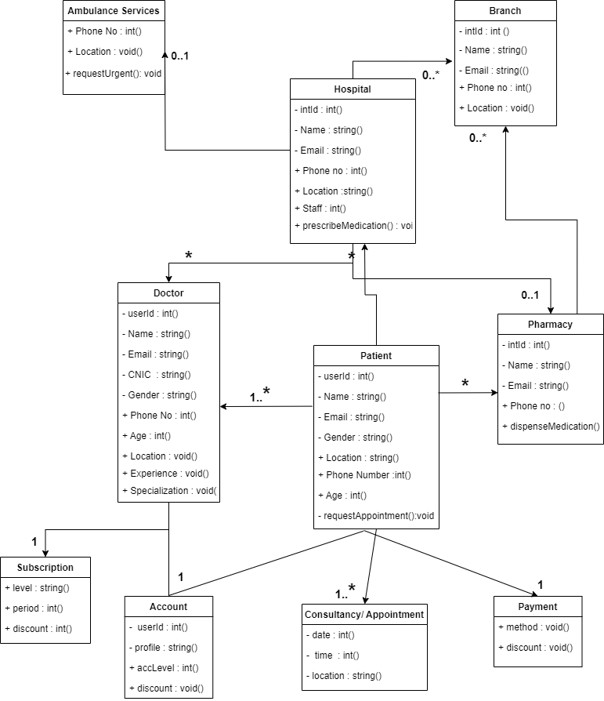

2.8 Database Model (Database Diagram)

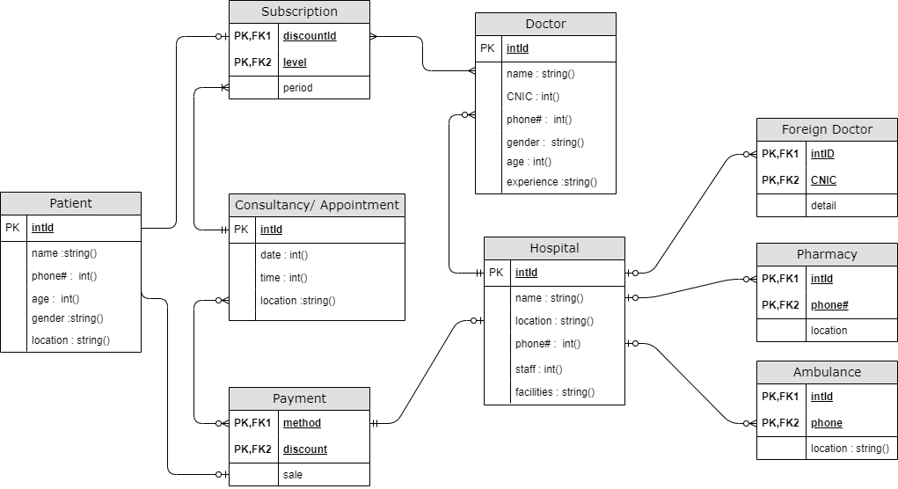
2.9 Graphical User Interfaces 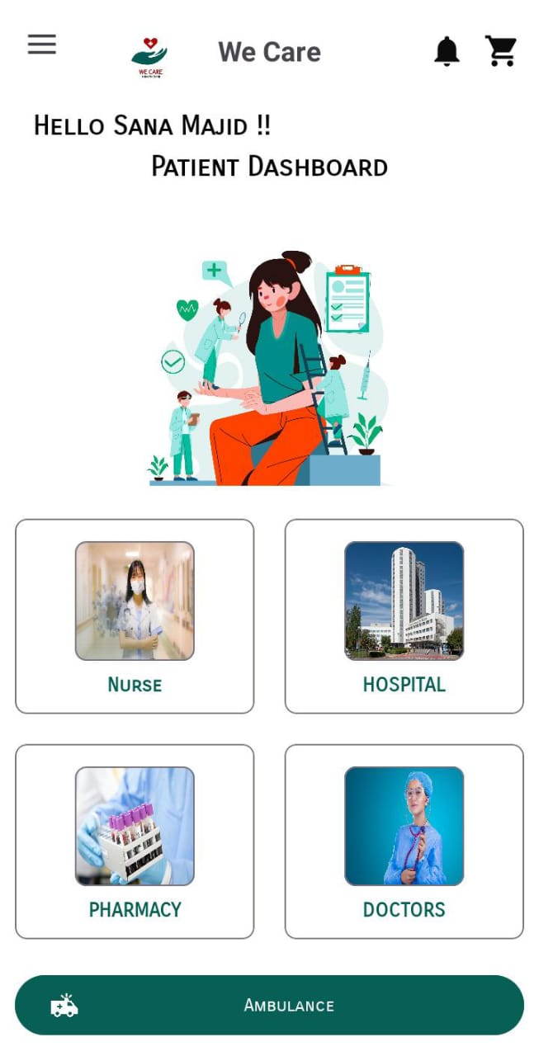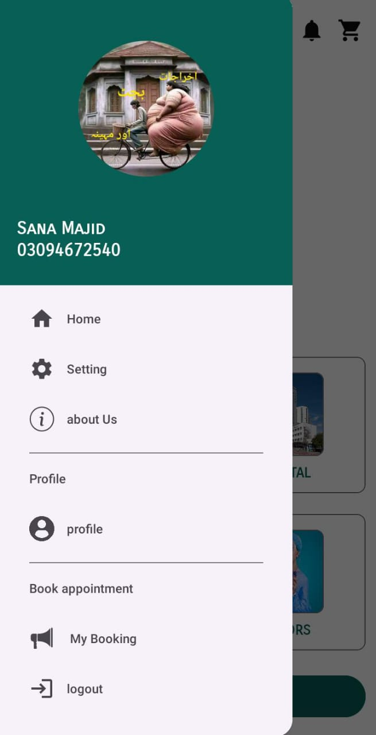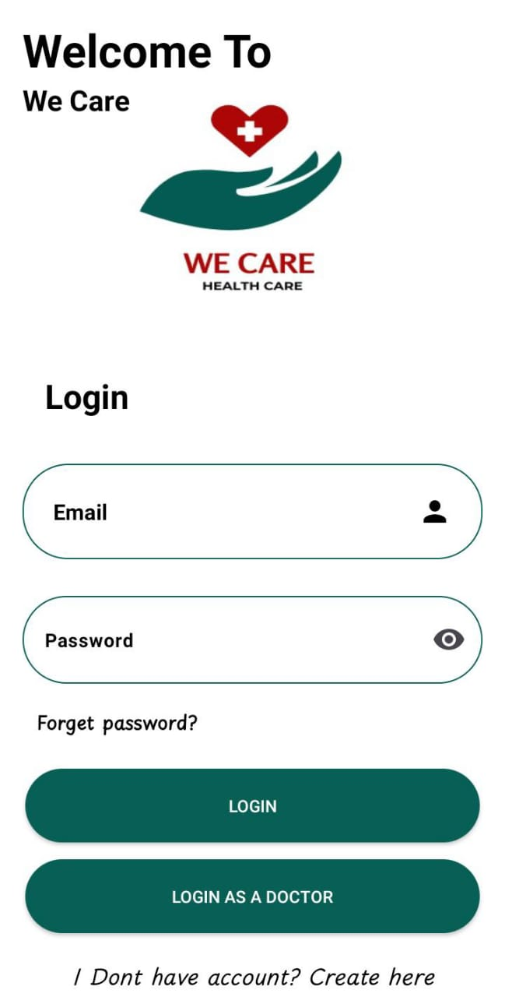

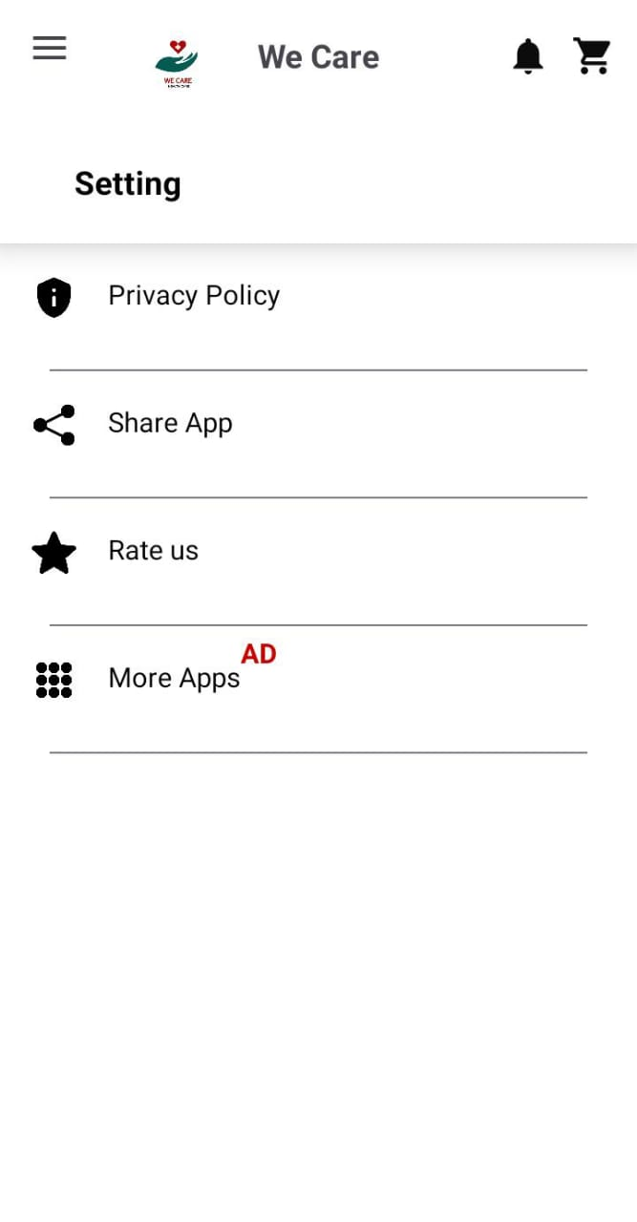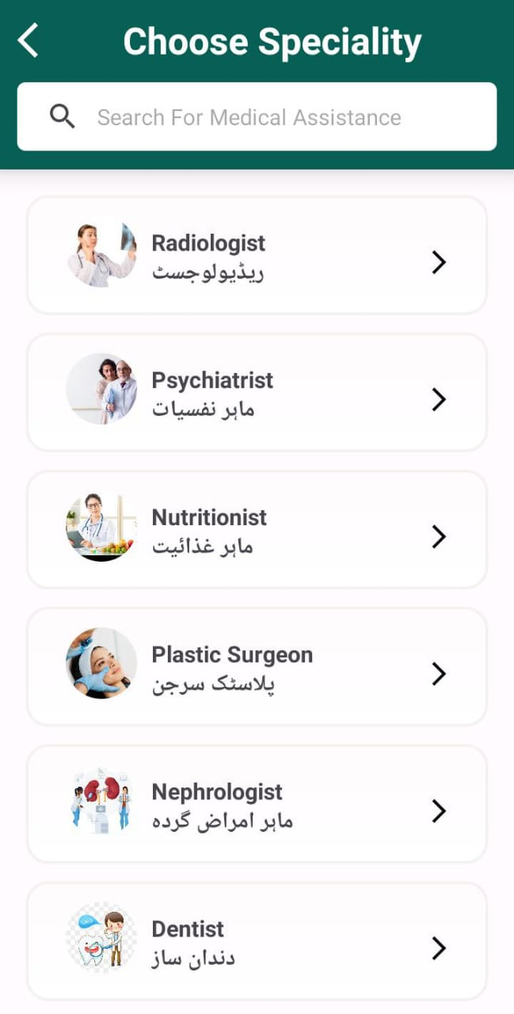

CHAPTER 3
Development

Chapter no.3
DEvelopment 13
3.1 Development plan (Architecture Diagram)

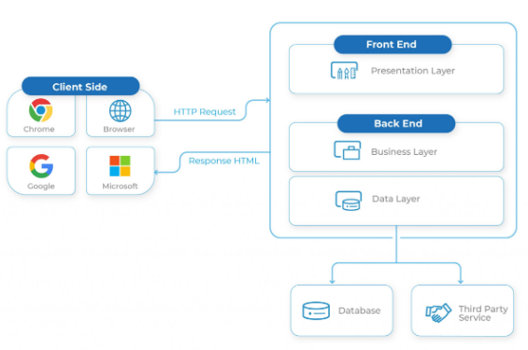
REFERENCES

- CS510 Software Requirement and Specification handouts VU.
- CS504 Software Engineering I handouts VU.
- CS605 Software Engineering II handouts VU.
- CS403 Database Management System handouts VU.
- CS603 Software Architecture and Design handouts VU.
- CS311 Website Development and Design
- https://www.google.com/
- https://www.youtube.com/
- https://www.w3schools.com/kotlin/default.asp
- https://www.w3schools.com/xml/default.asp
- https://www.draw.io.com/
- https://www.kotlinlang.org/docs/home.html
- https://www.firebase.google.com/docs/
- https://app.diagrams.net/
- https://www.youtube.com/watch?v=1JblVElt5K0&list=PLhW3qG5bs-L9DloLUPwC3GdFimY5Ce_gS
- https://chat.openai.com/
- https://www.blackbox.ai/
- https://www.perplexity.ai/
- https://freeformatter.com/xml-formatter.html
- https://codebeautify.org/xmlviewer

APPENDIX

Section 1 | Gathering & Analyzing Info
Section 2 | Designing the project
Section 3 | Development

