COMPUTER GRAPHICS
Stage 1: Game Design Submission

Car Crash Traffic Racer 2D
Game Design Document
Document Title | Car Crash Game Design
Project Name | Car Crash Game Design
Version | v1.1
Date | April 15, 2026

Project Team
Team Members:
Manar Azzam – 20234821
Noor Riyadh– 20232878
Rawan Ayman – 20232775
Hala Mohamed – 20234733

Section Details:
Day: Monday | Time: 03:00 - 05:00 PM
Supervised By:
Dr.Heba Hamdy Ali Hussien
Eng. Mona Mohamed Mohamed Ali

Table of Contents
1. Introduction and Game Overview 3
1.1 Core Game Objectives 3
2. Game Design Concept and Mechanics 3
2.1 Game World and Setting 3
2.2 Player Character and Controls 4
2.3 Traffic System 4
2.4 Scoring System 4
3. Design Layout: UI/UX Screen Descriptions 4
3.1 Main Menu Screen 5
3.2 Gameplay Screen 5
3.3 Game Over Screen 5
4. Design Layout 6
4.1 Game Assets 6
Player car image 6
Enemy car image 6
4.2 Screen Mockups 6
Main Menu 6
Gameplay screenshot 6
Game Over 6
4.3 Color Palette table 6
4.4 Asset Sizes table 6
5. Functionality Plan: Technical Breakdown 6
5.1 Player Car Movement 6
5.2 Road Scrolling 6
5.3 Traffic Vehicle Spawning 7
5.4 Collision Detection 7
5.5 Difficulty Escalation 7
5.6 Score System 8
5.7 Pause Functionality 8
6. Technology Stack 8
7. Bonus Features Strategy and Evaluation 9
7.1 Custom 2D Sprite Art (Strongly Recommended) 9
7.2 Custom 3D Model Sprites (Optional) 9
7.3 Multi-Platform Support (Recommended) 10
7.4 Same-Platform Multiplayer (Advanced) 10
7.5 Cross-Platform Multiplayer (Advanced) 10
8. Conclusion 10

Faculty of Computer Science | Spring 2026

1. Introduction and Game Overview
This document constitutes the formal Game Design submission for Stage 1 of the Computer Graphics course project, due April 18, 2026. It presents a comprehensive design blueprint for the selected game: Car Crash Traffic Racer 2D. The content herein covers the game concept, screen layout descriptions, detailed functionality plans, the technology stack, bonus feature strategies, and a projected development timeline.
The Car Crash Traffic Racer 2D is a fast-paced, single-player, top-down 2D driving game in which the player controls a vehicle navigating a multi-lane highway populated by incoming traffic. The primary objective is to survive for as long as possible while accumulating the highest possible score, which is derived from distance traveled and the number of obstacles successfully avoided. The game accelerates progressively over time, increasing the difficulty and demanding faster reflexes from the player.
This genre, commonly known as an endless runner or traffic racer, is an ideal candidate for a web-based implementation due to its lightweight graphical requirements, intuitive control scheme, and highly engaging game loop. The project will be developed as a 2D web application, ensuring compatibility across modern browsers on both desktop and mobile platforms.

1.1 Core Game Objectives
- Avoid collisions with oncoming traffic vehicles.
- Survive for the maximum duration possible.
- Achieve and surpass the all-time high score, which is stored and displayed persistently.
- Navigate an infinite, procedurally scrolling road environment.

2. Game Design Concept and Mechanics
The design philosophy of Car Crash Traffic Racer 2D is rooted in three core principles: accessibility, escalating challenge, and visual clarity. The game must be immediately understandable by a first-time player while offering sufficient depth to retain engagement through increasing difficulty.

2.1 Game World and Setting
The game world is presented from a top-down orthographic perspective, simulating the view from directly above a multi-lane highway. The road spans the vertical axis of the screen and scrolls downward continuously, creating the illusion of forward vehicular motion. The environment is composed of the following visual elements:
- A tiled, scrolling road surface with lane markings (dashed white center lines and solid yellow edge lines).
- Static side panels (grass or pavement) flanking the road to define playfield boundaries.
- A Heads-Up Display (HUD) overlaid on the canvas, showing score, best score, and pause button.

2.2 Player Character and Controls
The player controls a single car sprite positioned at the lower-center area of the screen. The car can be moved laterally (left and right) across the available lanes. The control scheme is designed to be intuitive across input modalities:
- Keyboard Input: Arrow keys (Left/Right) or A/D keys for lane changes on desktop.
- Touch Input: Left/right screen tap zones, or swipe gestures, for mobile browser compatibility.
- The player car does not accelerate vertically; the illusion of speed is created by increasing the scroll rate of the road and traffic vehicles.

2.3 Traffic System
Traffic vehicles are the primary obstacle in the game. They spawn at the top of the screen at randomized intervals and in randomized lanes, then travel downward toward the player at a speed relative to the current game difficulty level. The traffic system is governed by the following rules:
- Vehicles are spawned off-screen at the top and despawned when they pass below the canvas boundary.
- Multiple vehicle types (e.g., cars, trucks, motorcycles) may be defined as separate sprite assets, each with distinct dimensions.
- A minimum safe inter-vehicle gap is enforced algorithmically to ensure the game remains fair.
- Spawn frequency and vehicle speed increase at defined score thresholds to escalate difficulty.

2.4 Scoring System
The scoring mechanism rewards sustained survival. The score is calculated as a function of time survived multiplied by a difficulty coefficient that increases as the game progresses. Key scoring behaviors include:
- The score increments every game loop tick (frame), proportional to the current scroll speed.
- A Best Score value is stored in the browser's localStorage, persisting across sessions.
- Both Current Score and Best Score are displayed prominently in the HUD during gameplay.

3. Design Layout: UI/UX Screen Descriptions
The game comprises three primary screens, each serving a distinct function in the player experience pipeline. The following subsections provide a detailed description of each screen's layout, elements, and intended user interaction flow.

3.1 Main Menu Screen
The Main Menu is the entry point of the application. It establishes the game's visual identity and provides the player with navigation options. The layout is composed of the following elements:
- Game Logo / Title Banner: A stylized title graphic ("Car Crash Traffic Racer 2D") displayed at the top-center of the screen, rendered using a custom font or text graphic asset.
- Best Score Display: A label showing the player's personal best score, retrieved from localStorage. This element encourages replayability.
- Start Button: A prominently styled interactive button labeled "START" or "PLAY", centered on the screen. Clicking or tapping transitions the game to the Gameplay Screen.
- Background / Animated Preview: An animated or static visual of the road environment in the background, providing a thematic context for the player.

3.2 Gameplay Screen
The Gameplay Screen is the core interactive environment. It is designed to maximize the playfield area while providing essential real-time information through a non-intrusive HUD overlay. Elements include:
- Road Canvas: The primary rendering surface (HTML5 Canvas element) displaying the scrolling road, lane markings, player car, and traffic vehicles.
- Score HUD (Top-Center): Displays the current score ("Score: 0") and best score ("Best: 122") in a clean, readable typographic style.
- Pause Button (Top-Right): A pause/resume toggle button (icon-based) in the top-right corner. Accessible via mouse click or touch tap.
- Player Car Sprite: Positioned at the lower-center of the canvas; visually distinct from traffic vehicles (e.g., red player car vs. white/gray traffic cars).
- Traffic Vehicles: Multiple sprite instances of varying vehicle types rendered dynamically in randomized lanes.
- Side Boundaries: Left and right road edges rendered with a contrasting color or texture to visually constrain the player to the road surface.

3.3 Game Over Screen
The Game Over Screen is displayed immediately upon a collision event. It serves as a feedback mechanism for the player and provides re-engagement options. Elements include:
- "Game Over" Title: A bold, prominently displayed heading indicating the end of the game session.
- Final Score Display: Presents the player's score from the session that just ended.
- Best Score Display: If the current session score exceeds the stored best, a "New Best!" visual indicator is displayed and the record is updated.
- Restart Button: A clearly labeled "RESTART" or "PLAY AGAIN" button that resets all game state variables and transitions back to the Gameplay Screen.
- Main Menu Button: An option to return to the Main Menu Screen without restarting.

4. Design Layout

4.1 Game Assets

Player car image
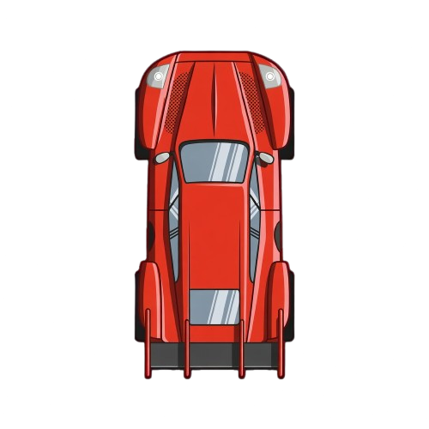

Enemy car image
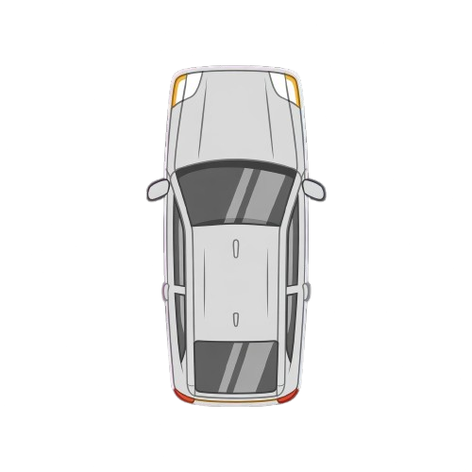

4.2 Screen Mockups

Main Menu
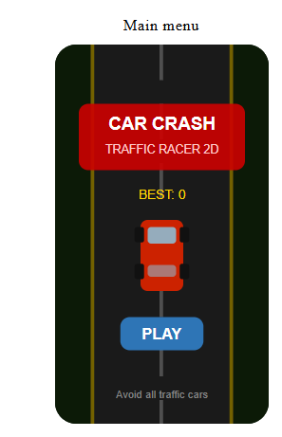
The Main Menu screen displays the game title at the top, the player's best score, and a PLAY button to start the game. The road background is visible behind the overlay to give the player a preview of the game environment.

Gameplay screenshot
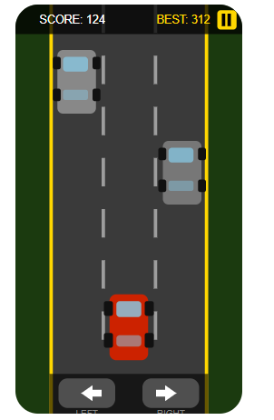
The Gameplay screen shows the 3-lane road scrolling downward. The red player car is controlled using arrow keys on desktop or the LEFT/RIGHT buttons on mobile. Enemy cars spawn from the top and move downward toward the player.

Game Over
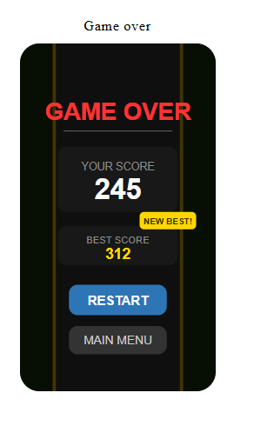
The Game Over screen appears immediately when the player collides with an enemy car. It displays the final score and the all-time best score. The player can restart the game or return to the Main Menu.

4.3 Color Palette table
Element | Color | Hex Code
Player car | Red | #CC2200
Enemy car | Gray | #888888
Road | Dark gray | #3A3A3A
Grass sides | Dark green | #1B3A0F
Road border | Gold | #FFD700
Lane lines | White | #FFFFFF
Background | Dark navy | #0D0D1A
PLAY button | Blue | #2E75B6
Score text | Gold | #FFD700

4.4 Asset Sizes table
Asset | Width | Height | Format
Player car | 50px | 100px | PNG transparent
Enemy car | 50px | 100px | PNG transparent
Canvas size | 400px | 700px | —

5. Functionality Plan: Technical Breakdown
The following section provides a detailed technical description of each functional component of the game. This plan serves as the architectural blueprint for the implementation phase (Stage 2).

5.1 Player Car Movement
The player car movement module is responsible for processing user input and translating it into positional updates on the canvas. The implementation approach is as follows:
- Keyboard Event Listeners: Event listeners on keydown and keyup capture left/right arrow key states. A Boolean flag (isMovingLeft, isMovingRight) is updated accordingly.
- Touch Event Listeners: touchstart and touchend events on defined screen regions enable mobile input.
- Boundary Clamping: The car's x-coordinate is clamped within the road boundaries to prevent the player sprite from exiting the playfield.
- Movement Speed: A configurable playerSpeed constant controls the pixels-per-frame lateral movement rate.

5.2 Road Scrolling
The infinite road effect is achieved through a tiling technique applied to the road background:
- A roadY offset variable is incremented each frame by the current gameSpeed value.
- The road texture (or drawn lane markings) is rendered at two vertical positions simultaneously, so when one tile scrolls off the bottom, the other seamlessly tiles above it.
- When roadY exceeds the canvas height, it resets to 0, creating a seamless loop.

5.3 Traffic Vehicle Spawning
The traffic spawning system manages the lifecycle of all NPC (non-player character) vehicles:
- A trafficVehicles array holds all currently active vehicle objects, each with properties: x, y, width, height, speed, and spriteType.
- A spawnTimer controls the interval between spawns, decreasing over time to increase density.
- Lane assignment is randomized using Math.random(), selecting from 3 available lanes defined by pre-calculated x-coordinates.
- Vehicles that pass below the canvas bottom are removed from the array to free memory (object pooling may be used for optimization).

5.4 Collision Detection
Axis-Aligned Bounding Box (AABB) collision detection is the standard approach for 2D sprite-based games and will be employed here. The algorithm checks whether the rectangular bounding box of the player car overlaps with any traffic vehicle bounding box:
- Each frame, the AABB check is run between the player's bounding box and every active traffic vehicle.
- A collision is confirmed when: playerX < traffic.x + traffic.width AND playerX + playerWidth > traffic.x AND playerY < traffic.y + traffic.height AND playerY + playerHeight > traffic.y.
- On confirmed collision: the game loop halts, an optional crash animation plays, and the Game Over screen is rendered.

5.5 Difficulty Escalation
The game employs a time-based difficulty curve to maintain player engagement:
- A gameSpeed variable begins at an initial value (e.g., 3 pixels/frame) and increments by a small delta every N seconds or every M score points.
- Both the road scroll speed and the traffic vehicle travel speed are derived from gameSpeed.
- A maximum speed cap prevents the game from becoming physically impossible.

5.6 Score System
- score is incremented each frame: score += Math.floor(gameSpeed * scoreFactor).
- On game over, if score > bestScore, bestScore is updated and saved to localStorage.
- Both values are rendered to the canvas HUD every frame using ctx.fillText().

5.7 Pause Functionality
- A Boolean isPaused flag controls whether the game loop executes update logic.
- The pause button toggles isPaused and changes its icon between pause/play states.
- When paused, a semi-transparent overlay is drawn on the canvas with a "PAUSED" text label.

6. Technology Stack
The game will be developed exclusively using front-end web technologies, ensuring it is platform-independent and runs natively in any modern browser without plugins or downloads.

Primary Language | JavaScript (ES6+)

Rendering Engine | HTML5 Canvas API (2D Context)

Markup | HTML5

Styling | CSS3 (for UI elements outside canvas)

Asset Design | Figma / Adobe Illustrator / Photoshop / Paint.NET

3D Modeling (Bonus) | Blender (for sprite rendering from 3D models)

Multi-Platform Packaging (Bonus) | Apache Cordova / Capacitor.js (Android APK wrapping)

Real-Time Networking (Bonus) | WebSocket API (Node.js server backend)

Data Persistence | Web localStorage API (for best score)

Version Control | Git / GitHub

The HTML5 Canvas API was selected as the rendering engine because it provides direct pixel-level control over the drawing surface, supports efficient frame-by-frame rendering through requestAnimationFrame(), and requires no external libraries or game engines. This keeps the project lightweight, academically transparent, and aligned with the course's computer graphics learning objectives.

7. Bonus Features Strategy and Evaluation
The following five bonus features have been identified in the project brief. Each has been analyzed for implementation complexity, estimated development cost (time), and strategic value to the team's final grade.

Bonus Feature | Difficulty | Recommended | Implementation Notes
Custom 2D Sprite Art | Low | Highly Recommended | Use Figma, Photoshop, or Paint.NET to design original car and road assets
Custom 3D Model Sprites | High | Optional | Model in Blender; render as 2D PNG sprites for use in canvas
Multi-Platform Support | Medium | Recommended | Responsive canvas + Android APK via Cordova or Capacitor
Same-Platform Multiplayer | High | If time allows | Two devices, WebSocket real-time race mode
Cross-Platform Multiplayer | Very High | Advanced/Optional | Android vs iOS real-time gameplay via WebSocket server

7.1 Custom 2D Sprite Art (Strongly Recommended)
Rather than using freely available sprite packs, the team will design all visual assets from scratch. This includes: the player vehicle sprite (top-down red car), traffic vehicle sprites (minimum 2-3 distinct types), road texture and lane marking assets, background side panels, HUD icons (pause button, score labels), and Game Over / Main Menu graphic elements. Recommended tools include Figma (free, vector-based, browser accessible) or Photoshop. Assets will be exported as PNG files with transparent backgrounds for canvas rendering.

7.2 Custom 3D Model Sprites (Optional)
For teams with a member experienced in 3D modeling, Blender (open-source) may be used to model top-down vehicle assets. The workflow involves creating a 3D car mesh, applying basic materials, setting up a top-down orthographic camera, and rendering the model as a high-resolution PNG sprite sheet. This adds significant visual quality to the game but is time-intensive. It is recommended only if a team member already has foundational Blender knowledge.

7.3 Multi-Platform Support (Recommended)
Since the game is built with HTML5 Canvas and JavaScript, it is inherently cross-browser and can run on any device with a modern browser. To formally support multiple platforms: (a) Responsive design: the canvas will scale to fit the viewport on mobile screens; (b) Touch controls: swipe and tap zones replace keyboard input on mobile; (c) Android APK: using Capacitor.js, the web application can be wrapped and compiled into a native Android APK, allowing the game to run as a standalone app on Android devices.

7.4 Same-Platform Multiplayer (Advanced)
A competitive multiplayer mode can be implemented where two players on two separate Android devices race simultaneously. This requires a lightweight WebSocket server (Node.js with the 'ws' library) to relay player position data in real time between devices. Each client sends its own car's x-position every frame, receives the opponent's position, and renders both cars on screen. Network latency must be managed through interpolation. This feature is recommended only if development time permits after core functionality is complete.

7.5 Cross-Platform Multiplayer (Advanced)
The most technically challenging bonus, cross-platform multiplayer extends the multiplayer functionality across different operating systems (e.g., Android vs. iOS, or mobile vs. desktop browser). Since the game is web-based, the same WebSocket infrastructure used for same-platform multiplayer applies here. The key differentiator is ensuring that the responsive design and touch/keyboard input systems function correctly across all target platforms simultaneously. This feature is an committed feature.

8. Conclusion
This document presents a comprehensive structured Game Design Plan for Car Crash Traffic Racer 2D, a 2D top-down web-based traffic avoidance game developed as part of the Computer Graphics course project.
The design covers all essential dimensions of the game: a clearly defined game concept with an engaging and escalating challenge loop, a well-organized UI/UX layout for three distinct game screens, a technically detailed functionality plan grounded in established 2D game development principles (AABB collision detection, object spawning systems, requestAimationFrame-based game loops), a deliberate and justified technology stack centered on HTML5 Canvas and JavaScript, and a realistic and prioritized bonus feature strategy.
The development team is prepared to proceed to the implementation phase following the Stage 1 discussion on April 18, 2026, with a clear roadmap toward the Final Submission on May 9, 2026. The primary success criteria are: a fully playable, collision-responsive, and scoring-capable game running in a web browser, enhanced by original 2D visual assets designed by the team.

End of Stage 1: Game Design Submission Document

