Course Name:
CSC 312 Analysis and Design of Algorithms
━━━━━━━━━━━━━━━━━━━━━━━━━━━━
Longest Common Subsequence (LCS)
Team Members:
Manar Azzam – 20234821
Noor Riyadh– 20232878
Rawan Ayman – 20232775
Hala Mohamed – 20234733

Section Details:
Day: Tuesday | Time: 01:00 - 03:00 PM
Supervised By:
Assoc. Prof. Wael Zakaria
Eng. Farah Ashraf

Table of Contents
PROJECT OVERVIEW 3
PROBLEM DEFINITION 4
Longest Common Subsequence (LCS) 4
Real-World Applications 4
ALGORITHM IMPLEMENTATIONS 5
Approach 1: Brute Force 5
Algorithm Design 5
Code Link 5
Complexity Analysis 5
Results 5
Approach 2: Backtracking with Sequence Reconstruction 6
Algorithm Design 6
Code Link 6
Complexity Analysis 6
Results 6
Approach 3: Dynamic Programming (Standard) 7
Algorithm Design 7
Code Link 7
Complexity Analysis 7
Results 7
Approach 4: Dynamic Programming (Space Optimized) 8
Algorithm Design 8
Code Link 8
Complexity Analysis 8
Results 8
COMPARATIVE ANALYSIS 9
Complexity Comparison Table 9
Performance Results 9
Algorithm Selection Recommendations 10
CONCLUSIONS 11
REFERENCES 12

PROJECT OVERVIEW
This project implements and analyzes multiple algorithmic approaches to solve the Longest Common Subsequence (LCS) problem. The primary objective is to compare different algorithms based on their time complexity, space complexity, and practical performance across various input sizes.
Project Objectives:
- Implement multiple LCS solution approaches
- Analyze theoretical time and space complexity
- Compare practical performance through empirical testing
- Identify optimal approaches for different scenarios

PROBLEM DEFINITION

Longest Common Subsequence (LCS)
Given two sequences X and Y, the Longest Common Subsequence (LCS) is the longest subsequence that appears in both sequences in the same relative order, but not necessarily consecutively.
Key Characteristics:
- Subsequence: Order matters, but elements need not be consecutive
- Common: Must appear in both input sequences
- Longest: We seek the maximum-length such subsequence
Example:
Input | Value
String X | "ABCDGH"
String Y | "AEDFHR"
LCS Result | "ADH" (Length = 3)
Explanation: The characters A, D, and H appear in both strings in the same order. This is the longest sequence.

Real-World Applications
- Bioinformatics: DNA sequence alignment
- Version Control: Diff tools (Git, SVN)
- Plagiarism Detection: Document similarity analysis
- Data Compression: Finding repeated patterns
- File Comparison: Text editors and merge tools

ALGORITHM IMPLEMENTATIONS

Approach 1: Brute Force

Algorithm Design
The brute force approach exhaustively explores all possible subsequences:
- Generate all possible subsequences of String X (2^{n} subsequences)
- For each subsequence, check if it appears in String Y in the same order
- Track and return the longest valid subsequence found

Code Link
File: lcs_bruteforce.py

Complexity Analysis
Complexity Type | Value
Time Complexity | O (2^{n} × m)
Space Complexity | O (n)
Analysis:
- Extremely inefficient due to exponential time complexity
- Only practical for very small inputs (n < 20)
- Educational value: demonstrates the problem space exhaustively
- Not suitable for production use

Results
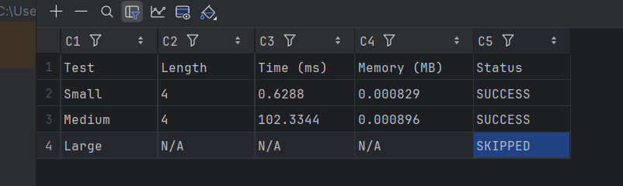

Approach 2: Backtracking with Sequence Reconstruction

Algorithm Design
The backtracking approach uses recursive exploration with pruning:
- Recursively explore matching characters from both strings
- If characters match, include in subsequence and recurse on remaining strings
- If characters don't match, try both: skip character in X or skip character in Y
- Return the longer of the two recursive results
- Reconstruct the actual LCS string during backtracking

Code Link
File: lcs_backtrack.py

Complexity Analysis
Complexity Type | Value
Time Complexity | O(2^{min(m,n)})
Space Complexity | O(m + n) - Recursion stack
Analysis:
- Still exponential but with better pruning than brute force
- Can reconstruct the actual LCS string, not just its length
- More efficient than brute force but still impractical for large inputs

Results
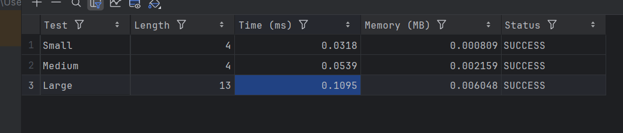

Approach 3: Dynamic Programming (Standard)

Algorithm Design
The standard DP approach builds a 2D table to store subproblem solutions:
- Create a 2D table dp[m+1][n+1] where m and n are string lengths
- Initialize first row and column to 0 (empty string cases)
- Fill table using recurrence relation:
  - If X[i] == Y[j]: dp[i][j] = dp[i-1][j-1] + 1
  - Else: dp[i][j] = max(dp[i-1][j], dp[i][j-1])
- Backtrack through table to reconstruct the actual LCS string

Code Link
File: lcs_dp_standard.py

Complexity Analysis
Complexity Type | Value
Time Complexity | O(m × n)
Space Complexity | O(m × n)
Analysis:
- Optimal polynomial time complexity
- Can reconstruct the actual LCS string through backtracking
- Most practical general-purpose solution
- Works efficiently for large inputs (strings up to thousands of characters)
- Industry standard approach

Results
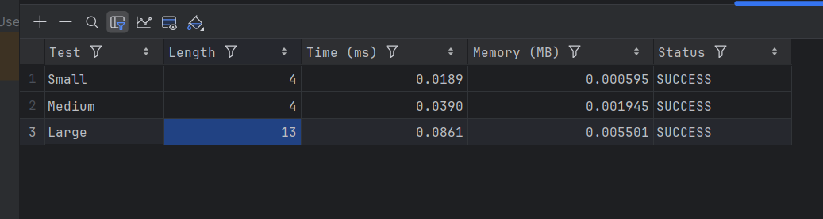

Approach 4: Dynamic Programming (Space Optimized)

Algorithm Design
The space-optimized DP approach reduces memory usage by using only two rows:
- Create only two arrays: current and previous (each of size n+1)
- Use the same recurrence relation as standard DP
- Alternate between current and previous rows for each iteration
- Final answer is in the last computed cell

Code Link
File: lcs_dp_optimized.py

Complexity Analysis
Complexity Type | Value
Time Complexity | O(m × n)
Space Complexity | O(min(m, n))
Analysis:
- Same time complexity as standard DP
- Significantly reduced space complexity: from O(m×n) to O(min(m,n))
- Best choice when memory is limited
- Trade-off: Cannot easily reconstruct the actual LCS string
- Ideal for finding LCS length only

Results
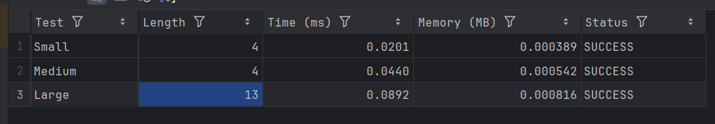

COMPARATIVE ANALYSIS

Complexity Comparison Table
Approach | Time | Space | Reconstruct
Brute Force | O(2^{n}×m) | O(n) | Yes
Backtracking | O(2^{min(m,n)}) | O(m+n) | Yes
DP Standard | O(m×n) | O(m×n) | Yes
DP Optimized | O(m×n) | O(min(m,n)) | No*
*Requires additional space to store sequence

Performance Results
The following table shows empirical results from testing on various input sizes:
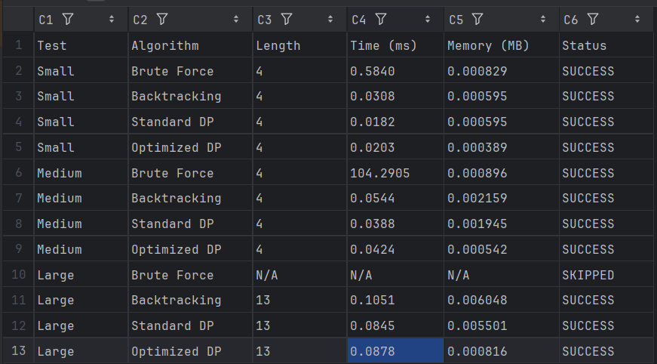
Test Input Categories:
- Small: Strings of length 10-50 characters
- Medium: Strings of length 100-500 characters
- Large: Strings of length 1000-5000 characters

Algorithm Selection Recommendations
Based on our analysis and testing, here are recommendations for different scenarios:
1. For Production Systems (General Use)
- Recommendation: Dynamic Programming (Standard)
- Rationale: Best balance of performance and functionality
- Use when: You need both the LCS length and the actual sequence
2. For Memory-Constrained Environments
- Recommendation: Dynamic Programming (Optimized)
- Rationale: Significantly reduced memory footprint
- Use when: Memory is limited or you only need the LCS length
3. For Educational Purposes
- Recommendation: Study all approaches in order of complexity
- Rationale: Understanding the evolution from brute force to DP illustrates algorithm optimization
4. Never Recommended for Production
- Approaches: Brute Force and Backtracking
- Reason: Exponential time complexity makes them impractical for real-world use

CONCLUSIONS
This project successfully implemented and analyzed four different approaches to the Longest Common Subsequence problem, demonstrating the dramatic improvements achieved through algorithmic optimization.
Key Findings:
- Algorithm choice dramatically affects performance: The difference between brute force (exponential) and dynamic programming (polynomial) is the difference between seconds and hours for moderately sized inputs.
- Dynamic programming is the clear winner: Both DP variants offer optimal polynomial time complexity, making them suitable for production use.
- Space-time trade-offs exist: The optimized DP approach reduces space complexity from O(m×n) to O(min(m,n)) while maintaining the same time complexity, at the cost of losing easy sequence reconstruction.
- Understanding algorithmic evolution is valuable: Studying the progression from naive to optimized solutions provides deep insights into algorithm design principles.
Future Work:
- Complete the backtracking implementation with sequence reconstruction
- Investigate parallel and GPU-accelerated implementations
- Explore applications in specific domains (bioinformatics, version control)
- Compare with approximate algorithms for very large sequences

REFERENCES
[1] Cormen, T. H., Leiserson, C. E., Rivest, R. L., & Stein, C. (2009). Introduction to Algorithms (3rd ed.). MIT Press.
[2] Hirschberg, D. S. (1975). A linear space algorithm for computing maximal common subsequences. Communications of the ACM, 18(6), 341-343.
[3] Wagner, R. A., & Fischer, M. J. (1974). The string-to-string correction problem. Journal of the ACM (JACM), 21(1), 168-173.
[4] Needleman, S. B., & Wunsch, C. D. (1970). A general method applicable to the search for similarities in the amino acid sequence of two proteins. Journal of Molecular Biology, 48(3), 443-453.
[5] Course materials: CSC 312 Analysis and Design of Algorithms, Future University in Egypt, Fall 2025.

