**CSC-103L Object Oriented Programming**

**Electronic Voting Machine**



**Submitted by:**

Noor Fatima 2024-SE-09

Kashaf Sajjad 2024-SE-29

Shehzal Irfan 2024-SE-44

**Submitted to:**

Ms. Zoha Sohail

Dated: 11th May, 2025

**Department of Computer Science**

**University of Engineering and Technology Lahore, New Campus**

**Electronic Voting Machine**

**UML:**

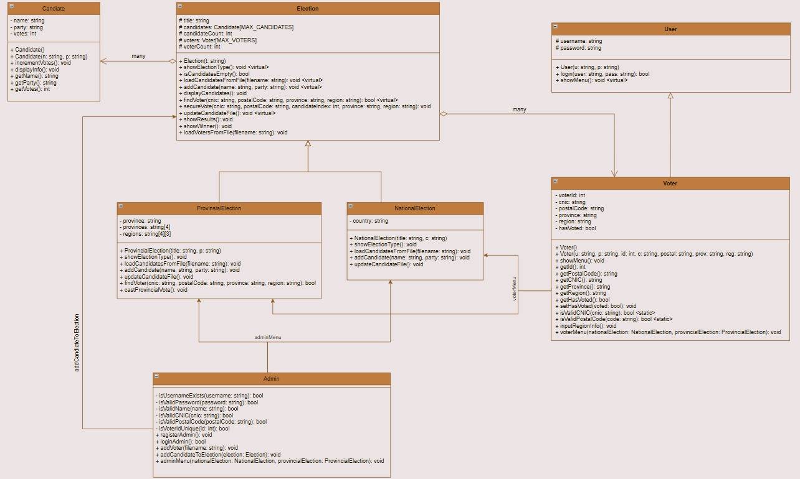

**GitHub Repository Link:**

<https://github.com/Noor-Shahbaz-18/Electronic_Voting_Machine>

**Video Link:**

<https://drive.google.com/file/d/1daBnO9bh1G55uSrAyoq7V_0EnOI3-PTv/view?usp=sharing>