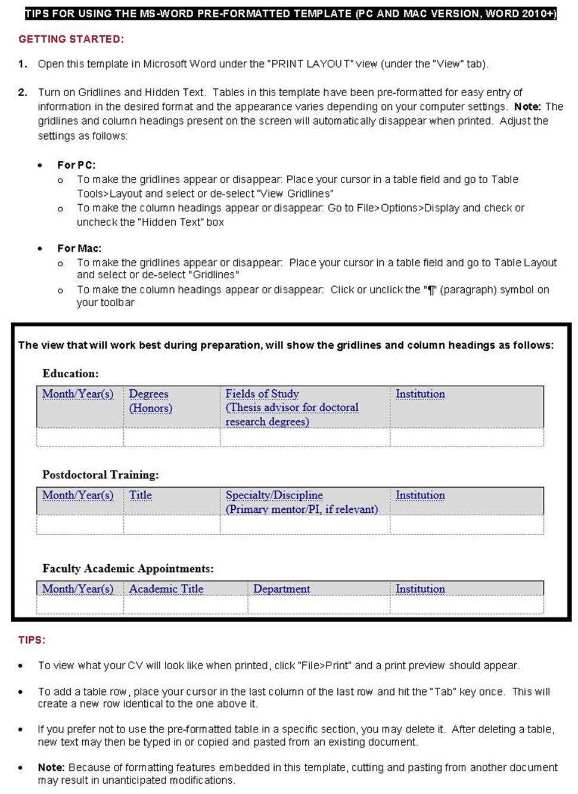General Instructions for Preparation of the Faculty of Medicine Curriculum Vitae

TIPS FOR USING THE-MS·WORD PRE-FORMATTED TEMPLATE (PC AND MAC VERSION, WORD2010+)

GETTING STARTED:

1. Open this template in Microsoft Word under the “PRINT LAYOUT" view (under the "View" tab).
2. Turn on Gridlines and Hidden Text. Tables in this template have been pre-formatted for easy entry of information in the desired format and the appearance varies depending on your computer settings. Note: The gridlines and column headings present on the screen will automatically disappear when printed. Adjust the settings as follows:

* For PC:
  + To make the gridlines appear or disappear: Place your cursor in a table field and go to Table>Tools>Layout and select or de-select "View Gridlines"
  + To make the column headings appear or disappear: Go to File> Options>Display and check or uncheck the "Hidden Text" box
* For Mac:
  + To make the gridlines appear or disappear: Place your cursor in a table field and go to Table Layout and select or de-select "Gridlines"
  + To make the column headings appear or disappear: Click or unclick the "¶'' (paragraph) symbol on your toolbar

The view that will work best during preparation, will show the gridlines and column headings as follows:

Education:

|  |  |  |  |
| --- | --- | --- | --- |
| Month/Year(s) | Degrees (Honors) | Fields of Study (Thesis advisor for doctoral research degrees) | Institution |
|  |  |  |  |

Postdoctoral Training:

|  |  |  |  |
| --- | --- | --- | --- |
| Month/Year(s) | Degrees (Honors) | Fields of Study (Thesis advisor for doctoral research degrees) | Institution |
|  |  |  |  |

Faculty Academic Appointments

|  |  |  |  |
| --- | --- | --- | --- |
| Month/Year(s) | Degrees (Honors) | Fields of Study (Thesis advisor for doctoral research degrees) | Institution |
|  |  |  |  |

TIPS:

* To view what your CV will look like when printed, click "File>Print" and a print preview should appear.
* To add a table row , place your curs or in the last column of the last row and hit the "Tab" key once. This will create a new row identical to the one above it.
* If you prefer not to use the pre-formatted table in a specific section, you may delete it. After deleting a table, new text may then be typed in or copied and pasted from an existing document.
* Note: Because of formatting features embedded in this template, cutting and pasting from another document may result in unanticipated modifications.

**(Please delete this first page from your final CV)**

The Faculty of Medicine of Harvard University   
Curriculum Vitae

|  |  |
| --- | --- |
| **Date Prepared:** |  |
| **Name:** |  |
| **Office Address:** |  |
| **Home Address:** |  |
| **Work Phone:** |  |
| **Work Email:** |  |

Education:

|  |  |  |  |
| --- | --- | --- | --- |
| Month/Year(s) | Degrees (Honors) | Fields of Study  (Thesis advisor for doctoral research degrees) | Institution  Location |
|  |  |  |  |

Postdoctoral Training:

|  |  |  |  |
| --- | --- | --- | --- |
| Month/Year(s) | Title | Specialty/Discipline  (Primary mentor/PI, if relevant) | Institution  Location |
|  |  |  |  |

Faculty Academic Appointments:

|  |  |  |  |
| --- | --- | --- | --- |
| Year(s) | Academic Title | Department | Academic Institution |
|  |  |  |  |

Appointments at Hospitals/Affiliated Institutions:

|  |  |  |  |
| --- | --- | --- | --- |
| Year(s) | Position Title | Department  (Division, if applicable) | Institution |
|  |  |  |  |

Faculty Membership in Harvard Initiatives, Programs, Centers, and Institutes

|  |  |  |  |
| --- | --- | --- | --- |
| Year(s) | Position Title | Program | Institution |
|  |  |  |  |

Other Professional Positions:

|  |  |  |  |
| --- | --- | --- | --- |
| Year(s) | Position Title | Institution | Level of effort  (current roles only) |
|  |  |  |  |

Major Administrative Leadership Positions:

Local

|  |  |  |
| --- | --- | --- |
| Year(s) | Position Title | Institution (note if specific department) |

|  |  |  |
| --- | --- | --- |
|  |  |  |

Regional

|  |  |  |
| --- | --- | --- |
| Year(s) | Position Title | Organization  Location |

|  |  |  |
| --- | --- | --- |
|  |  |  |

National

|  |  |  |
| --- | --- | --- |
| Year(s) | Position Title | Organization  Location |

|  |  |  |
| --- | --- | --- |
|  |  |  |

International

|  |  |  |
| --- | --- | --- |
| Year(s) | Position Title | Organization  Location |

|  |  |  |
| --- | --- | --- |
|  |  |  |

Committee Service:

Local

|  |  |  |
| --- | --- | --- |
| Year(s) | Name of Committee | Institution/Organization |
|  | Dates of Role(s) | Title of Role(s) |
|  |  |  |
|  |  |  |

Regional

|  |  |  |
| --- | --- | --- |
| Year(s) | Name of Committee | Institution/Organization |
|  | Dates of Role(s) | Title of Role(s) |
|  |  |  |
|  |  |  |

National

|  |  |  |
| --- | --- | --- |
| Year(s) | Name of Committee | Institution/Organization |
|  | Dates of Role(s) | Title of Role(s) |
|  |  |  |
|  |  |  |

International

|  |  |  |
| --- | --- | --- |
| Year(s) | Name of Committee | Institution/Organization |
|  | Dates of Role(s) | Title of Role(s) |

|  |  |  |
| --- | --- | --- |
|  |  |  |
|  |  |  |

Professional Societies:

|  |  |  |
| --- | --- | --- |
| Year(s) | Society Name |  |
|  | Dates of Role(s) | Title of Role(s) |
|  |  |  |
|  |  |  |

Grant Review Activities:

|  |  |  |
| --- | --- | --- |
| Year(s) | Name of Committee | Institution/Organization |
|  | Dates of Role(s) | Title of Role(s)  [indicate either Ad hoc or Permanent Member status, if applicable] |

|  |  |  |
| --- | --- | --- |
|  |  |  |
|  |  |  |

Editorial Activities:

* Ad hoc Reviewer

|  |
| --- |
| List journals for which you serve as a reviewer |

|  |
| --- |
|  |

* Other Editorial Roles

|  |  |  |
| --- | --- | --- |
| Year(s) | Role | Journal/Publication Title |

|  |  |  |
| --- | --- | --- |
|  |  |  |
|  |  |  |

Honors and Prizes:

|  |  |  |  |
| --- | --- | --- | --- |
| Year | Name of Honor/Prize | Awarding Organization | Achievement for which awarded  (if unclear from award title) |

|  |  |  |  |
| --- | --- | --- | --- |
|  |  |  |  |

Report of Funded and Unfunded Projects

Past

|  |  |
| --- | --- |
| Year(s) | Grant title |
|  | Funding Agency, Grant type and Grant number |
|  | Official role on project |
|  | Description of the major goals (limit to 1-2 sentences) |

|  |  |
| --- | --- |
|  |  |
|  |  |
|  |  |
|  |  |

Current

|  |  |
| --- | --- |
| Year(s) | Grant title |
|  | Funding Agency, Grant type and Grant number |
|  | Official role on Project (if PI or Site PI, report total direct costs for all years) |
|  | Description of the major goals (limit to 1-2 sentences) |

|  |  |
| --- | --- |
|  |  |
|  |  |
|  |  |
|  |  |

Projects Submitted for Funding

|  |  |
| --- | --- |
| Status | Grant title |
| Funding Agency and Grant type |
|  | Role on Project (if in PI role, list requested direct costs) |
|  | Description of the major goals (limit to 1-2 sentences)  Include preliminary scores or review date if known |

|  |  |
| --- | --- |
|  |  |
|  |  |
|  |  |
|  |  |

Training Grants and Mentored Trainee Grants

|  |  |
| --- | --- |
| Year(s) | Grant title |
|  | Funding Agency and Grant Type |
|  | Role on Project (e.g., Mentor or Faculty Member) |
|  | Description of the major goals (limit to 1-2 sentences) |

|  |  |
| --- | --- |
|  |  |
|  |  |
|  |  |
|  |  |

Unfunded Current Projects

|  |  |
| --- | --- |
| Year(s) | Title of Project |
|  | Role |
|  | One sentence description of the purpose of the project |

|  |  |
| --- | --- |
|  |  |
|  |  |

Report of Local Teaching and Training

Teaching of Students in Courses:

|  |  |  |
| --- | --- | --- |
| Year(s) | Course Title | Location |
|  | Type of Student/Audience | Level of Effort |

|  |  |  |
| --- | --- | --- |
|  |  |  |
|  |  |  |

Formal Teaching of Residents, Clinical Fellows and Research Fellows (post-docs):

|  |  |  |
| --- | --- | --- |
| Year(s) | Title | Location |
|  | Type of Trainee/Audience | Level of Effort |

|  |  |  |
| --- | --- | --- |
|  |  |  |
|  |  |  |

Clinical Supervisory and Training Responsibilities:

|  |  |  |
| --- | --- | --- |
| Year(s) | Type of Responsibility | Location |
|  | Type of Trainee/Audience | Level of Effort |

|  |  |  |
| --- | --- | --- |
|  |  |  |

Research Supervisory and Training Responsibilities:

|  |  |  |
| --- | --- | --- |
| Year(s) | Type of Responsibility | Location |
|  | Type of Trainee/Audience | Level of Effort |

|  |  |  |
| --- | --- | --- |
|  |  |  |

Formally Mentored Harvard Students (Medical, Dental, Graduate, and Undergraduate):

|  |  |
| --- | --- |
| Year(s) | Name, Program |
|  | Briefly describe the accomplishments of your mentee as a direct result of your mentorship. |

|  |  |
| --- | --- |
|  |  |
|  |  |

****Other Mentored Trainees and Faculty:****

|  |  |
| --- | --- |
| Year(s) | Name and degree(s) / Current position, Institution |
|  | Note the mentee’s career stage during the mentorship period and your mentoring role. Briefly describe the accomplishments of your mentee as a direct result of your mentorship. |

|  |  |
| --- | --- |
|  |  |
|  |  |

Formal Teaching of Peers (e.g., CME and other continuing education courses):

|  |
| --- |
| Check the **single** most appropriate statement below (double click the chosen box and change the default value to “checked”) |

*No presentations below were sponsored by 3rd parties/outside entities*

*Those presentations below sponsored by outside entities are so noted and the sponsor(s) is (are) identified.*

|  |  |  |
| --- | --- | --- |
| Year(s) | Title(s) or topic(s) of talks | Number of talks in a single course |
|  | Course Name (Sponsor, if any) | Location(s) (city or country) |
|  |  |  |
|  |  |  |

Local Invited Presentations:

|  |
| --- |
| Check the **single** most appropriate statement below (double click the chosen box and change the default value to “checked”) |

*No presentations below were sponsored by 3rd parties/outside entities*

*Those presentations below sponsored by outside entities are so noted and the sponsor(s) is (are) identified.*

|  |  |
| --- | --- |
| Year(s) | Title of presentation / Type of presentation |
|  | Department and Institution where presented (Sponsor, if any) |

|  |  |
| --- | --- |
|  |  |
|  |  |

Report of Regional, National and International Invited Teaching and Presentations

|  |
| --- |
| Check the **single** most appropriate statement below (double click the chosen box and change the default value to “checked”) |

*No presentations below were sponsored by 3rd parties/outside entities*

*Those presentations below sponsored by outside entities are so noted and the sponsor(s) is (are) identified.*

Regional

|  |  |
| --- | --- |
| Year(s) | Title of presentation or name of course / Type of presentation/role(s)  (note if presentation was the result of a selected abstract) |
|  | Location (Sponsor, if any) |

|  |  |
| --- | --- |
|  |  |
|  |  |

National

|  |  |
| --- | --- |
| Year(s) | Title of presentation or name of course / Type of presentation/role(s)  (note if presentation was the result of a selected abstract) |
|  | Location (Sponsor, if any) |

|  |  |
| --- | --- |
|  |  |
|  |  |

International

|  |  |
| --- | --- |
| Year(s) | Title of presentation or name of course / Type of presentation/role(s)  (note if presentation was the result of a selected abstract) |
|  | Location (Sponsor, if any) |

|  |  |
| --- | --- |
|  |  |
|  |  |

Report of Clinical Activities and Innovations

Past and Current Licensure and Board Certification:

|  |  |
| --- | --- |
| Year | Type of License or Certification |

|  |  |
| --- | --- |
|  |  |

Practice Activities:

|  |
| --- |
| List all clinical activities, both those at Harvard and its affiliates and those outside Harvard, and for each indicate: |

|  |  |  |  |  |  |  |
| --- | --- | --- | --- | --- | --- | --- |
| Year(s) | Type of activity | | | Name and location of practice | Level of activity | |
|  | |  |  | | |  |

If you have no current clinical activities, but have practiced in the past, you may provide a brief (1-4 sentences) description of those prior activities:

|  |
| --- |
|  |

Clinical Innovations:

|  |  |
| --- | --- |
| Name/location of clinical innovation; (Year(s) of activity) | Describe the influence or potential influence of the innovation on clinical care or practice management, including how the innovation is used or has been implemented locally (at HMS), regionally, nationally, or internationally; if developed as a member of a team or committee, describe your contribution.  (~1-3 sentences) |

|  |  |
| --- | --- |
|  |  |
|  |  |

Report of Teaching and Education Innovations

|  |  |
| --- | --- |
| Name/location of education innovation;  (Year(s) of activity) | Describe the influence or potential influence of the innovation on education or teaching, including how the material is used locally (at HMS), regionally, nationally, or internationally; if developed as a member of a team, describe your contribution. (~1-3 sentences) |
|  |  |
|  |  |

Report of Technological and Other Scientific Innovations

|  |  |
| --- | --- |
| Innovation;  (Year(s) of activity) | Describe the influence or potential influence of the innovation on research or clinical care, including how the material is used locally (at HMS), regionally, nationally, or internationally; if developed as a member of a team, describe your contribution. (~1-3 sentences) |
|  | If applicable, list information regarding any pending, awarded, and/or licensed patents. |
|  |  |
|  |  |

Report of Education of Patients and Service to the Community

|  |
| --- |
| Check the most appropriate statement below (double click the chosen box and change the default value to “checked”) |

*No presentations below were sponsored by 3rd parties/outside entities*

*Those presentations below sponsored by outside entities are so noted and the sponsor(s) is (are) identified.*

Activities

|  |  |
| --- | --- |
| Year(s) | Organization or institution / Role (Sponsor, if any) |
|  | One sentence description (optional) |

|  |  |
| --- | --- |
|  |  |
|  |  |

Educational Material for Patients and the Lay Community:

Books, articles, and presentations in other media

|  |  |  |  |
| --- | --- | --- | --- |
| Year | Title | Type of contribution (Sponsor, if any) | Citation, if any |

|  |  |  |  |
| --- | --- | --- | --- |
|  |  |  |  |

Educational material or curricula developed for non-professional audiences

|  |  |  |  |
| --- | --- | --- | --- |
| Year | Title | Type of contribution (Sponsor, if any) | Citation, if any |

|  |  |  |  |
| --- | --- | --- | --- |
|  |  |  |  |

Patient educational material

|  |  |  |  |
| --- | --- | --- | --- |
| Year | Title | Type of contribution (Sponsor, if any) | Citation, if any |

|  |  |  |  |
| --- | --- | --- | --- |
|  |  |  |  |

Recognition:

|  |  |  |
| --- | --- | --- |
| Year(s) | Name of award / recognition | Organization conferring recognition |

|  |  |  |
| --- | --- | --- |
|  |  |  |
|  |  |  |

Report of Scholarship

Peer-Reviewed Scholarship in print or other media:

|  |
| --- |
| Group peer-reviewed publications in three categories under the following headings:   * Research Investigations (full-length manuscripts that present new data and analysis; includes systematic reviews (with or without meta-analysis) * Other peer-reviewed scholarship (e.g., reviews, clinical guidelines or consensus statements, case reports, UpToDate and MedEdPORTAL submissions) * Scholarship without named authorship |

Research Investigations

|  |
| --- |
|  |

Other peer-reviewed scholarship

|  |
| --- |
|  |

Scholarship without named authorship

|  |
| --- |
|  |

Non-peer reviewed scholarship in print or other media:

|  |
| --- |
| Group materials into the following (optional) categories:   * Reviews, chapters, and editorials * Books/Textbooks for the medical or scientific community   + *Only include books for which you are listed as an author. Books that you edited should be listed under Other Editorial Activities.* * Case reports * Letters to the Editor * Other non-peer reviewed scholarship |

Reviews, chapters, and editorials

|  |
| --- |
|  |

Books/textbooks for the medical or scientific community

|  |
| --- |
|  |

Case reports

|  |
| --- |
|  |

Letters to the Editor

|  |
| --- |
|  |

Other non-peer reviewed scholarship

|  |
| --- |
|  |

Professional educational materials or reports, in print or other media:

|  |
| --- |
| For each item indicate:   * Type of material (e.g., syllabus, teaching case) * If published in print or on the web, provide citation * Intended audience (including course number, if applicable) and brief description of how the material is used locally (at HMS), regionally, nationally, or internationally; if developed as a member of a committee, describe your contribution (1-2 sentences) |

|  |
| --- |
|  |

Local/Unpublished Clinical Guidelines and Reports:

|  |
| --- |
| For each item indicate:   * Type of material (e.g., clinical protocol or standard of care) * If published in print or on the web, provide citation or link * Description of how the material is used locally (at HMS), regionally, nationally or internationally; if developed as a member of a committee, describe your contribution (1-2 sentences) |

|  |
| --- |
|  |

Thesis:

|  |
| --- |
| Provide full citation for doctoral thesis |

|  |
| --- |
|  |

Manuscripts Submitted to Preprint Servers

|  |
| --- |
| List any unpublished manuscripts that were submitted to, and posted on, a preprint server (e.g., bioRxiv, medRxiv, Research Square) within the last 3 years. Citations must include a digital object identifier (DOI). Remove listing if manuscript is accepted for publication in a journal. |

|  |
| --- |
|  |

Abstracts, Poster Presentations, and Exhibits Presented at Professional Meetings:

|  |
| --- |
| List abstracts published and posters presented at meetings during the last 3 years which have not already been published as full-length manuscripts. May also list all abstracts or exhibits, regardless of date, which received special recognition at a meeting (e.g., juried poster presentation, meeting commendation). |

|  |
| --- |
|  |

Narrative Report

|  |
| --- |
| The narrative should describe your major contributions and achievements and should be clear to those outside your field. Readers should understand your career trajectory and impact. You do not need to reiterate your history of training, but the chronology of your accomplishments should be clear. You should describe the extent of your reputation and the key achievements for which you are known. If your accomplishments bridge different arenas (e.g., research and clinical care), you may wish to clarify any connections that are not readily apparent. Additionally, feel free to include any meaningful educational experiences (e.g., leadership or specialized course training) that you feel have impacted your career trajectory.  General Guidelines   * Do not exceed two single-spaced pages; length is generally commensurate with rank (e.g. ≤ 1-page for Instructors and Assistant Professors) * Can be optionally organized with subheadings for different topics * Write in the first person (use “I” statements) * Avoid jargon; instead, write for a broad audience * Avoid or limit personal details about your family or health * Update periodically to account for career growth   Purpose of the Narrative   * Tell a cohesive story about the various aspects of your career * Describe the impact of your work on the field, with an extension to how it benefits healthcare * Demonstrate evidence of dissemination of your work * Convey the ‘big picture’ relevance of your work to non-experts * Give perspective about the importance of field-specific activities * Explain events or accomplishments that don’t fit anywhere else * Anticipate obvious questions about major career shifts or work gaps * Emphasize your recent and future work, including work in progress   Include contributions to:   * Your Area of Excellence, if applicable (e.g., Clinical Expertise and Innovation; Investigation; Teaching and Educational Leadership). * Teaching and mentorship (if not already described under your Area of Excellence). * Any Significant Supporting Activities (Administration & Institutional Service; Clinical Expertise; Education of Patients & Service to the Community; Diversity, Equity & Inclusion; Investigation; Special Merit in Education). |
|  |