MOMENTS
Unity Mini-Game Design Document
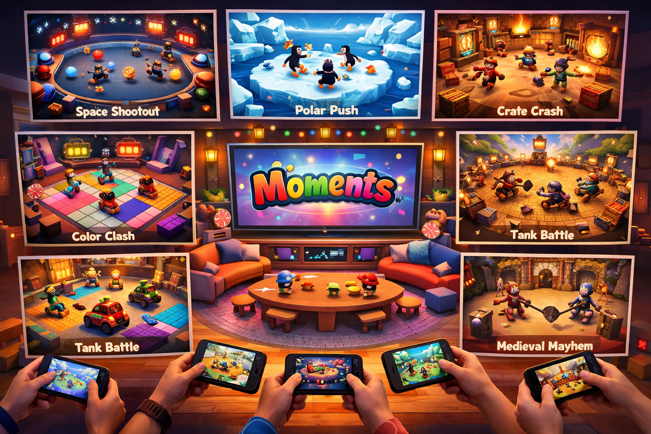
CORE  PITCH | Moments is a couch-party platform for TV play, where one TV hosts the session and each player joins with a phone as a touch controller. The product ships as one main game with fast, social mini-games, a shared leaderboard, short match flow, and a polished 3D toy-box visual style.
Version 1.1 • QR join + character select update • target engine: Unity

1. Product Vision
Moments should feel like a premium local multiplayer party game: instant to join, visually readable from the couch, and funny even when players are losing. The TV is the authority, camera, and spectacle surface. Phones are lightweight controllers that also carry player color, ready state, micro-prompts, and vibration feedback.
• Session length: 15–30 minutes for a full party round, with each mini-game lasting roughly 60–120 seconds.
• Audience: families, friends, events, cafés, living-room gatherings, and casual players who may not own console controllers.
• Game fantasy: every mini-game is a big, exaggerated ‘moment’—a tiny social challenge expanded into a vivid 3D arena.

2. Experience Pillars
Pillar | Implementation
Instant Join | Players scan a QR code or enter a room code on phone, choose a nickname, color, and avatar, then join in under 30 seconds.
Readable Chaos | The TV scene remains legible at a distance with bold silhouettes, clean color coding, low-clutter arenas, and oversized VFX.
Short Rules, High Replay | Each mini-game teaches itself in one instruction card and one practice beat.
Phone-First Input | Each mini-game maps cleanly to touch: virtual stick, big buttons, tap, swipe, hold, or tilt only when optional.

3. High-Level Game Loop
• TV boots to a hero screen with a large QR code, short room code, and animated attract mode.
• Players scan the TV QR code to open a lightweight controller page instantly—no app install required for the first playable version.
• After joining, each player chooses one character from a roster of pre-designed heroes; the TV shows live occupancy so no two players accidentally lock the same slot unless duplicates are enabled.
• Players join from phone web app or companion app, pick avatar and ready up.
• Main host starts a playlist, random rotation, or vote-based party set.
• Before each mini-game, the TV shows a 6–8 second rules card while each phone shows only the needed controls.
• Round ends with results, medals, and short momentum animations before returning to the carousel.
• A final podium crowns the winner of the full Moments session.

4. System Architecture (TV as Server)
Layer | Responsibility
TV / Host App | Unity executable on smart TV, console, mini-PC, or casting device. Runs authoritative game state, simulation, scorekeeping, and scene transitions.
Phone Controller Client | Responsive mobile web client is recommended first for frictionless onboarding; native wrapper can come later. Sends touch input, receives UI state, haptics, and phone-side prompts.
Networking | Local Wi-Fi preferred. WebSockets for reliable state + low-latency input messages. TV remains authoritative to prevent desync and cheating.
Session Services | Join token, reconnect handling, latency measurement, player color assignment, match timer sync, and analytics event logging.
Recommended Unity stack: Unity 6, URP, Addressables for mini-game scenes, WebSocketSharp or a maintained socket layer for controller comms, ScriptableObjects for mini-game configs, Cinemachine for TV cameras, and Unity Localization for multilingual party prompts.

5. Mini-Game Lineup
Mini-game | Genre | Core loop | Phone input | Win rule
Space Shootout | Arena deflection / score attack | Move, aim paddle shield, reflect plasma orbs into opponents’ goals. Power-ups split balls, slow time, or add shields. | Virtual stick + reflect button | Last player standing or highest score after 90 sec.
Polar Push | Knockback survival | Cute winter avatars bump, dash, and body-check on melting ice. Cracks widen and pieces break away over time. | Move + dash | Stay on the platform longest.
Color Clash | Tile capture | A dance-floor arena of tiles changes to the player color when stepped on, painted, or pulse-blasted. Hazards periodically clear zones. | Move + paint pulse | Own the largest tile percentage at timer end.
Crate Crash | Pickup combat | Players grab crates, throw objects, and pop shields in a compact arena. Pickups include bombs, boxing gloves, and boomerangs. | Move + throw + dodge | Most KOs or lives remaining.
Tank Battle | Twin-stick arena battle | Toy tanks slide around a courtyard with destructible cover, ricochet shells, mines, and boost pads. | Left stick steer / right fire or aim | First to target score.
Dash Circuit | Micro-racing | Short lap races with bumping, boost strips, sticky goo, and shortcut risk-reward. Works in 45–75 second rounds. | Steer + boost + brake/drift | Finish place or total points over 3 heats.
Medieval Mayhem | Arena objective rotation | A castle arena rotates between bomb tag, king-of-the-hill, loot run, and hammer duel modifiers. | Move + action + pickup | Objective points across rotating rules.

6. Phone Controller UX
• Controller screens must be radically simple. Show only one primary input zone per thumb and at most two action buttons.
• The first phone screen should be Join → Name → Character Select → Ready. Character cards need big portrait art, one-line role flavor, and a clear locked/available state.
• Character select should support fast couch play: swipe between heroes, tap to preview emote, then hold-to-lock so accidental taps do not choose the wrong character.
• Each mini-game swaps the phone layout dynamically: for example, Polar Push shows move + dash, while Tank Battle shows steering and fire on opposite sides.
• The phone reflects player identity with a strong color frame, avatar icon, battery-safe black background, and large countdown pulses.
• Use vibration to confirm join, ready state, collision hits, ultimate pickups, elimination, and podium placement.

7. TV UX and Match Presentation
• TV UI must prioritize legibility from 2–5 meters away: large names, large scores, minimal corner clutter.
• During lobby join, the TV should always keep the QR code visible in one corner while the center of the screen highlights connected players, selected characters, and who is ready.
• Character selection should feel theatrical on TV: large hero lineup, hover/lock animations, rarity-neutral balancing, and instant readability of each player color and seat.
• Between rounds, the TV shows quick replay-like hero shots, standings, and next-game cards.
• The lobby should feature animated mascots and controller previews so the screen is not static while players join.
• At the end of a session, show a celebratory podium with medals, confetti, and a rematch option.

8. QR Join & Character Select Flow
The join funnel must take under 10 seconds for a new player: scan QR on the TV, enter name or auto-generate nickname, pick one of the pre-designed characters, and hit Ready. The TV remains authoritative for lobby state while each phone only renders the local selection UI and confirmation states.

• Recommended lobby states: Waiting for Players, Character Select, Ready Check, Countdown, Reconnect Prompt.

• Character rules: pre-designed cast only for launch, strong silhouette separation, readable idle animation, duplicates optional by playlist setting, and locked picks reserved until a player disconnects or changes selection.

• Technical note: generate a unique session token in the TV host, encode it into the QR URL, and bind each phone websocket session to that token and a player slot.

9. Art Direction
The visual target is high-quality stylized 3D: rounded forms, toy-like materials, premium lighting, and big readable silhouettes. Characters should be customizable within a curated roster of pre-designed heroes, with oversized heads and props so they read clearly on TV. Each arena should feel like a playable diorama with a dominant color script and one signature animated set piece.
Area | Direction
Characters | Soft-bodied stylization, color-coded costumes, expressive emotes, and readable silhouettes.
Materials | Plastic, varnished wood, painted metal, ice, stone, and candy-like VFX rather than photorealism.
Cameras | TV uses dramatic wide shots with occasional punch-in finish cameras and spectator-safe framing.
Effects | Chunky particles, squash-and-stretch impacts, bloom-limited highlights, and high-contrast hit flashes.

10. Production Plan
• Vertical slice: lobby, phone join, one polished mini-game, score screen, and reconnect flow.
• Core alpha: 4 mini-games, session flow, art style lock, analytics, and party settings.
• Content beta: 7 mini-games, audio pass, balancing, accessibility, and localization.
• Launch: performance optimization, device QA matrix, marketing capture, storefront assets, and live ops hooks.

11. Recommended First Build Scope
For fastest validation, build the first playable milestone around the following set: shared lobby, TV QR join, phone browser controller, player name entry, pre-designed character selection, one full party playlist, and three mini-games: Polar Push, Color Clash, and Tank Battle. These three prove the main control patterns—movement with dash, territory capture, and twin-stick combat—while also covering the most important readability, lobby conversion, and networking risks.

Appendix A. Unity Asset & Scene Checklist
• Boot / attract / lobby / mini-game select / results / podium scenes
• Reusable player controller prefab with modular ability hooks
• Phone UI prefabs for move, tap, swipe, steer, aim, and hold inputs
• QR join pipeline: TV room code, tokenized join URL, reconnect path, and character select state sync
• Character roster system: pre-designed hero library, portrait cards, lock-in states, color variants, and emotes
• Environment kit per arena theme: props, hazards, animated hero element
• Common VFX library: hit spark, explosion, tile paint, dash trail, ice crack, score burst
• Audio: announcer stingers, join/ready cues, win/lose cues, mini-game signature loops

