Lab No | 1,2
Name | Noor Fatima
Reg No | 23_NTU_CS_1083
Semester | BSCS(6thA)
Subject | Web Development
Submitted to | Sir Abdul Basit
Submission Date | 9_02_2026


Computer Science
National Textile University Faisalabad

Lab NO1
Question .No.1
Code:
<!DOCTYPE html>
<html lang="en">
<head>
<meta charset="UTF-8">
<meta name="viewport" content="width=device-width, initial-scale=1.0">
<title>Document</title>
</head>
<body>
<h1> My First Hobby is watching Movies</h1>
<h2>My Second Hobby is sleeping</h2>
<h3>My Third Hobby is eating</h3>
<h4>My Fourth Hobby is playing games</h4>
<h5>My Fifth Hobby is reading books</h5>
<h6>My Sixth Hobby is travelling</h6>
</body>
</html>
Output:
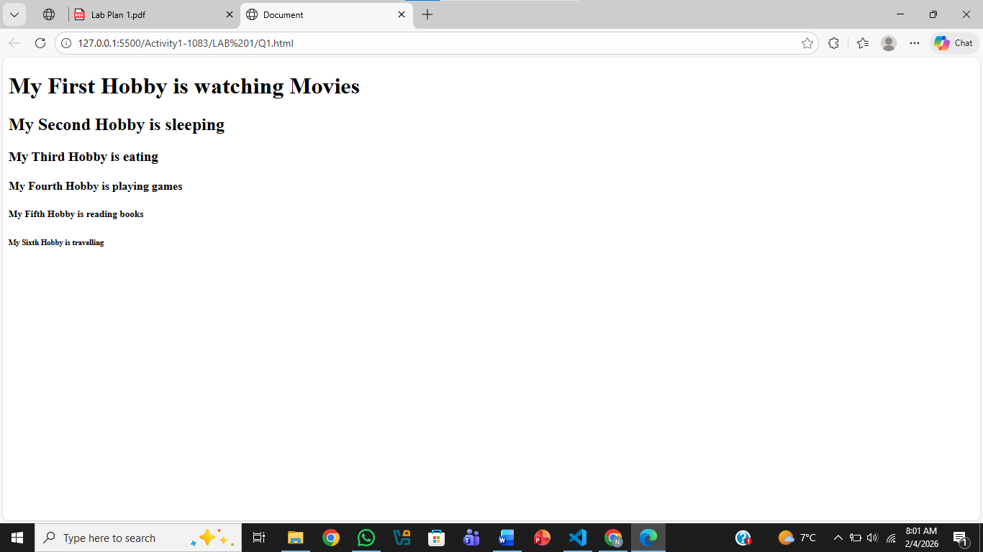

Question .No.2
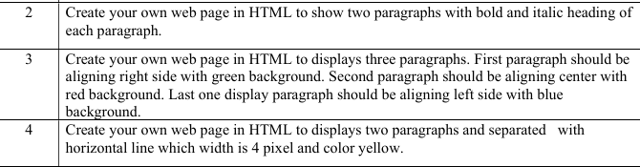
Code:
<!DOCTYPE html>
<html lang="en">
<head>
<meta charset="UTF-8">
<meta name="viewport" content="width=device-width, initial-scale=1.0">
<title>Document</title>
</head>
<body>
<h2><b><i>A Fresh Beginning</i></b></body></h2>
<p>The day starts softly, with light easing into the sky
and a sense of quiet promise. Small moments feel meaningful,
as if everything is ready to begin again.</p>
<h2><b><i>Finding Calm</i></b></h2>
<p>Even as the world rushes forward, there is comfort in slowing down.
In that pause, clarity appears,
and peace feels close enough to hold.</p>
</body>
</html>
Output:
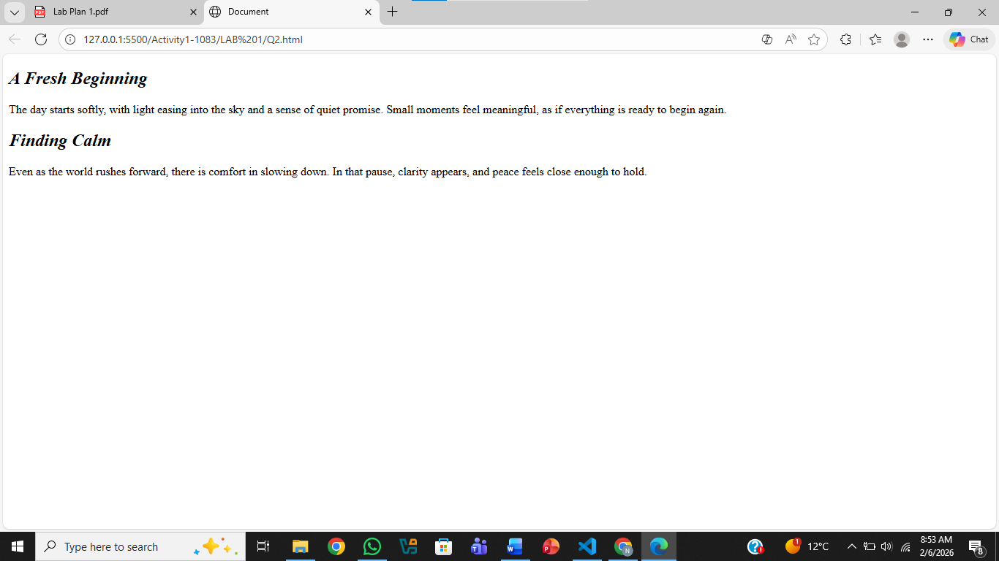
Question .No.3

Code:
<!DOCTYPE html>
<html lang="en">
<head>
<meta charset="UTF-8">
<meta name="viewport" content="width=device-width, initial-scale=1.0">
<title>Document</title>
</head>
<body>
<p style="background-color: green; text-align: right;">
The day starts softly, with light easing into the sky and a sense of quiet promise.
Small moments feel meaningful, as if everything is ready to begin again.
</p>
<p style="background-color: red; text-align: center;">
Even as the world rushes forward, there is comfort in slowing down. In that pause, clarity
appears, and peace feels close enough to hold.
</p>
<p style="background-color: blue; text-align: left;">
Each step forward brings
new possibilities and lessons to learn.With patience and hope,
the future feels open and full of opportunity.
</p>
</body>
</html>
Output:
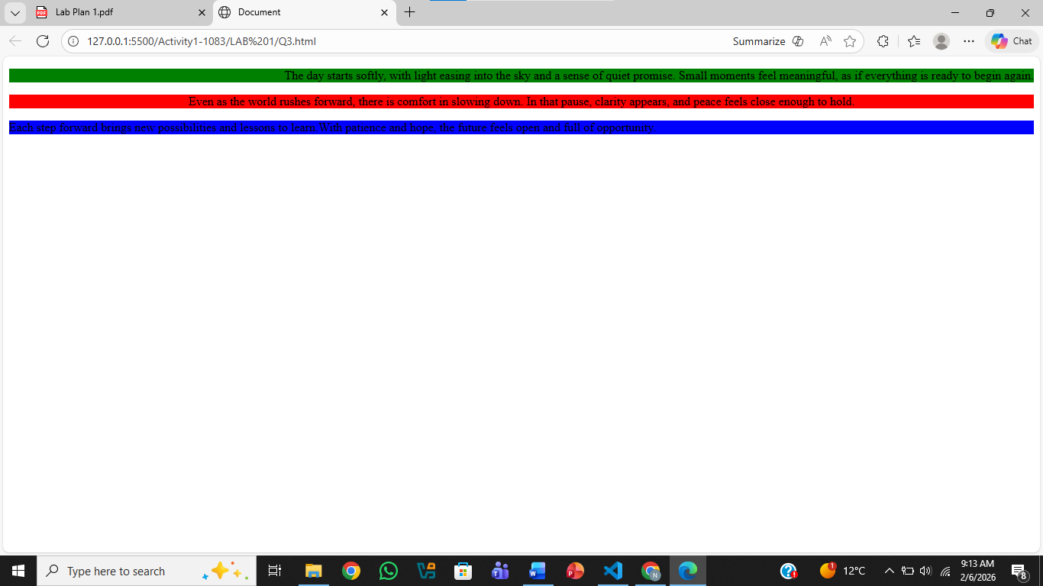
Question .No.4

Code:
<!DOCTYPE html>
<html lang="en">
<head>
<meta charset="UTF-8">
<meta name="viewport" content="width=device-width, initial-scale=1.0">
<title>Document</title>
</head>
<body>
<p>
The day starts softly, with light easing into the sky and a sense of quiet promise.
Small moments feel meaningful, as if everything is ready to begin again.
</p>
<hr style="width:4px; height:4px; background-color: red; border: none;">
<p>
Even as the world rushes forward, there is comfort in slowing down. In that pause, clarity
appears, and peace feels close enough to hold.
</p>
</body>
</html>
Output:
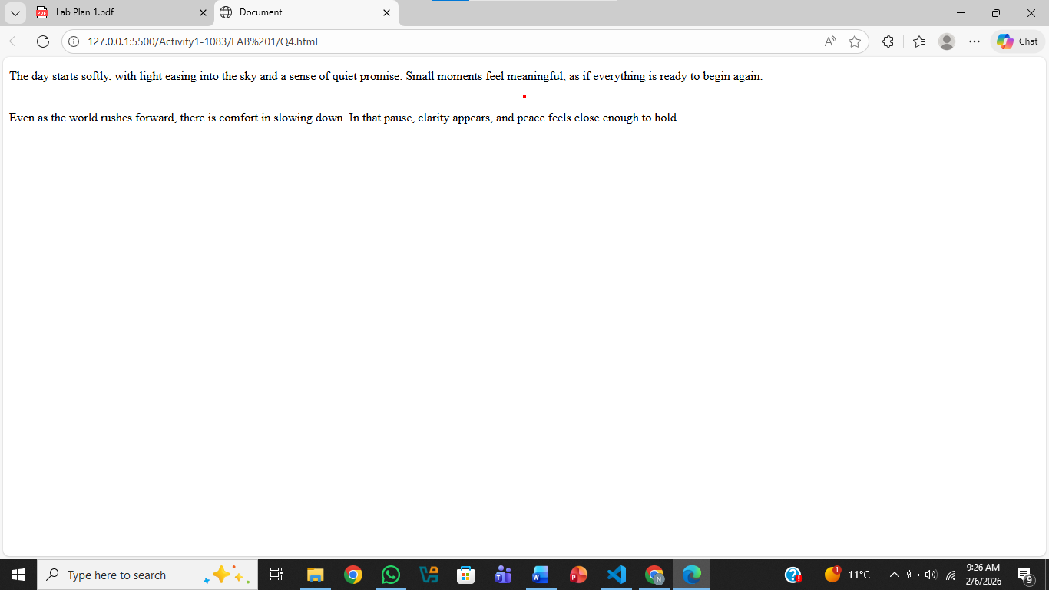
Question .No.5
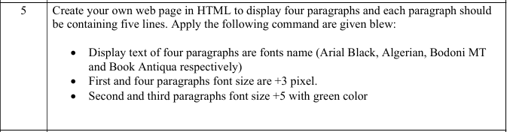
Code:
<!DOCTYPE html>
<html lang="en">
<head>
<meta charset="UTF-8">
<meta name="viewport" content="width=device-width, initial-scale=1.0">
<title>Document</title>
</head>
<body>
<p style="font-family: Arial Black; font-size:calc(100% + 3px);">
The sun rises slowly in the eastern sky,
Birds chirp and flutter as the day begins,
A soft breeze brushes against the leaves,
The world awakens with gentle sounds,
Hope fills the air like morning light.
</p>
<p style="font-family: Algerian; font-size:calc(100% + 5px); background-color: green;">
Clouds drift lazily across the azure sky,
Children laugh while playing in the park,
A dog runs freely chasing after a ball,
Laughter and joy mix with the warm sunlight,
Every moment feels alive and bright.
</p>
<p style="font-family: Bodoni MT; font-size:calc(100% + 5px); background-color: green;">
Evening comes with a golden glow,
Shadows stretch across the quiet streets,
The scent of flowers drifts on the breeze,
People return home, tired but happy,
The sky slowly deepens into night.
</p>
<p style="font-family: Book Antiqua; font-size:calc(100% + 3px);">
Stars emerge, twinkling softly in the sky,
The moon casts a calm silver light,
Crickets sing in harmony from the fields,
The world rests under a peaceful blanket,
Dreams begin to take their gentle flight.
</p>
</body>
</html>
Output:
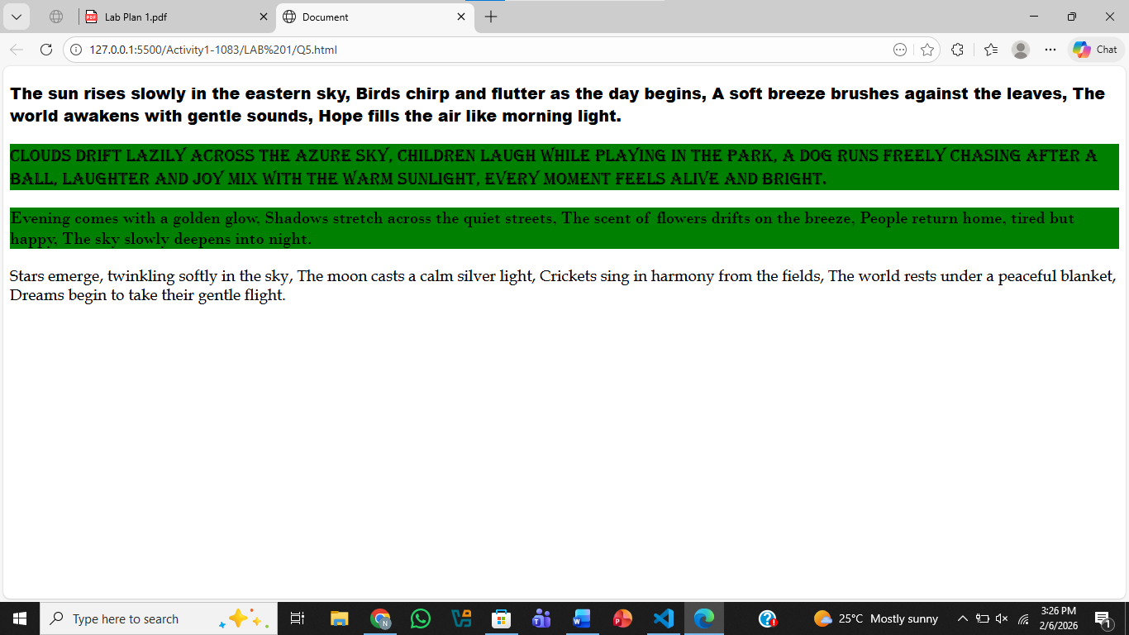
Question .No.6
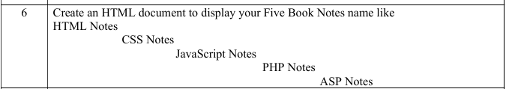
Code:
<!DOCTYPE html>
<html lang="en">
<head>
<meta charset="UTF-8">
<meta name="viewport" content="width=device-width, initial-scale=1.0">
<title>Document</title>
</head>
<body>
<pre>
HTML Notes
CSS Notes
JavaScript Notes
PHP Notes
ASP Notes
</pre>
</body>
</html>
Output:
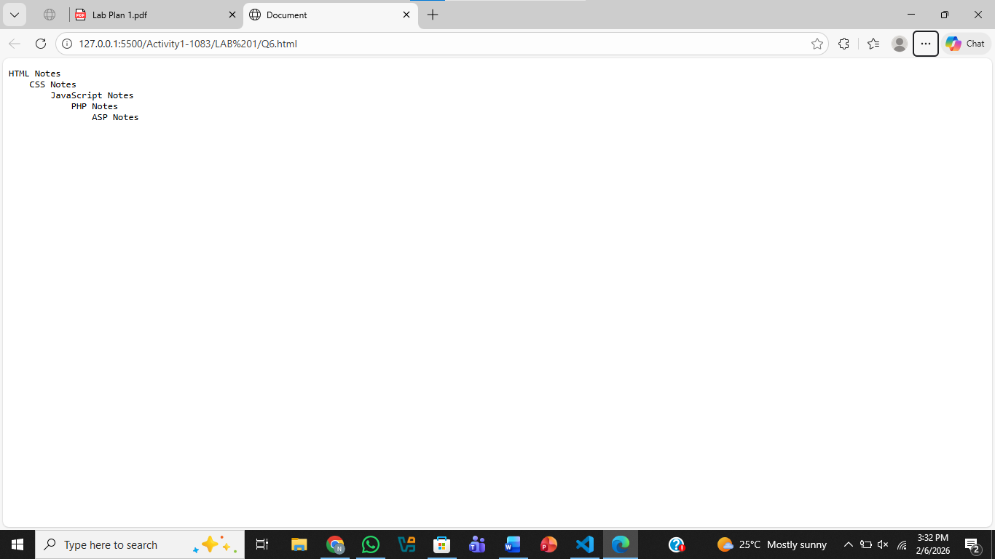
Question .No.7
Code:
<!DOCTYPE html>
<html lang="en">
<head>
<meta charset="UTF-8">
<meta name="viewport" content="width=device-width, initial-scale=1.0">
<title>Document</title>
</head>
<body>
<p>All copy rights &copy; are reserved and company Name
&lt;ABC Private &amp; limited&gt; trademark &reg; ®</p>
</body>
</html>
Output:
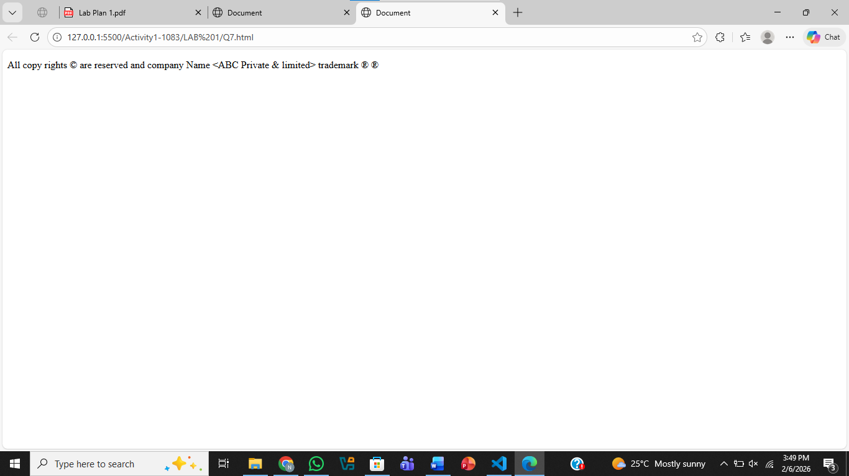
Question .No.8
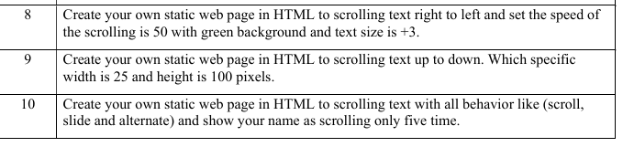
Code:
<!DOCTYPE html>
<html lang="en">
<head>
<meta charset="UTF-8">
<meta name="viewport" content="width=device-width, initial-scale=1.0">
<title>Document</title>
</head>
<body>
<marquee scrollamount="50" direction="left" style="background-color: green; font-size:calc(100% + 3px)">
The company ensures all software is secure, efficient, and user-friendly
for every client. Our team works diligently to maintain high standards
and provide excellent support at all times.
</marquee>
</body>
</html>
Output:
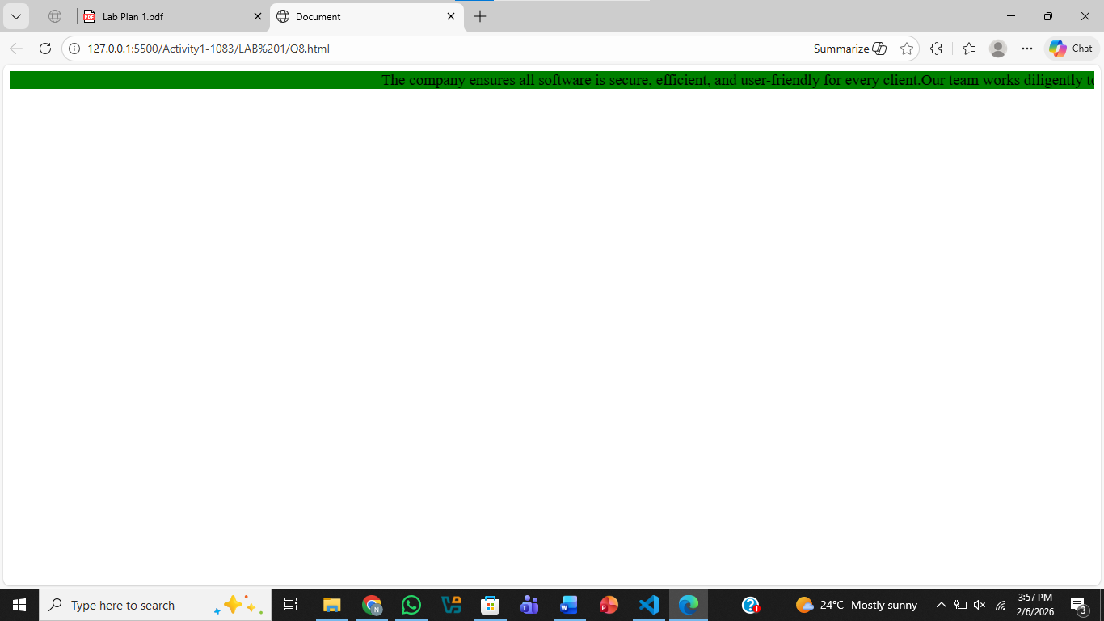
Question .No.9

Code:
<!DOCTYPE html>
<html lang="en">
<head>
<meta charset="UTF-8">
<meta name="viewport" content="width=device-width, initial-scale=1.0">
<title>Document</title>
</head>
<body>
<marquee direction="down" style="width:25px; height: 100px;">
The company ensures all software is secure, efficient, and user-friendly
for every client. Our team works diligently to maintain high standards
and provide excellent support at all times.
</marquee>
</body>
</html>
Output:
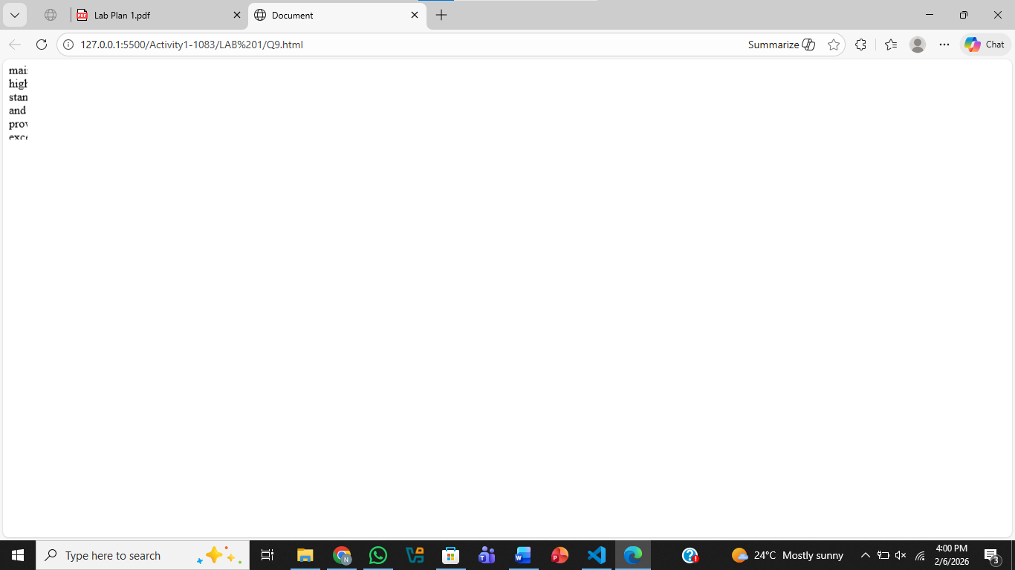
Question .No.10
Code:
<!DOCTYPE html>
<html lang="en">
<head>
<meta charset="UTF-8">
<title></title>
</head>
<body>

<marquee behavior="scroll" direction="left" scrollamount="10">
Noor Noor Noor Noor Noor
</marquee>
<br>
<!-- Slide behavior -->
<marquee behavior="slide" direction="left" scrollamount="10">
Noor Noor Noor Noor Noor
</marquee>
<br>
<!-- Alternate behavior -->
<marquee behavior="alternate" direction="left" scrollamount="10">
Noor Noor Noor Noor Noor
</marquee>
</body>
</html>
Output:
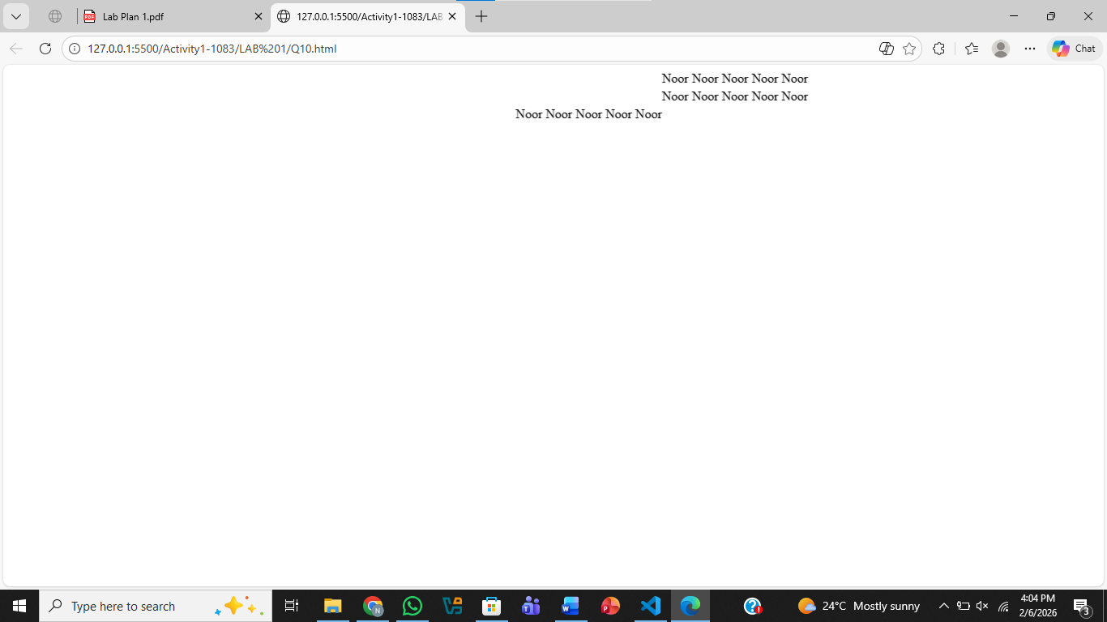

Lab NO2

Question .No.1
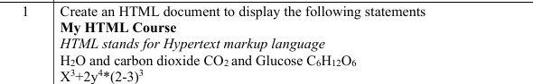
Code:
<!DOCTYPE html>
<html lang="en">
<head>
<meta charset="UTF-8">
<meta name="viewport" content="width=device-width, initial-scale=1.0">
<title>Document</title>
</head>
<body>
<h2>My HTML Course</h2>
<p>
HTML stands for Hypertext markup language
H<sub>2</sub>O and carbon dioxide CO<sub>2</sub> and Glucose C<sub>6</sub>H<sub>12</sub>O<sub>6</sub>
X<sup>3</sup>+2y<sup>4</sup>*(2-3)<sup>3</sup></p>
</body>
</html>
Output:
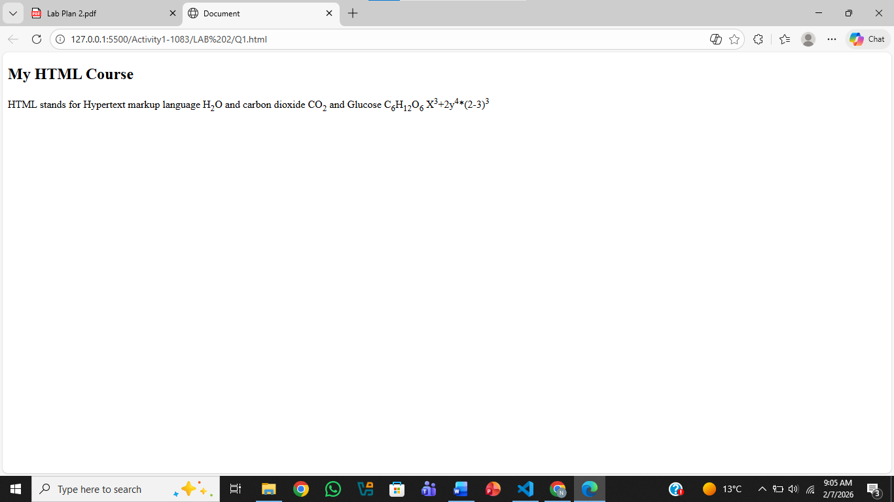
Question .No.2
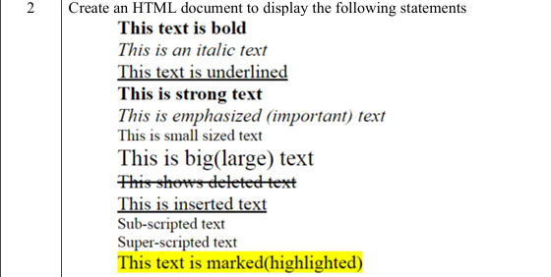
Code:
<!DOCTYPE html>
<html lang="en">
<head>
<meta charset="UTF-8">
<meta name="viewport" content="width=device-width, initial-scale=1.0">
<title>Document</title>
</head>
<body>
<b>This text is bold</b>
<br>
<i>This text is an italic text</i>
<br>
<u>This text is underlined</u>
<br>
<strong>This is strong text</strong>
<br>
<em>This is emphasized (important) text</em>
<br>
<small>This is small text</small>
<br>
<big>This is big (large) text</big>
<br>
<del>This shows deleted text</del>
<br>
<ins>This shows inserted text</ins>
<br>
<sub>Sub_script text</sub>
<br>
<sup>Sup_script text</sup>
<br>
<mark>This text is marked (highlighted)</mark>
</body>
</html>
Output:
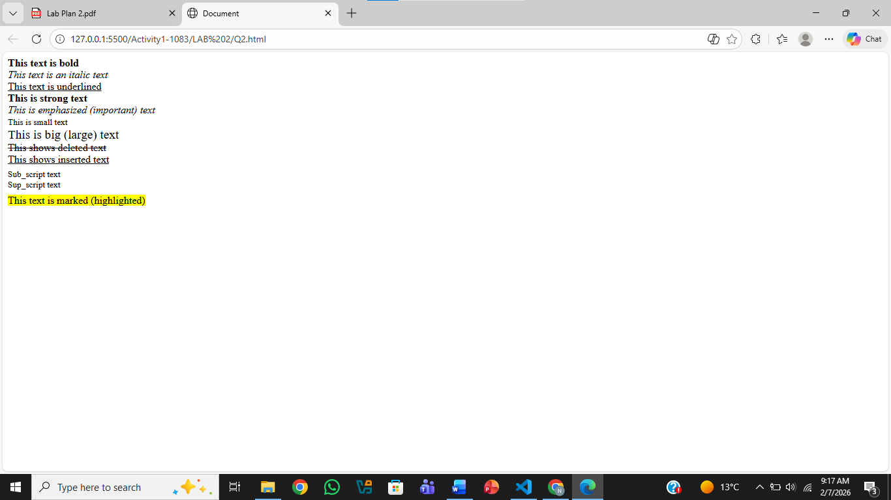
Question .No.3
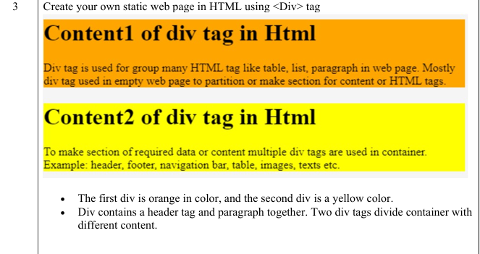
Code:
<!DOCTYPE html>
<html lang="en">
<head>
<meta charset="UTF-8">
<meta name="viewport" content="width=device-width, initial-scale=1.0">
<title>Document</title>
</head>
<body>
<div style="background-color: orange;">
<h2>Content1 of div tag in Html</h2>
<p>Div tag is used for group many HTML tag like table, list, paragraph
in web page. Mostly div tag used in empty web page to partition
or make section for content or HTML tags.</p>
</div>

<div style="background-color: yellow;">
<h2>Content2 of div tag in Html</h2>
<p>To make section of required data or content multiple div tags are
used in container. Example: header, footer, navigation bar,
table, images, texts etc.</p>
</div>
</body>
</html>
Output:
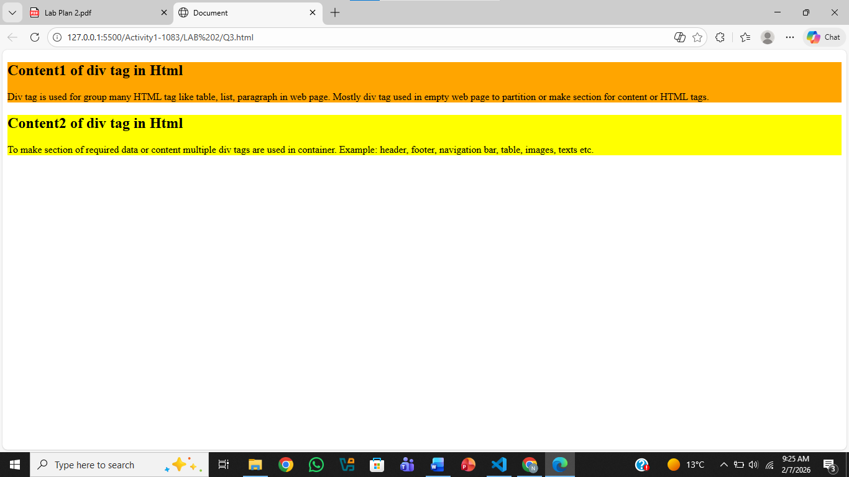
Question .No.4
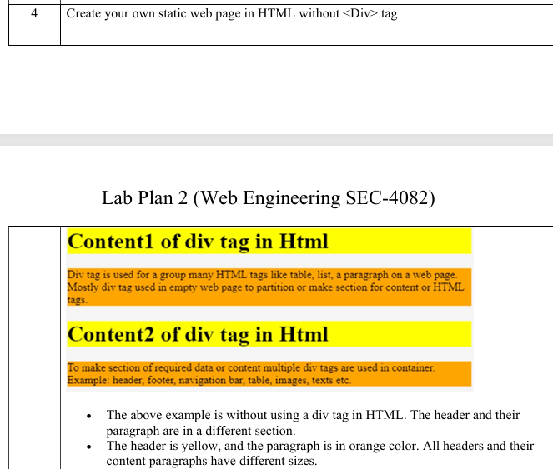
Code:
<!DOCTYPE html>
<html lang="en">
<head>
<meta charset="UTF-8">
<meta name="viewport" content="width=device-width, initial-scale=1.0">
<title>Document</title>
</head>
<body>
<h2 style="background-color: yellow;">Content1 of div tag in Html</h2>
<p style="background-color: orange;">Div tag is used for group many HTML tag like table, list, paragraph
in web page. Mostly div tag used in empty web page to partition
or make section for content or HTML tags.</p>

<h2 style="background-color: yellow;">Content2 of div tag in Html</h2>
<p style="background-color: orange;">To make section of required data or content multiple div tags are
used in container. Example: header, footer, navigation bar,
table, images, texts etc.</p>

</body>
</html>
Output:
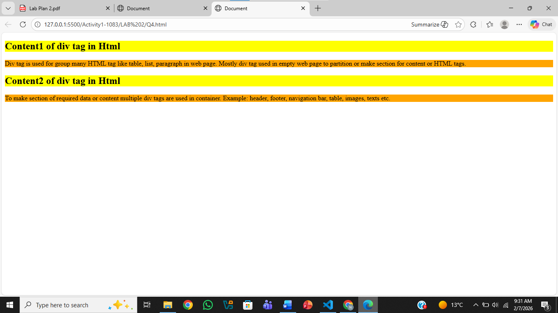
Question .No.5
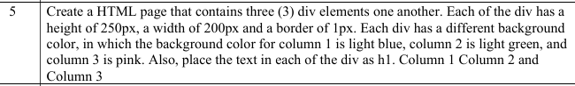
Code:
<!DOCTYPE html>
<html lang="en">
<head>
<meta charset="UTF-8">
<meta name="viewport" content="width=device-width, initial-scale=1.0">
<title>Document</title>
</head>
<body>
<div style="width: 200px; height: 250px; border: 1px;background-color: lightblue;">
<h2>Column 1</h2>
</div>

<div style="width: 200px; height: 250px; border: 1px;background-color: lightgreen;">
<h2>Column 2</h2>
</div>

<div style="width: 200px; height: 250px; border: 1px;background-color: pink;">
<h2>Column 3</h2>
</div>
</body>
</html>
Output:
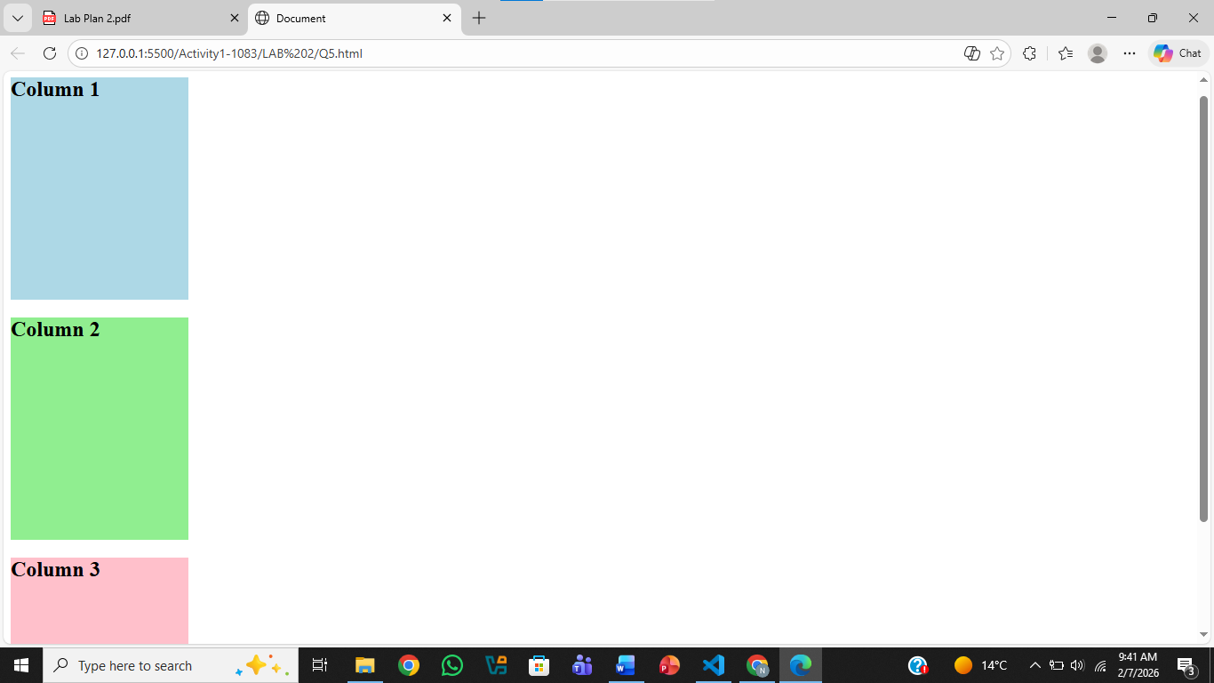
Question .No.6
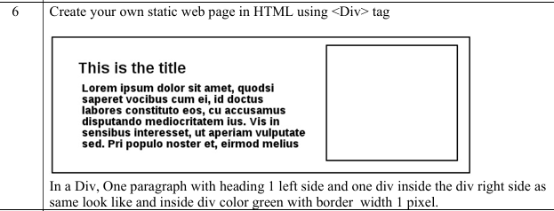
Code:
<!DOCTYPE html>
<html lang="en">
<head>
<meta charset="UTF-8">
<meta name="viewport" content="width=device-width, initial-scale=1.0">
<title>Document</title>
</head>
<body>

<div style="background-color: green; border: 1px solid black; padding: 10px;">

<div style="border: 1px solid black; float: right; width: 100px; height: 100px;"></div>

<h2 style="text-align: left;">This is the title</h2>

<p style="text-align: left;">
Lore ipsum dolor sit amet, quodsi saperet vocibus cum ei,doctus
<br>
labores constituto eos, cu accusamus disputando mediocritatem ius.
<br>
Vis in sensibus interesset, ut aperiam vulputate sed.
<br>
Pri populo nost er, erirmod melius
</p>
<div style="clear: both;"></div>

</div>

</body>
</html>
Output:
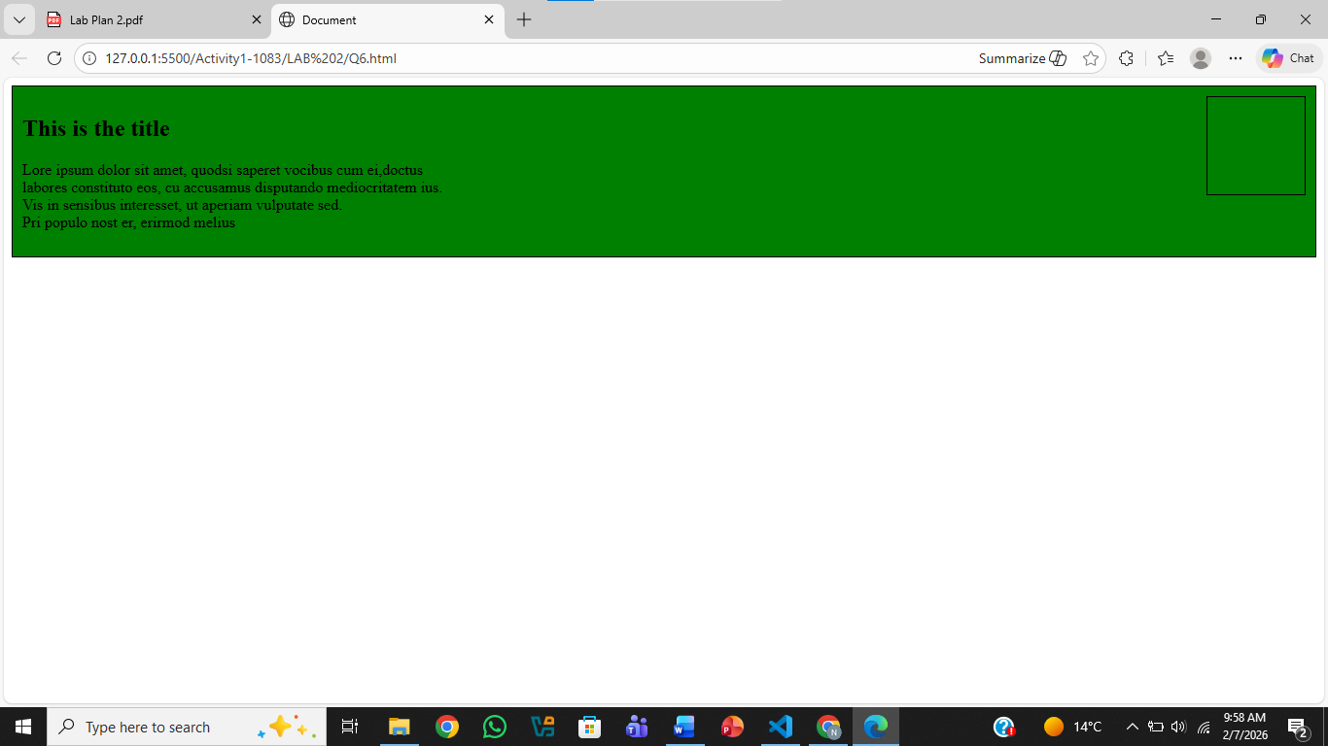
Question .No.7
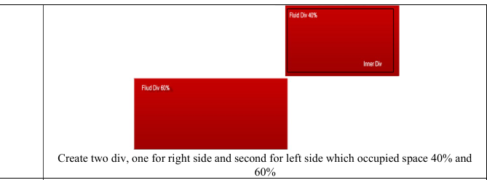
Code:
<!DOCTYPE html>
<html lang="en">
<head>
<meta charset="UTF-8">
<meta name="viewport" content="width=device-width, initial-scale=1.0">
<title></title>

<style>
.left {
position: absolute;
width: 60%;
height: 120px;
background: red;
bottom: 20px;
left: 20px;
}

.right {
position: absolute;
width: 40%;
height: 100px;
background: darkred;
top: 20px;
right: 20px;
}
</style>
</head>
<body>
<div class="left">Fluid Div 60%</div>
<div class="right">Fluid Div 40%</div>
</div>

</body>
</html>

Output:
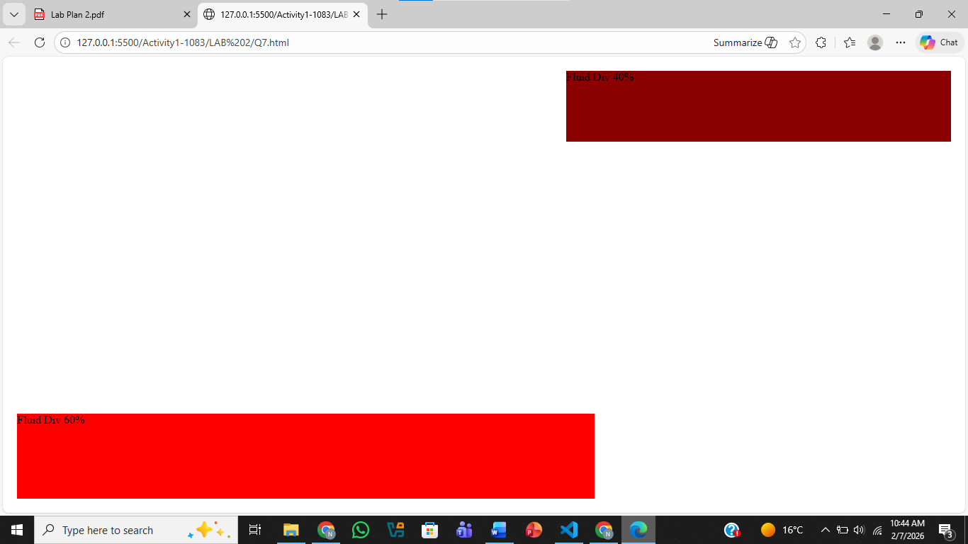
Question .No.8
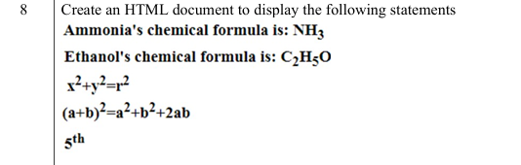
Code:
<!DOCTYPE html>
<html lang="en">
<head>
<meta charset="UTF-8">
<meta name="viewport" content="width=device-width, initial-scale=1.0">
<title>Document</title>
</head>
<body>
<p>Ammonia's chemical formula is: NH<sub>3</sub>
<br>
Ethanol's chemical formula is: C<sub>2</sub>H<sub>5</sub>O
<br>
x<sup>2</sup> + y<sup>2</sup> = z<sup>2</sup>
<br>
(a + b)<sup>2</sup> = a<sup>2</sup> + b<sup>2</sup> + 2ab
<br>
5<sup>th</sup>
</p>
</body>
</html>
Output:
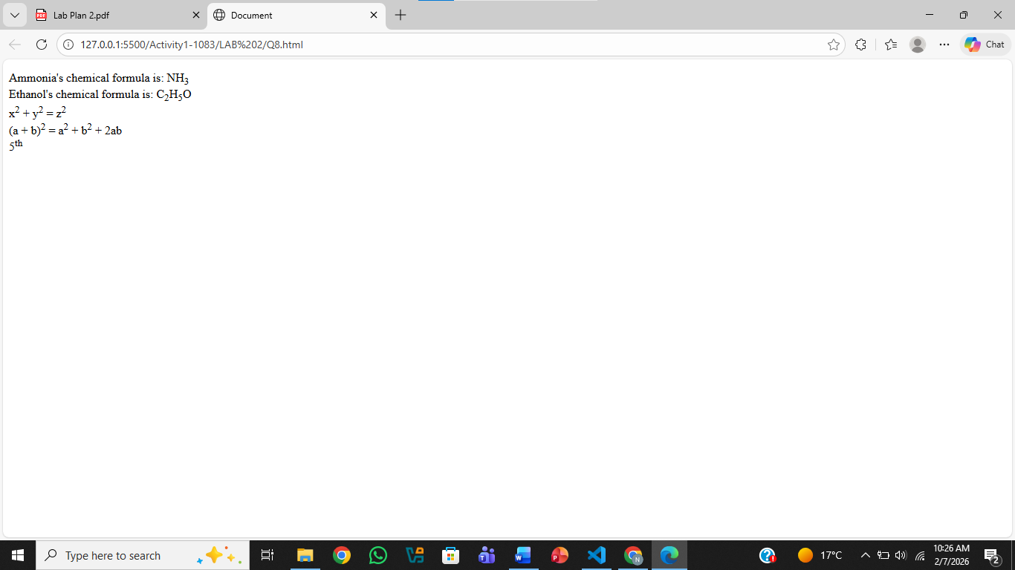
Question .No.9
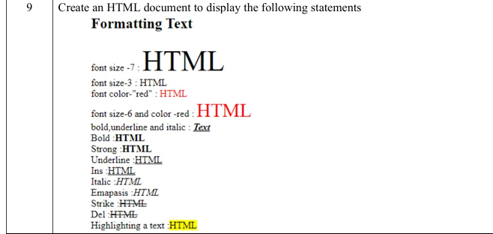
Code:
<!DOCTYPE html>
<html lang="en">
<head>
<meta charset="UTF-8">
<meta name="viewport" content="width=device-width, initial-scale=1.0">
<title>Formatting Text</title>
</head>
<body>

<h3>Formatting Text</h3>
font size -7 :
<font size="7">HTML</font>
<br><br>
font size -3 :
<font size="3">HTML</font>
<br><br>
font color - red :
<font color="red">HTML</font>
<br><br>
font size-6 and color-red :
<font size="6" color="red">HTML</font>
<br><br>
bold, underline and italic :
<b><u><i>Text</i></u></b>
<br><br>
Bold :
<b>HTML</b>
<br>
Strong :
<strong>HTML</strong>
<br>
Underline :
<u>HTML</u>
<br>
Ins :
<ins>HTML</ins>
<br>
Italic :
<i>HTML</i>
<br>
Emphasis :
<em>HTML</em>
<br>
Strike :
<strike>HTML</strike>
<br>
Del :
<del>HTML</del>
<br><br>
Highlighting a text :
<mark>HTML</mark>

</body>
</html>
Output:
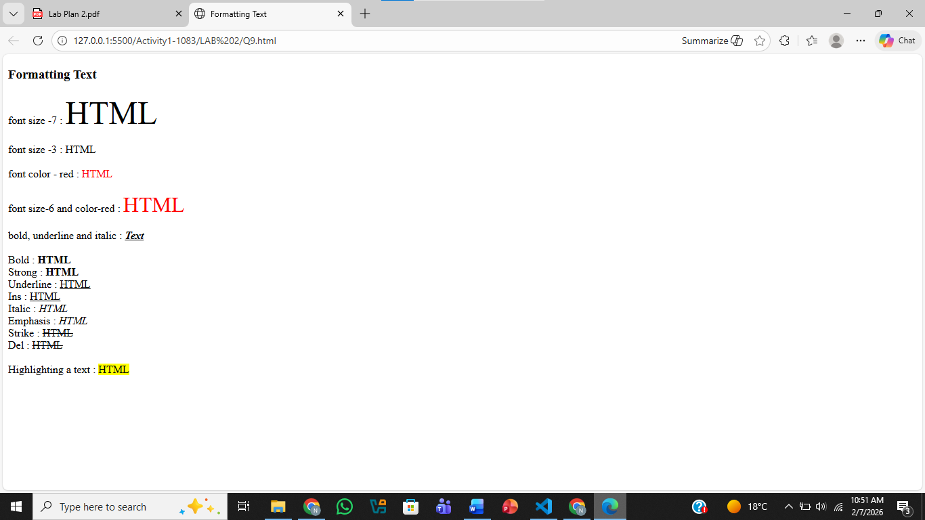
Question .No.10
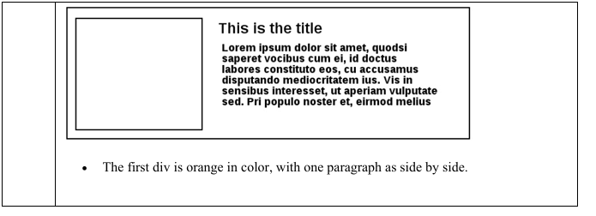
Code:
<!DOCTYPE html>
<html lang="en">
<head>
<meta charset="UTF-8">
<meta name="viewport" content="width=device-width, initial-scale=1.0">
<title>Document</title>
</head>
<body>

<div style="background-color: green; border: 1px solid black; padding: 10px;">

<div style=" background-color: white;border: 1px solid black; float: left; width: 100px; height: 100px;"></div>

<h2 style=" text-align: right;">This is the title</h2>

<p style="text-align: right;">
Lore ipsum dolor sit amet, quodsi saperet vocibus cum ei,doctus
<br>
labores constituto eos, cu accusamus disputando mediocritatem ius.
<br>
Vis in sensibus interesset, ut aperiam vulputate sed.
<br>
Pri populo nost er, erirmod melius
</p>
<div style="clear: both;"></div>

</div>

</body>
</html>

Output:
