Lab No | 5
Name | Noor Fatima
Reg No | 23_NTU_CS_1083
Semester | BSCS(6thA)
Subject | Web Development
Submitted to | Sir Abdul Basit
Submission Date | 14_02_2026


Computer Science
National Textile University Faisalabad

Lab NO5

Question. No.1
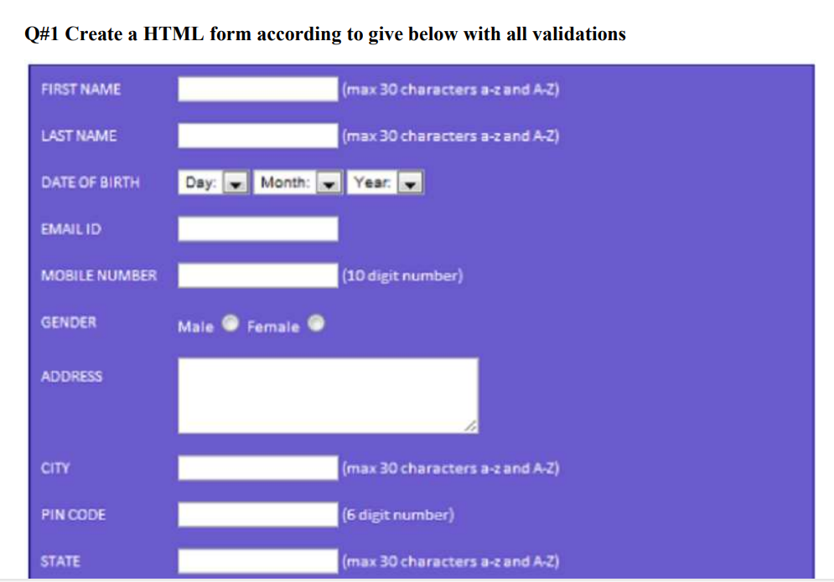
Code:
<!DOCTYPE html>
<html lang="en">
<head>
<meta charset="UTF-8">
<title>Document</title>
</head>
<body style="background-color: rgb(111, 111, 244); color:white;">
<form>
<table cellpadding="8">

<tr>
<td>First name:</td>
<td>
<input type="text" name="first_name" />
(max 30 characters a-z and A-Z)
</td>
</tr>

<tr>
<td>Last name:</td>
<td>
<input type="text" name="last_name" />
(max 30 characters a-z and A-Z)
</td>
</tr>

<tr>
<td>Date of Birth:</td>
<td><input type="date" name="dob" /></td>
</tr>

<tr>
<td>Email ID:</td>
<td><input type="text" name="email" /></td>
</tr>

<tr>
<td>Mobile Number:</td>
<td>
<input type="text" name="mobile" />
(10 digit number)
</td>
</tr>

<tr>
<td>Gender:</td>
<td>
<input type="radio" name="gender" value="Male"> Male
<input type="radio" name="gender" value="Female"> Female
</td>
</tr>

<tr>
<td>Address:</td>
<td>
<textarea cols="40" rows="5" name="address"></textarea>
</td>
</tr>

<tr>
<td>City:</td>
<td>
<input type="text" name="city" />
(max 30 characters a-z and A-Z)
</td>
</tr>

<tr>
<td>Pincode:</td>
<td>
<input type="text" name="pincode" />
(6 digit number)
</td>
</tr>

<tr>
<td>State:</td>
<td>
<input type="text" name="state" />
(max 30 characters a-z and A-Z)
</td>
</tr>

<tr>
<td>Country:</td>
<td>
<input type="text" name="country" value="India" />
</td>
</tr>

<tr>
<td>Hobbies:</td>
<td>
Drawing <input name="hobbies" value="Drawing" type="checkbox"/>
Singing <input type="checkbox" name="hobbies" value="Singing" />
Dancing <input type="checkbox" name="hobbies" value="Dancing" />
Sketching <input type="checkbox" name="hobbies" value="Sketching" />
<br><br>
Others <input name="others" type="checkbox"/>
<input type="text"/>
</td>
</tr>

</table>

<br><br>
<table>
<tr>
<td>Qualification</td>
<td>Sr.No.Examination</td>
<td align="center"> Board </td>
<td>Year of Passing</td>
<td>Percentage</td>
</tr>

<tr>
<td>1</td>
<td>Class X</td>
<td><input type="text" name="classX_board" /></td>
<td><input type="text" name="classX_year" /></td>
<td><input type="text" name="classX_percentage" /></td>
</tr>

<tr>
<td>2</td>
<td>Class XII</td>
<td><input type="text" name="classXII_board" /></td>
<td><input type="text" name="classXII_year" /></td>
<td><input type="text" name="classXII_percentage" /></td>
</tr>

<tr>
<td>3</td>
<td>Graduation</td>
<td><input type="text" name="graduation_board" /></td>
<td><input type="text" name="graduation_year" /></td>
<td><input type="text" name="graduation_percentage" /></td>
</tr>

<tr>
<td>4</td>
<td>Master</td>
<td><input type="text" name="master_board" /></td>
<td><input type="text" name="master_year" /></td>
<td><input type="text" name="master_percentage" /></td>
</tr>

</table>

<br><br>
courses applied for:
<input type="radio" name="course" value="BCA"/> BCA
<input type="radio" name="course" value="BBA"/> BBA
<input type="radio" name="course" value="BSC"/> BSC
<input type="radio" name="course" value="BA"/> BA
<br><br>
<input type="submit" value="Submit"/>
<input type="reset" value="Reset"/>

</form>

</body>
</html>
Output:
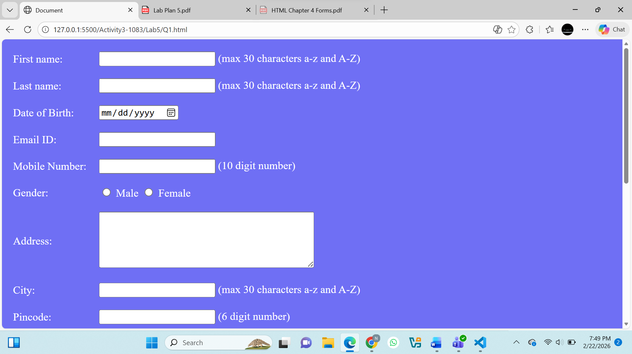
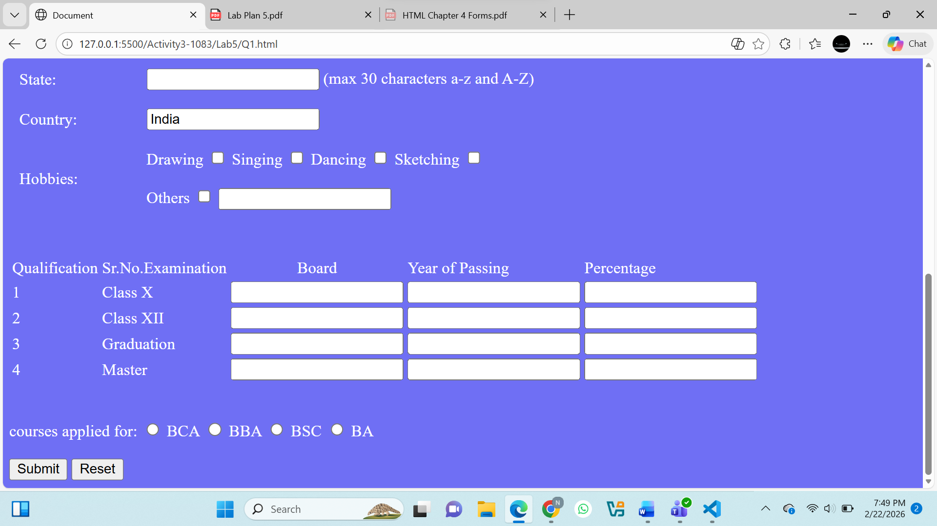
Question.No.2
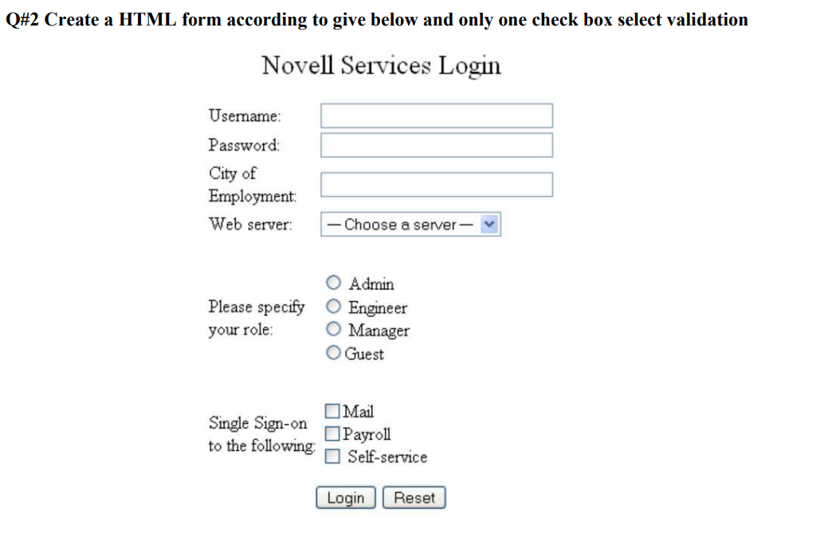
Code:
<!DOCTYPE html>
<html lang="en">
<head>
<meta charset="UTF-8">
<title>Document</title>
</head>
<body align="center">
<form>
<table align="center"cellpadding="8">
<h>Novell Service Login</h>
<tr>
<br><br>
<td>Username</td>
<td>
<input type="text" name="username" />
</td>
</tr>
<tr>
<td>Password:</td>
<td><input type="password" name="password" /></td>
</tr>
<tr>
<td>City of Employment</td>
<td><input type="text" name="city_of_employment" /></td>
</tr>
<tr>
<td>Web Servers</td>
<td> <select name="Web_Servers">
<option value="select">Select a Web Server</option>
<option value="html">HTML</option>
<option value="php">PHP</option>
<option value="python">Python</option>
</select>
</td>
</tr>
<tr>
<td>Please Specify your Role</td>
<td>
<input type="radio" name="role" value="Admin" /> Admin
<br>
<input type="radio" name="role" value="Engineer" /> Engineer
<br>
<input type="radio" name="role" value="Manager" /> Manager
<br>
<input type="radio" name="role" value="Guest" /> Guest
</td>
</tr>

<tr>
<td>Single sign on following</td>
<td>
<input type="checkbox" name="single_sign_on_following" value="mail" /> Mail
<br>
<input type="checkbox" name="single_sign_on_following" value="payrole" /> Payrole
<br>
<input type="checkbox" name="single_sign_on_following" value="self_service" /> Self Service
</td>
</tr>
</table>
<br><br>
<input style="width:auto;" type="submit" value="Login"/>
<input style="width:auto;" type="reset" value="Reset"/>

</form>

</body>
</html>
Output:
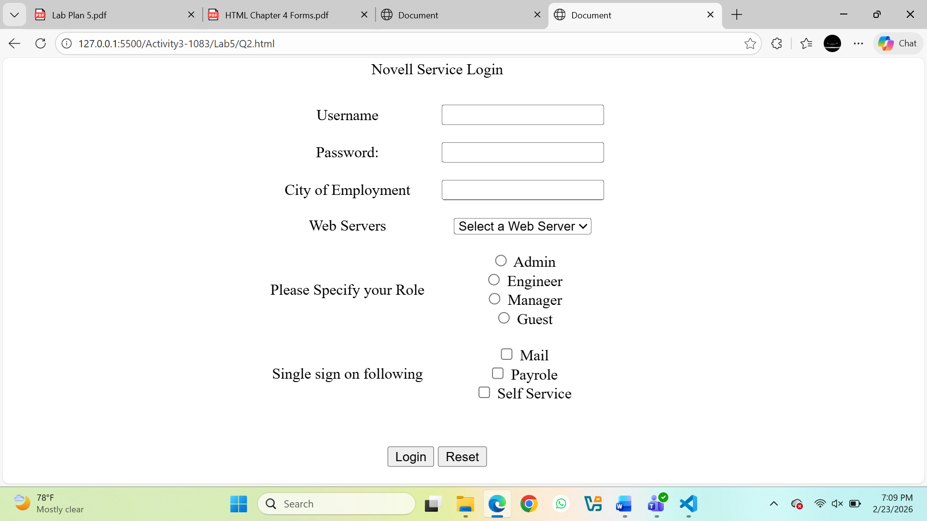
Question.No.3
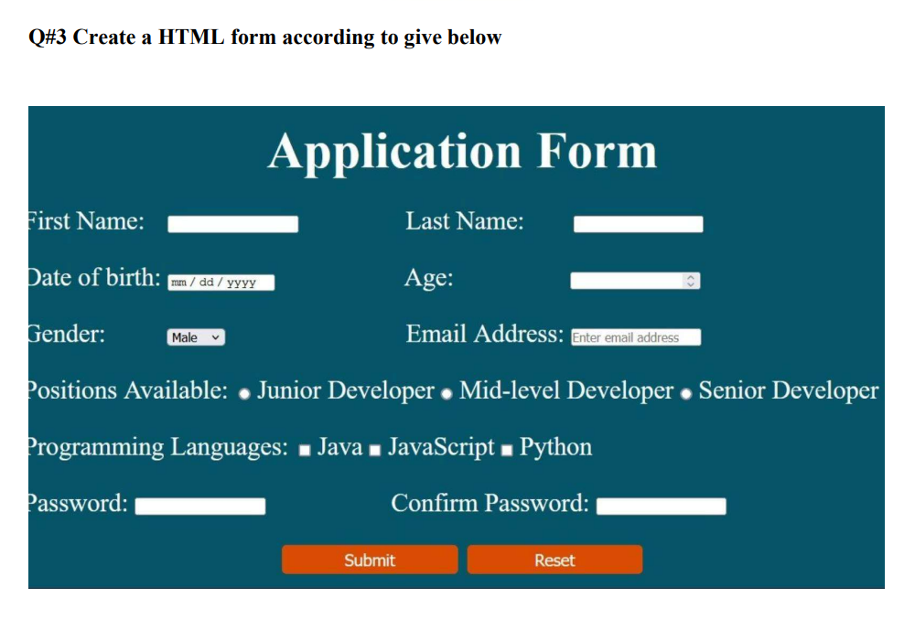
Code:
<!DOCTYPE html>
<html lang="en">
<head>
<meta charset="UTF-8">
<title>Document</title>
</head>
<body style="background-color: rgb(1, 108, 141); color:white;">
<h1 align="center">Application Form</h1>
<form>
<table cellpadding="8">

<tr>
<td>First name:</td>
<td>
<input type="text" name="first_name" />
</td>
<td>Last name:</td>
<td>
<input type="text" name="last_name" />
</td>
</tr>
<tr>
<td>Date of Birth:</td>
<td><input type="date" name="dob" /></td>
<td>Age:</td>
<td><input type="number" name="age" /></td>
</tr>
<tr>
<td>Gender:</td>
<td>
<select name="gender">
<option value="Male">Male</option>
<option value="Female">Female</option>
</select>
</td>
<td>Email Address:</td>
<td>
<input type="text" name="email_address" value="Enter your email"/>
</td>
</tr>
<tr>
<td>Positions Available:</td>
<td>
<input type="radio" name="Position" value="Junior Developer"/> Junior Developer
<input type="radio" name="Position" value="Mid Level Developer"/> Mid Level Developer
<input type="radio" name="Position" value="Senior Developer"/> Senior Developer
</td>
</tr>

<tr>
<td>Programming Languages:</td>
<td>
Java <input name="Programming" value="Java" type="checkbox"/>
JavaScript<input type="checkbox" name="Programming" value="JavaScript" />
Python <input type="checkbox" name="Programming" value="Python" />
</td>
</tr>
<tr>
<td>
Password:
<td><input type="password" name="password"/></td>
<td>Confirm Password:</td>
<td><input type="password" name="confirm_password"/></td>
</td>
</tr>
</table>
<br><br>
<p align="center">
<input style="background-color: orange;" type="submit" value="Submit"/>
<input style="background-color: orange;" type="reset" value="Reset"/>
</p>

</form>

</body>
</html>
Output:
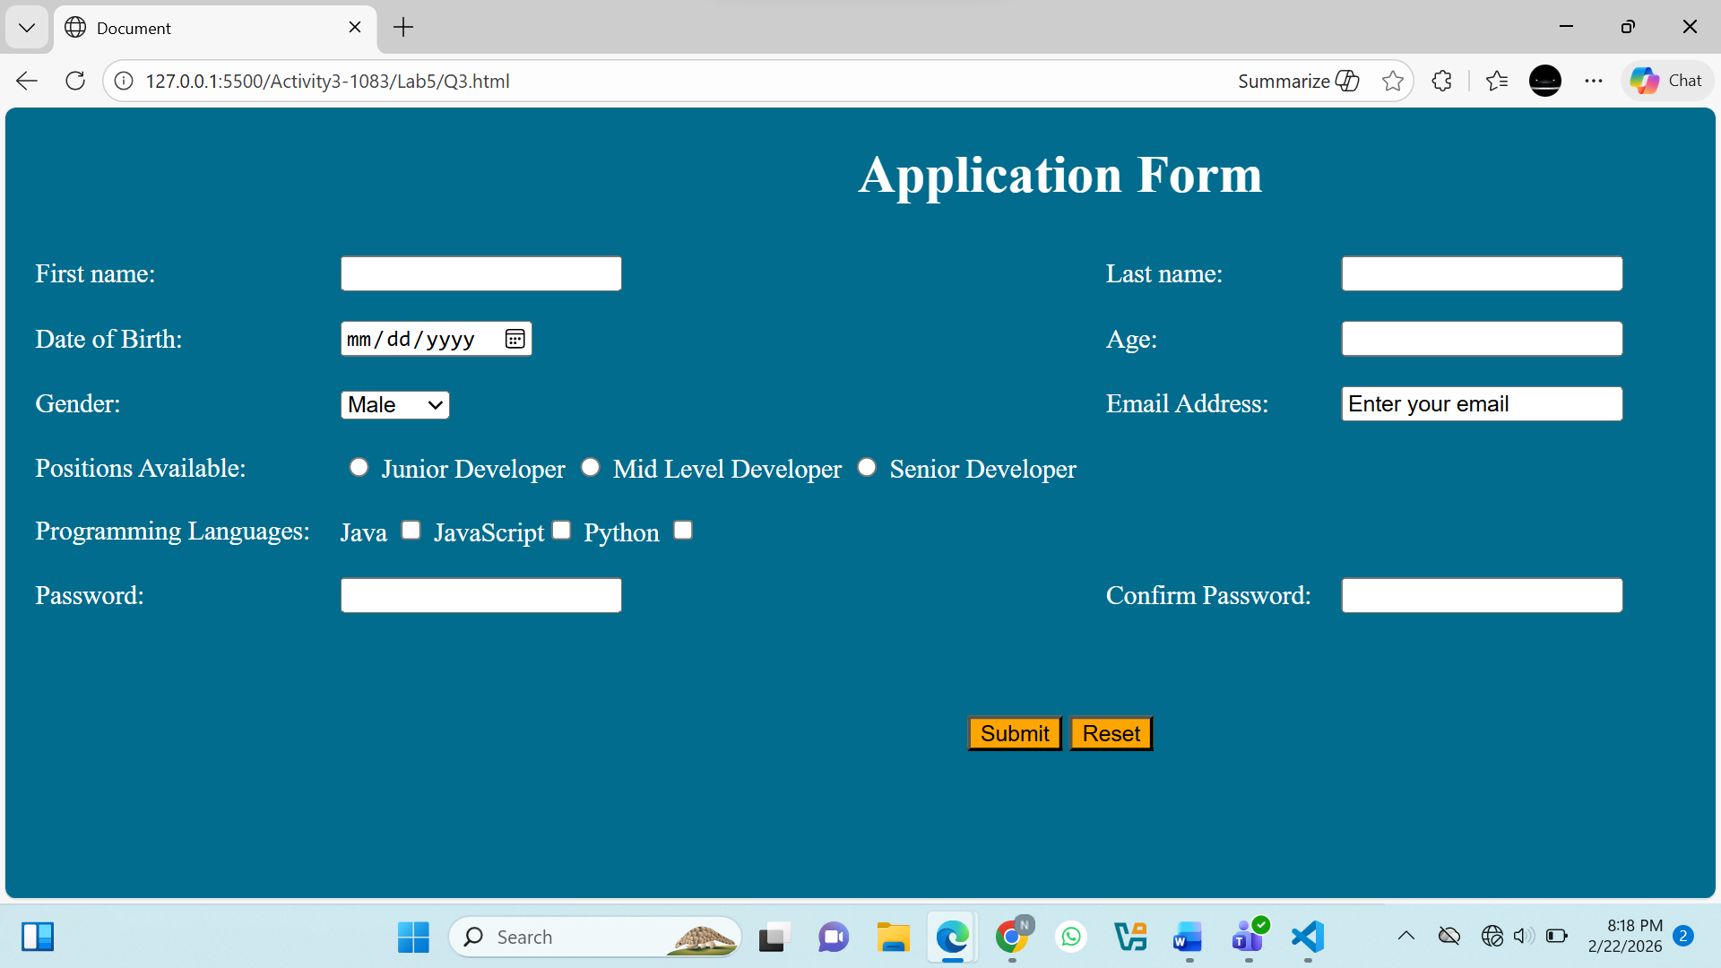
Question.No.4
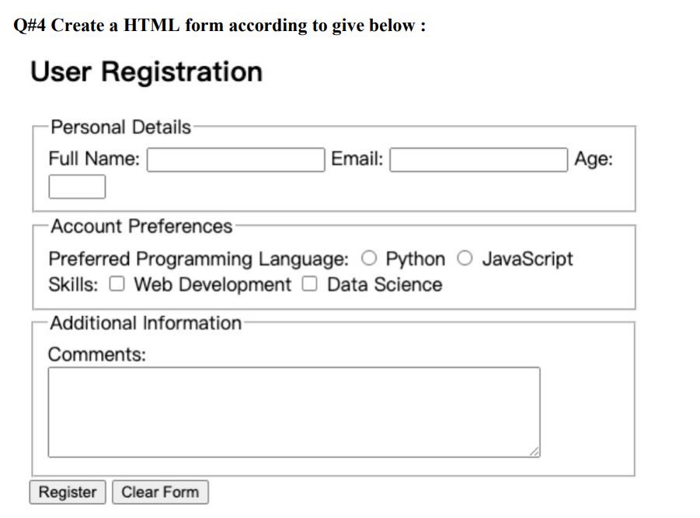
Code:
<!DOCTYPE html>
<html lang="en">
<head>
<meta charset="UTF-8">
<title>User Registration</title>
</head>
<body>

<h1 align="center">User Registration</h1>

<form>

<table align="center" cellpadding="5">

<!-- Personal Details Section -->
<tr>
<td colspan="2"><b>Personal Details</b></td>
</tr>
<tr>
<td>
Full Name:
<input type="text" name="full_name">

&nbsp;&nbsp;

Email:
<input type="email" name="email">

&nbsp;&nbsp;

Age:
<input type="number" name="age">
</td>
</tr>

<tr><td><br></td></tr>

<!-- Account Preferences Section -->
<tr>
<td><b>Account Preferences</b></td>
</tr>
<tr>
<td>
Preferred Programming Language:
<input type="radio" name="language" value="python"> Python
<input type="radio" name="language" value="javascript"> JavaScript
<br><br>
Skills:
<input type="checkbox" name="skills" value="web"> Web Development
<input type="checkbox" name="skills" value="data"> Data Science
</td>
</tr>

<tr><td><br></td></tr>

<!-- Additional Information Section -->
<tr>
<td><b>Additional Information</b></td>
</tr>
<tr>
<td>
Comments:<br><br>
<textarea name="comments" rows="5" cols="60"></textarea>
</td>
</tr>

<tr><td><br></td></tr>

<tr>
<td align="center">
<input type="submit" value="Register">
<input type="reset" value="Clear Form">
</td>
</tr>

</table>

</form>

</body>
</html>

Output:
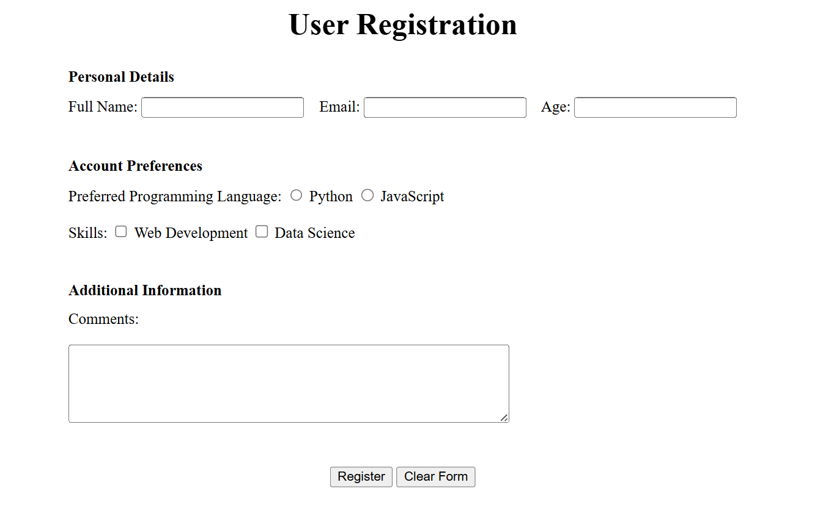
Question.No.5
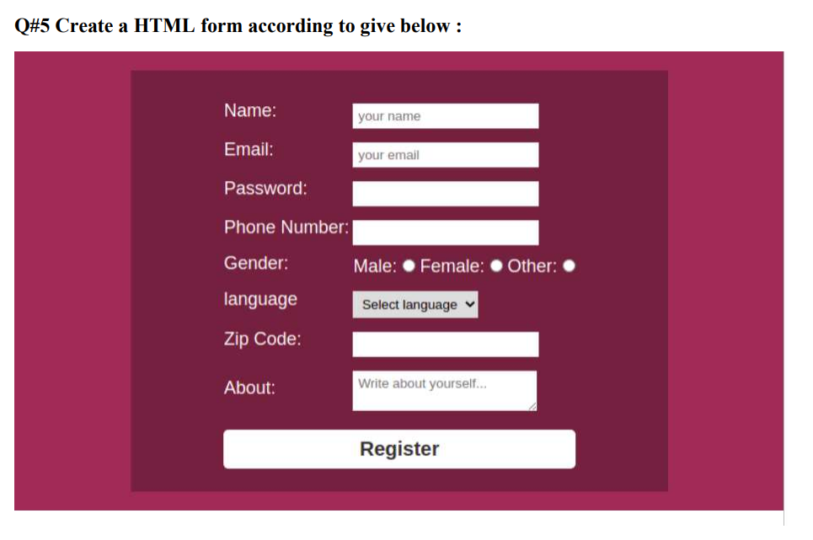
Code:
<!DOCTYPE html>
<html lang="en">
<head>
<meta charset="UTF-8">
<title>Document</title>
</head>
<body align="center" style="background-color: rgb(72, 32, 32); color:white;">
<form>
<table align="center" style="background-color: rgb(44, 10, 10);" cellpadding="8">

<tr>
<br><br>
<td>Full name:</td>
<td>
<input type="text" name="full_name" />
</td>
</tr>
<tr>
<td>Email Address:</td>
<td>
<input type="text" name="email_address" value="Enter your email"/>
</td>
</tr>
<tr>
<td>Phone Number:</td>
<td><input type="text" name="phone_number" /></td>
</tr>
<tr>
<td>Password:</td>
<td><input type="password" name="password" /></td>
</tr>
<tr>
<td>Gender</td>
<td>
<input type="radio" name="gender" value="male" /> Male
<input type="radio" name="gender" value="female" /> Female
<input type="radio" name="gender" value="other" /> Other
</tr>
<tr>
<td>languages</td>
<td> <select name="select_languages">
<option value="select">Select a language</option>
<option value="english">English</option>
<option value="spanish">Spanish</option>
<option value="french">French</option>
</select>
</td>
</tr>
<tr>
<td>Zip Code</td>
<td><input type="text" name="zip_code" /></td>
</tr>
<tr>
<td>About</td>
<br><br>
<td>
<textarea name="comments" rows="4" cols="50" value="Write about yourself"></textarea>
</tr>
</table>
<br><br>
<input style="width:auto;" type="submit" value="Register"/>

</form>

</body>
</html>
Output:
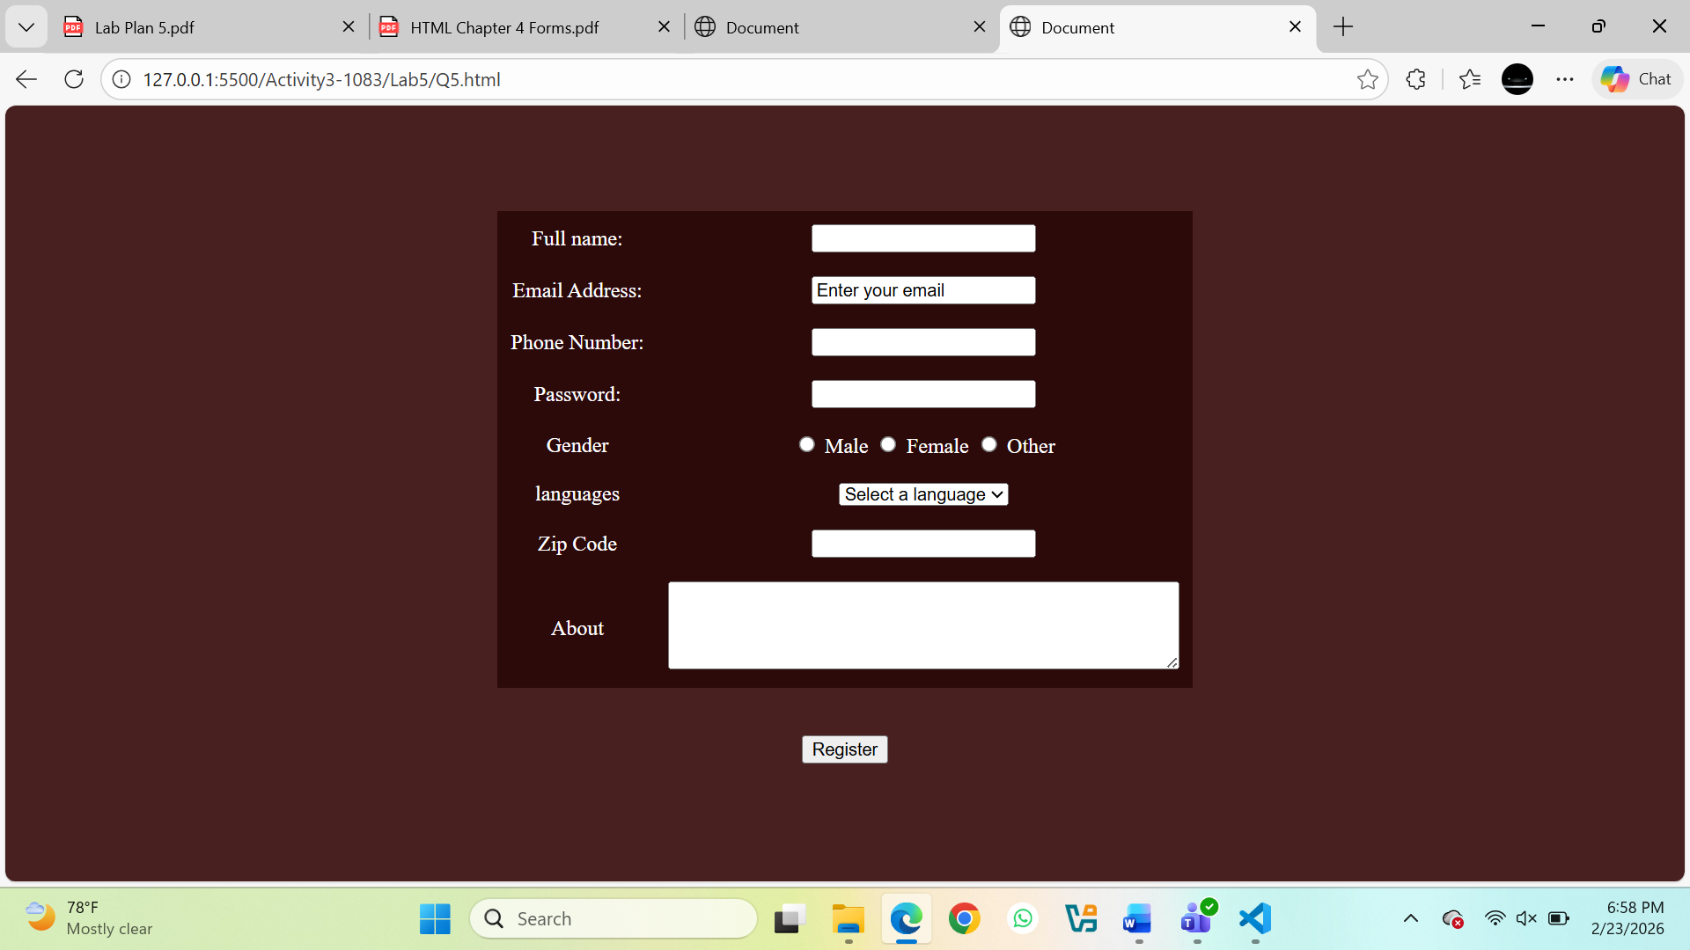
Question.No.6
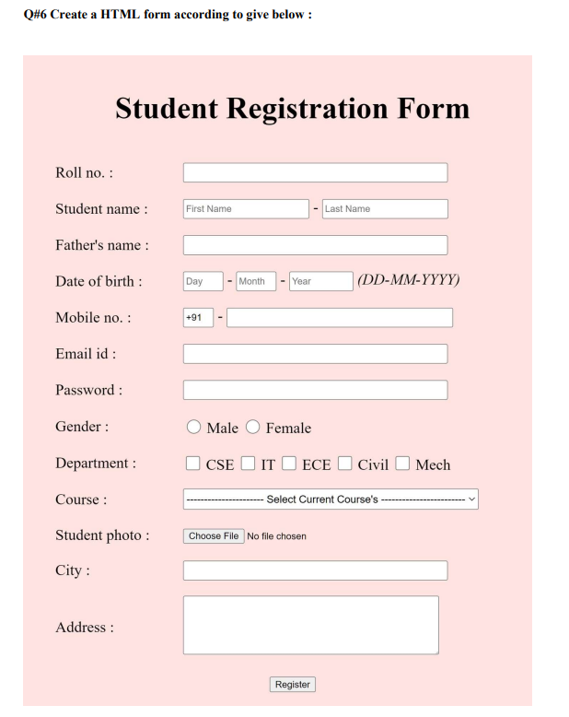
Code:
<!DOCTYPE html>
<html lang="en">
<head>
<meta charset="UTF-8">
<title>Student Registration Form</title>
</head>

<body style="background-color:#e6caca; font-family:Arial;">

<h1 align="center">Student Registration Form</h1>

<form>
<table cellpadding="10" align="center">

<tr>
<td>Roll No :</td>
<td><input type="text" name="rollno"></td>
</tr>

<tr>
<td>Student Name :</td>
<td>
<input type="text" name="firstname" placeholder="First Name">
-
<input type="text" name="lastname" placeholder="Last Name">
</td>
</tr>

<tr>
<td>Father's Name :</td>
<td><input type="text" name="fathername"></td>
</tr>

<tr>
<td>Date of Birth :</td>
<td>
<input type="text" placeholder="Day" size="4"> -
<input type="text" placeholder="Month" size="6"> -
<input type="text" placeholder="Year" size="6">
(DD-MM-YYYY)
</td>
</tr>

<tr>
<td>Mobile No. :</td>
<td>
<input type="text" value="+91" size="3"> -
<input type="text" name="mobile">
</td>
</tr>

<tr>
<td>Email Id :</td>
<td><input type="email" name="email"></td>
</tr>

<tr>
<td>Password :</td>
<td><input type="password" name="password"></td>
</tr>

<tr>
<td>Gender :</td>
<td>
<input type="radio" name="gender"> Male
<input type="radio" name="gender"> Female
</td>
</tr>

<tr>
<td>Department :</td>
<td>
<input type="checkbox"> CSE
<input type="checkbox"> IT
<input type="checkbox"> ECE
<input type="checkbox"> Civil
<input type="checkbox"> Mech
</td>
</tr>

<tr>
<td>Course :</td>
<td>
<select>
<option>---------------- Select Current Course ----------------</option>
<option>BCA</option>
<option>BBA</option>
<option>BSC</option>
<option>BA</option>
</select>
</td>
</tr>

<tr>
<td>Student Photo :</td>
<td><input type="file"></td>
</tr>

<tr>
<td>City :</td>
<td><input type="text" name="city"></td>
</tr>

<tr>
<td>Address :</td>
<td>
<textarea rows="4" cols="40"></textarea>
</td>
</tr>

<tr>
<td colspan="2" align="center">
<input type="submit" value="Register">
</td>
</tr>

</table>
</form>

</body>
</html>

Output:
