Lab No | 3,4
Name | Noor Fatima
Reg No | 23_NTU_CS_1083
Semester | BSCS(6thA)
Subject | Web Development
Submitted to | Sir Abdul Basit
Submission Date | 14_02_2026


Computer Science
National Textile University Faisalabad

Lab NO3
Question .No.1
Code:
<!DOCTYPE html>
<html lang="en">
<head>
<meta charset="UTF-8">
<meta name="viewport" content="width=device-width, initial-scale=1.0">
<title>Document</title>
</head>
<body>
<ol>
<li>Book</li>
<li>Keyboard</li>
<li>Microsoft</li>
<li>Computer</li>
<li>Laptop</li>
</ol>
</body>
</html>
Output:
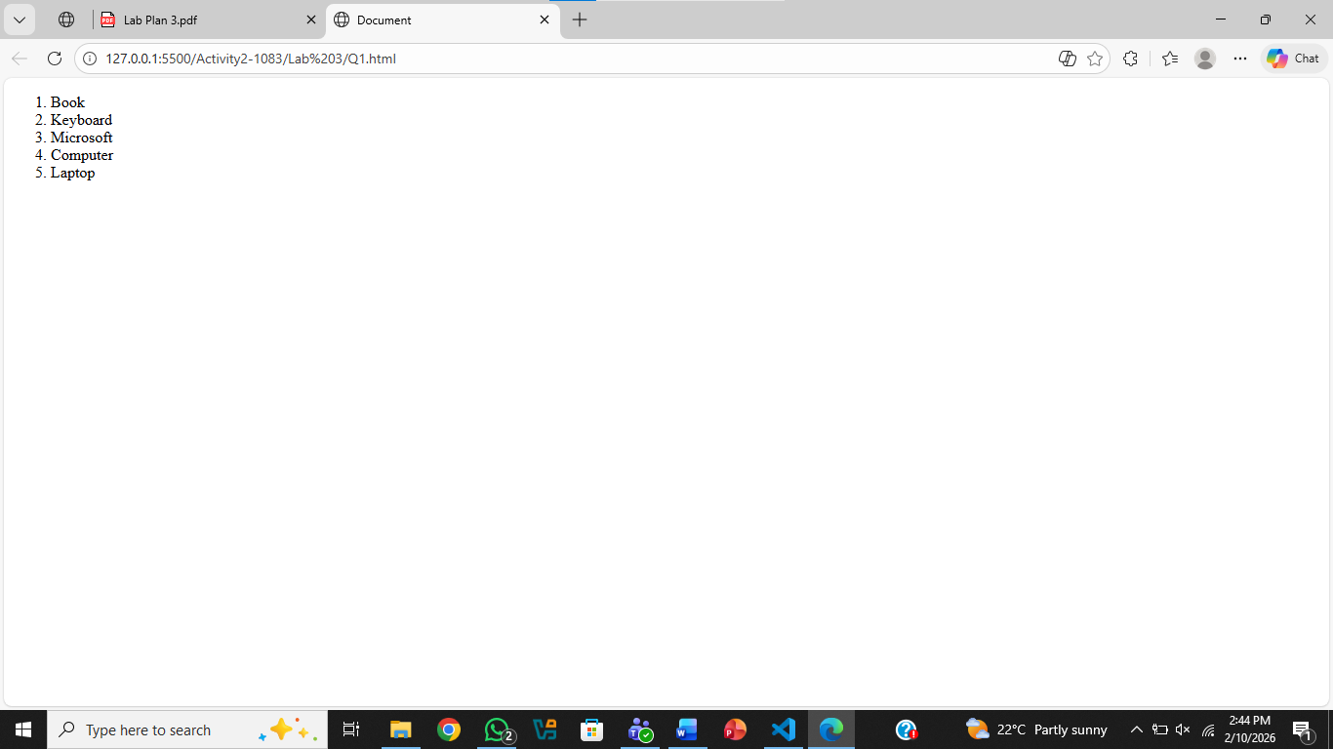
Question .No.2
Code:
<!DOCTYPE html>
<html lang="en">
<head>
<meta charset="UTF-8">
<meta name="viewport" content="width=device-width, initial-scale=1.0">
<title>Document</title>
</head>
<body>
<ul>
<li>Banana</li>
<li>Mango</li>
<li>Grapes</li>
<li>Gava</li>
<li>Orange</li>
<li>Apple</li>
<li>Watermelon</li>
</ul>
</body>
</html>
Output:
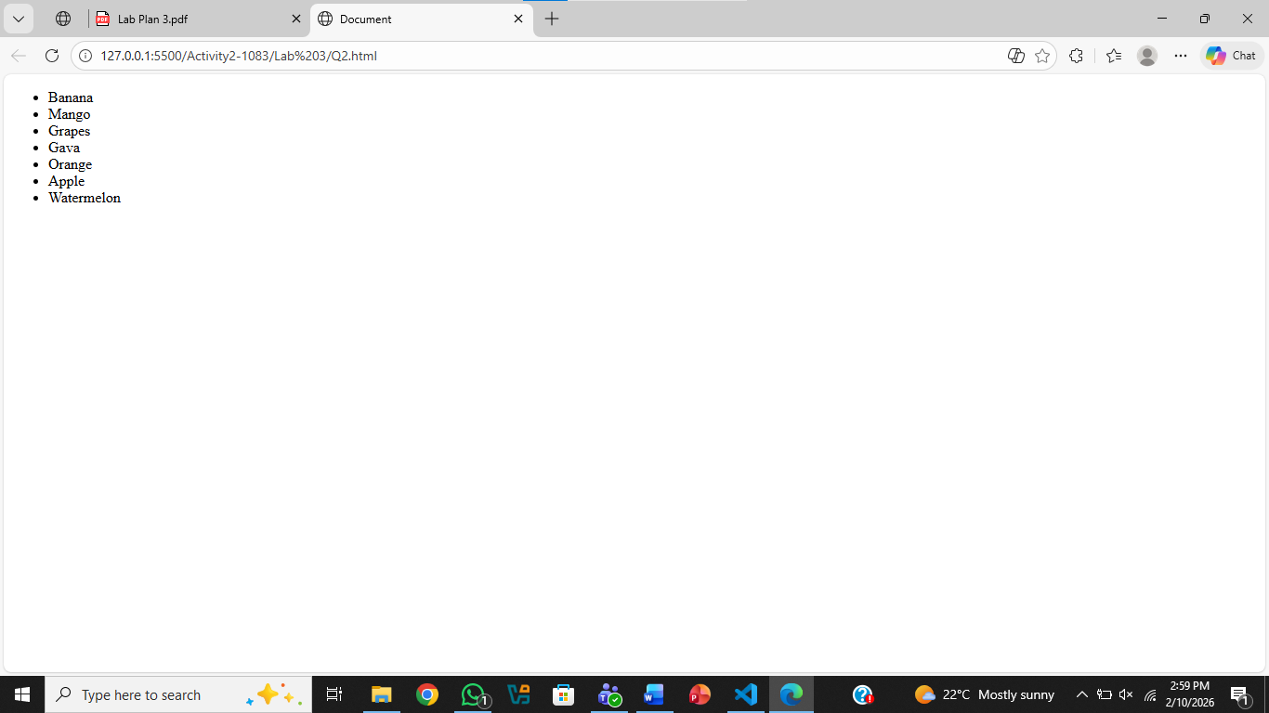
Question .No.3
Code:
<!DOCTYPE html>
<html lang="en">
<head>
<meta charset="UTF-8">
<meta name="viewport" content="width=device-width, initial-scale=1.0">
<title>Your Page.html</title>
</head>
<body>
<ol start="10">
<li>Item 10</li>
<li>Item 11</li>
<li>Item 12</li>
<li>Item 13</li>
<li>Item 14</li>
<li>Item 15</li>
<li>Item 16</li>
<li>Item 17</li>
<li>Item 18</li>
<li>Item 19</li>

</ol>
</body>
</html>
Output:
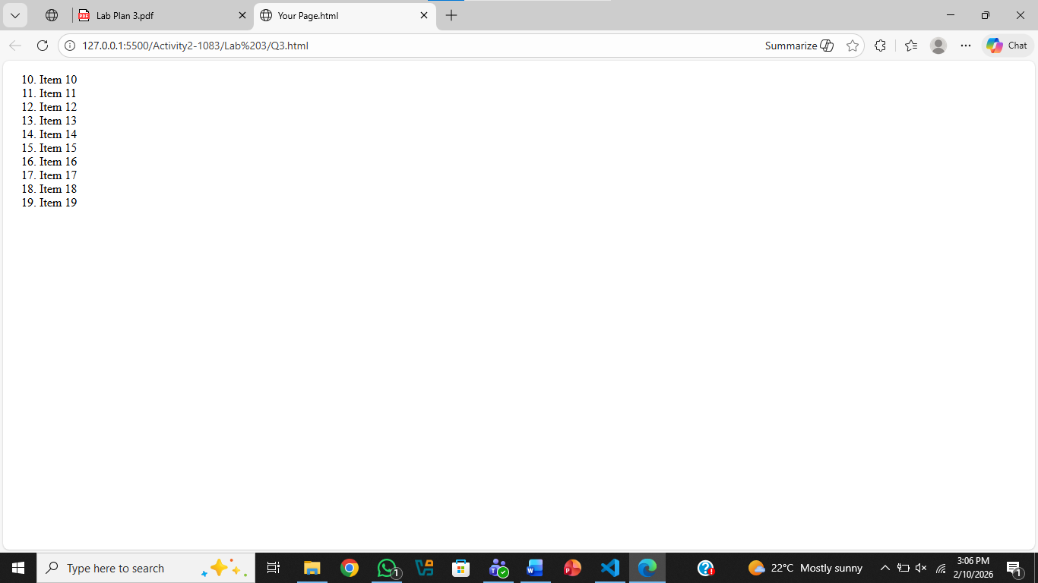
Question .No.4
Code:
<!DOCTYPE html>
<html lang="en">
<head>
<meta charset="UTF-8">
<meta name="viewport" content="width=device-width, initial-scale=1.0">
<title> Mypage.html</title>
</head>
<body>
<ol type="I" start="5" style="color:red">
<li>Item 10</li>
<li>Item 11</li>
<li>Item 12</li>
<li>Item 13</li>
<li>Item 14</li>
<li>Item 15</li>
<li>Item 16</li>
<li>Item 17</li>
<li>Item 18</li>
<li>Item 19</li>

</ol>
</body>
</html>
Output:
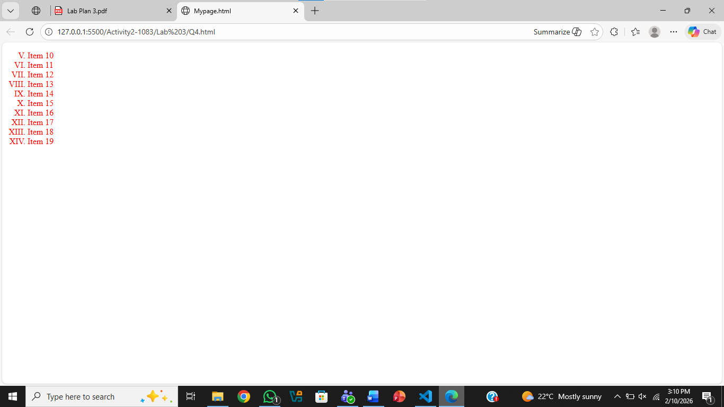
Question .No.5
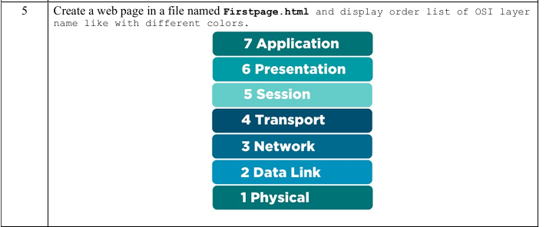
Code:
<!DOCTYPE html>
<html lang="en">
<head>
<meta charset="UTF-8">
<meta name="viewport" content="width=device-width, initial-scale=1.0">
<title>First Page.html</title>
</head>
<body>
<div style="width: 300px; margin: auto;">
<ol reversed style="list-style-position: inside;padding-left: 0;">
<li style="background-color: hsl(195, 96%, 11%);color: white; text-align: center;"><b>Application</b></li>
<li style="background-color: hsl(194, 85%, 51%);color: white; text-align: center;"><b>Presentation</b></li>
<li style="background-color: hsl(194, 48%, 47%);color: white; text-align: center;"><b>Session</b></li>
<li style="background-color: hsl(194, 91%, 25%);color: white; text-align: center;"><b>Transport</b></li>
<li style="background-color: hsl(194, 88%, 76%);color: white; text-align: center;"><b>Network</b></li>
<li style="background-color: hsl(191, 54%, 30%);color: white; text-align: center;"><b>Data Link</b></li>
<li style="background-color: hsl(194, 96%, 35%);color: white; text-align: center;"><b>Physical</b></li>
</ol>
</div>
</body>
</html>
Output:
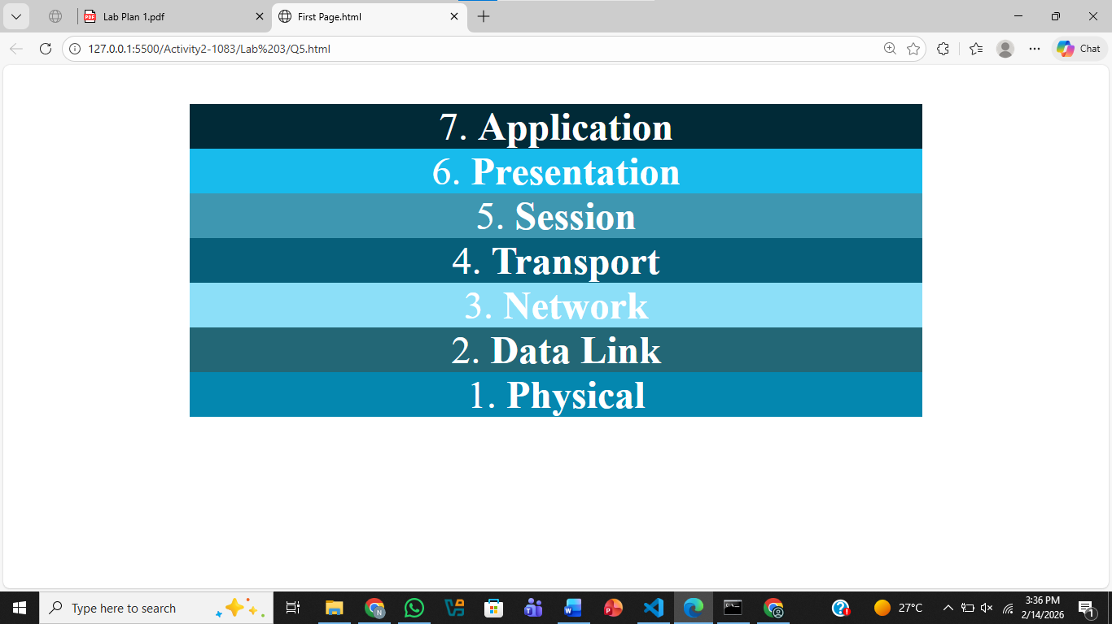
Question .No.6
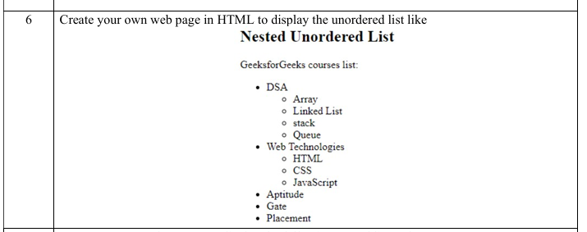
Code:
<!DOCTYPE html>
<html lang="en">
<head>
<meta charset="UTF-8">
<meta name="viewport" content="width=<device-width>, initial-scale=1.0">
<title>Document</title>
</head>
<body>
<h2>Nested Unordered List</h2>
Geeks for Geeks courese lists:
<ul>
<li>DSA</li>
<ul>
<li>Array</li>
<li>Linked List</li>
<li>Stack</li>
<li>Queue</li>
</ul>
<li>Web Technologies</li>
<ul>
<li>HTML</li>
<li>CSS</li>
<li>JavaScript</li>
</ul>
<li>Aptitude</li>
<li>Gate</li>
<li>Placement</li>
</ul>

</body>
</html>
Output:
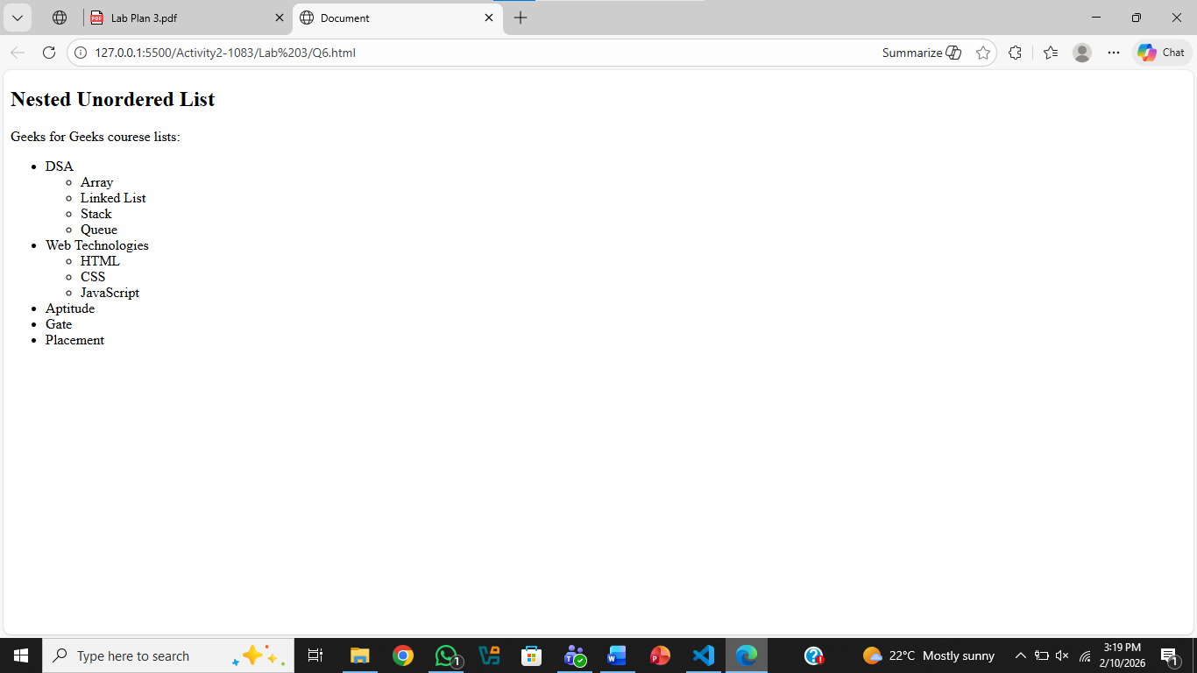
Question .No.7
Code:
<!DOCTYPE html>
<html lang="en">
<head>
<meta charset="UTF-8">
<meta name="viewport" content="width=device-width, initial-scale=1.0">
<title>Document</title>
</head>
<body>
Preceding Text
<ol type="I">
<li>List Item 1</li>
<ol type="a">
<li>Nested Item 1.1</li>
<li>Nested Item 1.2</li>
</ol>
<li>List Item 2</li>
<ol>
<li>Nested Item 2.1</li>
<li>Nested Item 2.2</li>
<ul type="circle">
<li>Nested Item 2.2.1</li>
<li>Nested Item 2.2.2</li>
<ul type="square">
<li>Nested Item 2.2.2.1</li>
<li>Nested Item 2.2.2.2</li>
</ul>
<li>Nested Item 2.2.3</li>
</ul>
<li>Nested Item 2.3</li>
</ol>

<li>List Item 3</li>
<ul type="disc">
<li>Nested Item 3.1</li>
<li>Nested Item 3.2</li>
<li>Nested Item 3.3</li>
</ul>
</ol>
</body>
</html>
Output:
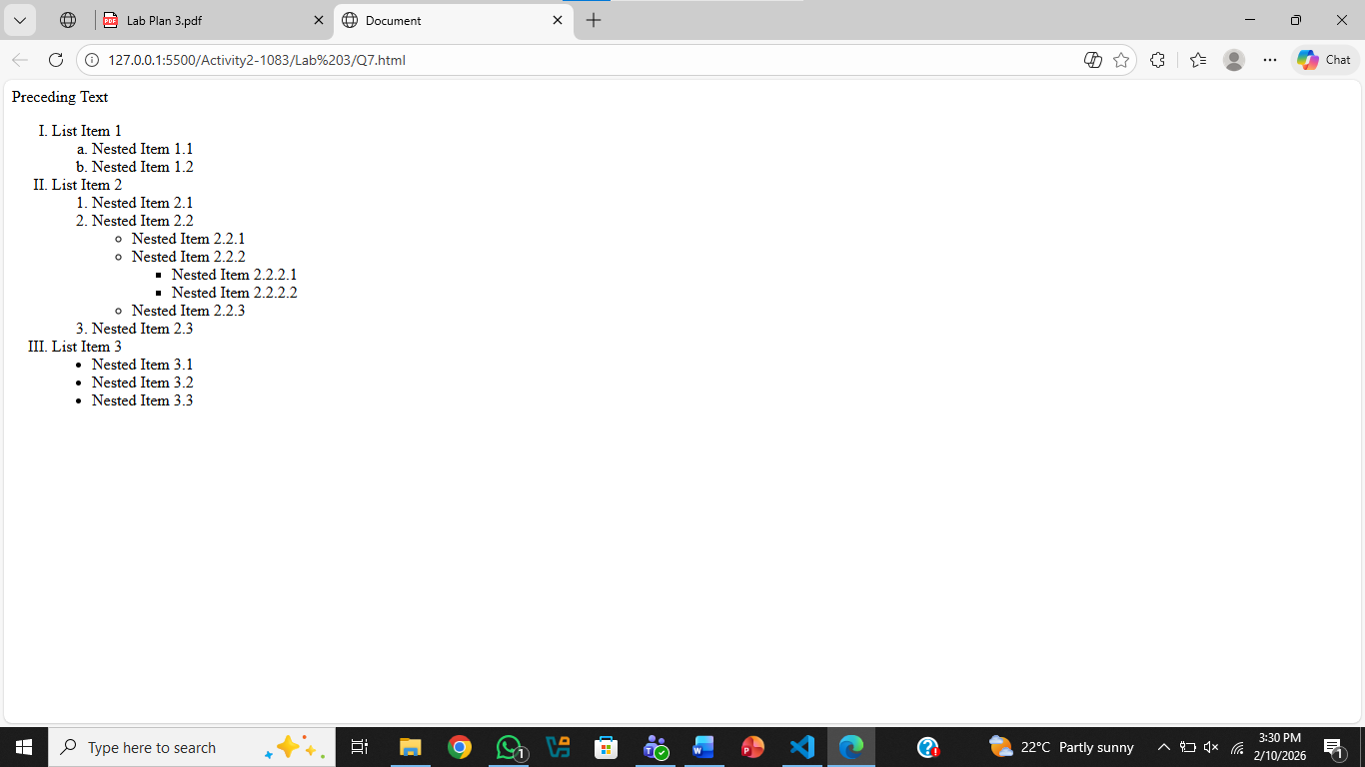
Question .No.8
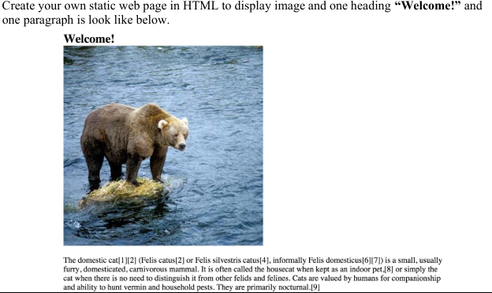
Code:
<!DOCTYPE html>
<html lang="en">
<head>
<meta charset="UTF-8">
<meta name="viewport" content="width=device-width, initial-scale=1.0">
<title>Document</title>
</head>
<body>
<h2>
Welcom!
</h2>
<img src="Bear.jpg" alt="Bear Image">
<p>Lorem ipsum dolor sit amet consectetur adipisicing elit.
Cum nisi placeat libero excepturi doloremque reprehenderit
vero itaque provident fugiat ullam sit, hic ab minus ad amet,
quam quibusdam, optio totam! Doloribus, voluptate
</p>
</body>
</html>
Output:
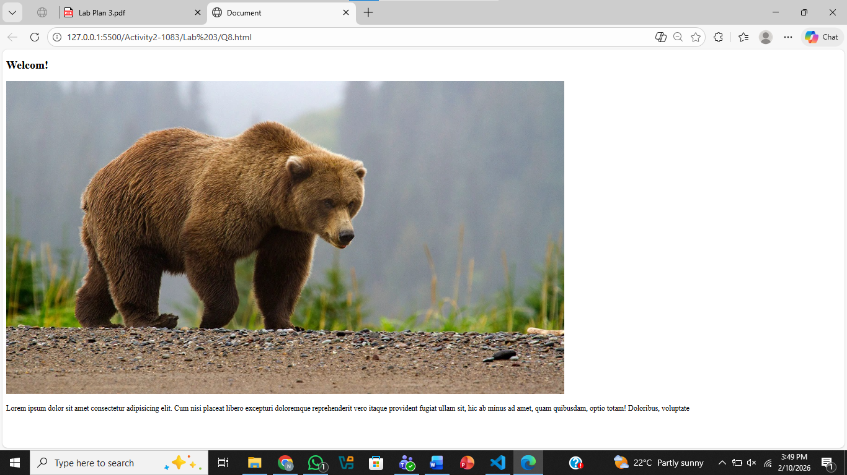
Question .No.9
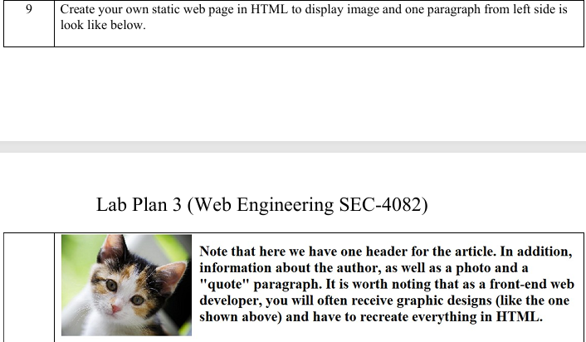
Code:
<!DOCTYPE html>
<html lang="en">
<head>
<meta charset="UTF-8">
<meta name="viewport" content="width=device-width, initial-scale=1.0">
<title>Document</title>
</head>
<body>
<img src="Cat.jpg" alt="Cat Image" style="float:left; margin-right:15px;">

<p style="font-size: 32px;">
Lorem ipsum dolor sit amet consectetur adipisicing elit.
Cum nisi placeat libero excepturi doloremque reprehenderit
vero itaque provident fugiat ullam sit, hic ab minus ad amet,
quam quibusdam, optio totam!
</p>

</body>
</body>
</body>
</html>
Output:
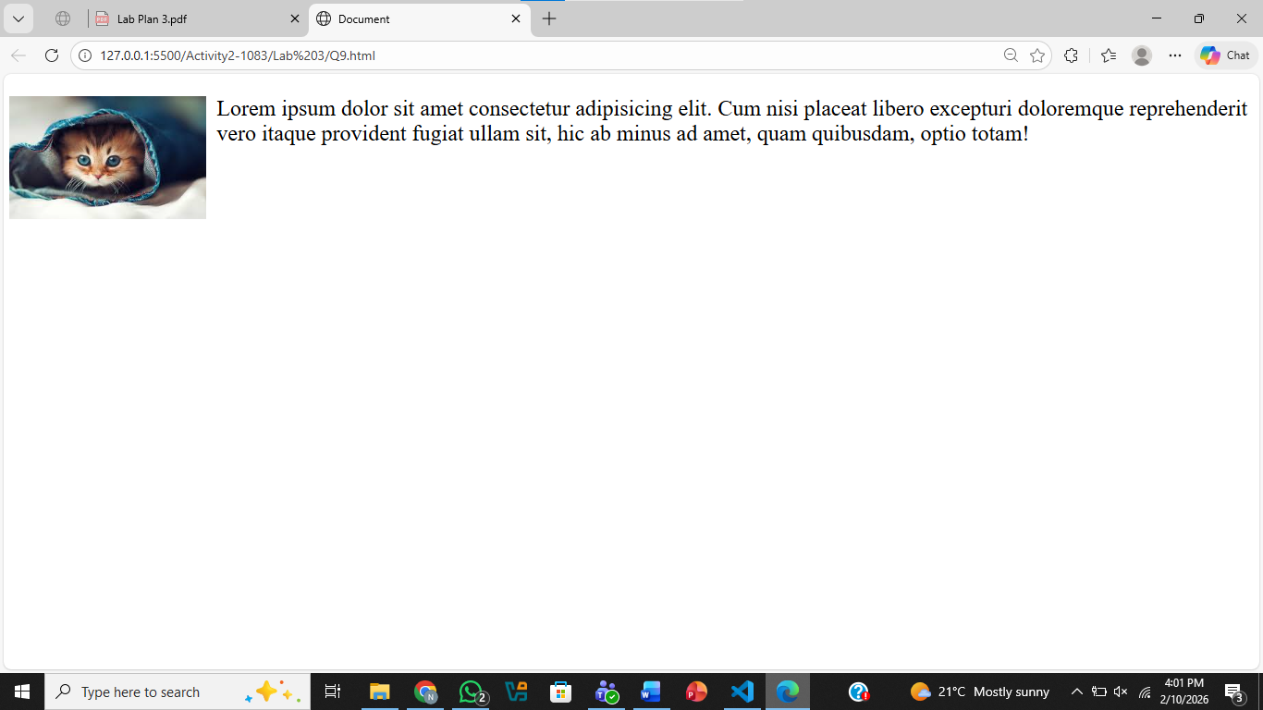
Question .No.10
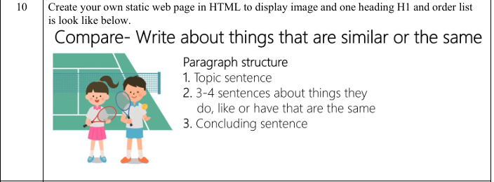
Code:
<!DOCTYPE html>
<html lang="en">
<head>
<meta charset="UTF-8">
<meta name="viewport" content="width=device-width, initial-scale=1.0">
<title>Document</title>
</head>
<body>
<p style="font-size: 28px;">Compare write about things
that are similar or the same</p>
<img src="Racket.jpg" alt="Racket Image" style="float:left; margin-right:15px;">

<p style="font-size: 24px;">
Paragraph Structue
</p>
<ol type="1" style ="font-size: 24px; float:left; ">
<li>Topic Sentence</li>
<li>3-4 Sentences about the things they do like or have that are the same </li>
<li>Concluding Sentence</li>
</ol>

</body>
</body>
</body>
</html>
Output:
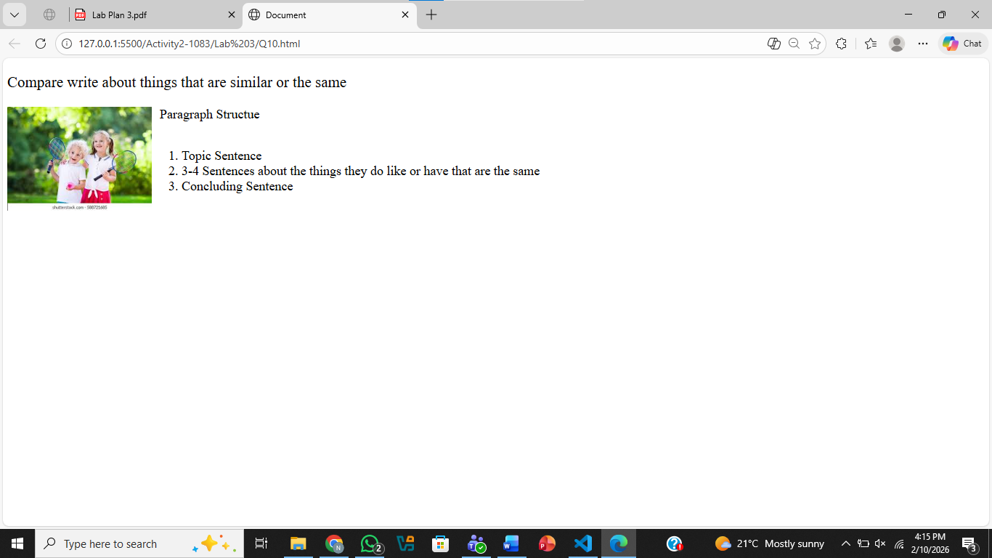

Lab NO4

Question .No.1
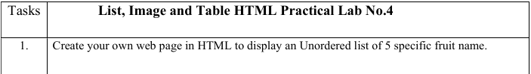
Code:
<!DOCTYPE html>
<html lang="en">
<head>
<meta charset="UTF-8">
<meta name="viewport" content="width=device-width, initial-scale=1.0">
<title>Document</title>
</head>
<body>
<ul>
<li>Banana</li>
<li>Mango</li>
<li>Orange</li>
<li>Apple</li>
<li>Watermelon</li>
</ul>
</body>
</html>
Output:
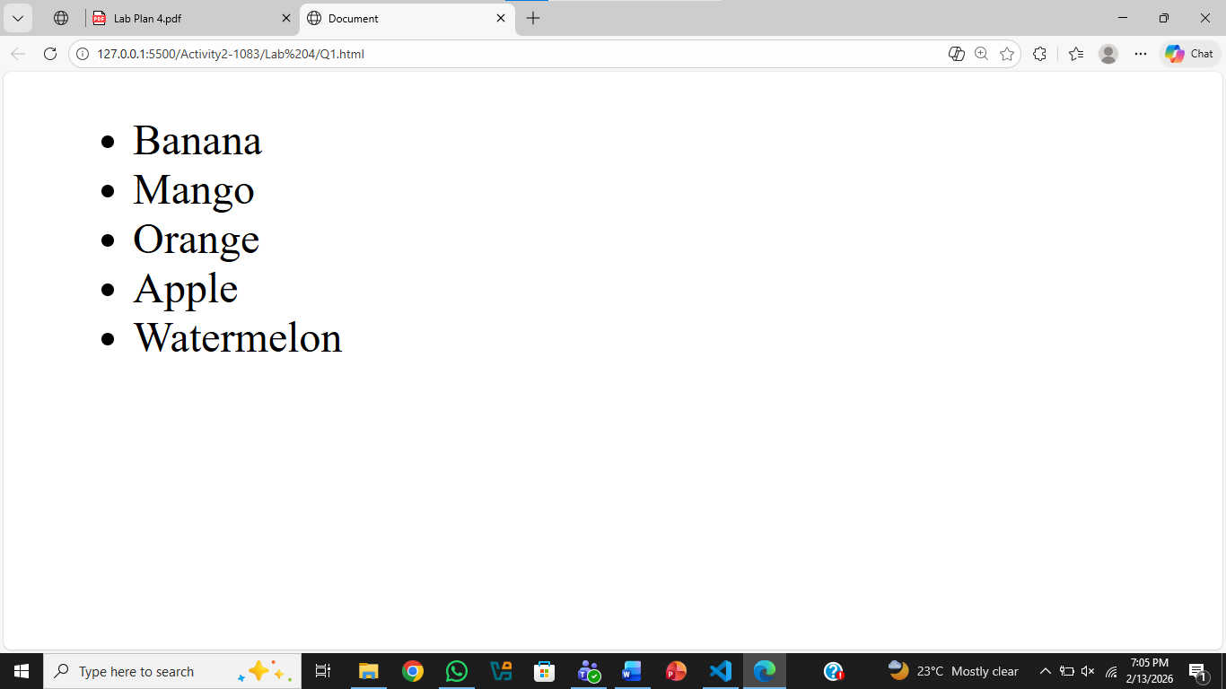
Question .No.2
Code:
<!DOCTYPE html>
<html lang="en">
<head>
<meta charset="UTF-8">
<meta name="viewport" content="width=device-width, initial-scale=1.0">
<title>Document</title>
</head>
<body>
<ul type="circle">
<li>Ali</li>
<li>Ahmed</li>
<li>Umer</li>
<li>Nouman</li>
</ul>
<ul type="disc">
<li>Faisalabad</li>
<li>Multan</li>
<li>Islamabad</li>
</ul>
</body>
</html>
Output:
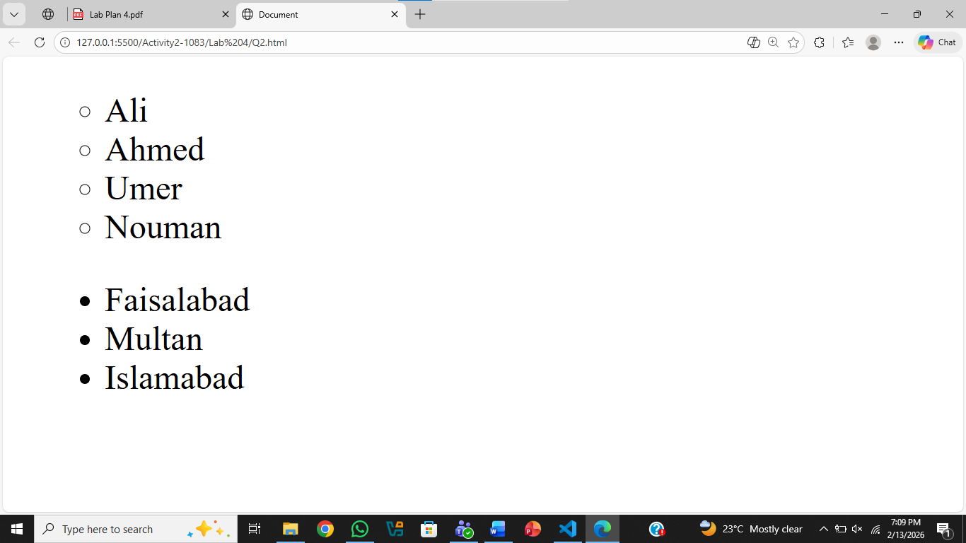
Question .No.3
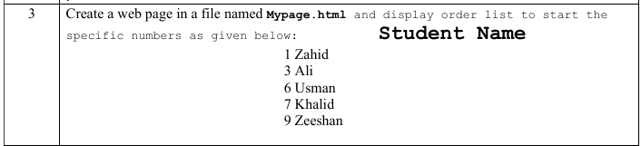
Code:
<!DOCTYPE html>
<html lang="en">
<head>
<meta charset="UTF-8">
<meta name="viewport" content="width=device-width, initial-scale=1.0">
<title>MyPage.html</title>
</head>
<body>
<h2 style="text-align: right;">Student Names</h2>
<ol>
<li value="1">Zahid</li>
<li value="3">Ali</li>
<li value="6">Usman</li>
<li value="7">Khalid</li>
<li value="9">Zeeshan</li>
</ol>
</body>
</html>
Output:
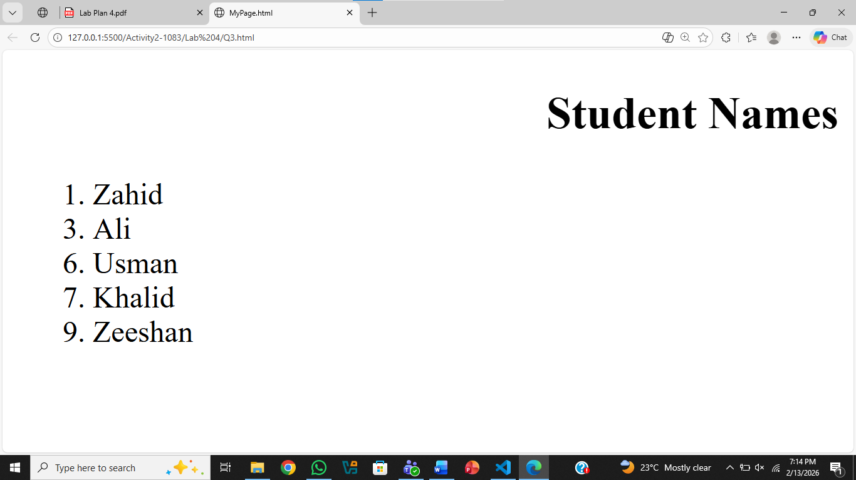
Question .No.4
Code:
<!DOCTYPE html>
<html lang="en">
<head>
<meta charset="UTF-8">
<meta name="viewport" content="width=device-width, initial-scale=1.0">
<title>MyList.html</title>
</head>
<body>

<ol start="7" type="a" style="color: green; font-family: Algerian; font-size: calc(100%, 3);">
<li>Zahid</li>
<li>Ali</li>
<li>Usman</li>
<li>Khalid</li>
<li>Zeeshan</li>
</ol>
</body>
</html>
Output:
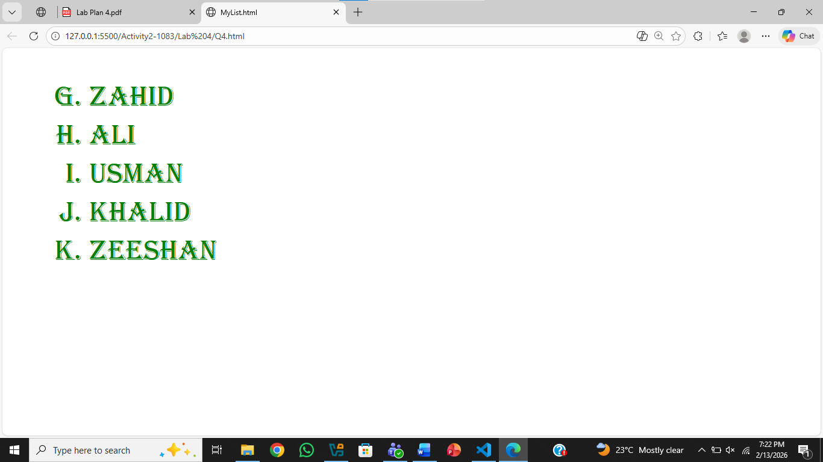
Question .No.5
Code:
<!DOCTYPE html>
<html>
<head>
<title>First Web Page</title>
</head>
<body>

<table width="100%">
<tr>
<td width="50%" valign="top">
<h3>Unordered Lists</h3>

<b>Disc</b>
<ul type="disc">
<li>First Item</li>
<li>Second Item</li>
<li>Third Item</li>
</ul>

<b>Square</b>
<ul type="square">
<li>First Item</li>
<li>Second Item</li>
<li>Third Item</li>
</ul>

<b>Circle</b>
<ul type="circle">
<li>First Item</li>
<li>Second Item</li>
<li>Third Item</li>
</ul>

<b>None_No Bullets</b>
<ul type="none">
<li>First Item</li>
<li>Second Item</li>
<li>Third Item</li>
</ul>
</td>

<td width="50%" valign="top" align="right">
<h3>Ordered Lists</h3>

<b>Decimal</b>
<ol type="1">
<li>First Item</li>
<li>Second Item</li>
<li>Third Item</li>
</ol>

<b>Lowercase ascii Letters</b>
<ol type="a">
<li>First Item</li>
<li>Second Item</li>
<li>Third Item</li>
</ol>

<b>Lowercase roman numerals</b>
<ol type="i">
<li>First Item</li>
<li>Second Item</li>
<li>Third Item</li>
</ol>
</td>

</tr>
</table>

</body>
</html>
Output:
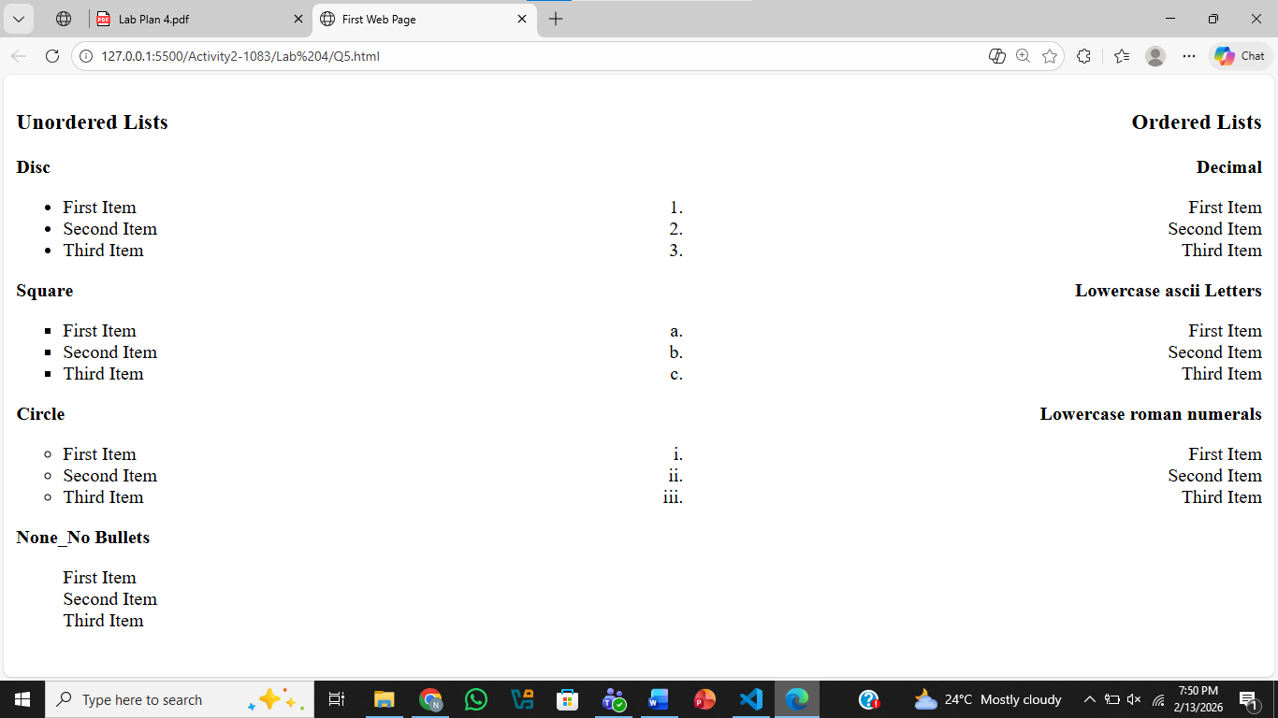
Question .No.6
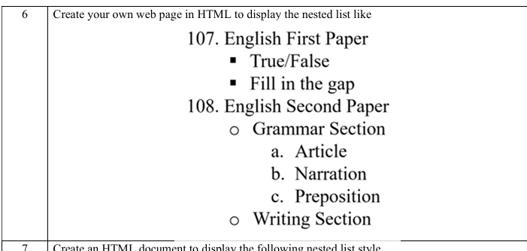
Code:
<!DOCTYPE html>
<html lang="en">
<head>
<meta charset="UTF-8">
<meta name="viewport" content="width=device-width, initial-scale=1.0">
<title>Document</title>
</head>
<body>
<ol>
<li value="107"> English First Paper</li>
<ul type="square">
<li>True/False</li>
<li>Fill in the blanks</li>
</ul>
<li value="108"> English Second Paper</li>
<ul type="circle">
<li>Grammer Section</li>
<ol type="a">
<li>Article</li>
<li>Narration</li>
<li>Preposition</li>
</ol>
<li>Writing Section</li>
</ol>
</body>
</html>
Output:
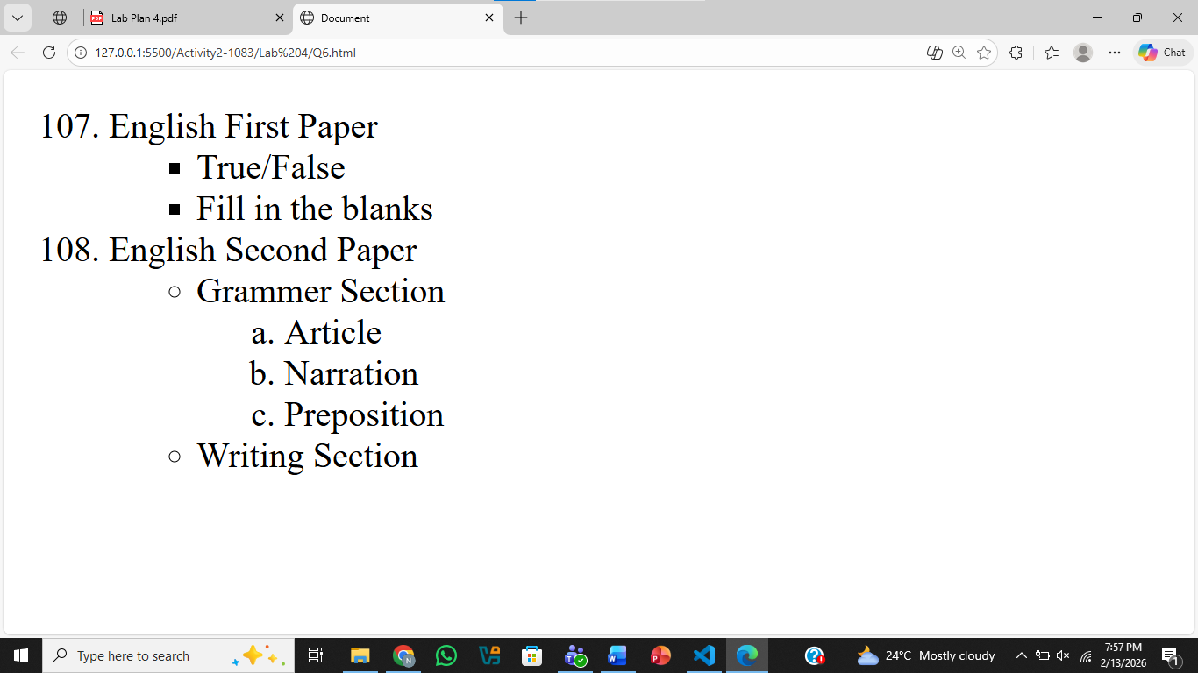
Question .No.7
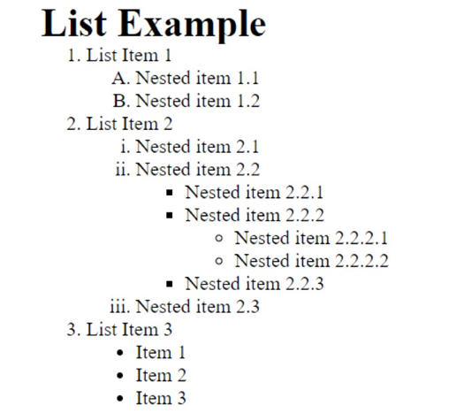
Code:
<!DOCTYPE html>
<html lang="en">
<head>
<meta charset="UTF-8">
<meta name="viewport" content="width=device-width, initial-scale=1.0">
<title>Document</title>
</head>
<body>
<h2>List Examples </h2>
<ol type="1">
<li>List Item 1</li>
<ol type="A">
<li>Nested Item 1.1</li>
<li>Nested Item 1.2</li>
</ol>
<li>List Item 2</li>
<ol type="i">
<li>Nested Item 2.1</li>
<li>Nested Item 2.2</li>
<ul type="SQUARE">
<li>Nested Item 2.2.1</li>
<li>Nested Item 2.2.2</li>
<ul type="circle">
<li>Nested Item 2.2.2.1</li>
<li>Nested Item 2.2.2.2</li>
</ul>
<li>Nested Item 2.2.3</li>
</ul>
<li>Nested Item 2.3</li>
</ol>

<li>List Item 3</li>
<ul type="disc">
<li>Nested Item 3.1</li>
<li>Nested Item 3.2</li>
<li>Nested Item 3.3</li>
</ul>
</ol>
</body>
</html>
Output:
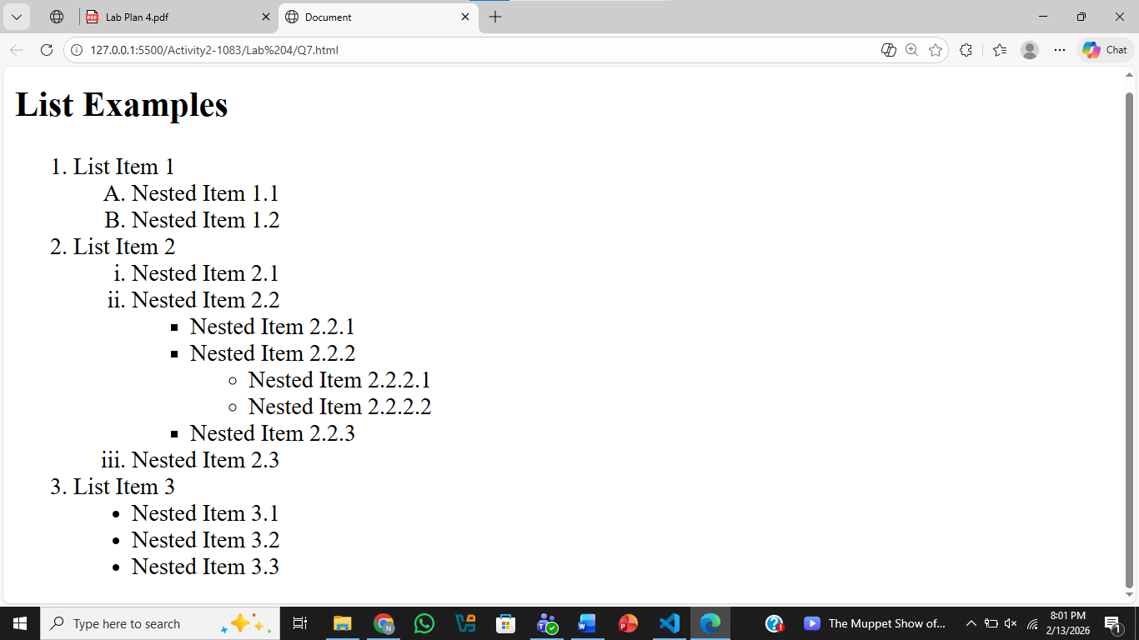
Question .No.8
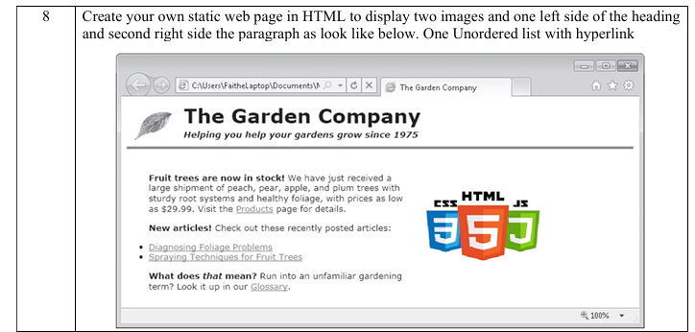
Code:
<!DOCTYPE html>
<html lang="en">
<head>
<meta charset="UTF-8">
<meta name="viewport" content="width=device-width, initial-scale=1.0">
<title>Document</title>
</head>
<body>
<img style="width: 50px; height: 50px; float:left" src="Leaf.png">
<h2>The Garden Company</h2>
<h4>Helping you help your gardens grow since 1975</h4>
<hr>
<b>Fruit trees are now in stock! </b>
We have just received a large shipment of peach, pear, apple,
and plum trees with sturdy root systems and healthy foliage,
<img style="float: right;" src="Web.png">
with prices as low as $29.99. Visit the Products page for details.
<br>

<b>New articles!</b> Check out these recently posted articles:
<br>
<ul>
<li> <u style="color: rgb(18, 177, 240);">Diagnosing Foliage Problems</u></li>
<li><u style="color: rgb(18, 177, 240);">Spraying Techniques for Fruit Trees</u></li>
</ul>
<br>
<b>What does that mean?</b> Run into an unfamiliar gardening term?
<br>
Look it up in our <u style="color: rgb(18, 177, 240);">Glossary</u>
</body>
</html>
Output:
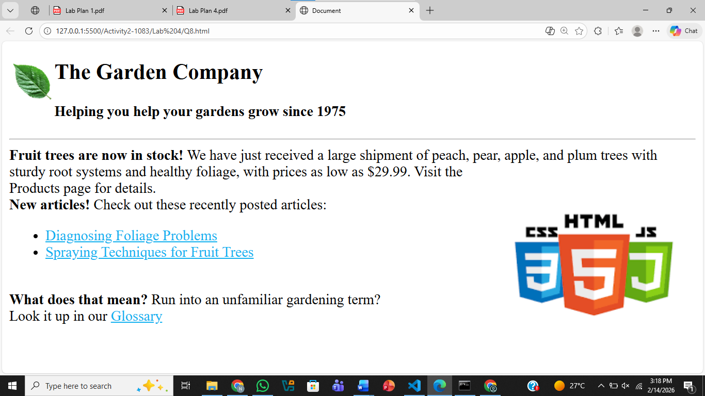
Question .No.9
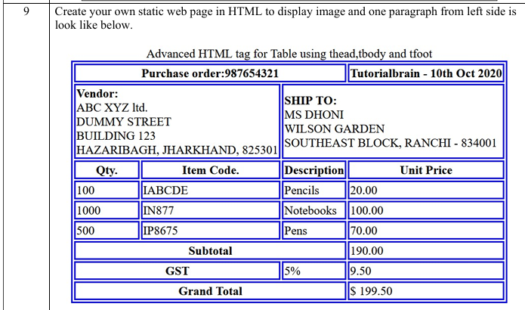
Code:
<!DOCTYPE html>
<html lang="en">
<head>
<meta charset="UTF-8">
<meta name="viewport" content="width=device-width, initial-scale=1.0">
<title>Document</title>
</head>
<body>
<p style="text-align: center;">Advanced HTML tag for Table using thead,tbody and tfoot</p>
<table border="2" style="border-color: blue;">

<thead style="border-color: blue;">
<tr>
<th>Purchase order:987654321</th>
<th>Tutorialbrain - 10th Oct 2020</th>
</tr>
</thead>
<tbody>
<tr style="border-color: blue;">
<td> <b>Vendor:</b>
<br>
ABC XYZ ltd.
<br>
DUMMY STREET
<br>
BUILDING 123
<br>
HAZARIBAGH, JHARKHAND, 825301
<td><b>SHIP TO:</b>
<br>
MS DHONI
<br>
WILSON GARDEN
<br>
SOUTHEAST BLOCK, RANCHI - 834001
</tr>
<th style="border-color: blue;">Qty.</th>
<th>Item Code</th>
<th>Description</th>
<th>Unit Price</th>
<tr>
<td>100</td>
<td>IABCDE</td>
<td>Pencils</td>
<td>20.00</td>
</tr>
<tr>
<td>1000</td>
<td>IN877</td>
<td>Notebooks</td>
<td>100.00</td>
</tr>
<tr>
<td>500</td>
<td>0P8675</td>
<td>Pens</td>
<td>70.00</td>
</tr>
<th colspan="3">Subtotal</th>
<td >$190.00</td>
</tr>
<tr>
<th colspan="2">GST</th>
<td>5%</td>
<td>9.50</td>
</tr>
<tr>
<th colspan="3">Grand Total</th>
<td >$199.50</td>
</tr>
</tbody>
<tfoot>
<tr>
</tr>
</tfoot>

</table>
</body>
</html>
Output:
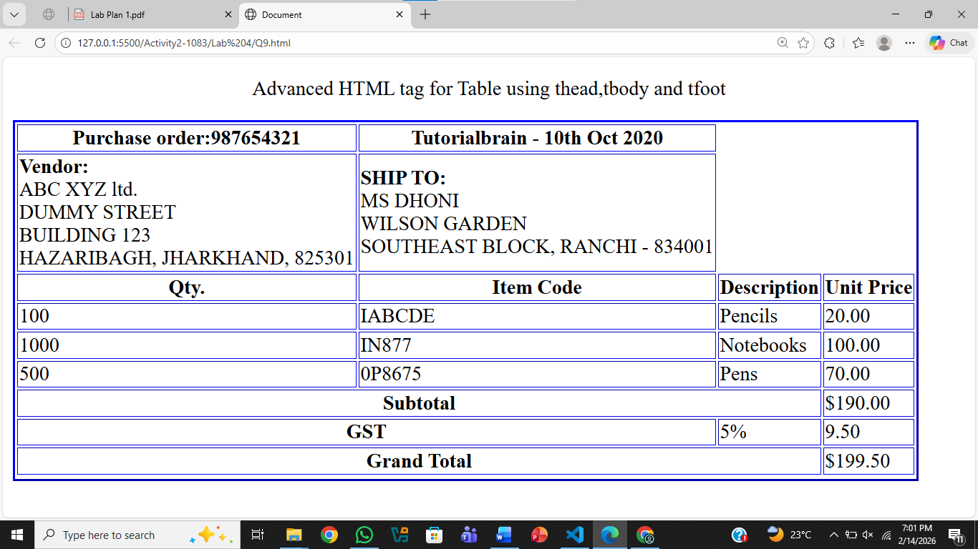
Question .No.10
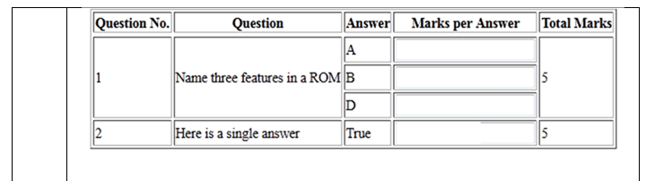
Code:
<!DOCTYPE html>
<html lang="en">
<head>
<meta charset="UTF-8">
<meta name="viewport" content="width=device-width, initial-scale=1.0">
<title>Document</title>
</head>
<body>

<table border="1">
<thead>
<tr>
<th>Question No</th>
<th>Question</th>
<th>Answer</th>
<th>Mark Per Answer</th>
<th>Total Marks</th>
</tr>
</thead>
<tbody>
<tr>
<td> 1
</td>
<td>
Name three feature in a ROM
</td>
<td>
A
<br>
B
<br>
D
</td>
<td></td>
<td>
5
</td>
</tr>
<tr>
<td> 2
</td>
<td>
Here is a single answer
</td>
<td>
True
</td>
<td></td>
<td>
5
</td>

</tbody>
<tfoot>

</tfoot>

</table>
</body>
</html>
Output:
