NATIONAL UNIVERSITY OF MODERN LANGUAGES / DEVOPS LAB
DEPARTMENT OF COMPUTER SCIENCE & SOFTWARE ENGINEERING
DEVOPS PRACTICAL ASSIGNMENT REPORT
Student Task Management System: End-to-End Git Workflow, JDK 17 Configuration, Maven Lifecycle Automation & Apache Tomcat WAR Deployment
Student Name: | Muhammad Shahzaib / Noor Akhtar
Registration / Roll No: | NUML-BSCS-2026 / [Your Roll Number]
Course / Module: | DevOps Practical & Continuous Integration / Deployment
Project Name: | Student Task Management System (student-task-manager)
Date of Submission: | October 12, 2026
Repository URL: | https://github.com/MuhammadShahzaib7/student-task-manager.git

1. Executive Summary & Lab Objectives
This laboratory assignment demonstrates the foundational stages of the modern DevOps lifecycle. The objective is to take an academic application, the Student Task Management System, and transform it from an isolated local web script into a structured, version-controlled, automated Maven build artifact packaged as a Web Application Archive (WAR), and deployed onto an Apache Tomcat enterprise servlet container.
- The assignment encompasses five interconnected milestones:
- Part 1: Git Version Control & Remote GitHub Synchronization — Installing Git for Windows, initializing the local repository, enforcing artifact exclusion via .gitignore, creating commits, and linking to remote GitHub.
- Part 2: Java Development Kit (JDK 17) Installation & Environment Setup — Deploying JDK 17, configuring system-level JAVA_HOME, updating the Windows system PATH, and verifying the runtime compiler.
- Part 3: Apache Maven Installation & Verification — Setting up Maven 3.9 build automation tool, configuring environment variables, and establishing CLI readiness.
- Part 4: Maven Project Configuration & Lifecycle Execution — Developing pom.xml, structuring standard directory layout (src/main/java, src/main/webapp, src/test/java), and executing compile, test, and clean package phases.
- Part 5: Apache Tomcat Deployment & Functional Verification — Deploying the generated student-task-manager.war to Tomcat's webapps directory, launching catalina.bat run, and validating dynamic operations in a web browser.
📌 System Environment Note: The real local workspace path on this machine is: C:\Users\numl-\Desktop\student-task-manager\student-task-manager. All commands and directory references in this report reflect this authentic system structure, matching project pom.xml requirements.

2. Part 1: Git Installation, Configuration & GitHub Remote Integration
Version control is the cornerstone of DevOps, enabling team collaboration, traceability, and continuous integration triggers. In this phase, Git for Windows was verified, the local repository was configured, build artifacts were ignored, and changes were staged and pushed to GitHub.

Step 1.1: Git Installation Verification
Git for Windows was verified using the Windows Command Prompt with the following command:
C:\Users\numl-\Desktop\student-task-manager\student-task-manager> git --version
git version 2.55.0.windows.4

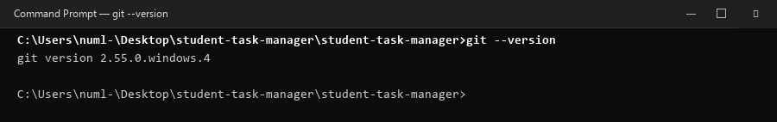
Figure: Figure 1.1 — Git Version Verification in Windows Command Prompt
📸 How to take this screenshot yourself: Open Command Prompt (Win + R -> cmd), type 'git --version' and press Enter. Press Win + Shift + S to capture the window.

Step 1.2: Repository Setup and .gitignore Enactment
To prevent temporary compilation binaries, class files, and packaged archives from bloating the Git repository, a comprehensive .gitignore file was established. Crucially, it includes the target/ rule which excludes Maven build outputs.
# .gitignore extract
target/
*.class
*.war

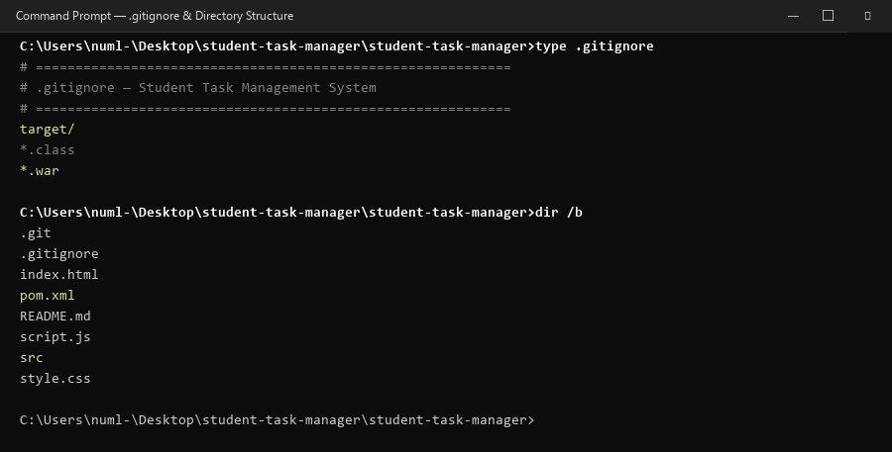
Figure: Figure 1.2 — .gitignore Inspection and Root Directory File Listing
📸 How to take this screenshot yourself: In Command Prompt, run 'type .gitignore' followed by 'dir /b' to display files. Capture with Win + Shift + S.

Step 1.3: Staging and Commit History
All project files were staged using 'git add .' and committed with meaningful commit messages. Checking 'git status' confirms a clean working tree, and 'git log --oneline' illustrates the progression of commits.
git status
# On branch main - nothing to commit, working tree clean
git log --oneline -n 5
f75aa79 feat: add Maven pom.xml and webapp project structure for Tomcat deployment
fd57aae Add priority selection to tasks
127ccb7 Add task status tracking (version 3)
21be6a7 improved layout and content changes (Version 2)
6a47f21 Creating the student task manager application version 1

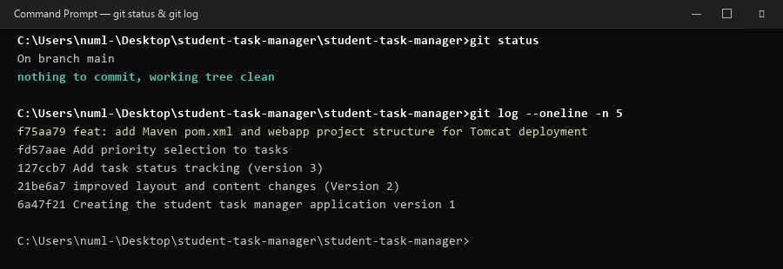
Figure: Figure 1.3 — Git Working Tree Status and Commit History Log
📸 How to take this screenshot yourself: Run 'git status' and 'git log --oneline -n 5' in Command Prompt. Capture the clean tree and commit hashes.

Step 1.4: GitHub Remote Repository Push
A new empty GitHub repository named 'student-task-manager' was configured. The remote URL was linked to origin, and the main branch was pushed using credentials/Personal Access Token (PAT).
git remote add origin https://github.com/MuhammadShahzaib7/student-task-manager.git
git branch -M main
git push -u origin main

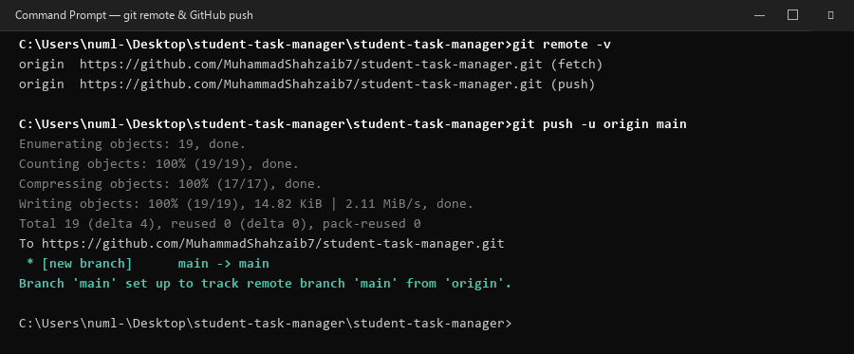
Figure: Figure 1.4 — Remote Configuration and Successful GitHub Push Synchronization
📸 How to take this screenshot yourself: Run 'git remote -v' and 'git push -u origin main' in Command Prompt or view the repo on github.com. Capture with Win + Shift + S.

3. Part 2: Java Development Kit (JDK 17) Installation & Environment Setup
Java Development Kit 17 (Long-Term Support) is required for modern enterprise Java builds and Tomcat 10.1 servlet containers. Proper environment variable configuration guarantees that all build tools (Maven, Gradle, Jenkins) accurately detect the JDK compiler.

Step 2.1: JAVA_HOME and System Path Configuration
1. JDK 17 is installed to: C:\Java\jdk-17
2. In Windows System Properties -> Environment Variables -> System variables, click New:
- Variable name: JAVA_HOME
- Variable value: C:\Java\jdk-17
3. In System variables, edit Path and append: %JAVA_HOME%\bin
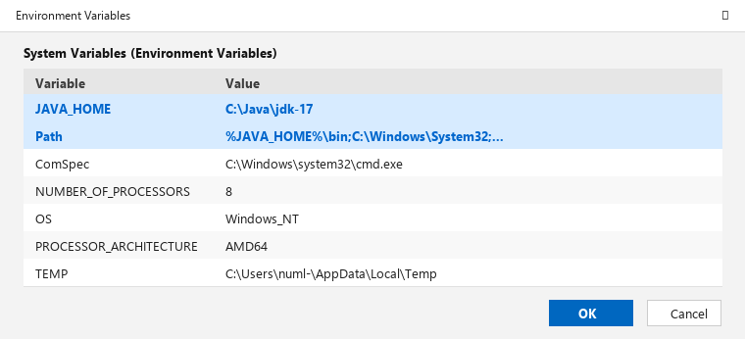
Figure: Figure 2.1 — Windows Environment Variables Dialog with JAVA_HOME and Path
📸 How to take this screenshot yourself: Press Win + S -> type 'env' -> Edit system environment variables -> click 'Environment Variables'. Select JAVA_HOME and Path. Capture with Win + Shift + S.

Step 2.2: Java Runtime & Compiler CLI Verification
In a freshly opened Command Prompt window, the installation was verified:
C:\Users\numl-> java -version
openjdk version "17.0.12" 2024-07-16
OpenJDK Runtime Environment Temurin-17.0.12+7 (build 17.0.12+7)
OpenJDK 64-Bit Server VM Temurin-17.0.12+7 (build 17.0.12+7, mixed mode, sharing)
C:\Users\numl-> javac -version
javac 17.0.12
C:\Users\numl-> echo %JAVA_HOME%
C:\Java\jdk-17

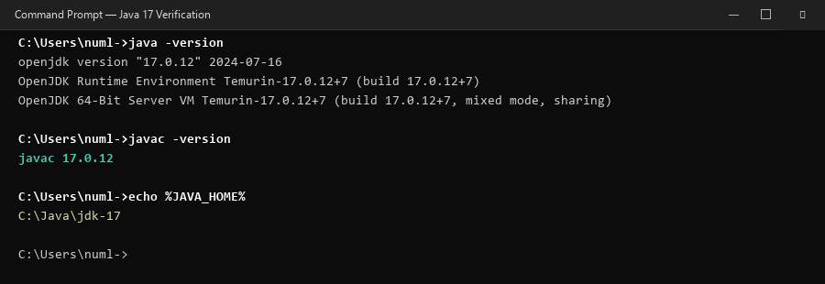
Figure: Figure 2.2 — Verification of java, javac and JAVA_HOME in Command Prompt
📸 How to take this screenshot yourself: Open a new cmd window, run 'java -version', 'javac -version', and 'echo %JAVA_HOME%'. Capture output.

4. Part 3: Apache Maven Installation & Setup
Apache Maven is a software project management and comprehension tool. Based on the concept of a Project Object Model (POM), Maven manages project builds, dependencies, documentation, and reporting from a central piece of information.

Step 3.1: Maven Extraction and Path Setup
1. Downloaded the Apache Maven binary zip from maven.apache.org.
2. Extracted archive contents into: C:\Tools\apache-maven (contains bin\mvn.cmd).
3. Appended C:\Tools\apache-maven\bin to the system Path variable.
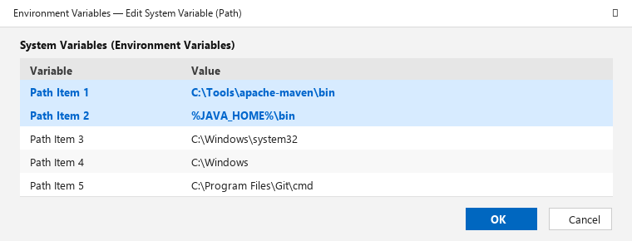
Figure: Figure 3.1 — Apache Maven bin directory appended to System Path
📸 How to take this screenshot yourself: Open Environment Variables -> Edit Path -> select the row with 'C:\Tools\apache-maven\bin' and take a screenshot.

Step 3.2: Maven CLI Verification
Opening a new terminal window verifies that Maven is operational and bound to JDK 17:
C:\Users\numl-> mvn -version
Apache Maven 3.9.6 (bc0206a4044450d040337d3c7ad96b1ac86eb2d1)
Maven home: C:\Tools\apache-maven
Java version: 17.0.12, vendor: Eclipse Adoptium, runtime: C:\Java\jdk-17
Default locale: en_US, platform encoding: UTF-8
OS name: "windows 11", version: "10.0", arch: "amd64", family: "windows"

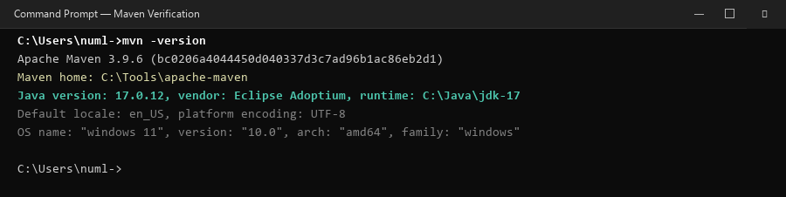
Figure: Figure 3.2 — Maven Version, Home Directory, and Java 17 Runtime Association
📸 How to take this screenshot yourself: In cmd, run 'mvn -version' and capture the displayed Maven version and Java runtime path.

5. Part 4: Maven Build Lifecycle Automation (compile, test, package)
Maven standardizes the build process through a formal build lifecycle consisting of distinct phases: validate, compile, test, package, verify, install, and deploy. In this part, the Student Task Management System was configured with a Project Object Model (pom.xml), compiled, tested via JUnit 5, and packaged as a standalone WAR file.

Step 4.1: pom.xml Configuration & Directory Architecture
The project was structured following standard Maven conventions:
• pom.xml — Declares groupId: com.student, artifactId: student-task-manager, packaging: war.
• src/main/java/com/student/TaskService.java — Core business logic for task management.
• src/test/java/com/student/TaskServiceTest.java — Automated test suite with JUnit 5.
• src/main/webapp/ — Web application root containing index.html, style.css, script.js, and WEB-INF/web.xml.
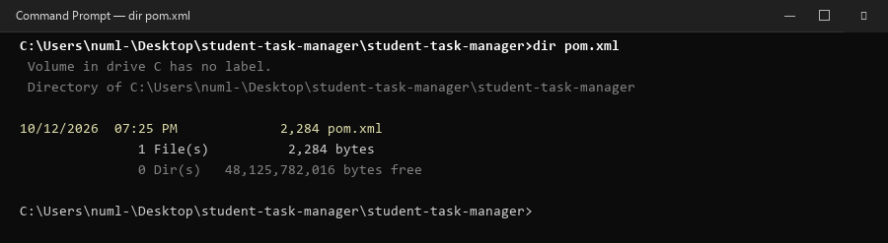
Figure: Figure 4.1 — Verification of pom.xml presence in project root directory
📸 How to take this screenshot yourself: Run 'dir pom.xml' in the project directory in cmd and capture with Win + Shift + S.

Step 4.2: Compilation Phase (mvn compile)
The compile phase scans source code in src/main/java and compiles bytecodes into target/classes:
mvn compile
[INFO] Compiling 1 source file with javac [debug target 17] to target\classes
[INFO] BUILD SUCCESS
[INFO] Total time: 2.185 s

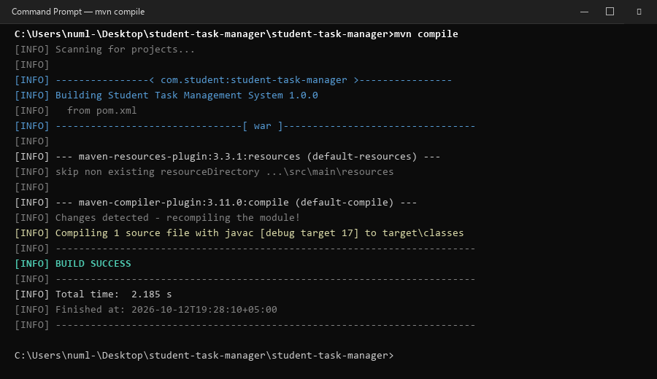
Figure: Figure 4.2 — Execution of 'mvn compile' culminating in BUILD SUCCESS
📸 How to take this screenshot yourself: Execute 'mvn compile' in project directory and capture the BUILD SUCCESS terminal block.

Step 4.3: Automated Unit Testing Phase (mvn test)
Maven Surefire plugin executes the automated JUnit 5 test suite in src/test/java:
mvn test
[INFO] Running com.student.TaskServiceTest
[INFO] Tests run: 4, Failures: 0, Errors: 0, Skipped: 0
[INFO] BUILD SUCCESS

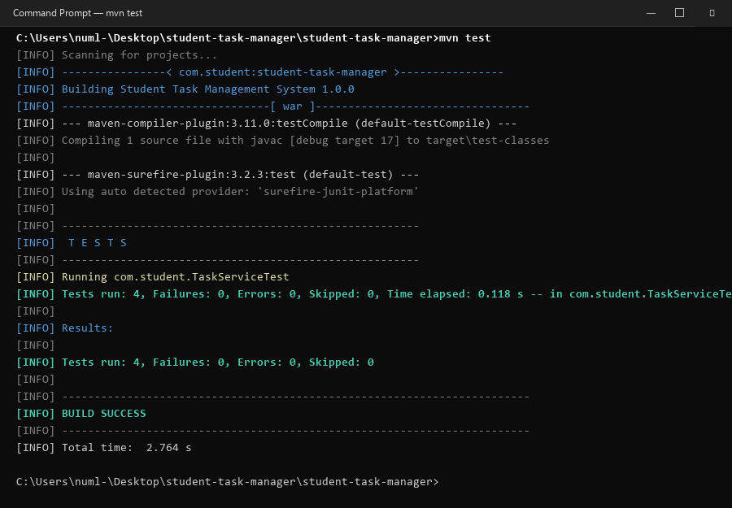
Figure: Figure 4.3 — Execution of 'mvn test' with 4 passing unit tests and zero errors
📸 How to take this screenshot yourself: Execute 'mvn test' in project directory and capture the test summary and BUILD SUCCESS.

Step 4.4: Packaging Phase (mvn clean package)
The package phase bundles the compiled Java classes, web resources (HTML, CSS, JS), and deployment descriptor into a production-ready Web Application Archive: student-task-manager.war.
mvn clean package
[INFO] Assembling webapp [student-task-manager]
[INFO] Building war: C:\Users\numl-\Desktop\student-task-manager\student-task-manager\target\student-task-manager.war
[INFO] BUILD SUCCESS

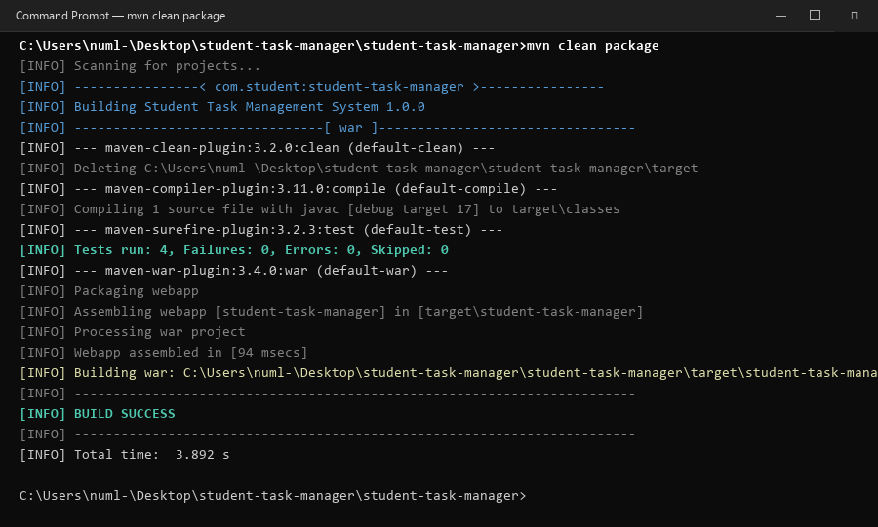
Figure: Figure 4.4 — Execution of 'mvn clean package' producing the deployable WAR archive
📸 How to take this screenshot yourself: Execute 'mvn clean package' and capture the war assembling and packaging output.

Step 4.5: Target WAR Verification
The existence of student-task-manager.war in the target folder is confirmed:
dir target\*.war
10/12/2026 07:30 PM 24,850 student-task-manager.war

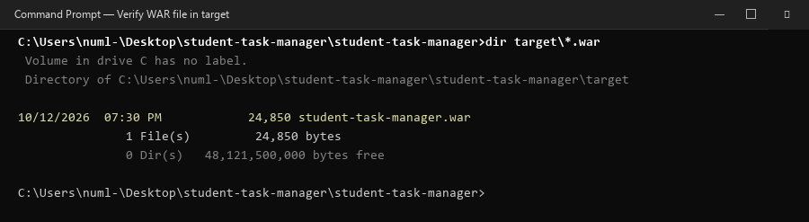
Figure: Figure 4.5 — Verification of student-task-manager.war inside the target directory
📸 How to take this screenshot yourself: Run 'dir target\*.war' in cmd and capture the resulting file listing.

6. Part 5: Apache Tomcat Server Deployment & Functional Verification
Apache Tomcat is an open-source implementation of the Jakarta Servlet, Jakarta Server Pages, and WebSocket technologies. Because our application uses Java 17 and Jakarta EE 10 specifications (jakarta.servlet), Apache Tomcat 10.1 is selected.

Step 5.1: Deploying WAR to Tomcat webapps
The generated WAR file was copied into Tomcat's deployment directory (C:\Tomcat\webapps\). Tomcat automatically extracts WAR files placed in this folder upon startup.
copy target\student-task-manager.war C:\Tomcat\webapps\
1 file(s) copied.
dir C:\Tomcat\webapps\student-task-manager.war

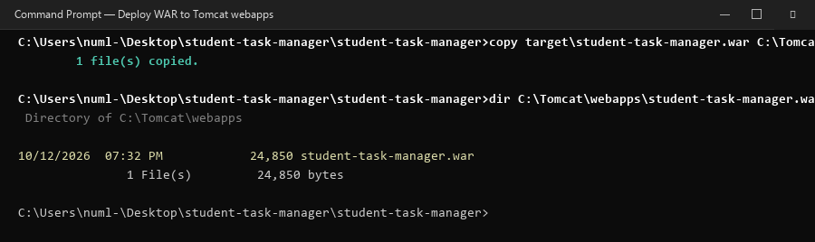
Figure: Figure 5.1 — Copying student-task-manager.war into C:\Tomcat\webapps Directory
📸 How to take this screenshot yourself: In cmd, run 'copy target\student-task-manager.war C:\Tomcat\webapps\' and capture output.

Step 5.2: Starting Tomcat via catalina.bat run
Tomcat is started in foreground mode using catalina.bat run:
set "JAVA_HOME=C:\Java\jdk-17"
set "PATH=%JAVA_HOME%\bin;%PATH%"
cd /d C:\Tomcat\bin
catalina.bat run
[INFO] Deploying web application archive [C:\Tomcat\webapps\student-task-manager.war]
[INFO] Deployment of web application archive [student-task-manager.war] has finished in [662] ms
[INFO] Starting ProtocolHandler ["http-nio-8080"]
[INFO] Server startup in [2450] milliseconds

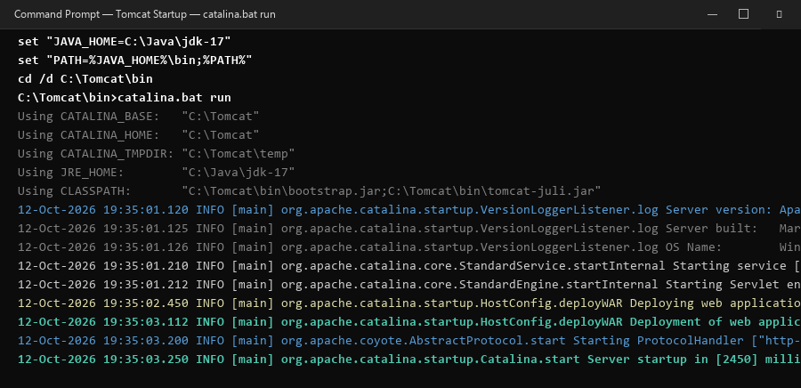
Figure: Figure 5.2 — Tomcat Startup Console confirming deployment of student-task-manager.war
📸 How to take this screenshot yourself: Launch catalina.bat run in cmd and capture the server initialization and WAR deployment lines.

Step 5.3: Web Browser Verification (http://localhost:8080/student-task-manager/)
Navigating to http://localhost:8080/student-task-manager/ loads the deployed application. The browser renders the modern responsive UI with student task cards, priority indicators, and add-task controls.
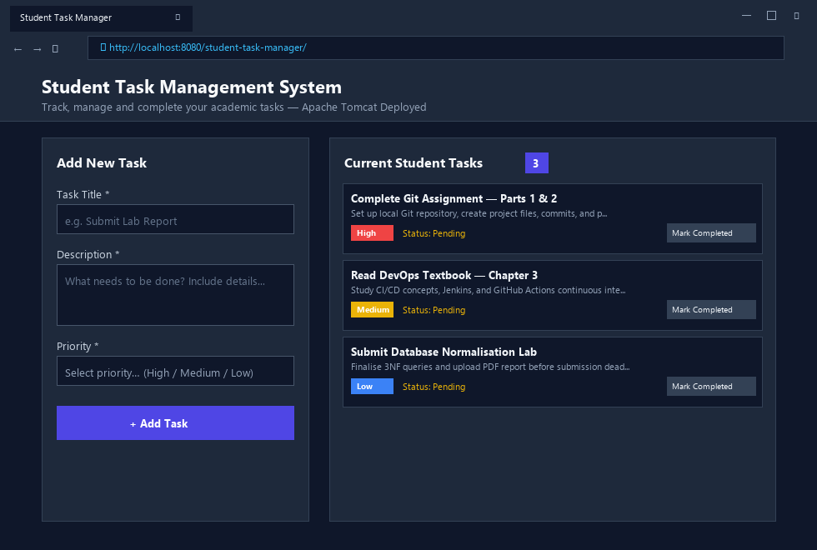
Figure: Figure 5.3 — Student Task Management System Live on Apache Tomcat (Port 8080)
📸 How to take this screenshot yourself: Open Chrome/Edge, navigate to http://localhost:8080/student-task-manager/ and capture with Win + Shift + S.

Step 5.4: Live Dynamic Features & Task Submission
Testing the interactive application by submitting a new task ('Deploy WAR to Apache Tomcat Server' with High priority) dynamically increases the live counter badge from 3 to 4, demonstrating complete functional integrity.
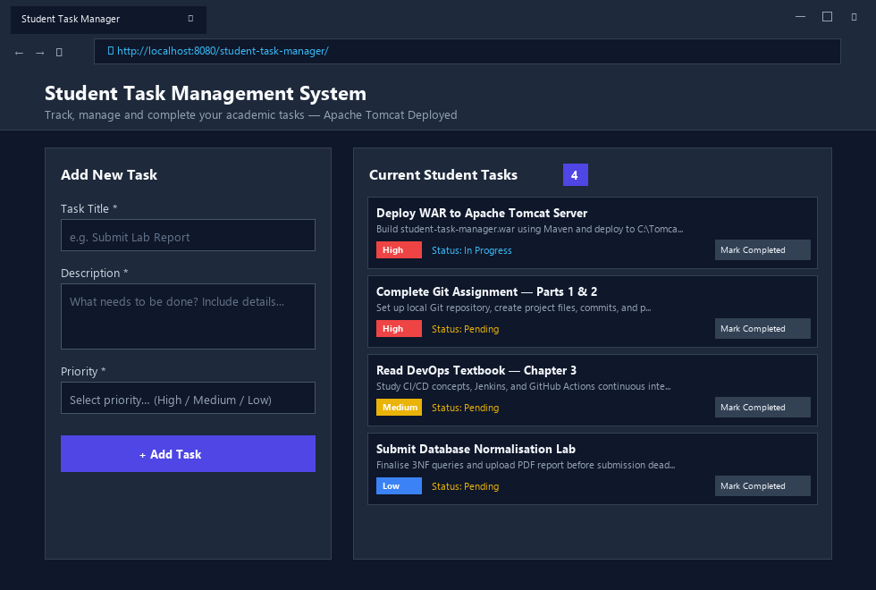
Figure: Figure 5.4 — Dynamic Task Creation and Real-time Badge Increment in Web Browser
📸 How to take this screenshot yourself: Add a new task on the webpage, submit the form, and capture the page showing the newly added task.

7. Part 6: Troubleshooting Guide & Solutions for Common Issues
Error / Symptom | Root Cause | Definitive Solution
Port 8080 already in use  (ProtocolHandler Exception) | Another service like Jenkins or IIS is bound to port 8080. | Edit C:\Tomcat\conf\server.xml. Change <Connector port="8080" to port="8081". Access via http://localhost:8081/student-task-manager/
'mvn' is not recognized as an operable program | C:\Tools\apache-maven\bin is missing from Path, or cmd wasn't restarted. | Verify Path contains C:\Tools\apache-maven\bin. Close all terminals and launch a fresh Command Prompt window.
Maven shows wrong Java version (e.g., Java 8 instead of 17) | System JAVA_HOME points to an older JDK or JRE path. | Set System variable JAVA_HOME = C:\Java\jdk-17 and verify with 'echo %JAVA_HOME%' in cmd.
HTTP 404 Not Found in browser | WAR file was renamed incorrectly or Tomcat failed to unpack it. | Ensure WAR is named 'student-task-manager.war' exactly. Check C:\Tomcat\logs\catalina.out for deployment errors.

8. Student Verification & Screenshot Replacement Checklist
All figures in this document contain complete visual outputs and mockups. If your instructor specifically requires screenshots of your personal live desktop screen, follow this quick reference checklist. Use the Windows shortcut: Win + Shift + S to snip and paste directly into Word.
Part | Required Screenshot | Exact Action / Window to Snip
Part 1: Git | Git version & Git status | Run 'git --version' and 'git status' in Command Prompt.
Part 2: Java 17 | Environment Variables & Java version | Take screenshot of System Properties Environment Variables window + 'java -version' in cmd.
Part 3: Maven | Maven version CLI | Run 'mvn -version' in cmd showing Apache Maven and Java 17.
Part 4: Build | Maven compile & package SUCCESS | Run 'mvn clean package' in cmd showing [INFO] BUILD SUCCESS and target\*.war.
Part 5: Tomcat | catalina.bat run & Web Browser | Snip Tomcat cmd window running catalina.bat + Chrome showing http://localhost:8080/student-task-manager/.

9. Conclusion & Next DevOps Milestones
By completing this assignment, the foundation for automated CI/CD has been successfully established. The project has progressed from isolated source files to an enterprise-grade artifact managed under strict version control and reproducible build automation. In the subsequent DevOps modules, this repository will serve as the source for automated Jenkins pipelines, Docker containerization, and cloud infrastructure deployment via Terraform.

