



**CS4001NI Programming**

**30% Individual Coursework**

**2022-23 Autumn**

**Student Name: Mohammad Nurullah**

**London Met ID: 22067059**

**College ID: NP01NT4A220019**

**Group: L1N1**

**Assignment Due Date: Friday, January 27, 2023**

**Assignment Submission Date: Friday, January 27, 2023**

*I confirm that I understand my coursework needs to be submitted online via MySecondTeacher under the relevant module page before the deadline in order for my assignment to be accepted and marked. I am fully aware that late submissions will be treated as non-submission and a marks of zero will be awarded.*

Table of Contents

1.1 Introduction 1

1.1.1 Bank Card 1

1.1.2 Debit Card 1

1.1.3 Credit Card 2

1.1.4 Tools Used 2

1.2 Class Diagram 4

1.2.1 Class Diagram of Bank_Card Class 4

1.2.2 Class Diagram of Debit_Card Class 5

1.2.3 Class Diagram of Credit_Card Class 6

1.2.4 Relationship Diagram Between the Classes 7

1.3 Pseudocode 8

1.3.1 Bank_Card Class 8

1.3.2 Debit_Card Class 11

1.3.3 Credit_Card Class 14

1.4 Method Description of Each Class 18

1.4.1 Bank_card 18

1.4.2 Debit_Card 19

1.4.3 Credit_Card 20

1.5 Test and Inspection 21

1.5.1 Test One 21

1.5.2 Test 2 26

1.5.3 Test 3 32

1.5.4 Test 4 36

1.6 Error Detection and Correction 39

1.6.1 Syntax Error and Solution 39

1.6.2 Semantic Error and Solution 39

1.6.3 Logical Error and Solution 39

1.7 Conclusion 39

1.8 Appendix 39

Figure 1: Class diagram of bank_card 4

Figure 2: Class diagram of debit card 6

Figure 3: Class diagram of credit card 7

Figure 4: Relationship diagram of classes 8

Table of tables

# Introduction

The goal of this project is to use Java's object-oriented idea to construct a real-world problem situation. This includes developing a class to represent a bank card and  it’s two subclasses to represent a debit card and a credit card respectively. This program contain three classes a bank card , a debit card and a credit card. Here, bank card represented as parent class and the remaining two classes debit card and credit card represented as sub-classes of bank card class.

## Bank Card

The five attributes that make up the BankCard class are CardId, ClientName, IssuerBank, BankAccount, and BalanceAmount. The client name, issuer bank, bank account, CardID, and balance amount are each represented as strings of text and CardID, and balance amount as a number. The client name attribute is initialized to an empty string in the constructor. The balance amount, card number, bank account, and issure bank are initialized in the constructor by being assigned the value of the parameters.There is a corresponding accessor method for each attribute.

## Debit Card

Debit Card is a subclass of Bank Cards class and have four attributes.. PIN number - an integer , Withdrawal Amount - an integer , date Of Withdrawal - a String and hasWithdrawn – Boolean(either true or false). The constructor accepts six parameters: the balance amount, the card ID, the bank account, the issuer bank, the client name, and the PIN number. The superclass constructor is called with four parameters and a setters method: setclientname. In addition, the parameter values for assign,pin number are assigned.

## Credit Card

Credit Card is a subclass of Bank Cards class and have six attributes.

CVC number- an integer , Credit Limit- a double , Interest Rate - a double , Expiration Date - a String of characters , Grace Period - an integer , isGranted – Boolean(either true or false). Card Id, client name, issuerbank, bank account, BalanceAmount, CVC number, Interest rate, and ExpirationDate are the eight parameters accepted by the constructor. The superclass constructor is called with four parameters and an asetter method. Additionally, in the constructor, assign the parameter values for CVC number, Interest rate, and Expiration Date. The isGranted attribute is set to false.

## Tools Used

1. **Blue J**

BlueJ is a Java development environment that is oriented for beginning and intermediate Java developers and allows developers to easily write Java programs thanks to a simple interface optimized for training.

**Feature of Blue J**

• IDE interface

• Runs on multiple platforms

• Designed for teaching

• Runs without USB stick installation

• Interaction among objects

• Easy to understand and code

1. **Draw.io Diagram**

A free, open-source Windows application called Draw.io enables us to make offline or online diagrams. Depending on the type of chart, we can save or import them into other programs or our software. Together with others, we may create workflows that are more efficient.

1. **Microsoft Word**

A word processing tool called Microsoft Word was created by the company for the first time in 1983. It can be found almost anywhere. Many PCs come with Word preinstalled, and it works well with other Microsoft Office applications. Word allows us to construct basic or fancy word processing documents like letters and reports. You may add color, utilize a variety of fonts, and more.

# Class Diagram

## Class Diagram of Bank_Card Class

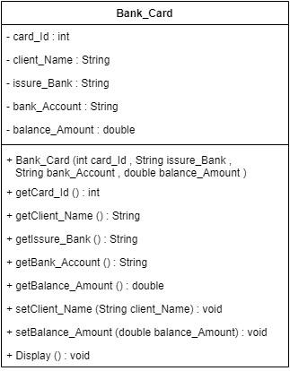

*Figure 1: Class diagram of bank_card*

## Class Diagram of Debit_Card Class

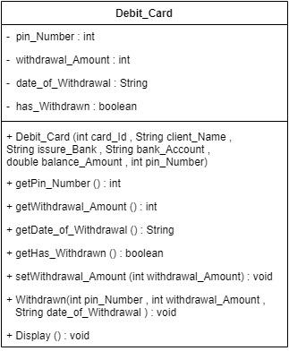

*Figure 2: Class diagram of debit card*

## Class Diagram of Credit_Card Class

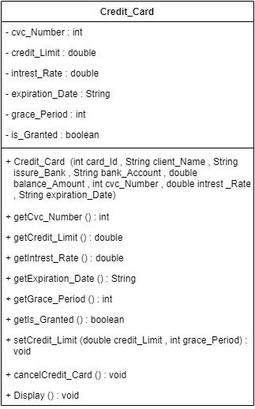

*Figure 3: Class diagram of credit card*

## Relationship Diagram Between the Classes

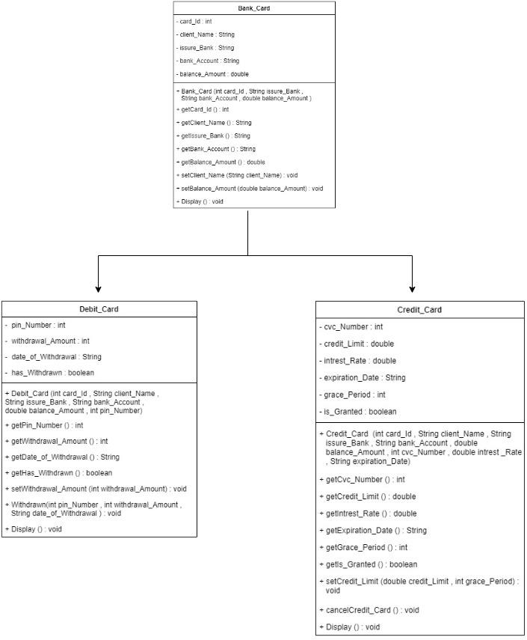

*Figure 4: Relationship diagram of classes*

# Pseudocode

## Bank_Card Class

**CREATE** parent class Bank_Card

**DO**

**DECLARE** instance variable card_Id with int data type

**DECLARE** instance variable client_Name with string data type

**DECLARE** instance variable issure_Bank with string data type

**DECLARE** instance variable bank_Account with String data type

**DECLARE** instance variable balance_Ammount with double data type

**CREATE** a constructor Bank_Card with four parameters card_Id, issure_Bank,

bank_Account, balance_Amount having data type int, String, String, double

respectively

**DO**

**ASSIGN** the value of instance variable card_Id from parameter card_Id

**ASSIGN** the value of instance variable client_Name as "empty"

**ASSIGN** the value of instance variable issure_Bank from parameter issure_Bank

**ASSIGN** the value of instance variable bank_Account from parameter

bank_Account

**ASSIGN** the value of instance variable balance_Amount from parameter

balance_Amount

**END DO**

**CREATE** an accessor method getcard_Id with int return data type

**DO**

**RETURN** the value of instance variable card_Id from parameter card_Id

**END DO**

**CREATE** an accessor method getclient_Name with String return data type

**DO**

**RETURN** the value of instance variable client_Name from parameter

client_Name

**END DO**

**CREATE** an accessor method getIssure_Bank with String return data type

**DO**

**RETURN** the value of instance variable issure_Bank from parameter

issure_Bank

**END DO**

**CREATE** an accessor method getBank_Account with String return data type

**DO**

**RETURN** the value of instance variable bank_Account from parameter

bank_Account

**END DO**

**CREATE** an accessor method getBalance_Ammount with double return data type

**DO**

**RETURN** the value of instance variable balance_Amount from parameter

balance_Amount

**END DO**

**CREATE** a mutator method setclient_Name with void return data type with parameter

client_Name

**DO**

**ASSIGN** the new value to instance variable client_Name from parameter

client_Name

**END DO**

**CREATE** a mutator method setBalance_Amount with void return data type with

parameter balance_Amount

**DO**

**ASSIGN** the new value to instance variable balance_Amount from parameter

balance_Amount

**END DO**

**CREATE** a display method with void return data type

**DO**

**PRINT** the text "Card ID is " and the value of instance variable card_Id

**PRINT** the text "Issure Bank is " and the value of instance variable

issure_Bank

**PRINT** the text "Bank account number is " and the value of instance variable

bank_Account

**PRINT** the text "Account balance is " and the value of instance variable

balance_Amount

**IF** (client_Name == "")

**PRINT** the text "Please enter your name "

**END IF**

**ELSE**

**PRINT** the text "Your Name is" and the value of instance variable client_Name

**END ELSE**

**END DO**

**END DO**

## Debit_Card Class

**CREATE** a sub class Debit_Card

**DO**

**DECLARE** instance variable pin_Number with int data type

**DECLARE** instance variable withdrawal_Amount with int data type

**DECLARE** instance variable date_of_Withdrawal with String data type

**DECLARE** instance variable has_Withdrawal with boolean data type

**CREATE** a constructor Debit_Card with six parameters card_Id, client_Name,

issure_Bank, bank_Account, balance_Amount, pin_Number having datatype

int, String, String, String, double, int respectively

**DO**

**CALL** the constructor from parent class Bank_Card with parameters

**CALL** the mutator setclient_Name with parameter

**ASSIGN** the value of instance variable pin_Number from parameter pin_Number

**ASSIGN** the value of instance variable has_Withdrawn to false

**END DO**

**CREATE** an accessor method getPin_Number with int return data type

**DO**

**RETURN** the value of instance variable pin_Number from parameter pin_Number

**END DO**

**CREATE** an accessor method getWithdrawal_Amount with int return data type

**DO**

**RETURN** the value of instance variable withdrawal_Amount from parameter

withdrawal_Amount

**END DO**

**CREATE** an accessor method getDate_of_withdrawal with String return data type

**DO**

**RETURN** the value of instance variable Date_of_Withdrawal from parameter

Date_of_Withdrawn

**END DO**

**CREATE** an accessor method getHas_withdrawn with boolean return data type

**DO**

**RETURN** the value of instance variable has_Withdrawn from parameter

has_Withdrawn

**END DO**

**CREATE** a mutator method setWithdrawal_Amount with void return data type with

parameter withdrawal_Amount

**DO**

**ASSIGN** the new value to instance variable withdrawal_Amount from parameter

withdrawal_Amount

**END DO**

**CREATE** mutator method Withdrawn with the parameters pin_Number,

withdrawal_Amount, date_of_Withdrawal having data type int,int,String

respectively

**DO**

**IF** (pin_Number == pin_Number && withdrawal_Amount <=

super.getBalance_Amount()

**ASSIGN** the value of has_Withdrawn to true

**CALL** setBalance_Amount(this.getBalance_Amount()-withdrawal_Amount)

**ASSIGN** the value of withdrawal_Amount from the parameter

withdrawal_Amount

**ASSIGN** the value of date_of_Withdrawal from the parameter

date_of_Withdrawal

**PRINT** the text "Your amount has withdrawn"

**PRINT** the text "Your withdrawan amount is:" and the value of instance

variable withdrawal_Amount

**PRINT** the text "Your remaining balance is:" and super.getBalance_Amount()

**PRINT** the text "Date of withdrawan :" and the value of instance variable

datea_of_Withdrawal

**END IF**

**ELSE**

**PRINT** the text "Incorrect PIN Number or Insufficient Account_Balance "

**END ELSE**

**CREATE** a diplay method with void return type

**DO**

**CALL** the display method of Bank_Card class

**IF** (has_Withdrawn == true)

**PRINT** the text “PIN_Number is” and the value of instance variable

pin_Number

**PRINT** the text “Withdrawal_Amount is ” and the value of instance variable

withdrawal_Amount

**PRINT** the text “Withdrawal-Date is” and the value of instance variable

date_of_Withdrawal

**END IF**

**ELSE**

**PRINT** the text "your balance amount is " and the value of getBalance_Amount

**END ELSE**

**END DO**

**END DO**

## Credit_Card Class

**CREATE** a sub class Credit_Card

**DO**

**DECLARE** instance variable cvc_Number with int data type

**DECLARE** instance variable credit_Limit with double data type

**DECLARE** instance variable intrest_Rate with double data type

**DECLARE** instance variable expiration_Date with String data type

**DECLARE** instance variable grace_Period with int data type

**DECLARE** instance variable is_Granted with boolean data type

**CREATE** a constructor Credit_Card with eight parameters card_Id, client_Name,

issure_Bank, bank_Account, balance_Amount, cvc_Number, intrest_Rate, expiration_Date having datatype int, String, String, String, double, int , double, String respectively

**DO**

**CALL** the attributes card_Id,issure_Bank,bank_Account,balance_Amount

**CALL** the mutator method setClient_Name

**ASSIGN** the value of cvc_Number from the parameters cvc_Number

**ASSIGN** the value of intrest_Rate from the parameters intrest_Rate

**ASSIGN** the value of expiration_Date from the parameters expiration_Date

**ASSIGN** the value of is_Granted to false

**CREATE** an accessor method getCvc_Number with int return data type

**DO**

**RETURN** the value of instance variable cvc_Number from parameter

cvc_Number

**END DO**

**CREATE** an accessor method getCredit_Limit with double return data type

**DO**

**RETURN** the value of instance variable credit_Limit from parameter

credit_Limit

**END DO**

**CREATE** an accessor method getIntrest_Rate with double return data type

**DO**

**RETURN** the value of instance variable intrest_Rate from parameter

intrest_Rate

**END DO**

**CREATE** an accessor method getExpiration_Date with String return data type

**DO**

**RETURN** the value of instance variable expiration_Date from parameter

expiration_Date

**END DO**

**CREATE** an accessor method getGrace_Period with int return data type

**DO**

**RETURN** the value of instance variable grace_Period from parameter

grace_Period

END DO

**CREATE** an accessor method getIs_Granted with boolean return data type

**DO**

**RETURN** the value of instance variable is_Granted from parameter

is_Granted

**END DO**

**CREATE** a mutator method setCredit_Limit with two parameters credit_Limit,

grace_Period having data type double, int respectively

**IF** (this.credit_Limit <= 2*super.getBalance_Amount())

**ASSIGN** the value of credit_Limit from the parameter credit_Limit

**ASSIGN** the value of grace_Period from the parameter grace_Period

**ASSIGN** the value of is_Granted to true

**PRINT** the text "Congratulation your credit card is on:"

**END IF**

**ELSE**

**PRINT** the text "cannot issue ur credit card"

**END ELSE**

**CREATE** a mutatornmethod cancelCreditCard

**DO**

**ASSIGN** the value of cvc_Number to 0

**ASSIGN** the value of credit_Limit to 0

**ASSIGN** the value of grace_Period to 0

**ASSIGN** the value of is_Granted to false

**END DO**

**CREATE** a Display method

**DO**

**CALL** the display method of Bank_Card class

**IF** (is_Granted == true)

**PRINT** the text "Credit limit is " and the value of an instance variable credit_Limit

**PRINT** the text "Grace period is " and the value of an instance variable

grace_Period

**END IF**

**ELSE**

**PRINT** the text "Credit limit is " and the value of an instance variable cvc_Number

**PRINT** the text "Credit limit is " and the value of an instance variable

intrest_Rate

**PRINT** the text "Credit limit is " and the value of an instance variable

expiration_Date

**PRINT** the text "Credit limit is " and the value of an instance variable is_Granted

**END ELSE**

**END DO**

**END DO**

# Method Description of Each Class

## Bank_card

| getCard_Id() | This method is used to return the value of variable card_Id which is of int data type |
| --- | --- |
| getClient_Name() | This method is used to return the value of variable client_Name which is of String data type |
| getIssure_Bank() | This method is used to return the value of variable issure_Bank which is of String data type |
| getBank_Account() | This method is used to return the value of variable bank_Account which is of String data type |
| getBalance_Amount() | This method is used to return the value of variable balance_Amount which is of double data type |
| setClient_Name() | This method is used to assign the new value to variable client_Name |
| setBalance_Amount() | This method is used to assign the new value to variable balance_Amount |
| Display() | This method is used to display the output card_Id, issure_Bank, bank_Account, balance_Amount, client_Name |

*Table 1: Method Discription of Bank_Card*

## Debit_Card

| getPin_Number() | This method is used to return the value of variable pin_Number which is of int data type |
| --- | --- |
| getWithdrawal_Amount() | This method is used to return the value of variable withdrawal_Amount which is of int data type |
| getDate_of_Withdrawal() | This method is used to return the value of variable date_of_Withdrawal which is of String data type |
| getHas_Withdrawn() | This method is used to return the value of variable has_Withdrawn which is of boolean data type |
| setWithdrawal_Amount() | This method is used to assign the new value to variable withdrawal_Amount |
| Withdrawn() | This method is used to assign new value to getter method getBalance_Amount and an instance variable withdrawal_Amount after performing calculation |
| Display() | This method is used to display the output of the parent class and if it accepts the condition that the  balance has withdrawn then it displays the following output pin_Number, withdrawal_Amount, date_of_Withdrawal |

*Table 2: Method Description of Debit_Card*

## Credit_Card

| getCvc_Number() | This method is used to return the value of variable cvc_Number which is of int data type |
| --- | --- |
| getCredit_Limit() | This method is used to return the value of variable credit_Limit which is of double data type |
| getIntrest_Rate() | This method is used to return the value of variable intrest_Rate which is of double data type |
| getExpiration_Date() | This method is used to return the value of variable expiration_Date which is of String data type |
| getGrace_Period() | This method is used to return the value of variable grace_Period which is of int data type |
| getIs_Granted() | This method is used to return the value of variable is_Granted which is of boolean data type |
| setCredit_Limit() | This method is used to assign the new value to variable credit_Limit and grace_Limit |
| cancelCreditCard() | This method is used to assign the value of cvc_Number,credit_Limit,grace_Period and is_Granted |
| Display() | This method is used to display the output of the parent class and if it accepts the condition that the transaction is granted then it displays the following output credit_Limit, grace_Period, or cvc_Number, intrest_Rate, expiration_Date, is_Granted |

*Table 3: Method Description of Credit_Card*

# Test and Inspection

## 1.5.1 Test One

| Test | 1 |
| --- | --- |
| Objective | To Inspect the Debit Card class, withdraw the amount, and re-inspect  the Debit Card Class |
| Action | * The Debit_Card class is called with the following arguments   card_Id = 1213  client_Name = “Noor”  issure_Bank = “NIC Asia”  bank_Account = “5678a”  balance_Amount = 1500.0  pin_Number = 1234   * Inspection of Debit_Card was done * Void Withdrawan is called with arguments   pin_Number = 1234  withdrawal_Amount = 250  date_of_Withdrawal =”25-01-2022”   * Re-inspection of Debit_Card * Display of void Withdrawan |
| Expected result | The balance will be withdrawn |
| Actual result | The balance is withdrawn |
| Conclusion | The test is successful |

*Table 4: Test 1*

**Output Result:**

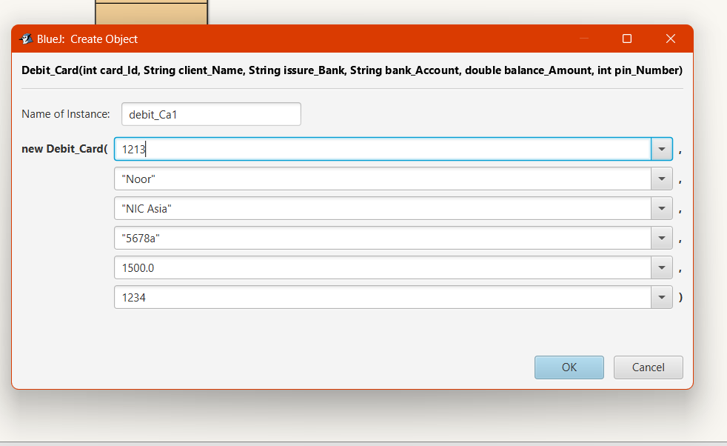

*Figure 5: Assigning the value*

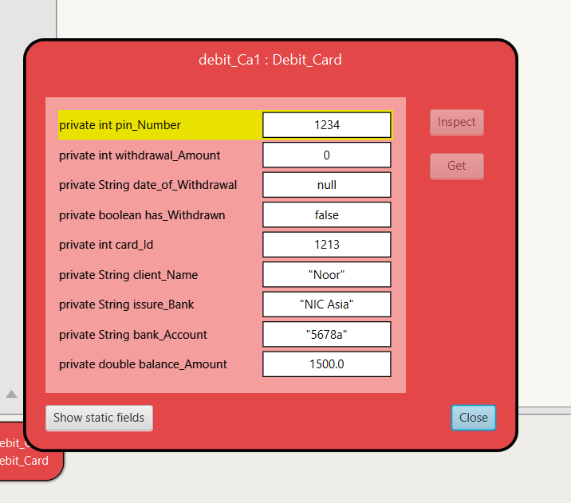

*Figure 6: Inspection*

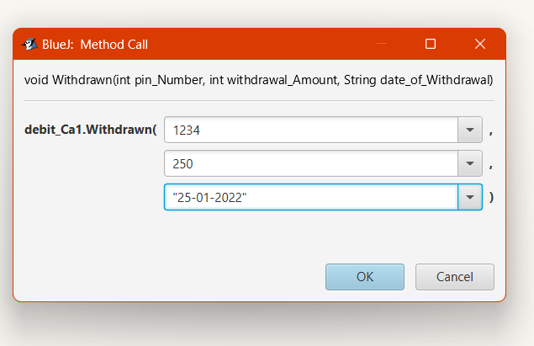

*Figure 7:Assigning the value of void withdrawn*

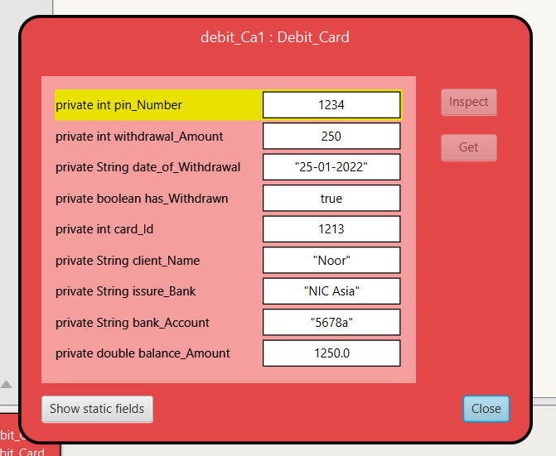

*Figure 8:Re-inspection*

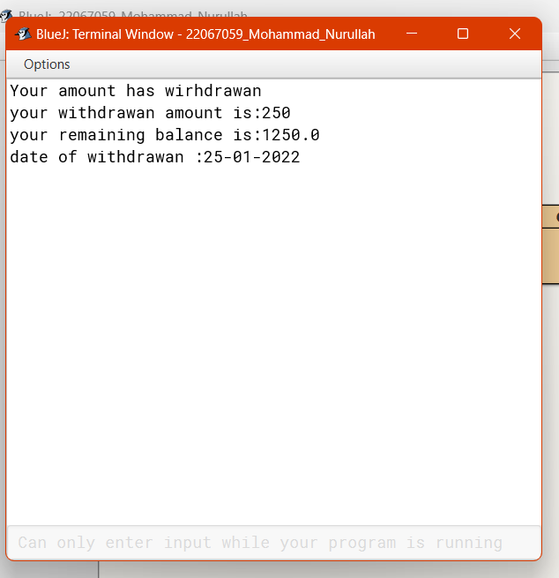

*Figure 9: Output Result*

## 1.5.2 Test 2

| Test | 2 |
| --- | --- |
| Objective | To Inspect Credit Card class, set the credit limit and reinspect the  Credit Card class |
| Action | * The Credit_Card class is called with the following arguments   card_Id = 1213  client_Name = “Noor”  issure_Bank = “NIC asia”  bank_Account = “2345”  balance_Amount = 12000  cvc_Number = 544  intrest_Rate = 2.0  expiration_Date = “20-1-2023”   * Inspection of Credit_Card * Void setCredit_Limit is called with arguments   credit_Limit = 4000  grace_period = 2   * Re-inspection of Credit_Card * Display of void setCredit_Limit |
| Expected result | The credit card will be granted |
| Actual result | The credit card is granted |
| Conclusion | The test is successful. |

*Table 5: Test 2*

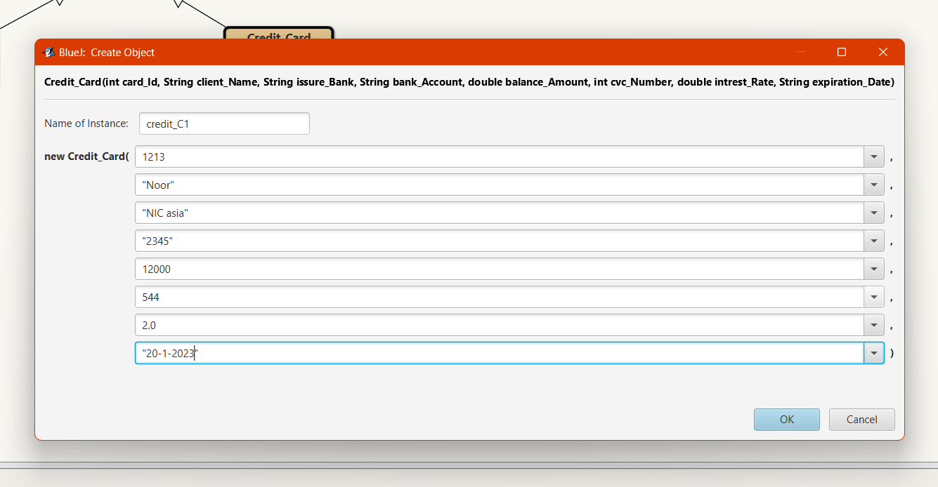

*Figure 10: Assigning the value*

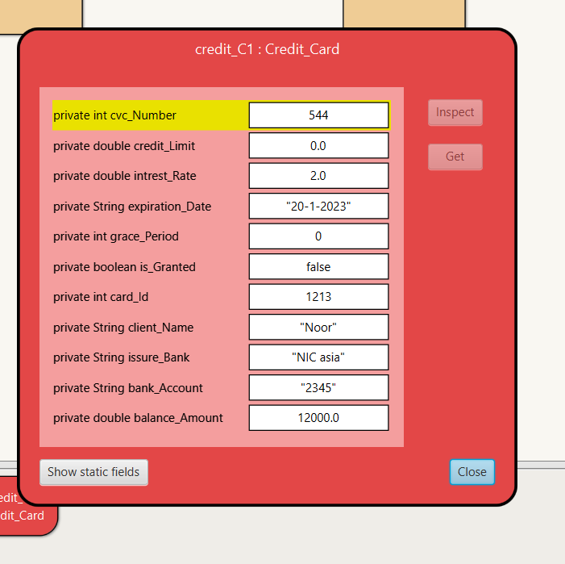

*Figure 11: Inspection*

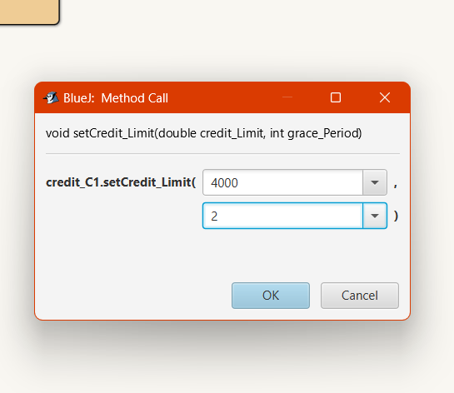

*Figure 12: Assigning the value of void setCredit_Limit*

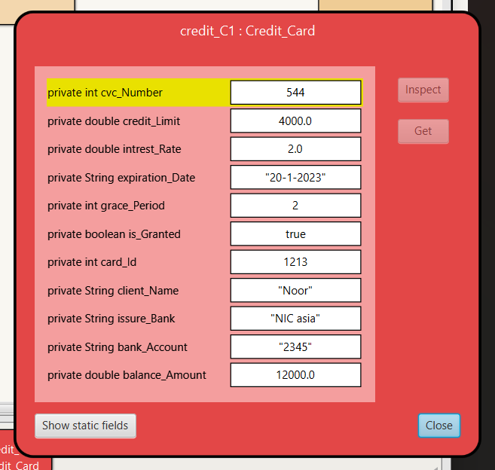

*Figure 13: Re-inspection*

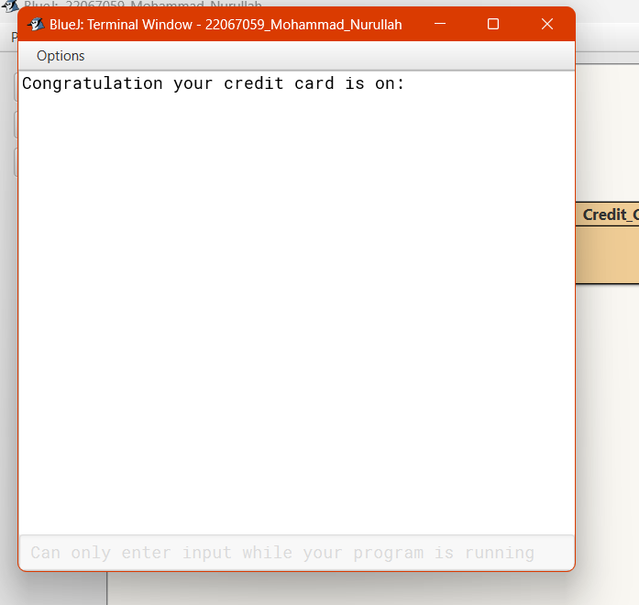

*Figure 14: Output Result*

## 1.5.3 Test 3

| Test | 3 |
| --- | --- |
| Objective | To Inspect Credit Card class again after cancelling the credit card. |
| Action | * Inspection of Credit_Card class is done. * Void cancelCreditCard method is called. * Re-inspection of Credit_Card class |
| Expected result | The credit card will be cancelled. |
| Actual result | The credit card is cancelled. |
| Conclusion | The test is successful. |

*Table 6: Test 3*



*Figure 15: Inspection*

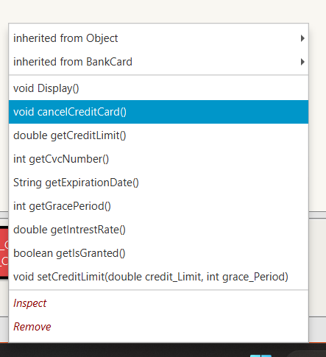

*Figure 16: Cancelling the method*

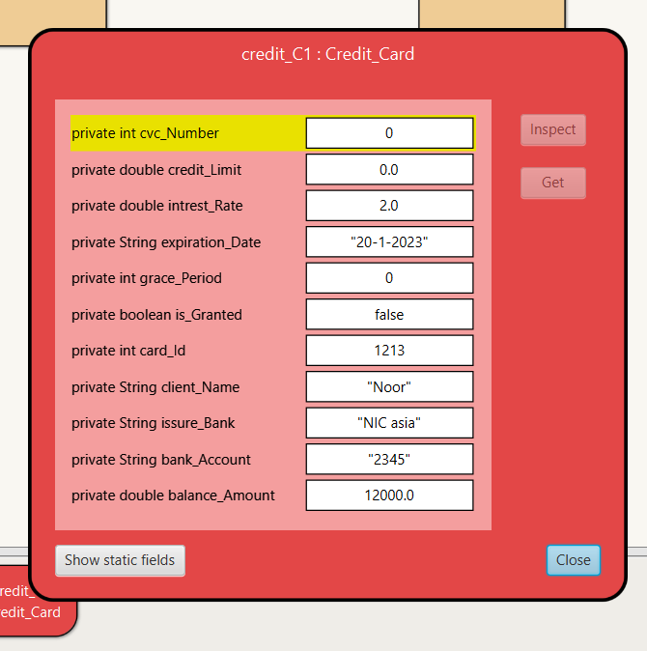

*Figure 17: Re-inspection*

## 1.5.4 Test 4

| Test | 4 |
| --- | --- |
| Objective | To display the details of Debit Card and Credit Card classes. |
| Action | * void Display method of Debit_Card is called * void Display method of Credit_Card is called |
| Expected result | It will display the output result of Debit_Card and Credit_Card. |
| Actual result | It displayed the output result of Debit_Card and Credit_Card. |
| Conclusion | The test is successful |

*Table 7: Test 4*

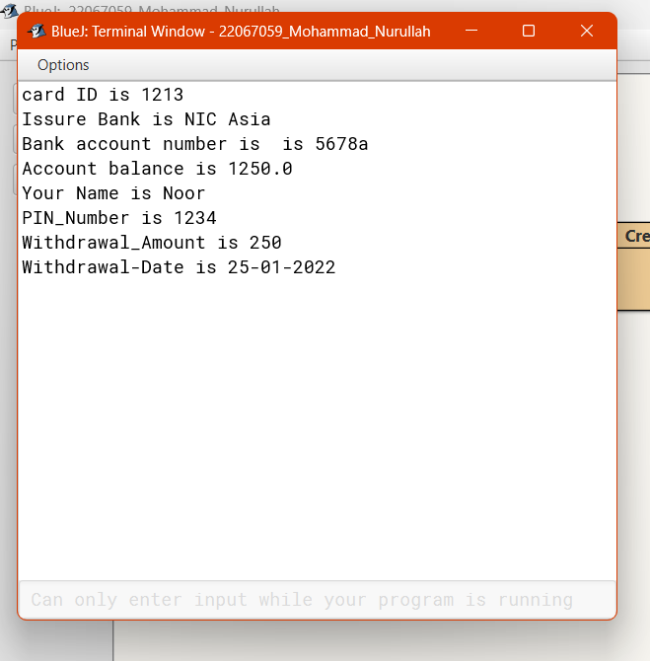

*Figure 18: Display of Debit_Card*

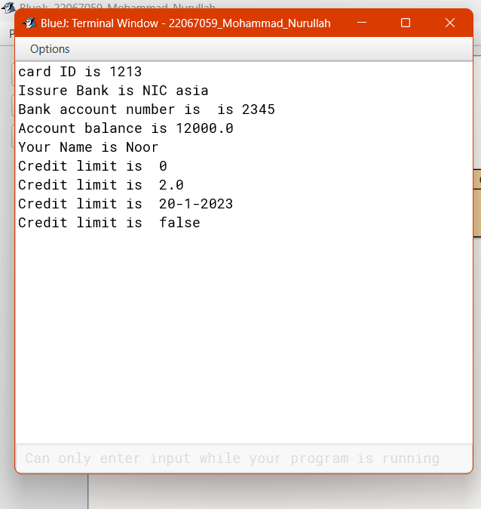

*Figure 19: Display of Credit_Card*

# Error Detection and Correction

## Syntax Error and Solution

**Screenshot of Syntax error**

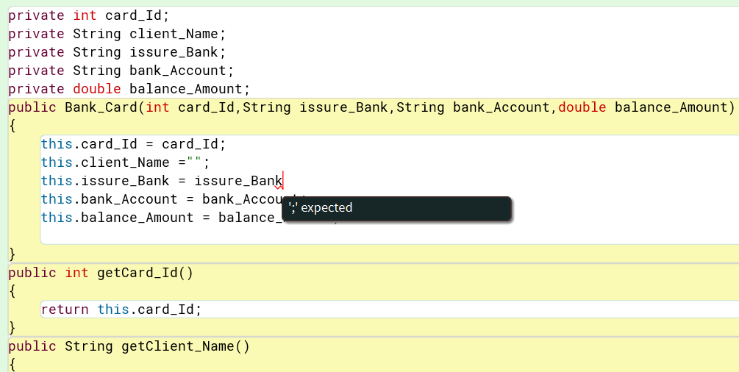

*Figure 20: Screenshot of syntax error*

The structure of different programs is determined by a set of principles known as syntax. Mistakes in source code's syntax include typing errors of instructions, missing to declare variables before using them in programs, and failing to use semicolons after declaring variables.

The semicolon that was missing after declaring the variable in this scenario results in a syntax error. In order to run the code, a semicolon can be added after the declared variable.

**Screenshot of Syntax error correction**

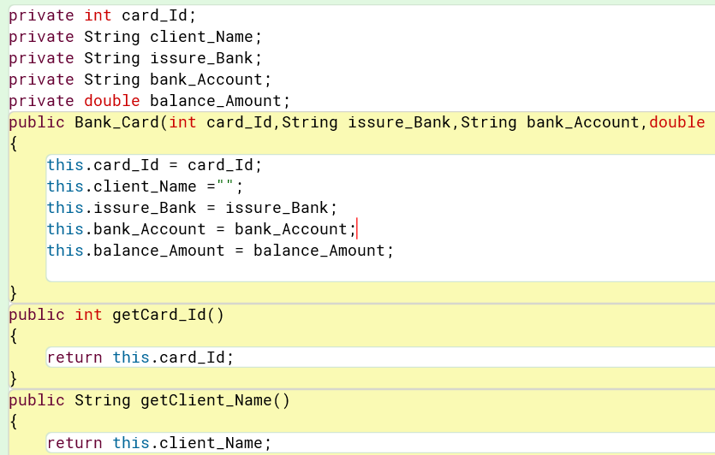

*Figure 21: Screenshot of syntax error correction*

## Semantic Error and Solution

**Screenshot of semantic error**

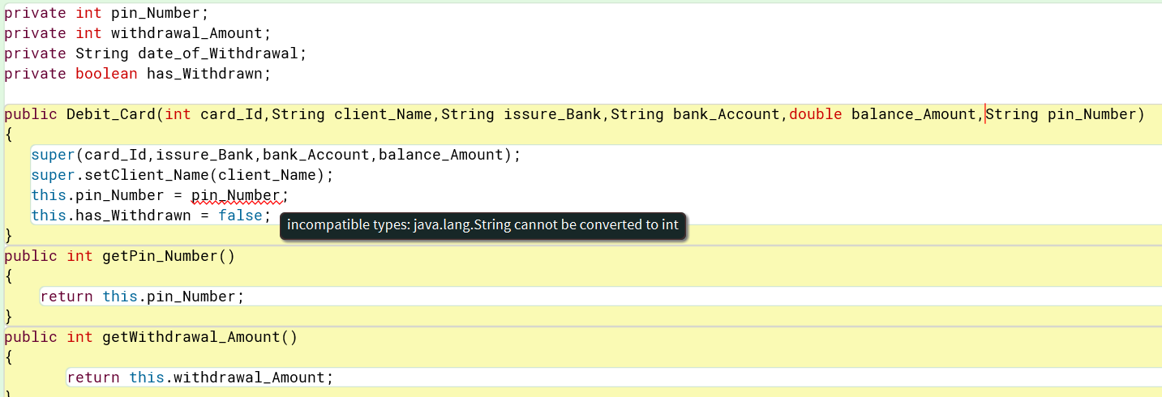

*Figure 22: Screenshot of semantic error*

When a statement is syntactically correct but fails to perform the task specified by the user or the compiler, this is known as a semantic error. Some types of basic programming semantic errors are now more easily identified by compilers.

Here, parameter is assigned with a String datatype in the constructor, but the desired outcome requires an Int datatype. Assigning an int datatype to the parameter of constructor will therefore solve the issue. Screenshots that verify the error solution are presented.

**Screenshot of semantic error correction**

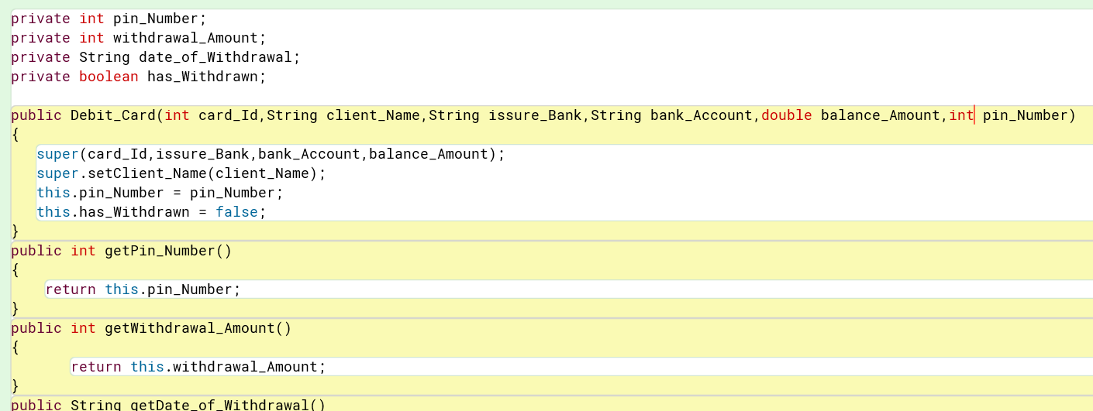

*Figure 23: Screenshot of semantic error correction*

## Logical Error and Solution

**Screenshot of logical error**

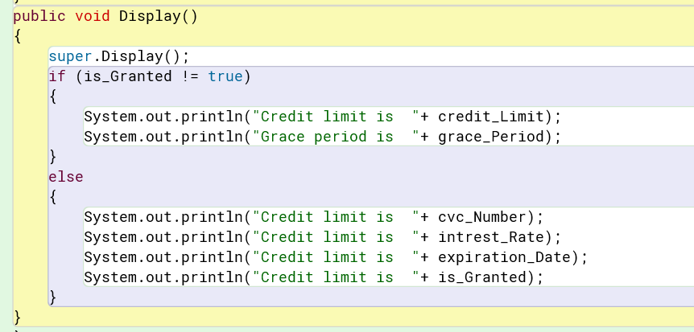

*Figure 24: Screenshot of logical error*

A logical error is a programming mistake or error in the source code that results in unexpected output. The condition in the code above determines that is_Granted is not equal to true and provides an unexpected output based on the users' needs. However, this kind of error is handled by the compiler and does not cause the source code to crash, but it does produce unexpected results.

So, the Equal to Equal operator (==) can be used to correct this logical error. After this, the output is what was anticipated and the if condition checks that is Granted is equal to equal to true. Through screenshots, the error solution is shown.

**Screenshot of logical error correction**

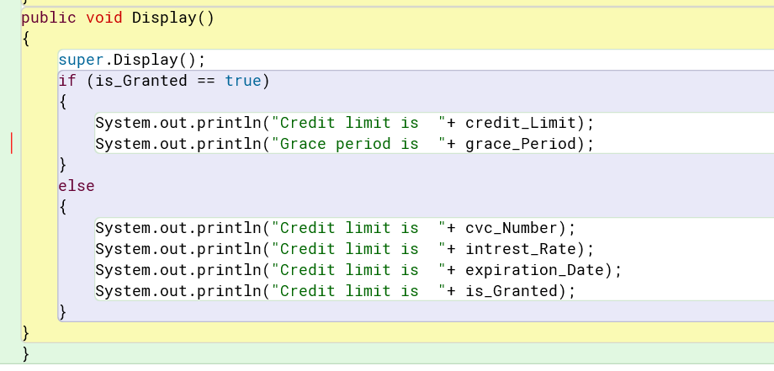

*Figure 25: Screenshot of logical error correction*

# Conclusion

The aim of this project is to apply Java's object-oriented concept to execute a real-world problem scenario. To that end, a class called Bank Card and its two subclasses, Debit Card and Credit Card, are being constructed.

This program consists of three classes. Bank, debit, and credit cards. Bank Card is referred to as the parent class or the main class in this case. Subclasses include Debit Card and Credit Card. Also, the parent class inherits both of the subclasses.

We have never performed a task of this kind before. So, during the coursework period, we experienced a lot of misunderstanding and issues. Attending the lecture session and workshop class helped to clarify many concepts. We also gained knowledge in coding testing and debugging. then after, my   Coding and debugging skills improved significantly.

We face significant challenges while we work on this project. We misunderstood the question when the assignment was given, but this issue was resolved by attending the lecture classes. We had no idea how to write pseudocode, but with the help of the internet, we were able to complete it. Thus, managed to overcome all of the challenges and resolving problems, we were able to finish our assignment and submit it in.

# Appendix

## Code of Bank_Card

public class Bank_Card

{

private int card_Id;

private String client_Name;

private String issure_Bank;

private String bank_Account;

private double balance_Amount;

public Bank_Card(int card_Id,String issure_Bank,String bank_Account,double balance_Amount)

{

this.card_Id = card_Id;

this.client_Name ="";

this.issure_Bank = issure_Bank;

this.bank_Account = bank_Account;

this.balance_Amount = balance_Amount;

}

public int getCard_Id()

{

return this.card_Id;

}

public String getClient_Name()

{

return this.client_Name;

}

public String getIssure_Bank()

{

return this.issure_Bank;

}

public String getBank_Account()

{

return this.bank_Account;

}

public double getBalance_Amount()

{

return this.balance_Amount;

}

public void setClient_Name(String client_Name)

{

this.client_Name = client_Name;

}

public void setBalance_Amount(double balance_Amount)

{

this.balance_Amount = balance_Amount;

}

public void Display()

{

System.out.println("card ID is "+ card_Id);

System.out.println("Issure Bank is "+ issure_Bank);

System.out.println("Bank account number is is "+ bank_Account);

System.out.println("Account balance is "+ balance_Amount);

if(client_Name == "")

{

System.out.println("Please enter your name");

}

else

{

System.out.println("Your Name is "+ client_Name);

}

}

}

## Code of Debit_Card

public class Debit_Card extends Bank_Card

{

private int pin_Number;

private int withdrawal_Amount;

private String date_of_Withdrawal;

private boolean has_Withdrawn;

public Debit_Card(int card_Id,String client_Name,String issure_Bank,String bank_Account,double balance_Amount,int pin_Number)

{

super(card_Id,issure_Bank,bank_Account,balance_Amount);

super.setClient_Name(client_Name);

this.pin_Number = pin_Number;

this.has_Withdrawn = false;

}

public int getPin_Number()

{

return this.pin_Number;

}

public int getWithdrawal_Amount()

{

return this.withdrawal_Amount;

}

public String getDate_of_Withdrawal()

{

return this.date_of_Withdrawal;

}

public boolean getHas_Withdrawn()

{

return this.has_Withdrawn;

}

public void setWithdrawal_Amount(int withdrawal_Amount)

{

this.withdrawal_Amount = withdrawal_Amount;

}

public void Withdrawn(int pin_Number,int withdrawal_Amount,String date_of_Withdrawal)

{

if(pin_Number == pin_Number && withdrawal_Amount <= super.getBalance_Amount())

{

this.has_Withdrawn = true;

super.setBalance_Amount(this.getBalance_Amount()-withdrawal_Amount);

this.withdrawal_Amount=withdrawal_Amount;

this.date_of_Withdrawal =date_of_Withdrawal;

System.out.println("Your amount has wirhdrawn");

System.out.println("Your withdrawan amount is:" + withdrawal_Amount);

System.out.println("Your remaining balance is:"+ super.getBalance_Amount());

System.out.println("Date of withdrawan :" + date_of_Withdrawal);

}

else

{

System.out.println("Incorrect PIN Number or Insufficient Account_Balance ");

}

}

public void Display()

{

super.Display();

if(has_Withdrawn == true)

{

System.out.println("PIN_Number is " + pin_Number);

System.out.println("Withdrawal_Amount is " + withdrawal_Amount);

System.out.println("Withdrawal-Date is " + date_of_Withdrawal);

}

else

{

System.out.println("your balance amount is "+ getBalance_Amount());

}

}

}

## Code of Credit_Card

public class Credit_Card extends Bank_Card

{

private int cvc_Number;

private double credit_Limit;

private double intrest_Rate;

private String expiration_Date;

private int grace_Period;

private boolean is_Granted;

public Credit_Card(int card_Id,String client_Name,String issure_Bank,String bank_Account,double balance_Amount,int cvc_Number,double intrest_Rate,String expiration_Date)

{

super(card_Id,issure_Bank,bank_Account,balance_Amount);

super.setClient_Name(client_Name);

this.cvc_Number = cvc_Number;

this.intrest_Rate = intrest_Rate;

this.expiration_Date = expiration_Date;

this.is_Granted = false;

}

public int getCvc_Number()

{

return this.cvc_Number;

}

public double getCredit_Limit()

{

return this.credit_Limit;

}

public double getIntrest_Rate()

{

return this.intrest_Rate;

}

public String getExpiration_Date()

{

return this.expiration_Date;

}

public int getGrace_Period()

{

return this.grace_Period;

}

public boolean getIs_Granted()

{

return this.is_Granted;

}

public void setCredit_Limit(double credit_Limit,int grace_Period)

{

if(this.credit_Limit <= 2*super.getBalance_Amount())

{

this.credit_Limit = credit_Limit;

this.grace_Period = grace_Period;

this.is_Granted = true;

System.out.println("Congratulation your credit card is on:");

}

else

{

System.out.println("cannot issue ur credit card");

}

}

public void cancelCreditCard()

{

this.cvc_Number = 0;

this.credit_Limit = 0;

this.grace_Period = 0;

this.is_Granted = false;

}

public void Display()

{

super.Display();

if (is_Granted == true)

{

System.out.println("Credit limit is "+ credit_Limit);

System.out.println("Grace period is "+ grace_Period);

}

else

{

System.out.println("Credit limit is "+ cvc_Number);

System.out.println("Credit limit is "+ intrest_Rate);

System.out.println("Credit limit is "+ expiration_Date);

System.out.println("Credit limit is "+ is_Granted);

}

}

}