BUSINESS REQUIREMENTS DOCUMENT (BRD)
For

Project Management System (TaskForge)

Initial draft

Prepared by

Group A

Bangladesh Army University of Engineering and Technology

25th June, 2026

Table of Contents

1. Executive Summary 3
2. Business Objectives 3
3. Project Scope 3
4. Business Requirements 4
5. Stakeholders 5
6. Business Process 6
7. Functional Requirements Summary 7
8. Assumptions and Constraints 8
9. Risks 8
10. Success Criteria 8
11. Future Scope 9
12. Conclusion 9

1. Executive Summary

The AI-Based Project Management System is designed to improve project planning, execution, monitoring, and collaboration through Artificial Intelligence technologies. Traditional project management methods often face challenges such as inefficient task allocation, delayed project completion, poor resource utilization, and difficulty identifying risks.

This system aims to address these issues by introducing AI-powered decision support and automation.

2. Business Objectives
The main objectives of the project are:
- To improve project management efficiency
- To reduce project completion delays
- To improve resource allocation
- To increase team productivity
- To automate repetitive project management tasks
- To predict project risks through AI analysis
- To support better decision-making

3. Project Scope
In Scope
The project will include:
- User registration and login
- Project creation and management
- Task management
- AI-based recommendations
- Progress tracking
- Team collaboration
- Report generation
- Notifications and reminders
- Dashboard analytics
Out of Scope
The project will not include:
- Mobile application support
- Voice-based controls
- Video conferencing features
- Third-party enterprise integrations
- Advanced AI training systems

4. Business Requirements
ID | Title | Description System Shall | Functions Features
BR-1 | User Management | The system shall allow users to manage their accounts securely. | Register accounts Login securely  Reset passwords  Manage profiles
BR-2 | Project Management | The system shall enable users to handle project operations efficiently. | Create projects  Edit project details  Delete projects  Monitor project status
BR-3 | Task Management | The system shall support task creation and tracking. | Create tasks  Assign tasks  Update progress  Track task status
BR-4 | AI Recommendation Services | The system shall provide intelligent suggestions using AI. | Suggest task priorities  Predict completion dates  Identify project issues  Recommend resource allocation
BR-5 | Reporting System | The system shall generate and display analytical reports. | • Generate reports • Display analytics • Export reports
BR-6 | Notification Services | The system shall keep users informed through alerts and reminders. | • Send reminders • Notify task updates • Alert critical project issues

5. Stakeholders
Stakeholder | Role
Project Sponsor | Provides funding and approval
Project Manager | Manages project execution
Administrator | Controls system operations
Team Members | Perform assigned tasks
Developers | Build the system
End Users | Use the application

6. Business Process
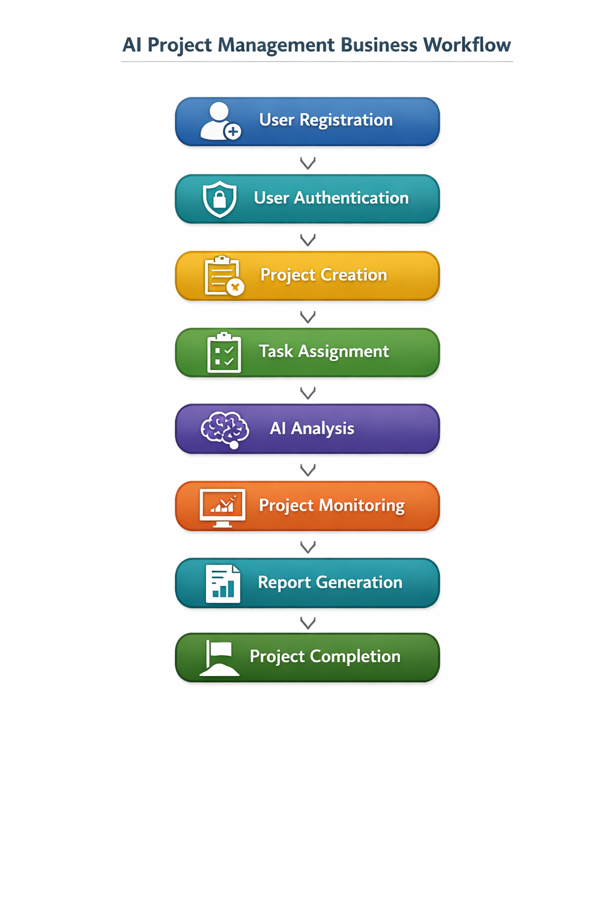
Figure 6.1: Work flow Diagram

- User Registration → New users create accounts
- User Authentication → Secure login and verification
- Project Creation → Start new projects
- Task Assignment → Assign tasks to team members
- AI Analysis → System analyzes data and predicts outcomes
- Project Monitoring → Track progress and performance
- Report Generation → Generate analytical reports
- Project Completion → Finalize and close the project

7. Functional Requirements Summary
ID | Requirement
FR-1 | User Registration
FR-2 | User Login
FR-3 | Project Creation
FR-4 | Task Assignment
FR-5 | AI Recommendations
FR-6 | Report Generation
FR-7 | Notifications

8. Assumptions and Constraints
Assumptions
- Users have internet access
- Users possess basic computer knowledge
- Required hardware resources are available
Constraints
- AI prediction accuracy depends on historical data
- Limited hardware resources may affect performance
- Continuous internet connection required
9. Risks
Potential project risks:
- Poor quality data for AI training
- Security vulnerabilities
- Delays in implementation
- Hardware limitations
- User adoption challenges

10. Success Criteria
The project will be considered successful if:
- Project productivity increases
- Task completion efficiency improves
- Resource utilization improves
- Project delays decrease
- User satisfaction reaches acceptable levels

11. Future Scope
Future enhancements may include:
- Mobile applications
- Voice assistant support
- Chatbot integration
- Real-time collaboration tools
- Advanced predictive analytics

12. Conclusion
The AI-Based Project Management System is intended to improve business efficiency by integrating Artificial Intelligence with project management practices. The system will support organizations in improving productivity, reducing project risks, and optimizing resource utilization.

