SOFTWARE REQUIREMENTS SPECIFICATION

For

Project Management System (TaskForge)

Initial draft

Prepared by

Group A

Bangladesh Army University of Engineering and Technology

25th June, 2026

Table of Contents

1. Introduction 3
1.1 Purpose 3
1.2 Scope 3
1.3 Definitions and Acronyms 3
2. Overall Description 4
2.1 Product Perspective 4
2.2 Product Functions 4
2.3 User Journey 5
2.4 Operating Environment 6
3. Functional Requirements 7
4. External Interface Requirements 9
5. Non-Functional Requirements 10
6. System Models 11
6.1 Use Case Diagram 11
6.2. Data Flow Diagram (DFD) 11
6.3 UML Class Diagram 13
7. Database Design 13
8. Constraints 14
9. Future Scope 14
10.Conclusion 15

1. Introduction

1.1 Purpose
The purpose of this Software Requirements Specification (SRS) document is to define the requirements for an AI-Based Project Management System that uses Artificial Intelligence techniques to automate and improve project planning, task allocation, progress monitoring, and decision-making.

1.2 Scope
- The proposed system will help organizations and teams manage projects efficiently by integrating AI capabilities.
- Major functionalities include:
- User registration and authentication
- Project creation and management
- Task scheduling
- AI-based recommendations
- Progress tracking
- Team collaboration
- Resource allocation
- Risk analysis
- Report generation
- Notification system

1.3 Definitions and Acronyms
Acronym | Meaning
AI | Artificial Intelligence
SRS | Software Requirements Specification
UML | Unified Modeling Language
DFD | Data Flow Diagram
ERD | Entity Relationship Diagram
API | Application Programming Interface

2. Overall Description

2.1 Product Perspective
The AI-Based Project Management System is a web-based platform that combines project management tools with machine learning algorithms.

2.2 Product Functions
The system shall:
- Register users
- Authenticate users
- Create projects
- Assign tasks
- Monitor project progress
- Predict project risks using AI
- Generate reports
- Send notifications

2.3 User Journey
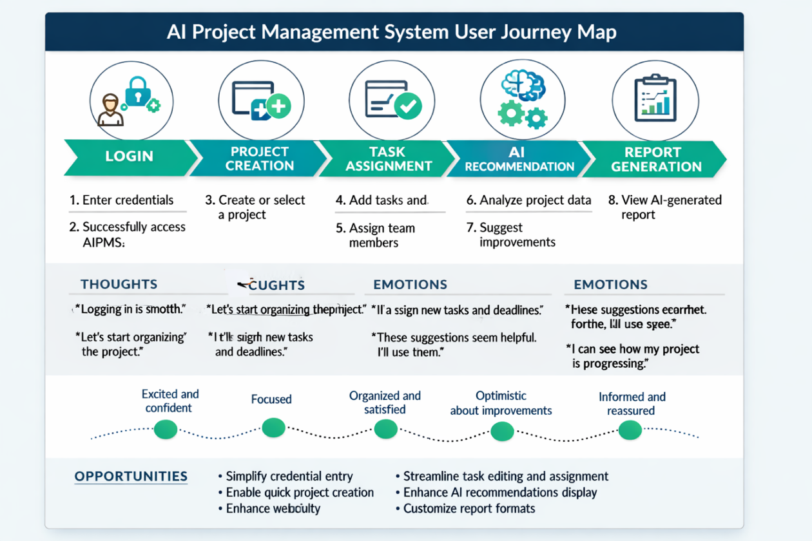
Figure (a): Diagram of User Journey
Phases → Login, Project Creation, Task Assignment, AI Recommendation, Report Generation
Tasks → Enter credentials, create/select project, assign tasks, get AI suggestions, generate reports
Thoughts → Smooth login, focused project setup, confident task assignment, optimistic about AI, satisfied with reports
Emotions → Excited, focused, organized, optimistic, reassured
Opportunities → Simplify login, quick project creation, streamline task assignment, enhance AI display, customizable reports

2.4 Operating Environment
Hardware Requirements
Component | Specification
Processor | Intel Core i3 or higher
RAM | Minimum 4 GB
Storage | Minimum 20 GB available space

Frontend Technologies
Tool / Framework | Purpose
React.js | Dynamic and responsive UI components

Database
System | Purpose
MySQL | Data storage and management

AI Framework

Library | Purpose
TensorFlow | Deep learning and predictive modeling
Scikit-learn | Machine learning algorithms and analysis

3. Functional Requirements
ID | Title | Description | Priority | Acceptance Criteria
FR-1 | User Registration | Allow new users to register with valid credentials. | High | Allow new users to register with valid credentials.
FR-2 | User Login | Authenticate registered users to access the system | High | Login succeeds with correct credentials
FR-3 | Password Reset | Enable users to reset forgotten passwords securely | Medium | Password reset link works and updates password
FR-4 | Logout | Allow users to log out safely | Medium | Session ends and user is redirected to login page
FR-5 | Create Project | Users can create new projects with details | High | Project saved and visible in dashboard
FR-6 | Update Project | Modify existing project information | Medium | Changes reflect immediately in project list
FR-7 | Delete Project | Remove unwanted projects | Medium | Project deleted and no longer accessible
FR-8 | View Project Status | Display project progress and completion percentage | High | Status updates dynamically based on tasks
FR-9 | Create Task | Add new tasks under a project | High | Task appears under correct project
FR-10 | Assign Task | Assign tasks to team members | High | Assigned user receives task notification
FR-11 | Set Deadline | Define deadlines for tasks | Medium | Deadline visible in task details
FR-12 | Update Task Progress | Modify task completion percentage | Medium | Progress bar updates accordingly
FR-13 | Track Task Status | Monitor task completion and pending tasks | High | Task list shows accurate status
FR-14 | Predict Project Completion Date | AI predicts estimated completion date | High | Prediction displayed in project summary
FR-15 | Suggest Task Priority | AI ranks tasks based on urgency | High | Priority suggestions visible to manager
FR-16 | Identify Project Risks | AI detects potential delays or issues | High | Risk alerts generated automatically
FR-17 | Suggest Resource Allocation | AI recommends optimal resource distribution | Medium | Resource suggestions accepted by manager
FR-18 | Recommend Workload Balancing | AI ensures fair workload among team members | Medium | Balanced workload reflected in dashboard
FR-19 | Generate Reports | Create detailed project reports | High | Reports generated accurately
FR-20 | Export PDF Reports | Allow exporting reports in PDF format | Medium | PDF file downloads successfully
FR-21 | View Analytics Dashboard | Display project analytics and insights | High | Dashboard shows updated metrics
FR-22 | Send Reminders | Notify users about deadlines | Medium | Reminder notifications sent on time
FR-23 | Notify Updates | Inform users about task or project changes | Medium | Update notifications appear instantly
FR-24 | Generate Alerts | Alert users for critical issues | High | Alerts displayed in dashboard and via email

4. External Interface Requirements
User Interface Requirements
- System interfaces should provide:
- User-friendly dashboard
- Responsive layout
- Search functionality
- Simple navigation
Software Interface
- Database Server
- Web Browser
- AI APIs
Communication Interface
Protocols:
- HTTP
- HTTPS

5. Non-Functional Requirements
Performance
- Response time under 3 seconds
- Support 1000 users simultaneously
Security
- Password encryption
- Authentication system
- Role-based access control
Reliability
- System uptime: 99.9%
Availability
- Service available 24/7
Maintainability
- Easy code maintenance

6. System Models

6.1 Use Case Diagram

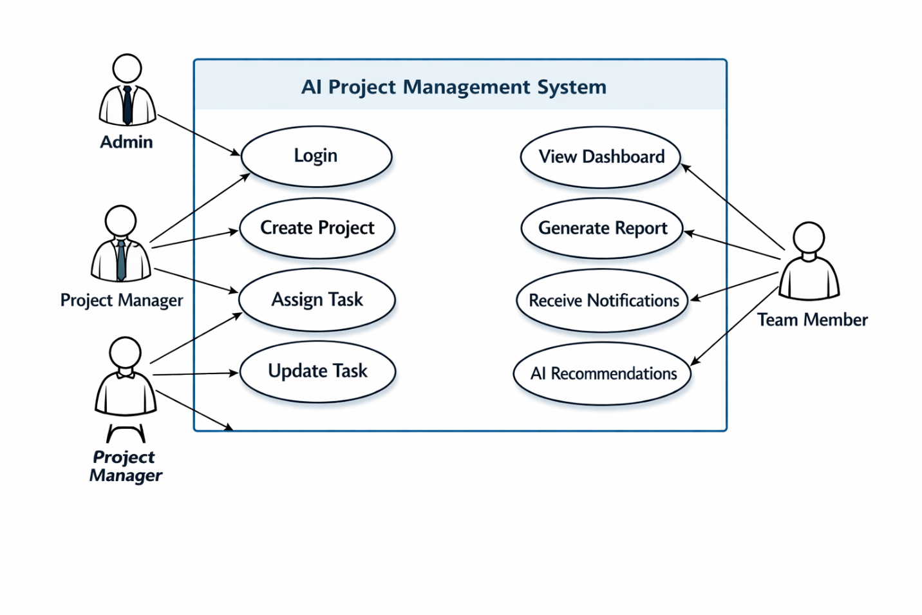
Figure 6.1: Use Case Diagram
- Actors → Admin, Project Manager, Team Member
- System Boundary → AI Project Management System
- Use Cases → Login, Create Project, Assign Task, Update Task, View Dashboard, Generate Report, Receive Notifications, AI Recommendations
- Connections → Each actor linked to their relevant use cases with clear lines

6.2. Data Flow Diagram (DFD)
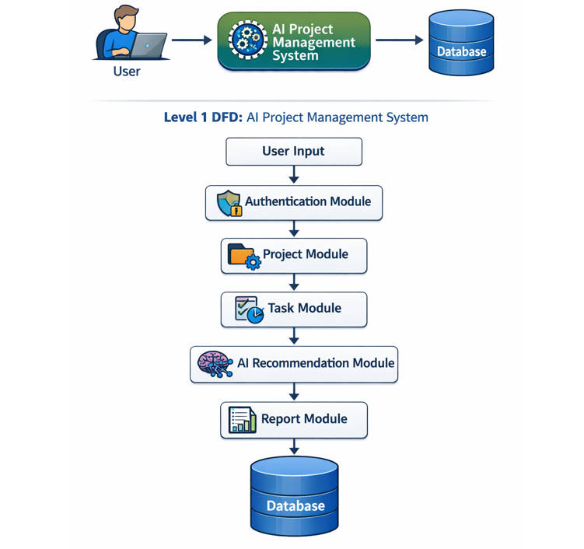
Figure 6.2: Data Flow Diagram (DFD)
- Level 0 DFD → Shows the high-level interaction: User → AI Project Management System → Database
- Level 1 DFD → Breaks down the internal flow: User Input → Authentication Module → Project Module → Task Module → AI Recommendation Module → Report Module → Database

6.3 UML Class Diagram
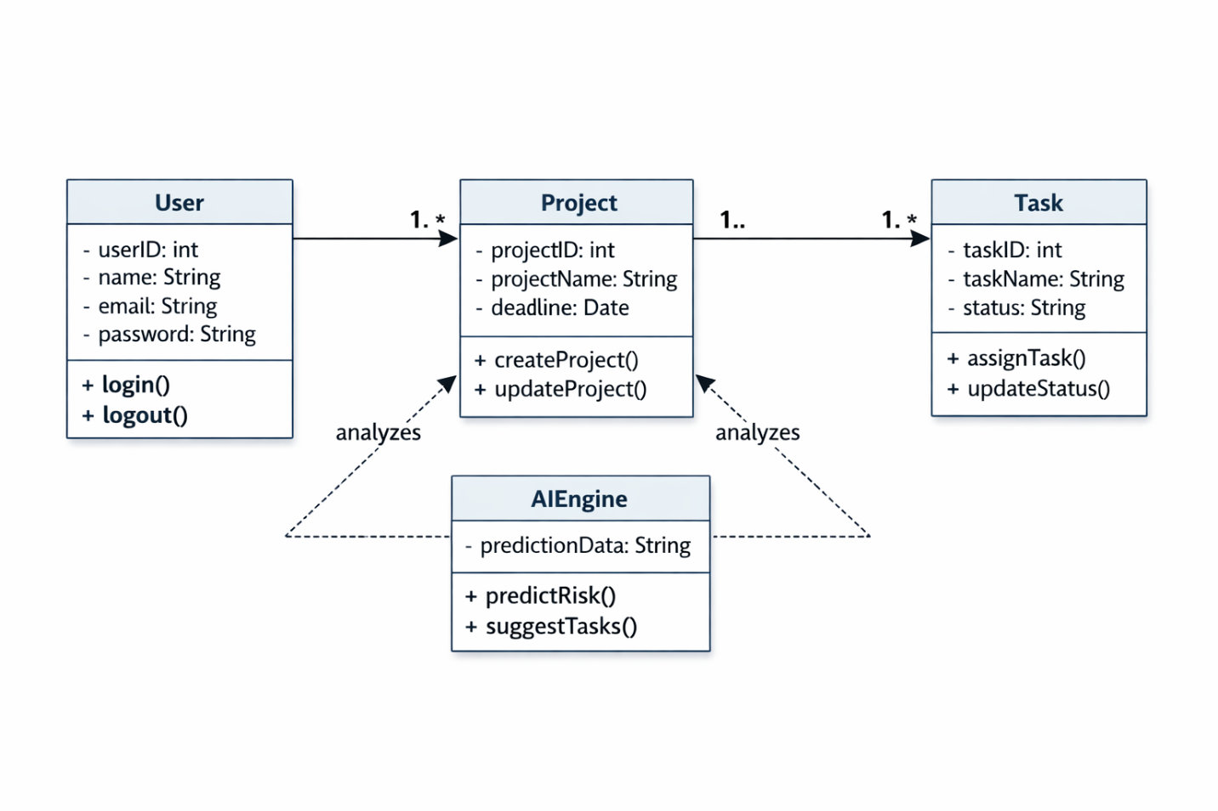
Figure 6.3: UML Class Diagram
- Classes: User, Project, Task, and AIEngine
- Attributes: IDs, names, deadlines, statuses, and prediction data
- Methods: Login(), Logout(), CreateProject(), UpdateProject(), AssignTask(), UpdateStatus(), PredictRisk(), SuggestTasks()
- Relationships:
User → Project (one‑to‑many)
Project → Task (one‑to‑many)
AIEngine → Project/Task (association for analysis and prediction)

7. Database Design
Entity Relationship Diagram (ERD)
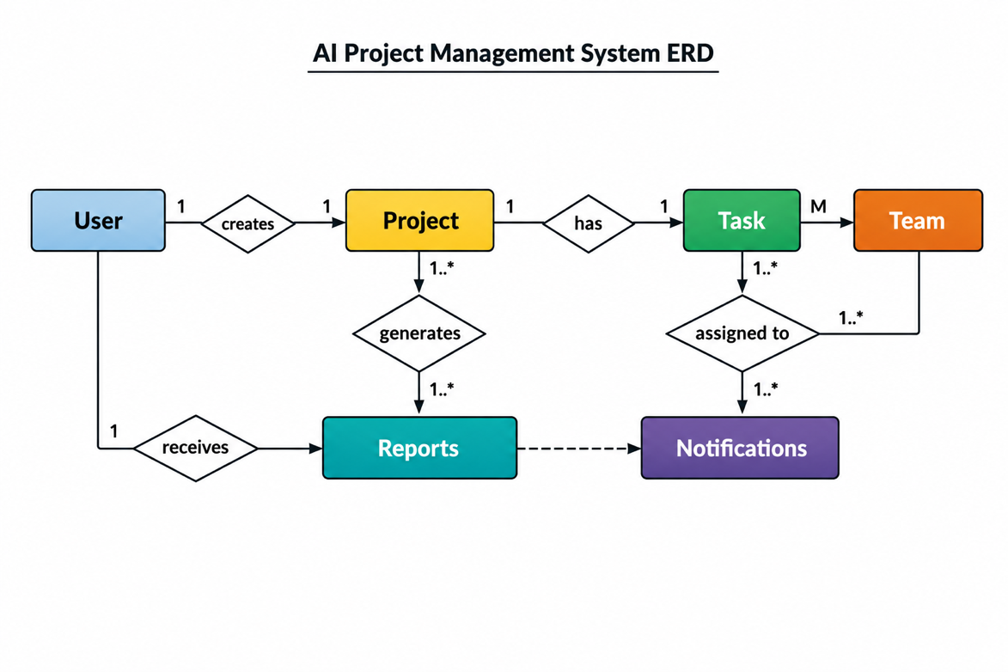
Figure 7.1: Diagram of Entity Relationship Diagram (ERD)
  - Entities: User, Project, Task, Team, Reports, Notifications
  - Relationships:
- One User creates multiple Projects
- One Project contains multiple Tasks
- One Task is assigned to one or more Team Members
- Each Project generates Reports
- Each User receives Notifications

8. Constraints
- Internet connection required
- AI prediction depends on available data quality
- Limited system performance under low hardware resources

9. Future Scope
- Mobile application
- Chatbot integration
- Voice assistant support
- Real-time video collaboration
- Advanced AI prediction system

10.Conclusion
The AI-Based Project Management System integrates traditional project management with Artificial Intelligence to improve productivity, automate repetitive tasks, and support better decision-making.

