Beyond the Single Split: A Reproducible Benchmark of Bengali Book Review Sentiment Classification with Explanations and Label-Noise Analysis
Anonymous Authors

Abstract—Bengali book review sentiment classification remains challenging because of spelling variation, informal language, and limited annotated data. This study benchmarks twelve trainable-embedding recurrent and attention-based models, nineteen classical TF-IDF classifiers, and the pretrained BanglaBERT transformer (compared with XLM-R and multilingual BERT) for binary sentiment prediction. A dataset of 2,009 unique reviews (1,029 negative and 980 positive) was assembled from the Mendeley Bengali Book Reviews corpus and BanglaBook, and all models were evaluated with stratified five-fold cross-validation (five seeds for the recurrent models, three for BanglaBERT). The recurrent models reached at most 81.08% mean accuracy (BiLSTM with Attention), with single-fold accuracies spanning 13 points, whereas fine-tuned BanglaBERT reached 93.84% ± 1.10 over three seeds, BanglaBERT-large 93.81% ± 1.04 (no difference from the base model), and their probability-averaging ensemble 94.23% ± 0.82 (a gain that is not statistically significant). On the original Mendeley corpus, BanglaBERT reached 96.72% ± 1.19 accuracy against 94.24% for the strongest TF-IDF baseline (Multinomial Naive Bayes) and 84% reported earlier on a larger corpus; on the Rokomari corpus it reached 90.60% ± 0.72. Ablation and SHAP analyses show that results are stable across fine-tuning choices and that predictions rely on sentiment-bearing words. Accuracy on a cleaned external collection remained limited (73.0%), indicating a persistent generalization gap.
Index Terms— Bengali Sentiment Analysis, Book Reviews, BanglaBERT, Word Embedding, BiGRU, BiLSTM, Attention, SHAP, Text Classification.
1.Introduction
Bengali is a widely spoken language with a growing volume of reader-generated reviews on digital platforms. Such reviews contain useful signals about readers’ preferences, satisfaction, and criticism, but manually examining them at scale is difficult. Automated sentiment classification can help summarize positive and negative opinions and support downstream review analytics. Unlike standardized written text, online Bengali reviews may include informal wording, spelling variants, punctuation differences, and variable sentence lengths. These characteristics make reliable sentiment identification difficult, especially when labeled training resources are limited. Traditional feature-based classifiers often rely on sparse lexical representations; recurrent neural networks instead process sequences of word representations and can learn order-dependent information. LSTM and GRU models use gating mechanisms to handle dependencies, while bidirectional variants incorporate information from both directions. Attention layers can additionally assign different importance to words within a review. In this study, we compare recurrent and attention-based configurations on Bengali book reviews, using trainable embeddings and a consistent evaluation pipeline.

The primary comparison uses a deduplicated dataset of 2,009 labeled reviews; the earlier 1,444-review experiment corresponds to the Mendeley corpus, which is also evaluated separately. Because a single train/test split of a small corpus gives unstable estimates, all results are reported as stratified five-fold cross-validation means with standard deviations. Beyond the held-out folds, performance is checked on a separately annotated Rokomari review collection to assess whether learned sentiment patterns transfer across sources. The remainder of this paper is organized as follows: Section II reviews related work; Section III describes the methodology; Section IV presents the experimental results, including comparisons with transformer, classical and published baselines, explainability and cross-dataset evaluation; Sections V–VIII contain the discussion, limitations, conclusion and future work, followed by acknowledgments and references.

II Related Works
Sentiment analysis is a critical research area in natural language processing, aimed at identifying opinions and emotional polarity from textual data. Early approaches relied on traditional machine learning techniques such as Naive Bayes, Logistic Regression, and Support Vector Machines, using manually extracted features such as TF- IDF. However, these approaches often struggled to capture complex contextual relationships and long-range dependencies in review texts [1].
In recent years, deep learning models, particularly recurrent neural networks (RNNs), have become widely used for sentiment classification by automatically learning sequential features from text. RNNs can effectively process word sequences, but conventional RNNs may face difficulties in learning long-term dependencies [2]. Long Short-Term Memory (LSTM) and Gated Recurrent Unit (GRU) architectures address these limitations through gating mechanisms, enabling them to retain important information over longer sequences [3], [4]. Bidirectional architectures such as BiLSTM and BiGRU further improve contextual representation by processing text in both forward and backward directions [5]. Attention mechanisms have also gained significant attention in sentiment analysis because they enable models to focus on the most informative words within a sequence. Attention-based recurrent models can capture important sentiment-related features while reducing the influence of less relevant information [6]. Several studies have demonstrated that combining recurrent architectures with attention can improve

performance in text classification tasks [7]. Bengali sentiment analysis remains challenging due to spelling variation, informal expressions,and limited language resources. Previous studies have explored machine learning, word embedding, and deep learning techniques for Bengali sentiment classification, demonstrating the effectiveness of neural approaches for processing Bengali textual data [8], [9]. Word embeddings have also played an important role in deep-learning-based sentiment analysis by representing words as dense numerical vectors and capturing semantic relationships between words [10]. Recent research has further investigated Bengali text classification using neural and transformer-based approaches, showing the potential of learned representations for handling the linguistic characteristics of Bengali [11], [12]. However, differences in datasets and model architectures can lead to significant variations in classification performance.this work systematically evaluates twelve recurrent and attention-based configurations, including RNN, BiRNN, GRU, BiGRU, LSTM, BiLSTM, and their attention variants. three ensemble of high-performing models is investigated to examine whether combining complementary predictions can improve classification reliability [13]. External cross-dataset validation is also performed to examine the generalization capability of the developed models beyond the primary dataset. Recent advancements in Bengali natural language processing have highlighted the importance of language-specific representations and attention-based architectures for improving text classification performance. Bhattacharjee et al. [14]. introduced BanglaBERT, a pretrained language model designed for Bengali language understanding, demonstrating the effectiveness of language-specific pretraining across multiple natural language processing tasks. Similarly, Vaswani et al. [15]. proposed the Transformer architecture, which relies on self-attention mechanisms to capture contextual relationships between words without recurrent computations. These developments have encouraged researchers to investigate attention-based approaches for sentiment classification. However, pretrained language models often require considerable computational resources, while recurrent architectures with trainable word embeddings offer an alternative for relatively small datasets. Motivated by these developments, the present study investigates twelve recurrent and attention-based deep learning configurations, including RNN, BiRNN, GRU, BiGRU, LSTM, BiLSTM, and their attention-enhanced variants. Furthermore, an ensemble of selected models is evaluated to examine whether combining predictions improves classification performance. Cross-dataset validation is also conducted to assess the generalization capability of the developed models on an independent Bengali review dataset.

III. METHODOLOGY
The proposed methodology consists of several stages, including data preprocessing, text tokenization, word representation, model development, model training, and performance evaluation. Figure 1 illustrates the overall framework of the proposed Bengali book review sentiment classification system, showing the sequential workflow from input review data to final sentiment prediction.

Each stage contributes to transforming raw Bengali text into meaningful representations and accurately classifying reviews

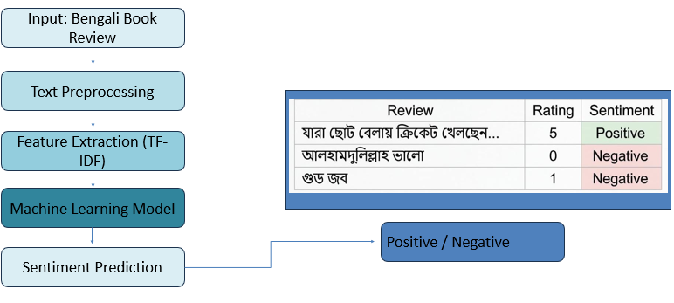

Fig. 1. Proposed Bengali book review sentiment classification
framework.

A. Dataset Description
The primary dataset contains 2,009 unique Bengali book reviews: 980 positive (label 1) and 1,029 negative (label 0). It combines the Mendeley Bengali Book Reviews corpus [16] (1,414 reviews after near-duplicate removal; 947 positive, 467 negative) with 595 reviews from BanglaBook [11] (562 negative and 33 positive; star ratings 1–2 mapped to negative and 5 to positive, Bengali script only, at least three words). Duplicate and missing entries were removed. The merged corpus is a reconstruction from the public sources above, built for this study; it is not a continuation of an earlier private file. We release the review text, labels, source flags and the exact fold assignments (BBR-2009, with a datasheet) for non-commercial use, following the more restrictive BanglaBook licence. Because the BanglaBook portion is almost entirely negative, accuracy is also reported per source in Section IV. The Mendeley corpus alone (1,442 unique reviews) and the Rokomari corpus [17] (positive/negative reviews only) are evaluated separately. The class distribution of the primary dataset is shown in Fig. 2.
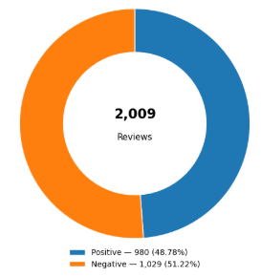
Fig 2: Overall sentiment distribution of positive and negative
Bengali book reviews.

B. Data Preprocessing
Bengali book reviews were preprocessed by removing unnecessary characters, punctuation, and noise while preserving Bengali Unicode text. The cleaned reviews were tokenized using a vocabulary size of 15,000 words with an OOV token. Padding and truncation were applied to maintain a sequence length of 150 tokens. Finally, the processed sequences were passed to the word embedding layer for sentiment classification.

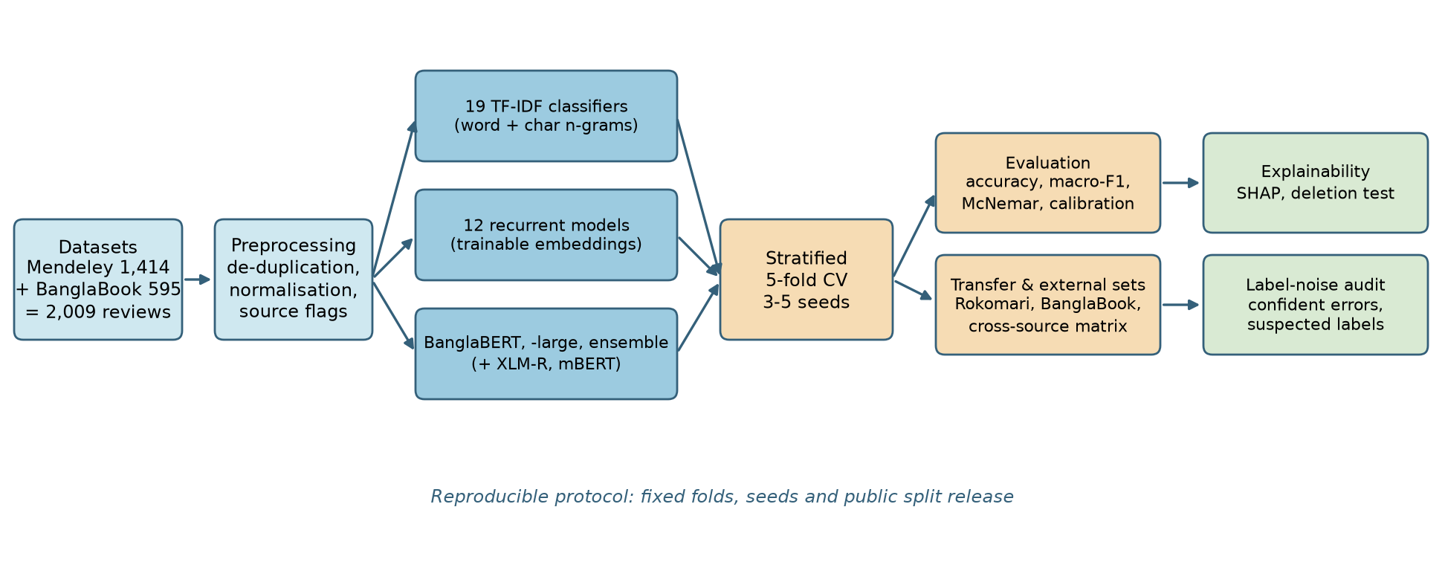

Fig:3 Experimental pipeline: classical, recurrent and transformer models evaluated under repeated stratified cross-validation, followed by transfer, explainability and label-noise analyses.

C Word Embedding

A trainable embedding layer transforms integer-encoded Bengali tokens into compact, dense word vectors. For the expanded experiment, the embedding dimension was 128. Unlike sparse one-hot vectors, these learned representations allow the recurrent networks to use a continuous representation of the review vocabulary. The embedding parameters are optimized jointly with the sentiment classifier during training, so the representation can adapt to words and expressions in Bengali book reviews. The pilot experiment used 64-dimensional embeddings, which should not be confused with the expanded model comparison.

D.Training Configuration

Models were evaluated with stratified five-fold cross-validation (five random seeds for the recurrent models, three for the Mendeley corpus and for BanglaBERT and BanglaBERT-large on the 2,009-review set, and one for the Rokomari corpus and the ablations), giving about 1,607 training and 402 test reviews per fold. For the recurrent models, 10% of each training fold was held out for validation-based early stopping (patience 4, at most 20 epochs), so test folds were never used for model selection; Adam (learning rate 1e-3), gradient clipping at 1.0, dropout 0.3 and balanced class weights computed from the training labels were used. BanglaBERT [14], an ELECTRA-based model pretrained on Bengali text, was fine-tuned for four epochs with AdamW (learning rate 3e-5, batch size 16, maximum length 128, linear warm-up and decay, balanced class weights); BanglaBERT-large used learning rate 2e-5 and batch size 8. Nineteen classical classifiers were trained on word (1–2-gram) and character (2–5-gram) TF-IDF features. Accuracy and macro-averaged precision, recall and F1-score are reported.

Table 1. Dataset and training configuration of the cross-validated Bengali book review experiment

Parameter | Value
Training samples | ≈1,607 per fold
Testing samples | ≈402 per fold
Vocabulary size | 15,000
Maximum sequence length | 150 (RNN) / 128 (BERT)
Embedding dimension | 128
Batch size / maximum epochs | 32 / 20 (RNN); 16 / 4 (BERT)
Early stopping patience | 4
Class weight for class 0 | Balanced weights computed from training labels
Class weight for class 1 | Balanced weights computed from training labels

IV Experimental Result

The performance of all models was assessed using accuracy and macro-averaged precision, recall and F1-score. Every model used the same preprocessed data and the same stratified five-fold protocol. Recurrent models were repeated with five random seeds (25 train/test runs each) and are reported as mean ± standard deviation. This avoids the optimism of a single 400-review test set, whose 95% confidence interval for an accuracy near 95% is already about ±2 percentage points.

Comparison of Deep Learning Models

The recurrent configurations (RNN, GRU and LSTM, each unidirectional or bidirectional, with or without additive attention) all use a 15,000-word vocabulary, a maximum length of 150 tokens and 128-dimensional trainable embeddings. With the corrected training procedure (packed variable-length sequences, gradient clipping and validation-based early stopping), no configuration collapsed to a single class, as some unidirectional recurrent models can do without these safeguards. Table 2 lists the cross-validated results. Attention improved five of the six cell/direction combinations, and the best recurrent model was BiLSTM with Attention (81.08% ± 3.75 accuracy), followed by BiGRU with Attention (80.62% ± 4.05).

Table 2: Five-fold cross-validated performance (mean over 25 runs; accuracy as mean ± std) of recurrent models and BanglaBERT on the 2,009-review dataset

Model | Accuracy | Precision (macro) | Recall (macro) | F1-score (macro)
RNN | 73.57±6.20 | 74.00 | 73.60 | 73.43
BiRNN | 75.11±4.82 | 75.47 | 75.11 | 75.00
GRU | 78.06±6.72 | 78.57 | 78.14 | 77.94
BiGRU | 79.88±4.81 | 80.24 | 79.93 | 79.82
LSTM | 79.54±4.87 | 80.32 | 79.65 | 79.40
BiLSTM | 80.43±4.33 | 80.86 | 80.48 | 80.36
RNN + Attention | 78.33±4.18 | 78.91 | 78.39 | 78.20
BiRNN + Attention | 79.41±4.02 | 80.10 | 79.48 | 79.29
GRU + Attention | 79.45±3.58 | 80.25 | 79.57 | 79.31
BiGRU + Attention | 80.62±4.05 | 81.31 | 80.69 | 80.50
LSTM + Attention | 78.78±4.35 | 79.34 | 78.81 | 78.66
BiLSTM + Attention | 81.08±3.75 | 81.63 | 81.13 | 80.99
BanglaBERT (base) | 93.84±1.10 | 93.93 | 93.90 | 93.84

Variation across folds is large for the recurrent models (standard deviations of 3.6–6.7 points), and the same BiLSTM with Attention scores anywhere between 72.6% and 85.8% on different folds. In contrast, BanglaBERT (last row of Table 2, three seeds) reached 93.84% ± 1.10 accuracy and 93.84% macro-F1 with markedly lower variance.

Comparison with Transformer, Classical and Published Baselines
Table 4 compares BanglaBERT with the recurrent models, with nineteen classical classifiers trained on word and character TF-IDF features (logistic regression, linear and RBF SVM, k-NN, tree ensembles, gradient boosting, Naive Bayes variants, LDA/QDA and an MLP) and with the best previously published results. On the Mendeley corpus, fine-tuned BanglaBERT (96.72% ± 1.19 over 15 folds) exceeded the strongest classical baseline, Multinomial Naive Bayes (94.24% ± 1.72), by 2.5 points and was higher on every fold of seed 0 (minimum fold-wise gain 1.0 points). The 84% reported for Naive Bayes in [16] comes from the authors' own 2,000-review corpus, of which only 1,443 reviews are public, so the comparison is indicative only. On the Rokomari corpus, BanglaBERT reached 90.60% ± 0.72 accuracy (macro-F1 90.47%) against 88.42% for linear SVM; the published 88.95% weighted F1 of XLM-R [17] was obtained with a different split, so that comparison is indicative only. The original shuffle in the authors' code is unseeded, so their exact split cannot be reproduced. We therefore followed their protocol (positive and negative reviews only, at most 300 words, stratified 80/10/10 split) with three random shuffles and fine-tuned BanglaBERT for four epochs: weighted F1 was 89.21%, 90.35% and 90.35% (mean 89.97% ± 0.66; 519 test reviews per shuffle). This is 1.0 point above the published 88.95%, but with a test set of this size and a different split the difference is within the shuffle-to-shuffle variation and is not evidence of superiority. On the 2,009-review dataset (BBR-2009) BanglaBERT (93.84% ± 1.10) and BanglaBERT-large (93.81% ± 1.04) were indistinguishable over three seeds (paired Wilcoxon p = 0.89), and their ensemble reached 94.23% ± 0.82; this gain of 0.4 points over the base model is smaller than the fold-to-fold deviation and not significant (p = 0.16). In an earlier single-seed run the large model appeared better (94.28% vs 93.53%), which was seed noise. Models designed for tabular features were not evaluated because the inputs are raw text.
Table 4: Five-fold CV accuracy (%, mean ± std) of BanglaBERT, recurrent and classical models on three datasets, with the best published results
Method | Mendeley | BBR-2009 | Rokomari
BanglaBERT (base) | 96.72 ± 1.19 | 93.84 ± 1.10 | 90.60 ± 0.72
BanglaBERT-large | – | 93.81 ± 1.04 | –
Base + large ensemble | – | 94.23 ± 0.82 | –
BiLSTM + Attn (scratch) | – | 81.08 ± 3.75 | –
Linear SVM (TF-IDF) | 93.55 ± 1.84 | 90.19 ± 1.53 | 88.42 ± 1.02
Logistic regression | 93.48 ± 1.69 | 90.08 ± 1.66 | 88.16 ± 0.94
Multinomial NB | 94.24 ± 1.72 | 89.50 ± 1.67 | 84.08 ± 1.52
Published best | 84.0 [16] | n/a | 88.95 wF1 [17]
Table 5 reports a fine-tuning ablation of BanglaBERT on the 2,009-review dataset (three seeds). Removing class weights, shortening the maximum length to 64 tokens, reducing training to two epochs or raising the learning rate to 5e-5 all stayed within one standard deviation of the default configuration (93.13–93.86%), so the result is not sensitive to these choices.
Table 5: Ablation of BanglaBERT fine-tuning choices (accuracy %, mean ± std over five folds)
BanglaBERT variant | Accuracy
Default (3e-5, len 128, 4 ep., class weights) | 93.84 ± 1.10
Learning rate 5e-5 | 93.86 ± 1.31
No class weights | 93.83 ± 1.27
Maximum length 64 | 93.26 ± 1.42
2 epochs | 93.13 ± 1.21

B.Confusion Matrix Analysis

Fig. 4 shows out-of-fold confusion matrices for BanglaBERT and BanglaBERT-large pooled over the five folds (seed 0). The base model misclassified 95 negative and 35 positive reviews (130 errors among 2,009), and the large model 81 and 34 (115 errors); both are somewhat more likely to label a negative review as positive.

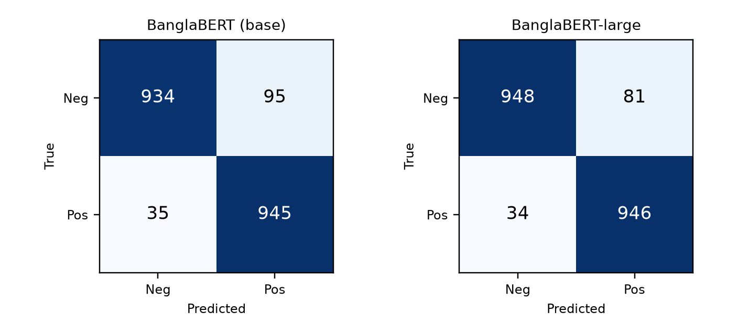

Fig 4: Out-of-fold confusion matrices of BanglaBERT (left) and BanglaBERT-large (right) on the 2,009-review dataset (five-fold CV, seed 0).

Explainability and Error Analysis
To inspect what BanglaBERT relies on, SHAP values [18] were computed with a text masker on 60 held-out reviews (a single 80/20 stratified split with 93.03% accuracy and 28 errors among 402 test reviews). Fig. 5 shows the tokens with the largest mean contribution: negative evidence comes from words such as “বাজে” (bad), “হতাশ” (disappointed) and “পুরাতন” (old), and positive evidence from “চমৎকার” (excellent), “সুন্দর” (beautiful), “অসাধারণ” (extraordinary) and “সেরা” (best), i.e. sentiment-bearing words. A few frequent function words and sub-word pieces also appear, indicating some dataset-specific cues. Many errors involve emoji-only reviews, mixed praise and criticism, or very short texts. Accuracy also differs by source: 95.5% (negative) and 97.3% (positive) on Mendeley-originated reviews, but 86.8% and 72.7% on BanglaBook-originated negatives and positives (only 33 positives), suggesting that rating-derived labels are noisier than manually annotated ones.
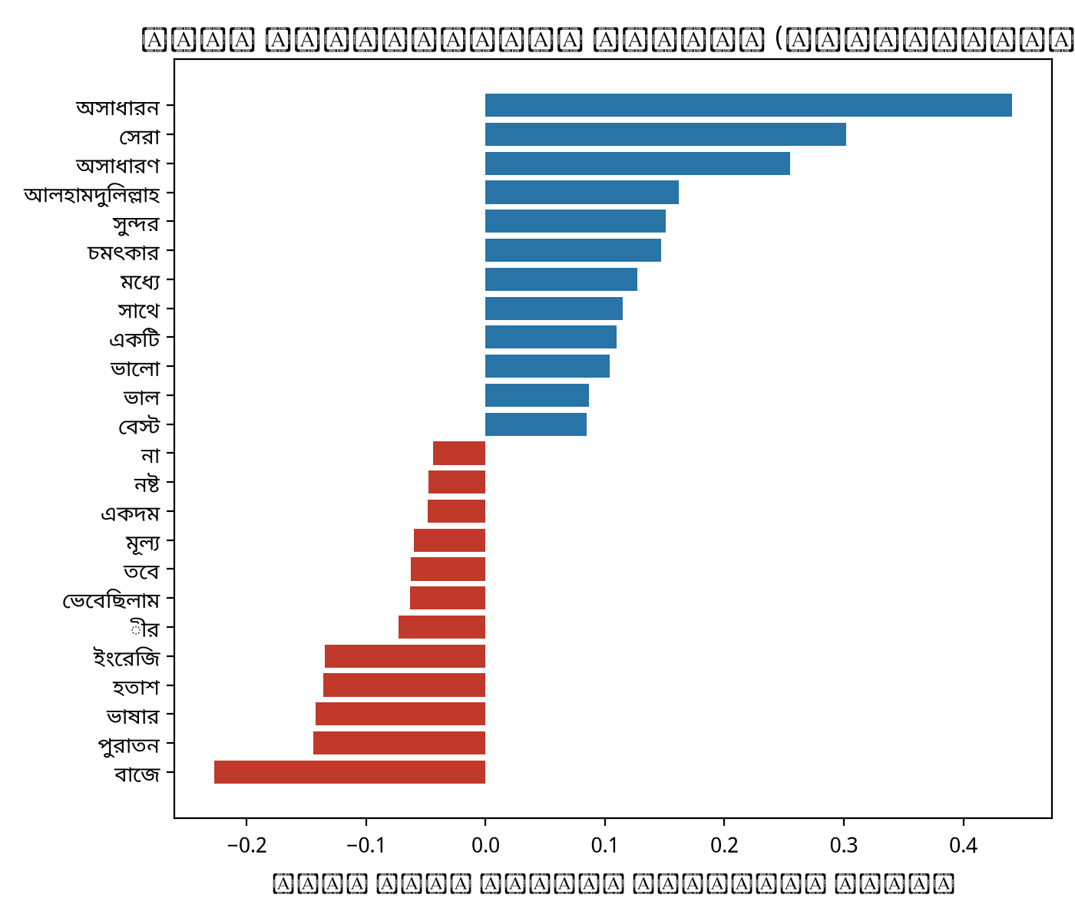
Fig 5: Tokens with the largest mean SHAP contribution toward the positive class (BanglaBERT, 60 held-out reviews; red = negative, blue = positive).

- Cross-Dataset Validation

To assess generalization, an external collection of 6,541 Bengali book reviews crawled from Rokomari [17] (five columns, including review text, rating and a sentiment category) was used. Neutral reviews (rating 3) were removed, ratings of 4–5 were treated as positive and 0–2 as negative, reviews with fewer than three Bengali words were dropped, and any review found in the primary dataset was excluded, leaving 5,277 reviews (2,670 positive, 2,607 negative). Every model trained in cross-validation was applied to this set without further training and the mean accuracy was recorded.
BanglaBERT reached 73.0% ± 1.2 and BanglaBERT-large 73.5% ± 0.8 accuracy, while the recurrent models reached 55–61% (best BiGRU with Attention, 61.2%). This is a substantial drop relative to within-dataset performance. Part of the gap is label noise: ratings are only a proxy for sentiment, and Table 3 shows reviews such as “আলহামদুলিল্লাহ ভালো” (praise) with rating 0 labelled Negative. Differences in vocabulary, writing style and annotation scheme between the primary data and the external collection also contribute.
To examine transfer between sources, BanglaBERT was trained on one source and tested on the others (single seed; texts shared between sources were removed from the training data). Training on Mendeley and testing on Rokomari gave 84.5% accuracy (macro-F1 84.3%), and the reverse gave 91.2% (macro-F1 90.3%). Both models transferred poorly to the 595 BanglaBook-derived reviews (77.0% and 82.4% accuracy; macro-F1 58.3% and 63.8%), consistent with their rating-derived labels and with the source–label confound described above.
Suspected label errors. Pooling out-of-fold predictions over three seeds and both model sizes, 111 of 2,009 reviews (5.5%) were misclassified by the ensemble, and 69 of these errors (62%) were made with a predicted probability above 0.9. Such confident disagreements are candidates for mislabelled data. They concentrate in the rating-derived source: 51 of 595 BanglaBook-originated reviews (8.6%) against 18 of 1,414 Mendeley reviews (1.3%); the overall error rate differs accordingly (12.1% versus 2.8%). These reviews have not been manually verified, so they are suspected, not confirmed, label errors; their identifiers are released for annotation.
Blind re-annotation audit. To test whether these suspected errors are real, 69 suspected and 131 randomly drawn reviews were shuffled, stripped of their labels and re-labelled as positive, negative or unclear by a single large-language-model annotator, working from the review text only. This is an LLM-assisted audit by one annotator, not a human annotation study, and it should be replicated with independent human annotators. 28 reviews were judged unclear (13 random, 15 suspected) and excluded. On the 118 labelled random reviews the annotator agreed with the dataset label in 96.6% of cases (Cohen's kappa 0.93; 100% on Mendeley-originated and 87.1% on BanglaBook-originated reviews), so the annotator does not merely contradict the data. On the 54 labelled suspected reviews agreement was only 25.9% (kappa 0.00): 39 of the 43 reviews labelled negative in the dataset were judged positive, and agreement was 9.8% for BanglaBook-originated suspected reviews against 76.9% for Mendeley-originated ones. Most suspected errors are therefore likely rating-derived labels that contradict the review text, which supports the view that star-rating labels are a noisy proxy for sentiment. Reported accuracy on the BanglaBook-originated portion is correspondingly pessimistic, because some model errors are label errors.
Extended explanation. SHAP was recomputed for all 402 held-out reviews of the 80/20 split. As a faithfulness check, the k highest-SHAP tokens of each review were deleted and the drop in the predicted-class probability was compared with deleting k random tokens: 0.120 versus 0.024 (k = 1), 0.324 versus 0.095 (k = 3) and 0.444 versus 0.150 (k = 5). SHAP-selected tokens are therefore three to five times more influential than random ones. The strongest negative tokens include “অস্থির”, “দুর্বল”, “বিরক্তিকর”, “বাজে” and “ফালতু”, and the strongest positive ones “ভালোই”, “বেস্ট”, “অসাধারণ”, “চমৎকার”, “দারুণ” and “সেরা”. Token-level attributions were also computed separately for Mendeley- and BanglaBook-originated reviews and for the suspected label errors.
Statistical tests, calibration and error analysis. McNemar's test showed that the BanglaBERT ensemble was significantly more accurate than the best classical model (linear SVM) in every seed (p < 1e-8; in seed 0, 130 reviews were correct only for the ensemble and 48 only for the SVM). The ensemble was significantly better than the base model in only one of three seeds (p = 0.03, 0.87 and 0.67). The expected calibration error (10 bins) was 0.047 for the base model, 0.057 for the large model and 0.041 for the ensemble. Errors were more frequent for BanglaBook-originated reviews (12.1% versus 2.8%) and for negative reviews (7.5% versus 3.5% for positive); the presence of a negation word did not increase the error rate (4.7% versus 5.9%), and there was no clear trend with review length (4.2–7.0% across length quartiles).
Other pretrained encoders. Under the same protocol (2,009 reviews, three seeds, five folds, four epochs), XLM-R base reached 91.31% ± 1.12 after tuning (91.11% ± 1.12 with default settings) and multilingual BERT 86.83% ± 1.54 (86.53% ± 1.45 by default), compared with 93.84% ± 1.10 for BanglaBERT. The ordering BanglaBERT > XLM-R > mBERT held in every seed (seed means 91.2, 91.1 and 91.0% for XLM-R; 86.5, 86.3 and 86.8% for mBERT), so language-specific pretraining on Bengali text was more useful than multilingual pretraining; XLM-R was still about one point above the best TF-IDF baseline (90.19%), whereas mBERT was below it. Tuning changed the results by at most 0.3 points.
Official BanglaBook benchmark. BanglaBERT-large fine-tuned on the official three-class BanglaBook split reached 91.87% weighted F1 (accuracy 93.04%, macro-F1 64.13%) after three epochs with square-root class weights, below the 0.93 reported in [11]. An unweighted two-epoch run reached 89.20%, and a four-epoch run with maximum length 192 collapsed to the majority class (84.65%). Performance on the neutral class remains weak, so we do not claim to match the published result on this benchmark. Under the protocol of [17] (positive and negative reviews of at most 300 words, stratified 80/10/10 split, three shuffles) BanglaBERT is reported in the Rokomari discussion above.

Review | Rating | Sentiment
যারা ছোট বেলায় ক্রিকেট খেলছেন... | 5 | Positive
আলহামদুলিল্লাহ ভালো | 0 | Negative
গুড জব | 1 | Negative

Table 3: Sample Entries from the external dataset

V. DISCUSSION

The cross-validated experiments show that recurrent models trained from scratch on about 1,600 reviews are limited to roughly 73–81% accuracy and are unstable across folds, whereas a pretrained Bengali language model reaches 93.8–94.2% with much lower variance. Strong TF-IDF baselines (up to 90.3% on the 2,009-review dataset and 94.2% on the Mendeley corpus) outperform every recurrent model, so pretraining rather than recurrence or attention is the decisive factor. Bidirectional processing and attention gave small, inconsistent gains. Single folds of the same model differ by 13 points, illustrating how fragile a single 400-review test set is. The lower external accuracy shows that within-dataset scores do not guarantee transfer across sources.
VI. Limitations

This study has several limitations. First, the primary dataset is small and was assembled from two sources of different origin: 595 reviews come from rating-labelled BanglaBook (almost all negative), so source and label are partly confounded and the model is weaker on those reviews. Second, labels derived from star ratings are noisy, which also affects the external evaluation. Third, the Rokomari cross-validation used a single seed, and the differences between base, large and ensemble models are within one standard deviation. Fourth, comparison with published results is indicative only because splits and preprocessing differ, and on the full BanglaBook benchmark our result remains below the published one (Section IV). Finally, only recurrent, classical and BanglaBERT models were compared; other transformers and large language models were not tested.
.
VII. Conclusion

This study benchmarked twelve recurrent configurations, nineteen classical TF-IDF classifiers and fine-tuned BanglaBERT for Bengali book review sentiment classification under stratified five-fold cross-validation. Recurrent models trained from scratch reached at most 81.08% accuracy, and single folds of one model span 13 points, so a single split is unreliable. BanglaBERT reached 93.84% ± 1.10 on the 2,009-review dataset (93.81% for BanglaBERT-large and 94.23% for the ensemble, a non-significant gain), 96.72% ± 1.19 on the Mendeley corpus and 90.60% ± 0.72 on the Rokomari corpus, exceeding the strongest TF-IDF baselines by 2.2–3.2 points and the previously published Mendeley result.
SHAP analysis indicated that predictions rely mainly on sentiment-bearing words, and the ablation showed that results are insensitive to the main fine-tuning choices. Accuracy on a cleaned external collection remained at about 73%, so reliable transfer across sources requires more diverse and more carefully labelled data.

VIII. Future Work

Future research can focus on larger and more diverse Bengali book review datasets with manually verified labels, and on manual re-annotation of the suspected label errors identified here. Other pretrained models (for example XLM-R, BanglaT5 and instruction-tuned large language models), emoji-aware preprocessing and domain-adaptive pretraining may further improve accuracy and robustness. Calibrated confidence estimates and a web-based sentiment analysis system are further directions.

Acknowledgment

We would like to express our sincere gratitude for the valuable guidance, support, and encouragement received throughout this research. We also acknowledge the creators and contributors of the Bengali book review dataset for making the data available for this study. Finally, we extend our heartfelt gratitude to our families and friends for their continuous encouragement, patience, and support throughout the completion of this work.

References

[1] B. Pang, L. Lee, and S. Vaithyanathan, “Thumbs up? Sentiment classification using machine learning techniques,” in Proc. Conf. Empirical Methods in Natural Language Processing (EMNLP), pp. 79–86, 2002.
[2] T. Mikolov, M. Karafiát, L. Burget, J. Černocký, and S. Khudanpur, “Recurrent neural network based language model,” in Proc. Interspeech, pp. 1045–1048, 2010.
[3] S. Hochreiter and J. Schmidhuber, “Long short-term memory,” Neural Computation, vol. 9, no. 8, pp. 1735–1780, 1997.
[4] K. Cho et al., “Learning phrase representations using RNN encoder-decoder for statistical machine translation,” in Proc. EMNLP, pp. 1724–1734, 2014.
[5] M. Schuster and K. K. Paliwal, “Bidirectional recurrent neural networks,” IEEE Trans. Signal Process., vol. 45, no. 11, pp. 2673–2681, 1997.
[6] D. Bahdanau, K. Cho, and Y. Bengio, “Neural machine translation by jointly learning to align and translate,” in Proc. ICLR, 2015.

[7] Y. Wang, M. Huang, X. Zhu, and L. Zhao, “Attention-based LSTM for aspect-level sentiment classification,” in Proc. EMNLP, pp. 606–615, 2016.
[8] K. I. Islam, M. S. Islam, and M. R. Amin, “Sentiment analysis in Bengali via transfer learning using multilingual BERT,” arXiv preprint arXiv:2012.07538, 2020.
[9] M. A. Hasan, J. Tajrin, S. A. Chowdhury, and F. Alam, “Sentiment classification in Bangla textual content: A comparative study,” in Proc. 23rd Int. Conf. Computer and Information Technology (ICCIT), 2020, arXiv:2011.10106.
[10] T. Mikolov, K. Chen, G. Corrado, and J. Dean, “Efficient estimation of word representations in vector space,” arXiv preprint arXiv:1301.3781, 2013.
[11] M. Kabir, O. B. Mahfuz, S. R. Raiyan, H. Mahmud, and M. K. Hasan, “BanglaBook: A large-scale Bangla dataset for sentiment analysis from book reviews,” in Findings of the Association for Computational Linguistics: ACL 2023, 2023, arXiv:2305.06595.
[12] A. Bhowmick and A. Jana, “Sentiment analysis for Bengali using transformer based models,” in Proc. 18th Int. Conf. Natural Language Processing (ICON), 2021.
[13] T. G. Dietterich, “Ensemble methods in machine learning,” in Multiple Classifier Systems, Springer, pp. 1–15, 2000.
[14] A. Bhattacharjee et al., “BanglaBERT: Language model pretraining and benchmarks for low-resource language understanding evaluation in Bangla,” in Findings of the Association for Computational Linguistics: NAACL 2022, pp. 1318–1327, 2022, doi: 10.18653/v1/2022.findings-naacl.98.
[15] A. Vaswani et al., “Attention is all you need,” in Advances in Neural Information Processing Systems, vol. 30, pp. 5998–6008, 2017.
[16] E. Hossain, O. Sharif, and M. M. Hoque, “Sentiment polarity detection on Bengali book reviews using multinomial Naïve Bayes,” arXiv preprint arXiv:2007.02758, 2020.
[17] G. C. Sarker, K. M. Sadat, and A. Das, “Book review sentiment classification in Bangla using deep learning and transformer model,” in Proc. 4th Int. Conf. Sustainable Technologies for Industry 4.0 (STI), 2022.
[18] S. M. Lundberg and S.-I. Lee, “A unified approach to interpreting model predictions,” in Advances in Neural Information Processing Systems, vol. 30, 2017.

