Leakage-controlled benchmarking of radiograph body-part classification: reliability, label audit, explainability and cross-dataset transfer on public data
Sheikh Noor Abdullah1,*, A.B.M. Kabir Hossain1
1 Department of Information and Communication Engineering, Bangladesh Army University of Engineering & Technology (BAUET), Qadirabad Cantonment, Natore, Bangladesh
* Corresponding author: sheikhnoorabdullah02@gmail.com. ORCID: 0009-0002-7193-4284

Abstract
Background. Published accuracies for radiograph body-part classification are hard to compare: splits, thresholds and uncertainty are rarely reported, and most large studies use private data.
Methods. We built a leakage-controlled benchmark on the public UNIFESP dataset (22 classes, 1,738 radiographs, 768 patients) with patient-level folds, a 323-image held-out set, all choices made on out-of-fold predictions and patient-bootstrap confidence intervals. We added ablations, a frozen foundation-model baseline, transfer to MURA and FracAtlas, a MURA benchmark, calibration and selective prediction, and a label audit.
Results. The ensemble reached a held-out sample-mean F1 of 0.919 (95 % CI 0.867 to 0.960), not significantly above its best single model (+0.0066, p = 0.063); no ablation differed from the reference (all p > 0.08). A gated CNN-Transformer fusion ignored its CNN branch. A random image-level split overstated validation F1 by 0.0144 (patient-level folds: 0.0004), and tuning thresholds on the scored set added 0.0083. On the official MURA validation set accuracy was 0.9747 (0.9663 to 0.9818), against 0.9643 reported by Shah et al. for the same images. The ensemble was well calibrated (ECE 0.054), and accuracy on retained images rose from 0.926 to 0.945 at 90 % coverage. The audit flagged 39 of 1,415 training images (2.8 %) as possible label errors, unreviewed by clinicians. A late Kaggle submission without pseudo-labels scored 0.9256 (private), between second and third place.
Conclusion. How a classifier is evaluated matters more than its architecture: gains from fusion, ensembling and pseudo-labelling fell within the noise of a 323-image held-out set.
Keywords: body-part classification; radiograph; data leakage; reproducibility; calibration; label noise

1 Introduction
A radiograph usually reaches the archive with its anatomical region stored in a DICOM tag or a free-text study description, and either can be wrong or missing. An early audit of 562 images found false Body Part Examined entries in 15.3 % of them (Güld et al., 2002). Deep networks can read the region from the pixels instead (Pham et al., 2021; Langer et al., 2024; Mitsuyama et al., 2026). Most of that work uses private data, reports accuracy alone and says little about how the splits and thresholds were chosen.
On the public UNIFESP dataset (Farina, Abdala and Kitamura, 2022) we found only one academic paper. It reports 86.94 % accuracy for the best of five CNNs (Krishnan and Padmavathi, 2025), treats the 1,738 training images as a single-label 22-class problem, and adds 1,088 GAN-generated images to the 1,686 originals. We could not find a patient-level split or a held-out protocol described in it. The same data were also the basis of a Kaggle competition, whose final private leaderboard is led by a score of 0.93378. Two evaluation shortcuts are known to inflate results in other fields: leakage between images of the same patient, and thresholds or checkpoints chosen on data that is later scored (Kapoor and Narayanan, 2023; Roberts et al., 2021). A search of PubMed, arXiv and general web sources in November 2026 turned up studies of leakage in other imaging tasks, but none that measured how large these effects are for radiograph body-part classification. Fig. 1 shows what the data look like.
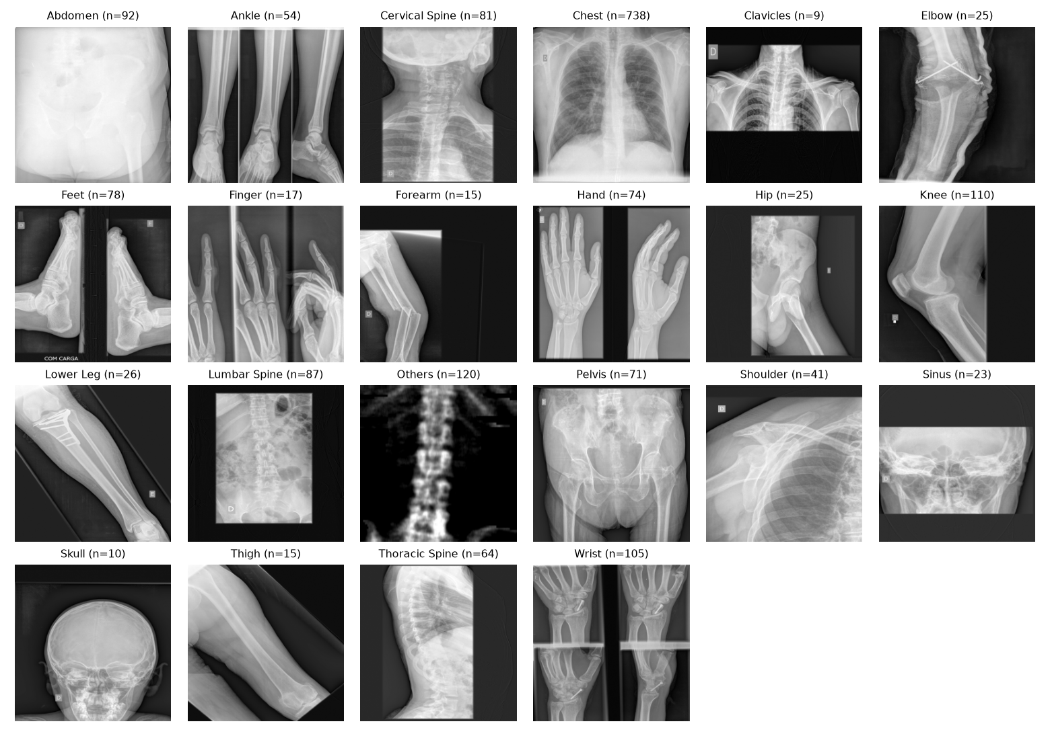
Fig. 1. One example radiograph per class from the UNIFESP dataset (CC BY-NC-SA 4.0), with the number of training images in each class. Several images show more than one view side by side.
So instead of chasing the leaderboard we asked two questions. How much of the reported performance survives a leakage-controlled protocol? And what would a clinical router need besides accuracy? The paper contributes:
- a reproducible, patient-level benchmark on public data with confidence intervals (Tables 1 and 2);
- a measurement of how much common shortcuts inflate scores (Tables 4 and 5);
- negative results: no ablation, fusion variant or ensembling step was significantly better, and a gated CNN-Transformer fusion collapsed onto one branch (Tables 4 and 6);
- results on MURA and FracAtlas, including a body-part benchmark on the official MURA split (Tables 7 to 9);
- calibration, risk-coverage and a label audit based on out-of-fold predictions, aimed at routing use (Section 5.7);
- a frozen foundation-model baseline with a label-efficiency curve (Section 5.6) and a Grad-CAM faithfulness check (Table 10).
Fig. 2 gives the whole protocol at a glance, from the patient-level split to the one-time scoring of the held-out set.
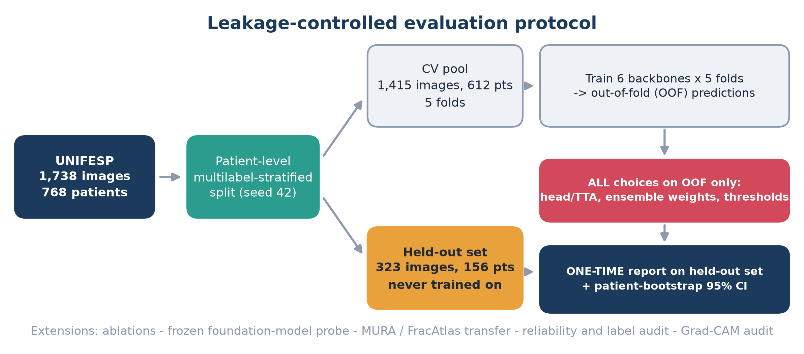
Fig. 2. Evaluation protocol. Images are split by patient into a cross-validation pool and a held-out set. Every choice is made on out-of-fold predictions, and the held-out set is scored once, with patient-bootstrap confidence intervals.

2 Related work
Body-part and anatomy classification. Deep convolutional networks were applied to anatomy-specific classification of medical images early on (Roth et al., 2015), and the task has since been studied on CT and MRI, for example by Raffy et al. (2023), who separated 17 CT and 18 MRI body regions and tested on cases from 27 institutions. For radiographs the motivation is practical. The body-part tag in the DICOM header is often wrong or missing, and recent work still tries to standardise body-part descriptions with deep learning (Cheng et al., 2025). Pham et al. (2021) sorted 16,093 images into five coarse groups for DICOM routing (recall 0.982) and pointed out that routing needs near-perfect accuracy. Langer et al. (2024, preprint) classified 14 regions on 48,434 hospital radiographs (96.6 % for a single model, 97.7 % for an ensemble). When experts reviewed the test errors, 35 % turned out to be wrong labels and 11 % were out-of-domain images, so label noise accounts for part of the remaining error.
Mitsuyama et al. (2026) trained a seven-category model (Head, Neck, Chest, Incomplete Chest, Abdomen, Pelvis, Extremities) on 429,341 radiographs from two institutions and MURA, and tested it on a second institution and on MURA. Every MURA image was labelled "Extremities", and micro-accuracy on MURA was 98.6 % (99 % CI 98.4 to 98.7 %). Radiologist review changed the DICOM-derived body-part label of 3.9 % of the radiographs from one institution and 12.8 % from the other. Their MURA figure cannot be compared with ours: theirs is a coarse seven-way task in which all MURA images share one class, whereas we separate the seven MURA study types.
On MURA, Shah et al. (2026) classified the seven upper-extremity study types with an attention-fused Xception-Swin model and reached an accuracy of 0.9643, a macro-F1 of 0.9574 and an AUC of 0.9963. They used the public validation set (3,197 images) as the test partition, a fixed seed (42), a patient-wise data organisation and image-level evaluation, and they report Wilson confidence intervals for the abnormality-detection accuracies; we did not find intervals or repeated seeds for the body-part result. Fink et al. (2024) classified projection and body side in musculoskeletal radiographs with a patient-level split. On the public UNIFESP dataset the only academic study we found is the one by Krishnan and Padmavathi (2025) described in the Introduction. All of these studies differ from ours in data, class set and metric. Table 16 puts them side by side.
Table 1. Studies of body-part or anatomy classification, and what each reports
study | images and classes | data | split unit | label review | external data | calib.
Pham et al. (2021) | 16,093 radiographs, 5 coarse groups | public | - | - | - | -
Langer et al. (2024, preprint) | 48,434 radiographs, 14 regions | hospital | - | experts reviewed test errors | - | -
Mitsuyama et al. (2026) | 429,341 radiographs, 7 categories | 2 sites | - | radiologists corrected tags | second institution, MURA | -
Krishnan and Padmavathi (2025) | UNIFESP, 22 classes, single label | public | not described | - | - | -
Shah et al. (2026) | MURA, 7 study types | public | patient-wise | - | - | -
Fink et al. (2024) | musculoskeletal radiographs, projection and side | - | patient | - | - | -
Raffy et al. (2023) | CT and MRI, 17 and 18 regions | - | - | - | 27 institutions | -
This work | UNIFESP 22 classes (multilabel), MURA 7 classes, FracAtlas, COVID-19 | public only | patient, nested | audit of 39 suspects (no clinician) | MURA, FracAtlas, UNIFESP | ECE, risk-coverage
calib. = calibration or selective prediction; 2 sites = two institutions. A dash means the item was not reported in the abstract or in the parts of the paper we read; we did not check every full text, so a dash is not proof of absence.
Fusion models and hierarchical losses. Hybrid CNN-Transformer models with gated or attention-based fusion are common. We did not find a report that inspects the learned gate, although absence from our search does not prove absence from the literature. Hierarchical losses have also been tried: Wu, Tygert and LeCun (2019) found that minimising a hierarchical loss directly is difficult, and that minimising cross-entropy often lowers it almost as well, which makes it more useful as a metric than as a training objective.
Evaluation quality and shortcuts. Leakage is widespread in machine-learning-based science (Kapoor and Narayanan, 2023) and in COVID-19 imaging (Roberts et al., 2021). In radiographs, models can pick up cues that have little to do with the target. A pneumonia model generalised unevenly across hospitals (Zech et al., 2018), and COVID-19 detectors relied on shortcuts rather than on signal (DeGrave et al., 2021). Aggregate scores can also hide failures in subgroups (Oakden-Rayner et al., 2020), which matters for us because several of our classes have only a handful of held-out images. Reporting guidance exists in the CLAIM 2024 update (Tejani et al., 2024).
Reliability and label quality. Modern networks are often over-confident, and temperature scaling is a cheap remedy (Guo et al., 2017). A model that can abstain can hand uncertain cases to a person (Geifman and El-Yaniv, 2017); Leibig et al. (2017) used uncertainty in this way for disease detection. Calibration of chest-radiograph classifiers has been benchmarked under cross-dataset shift (Shamim and Hussain, 2026, preprint), but we did not find the same for body-part classification. On label quality, Oakden-Rayner (2020) audited MURA labels and found them more accurate than those of ChestX-ray14, although the normal/abnormal labels were unreliable for cases with degenerative joint disease. Confident-learning methods find label errors from out-of-fold probabilities (Northcutt et al., 2021), which is the approach we follow for our audit.
Pretrained encoders. Self-supervised image encoders such as DINOv2 (Oquab et al., 2024) can be used frozen with a linear probe, and image-only encoders have been trained specifically for radiology (Pérez-García et al., 2025). We use a frozen DINOv2 probe as a baseline, to see how much of the fine-tuned performance such features recover.
What is still missing. Patient-level splits are used in related radiograph tasks, but we did not find a study that measures what they change for body-part classification. For the public UNIFESP dataset we found no benchmark that combines patient-level evaluation, calibration and selective prediction, a label audit and cross-dataset transfer (Table 16). Our contribution is to put these pieces together on public data and to measure how much each evaluation choice matters.

3 Data
UNIFESP (Farina, Abdala and Kitamura, 2022; Kaggle, CC BY-NC-SA 4.0) holds 2,481 DICOM radiographs. They are de-identified, come from the Universidade Federal de São Paulo under IRB approval, and the Kaggle version is reduced to 256 x 256 pixels. Radiology residents labelled them on the MD.ai platform, with 20 body regions plus "Others", in a multilabel scheme. The dataset page names four residents; it does not say how many readers saw each image, whether disagreements were adjudicated, or who the patients were.
There are 1,738 training images from 768 patients (63 % of patients have several images) and 743 test images from 330 patients whose labels are hidden. No patient appears in both sets. Ninety-five percent of the images are MONOCHROME1 (inverted). The DICOM BodyPartExamined tag is empty in all 2,481 files, so we could not measure the tag error rate on this dataset. Of the training images, 92.4 % carry one label (122 carry two, 10 carry three), and class frequency runs from 738 (Chest) down to 9 (Clavicles).
A random forest on metadata alone (photometric interpretation, bits stored, size; patient-grouped cross-validation) reached accuracy 0.486 against 0.451 for the majority class, with macro-F1 0.059, so acquisition metadata hold almost no label information. The class counts are shown in Fig. 3.
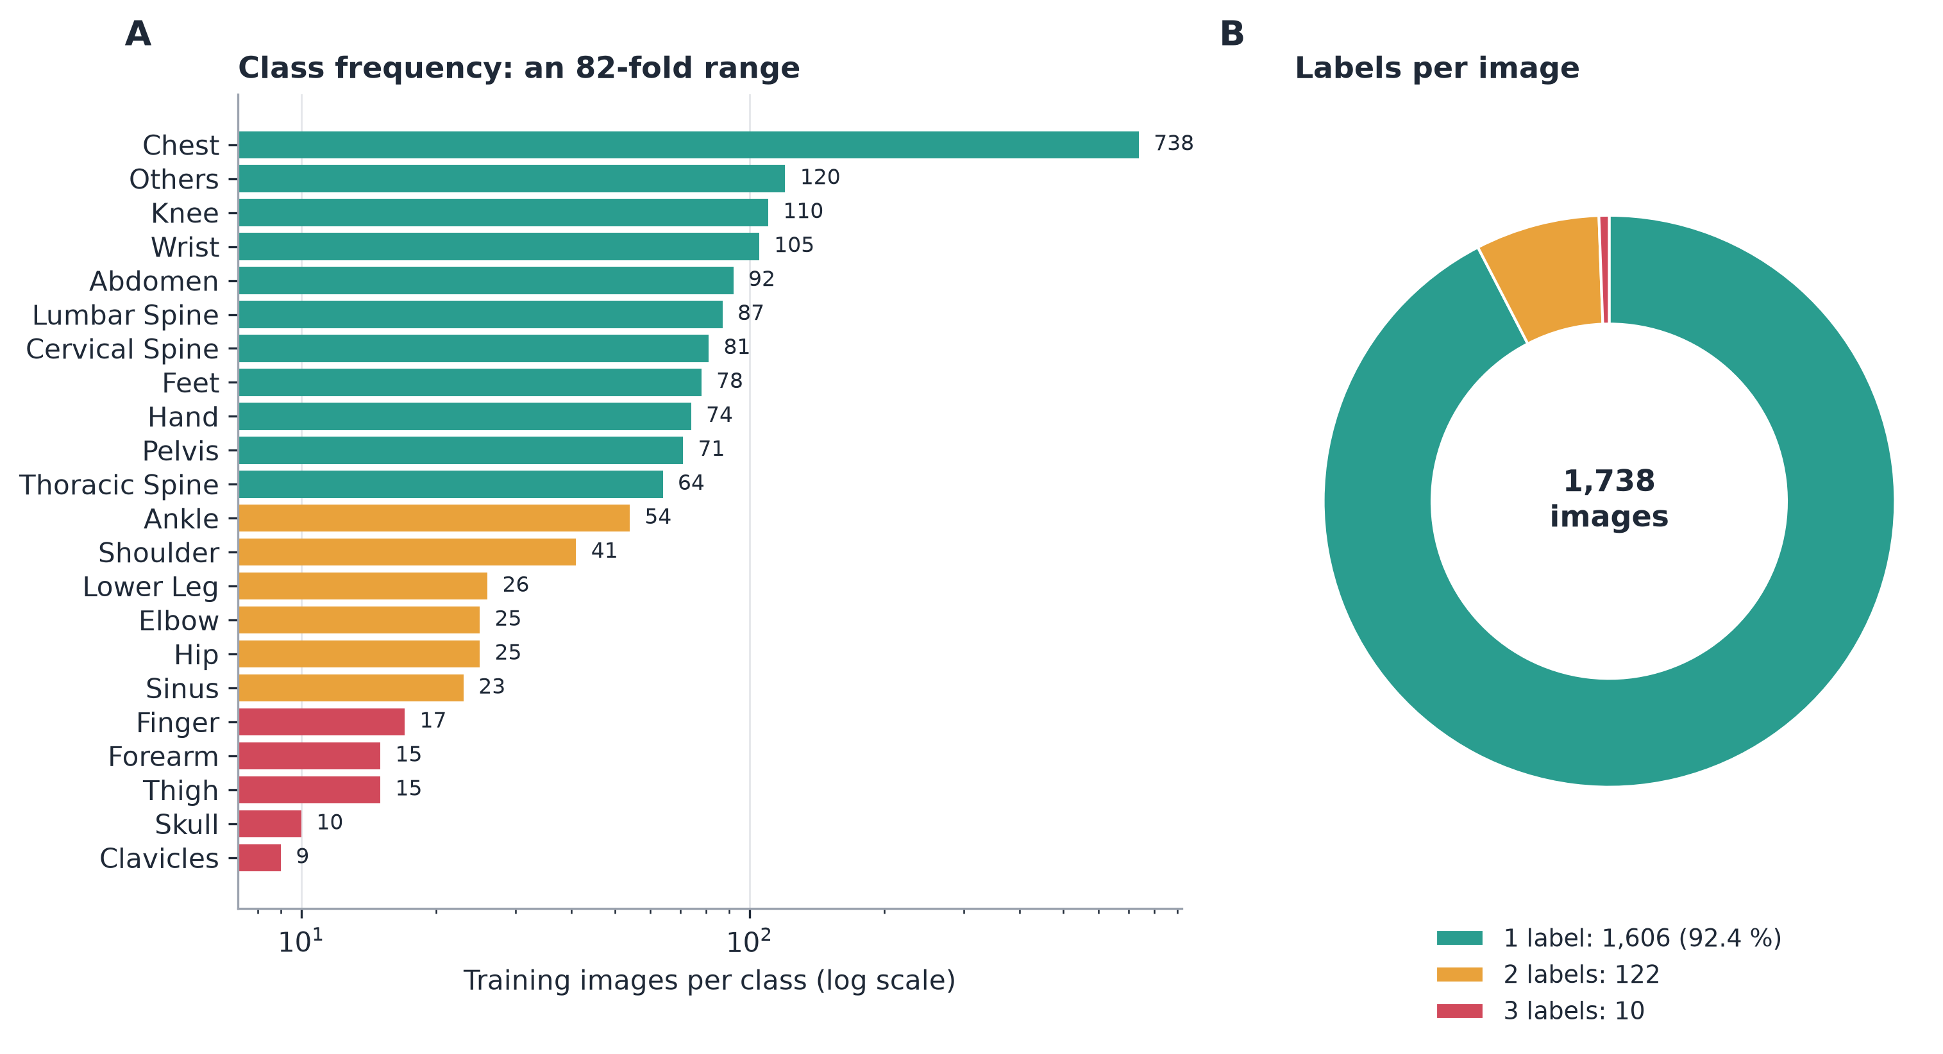
Fig. 3. (A) Training images per class, on a log scale. (B) Number of labels per image.
Splits. We split by patient with multilabel stratification (iterative stratification, Sechidis et al., 2011; seed 42). That gave a fixed held-out set of 323 images from 156 patients and a cross-validation pool of 1,415 images from 612 patients in five folds. The held-out set has only 1 to 3 positives for Clavicles (1), Skull (2), Forearm (3), Elbow (3) and Thigh (3), so per-class numbers for these classes are unstable. Fig. 4 shows the label combinations (A) and that both parts of the data cover every class.
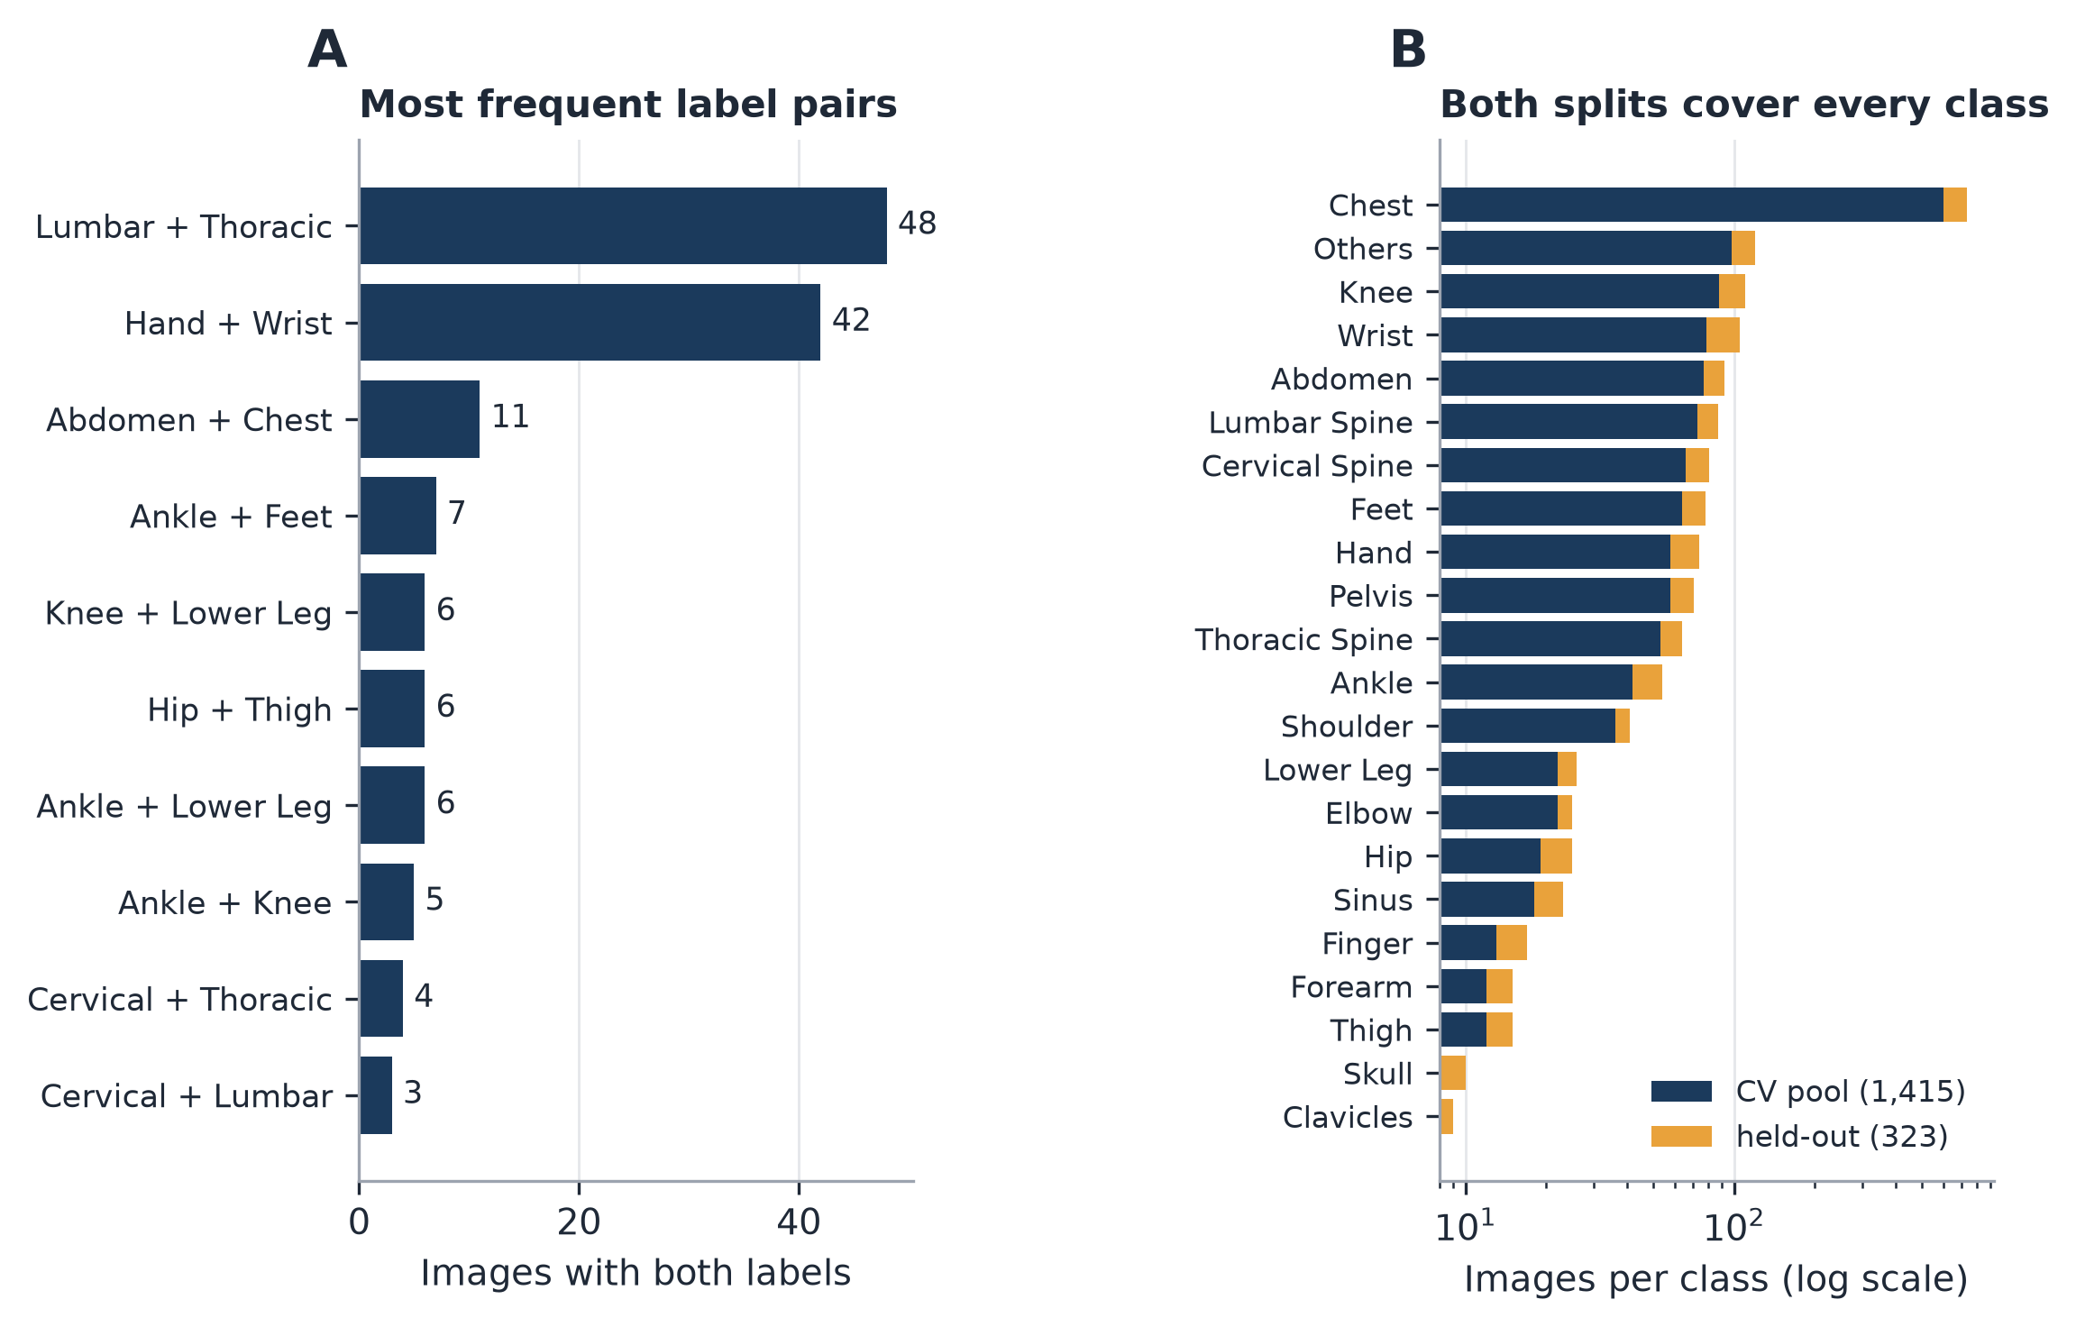
Fig. 4. (A) The ten most frequent label pairs; two pairs, Lumbar with Thoracic Spine and Hand with Wrist, account for most multilabel images. (B) Images per class in the cross-validation pool and in the held-out set, on a log scale.
Other datasets. For MURA (Rajpurkar et al., 2018) we took the body part from the XR_* folder name (7 classes) and used the official train/validation split. FracAtlas (Abedeen et al., 2023; CC BY 4.0) has 4,083 images from three hospitals in Bangladesh, annotated by two radiologists and an orthopaedist; we used the 3,685 with a single region (hand, hip, leg or shoulder) for zero-shot transfer. COVID-19 Radiography (Chowdhury et al., 2020) has 4 classes and no patient identifiers, so its split is image-level.
Dataset availability. All four datasets are public, but access conditions differ.
- UNIFESP X-Ray Body Part Classification: https://www.kaggle.com/datasets/felipekitamura/unifesp-xray-bodypart-classification (doi:10.34740/KAGGLE/DSV/3399135; CC BY-NC-SA 4.0).
- MURA (v1.0): Stanford AIMI, https://stanford.redivis.com/datasets/cv1a-apytk3j44 (project page https://stanfordmlgroup.github.io/competitions/mura/). Access requires AIMI membership and acceptance of the Stanford University School of Medicine Dataset Research Use Agreement (non-commercial, research-only use; redistribution of the data is not permitted). The first author holds approved access under this agreement (status checked on 6 November 2026). Because redistribution is prohibited we do not release MURA images or derived image files, only code, split lists and result files. The experiments reported here ran on a third-party Kaggle copy of MURA v1.1 (https://www.kaggle.com/datasets/cjinny/mura-v11, with no description and no stated licence), which we had downloaded before the official access was granted. Afterwards we compared all 40,005 image files of that copy with the official Redivis file index. File names, sizes and MD5 hashes (checked on the first 48 bits) were identical, so the copy holds the same images as the official release. The official index also lists four macOS metadata files that are not images. The official validation split served as our held-out set, because the official test set is hidden.
- COVID-19 Radiography Database: https://www.kaggle.com/datasets/tawsifurrahman/covid19-radiography-database (the images remain the property of their original authors; see Chowdhury et al., 2020 and Rahman et al., 2021).
- FracAtlas: figshare, doi:10.6084/m9.figshare.22363012 (CC BY 4.0). We used the Kaggle copy https://www.kaggle.com/datasets/orvile/fracatlas with 4,083 images as in the Scientific Data paper; the current figshare version (v7) lists 4,073 images, so the two are not identical.
No new patient data were collected. Our code, split files, seeds and result files are public at https://github.com/NoorAbdullah02/unifesp-bodypart-benchmark and archived on Zenodo (Abdullah and Hossain, 2026; doi:10.5281/zenodo.24027438).

4 Methods
Pre-processing. We applied the DICOM rescale slope and intercept, inverted MONOCHROME1 images, normalised each image to 8 bit by its own minimum and maximum, replicated it to three channels and resized it to 224 pixels (Swin-T) or 256 pixels (all others). ImageNet mean and standard deviation were used for scaling.
Models. All backbones were ImageNet-pretrained timm models (Wightman, 2019): Swin-T (Liu et al., 2021), DenseNet121 (Huang et al., 2017), EfficientNetV2-S (Tan and Le, 2021), ConvNeXt-T (Liu et al., 2022), ResNet50 (He et al., 2016) and EfficientNet-B3 (Tan and Le, 2019), each with a 22-way sigmoid head and a 22-way softmax head. For the fusion ablation we combined DenseNet121 and Swin-T in five ways: a learned gate on raw features, the same gate with LayerNorm, a fixed 0.5/0.5 average, the CNN branch alone, and the Swin branch alone. Fig. 5 shows the model and the decision pipeline.
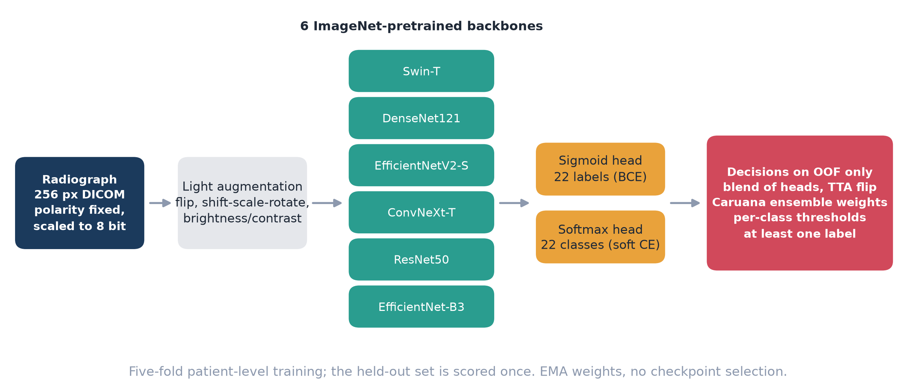
Fig. 5. The models and the decision pipeline. Six pretrained backbones, each with a sigmoid and a softmax head, are trained on five patient-level folds. Head blending, ensemble weights, thresholds and the minimum-one-label rule are all chosen on out-of-fold predictions.
Training. We used AdamW (Loshchilov and Hutter, 2019; weight decay 1e-4; learning rate 2e-4 for Swin, 3e-4 for DenseNet, ResNet and EfficientNet, 1e-4 for ConvNeXt), a cosine schedule with one warm-up epoch, 30 epochs, batch size 32, fp16, an exponential moving average of the weights (0.998) and gradient clipping at 5. The loss was binary cross-entropy with positive weights capped at 20, plus 0.5 times a soft-target cross-entropy on the softmax head. Light augmentation was flip, shift-scale-rotate and brightness/contrast; heavy augmentation added noise and blur. We did not pick checkpoints: the final averaged weights were used.
Decisions made on out-of-fold (OOF) predictions only. These were the head and test-time-augmentation variant of each run, the ensemble weights (greedy ensemble selection after Caruana et al., 2004, 40 iterations), the per-class thresholds (coordinate ascent on sample-mean F1, shrunk towards 0.5 with weight n_pos/(n_pos+20)) and the rule that every image gets at least one label. The held-out set was used once (Fig. 2).
Metrics and statistics. We report sample-mean F1 (the competition metric), macro-F1, micro-F1 and subset accuracy. Confidence intervals are 95 % patient-level bootstrap intervals (2,000 resamples, or 1,000 for the reliability analysis), and model comparisons use a paired patient bootstrap. FracAtlas and the other transfer targets have no patient identifiers, so their intervals come from an image-level bootstrap and are optimistic.
Frozen foundation-model baseline. We froze DINOv2-S and DINOv2-B (Oquab et al., 2024) and an ImageNet Swin-T at 224 pixels, standardised the features on the cross-validation pool and trained a linear probe with 22 sigmoid outputs (binary cross-entropy plus L2). Weight decay was chosen on OOF predictions, and folds and held-out set were the same as before. To get a label-efficiency curve we repeated this with 10, 25, 50 and 100 % of the training patients in each fold.
Cross-dataset transfer. We mapped the label spaces onto each other in a closed set (for example MURA hand, wrist and forearm onto the UNIFESP classes of the same name), restricted predictions to the shared groups and report accuracy and macro-F1. The map is our own assumption.
Reliability analysis. The ensemble combined five saved ablation runs (three Swin-T seeds, DenseNet121 and ConvNeXt-T) with weights fitted on OOF predictions. We measured top-1 calibration (ECE with 15 bins and temperature scaling, Guo et al., 2017; temperature fitted on OOF, applied to the held-out set), drew a risk-coverage curve in which the model abstains on low-confidence images (Geifman and El-Yaniv, 2017), and computed per-class precision, recall and F1 with patient bootstrap intervals. For the label audit, a training image counts as a suspect when the OOF ensemble gives probability 0.9 or more to a class other than its given label and a low probability to the given one (as in confident learning). Suspects are not proven errors.
Explainability. We computed Grad-CAM maps (Selvaraju et al., 2017) for three fold-0 models on the held-out set, ran a deletion test against a random map on the same grid, and ran a randomisation sanity check (Adebayo et al., 2018).
Stage 2 (competition only). To see how far more data and pseudo-labels could push the Kaggle score, we repeated the pipeline on all 1,738 training images with no held-out set, so that every image receives an out-of-fold prediction (eight models, called s2a). The s2a ensemble then labelled the 743 unlabelled test images; the 539 predictions with confidence 0.9 or higher were added to every training fold as pseudo-labels (the competition rules allow pseudo-labelling but not manual annotation of the test set), and the same eight models were retrained (s2b). The final entry, s2u, combines all 16 models with weights fitted on the out-of-fold predictions. Stage 2 therefore has no clean held-out set, and it uses test images without their labels; we report it only as a late competition score and as out-of-fold estimates (Section 5.2), not as evidence of generalisation.
Hardware and software. All runs used Kaggle notebooks on 2 x NVIDIA T4 GPUs (Stage 2 took 18,811 s) with PyTorch 2.11.0 (CUDA 13.0). The other libraries (timm, albumentations, pydicom, scikit-learn) were the versions preinstalled on the Kaggle image at the time of the runs, from October to November 2026; we did not record a full package list, which we list as a limitation.

5 Results

5.1 Main result (UNIFESP held-out set; Table 1)
The ensemble of six candidate runs (four received non-zero weight, see Table 1), with thresholds tuned on OOF predictions, reached a sample-mean F1 of 0.9189 [0.8669, 0.9602], macro-F1 0.8630 [0.6891, 0.8916], micro-F1 0.9148 and subset accuracy 0.8885. At a plain 0.5 threshold the first two values are 0.9164 and 0.8537. The best single run by OOF (ConvNeXt-T) reached 0.9123, so the ensemble gained +0.0066 [-0.0002, +0.0142] (p = 0.063). Single runs (Table 2) lie between 0.910 and 0.922 (Fig. 6).
Table 2. UNIFESP held-out performance (decisions made on out-of-fold predictions only)
decoding | sample mean F1 | macro F1 | micro F1 | subset acc
ensemble, threshold 0.5 | 0.9164 | 0.8537 | 0.9130 | 0.8885
ensemble, 0.5 + min-one | 0.9164 | 0.8537 | 0.9130 | 0.8885
ensemble, per-class thresholds tuned on OOF + min-one | 0.9189 [0.8669, 0.9602] | 0.8630 [0.6891, 0.8916] | 0.9148 | 0.8885
best single run by OOF (convnext_tiny_s256), 0.5 + min-one | 0.9123 | 0.8482 | 0.9070 | 0.8762
Held-out set: 323 images / 156 patients; 95 % CIs by patient-level bootstrap. Ensemble minus best single: +0.0066 [-0.0002, +0.0142], p = 0.063. Ensemble weights fitted on OOF predictions (Caruana selection; the other two runs, Swin-T and DenseNet121, received weight 0): EfficientNetV2-S 0.10, ConvNeXt-T 0.27, ResNet50 (heavy augmentation) 0.29, EfficientNet-B3 0.34.
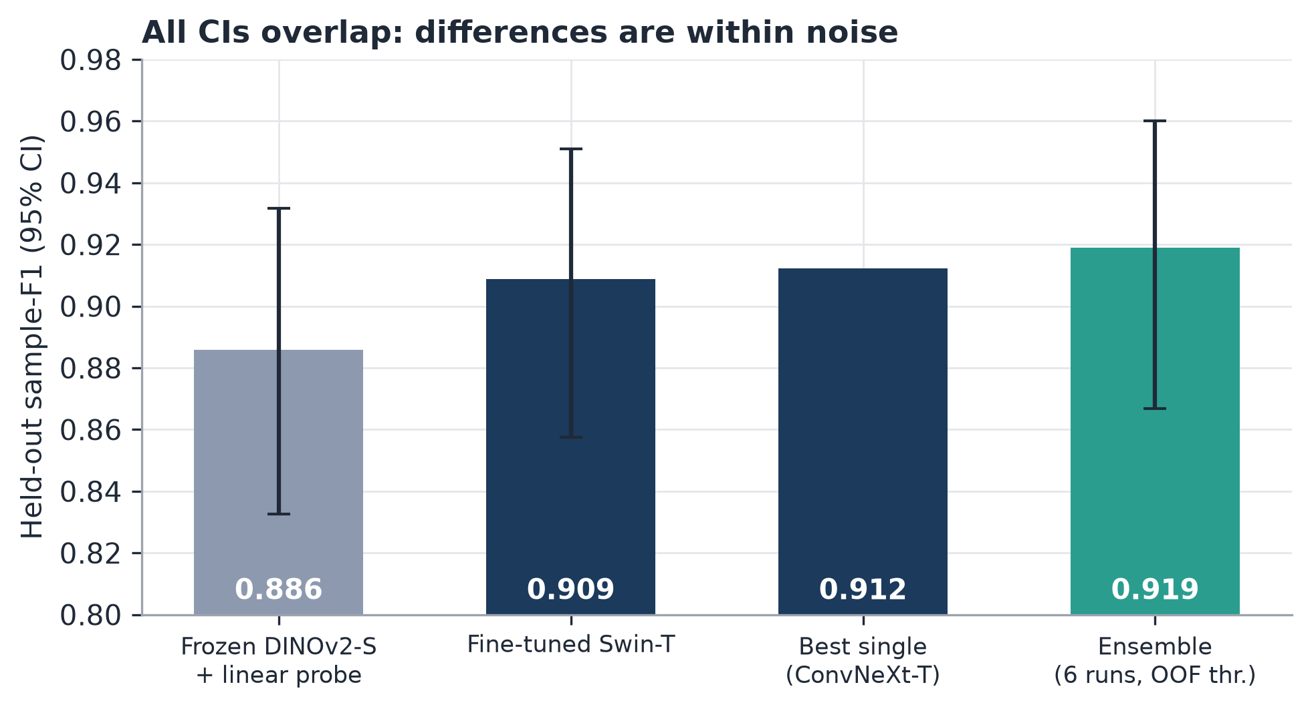
Fig. 6. Held-out sample-F1 for a frozen DINOv2-S probe, the fine-tuned Swin-T, the best single model and the ensemble. All 95 % confidence intervals overlap.

5.2 Competition score (Table 3)
Both late submissions are unranked, and we report every submission we made. The Stage 1 ensemble scored 0.92563 on the private leaderboard and 0.92704 on the public one; the Stage 2 ensemble of 16 models scored 0.92638 and 0.93378. The final private leaderboard has 0.93378 in first place, 0.92787 in second and 0.92488 in third, so both of our submissions would sit between second and third place.
Table 3. Kaggle UNIFESP private score vs. the competition leaderboard
entry | private score | public score
1st place | 0.93378 | n/a
2nd place (ResNet50/152, FastAI) | 0.92787 | n/a
ours: stage-2 union (late submission) | 0.92638 | 0.93378
ours: stage-1 ensemble (late submission) | 0.92563 | 0.92704
3rd place | 0.92488 | n/a
4th place | 0.92414 | n/a
5th place | 0.92182 | n/a
Mean F1 (sample-wise); private score uses ~60 % of the test set with the original (partly noisy) labels, so differences of ~0.003 are within noise. Late submissions are not listed on the leaderboard; we report every submission we made. Public scores of other teams are not shown (n/a).
The private score uses about 60 % of the 743 test images and their original, partly noisy labels. We estimate its standard error at about 0.012, which means the gap to first place (0.0074) cannot be resolved and the gain of Stage 2 over Stage 1 (+0.00075) is indistinguishable from noise.
Stage 2 was evaluated differently, with OOF predictions on all 1,738 training images, so its numbers are not comparable with the held-out results (Table 11). The plain ensemble of 8 models scored 0.9262 [0.9092, 0.9414]. The same models retrained with pseudo-labels from 539 of the 743 unlabelled test images (confidence 0.9 or higher) scored 0.9233 [0.9058, 0.9392], and the union of all 16 models scored 0.9279 [0.9116, 0.9428]. In paired patient-bootstrap comparisons the union beat the plain ensemble by +0.0017 [-0.0010, +0.0046] (p = 0.25), and the pseudo-labelled models fell short of it by 0.0029 [-0.0092, +0.0034] (p = 0.36). Pseudo-labelling on its own did not help. It lowered both OOF F1 and macro-F1 (the latter from 0.8749 to 0.8587). The union's small gain rests on weights fitted to the same OOF predictions, so it is optimistic. The pseudo-labelled set contains no Hand, Hip, Lumbar Spine, Thoracic Spine, Skull, Thigh, Forearm or Clavicles images and 322 Chest images, so it leans heavily towards frequent classes. Because the procedure uses test images, we do not report it as evidence of generalisation.
Table 4. Stage 2: out-of-fold results on all 1,738 training images and Kaggle late-submission scores
ensemble | OOF sample-F1 [95% CI] | macro-F1 | subset acc. | Kaggle private / public
s2a: 8 models, no pseudo-labels | 0.9262 [0.9092, 0.9414] | 0.8749 | 0.8867 | not submitted
s2b: 8 models, pseudo-labels | 0.9233 [0.9058, 0.9392] | 0.8587 | 0.8855 | not submitted
s2u: union (16 models) | 0.9279 [0.9116, 0.9428] | 0.8754 | 0.8884 | 0.92638 / 0.93378
difference s2u - s2a | +0.0017 [-0.0010, +0.0046], p = 0.25
difference s2b - s2a | -0.0029 [-0.0092, +0.0034], p = 0.36
OOF numbers are not comparable with the held-out numbers; ensemble weights are fitted on the same OOF predictions, so the union estimate is optimistic. Pseudo-labels use unlabelled test images.

5.3 Evaluation shortcuts (Tables 4 and 5)
With a random image-level split, the validation score exceeded the held-out score by 0.0144; with patient-level folds the difference was 0.0004. The held-out score of the leaky model (0.9163) is not significantly different from the reference (p = 0.141), so leakage distorted the validation estimate rather than the held-out result. Tuning per-class thresholds on the held-out set itself gave 0.9182, against 0.9099 when the thresholds were tuned on OOF predictions (+0.0083). That difference is a gain taken from the test set. Our earlier notebooks, which tuned thresholds and chose checkpoints on the scored fold, reported 0.9356 (sample-F1) and 0.909 (macro-F1). Under the nested protocol the same quantities are 0.9189 and 0.8630 (Fig. 7A).
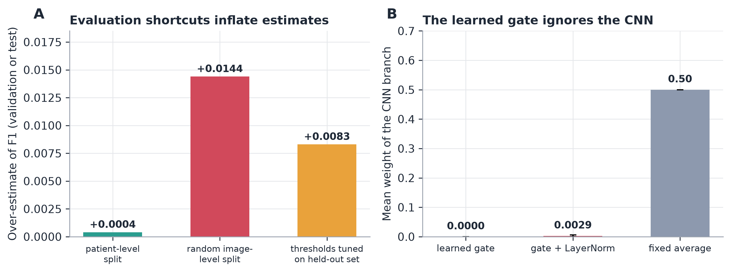
Fig. 7. (A) How much a random image-level split and tuning thresholds on the held-out set overstate the score. (B) Mean weight the learned fusion gates give the CNN branch, compared with a fixed average.

5.4 Ablations (Table 4)
Against the reference Swin-T (0.9089 [0.8576, 0.9509]) no configuration differed significantly. Heavy augmentation changed F1 by -0.0075 (p = 0.088), dropping the softmax head by -0.0051 (p = 0.152), two other seeds by +0.0055 and +0.0065 (p = 0.37 and 0.27), DenseNet121 by +0.0111 (p = 0.119), the CNN-only fusion branch by +0.0117 (p = 0.097) and the average of three seeds by +0.0049 (p = 0.38). All 95 % intervals include zero. The seed-to-seed spread (0.9089 to 0.9154) is as large as most of these effects, so a single-run difference of this size should not be called an improvement (Fig. 8).
Table 5. Ablations (5 CV folds each, same held-out set; paired patient bootstrap vs. the reference)
config | held-out sample-F1 [95% CI] | macro-F1 | OOF - held-out | diff vs reference [95% CI] | p
swin_tiny_s224 | 0.9089 [0.8576, 0.9509] | 0.837 | 0.0004
swin_tiny_s224_heavy | 0.9013 [0.8494, 0.9440] | 0.829 | 0.0074 | -0.0075 [-0.0164, 0.0009] | 0.088
swin_tiny_s224_ce0 | 0.9038 [0.8529, 0.9470] | 0.8261 | 0.0041 | -0.0051 [-0.0124, 0.0016] | 0.152
swin_tiny_s224_ce1 | 0.9132 [0.8616, 0.9568] | 0.8495 | 0.0012 | 0.0043 [-0.0063, 0.0149] | 0.447
swin_tiny_s224_leaky | 0.9163 [0.8644, 0.9587] | 0.856 | 0.0144 | 0.0074 [-0.0020, 0.0178] | 0.141
swin_tiny_s224_seed1 | 0.9143 [0.8620, 0.9576] | 0.8533 | 0.0028 | 0.0055 [-0.0060, 0.0173] | 0.366
swin_tiny_s224_seed2 | 0.9154 [0.8635, 0.9592] | 0.8585 | -0.0014 | 0.0065 [-0.0049, 0.0178] | 0.268
hybrid_gate_s224 | 0.9136 [0.8609, 0.9568] | 0.8497 | -0.0 | 0.0047 [-0.0063, 0.0161] | 0.401
hybrid_gate_ln_s224 | 0.9158 [0.8641, 0.9577] | 0.8536 | -0.0019 | 0.0069 [-0.0032, 0.0182] | 0.226
hybrid_avg_s224 | 0.9164 [0.8651, 0.9585] | 0.8537 | -0.0004 | 0.0075 [-0.0048, 0.0201] | 0.235
hybrid_cnn_s224 | 0.9205 [0.8684, 0.9613] | 0.8705 | -0.0012 | 0.0117 [-0.0016, 0.0257] | 0.097
hybrid_swin_s224 | 0.9127 [0.8611, 0.9565] | 0.8467 | 0.0013 | 0.0038 [-0.0070, 0.0145] | 0.539
densenet121_s256 | 0.9200 [0.8694, 0.9618] | 0.8542 | -0.0042 | 0.0111 [-0.0022, 0.0275] | 0.119
convnext_tiny_s256 | 0.9117 [0.8605, 0.9546] | 0.8472 | 0.0081 | 0.0028 [-0.0084, 0.0142] | 0.674
swin_3seeds_average | 0.9137 [0.8623, 0.9574] | 0.848 | 0.0012 | 0.0049 [-0.0052, 0.0148] | 0.38
`OOF - held-out` large and positive = the validation score over-estimates (compare `_leaky` with the patient-level reference for the split ablation).
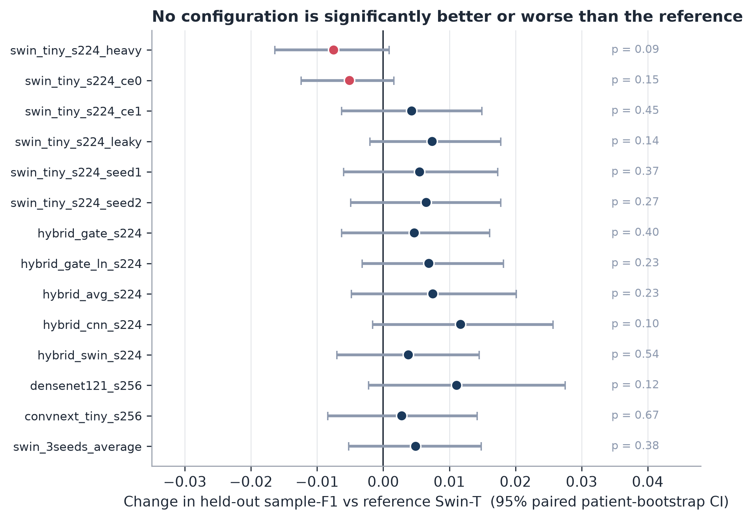
Fig. 8. Change in held-out sample-F1 against the reference Swin-T for each ablation (95 % paired patient-bootstrap interval; p-values on the right). None of the intervals excludes zero.

5.5 Fusion gate (Table 6)
Across five folds the learned gate gave the CNN branch a mean weight of 0.0000 (raw gate) and 0.0029 (LayerNorm gate). The fused model therefore behaves like the Transformer alone (Fig. 7B). Neither gate beat the fixed average (+0.0047 and +0.0069 against the reference, p = 0.40 and 0.23) or the CNN-only branch.

5.6 Frozen foundation-model baseline
A linear probe on frozen DINOv2-S reached 0.8699 OOF and 0.8859 on the held-out set [0.8327, 0.9318]. DINOv2-B reached 0.8839 [0.8300, 0.9276] and the ImageNet Swin-T 0.8762 [0.8248, 0.9204], while the fine-tuned Swin-T reference reached 0.9089. Frozen features therefore recover most of the fine-tuned performance, but not all of it. With 10 % of the training patients the DINOv2-S probe scored 0.6435 OOF, with 25 % 0.7457, with 50 % 0.8235 and with all of them 0.8699. The curve is still rising, so this task looks limited by labelled data. A random-weight ResNet18 control gave 0.563 OOF but 0.095 on the held-out set, an inconsistency we could not resolve, so we leave it out of our claims. BiomedCLIP could not be downloaded and one ConvNeXt tag was invalid; both were skipped (Fig. 9).
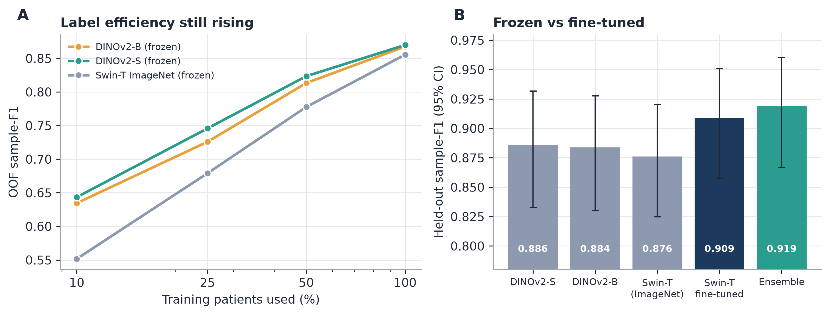
Fig. 9. (A) Label efficiency of frozen encoders. (B) Held-out F1 of the frozen probes next to the fine-tuned models.

5.7 Reliability and label audit
Calibration. Top-1 accuracy of the five-model ensemble on the held-out set was 0.9257. ECE was 0.0545, and 0.0517 after temperature scaling (T = 1.15), so the ensemble is already close to calibrated and scaling changes little.
Selective prediction. Accuracy on the images the model kept rose from 0.926 at full coverage to 0.945 [0.900, 0.985] at 90 % coverage, 0.973 at 80 % and 0.982 at 70 %. A threshold chosen on OOF predictions for 0.95 accuracy gave 0.937 accuracy at 98.5 % coverage on the held-out set, so the target was missed. A 0.98 target gave 0.983 at 74 % coverage. Operating points chosen on OOF predictions therefore do not transfer exactly (Fig. 10).
Per class (held-out). Chest reached an F1 of 0.993 (n = 138), and Cervical Spine, Feet, Hand, Sinus, Skull and Thigh reached 1.0. The weakest classes were Others (recall 0.41 [0.13, 0.91]), Forearm (0.33), Hip (0.33), Shoulder (0.60) and Ankle (0.75), all with 3 to 22 positives and wide intervals (Supplementary Table 13 and Supplementary Fig. S1).
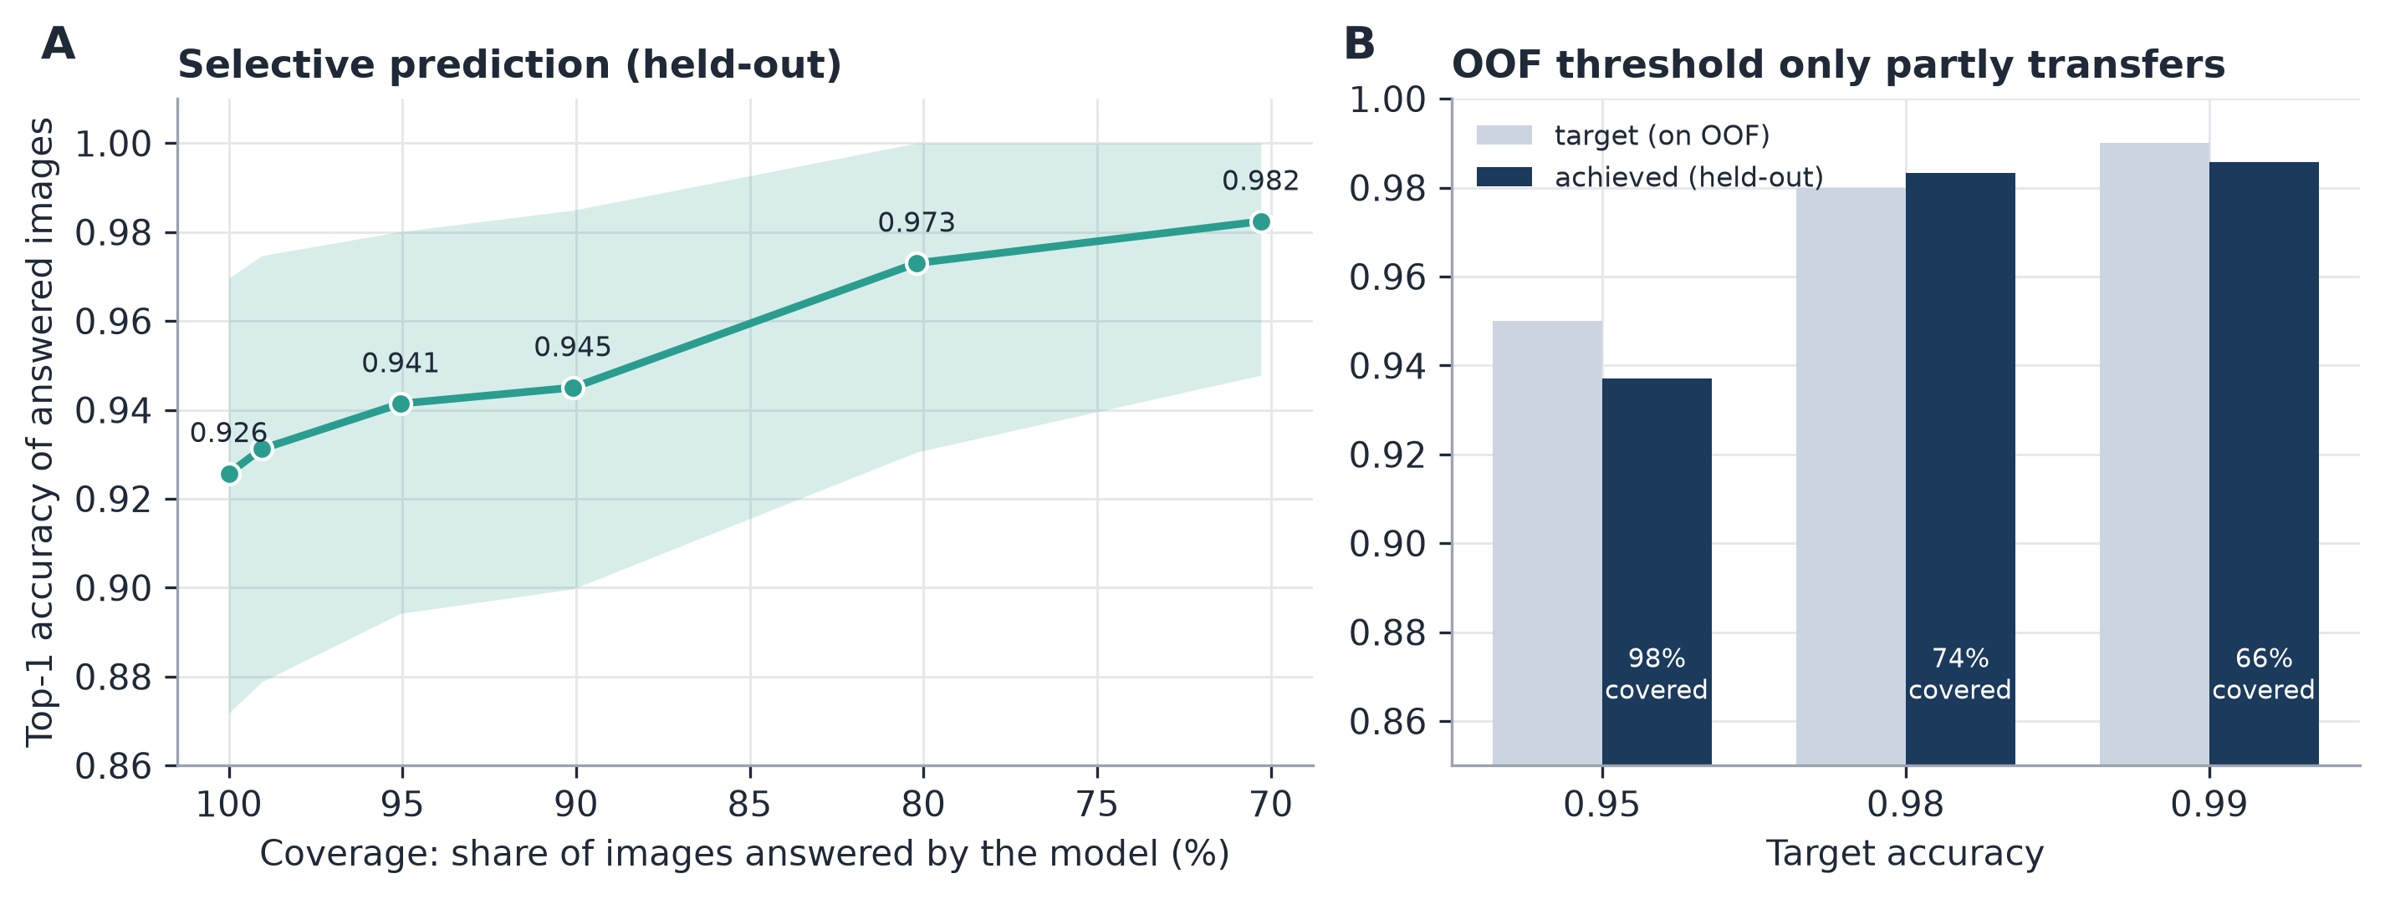
Fig. 10. (A) Accuracy on the images the model answers, as a function of coverage. (B) Accuracy targets chosen on out-of-fold predictions, and the accuracy reached on the held-out set.
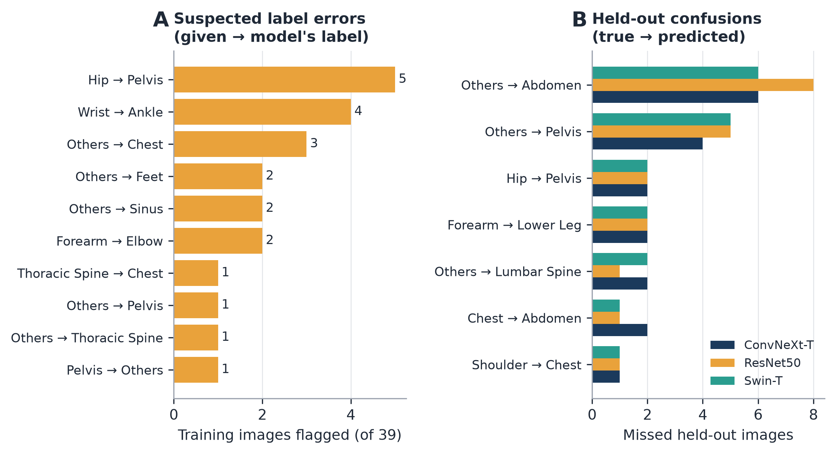
Fig. 11. (A) The pairs of given and suggested labels among the 39 suspected label errors. (B) The most frequent misclassifications of the three explained models on the held-out set.
Label audit. At p of 0.9 or more, 39 of 1,415 training images (2.8 %) were flagged. The most frequent pairs were Hip to Pelvis (5), Wrist to Ankle (4) and Others to Chest (3). The Hip-to-Pelvis pattern mirrors the low Hip recall, which fits either label noise or a real boundary problem between the two classes. No clinician has reviewed any of the 39 suspects.
Error analysis (Table 12). In the three explained fold-0 models the most frequent held-out misses were Others labelled as Abdomen (6 to 8 images per model) and Others labelled as Pelvis (4 to 5), followed by Hip as Pelvis (2 per model) and Forearm as Lower Leg (2 per model). The heterogeneous "Others" class is mostly absorbed by large body regions. Fig. 11 shows which label pairs the suspects fall into (A) and how the three explained models misclassify the held-out images (B).

5.8 Generalisation (Tables 7 and 9; Supplementary Table 8)
On the official MURA split the five-fold bagged ensemble reached an accuracy of 0.9747 [0.9663, 0.9818] and a macro-F1 of 0.9707 [0.9616, 0.9788]. Shah et al. (2026) report 0.9643 and 0.9574 on the same 3,197-image validation set, so the two results are comparable in data but not in method details.
On COVID-19 Radiography (4 classes, image-level split) sample-F1 was 0.9647 [0.9595, 0.9697] and macro-F1 0.9681, and these numbers may be optimistic.
Zero-shot transfer (Table 9) gave 0.875 to 0.880 from MURA to UNIFESP (n = 184) and 0.813 to 0.821 from UNIFESP to MURA (n = 12,000). From MURA to FracAtlas, restricted to hand and shoulder (1,281 of the 1,382 images are hand), accuracy was 0.691 with the softmax head and 0.858 with the sigmoid head. From UNIFESP to FracAtlas (hand, hip, leg, shoulder; n = 3,685) it was 0.708 and 0.698. Many FracAtlas JPEGs are truncated and were decoded only partly. Fig. 12 summarises the MURA comparison (A) and the transfer results (B).
Table 6. MURA body-part classification: held-out = MURA validation set
model | accuracy [95% CI] | macro-F1 [95% CI]
ours: 5-fold bagged ensemble (official MURA split) | 0.9747 [0.9663, 0.9818] | 0.9707 [0.9616, 0.9788]
Xception-Swin (Shah 2026) | 0.9643 (CI n/a) | 0.9574 (CI n/a)
DenseNet-201 | 0.9187 (CI n/a) | 0.9093 (CI n/a)
EfficientNet-B0 | 0.9043 (CI n/a) | 0.8952 (CI n/a)
ResNet-101 | 0.8934 (CI n/a) | 0.8831 (CI n/a)
VGG-19 | 0.8612 (CI n/a) | 0.8498 (CI n/a)
Shah et al. 2026 (Table 8; verified in the full text): same MURA validation set (3,197 images), fixed seed 42, image-level evaluation; no CI is shown for these body-part numbers.
Table 7. Zero-shot cross-dataset transfer through the class map
source | target | head | groups | n | accuracy | ci | macro f1
mura | unifesp | softmax | elbow,finger,forearm,hand,shoulder,wrist | 184 | 0.875 | [0.826, 0.924] | 0.8478
mura | unifesp | sigmoid | elbow,finger,forearm,hand,shoulder,wrist | 184 | 0.8804 | [0.837, 0.924] | 0.856
unifesp | mura | softmax | elbow,finger,forearm,hand,shoulder,wrist | 12000 | 0.8133 | [0.806, 0.820] | 0.7444
unifesp | mura | sigmoid | elbow,finger,forearm,hand,shoulder,wrist | 12000 | 0.8208 | [0.814, 0.828] | 0.7481
mura | fracatlas | softmax | hand,shoulder | 1382 | 0.691 | [0.667, 0.715] | 0.5606
mura | fracatlas | sigmoid | hand,shoulder | 1382 | 0.8575 | [0.840, 0.875] | 0.7115
unifesp | fracatlas | softmax | hand,hip,leg,shoulder | 3685 | 0.708 | [0.693, 0.722] | 0.7409
unifesp | fracatlas | sigmoid | hand,hip,leg,shoulder | 3685 | 0.6982 | [0.684, 0.713] | 0.699
Closed-set decision among the shared groups; CIs are image-level (the targets have no patient ids). The class map is an assumption to be checked by a clinician.
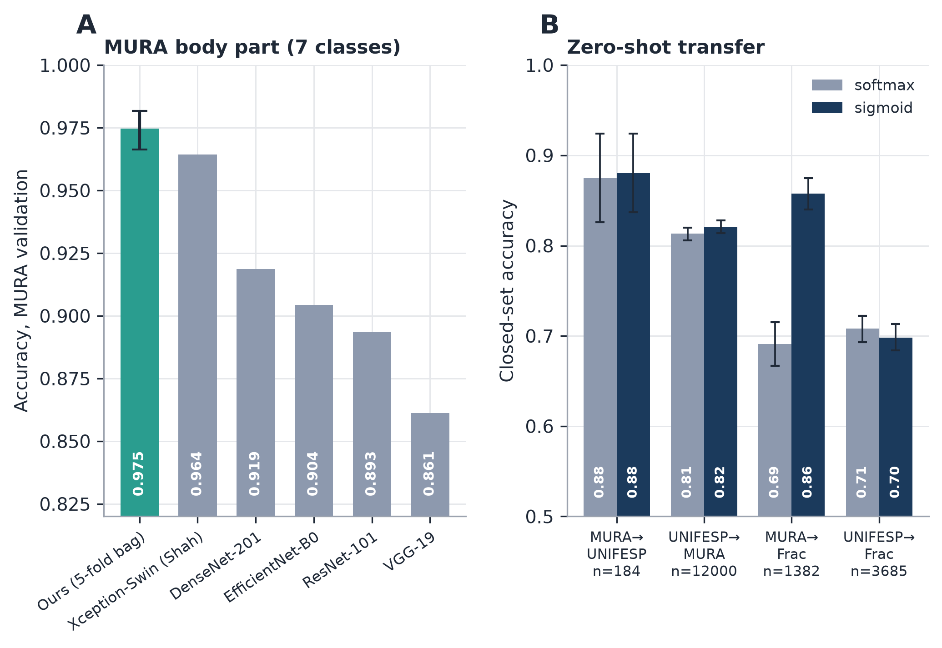
Fig. 12. (A) Body-part accuracy on MURA (seven classes), compared with the models reported by Shah et al. (2026). (B) Zero-shot accuracy through the class map, for the softmax and sigmoid heads; intervals come from an image-level bootstrap and are optimistic.
Transfer is moderate and depends on the head, and the class maps are our own assumptions.

5.9 Explainability (Table 10)
For all three models, deleting the most salient pixels first removed class evidence faster than deleting a random block of the same size (gain 0.284 [0.252, 0.316] for ConvNeXt-T, 0.204 for ResNet50, 0.164 for Swin-T). The maps were uncorrelated with those of randomly initialised networks for ConvNeXt-T and Swin-T (rho 0.11 and 0.02). ResNet50 differed too, but with a systematic negative correlation (rho -0.31). The feature grids are coarse (7 x 7 to 8 x 8), there is no localisation ground truth and no radiologist reviewed the maps. We therefore describe them as faithful to the model, not as clinically valid (Fig. 13).
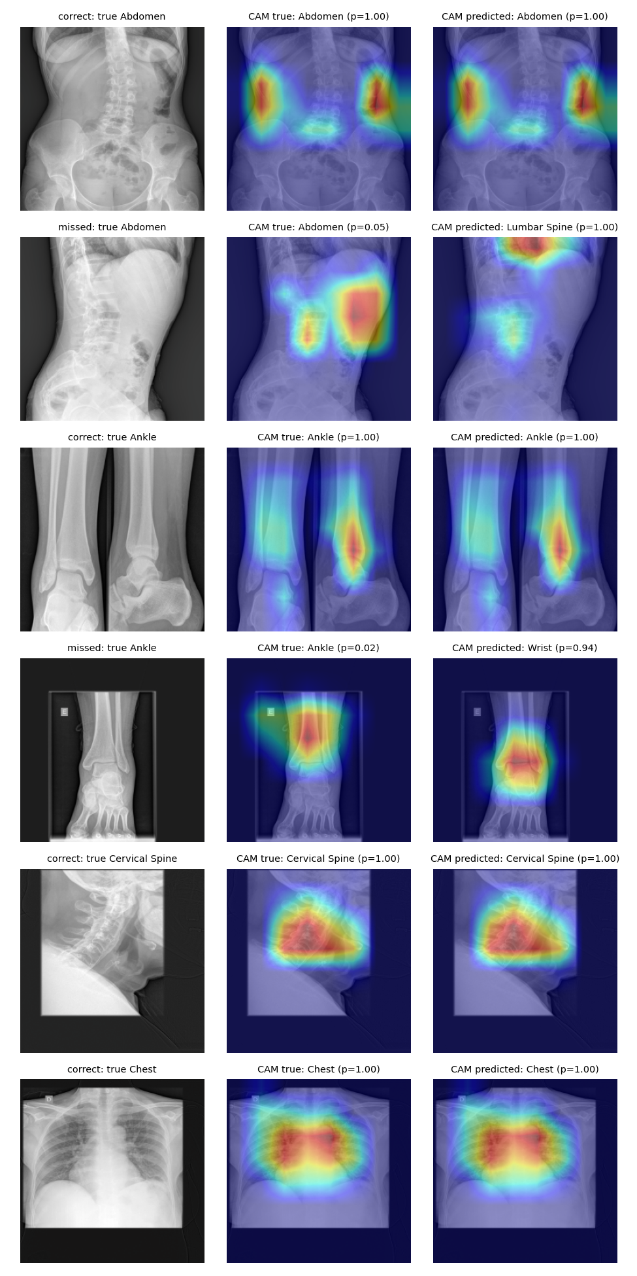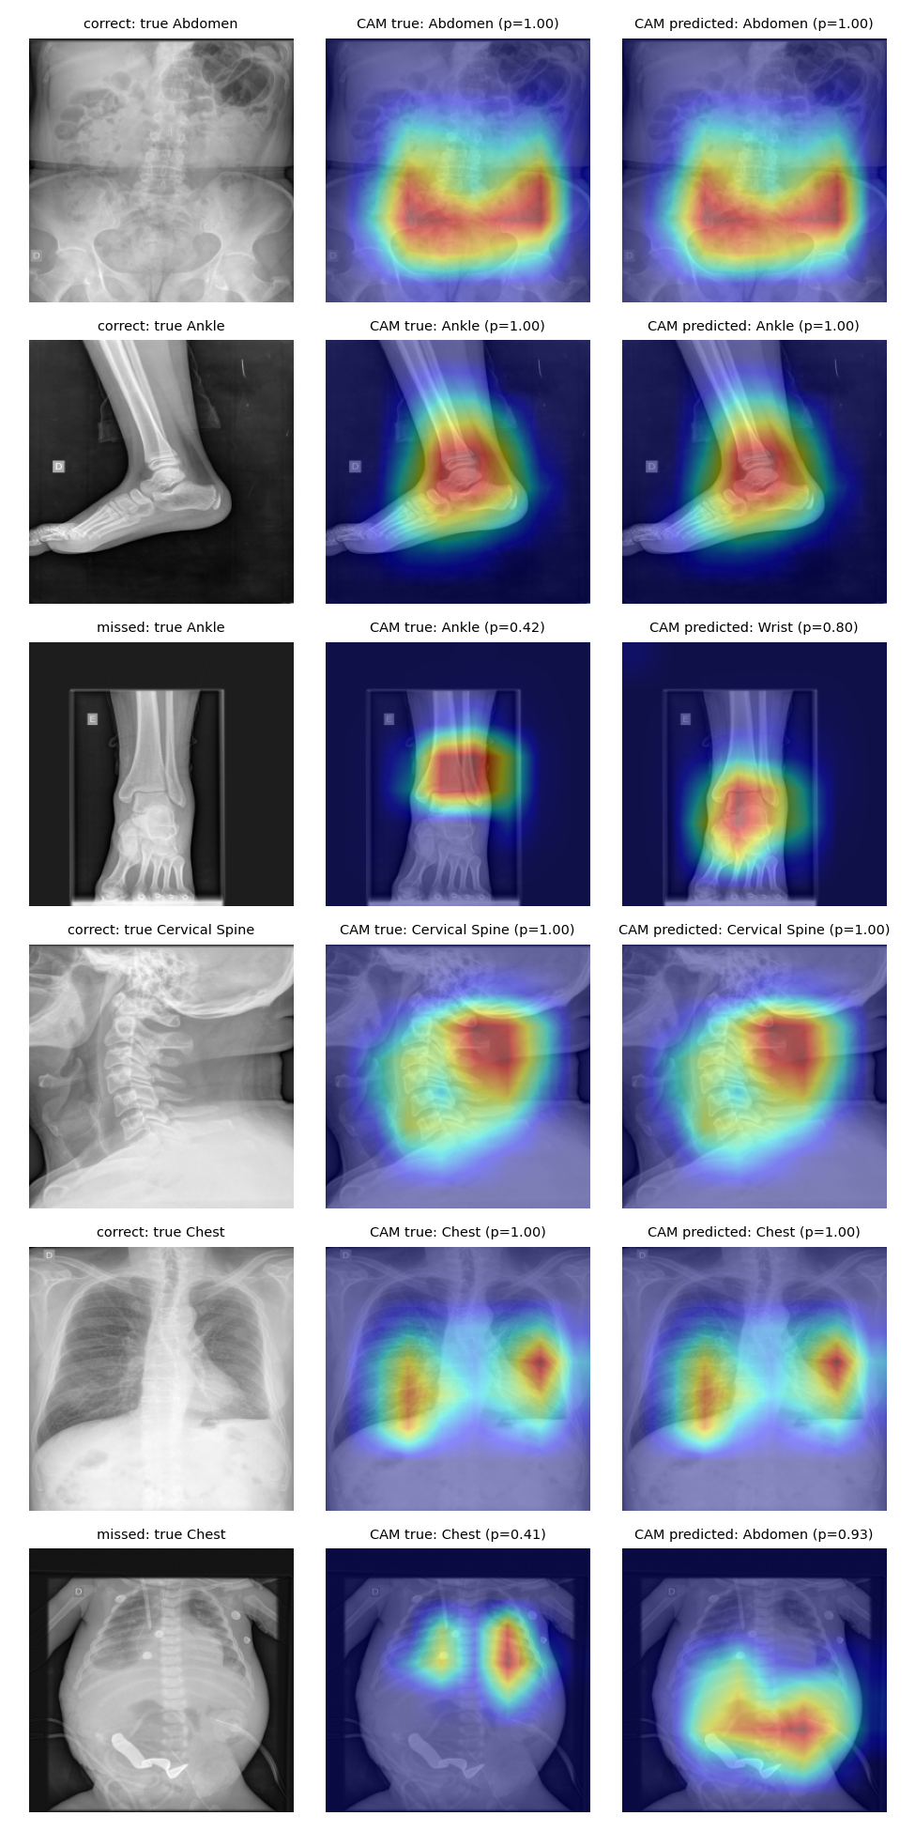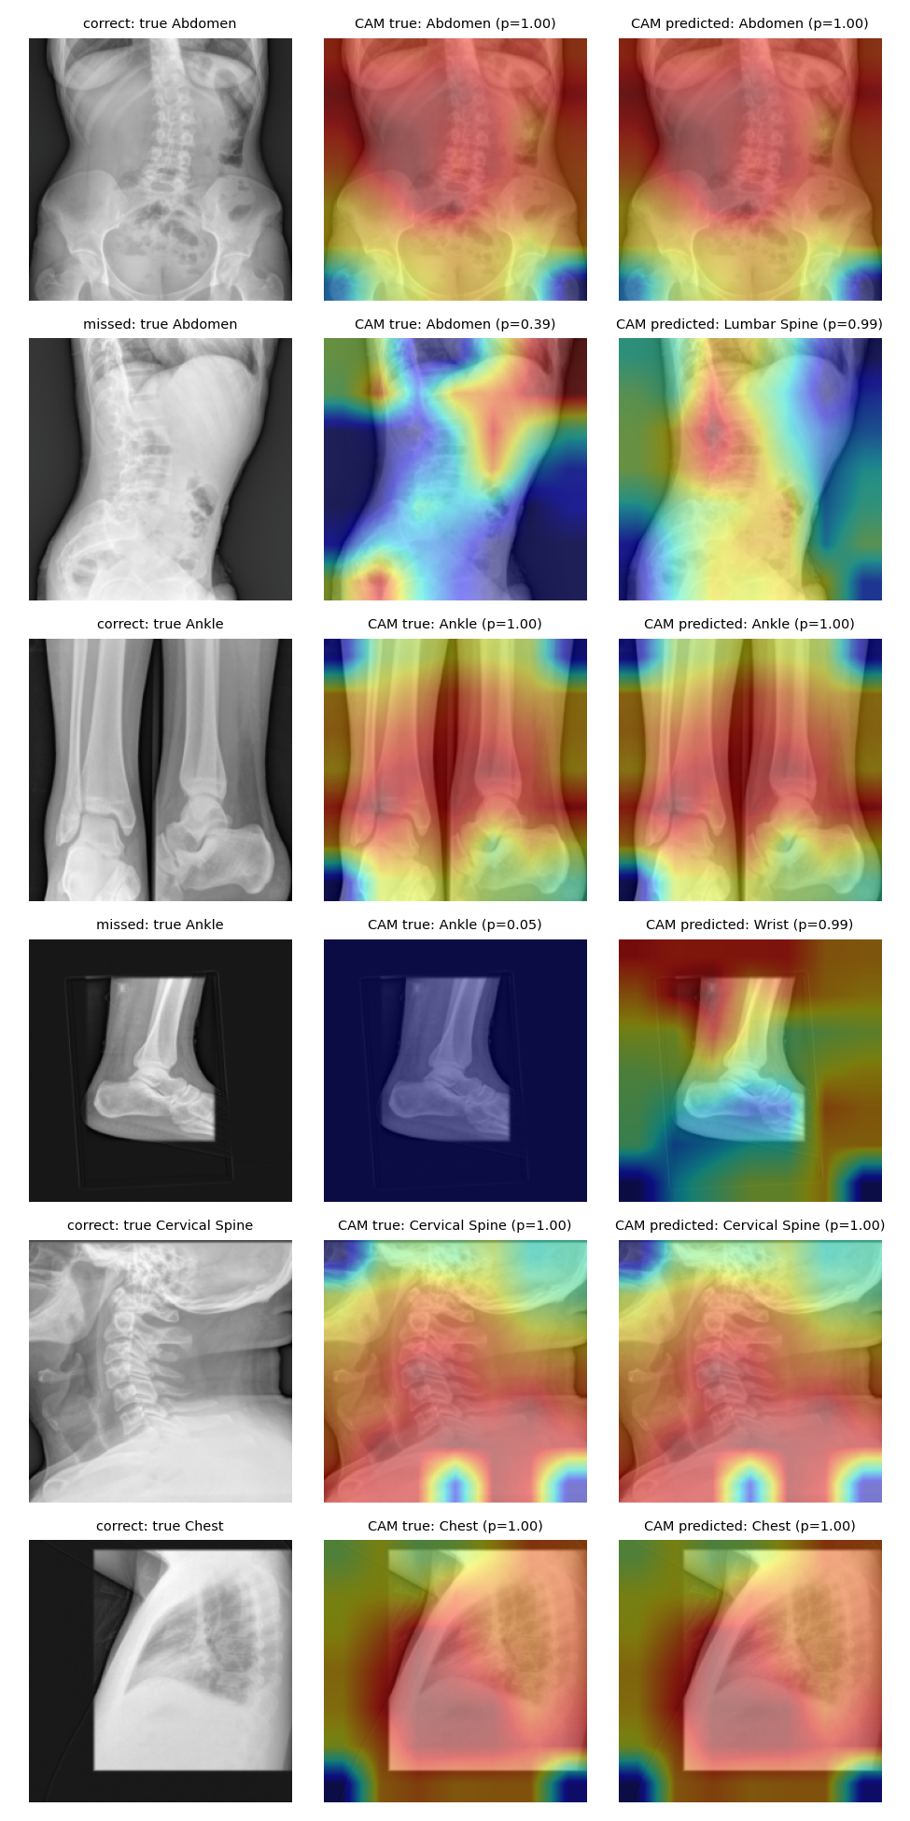
Fig. 13. Grad-CAM galleries for ConvNeXt-T (left), ResNet50 (middle) and Swin-T (right). For each class there is one correct and one missed held-out image, with the map for the true class and for the predicted class.

6 Discussion
Evaluation mattered more than architecture here. Ensembling, fusion, heavy augmentation, extra seeds and pseudo-labelling each moved the held-out score by about 0.01 at most, none of them significantly, and seed noise was about as large. Papers that report differences of this size without intervals deserve some caution. It is a less exciting finding than a new architecture, but we think it is the more useful one.
The paired intervals on the held-out set are between about ±0.007 and ±0.015 wide, so a gain of 0.03 would very likely have been detected, while gains of 0.01 or less can be neither confirmed nor ruled out with 323 images. For anyone reporting a body-part classifier, our numbers suggest a short list. Split by patient and say how. Choose every threshold, ensemble weight and checkpoint on out-of-fold predictions, and score the held-out set once. Resample patients, not images, when computing intervals, and test model differences with a paired bootstrap. The reason is visible in our own results: the leaky split moved the validation score by 0.0144, more than any architecture change we tried, and tuning thresholds on the held-out set added 0.0083, more than most of them.
Most errors sit in the rare classes (1 to 6 held-out positives) and in the heterogeneous "Others" class. The Hip-to-Pelvis cluster in the audit, and the competition hosts' offline re-annotation of the test set, suggest that label noise sets part of the ceiling, as Langer et al. (2024) found on a hospital dataset. The label-efficiency curve was still rising, so more labelled data would probably help more than a different architecture.
We did not test why the gate collapsed. One possibility is that a gate learned on the raw features of two networks with different activation scales lets one branch dominate. The learned weights point to a degenerate solution, not to complementary fusion, and fixed averaging was no worse.
For clinical use, a router that answers 90 % of the images keeps 94.5 % top-1 accuracy and sends the other 10 % to a person. The operating point chosen on OOF predictions should be re-validated on local data before anyone relies on it. We see the classifier as a way to flag suspicious metadata, not as a replacement for it.
Our MURA accuracy is higher than the one published figure we found for this task. Other studies report 97 to 99 % on other data and with much larger private training sets (Langer et al., 2024; Mitsuyama et al., 2026), and we do not claim to outperform them.

7 Limitations
The data come from a single centre and amount to only 1,738 labelled images. The 323-image held-out set has just 1 to 6 positives for several classes, so the per-class numbers are shaky. The COVID and FracAtlas results rest on image-level splits and intervals. Nobody has reviewed the class maps we used for transfer, and no clinician has checked the label audit or the Grad-CAM maps. The private test labels are noisy. Stage 2 uses unlabelled test images (a transductive step) and ensemble weights fitted on the same OOF predictions. The explainability analysis covers one fold per model. Our runs came from several Kaggle accounts, although all of them can be reproduced from the released code. One control, the random-weight probe, gave inconsistent results and is left out. Finally, we did not record a full package list for the Kaggle runs, and we had no external clinical site.

8 Conclusion
Under a leakage-controlled protocol an ensemble reaches a sample-F1 of 0.919 (0.867 to 0.960) on public UNIFESP data. Fusion, extra seeds and pseudo-labels add nothing we can tell apart from noise, while random splits and test-set thresholds inflate the estimates. On the official MURA validation set body-part accuracy is about 97 %. The ensemble is reasonably calibrated and can abstain on uncertain images, and the label audit hands experts a short list of 39 images to check.

9 Declarations
Funding: This research did not receive any specific grant from funding agencies in the public, commercial, or not-for-profit sectors.
Declaration of competing interest: none declared.
CRediT authorship contribution statement: Sheikh Noor Abdullah: Conceptualization, Methodology, Software, Formal analysis, Investigation, Data curation, Visualization, Writing - original draft. A.B.M. Kabir Hossain: Supervision, Writing - review and editing.
Ethics: only public, de-identified datasets were used; their licences and access conditions are listed in Section 3. Data availability: see Section 3 for the datasets and for the code repository; MURA images cannot be redistributed.

Declaration of generative AI and AI-assisted technologies in the manuscript preparation process
The authors used Claude (Anthropic) for code and drafting support, then reviewed and edited everything and take full responsibility for the content.

References
Abdullah, S.N. and Hossain, A.B.M.K. (2026). unifesp-bodypart-benchmark: code, split files and result files (software, version v1.0.0). Zenodo. doi:https://doi.org/10.5281/zenodo.24027438.
Abedeen, I., Rahman, M.A., Prottyasha, F.Z., Ahmed, T., Chowdhury, T.M. and Shatabda, S. (2023). FracAtlas: A Dataset for Fracture Classification, Localization and Segmentation of Musculoskeletal Radiographs. Scientific Data 10:521. doi:https://doi.org/10.1038/s41597-023-02432-4.
Adebayo, J., Gilmer, J., Muelly, M., Goodfellow, I., Hardt, M. and Kim, B. (2018). Sanity Checks for Saliency Maps. In: Advances in Neural Information Processing Systems 31 (NeurIPS), 9505–9515.
Caruana, R., Niculescu-Mizil, A., Crew, G. and Ksikes, A. (2004). Ensemble Selection from Libraries of Models. In: Proceedings of the 21st International Conference on Machine Learning, 18. doi:https://doi.org/10.1145/1015330.1015432.
Cheng, K.Y., Fabel, M., Bergh, B. and Saalfeld, S. (2025). Standardizing DICOM annotation: deep learning enhances body part description in X-ray image retrieval for clinical research. BMC Medical Imaging 26(1):39. doi:https://doi.org/10.1186/s12880-025-02099-w.
Chowdhury, M.E.H., Rahman, T., Khandakar, A., Mazhar, R., Kadir, M.A., Mahbub, Z.B., et al. (2020). Can AI Help in Screening Viral and COVID-19 Pneumonia? IEEE Access 8:132665–132676. doi:https://doi.org/10.1109/ACCESS.2020.3010287.
DeGrave, A.J., Janizek, J.D. and Lee, S.I. (2021). AI for radiographic COVID-19 detection selects shortcuts over signal. Nature Machine Intelligence 3(7):610–619. doi:https://doi.org/10.1038/s42256-021-00338-7.
Farina, E.M.J.M., Abdala, N. and Kitamura, F.C. (2022). The UNIFESP X-Ray Body Part Classification Dataset. Kaggle. doi:https://doi.org/10.34740/KAGGLE/DSV/3399135.
Fink, A., Tran, H., Reisert, M., Rau, A., Bayer, J., Kotter, E., et al. (2024). A deep learning approach for projection and body-side classification in musculoskeletal radiographs. European Radiology Experimental 8(1):23. doi:https://doi.org/10.1186/s41747-023-00417-x.
Geifman, Y. and El-Yaniv, R. (2017). Selective Classification for Deep Neural Networks. In: Advances in Neural Information Processing Systems 30 (NeurIPS), 4878–4887.
Guo, C., Pleiss, G., Sun, Y. and Weinberger, K.Q. (2017). On Calibration of Modern Neural Networks. In: Proceedings of the 34th International Conference on Machine Learning, PMLR 70, 1321–1330.
Güld, M.O., Kohnen, M., Keysers, D., Schubert, H., Wein, B.B., Bredno, J., et al. (2002). Quality of DICOM header information for image categorization. In: Proc. SPIE 4685, Medical Imaging 2002: PACS and Integrated Medical Information Systems, 280–287. doi:https://doi.org/10.1117/12.467017.
He, K., Zhang, X., Ren, S. and Sun, J. (2016). Deep Residual Learning for Image Recognition. In: Proceedings of the IEEE/CVF Conference on Computer Vision and Pattern Recognition (CVPR), 770–778. doi:https://doi.org/10.1109/CVPR.2016.90.
Huang, G., Liu, Z., van der Maaten, L. and Weinberger, K.Q. (2017). Densely Connected Convolutional Networks. In: Proceedings of the IEEE/CVF Conference on Computer Vision and Pattern Recognition (CVPR), 2261–2269. doi:https://doi.org/10.1109/CVPR.2017.243.
Kapoor, S. and Narayanan, A. (2023). Leakage and the reproducibility crisis in machine-learning-based science. Patterns 4(9):100804. doi:https://doi.org/10.1016/j.patter.2023.100804.
Krishnan K, R. and Padmavathi, S. (2025). Body Part Classification from Gabor Enhanced X-Ray Images using Deep Convolutional Models. Procedia Computer Science 260:101–109. doi:https://doi.org/10.1016/j.procs.2025.03.182.
Langer, S., Ritter, J., Braren, R., Rueckert, D. and Hager, P. (2024). Self-Supervised Radiograph Anatomical Region Classification – How Clean Is Your Real-World Data? arXiv:2412.15967.
Leibig, C., Allken, V., Ayhan, M.S., Berens, P. and Wahl, S. (2017). Leveraging uncertainty information from deep neural networks for disease detection. Scientific Reports 7(1):17816. doi:https://doi.org/10.1038/s41598-017-17876-z.
Liu, Z., Lin, Y., Cao, Y., Hu, H., Wei, Y., Zhang, Z., et al. (2021). Swin Transformer: Hierarchical Vision Transformer using Shifted Windows. In: Proceedings of the IEEE/CVF International Conference on Computer Vision (ICCV), 9992–10002. doi:https://doi.org/10.1109/ICCV48922.2021.00986.
Liu, Z., Mao, H., Wu, C.Y., Feichtenhofer, C., Darrell, T. and Xie, S. (2022). A ConvNet for the 2020s. In: Proceedings of the IEEE/CVF Conference on Computer Vision and Pattern Recognition (CVPR), 11966–11976. doi:https://doi.org/10.1109/CVPR52688.2022.01167.
Loshchilov, I. and Hutter, F. (2019). Decoupled Weight Decay Regularization. In: International Conference on Learning Representations (ICLR).
Mitsuyama, Y., Takita, H., Walston, S.L., Watanabe, K., Ishimaru, S., Miki, Y., et al. (2026). Deep learning models for radiography body-part classification and chest radiograph projection/orientation classification: a multi-institutional study. European Radiology 36(4):2576–2590. doi:https://doi.org/10.1007/s00330-025-12053-7.
Northcutt, C., Jiang, L. and Chuang, I. (2021). Confident Learning: Estimating Uncertainty in Dataset Labels. Journal of Artificial Intelligence Research 70:1373–1411.
Oakden-Rayner, L. (2020). Exploring Large-scale Public Medical Image Datasets. Academic Radiology 27(1):106–112.
Oakden-Rayner, L., Dunnmon, J., Carneiro, G. and Re, C. (2020). Hidden stratification causes clinically meaningful failures in machine learning for medical imaging. In: Proceedings of the ACM Conference on Health, Inference, and Learning, 151–159. doi:https://doi.org/10.1145/3368555.3384468.
Oquab, M., et al. (2024). DINOv2: Learning Robust Visual Features without Supervision. Transactions on Machine Learning Research.
Pham, H.H., Do, D.V. and Nguyen, H.Q. (2021). DICOM Imaging Router: An Open Deep Learning Framework for Classification of Body Parts from DICOM X-ray Scans. arXiv:2108.06490.
P\'erez-García, F., Sharma, H., Bond-Taylor, S., Bouzid, K., Salvatelli, V., Ilse, M., et al. (2025). Exploring scalable medical image encoders beyond text supervision. Nature Machine Intelligence 7(1):119–130. doi:https://doi.org/10.1038/s42256-024-00965-w.
Raffy, P., Pambrun, J.F., Kumar, A., Dubois, D., Patti, J.W., Cairns, R.A., et al. (2023). Deep Learning Body Region Classification of MRI and CT Examinations. Journal of Digital Imaging 36(4):1291–1301. doi:https://doi.org/10.1007/s10278-022-00767-9.
Rahman, T., Khandakar, A., Qiblawey, Y., Tahir, A., Kiranyaz, S., Kashem, S.B.A., et al. (2021). Exploring the effect of image enhancement techniques on COVID-19 detection using chest X-ray images. Computers in Biology and Medicine 132:104319.
Rajpurkar, P., Irvin, J., Bagul, A., Ding, D., Duan, T., Mehta, H., et al. (2018). MURA: Large Dataset for Abnormality Detection in Musculoskeletal Radiographs. arXiv:1712.06957.
Roberts, M., et al. (2021). Common pitfalls and recommendations for using machine learning to detect and prognosticate for COVID-19 using chest radiographs and CT scans. Nature Machine Intelligence 3:199–217. doi:https://doi.org/10.1038/s42256-021-00307-0.
Roth, H.R., Lee, C.T., Shin, H.C., Seff, A., Kim, L., Yao, J., et al. (2015). Anatomy-specific classification of medical images using deep convolutional nets. In: 2015 IEEE 12th International Symposium on Biomedical Imaging (ISBI), 101–104. doi:https://doi.org/10.1109/ISBI.2015.7163826.
Sechidis, K., Tsoumakas, G. and Vlahavas, I. (2011). On the Stratification of Multi-label Data. In: Machine Learning and Knowledge Discovery in Databases (ECML PKDD), LNCS 6913, 145–158. doi:https://doi.org/10.1007/978-3-642-23808-6_10.
Selvaraju, R.R., Cogswell, M., Das, A., Vedantam, R., Parikh, D. and Batra, D. (2017). Grad-CAM: Visual Explanations from Deep Networks via Gradient-based Localization. In: Proceedings of the IEEE/CVF International Conference on Computer Vision (ICCV), 618–626. doi:https://doi.org/10.1109/ICCV.2017.74.
Shah, S.B.H., Wajid, M., Shah, S.A.H., Godio, S., Kassem, K., Zaidi, G.B., et al. (2026). Explainable Two-Stage Xception-Swin Transformer Learning for Body-Part-Aware Fracture Detection in Musculoskeletal X-Rays. Journal of Imaging 12(7):298. doi:https://doi.org/10.3390/jimaging12070298.
Shamim, F. and Hussain, R.A. (2026). Calibration, Uncertainty, and Data Efficiency of Deep Learning Chest Radiograph Classifiers Under Cross-Dataset Distribution Shift: A Multi-Dataset Benchmark. medRxiv preprint. doi:https://doi.org/10.64898/2026.10.14.26365516.
Tan, M. and Le, Q.V. (2019). EfficientNet: Rethinking Model Scaling for Convolutional Neural Networks. In: Proceedings of the 36th International Conference on Machine Learning, PMLR 97, 6105–6114.
Tan, M. and Le, Q.V. (2021). EfficientNetV2: Smaller Models and Faster Training. In: Proceedings of the 38th International Conference on Machine Learning, PMLR 139, 10096–10106.
Tejani, A.S., Klontzas, M.E., Gatti, A.A., Mongan, J.T., Moy, L., Park, S.H., et al. (2024). Checklist for Artificial Intelligence in Medical Imaging (CLAIM): 2024 Update. Radiology: Artificial Intelligence 6(4):e240300.
Wightman, R. (2019). PyTorch Image Models (timm). GitHub. doi:https://doi.org/10.5281/zenodo.4414861.
Wu, C., Tygert, M. and LeCun, Y. (2019). A hierarchical loss and its problems when classifying non-hierarchically. PLOS ONE 14(12):e0226222. doi:https://doi.org/10.1371/journal.pone.0226222.
Zech, J.R., Badgeley, M.A., Liu, M., Costa, A.B., Titano, J.J. and Oermann, E.K. (2018). Variable generalization performance of a deep learning model to detect pneumonia in chest radiographs: A cross-sectional study. PLOS Medicine 15(11):e1002683. doi:https://doi.org/10.1371/journal.pmed.1002683.

