* 301466807_Ahmad_01_GET_ALL.png

* 301466807_Ahmad_02_GET_FILTER.png

* 301466807_Ahmad_03_GET_ONE.png

Game/0

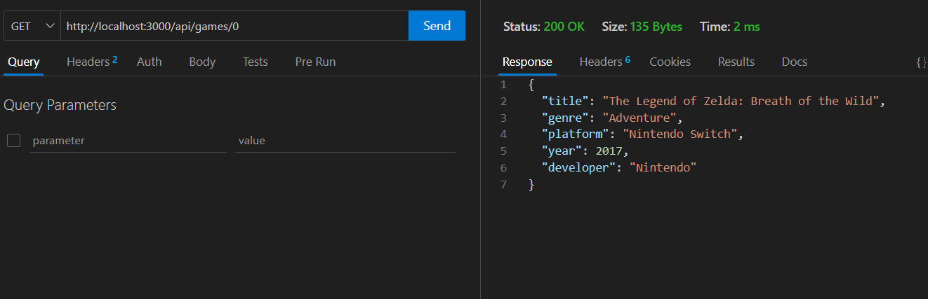

Game/6

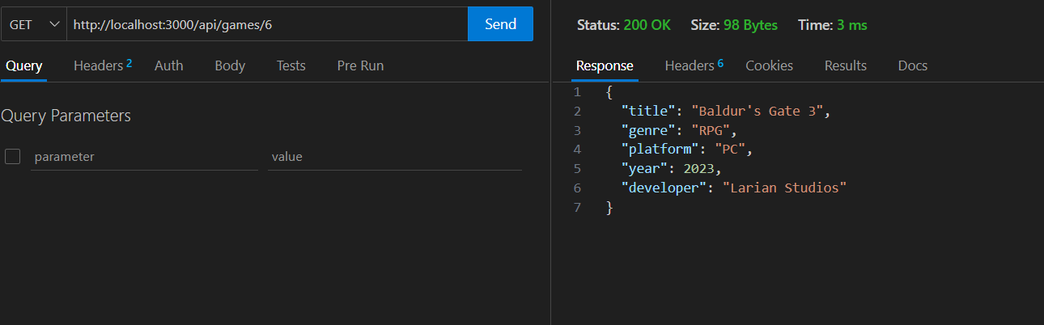

Game/5

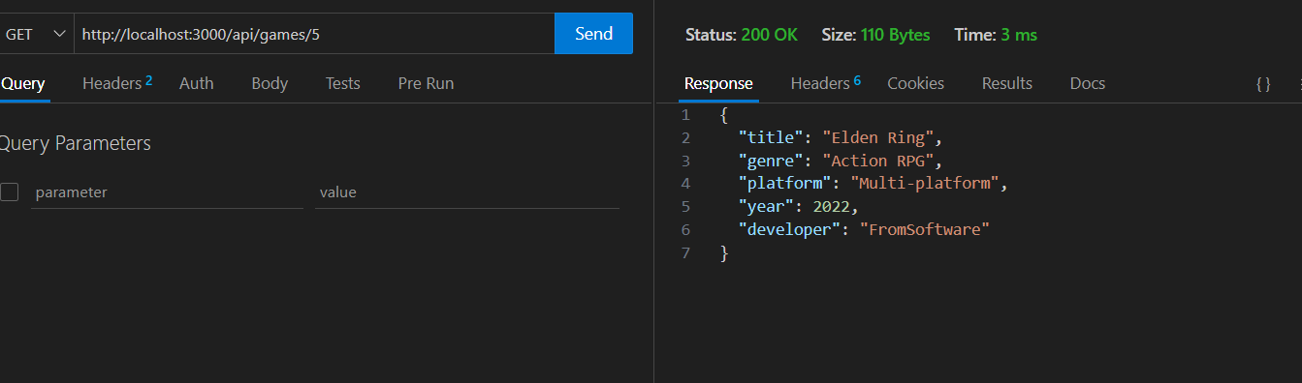

* 301466807_Ahmad_04_POST.png

* 301466807_Ahmad_05_PUT.png

* 301466807_Ahmad_06_DELETE.png

