Q1:Answer it will ignore just the third statement all other statement will executed

|  |  |  |  |
| --- | --- | --- | --- |
| A | B | C | result |
| T | T | T | Blue |
| T | T | F | yellow |
| T | F | T | Green |
| T | F | F | Red |
| F | T | T | yellow |
| F | T | F | yellow |
| F | F | T | yellow |
| F | F | F | yellow |

Q2: Answer it will execute the first statement only

|  |  |  |  |
| --- | --- | --- | --- |
| A | B | C | result |
| T | T | T | Blue |
| T | T | F | Blue |
| T | F | T | Blue |
| T | F | F | Blue |
| F | T | T | Blue |
| F | T | F | Blue |
| F | F | T | Blue |

Q3: all will execute but it will take the final statement 5.4

|  |  |  |  |
| --- | --- | --- | --- |
| A | B | C | result |
| T | T | T | White |
| T | T | F | White |
| T | F | T | White |
| T | F | F | White |
| F | T | T | White |
| F | T | F | White |
| F | F | T | White |
| F | F | F | White |

Q5-

|  |  |  |  |  |  |
| --- | --- | --- | --- | --- | --- |
| i |  | Screen | |  | |
| 0 | TRUE | 0 |  | |
| 1 | TRUE | 1 |  | |
| 2 | TRUE | 2 |  | |
| 3 | TRUE | 3 |  | |
| 4 | TRUE | 4 |  | |
| 5 | fales |  |  | |
|  |  |  |  | |

Answer: 5 loops

Final Value =4

Q6:

|  |  |  |  |  |
| --- | --- | --- | --- | --- |
| X | Y | I | holder |  |
| 0 | 10 | 0 | 0 |  |
|  |  | 1 | 0 |  |
|  |  | 2 | 2 | Holder =20 |
|  |  | 3 | 6 | I=10 |
|  |  | 4 | 12 |  |
|  |  | 5 | 20 |  |
|  |  | 6 |  |  |
|  |  | 7 |  |  |
|  |  | 8 |  |  |
|  |  | 9 |  |  |
|  |  | 10 |  |  |
|  |  |  |  |  |

Q7: The final print x=2, Y=-5 , Z=20 ,d= 5, e=25

|  |  |  |  |  |
| --- | --- | --- | --- | --- |
| X | y | z | d | E |
|  | -5 |  | 5 | 25 |
| 2 |  | 20 |  |  |
|  |  |  |  |  |
|  |  |  |  |  |

Q8 : Answer : get inside home in my linux nano . bashrc and I have added alias called time with command history time.

Alias time=”HISTTIMEFORMAT=’%d/%m/%y %T ‘”

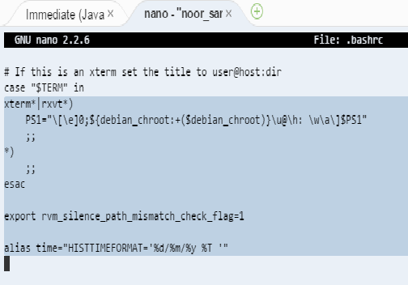

Then close bashrc

Go back to my linux

noor_samir:~/workspace $ time

noor_samir:~/workspace $ history

1 29/09/16 00:04:14 date

2 29/09/16 00:04:14 history

3 29/09/16 00:04:14 cd ..

4 29/09/16 00:04:14 nano .bashrc

5 29/09/16 00:04:14 cd workspcae

6 29/09/16 00:04:14 cd workspace

7 29/09/16 00:04:14 time

8 29/09/16 00:04:14 history

9 28/09/16 02:52:13 time

10 28/09/16 02:52:16 hisotry

11 28/09/16 02:52:19 time

12 28/09/16 02:52:46 cd ..

13 28/09/16 02:52:57 nano .bashrc

14 28/09/16 02:54:25 time

15 28/09/16 02:54:28 history

16 28/09/16 02:55:42 time

17 28/09/16 02:55:45 history

18 28/09/16 02:58:52 grep history | time

19 28/09/16 02:59:04 grep history | time | wc -1

20 28/09/16 02:59:23 grep time | history | wc -1

21 28/09/16 02:59:29 grep time | history

22 28/09/16 03:00:29 time

23 28/09/16 03:00:32 history

24 28/09/16 03:00:42 grep time | history

25 28/09/16 03:21:20 history | grep time

26 29/09/16 00:28:54 nano .bashrc

27 29/09/16 00:29:01 cd ..

28 29/09/16 00:29:24 cd workspace

29 29/09/16 00:29:27 time

30 29/09/16 00:29:31 history

31 29/09/16 00:29:37 history |wc

32 29/09/16 00:29:48 history |wc-l

33 29/09/16 00:29:51 history |wc -l

34 29/09/16 00:30:28 cd ..

35 29/09/16 00:30:34 nano .bashrc

36 29/09/16 00:34:54 cd workspace

37 29/09/16 00:34:57 time

38 29/09/16 00:35:01 history

noor_samir:~/workspace $ history | wc –l

39

Q9.