🐝
BudgetBasics
NextGen BudgetBee
Technical & Functional Documentation
A student financial-literacy web app — client-side, browser-only
Project: NEX GEN CODERS · TechWiz 72-Hour Web Development Challenge
Team: Noor Fatima (team leader) · Asfad Mubarak Ali · Shanza Zahid · Iqbal Tahir · Kashaf Zahid
Live site: https://noorfatima-ship-it.github.io/BudgetBasics-TechWiz/Website/index.html
September 2026

Table of Contents
1. Project Overview
1.1 What the site contains · 1.2 Educational framing
2. Technology Stack
3. System Architecture
3.1 Initialisation order · 3.2 Shared helpers
4. Site-Wide Features (present on every section)
4.1 Header, navigation & scroll-spy · 4.2 Dark / light theme · 4.3 Tips & Quick Facts ticker · 4.4 Ambient background & motion · 4.5 Clock, visitor counter & footer · 4.6 Back-to-top & toasts
5. Section-by-Section Reference
5.1 – 5.15 Hero through Footer, in on-page order
6. Data Persistence & Privacy
7. Accessibility Notes
8. Voice Features in Detail (Web Speech API)
9. Responsive Behaviour
10. Design Decisions & Known Issues
11. Known Limitations & Suggested Enhancements
Appendix A — Flowchart Index
Appendix B — Test Data Summary
(Headings are also tagged with Word's built-in heading styles, so a live table of contents can be inserted via References → Table of Contents if the document is edited.)

1. Project Overview
BudgetBasics (branded on-page as "NextGen BudgetBee") is a single-page, browser-only educational website that teaches students the basics of personal budgeting: income vs. expenses, needs vs. wants, the 50/30/20 guideline, savings goals, an expense-planning practice space and everyday money habits. Everything runs client-side — there is no server, database, login or account system anywhere in the project.
The site was built for the TechWiz 72-hour web development challenge ("Web Innovation Unleashed" category) by the team NEX GEN CODERS: Noor Fatima (team leader), Asfad Mubarak Ali, Shanza Zahid, Iqbal Tahir and Kashaf Zahid. The About section now shows these real names and roles.

1.1 What the site contains
The project is four source files, one data file, a small docs folder and a folder of images:
- index.html — all markup for every one of the 15 anchor sections, in a single file.
- assets/css/style.css — one style sheet covering layout, light/dark themes, responsive rules and all animation.
- assets/js/content.js — all pre-populated learning content (ticker tips, chatbot answers, navigation shortcuts, search index, needs-vs-wants practice items, category tips) as a single window.BudgetBasicsContent object, so content can be extended without touching logic.
- assets/js/Nexgen.js — one IIFE-wrapped script that powers every interactive feature.
- assets/images/ — BudgetBee logo and avatar SVGs, each in a light and a dark variant.
- data/test-data.json — test inputs and expected outputs for every module (calculator, savings, planner, chatbot, search, forms).
- docs/installation.md, docs/ai-usage.md, README.md, ReadMe.doc — setup steps, AI-usage acknowledgement and submission notes with stated assumptions.
There is no build step, no framework and no package.json — this is hand-written HTML/CSS/JS loaded directly by the browser. Both scripts are loaded with defer, content.js first so its data object exists before Nexgen.js runs.

1.2 Educational framing and disclaimers
The whole app is explicit about being a learning demo, not a real financial tool. It says so in several places:
- The calculator's result panel: "Educational estimate only. Adjust the split to suit your circumstances." — and the detail panel prints the exact formula and calendar assumptions used.
- The expense planner: "🔒 Practice data only · Entries stay in this tab, are cleared when you close it, and are never transmitted. Please do not enter real banking details."
- The chat section badge: "✦ Rule-based answers · Nothing you type is sent" and its disclaimer: "BudgetBee provides basic educational information and is not professional financial advice."
- Both the Feedback and Contact forms state that nothing is actually sent or stored — they only simulate success ("Client-side demo only").
- The footer closes with "For learning only · Not financial advice".
This is a consistent design decision worth preserving in any future change: the app never overstates what it can do.

2. Technology Stack
No frameworks, no npm dependencies, no bundle. Everything is native browser technology:
Layer | Technology used in the code | Where it shows up
Markup | HTML5, semantic <section> elements with id anchors (#home, #basics, …), <details> accordions, <table> for the sample budget | index.html
Styling | CSS3 custom properties (--violet, --cyan, --split-needs, …), Flexbox & CSS Grid, color-mix(), clamp() | style.css
Theming | Dark-first; manual toggle via body.dark class + [data-theme] attribute; inline <style> in <head> sets color-scheme: dark to avoid a flash | index.html, style.css, Nexgen.js
Scripting | Vanilla ES2020+ JavaScript, one IIFE, optional chaining, crypto.randomUUID(), no imports/exports, no transpilation | Nexgen.js
Content data | Plain JS object on window.BudgetBasicsContent; chatbot patterns are regex strings compiled at start-up | content.js
Persistence | sessionStorage (planner entries + budget) and localStorage (theme, per-day visit counter); all access wrapped in try/catch | Nexgen.js
Voice | Web Speech API — SpeechRecognition (input) and SpeechSynthesis (output) | Nexgen.js — chat widget
Animation | IntersectionObserver (scroll reveal, count-up, nav scroll-spy), requestAnimationFrame (parallax, count-up), CSS keyframes (ticker, orbs) | Nexgen.js, style.css
Formatting | Intl.DateTimeFormat (clocks, milestone months), Number.toLocaleString('en-PK') for "Rs. 25,000" | Nexgen.js
Fonts | Google Fonts CDN — DM Sans (body) and Manrope (headings), with system-font fallback | index.html <head>
Because there is no framework, every feature described in this document is implemented as plain DOM manipulation: querySelector, addEventListener, innerHTML template strings (with an escapeHtml() helper for user text) and classList toggles.

3. System Architecture
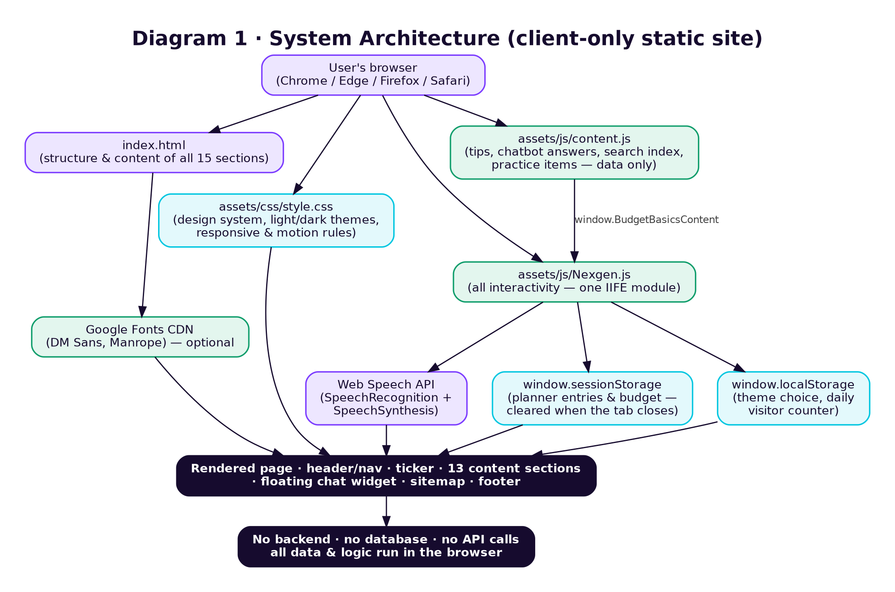
Diagram 1 — how the four source files and browser APIs fit together. There is no backend of any kind.
The single most important architectural fact about this project: nothing ever leaves the browser. Every "save", "submit" or "send" action in the UI is either (a) a write to sessionStorage/localStorage, or (b) a simulated success message. This is stated openly in the UI copy, so it is a deliberate design choice, not an oversight.

3.1 Initialisation order
Nexgen.js is one IIFE that defines helpers and modules, then calls seventeen init…() functions once, in a fixed order. Every module is independent; if an element is missing the function simply returns.
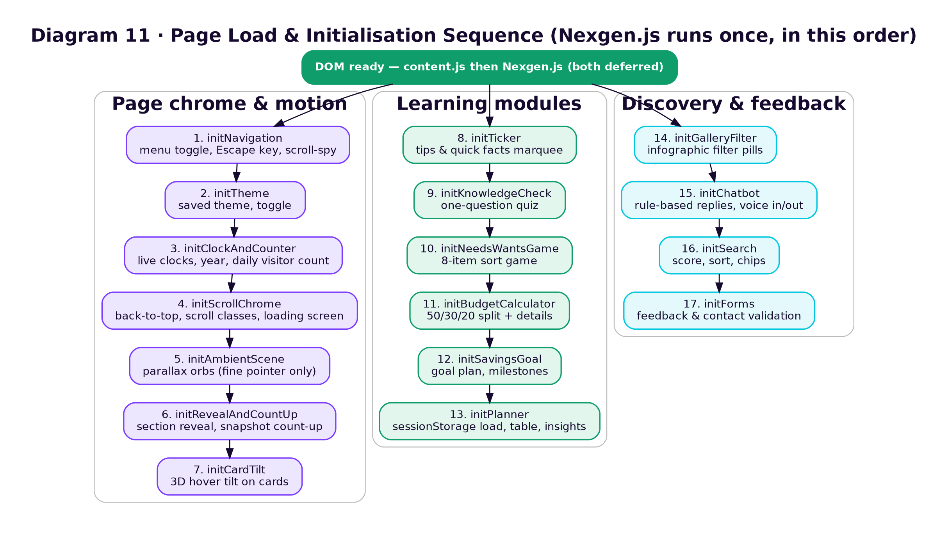
Diagram 11 — the start-up sequence at the bottom of Nexgen.js.

3.2 Shared helpers
Helper | Purpose
money(v) | Formats any number as "Rs. 1,234.5" using the en-PK locale (max 2 decimals); rounded(v) rounds first.
isNonNegativeNumber(v) | True for a non-empty string that is a finite number ≥ 0 — the single validation rule reused by every form.
perWeek(m), perDay(m) | monthly × 12 ÷ 52 and monthly × 12 ÷ 365 — the stated calendar assumptions.
monthYear(), monthsFromNow(), shortDuration() | Milestone month labels ("Nov 2027") and durations ("1y 1m").
escapeHtml(v) | Escapes & < > " ' before user text is placed inside an HTML template string.
statTile(), barRow() | Reusable HTML fragments for the calculator and planner stat panels.
toast(msg) | Slides up the dark toast bar for 2.6 s.
storage.get/set/remove(area, key) | try/catch wrapper around window.localStorage / window.sessionStorage.
reduceMotion, finePointer | matchMedia flags that switch off parallax, tilt and count-up when appropriate.

4. Site-Wide Features (present on every section)

4.1 Header, navigation and scroll-spy
- The sticky top bar holds the brand mark, a 12-link menu (Home, Basics, Needs vs Wants, 50/30/20, Savings, Planner, Mistakes, Infographics, About, Feedback, Contact, AI Chatbot), the theme toggle and a "Start planning ↗" call-to-action.
- Responsive menu: at widths ≤ 1520 px the links collapse behind a ☰ button that opens a 4-column dropdown (grid); at ≤ 760 px it becomes a single stacked list. Clicking any link, or pressing Escape, closes it and the button label/icon switch between "Open navigation ☰" and "Close navigation ×" with aria-expanded kept in sync.
- Scroll-spy: an IntersectionObserver with a −45 % / −50 % root margin watches every section that has a menu link and adds .active + aria-current="true" to the link of the section currently in the middle of the viewport.
- The "AI Chatbot" menu link does not scroll; it opens the floating chat panel instead.

4.2 Dark / light theme
A toggle button (◐ / ☼) in the header switches the whole site between light and dark. Dark is the default; the choice is remembered.
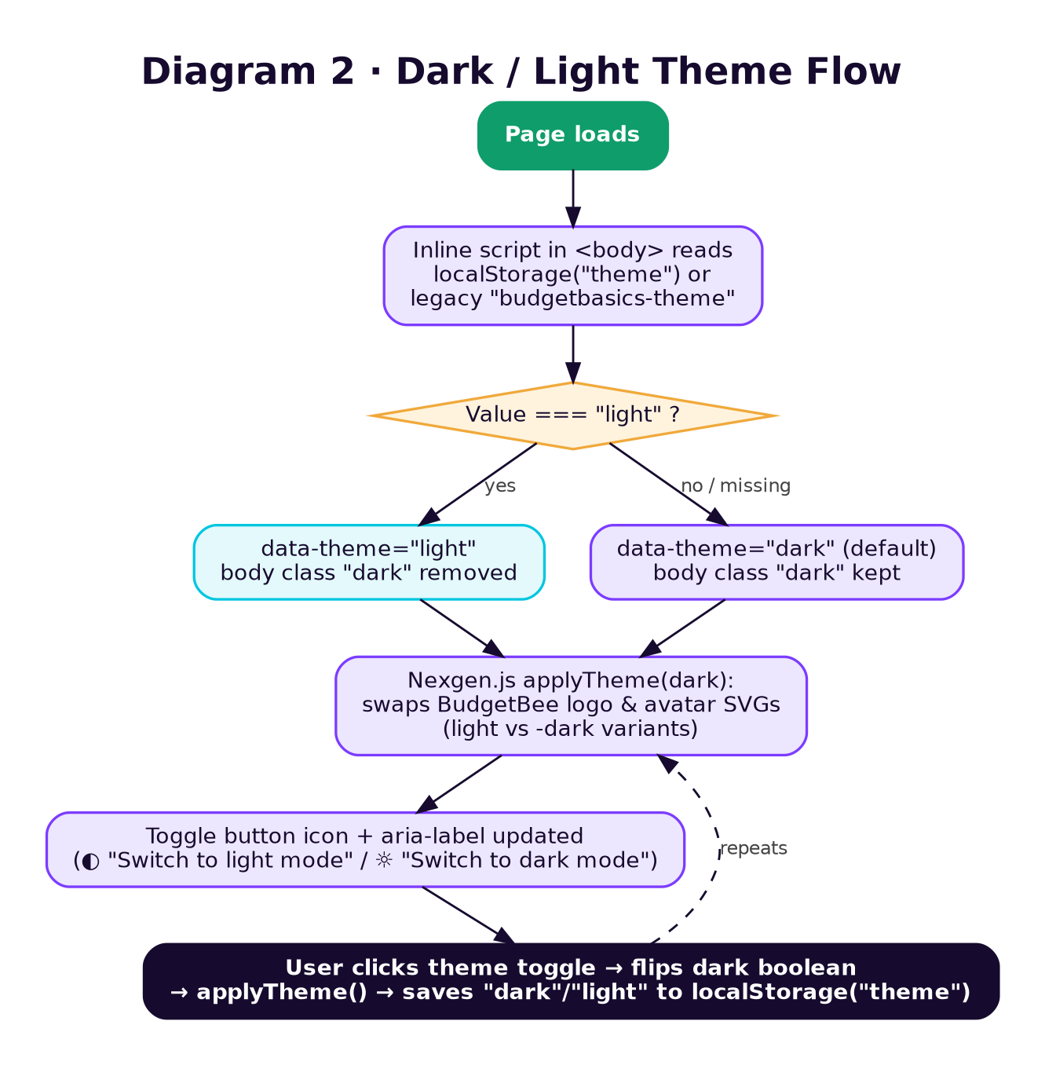
Diagram 2 — theme detection on load, and what happens when the toggle is clicked.
- An inline script at the top of <body> reads the saved theme before the main script runs, and an inline <style> in <head> paints the background #0D0518 immediately, so there is no visible "flash" of the wrong theme.
- Two localStorage keys are checked for backward compatibility: theme (current) and budgetbasics-theme (legacy).
- Switching themes also swaps every [data-bee-logo] / [data-bee-avatar] image between budgetbee-logo.svg and budgetbee-logo-dark.svg (and the avatar equivalents), including chat-message avatars.

4.3 Tips & Quick Facts ticker (new)
- Directly under the hero strip, a marquee labelled "💡 TIPS & QUICK FACTS" scrolls eight items from content.tickerItems, each tagged Tip, Fact or Quote (e.g. "Saving Rs. 5,000 a month builds Rs. 60,000 in one year.").
- The list is rendered twice so the CSS animation loops seamlessly; the duplicate is aria-hidden.
- A ❚❚ / ▶ button pauses and resumes the scroll (aria-pressed, label "Pause tips ticker" / "Play tips ticker"). Under the OS "reduce motion" setting the ticker starts paused.

4.4 Ambient background & motion
- A parallax layer of soft orbs, spheres, rings, a grid and ten particles drifts in response to pointer movement and scroll position. Pointer tracking runs only on devices with a fine pointer (hover: hover and pointer: fine); on touch devices only scroll parallax runs, at 42 % strength. Nothing runs under prefers-reduced-motion.
- Movement is eased each frame (requestAnimationFrame, factor 0.085) and written to CSS custom properties --parallax-x/-y and --tilt-x/-y per shape, scaled by each shape's data-depth.
- The page body receives .scrolled, .in-middle and .in-bottom classes as the visitor moves through 24 % and 82 % of the page, so the background shifts from violet (top) to cyan (middle) to neutral (bottom).
- A loading screen with the BudgetBee logo covers the page for 950 ms on first load, then fades out.
- Sections fade/slide into view the first time they scroll into the viewport (.reveal-ready via IntersectionObserver, threshold 8 %).
- The four numbers in the "Snapshot" section animate upward from zero over 900 ms with an ease-out curve the first time that section is 60 % visible.
- On devices with a mouse, concept, calculator, gallery, contact, snapshot, goal and item cards tilt up to ±4° toward the cursor (.tilt-card).

4.5 Clock, visitor counter and footer
- A live clock in the hero strip ("LOCAL TIME") and another in the footer ("YOUR LOCAL TIME") update every second, formatted with Intl.DateTimeFormat for the visitor's own locale and timezone (weekday, month, day, hh:mm:ss).
- A "Simulated visitors today" counter in the footer starts from a seed of 1,283, increments by one on every page load and is stored under a date-stamped localStorage key (budgetbasics-visits-YYYY-MM-DD), so it resets automatically the next calendar day; capped at 999,999.
- The footer copyright year is set from the visitor's system clock, so it never needs manual updating.

4.6 Back-to-top and toast notifications
- A round ↑ button appears once the visitor has scrolled past 500 px and smooth-scrolls back to the top on click (instant scroll under reduced motion).
- A small dark "toast" bar slides up from the bottom for brief confirmations — "Sample expense updated.", "Sample expense removed.", "All practice expenses cleared.", "Planner budget updated." — and auto-hides after 2.6 seconds.

5. Section-by-Section Reference
The sections below follow the exact top-to-bottom order they appear in index.html, and match each section's id attribute so they can be located instantly in the source.
# | Section | id | Type
5.1 | Hero / Home | #home | Presentational + ticker
5.2 | Snapshot | #snapshot | Animated sample figures
5.3 | Budgeting Basics | #basics | Cards, sample budget table, quiz
5.4 | Needs vs Wants | #needs | Interactive sort game
5.5 | 50/30/20 Rule & Calculator | #rule | Interactive calculator
5.6 | Savings Goals | #savings | Interactive planner
5.7 | Expense Planner | #planner | Interactive tracker (session)
5.8 | Money Mistakes | #mistakes | Accordions
5.9 | Infographics Gallery | #gallery | CSS art + filter
5.10 | BudgetBee Chatbot | #chatbot | Rule-based chat + voice
5.11 | Site Search | #search | Search, sort, filter
5.12 | About | #about | Team
5.13 | Feedback & Contact | #feedback, #contact | Validated demo forms
5.14 | Sitemap | #sitemap | Jump links
5.15 | Footer | — | Links, counter, clock

5.1 Hero / Home — #home
The landing view. A two-column hero: eyebrow "NEXTGEN BUDGETBEE", headline "Your money. Your plan. Your future.", call-to-action buttons ("Start learning →", "Try budget calculator") and the note "Made for students, by students" on the left; on the right an illustrated BudgetBee mascot inside a glowing sphere with four floating stat cards ("Monthly income Rs. 50,000", "Your framework 50 / 30 / 20", "This month's plan — Looking good! ✓", "Savings goal Rs. 8,500 / Rs. 15k").
- A four-column strip beneath the hero repeats the site's core promises ("50/30/20 — A simple place to start", "Small steps — Build lasting habits", "100% student-first — Learn at your own pace") alongside the live clock.
- Below the strip sits the Tips & Quick Facts ticker (Section 4.3).
- Purely presentational — no forms or calculations happen in this section.

5.2 Snapshot — #snapshot
"A sample month, in balance." — four cards showing a fictional student's Income (Rs. 50,000), Expenses (Rs. 30,000), Savings (Rs. 10,000) and Balance (Rs. 10,000), each with a small decorative glyph. The rupee figures count upward from 0 the first time the section scrolls into view (see 4.4).
- These numbers are hard-coded sample data. They are now explicitly cross-referenced by the sample budget table in Basics ("It matches the sample month above"), but they are not connected to the live calculator or planner — a product decision(see Section 10).

5.3 Budgeting Basics / Learn — #basics
Six concept cards (Income, Fixed expenses, Variable expenses, Needs, Wants, Savings), each with a one-line definition and an "Example ·" line, followed by a worked sample student budget table and a one-question "quick knowledge check" quiz.
Category | Type | Amount | Share of income
Education | Need | Rs. 7,000 | 14 %
Transport | Need | Rs. 5,000 | 10 %
Food | Need | Rs. 8,000 | 16 %
Personal & fun | Want | Rs. 10,000 | 20 %
Savings | Saving | Rs. 10,000 | 20 %
Flexible balance | Unplanned | Rs. 10,000 | 20 %
Total |  | Rs. 50,000 | 100 %
- The table is a real semantic <table> (with a caption) rather than CSS bars, and the copy links it to the Snapshot figures. A "Build your own plan →" link jumps to the calculator.
- The quiz ("Which one is usually a need?") is a single multiple-choice question with three buttons (gaming subscription / textbook for class / concert tickets); clicking any option immediately shows green or orange feedback explaining the answer. No score is kept — see Diagram 10.

5.4 Needs vs. Wants — #needs
An interactive "Quick Sort" game: BudgetBee shows one item at a time from content.needsWantsItems (8 items — Textbooks, Gaming subscription, Groceries, New headphones, Bus fare to class, Movie ticket, Rent, Designer shoes, each with an emoji) and the visitor taps "It's a need" or "It's a want". A running score (correct / attempted) is shown, and each answer is followed by a short explanation, since several items are deliberately ambiguous (e.g. headphones: "A replacement may be a need if your old pair is essential for study; an upgrade is often a want.").
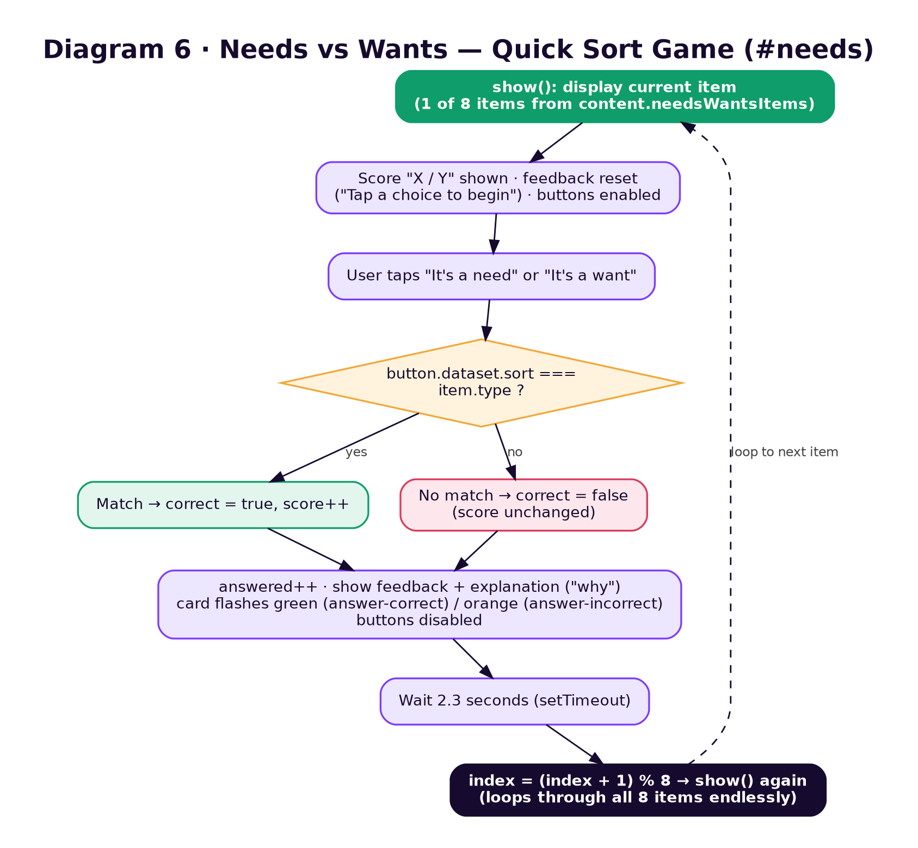
Diagram 6 — the Needs vs. Wants sorting game loop, including the deliberate ambiguity built into some items.
- A four-step "decision guide" strip below the game ("01 Do I need it? / 02 Can I afford it? / 03 Can it wait? / 04 Does it help my goals?") is static reference text, not interactive.

5.5 The 50/30/20 Rule & Calculator — #rule
Explains the 50/30/20 guideline (50 % needs, 30 % wants, 20 % savings) with a colour-coded legend, then an interactive calculator: enter a monthly income and instantly see the three-way split — now with a full detail panel.
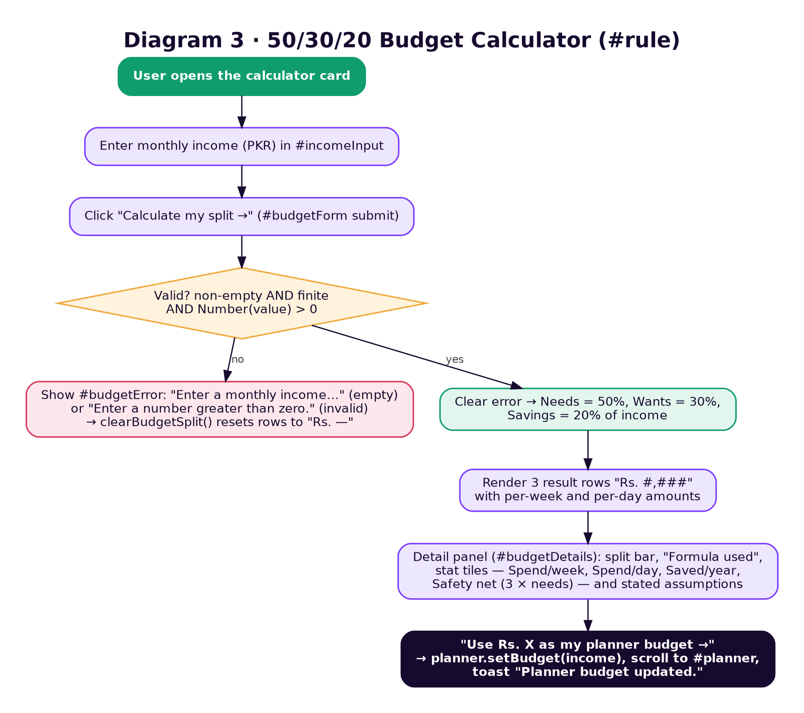
Diagram 3 — validation, calculation and the detail panel behind the budget calculator card.
- Validation distinguishes an empty field ("Enter a monthly income to calculate your sample split.") from an invalid one ("Enter a number greater than zero."); the input gets aria-invalid and any earlier result is wiped back to "Rs. —" so a stale answer never stays on screen.
- Each result row shows the amount plus "Rs. X / week · Rs. Y / day".
- The detail panel shows a 50-30-20 split bar, a "FORMULA USED" box (e.g. "Needs = Rs. 50,000 × 50% = Rs. 25,000"), four stat tiles — Spend / week and Spend / day (needs + wants), Saved / year (savings × 12), Safety net (3 × needs, with months to build it = ceil(safety net ÷ savings)) — and the assumptions line "week = monthly × 12 ÷ 52, day = monthly × 12 ÷ 365".
- A "Use Rs. X as my planner budget →" button hands the income to the Expense Planner (planner.setBudget), scrolls to it and shows a toast — the one place where two tools are linked.
- All currency is formatted through the shared money() helper, e.g. "Rs. 25,000".
Test (test-data.json) | Input | Expected
BC-01 | 50000 | Needs 25,000 · Wants 15,000 · Savings 10,000 · spend/week 9,231 · spend/day 1,315 · saved/year 120,000 · safety net 75,000 (8 months)
BC-03 | 1234.5 | Needs 617.25 · Wants 370.35 · Savings 246.9
BC-04 / BC-05 / BC-06 | "" / −5 / 0 | Error message; previous results cleared

5.6 Savings Goals — #savings
A goal-planning form (goal name, target amount, amount already saved, monthly contribution) that produces a live preview card: a progress bar, a circular percentage "ring", a stat strip, milestone dates and a tip from BudgetBee.
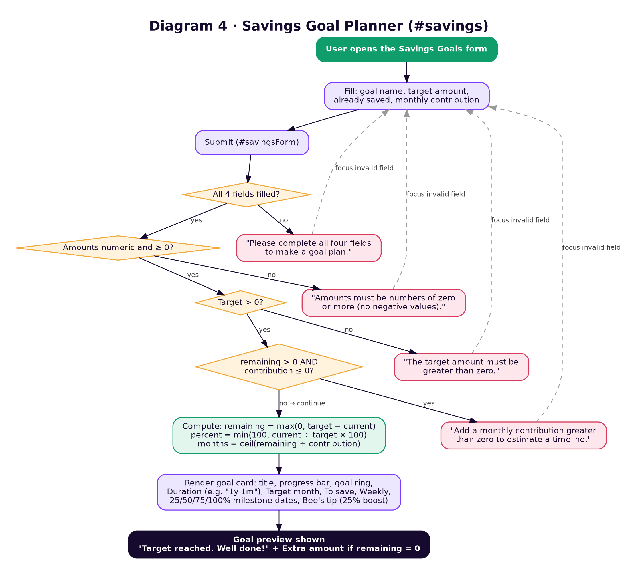
Diagram 4 — the four layered validation checks and the resulting timeline calculation.
- Months-to-goal = Math.ceil(remaining ÷ monthly contribution); contributions are assumed to start next month; interest and inflation are not included (stated on the card).
- The stat strip shows Duration ("13 months" or "1y 1m"), Target month (e.g. "Oct 2027"), To save and Weekly (contribution × 12 ÷ 52).
- A milestone list gives the month each of 25 %, 50 %, 75 % and 100 % will be reached, or "✓ Done" for milestones already passed.
- Bee's tip checks whether saving 25 % more per month would finish sooner: "Save Rs. 12,500 a month instead and you finish 3 months sooner."; otherwise "Set aside your contribution as soon as you receive your income."
- If the target is already met the card instead shows "Target reached. Well done!", the Extra amount saved beyond the target, and "Goal reached! Pick a new goal…".
- On any error the preview resets to its empty state, the offending field gets aria-invalid and focus.

5.7 Expense Planner — #planner
A private, in-browser expense tracker. Visitors set a monthly budget (default Rs. 50,000, editable), then log sample expenses (date, category, description, amount) and watch "Planned spending" and "Balance left" update. Rows can be searched by text, filtered by category, sorted, edited in place, deleted one by one or cleared all at once.
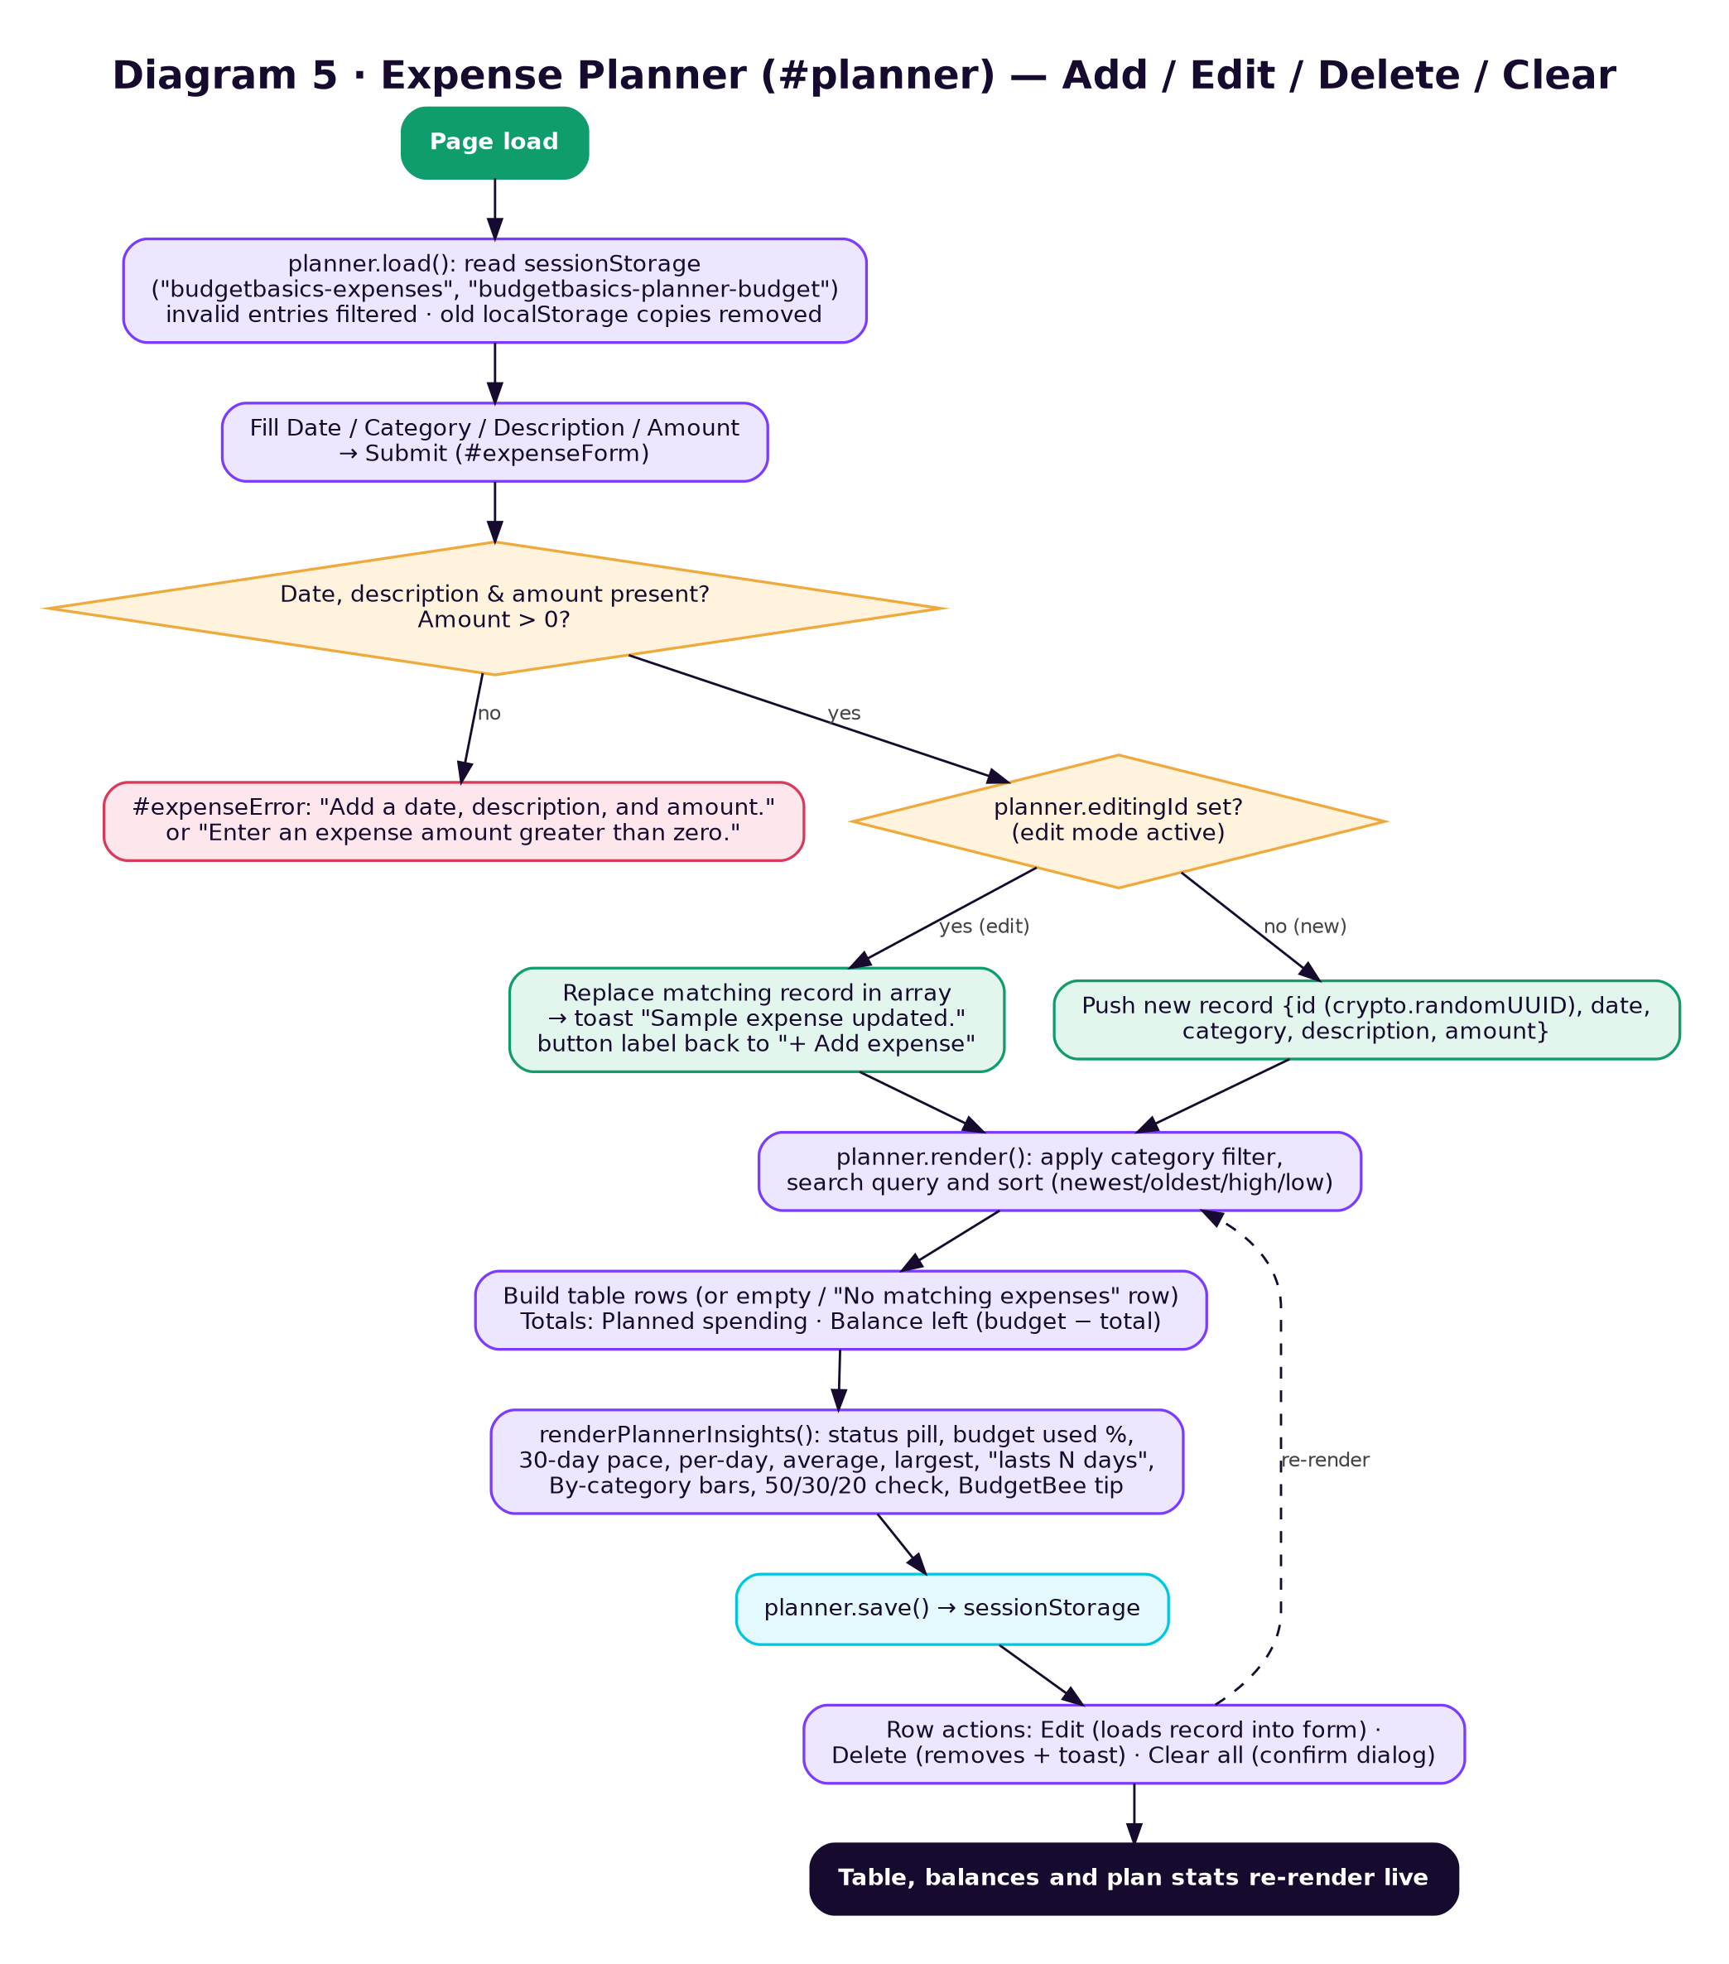
Diagram 5 — add / edit / delete / clear flow and how the table, balances and plan stats stay in sync with sessionStorage.
- Storage changed to sessionStorage. Entries (budgetbasics-expenses) and the budget (budgetbasics-planner-budget) survive a page reload but are wiped when the tab closes. On load any copies left in localStorage by earlier versions are deleted, so nothing outlives the session. The UI copy says so: "Entries stay in this tab, are cleared when you close it, and are never transmitted."
- Seven categories: Food, Transport, Education, Entertainment, Shopping, Utilities, Miscellaneous. The date field defaults to today.
- Editing a row repopulates the form and changes the submit button's label from "+ Add expense" to "Save changes" until the edit is submitted or another row is edited. Deleting the row being edited resets the form.
- Clear all is disabled while the list is empty and asks "Remove all practice expenses from this tab?" before wiping.
- Sort options: Newest first, Oldest first, Amount high→low, Amount low→high. Search matches category, description and date. With entries present but none matching, the table says "No matching expenses."; with no entries at all, "Your practice list is empty."

Plan Stats panel (new)
Once at least one expense exists, renderPlannerInsights() builds a "How your month is tracking" panel:
Element | How it is calculated
Status pill | Over budget by Rs. X if used > 100 % · Getting close to your limit if ≥ 80 % · Spending pace is above budget if 30-day pace > budget · otherwise On track
Usage bar | total ÷ budget, capped at 100 %, with "N % used · 30-day pace Rs. X" and "Rs. Y left / over"
Per day | total ÷ days spanned from first to last entry date (span ≥ 1)
Average | total ÷ number of entries
Largest | The single biggest expense and its description
Lasts | floor(remaining ÷ per-day) days "at this pace", or "Used up"
By category | One bar per category, largest first, with entry count and share of total
50 / 30 / 20 check | Needs = Food + Transport + Education + Utilities; Wants = everything else; Savings = max(0, remaining). Each bar shows share of budget against a 50 / 30 / 20 guide marker, ticked ✓ when needs ≤ 50 %, wants ≤ 30 %, savings ≥ 20 %
BudgetBee tip | spendingTip() picks the content.categoryTips entry for the biggest category and appends "(Shopping is 50% of your planned spending.)"
Worked example from test-data.json: Groceries 6,000 (Food, 1 Sep) + Bus pass 3,000 (Transport, 5 Sep) + Shoes 9,000 (Shopping, 10 Sep) against Rs. 50,000 → total 18,000, balance 32,000, 36 % used, per day 1,800 over 10 days, 30-day pace 54,000 → status "Spending pace is above budget", biggest category Shopping (50 %), needs 9,000, wants 9,000.

5.8 Money Mistakes — #mistakes
Five expandable <details> accordion panels, each covering one common student money mistake: 01 Impulse buying, 02 Ignoring small expenses, 03 Late payments, 04 Unused subscriptions, 05 Spending without a plan. Every panel follows the same three-part structure — a relatable student scenario, why it matters, and one concrete thing to try.
- Purely informational; no interactivity beyond the native expand/collapse of the <details> element (a rotating + / ✕ icon reflects open state via CSS).

5.9 Infographics Gallery — #gallery
Six small illustrated "visual guides" (Needs vs. wants, The 50/30/20 rule, A monthly budget cycle, Small-step saving, Expense categories, Smart spending checklist), each hand-drawn in CSS rather than as image files, with a caption, a topic badge and descriptive aria-label. A filter bar (All / Planning / Saving / Spending) lets visitors narrow the set.
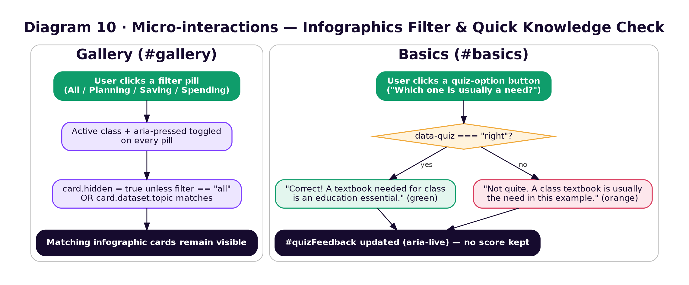
Diagram 10 — the gallery filter (left) alongside the separate one-question quiz from Section 5.3 (right), shown together since both are simple, self-contained interactions.

5.10 BudgetBee Chatbot — #chatbot
A section with four "Try asking" prompt cards (What is a need? · How much should I save? · How do I avoid overspending? · Get a spending tip) plus a floating chat widget (opened via the bottom-right launcher button, the "AI Chatbot" menu link, or any prompt card). It answers budgeting questions using a fixed set of keyword/regex rules from content.chatAnswers — it is explicitly labelled "Rule-based answers · Nothing you type is sent", not a connection to any AI model or API.
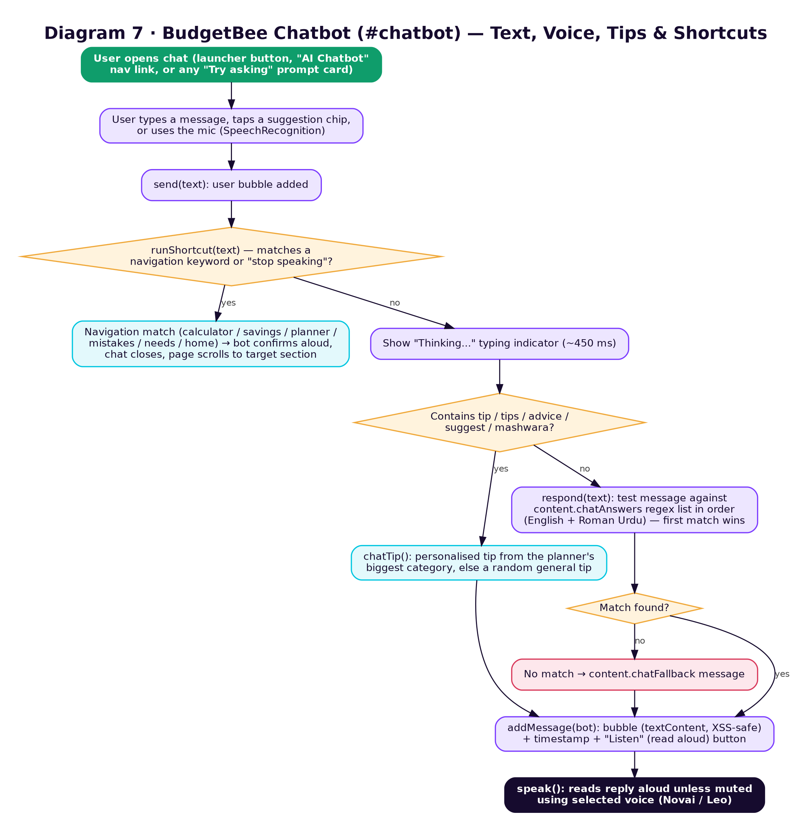
Diagram 7 — how a typed, tapped or spoken message is turned into a reply, including tips and the built-in navigation shortcuts.
Notable capabilities baked into this one widget:
- Bilingual matching: the 12 rules recognise both English ("what is saving?") and Roman Urdu ("paise ka plan", "bachana", "zaroorat", "khwahish", "kharcha", "aamdani", "salam") phrasing. Rules are tested in order and the first match wins, so the specific "50/30/20" and "how much should I save" rules come before the generic "save" and "budget" rules.
- Personalised tips: any message containing tip / tips / advice / suggest / mashwara is answered by chatTip() — "Based on your expense planner: Shopping is your biggest spend…" if the planner has entries, otherwise a random tip from content.generalTips plus an invitation to add expenses.
- Navigation shortcuts: "open calculator" / "hisab kitab", "savings goals" / "bachat goal", "expense planner" / "kharcha planner", "money mistakes", "needs and wants", "go home" and "stop speaking" scroll the page to that section (closing the chat) instead of returning an answer. The panel's "Open calculator" chip uses this.
- Voice in: a 🎤 button uses SpeechRecognition (en-US, single result) to transcribe speech into a message and send it automatically. Status line states: "🎤 Listening…", "Microphone permission is required…", "Sorry, I couldn't hear you."
- Voice out: every bot reply is read aloud via SpeechSynthesis, prefixed with the persona name ("Novai here." / "Leo here."); a dropdown picks Novai (female-leaning, pitch 1.08) or Leo (male-leaning, pitch 0.92), matched heuristically against the browser's installed English voices, rate 0.96.
- Mute (🔔/🔇) and ■ stop controls, a "Listen" button on every past bot message, a ↺ clear-conversation button that resets to the welcome greeting, − minimise and × close. The panel also closes on Escape or on a click outside it.
- Messages are built with textContent (never innerHTML), so user input can never inject markup. Each bubble carries an hh:mm timestamp; a "Thinking…" indicator shows for ~450 ms before each reply.
- If SpeechRecognition is unsupported the mic disables itself and the status line says so; if speechSynthesis is unsupported the mute/stop buttons disable — the text chat still works.

5.11 Site Search — #search
A search box over content.searchIndex — twelve topic entries (Budgeting basics, Income, Fixed and variable expenses, Needs vs wants, 50/30/20 guideline, Savings goals, Expense planner, Impulse buying, Unused subscriptions, Money mistakes, Visual learning gallery, Ask BudgetBee), each with a description, jump link, topic (Planning / Saving / Spending) and keyword list.
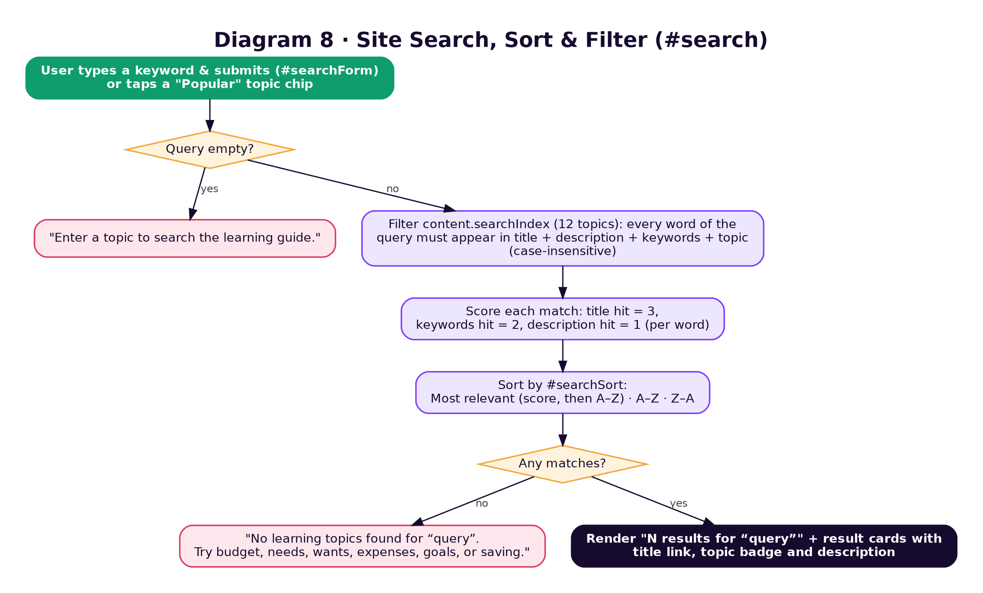
Diagram 8 — search matching, relevance scoring, sorting and the two empty-state messages.
- Matching: every word in the query must appear somewhere in title + description + keywords + topic (case-insensitive).
- Relevance: per word, a title hit scores 3, a keyword hit 2, a description hit 1; ties break alphabetically.
- Sort: "Most relevant", "A–Z" or "Z–A"; changing the sort re-runs the current search.
- Seven "Popular" chips (Budgeting, Needs vs wants, 50/30/20 rule, Savings goals, Expenses, Money mistakes, Ask BudgetBee) fill the box and search immediately; the matching chip is highlighted.
- Results read "N results for “query”" with a topic badge per card; an unknown term such as "bitcoin" yields "No learning topics found…".

5.12 About — #about
Introduces the project ("A student-led project — About NEX GEN CODERS") and credits the TechWiz 72-hour web development challenge as its origin. Five team cards list the members and roles: 01 Noor Fatima — Team leader; 02 Asfad Mubarak Ali; 03 Shanza Zahid; 04 Iqbal Tahir; 05 Kashaf Zahid — Team members.

5.13 Feedback — #feedback — and Contact Us — #contact
Two separate but structurally identical demo forms. Feedback collects name, email, a 1–5 star rating (dropdown: ★★★★★ Excellent … ★☆☆☆☆ Needs work) and a 10–500 character comment; Contact collects name, email and a message of at least 10 characters.
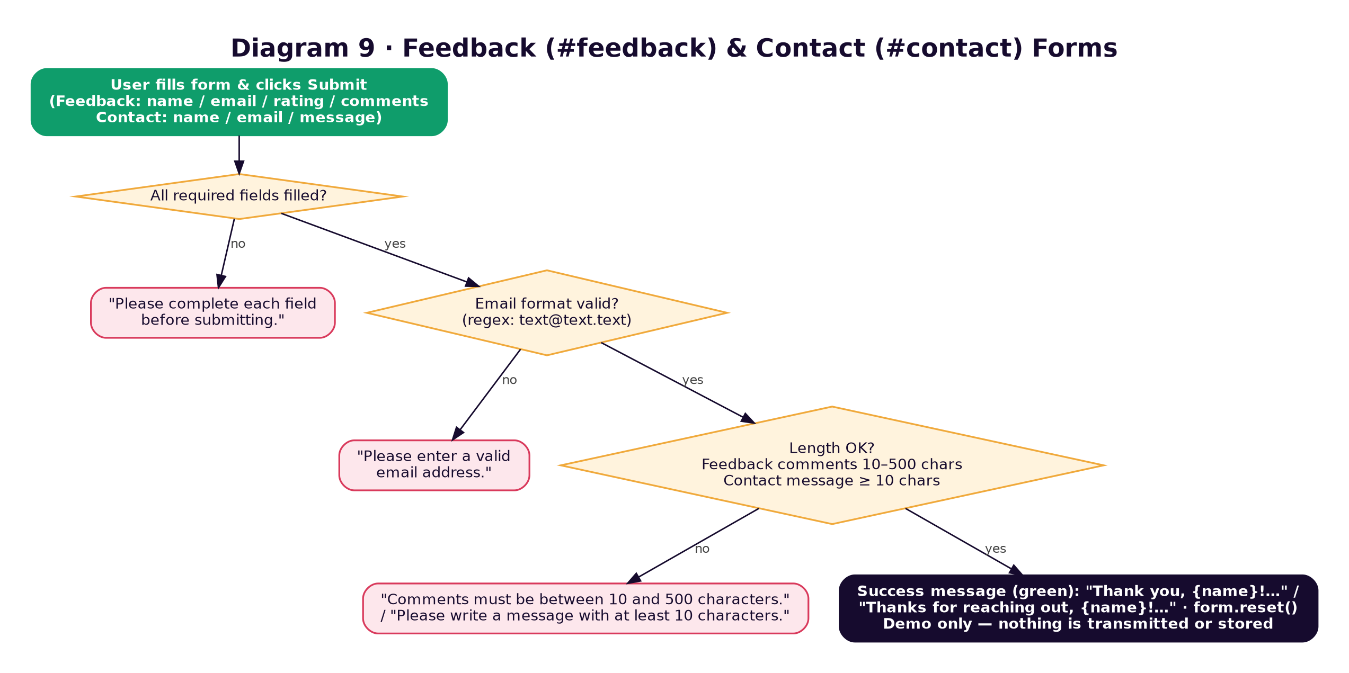
Diagram 9 — shared three-stage validation used by both forms.
- Both forms explicitly state that nothing is transmitted or stored — success is simulated client-side ("Thank you, Ali! Your feedback has been received.") and the form is reset.
- The Contact section also shows demo contact cards: email hello@budgetbasics.demo, phone +92 300 1234567 (Mon–Fri, 9:00–17:00 PKT), a demo Lahore address, and Instagram / Facebook / LinkedIn / GitHub links marked "opens in a new tab".

5.14 Sitemap — #sitemap
A flat list of jump links to every section on the page (Home through Contact Us, including AI Chatbot), provided as a plain-text fallback way to navigate the single-page site.

5.15 Footer
Repeats the brand mark and a short tagline, two columns of quick links ("Explore": Budgeting basics, Needs vs wants, 50/30/20 calculator, Savings goals, Expense planner, Ask BudgetBee; "Project": About the team, Share feedback, Contact, Full site map, "Static browser-only demo"), the simulated visitor counter, the live footer clock, a privacy note ("Planner examples and theme settings stay in this browser. Forms are demo-only and are not submitted.") and the closing line "© 2026 NEX GEN CODERS · For learning only · Not financial advice".

6. Data Persistence & Privacy
The only client-side storage used anywhere in the project is window.sessionStorage and window.localStorage. No cookies, no IndexedDB, no network calls of any kind (fetch/XMLHttpRequest do not appear anywhere in the scripts).
Storage | Key | Holds | Set / read by | Lifetime
localStorage | theme (legacy: budgetbasics-theme) | "dark" or "light" (dark is the default when absent) | Theme toggle + the inline <body> script on load | Until cleared
localStorage | budgetbasics-visits-YYYY-MM-DD | A running integer, one key per calendar day | Footer visitor counter, +1 per page load | Stale keys stay but are never read again
sessionStorage | budgetbasics-expenses | JSON array of {id, date, category, description, amount} | Expense Planner — loaded on page load, re-saved after every render | Until the tab closes
sessionStorage | budgetbasics-planner-budget | The monthly budget number | Planner budget field / calculator "Use as budget" | Until the tab closes
Every storage access goes through the storage helper, whose try/catch lets the site degrade gracefully (falling back to defaults) in browsers or private-mode sessions where storage is blocked. On load the planner also removes any budgetbasics-expenses / budgetbasics-planner-budget values left in localStorage by the previous version, so old practice data cannot outlive a session.

7. Accessibility Notes
- Every icon-only control (menu toggle, theme toggle, ticker pause, chat launcher, mic, mute, stop, clear, minimise, close, back-to-top, row Edit/Delete) carries an aria-label, and several update it dynamically to reflect state (e.g. "Switch to light mode" ⇄ "Switch to dark mode", "Open navigation" ⇄ "Close navigation"). Toggle buttons expose aria-pressed; the menu and launcher expose aria-expanded.
- Live regions (aria-live="polite") are used for form errors, quiz/game feedback, chat messages, the voice status line and search results, so screen readers announce updates without focus moving.
- Invalid inputs receive aria-invalid="true" and focus is moved to the first failing field in the savings form.
- Screen-reader-only text (.sr-only) labels the chat input and the search input even though their visible placeholder text could be mistaken for a label; the sample budget table has a <caption>.
- Decorative illustrations (the gallery's hand-drawn CSS art, the split bar, the goal ring, the ambient background) are marked role="img" with a descriptive aria-label, or aria-hidden="true" where purely decorative; the goal progress bar is a real role="progressbar" with aria-valuenow.
- The navigation link of the section in view carries aria-current="true"; the menu and chat panel both close on Escape and return focus to their trigger.
- All animation — the ambient parallax, scroll-reveal, loading screen, counters, ticker, hero entrance and hover-tilt — is switched off or paused under prefers-reduced-motion: reduce; smooth scrolling becomes instant.
- Focus is clearly visible everywhere via a shared :focus-visible outline style rather than the browser default. External links say "(opens in a new tab)".

8. Voice Features in Detail (Web Speech API)
The chatbot is the only part of the site that uses speech, and it uses two independent browser APIs:
- SpeechRecognition (voice IN): created fresh on each mic click (lang = "en-US", no interim results, one alternative); the transcript is trimmed and sent as a chat message automatically. Clicking the mic again while listening stops it. Permission errors (not-allowed, service-not-allowed) are distinguished from "didn't catch that" errors in the status line, and the panel gets a .listening class while active.
- SpeechSynthesis (voice OUT): reads bot replies aloud after cancelling any speech in progress. Voice selection is heuristic — the code filters the browser's installed English voices and pattern-matches common voice names (e.g. "zira", "samantha", "aria", "jenny" for Novai; "david", "mark", "daniel", "guy" for Leo), falling back to the first en-US voice and then the first English voice, so actual voice quality depends on what the visitor's OS/browser has installed. The panel gets a .speaking class and the status reads "🔊 BudgetBee is speaking…" until the utterance ends.
- Both APIs are fully optional — if either is missing, that half of the feature quietly disables itself (mic button, or mute/stop buttons) rather than throwing errors, and the status line tells the visitor voice is unavailable.
- Voice input is most reliable over http://localhost or HTTPS in Chrome/Edge; Safari and Firefox support for SpeechRecognition is inconsistent.

9. Responsive Behaviour
The style sheet is mobile-aware through width- and capability-based @media rules. The most important ones:
Breakpoint | What changes
max-width: 1520 px | Menu links hide behind the ☰ button and open as a 4-column dropdown grid under the header
max-width: 1000 px | Hero collapses to a single column (copy above the BudgetBee illustration); several two-column layouts stack
max-width: 900 px | Snapshot cards drop from 4 columns to 2
max-width: 760 px | Header shrinks to 68 px; the menu becomes a single stacked list; concept cards go 2-up; heavier ambient shapes are hidden
max-width: 600 px | Snapshot grid gap shrinks; the hero's BudgetBee sphere and orbiting stat cards scale down; the chat window becomes near-full-width
max-width: 500–520 px / 430 px | Planner tools stack full-width; fine typography and padding adjustments
hover: none, or max-width: 760 px | The dark-mode 3D hover-tilt on cards is reduced to a simple lift (no rotation), since there is no hover on touch devices
prefers-reduced-motion: reduce | The loading screen, ambient background, hero entrance animation, ticker motion and all card/element transforms are disabled outright
min-width: 981 px | The 50/30/20 explanation column becomes sticky beside the calculator

10. Design Decisions & Known Issues
While building and testing the site we made a few deliberate choices, and found a few things that are worth writing down so nobody is surprised later.

10.1 Decisions we made on purpose
- Two different quizzes. The Needs-vs-Wants "Quick Sort" game (Section 5.4) keeps a score and cycles through 8 items; the "Quick Knowledge Check" inside Basics (Section 5.3) is a single question with no score. They look similar but are separate features with separate code.
- Snapshot figures are static. The Snapshot cards and the sample budget table both use the same Rs. 50,000 example and match each other, but they are not driven by the calculator or planner. The only live link between tools is the calculator's "Use as my planner budget" button. We kept the Snapshot as a fixed teaching example.
- Planner data lives in the tab only. We moved planner entries from localStorage to sessionStorage so practice data never outlives the session, and the code deletes any older localStorage copies on load.
- Every calculator shows its formula. The 50/30/20 split, the savings timeline and the planner stats all print the formula and assumptions on screen, and data/test-data.json records the expected result for each so anyone can re-check them in the browser.
- User text is always escaped. Anything a visitor types is passed through escapeHtml() before it enters an HTML template, and chat bubbles are built with textContent, so no input can inject markup.

10.2 Things to keep in mind
- Chatbot rule order matters. Rules in content.js are tested top to bottom and the first match wins, so specific patterns ("50/30/20", "how much … save") must stay above generic ones ("save", "budget"). Close paraphrases can still fall through to the fallback message — that is expected for a rule-based bot.
- Voice quality depends on the device. Novai and Leo are matched by name against whatever English voices the OS provides; if no good match exists the first English voice is used silently.
- Planner pace with one entry. Per-day spending divides by the days between the first and last entry, so a single entry projects a 30-day pace of amount × 30. It is correct, but can look alarming until a second entry is added.
- style.css is large. It still carries three successive dark-palette blocks (legacy, violet/cyan, midnight glass) and some repeated media queries. The last block wins so the site renders correctly; consolidating them is a safe cleanup we have not done yet.
- Two hamburger rules. The ☰ menu is styled at ≤ 760 px (stacked list) and again at ≤ 1520 px (4-column grid). Both are intentional and should be edited together.
- Contact details are demo values (email, phone, address, social links) and are labelled as such on the page.

11. Known Limitations & Suggested Enhancements
- No account system or cross-device sync — theme and visit count live in one browser; planner entries live in one tab and disappear when it closes (by design, but an optional "download my plan as CSV" button would let students keep their practice data).
- The Feedback and Contact forms do not send anything anywhere; wiring them to a real inbox or form service (e.g. an email API or a lightweight backend) would be needed before relying on them for real feedback.
- Voice features require a Chromium-based browser in most cases; Safari and Firefox support for SpeechRecognition in particular is inconsistent, so the graceful-degradation path (mic disabled, text chat still usable) is the one most visitors on those browsers will see.
- Because the chatbot is rule-based, expanding its knowledge means adding new regex patterns to content.js by hand rather than retraining a model — fine for a small curated topic list, but it will not scale to open-ended questions.
- The Snapshot figures could be driven from the calculator (or vice-versa) if we decide the two should be linked.
- Google Fonts are the only external dependency; offline the site falls back to system fonts. Self-hosting the two font files would make the project fully offline-capable.

Appendix A — Flowchart Index
# | Diagram | Covers | Section
1 | System Architecture | The four source files, browser APIs used, and the "no backend" boundary | 3
2 | Dark / Light Theme Flow | Theme detection on load and what the toggle button does | 4.2
3 | 50/30/20 Budget Calculator | Validation, the split calculation, the detail panel and the planner hand-off | 5.5
4 | Savings Goal Planner | The four validation gates, the months-to-goal calculation and milestones | 5.6
5 | Expense Planner | Add / edit / delete / clear of expense rows, sessionStorage sync and plan stats | 5.7
6 | Needs vs. Wants Sorting Game | The scored, looping 8-item game in the #needs section | 5.4
7 | BudgetBee Chatbot | Text, voice, tip and navigation-shortcut handling in the chat widget | 5.10
8 | Site Search, Sort & Filter | Every-word matching, relevance scoring and sorting over the 12 built-in topics | 5.11
9 | Feedback & Contact Forms | The shared three-stage validation used by both demo forms | 5.13
10 | Micro-interactions | The Gallery filter pills and the one-question Basics quiz | 5.9
11 | Page Load & Initialisation | The seventeen init functions Nexgen.js runs, in order | 3.1

Appendix B — Test Data Summary (data/test-data.json)
The repository ships a machine-readable test file. The table summarises what each block verifies so a reviewer can reproduce the checks in the browser.
Block | Cases | What is verified
budgetCalculator_50_30_20 | BC-01 … BC-06 | Correct 50/30/20 split for whole and decimal incomes; the weekly/daily/yearly/safety-net tiles; empty, negative and zero inputs produce the right error and clear stale results
savingsGoal | SG-01 … SG-06 | Remaining, months, duration label, progress %, weekly amount and the 25 %-boost tip; target-reached case with "Extra"; missing field, negative amount and zero contribution errors
expensePlanner | 3 entries + EP-01, EP-02 | Totals, balance, budget used %, largest entry, biggest category share, needs/wants totals, per-day, 30-day pace, status text; missing-field and zero-amount errors; the seven categories
needsVsWants | 4 items | Expected classification for Textbooks, Gaming subscription, Groceries, Movie ticket
chatbot | 7 questions | English and Roman Urdu matches, the personalised tip path and the fallback for an off-topic question
search | 5 queries | Hits for saving / needs / expenses / goals and the no-results message for "bitcoin"
forms | FB-01 … FB-04, CT-01 | All three validation stages for Feedback and the message-length rule for Contact

