

***ASSIGNMENT #1(LAB)***

|  |  |
| --- | --- |
| **NAME:** | NOOR FATIMA |
| **REGISTRATION NO:** | SP23-BCS-109 |
| **COURSE:** | DATABASE MANAGEMENT SYSTEM |
| **TEACHER:** | Dr. Abid Suhail Bhutta |
| **SECTION:** | C |
| **DATE :** | 12-12-2024 |

***Hostel Management System***

***Topic Description:***

In a hostel, students or residents are provided with accommodation, and the hostel management system is designed to handle various tasks related to room allocation, payments, and overall hostel operations. The system keeps track of available rooms, room types (single, double,) and their capacity. Students are assigned rooms based on their preferences and availability. Each student's private information, as well as the room reservation details, are noted down, and the system manages check-in and check-out processes efficiently.

The hostel management system also tracks the financial side by monitoring the payments of residents. It tracks the due dates of fee payments and generates receipts for payment. The system also tracks requests for maintaining rooms and common areas. The hostel staff, wardens, and housekeeping are also tracked through the system. The system tracks information like the schedule and attendance of staff.

Besides, the system records visitor's data to maintain security and proper documentation of guest entries. The management system for hostels helps the administrator to generate reports on occupancy, payments, and maintenance to streamline hostel operations. All these features make it easier to manage daily operations, improve efficiency, and give better experience for both residents and staff.

***Relational Schema:***

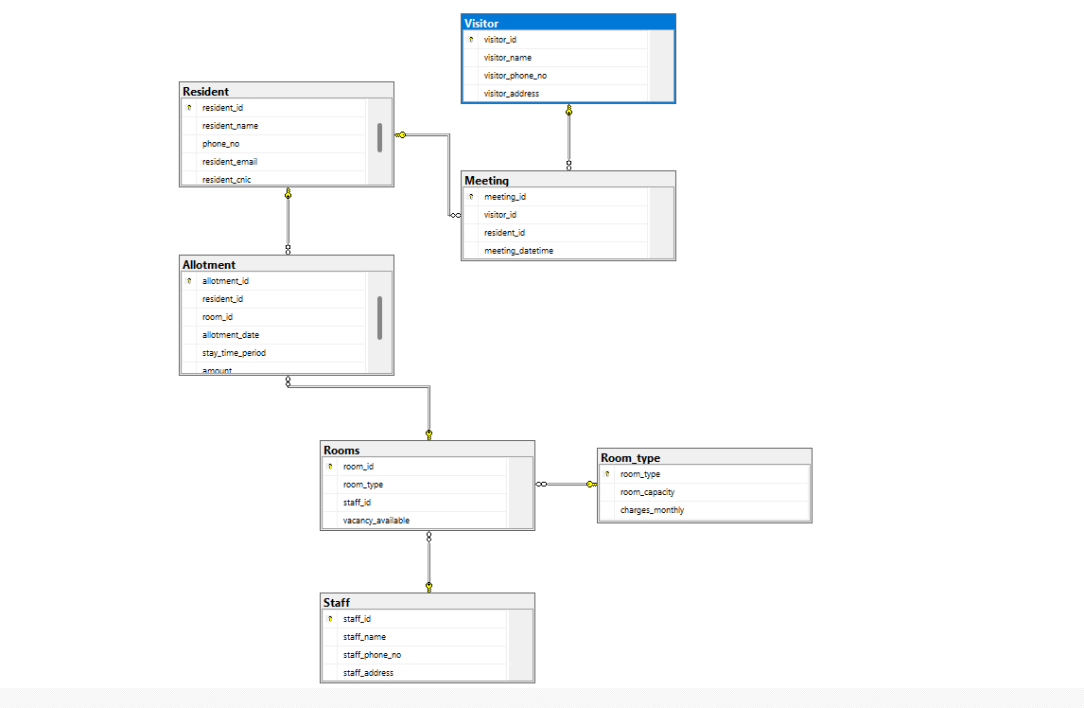

***Schema (SQL SERVER ):***

Create database Hostel

use Hostel

**CREATE TABLE Resident** (

resident_id INT PRIMARY KEY, resident_name VARCHAR(100), resident_phone_no VARCHAR(30),

resident_email VARCHAR(100),

resident_cnic VARCHAR(15)

);

**CREATE TABLE Room_type** (

room_type VARCHAR(20) PRIMARY KEY, -- Added PRIMARY KEY

room_capacity INT, -- Corrected column name capitalization

charges_monthly INT

);

**CREATE TABLE Rooms** (

room_id INT PRIMARY KEY,

room_type VARCHAR(20),

staff_id INT,

vacancy_available VARCHAR(20),

FOREIGN KEY (room_type) REFERENCES Room_type(room_type),

FOREIGN KEY (staff_id) REFERENCES Staff(staff_id)

);

**CREATE TABLE Allotment** (

allotment_id INT PRIMARY KEY,

resident_id INT,

room_id INT,

allotment_date DATE,

stay_time_period INT,

amount int,

FOREIGN KEY (resident_id) REFERENCES Resident(resident_id),

FOREIGN KEY (room_id) REFERENCES Rooms(room_id)

);

**CREATE TABLE Visitor** (

visitor_id INT PRIMARY KEY,

visitor_name VARCHAR(100),

visitor_phone_no VARCHAR(20),

visitor_address VARCHAR(100)

);

**CREATE TABLE Meeting** (

meeting_id INT PRIMARY KEY,

visitor_id INT,

resident_id INT,

meeting_datetime DATETIME,

FOREIGN KEY (resident_id) REFERENCES Resident(resident_id),

FOREIGN KEY (visitor_id) REFERENCES Visitor(visitor_id)

);

**CREATE TABLE Staff** (

staff_id INT PRIMARY KEY,

staff_name VARCHAR(100),

staff_phone_no VARCHAR(40),

staff_address VARCHAR(100)

);