

Project Title:

**Accord –Ask About Islam**

Submitted by:

**Umm e Roman 2023-CE-16**

**Noor Fatima 2023-CE-17**

Submitted to:

**Sir Afeef Obaid**

Course:

**Programming Fundamentals And Data Science**

Semester:

**2nd (spring)**

Date of Submission:

**05-05-2024**

**Department of Computer Engineering**

**University of Engineering and Technology, Lahore**

**Table of contents**

* [Accord - Ask about Islam](https://github.com/NoorFatimaAfzal/Accord/tree/main#code-innovate-chat-hub---group-chat-app)
  + [Overview](https://github.com/NoorFatimaAfzal/Accord/tree/main#overview)
  + Requirements
* tkinter==8.6
* Pillow==8.3.2
* pymongo==3.12.0
* google-auth-oauthlib==0.4.6
* google-auth==1.35.0
* google-auth-httplib2==0.1.0
* google-api-python-client==2.24.0
* nltk==3.6.2
* pandas==1.3.3
* scikit-learn==0.24.2
* scikit-learn==1.4.2
  + [UX](https://github.com/NoorFatimaAfzal/Accord/tree/main#ux)
* Screenshots of GUI
  + [Features](https://github.com/NoorFatimaAfzal/Accord/tree/main#features)
* Frontend in tkinter
* backend with mongo dB
* Quran listen and read with Quran API
* signup and login with google
* ML model that detects the messages
* ML model that detects Articles Content
  + [Tools Used](https://github.com/NoorFatimaAfzal/Accord/tree/main#tools-used)

**Overview**

**Accord:**

"Accord" is a Python-based GUI project designed to facilitate scholarly discussions and knowledge sharing on religious topics. It features user signup and signin modules, channels for different religious topics, private messaging with scholars, Namaz reminders, and prayer timing displays. Additionally, it includes a calendar to track important dates and events, as well as the option to listen to the entire Quran and read its translation. "Accord" aims to create a user-friendly environment for seekers of knowledge and scholars to engage in meaningful discussions and receive guidance. With its intuitive navigation and engaging interface, "Accord" provides a seamless platform for individuals to deepen their understanding of religion and connect with experts in their field. Through personalized interactions and practical tools, it empowers users to navigate their spiritual journeys effectively while fostering a vibrant community of learning and exchange.

**Requirements:**

Requiremts.txt file contains all the dependencies required for the project to run. To install the dependencies, run the following command in the terminal:



**UX**

**Loading page**

* Page that loads all data.
* It initiates the .pyw file that send notifications to users for Namaz reminders.

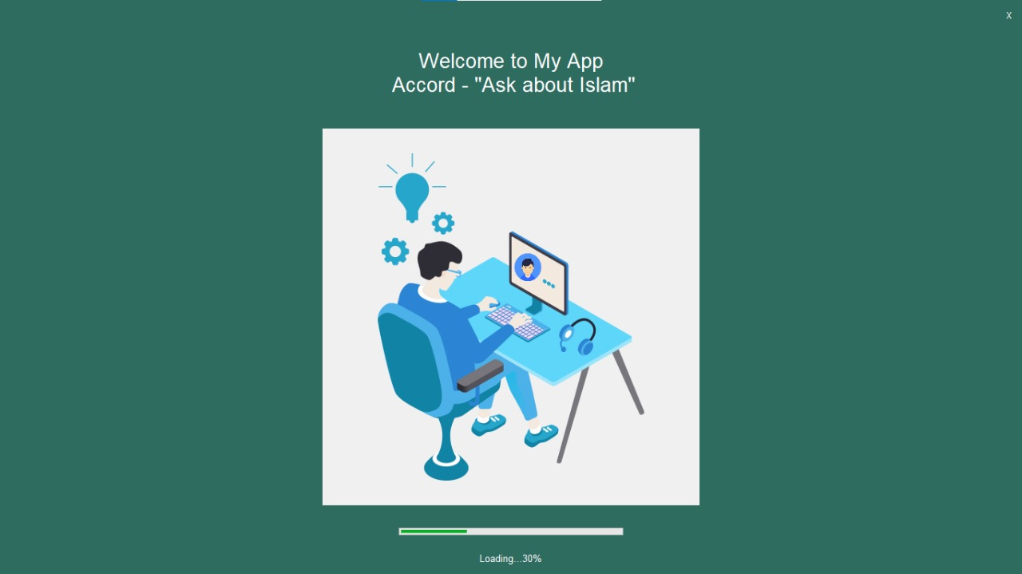

**Sign Up and Login**

* User registration and authentication.
* User roles and permissions for various levels of access.
* Profile creation and management.

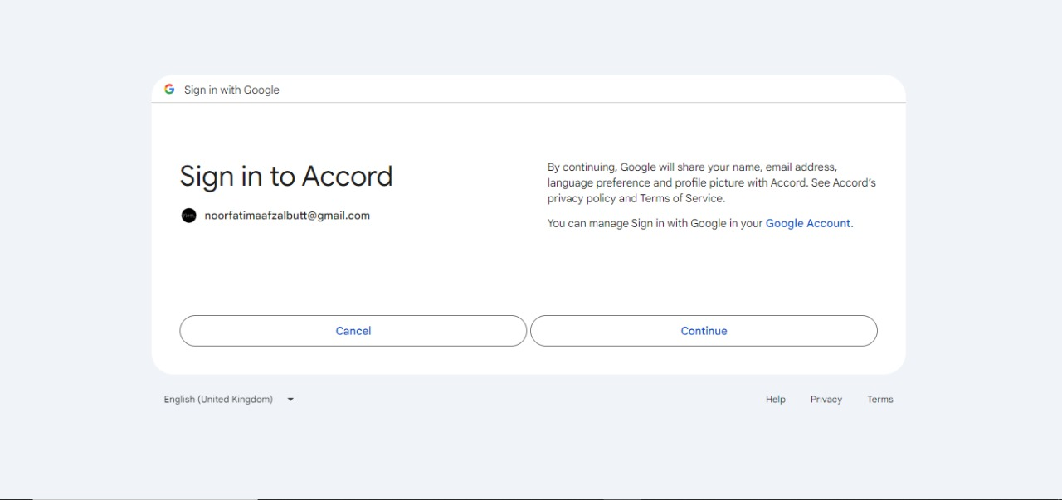

**User Management**

* User registration and authentication.
* User roles and permissions for various levels of access.
* Profile creation and management.

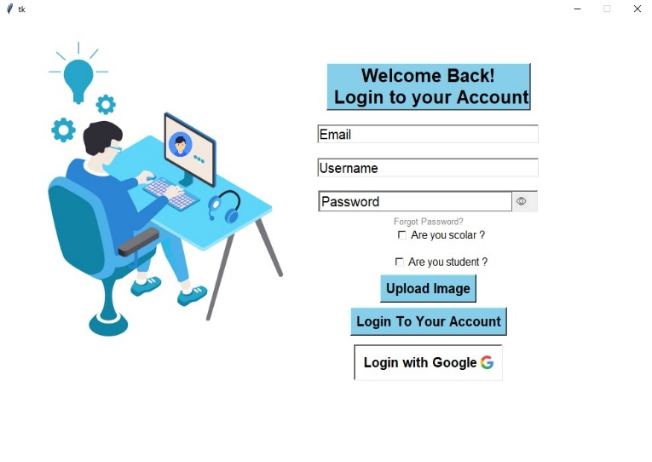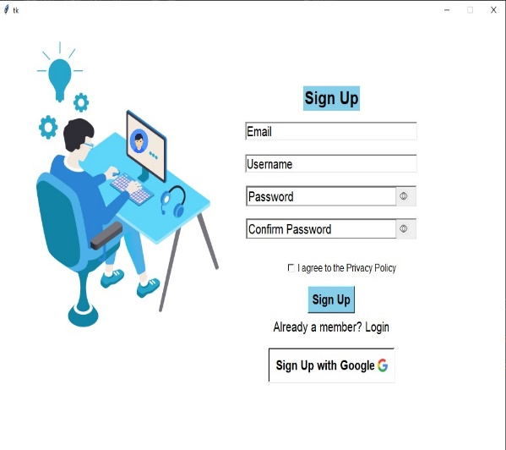

**Home Pages**

* Homes pages of scholars and students separately.
* Home Page contains dashboard, link to all channels and articles.
* Quran Read and listen button.

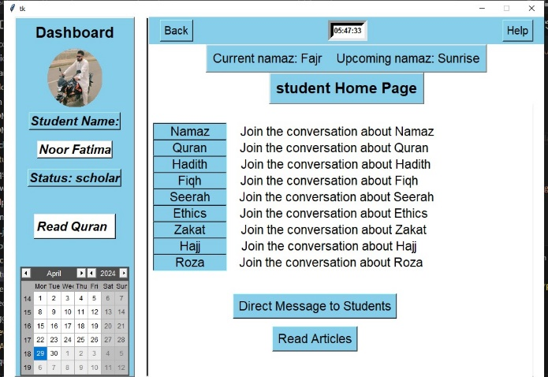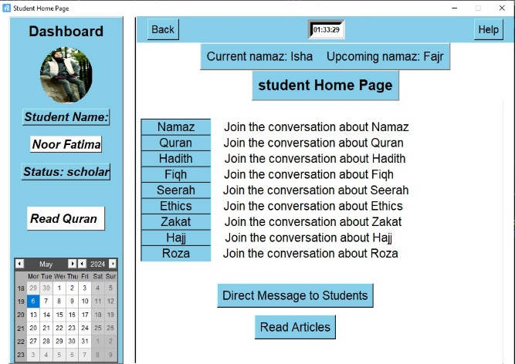

**Communication Features**

* Real-time messaging functionality for group discussions in channels.
* Direct messaging for private one-on-one conversations.
* Notifications for Queries will be sent to scholar.

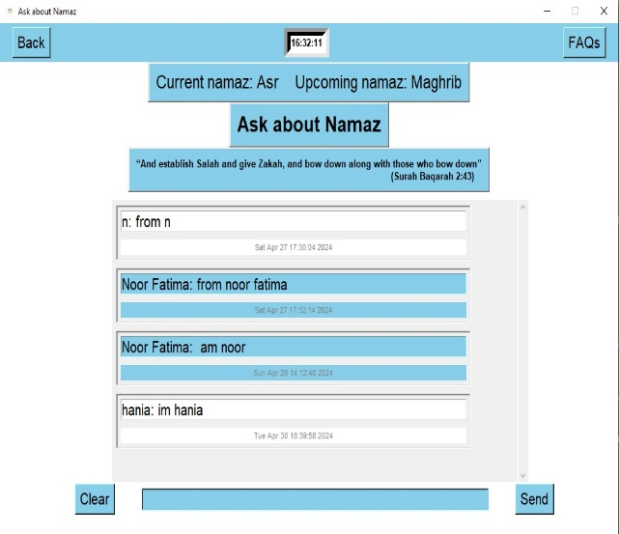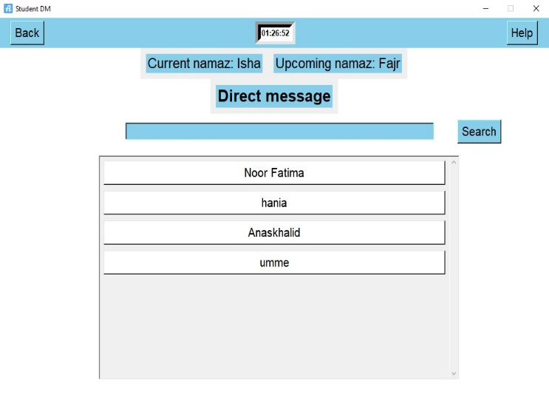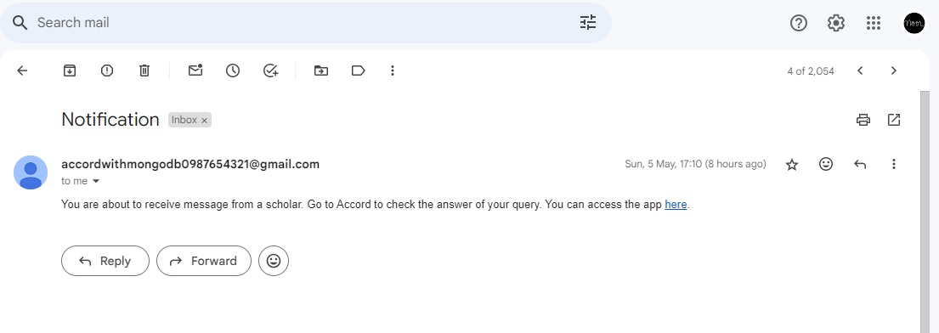

**Channel Management**

* Creation, joining, and leaving of channels.
* Categorization of channels based on Religious topics or modules.
* Ability to search relevant channels.

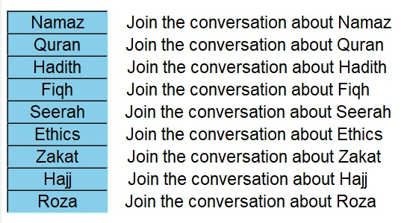

**Read and listen Quran**

* Read the Quran with translation.
* Listen to the Quran with translation.

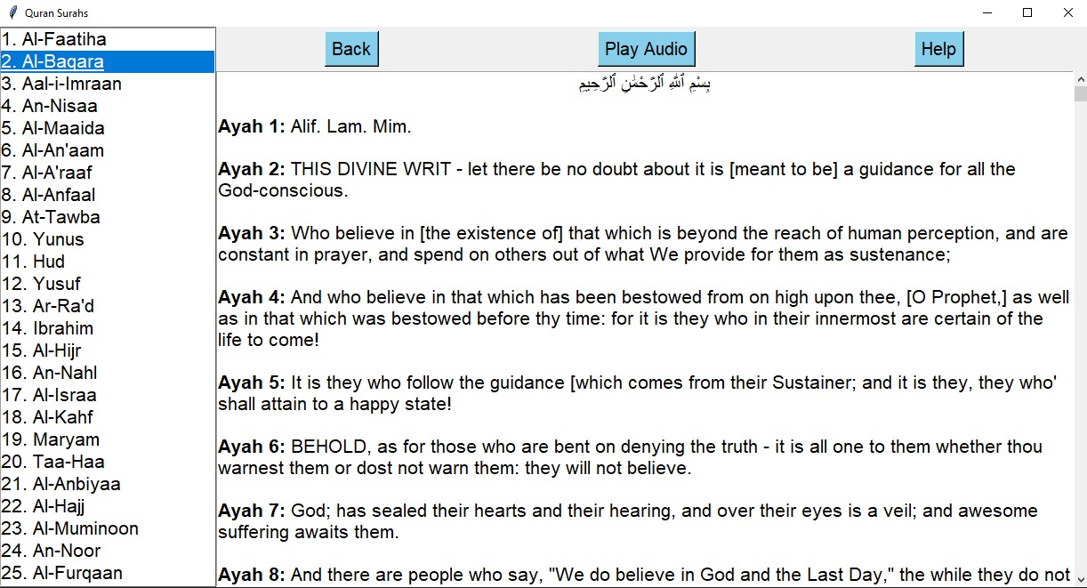

**Prayer Timing**

* Display prayer timings.
* Send Namaz reminders through Emails.

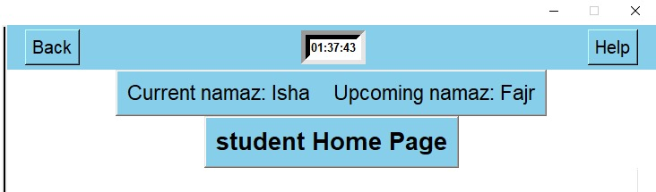

**Calendar**

* Display current date.

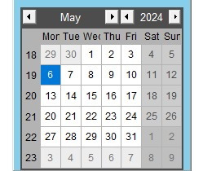

**FAQs page**

* Page that contains the answers of all frequently asked questions.
* Users can like or dislike the answers.

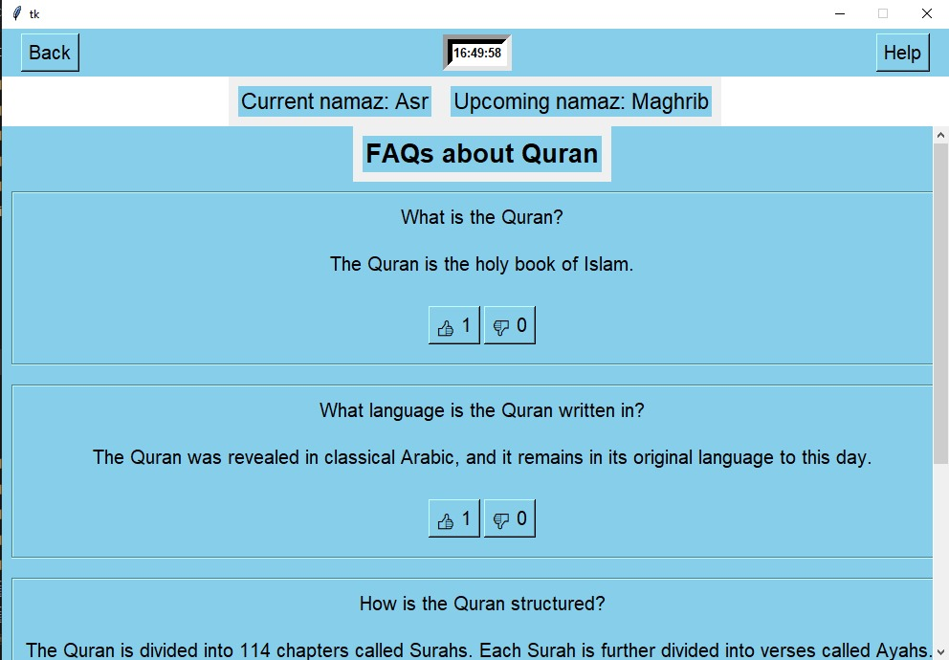

**Help page**

* Page that contains link to all the socials of developer.
* User can click on that links.

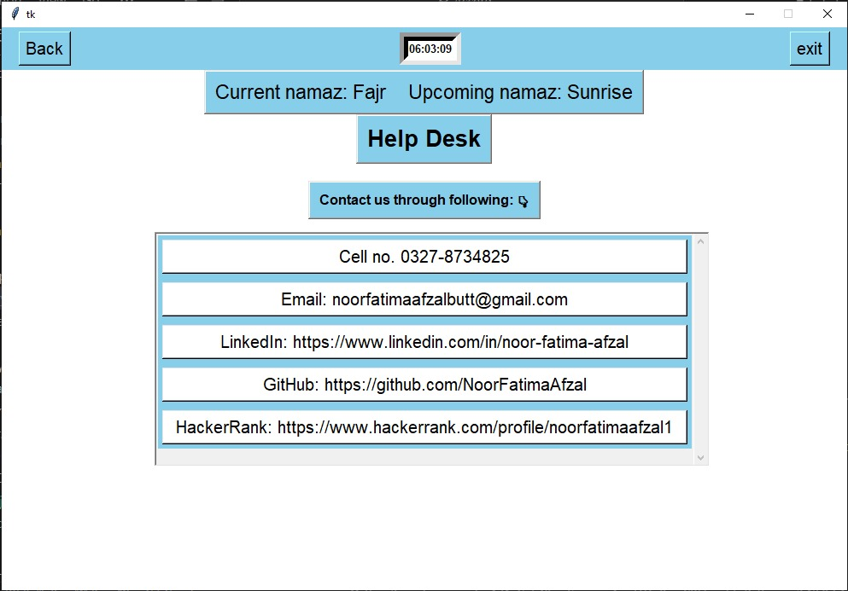

**ML model detection**

* ML model detects messages based on them to be Islamic or non-Islamic.
* **Send warning emails to users if he/she sends non-Islamic messages.**
* **Scholar can not post article if his article contains Non-Islamic content.**

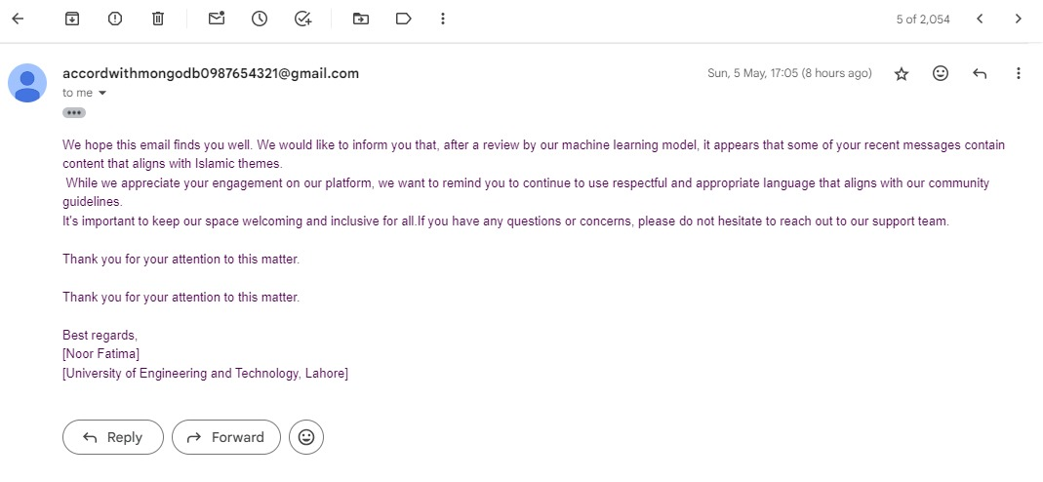

**Flowchart**

**[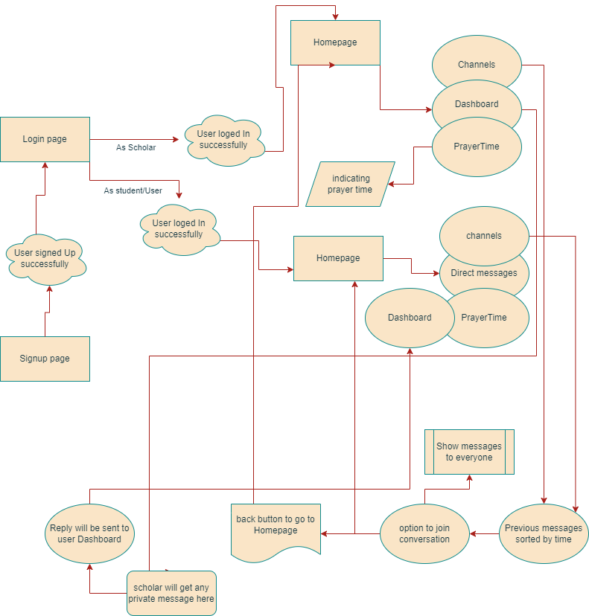](https://github.com/NoorFatimaAfzal/Accord/blob/main/flowchart/flow.png)**

**Tools Used**

[GitHub](https://github.com/) - used for hosting the source code of the program  
[Visual Studio](https://code.visualstudio.com/) - for writing and testing the code  
[Draw.io](http://draw.io/) - used for creating the Flowchart and Database relational schema  
[Favicon.io](https://favicon.io/) - used for generating the website favicon  
[Font Awesome](https://fontawesome.com/) - for creating attractive UX with icons[Google Fonts](https://fonts.google.com/) - for typography