**Adjusted R-squared (Adjusted R²) Score**

**Definition**:

* Adjusted R-squared is a modified version of the R-squared (R²) metric that accounts for the number of predictors (independent variables) in a model. It adjusts the R² value based on the number of predictors, providing a more accurate measure of the goodness-of-fit, especially when comparing models with different numbers of predictors.

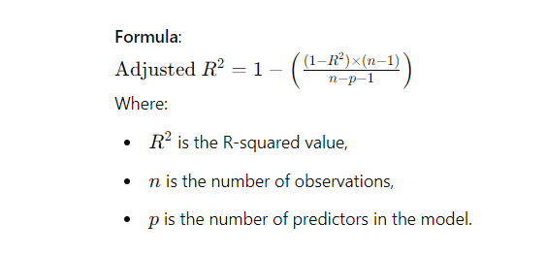**Interpretation**:

* Adjusted R² adjusts the R² value by penalizing the addition of irrelevant predictors that do not improve the model.
* Unlike R², Adjusted R² can decrease if the added predictors do not contribute significantly to the model.
* It provides a more reliable measure of model performance when comparing models with different numbers of predictors.

**Advantages**:

* Adjusted R² is more informative than R² when comparing models with different numbers of predictors, as it adjusts for the complexity of the model.
* It helps to avoid overfitting by penalizing the addition of non-significant predictors.

**Disadvantages**:

* Adjusted R² is more complex to calculate and interpret compared to R².
* It still does not provide information about the magnitude of prediction errors or whether the predictions are biased.

**Use Cases**:

* Adjusted R² is particularly useful in multiple regression models where the number of predictors can vary.
* It is commonly used when selecting the best model among several candidates, especially when these models have different numbers of predictors.

**Comparison with R-squared (R²)**:

* **R²**: Measures the proportion of variance explained by the model but can increase with the addition of predictors, even if they are not significant.
* **Adjusted R²**: Adjusts the R² value by accounting for the number of predictors, providing a more accurate measure of model performance, especially in models with multiple predictors.

**Python Implementation Example**:

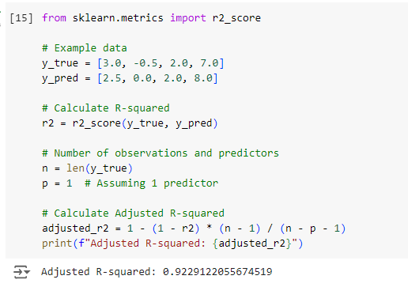

**When to Use Adjusted R²**:

* When comparing multiple regression models with different numbers of predictors.
* In situations where you want to ensure that added predictors contribute meaningfully to the model, avoiding overfitting.