**Mean Absolute Error (MAE)**

**Definition**:

* Mean Absolute Error (MAE) is a measure used to evaluate the accuracy of a regression model. It represents the average of the absolute differences between the predicted and actual values.

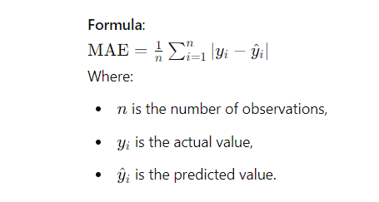

**Interpretation**:

* MAE measures the average magnitude of errors in a set of predictions, without considering their direction (i.e., ignoring whether errors are positive or negative).
* A lower MAE indicates a better fit of the model to the data.
* MAE is easy to interpret, as it is in the same unit as the original data.

**Advantages**:

* Simple to calculate and interpret.
* Provides a linear score, meaning all individual differences are weighted equally.
* Robust to outliers compared to Mean Squared Error (MSE) because it doesn’t square the errors, making it less sensitive to large errors.

**Disadvantages**:

* Does not penalize large errors as much as MSE, which might be a drawback if large errors are particularly undesirable.
* May not be differentiable at all points, making it less suitable for some optimization algorithms.

**Use Cases**:

* MAE is often used in regression problems where the goal is to minimize the average prediction error.
* It is suitable for cases where outliers are not excessively influential or when a more intuitive understanding of error magnitude is preferred.

**Comparison with Other Metrics**:

* **Mean Squared Error (MSE)**: Unlike MSE, which squares the errors, MAE takes the absolute value of errors. MSE penalizes larger errors more heavily, while MAE treats all errors equally.
* **Root Mean Squared Error (RMSE)**: RMSE is the square root of MSE, which provides a measure that is interpretable in the same units as the original data, similar to MAE but still more sensitive to outliers.
* **R-squared (R^2)**: While MAE measures the average error, R^2 provides a measure of how well the model explains the variability in the data. R^2 does not directly convey the magnitude of errors, which MAE does.

**Python Implementation Example**:

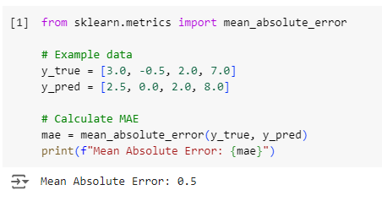

**When to Use MAE**:

* When you need a simple, interpretable metric that is less sensitive to outliers.
* In applications where the importance of errors should be treated equally, without any particular emphasis on large deviations.