**R-squared (R²) Score**

**Definition**:

* R-squared (R²), also known as the coefficient of determination, is a statistical measure that evaluates the goodness-of-fit of a regression model. It represents the proportion of the variance in the dependent variable that is predictable from the independent variables.

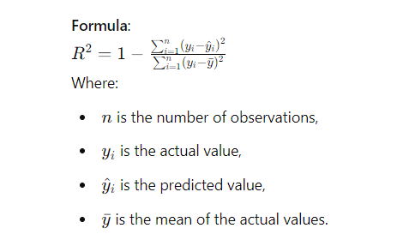

**Interpretation**:

* R² ranges from 0 to 1:
  + **R² = 1**: The model explains all the variance in the dependent variable.
  + **R² = 0**: The model explains none of the variance.
* An R² value closer to 1 indicates a better fit of the model to the data.
* If R² is negative (which can happen in certain cases, particularly in models without an intercept), it suggests that the model performs worse than a simple horizontal line (mean of the data).

**Advantages**:

* Provides a clear and intuitive measure of how well the model explains the variability in the data.
* Useful for comparing the goodness-of-fit of different regression models.

**Disadvantages**:

* R² does not indicate the magnitude of prediction errors; it only measures the proportion of variance explained.
* It does not tell you whether the predictions are biased or how well the model fits the data overall.
* R² can be misleading in cases of non-linear relationships or when the assumptions of linear regression are not met.

**Use Cases**:

* R² is commonly used in linear regression models to assess how well the model fits the data.
* It is useful when you want to quantify the proportion of variance in the dependent variable that is predictable from the independent variables.

**Comparison with Other Metrics**:

* **Mean Squared Error (MSE)**, **Mean Absolute Error (MAE)**, **Root Mean Squared Error (RMSE)**: These metrics provide information about the magnitude of prediction errors, while R² focuses on the proportion of variance explained.
* R² is often used alongside these metrics for a more comprehensive evaluation of model performance.

**Python Implementation Example**:

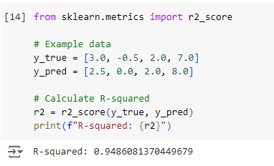

**When to Use R²**:

* When you want to understand the proportion of variance in your data explained by the model.
* In regression analysis, particularly when comparing different models to determine which one best fits the data.