**Root Mean Squared Error (RMSE)**

**Definition**:

* Root Mean Squared Error (RMSE) is a metric used to evaluate the accuracy of a regression model. It is the square root of the Mean Squared Error (MSE), providing an error measure that is in the same units as the original data.

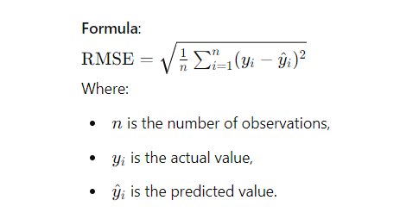

**Interpretation**:

* RMSE measures the average magnitude of errors between predicted and actual values, but it gives more weight to larger errors because of the squaring process.
* A lower RMSE indicates a better fit of the model to the data.
* RMSE is more interpretable than MSE, as it is in the same unit as the original data.

**Advantages**:

* Provides an error measure that is easily interpretable, as it is in the same units as the target variable.
* Penalizes larger errors more heavily, which is useful in cases where large deviations are particularly undesirable.
* Commonly used as a standard metric for regression model performance evaluation.

**Disadvantages**:

* Sensitive to outliers, as large errors are squared, increasing their impact on the final RMSE value.
* Like MSE, it may not be the best metric in cases where you want to give equal importance to all errors, regardless of their magnitude.

**Use Cases**:

* RMSE is often used in regression problems where the goal is to minimize prediction errors.
* It is widely used in various fields such as finance, engineering, and environmental modeling to measure the accuracy of predictions.

**Comparison with Other Metrics**:

* **Mean Absolute Error (MAE)**: Unlike RMSE, which squares errors, MAE takes the absolute value of errors. RMSE penalizes larger errors more heavily, while MAE treats all errors equally.
* **Mean Squared Error (MSE)**: RMSE is the square root of MSE. While MSE provides an error measure in squared units, RMSE converts it back to the original unit, making it more interpretable.
* **R-squared (R^2)**: R^2 measures the proportion of variance explained by the model, whereas RMSE provides an absolute measure of error magnitude. Both are often used together to assess model performance.

**Python Implementation Example**:

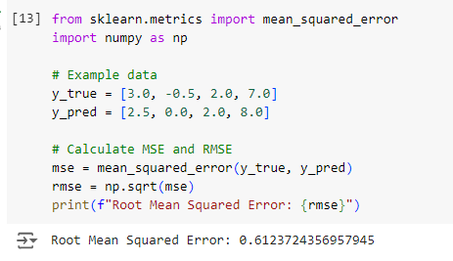

**When to Use RMSE**:

* When you need an error metric that is easily interpretable and in the same units as the original data.
* In cases where larger errors should be penalized more heavily than smaller ones.
* When comparing the performance of different models, especially in scenarios where understanding the magnitude of prediction errors in the original units is important.