🏥 CLINICAL REHABILITATION PLATFORM
Technical Feasibility Report

A centralized, multilingual healthcare platform for patient rehabilitation with Web + Android App.
Goal: Simplify patient registration, treatment tracking, scheduling, and communication for clinics and rehab centers.

Prepared by a Technical Feasibility Analyst & Healthcare IT Consultancy Practice

Prepared for: AL-Nafay E-Services Enterprises
Document Type: Project Feasibility Study
Date: August 2026

Executive Summary
This report evaluates the technical feasibility of building a comprehensive Clinical Data and Rehabilitation Management System encompassing patient records, longitudinal tracking, AI-powered analytics, multi-channel booking (WhatsApp Chat, WhatsApp AI Agent, Online Reservation), dynamic scheduling, and enterprise-grade security.

VERDICT: FEASIBLE
- All core requirements are technically achievable using modern, proven technology stacks. The primary constraints are regulatory compliance (healthcare data), AI model accuracy validation (clinical predictions), and real-time multi-channel synchronization. A phased 12-month rollout is recommended.

Metric | Value
Total Development Investment | $635K – $850K
Annual Operating Costs | $180K – $240K
Implementation Timeline | 12 Months (3 Phases)
Primary Risk Factors | Compliance, AI Accuracy, Multi-channel Sync
Infrastructure | Low-cost commodity hardware compatible

1. Technical Architecture Overview

1.1 Architectural Philosophy
The system follows a microservices architecture with an event-driven backbone, enabling independent scaling of clinical, scheduling, analytics, and communication services.
- Separation of Concerns: Clinical data, scheduling logic, AI analytics, and communication channels operate as independent services
- Eventual Consistency: Apache Kafka ensures all booking channels remain synchronized without blocking operations
- Defense in Depth: Multiple security layers (WAF, API Gateway, encryption, anomaly detection) protect PHI
- Low-Cost Commodity Infrastructure: Containerized deployment on budget cloud VPS or on-premise hardware.

1.2 System Architecture Layers
Layer | Components | Purpose
Client Channels | Web App (React PWA), Android Native (Kotlin), WhatsApp Chat, WhatsApp AI Agent, Online Booking Portal | Multi-platform patient and clinician access
Security & Gateway | NGINX/Traefik, JWT/OAuth2, Rate Limiter, WAF | Traffic management, authentication, DDoS protection
Core Services | Patient, Clinical, Scheduling, Reporting, Notification, Billing, Anomaly Detection, i18n | Business logic microservices
AI/ML Engine | Outcome Prediction, Plateau Detection, Trend Forecasting, AI Scheduling, NLP Agent | Intelligent automation and analytics
Data & Infrastructure | PostgreSQL, TimescaleDB, Redis, Elasticsearch, MinIO/S3, Docker/Kubernetes | Persistence, caching, search, storage, orchestration

1.3 Data Flow: Multi-Channel Booking Coordination
- Redis Distributed Locks prevent double-booking at the millisecond level using SETNX atomic operations
- Apache Kafka Event Bus broadcasts booking state changes to all subscriber services in real-time
- AI Scheduling Engine optimizes patient-clinician-room allocations after every successful booking
- Conflict Detector validates against clinician availability, room capacity, equipment needs, and patient contraindications.

2. Platform Requirements

2.1 Recommended Technology Stack
Component | Technology | Rationale
Frontend (Web) | React 18 + TypeScript + Tailwind CSS | Component-based, type-safe, responsive, excellent ecosystem
Mobile (Android) | Kotlin + Jetpack Compose | Native performance, Google-recommended, modern UI toolkit
Backend API | Node.js (NestJS) or Python (FastAPI) | Rapid development, async handling, strong typing
Database (Primary) | PostgreSQL 15+ | ACID compliance, JSON support, row-level security, HIPAA-friendly
Database (Time-Series) | TimescaleDB or ClickHouse | Optimized for longitudinal patient data and reporting cycles
Cache & Sessions | Redis 7+ | Distributed locking, real-time slot reservation, session management
Search & Logs | Elasticsearch + Kibana | Full-text patient search, security audit logging
Message Queue | Apache Kafka or RabbitMQ | Event-driven architecture, booking channel sync
AI/ML Framework | Python (TensorFlow/PyTorch) + scikit-learn | Mature clinical ML libraries, ONNX for deployment
NLP Agent | Rasa Open Source or Dialogflow CX | On-premise option for data privacy; Dialogflow for speed
Scheduling Engine | OR-Tools (Google) + Custom Heuristics | Proven optimization library for resource allocation
Containerization | Docker + Kubernetes (K3s) | Industry standard, K3s runs on commodity hardware
Object Storage | MinIO (S3-compatible) | On-premise alternative to AWS S3, encrypted at rest
Monitoring | Prometheus + Grafana | Open-source, cost-effective observability

2.2 Infrastructure Specifications (Low-Cost)
Resource | Specification | Monthly Cost
Application Servers | 2× VPS (4 vCPU, 8GB RAM) or 3× commodity servers | $80 – $200
Database Server | 1× VPS (4 vCPU, 16GB RAM) + SSD storage | $60 – $150
AI/ML Worker Node | 1× VPS (8 vCPU, 16GB RAM, GPU optional) | $100 – $300
Redis + Kafka | Shared on app nodes or separate small VPS | $40 – $80
Load Balancer + WAF | NGINX (self-managed) or Cloudflare ($20/mo) | $0 – $20
Backup Storage | MinIO cluster or cloud backup (encrypted) | $30 – $60
TOTAL INFRASTRUCTURE |  | $310 – $810/month

Assumption: For true commodity/budget deployment, K3s (lightweight Kubernetes) on 3–4 refurbished enterprise servers or budget VPS providers (Hetzner, DigitalOcean, Linode) can achieve sub-$500/month operational costs at launch.

3. Feature Feasibility Assessment
The following matrix categorizes all required features by implementation complexity and technical feasibility. Circle markers indicate standard off-the-shelf implementations; square markers indicate custom development.

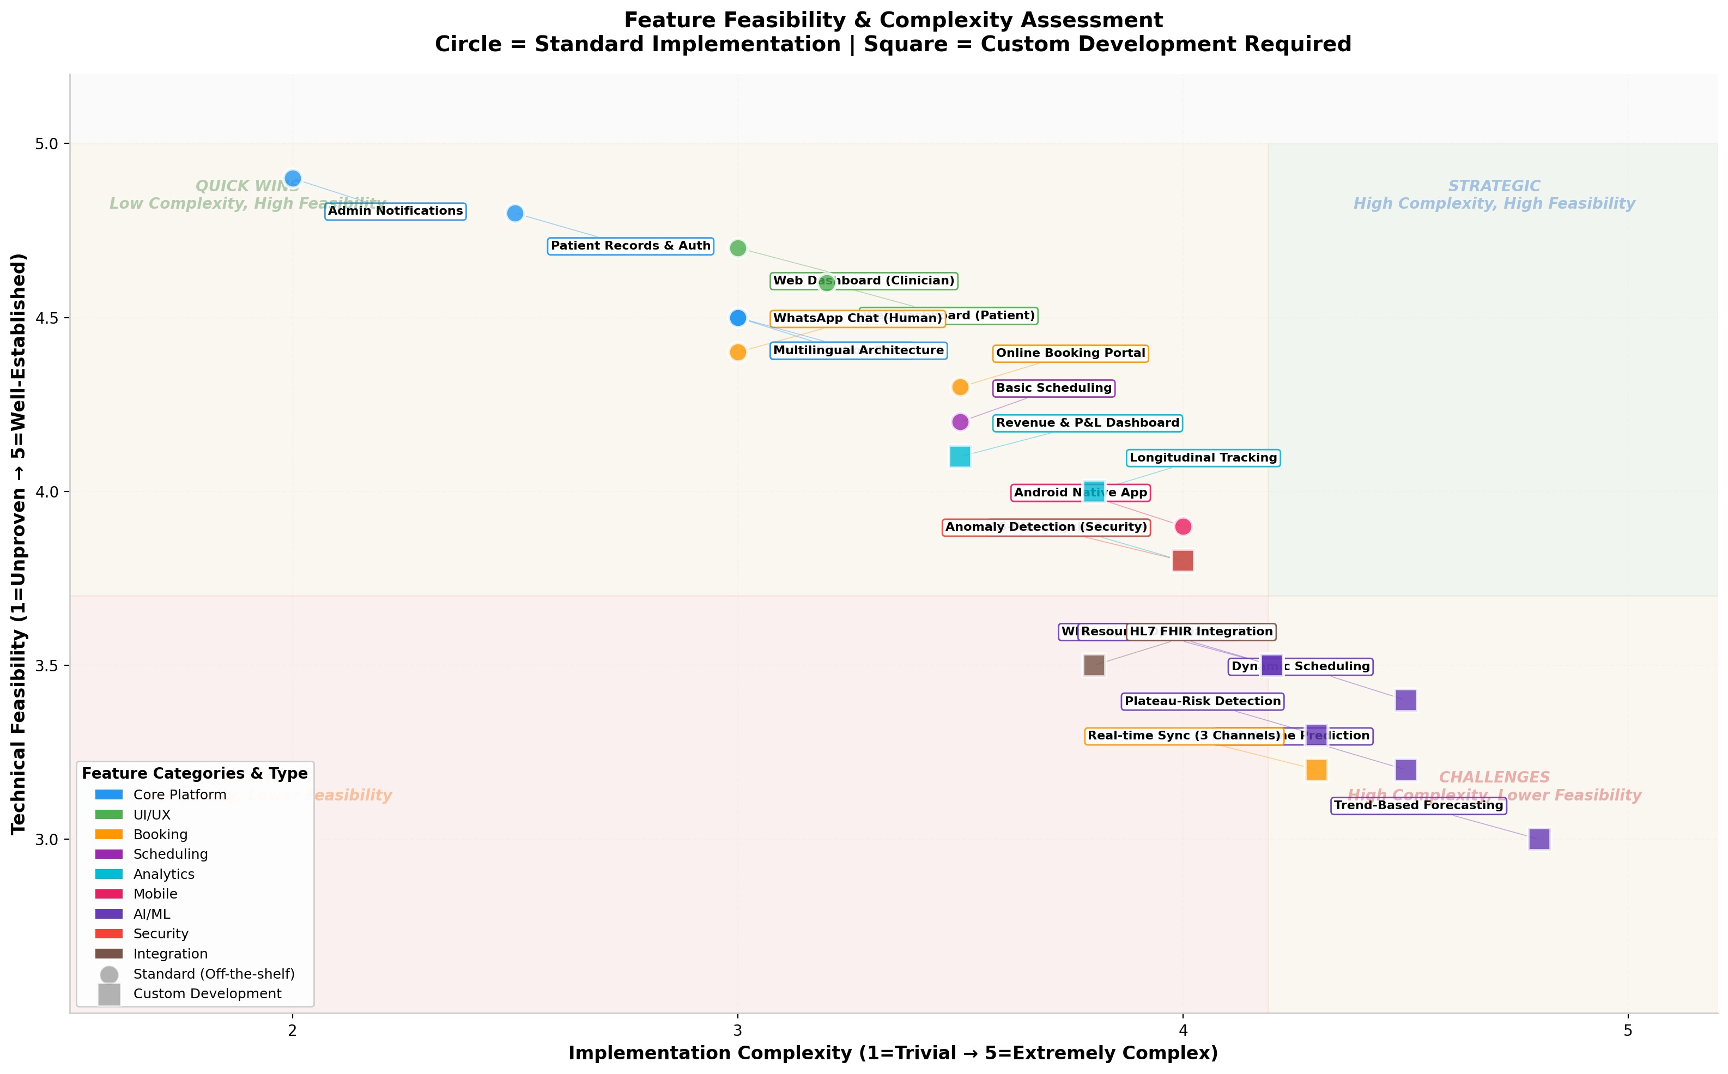

3.1 Standard Implementation Features (Quick Wins)
Feature | Complexity | Feasibility | Timeline
Patient Records & Auth | Low | Very High | 3–4 weeks
Admin Notifications | Very Low | Very High | 1–2 weeks
Web Dashboards (Patient/Clinician) | Medium | Very High | 4–6 weeks
Online Booking Portal | Medium | High | 4–5 weeks
WhatsApp Chat (Human) | Medium | High | 3–4 weeks
Multilingual Architecture | Medium | High | 3–4 weeks

3.2 Custom Development Features (Strategic Investments)
Feature | Complexity | Feasibility | Timeline
AI Outcome Prediction | High | Medium | 8–10 weeks
Plateau-Risk Detection | High | Medium | 6–8 weeks
Trend-Based Forecasting | Very High | Medium-Low | 10–12 weeks
Dynamic AI Scheduling | High | Medium | 8–10 weeks
WhatsApp AI Agent (NLP) | High | Medium | 6–8 weeks
Real-time 3-Channel Sync | High | Medium | 6–8 weeks
Anomaly Detection (Security) | High | Medium-High | 6–8 weeks
HL7 FHIR Integration | High | Medium | 6–8 weeks
Feasibility Summary: Approximately 45% of features are standard implementations achievable with proven libraries. 55% require custom AI/ML development or complex systems engineering. No features are technically infeasible the primary risk is model accuracy and data quality for AI components, not implementation capability.

4. Integration Feasibility

4.1 WhatsApp Business API Integration
Aspect | Feasibility | Details
Human Chat Channel | ✅ High | Webhook-based message reception; reply via Messages API. Requires Meta Business Verification.
AI Agent Channel | ⚠️ Medium | Dialogflow CX or Rasa integration. NLP training needed for medical terminology. Must handle escalation to human agents.
Approval Process | ⚠️ Medium | Meta requires Business Verification (~1–2 weeks). Healthcare use cases may need additional review.
Rate Limiting | ⚠️ Risk | 80 messages/second default limit. Burst traffic requires rate queue management.

4.2 Multi-Channel Booking Coordination
Challenge | Mitigation Strategy
Double-booking | Redis SETNX atomic locks with 5-minute TTL
Stale availability | Kafka events invalidate caches within 100ms
Channel conflicts | Optimistic locking in PostgreSQL with version numbers
Offline channel recovery | Idempotent booking API with deduplication keys

4.3 Clinical Analytics Engine Integration
- EHR Systems (HL7 FHIR): FHIR R4 API adapter; map to internal patient schema
- Lab Results: Standardized import pipeline with data validation
- Wearable Devices: Bluetooth/API integration for real-time rehab metrics
- Third-party AI Models: ONNX runtime for cross-platform model deployment

5. Hardware and Infrastructure Requirements

5.1 Minimum Viable Production Specs
Component | Minimum Spec | Recommended Spec
Application Servers | 2× 4 vCPU / 8GB RAM | 3× 8 vCPU / 16GB RAM
Database | 4 vCPU / 16GB RAM / 500GB SSD | 8 vCPU / 32GB RAM / 1TB NVMe SSD
AI/ML Node | 8 vCPU / 16GB RAM | 8 vCPU / 32GB RAM / NVIDIA T4 GPU
Storage | 1TB (encrypted) | 5TB (encrypted + replicated)
Network | 100 Mbps symmetric | 1 Gbps symmetric
Backup | Daily to secondary location | Real-time replication + daily snapshots

5.2 Low-Cost Deployment Options
Option | Pros | Cons | Best For
Self-managed K3s on refurbished servers | Lowest long-term cost, full data control | Higher maintenance overhead | Established clinics with IT staff
Budget VPS (Hetzner/DigitalOcean) | Quick setup, predictable costs | Data residency concerns | Startups, rapid prototyping
Hybrid (VPS + on-premise DB) | Balance of cost and control | Complex networking | Mid-size rehabilitation centers
Managed Kubernetes (EKS/GKE) | Minimal ops overhead | Higher cost, vendor lock-in | Enterprises with larger budgets

5.3 Security Compliance Architecture
Given the 100% secure anomaly detection requirement and healthcare context, the following layered security model is mandatory:
Layer | Implementation | Response
Encryption at Rest | AES-256 for all databases and file storage | Data protection even if physical media compromised
Encryption in Transit | TLS 1.3 for all API communications | Prevents man-in-the-middle attacks
Key Management | HashiCorp Vault or AWS KMS with HSM | Centralized, auditable key lifecycle
Access Control | RBAC with principle of least privilege; MFA for admin | Prevents unauthorized access
Audit Logging | Immutable logs to Elasticsearch; 7-year retention | Regulatory compliance and forensic analysis
Anomaly Detection | Statistical baselines + ML models for intrusion detection | Real-time threat identification
Penetration Testing | Quarterly third-party audits; annual SOC 2 Type II | Independent security validation
Data Residency | Configurable region locking for GDPR/local compliance | Legal compliance across jurisdictions

6. UI/UX Considerations

6.1 Responsive Design Strategy
Platform | Approach | Key Considerations
Desktop Web | React responsive grid (Tailwind) | Large data tables, side-by-side dashboards, keyboard shortcuts for clinicians
Tablet Web | Touch-optimized controls | Clinicians carrying tablets between rooms; swipe gestures
Mobile Web | Progressive Web App (PWA) | Offline capability for rural/low-connectivity areas
Android Native | Jetpack Compose with Material You | Deep system integration: notifications, calendar, biometrics

6.2 Design System Recommendations
- Component Library: Material-UI (MUI) for web + Material Design Components for Android ensures visual consistency
- Color Psychology: Calming blues/greens for patient interfaces; high-contrast oranges for alerts and admin actions
- Accessibility: WCAG 2.1 AA compliance screen reader support, minimum 4.5:1 contrast ratios, keyboard navigation
- Typography: Inter or Roboto for readability across devices; minimum 16px base font for mobile

6.3 Patient vs. Clinician Workflow Differentiation
Aspect | Patient Interface | Clinician Interface
Primary Goal | Self-service, reassurance, progress visibility | Efficiency, data density, rapid decision-making
Dashboard Layout | Card-based, single-column, celebratory milestones | Multi-panel, data tables, quick-action buttons
Color Scheme | Soft gradients, progress indicators | High information density, color-coded severity
Notifications | Encouraging, educational | Action-oriented, priority-flagged

7. Implementation Timeline Estimate
The following Gantt-style timeline illustrates the 12-month phased rollout with key milestones and dependencies.

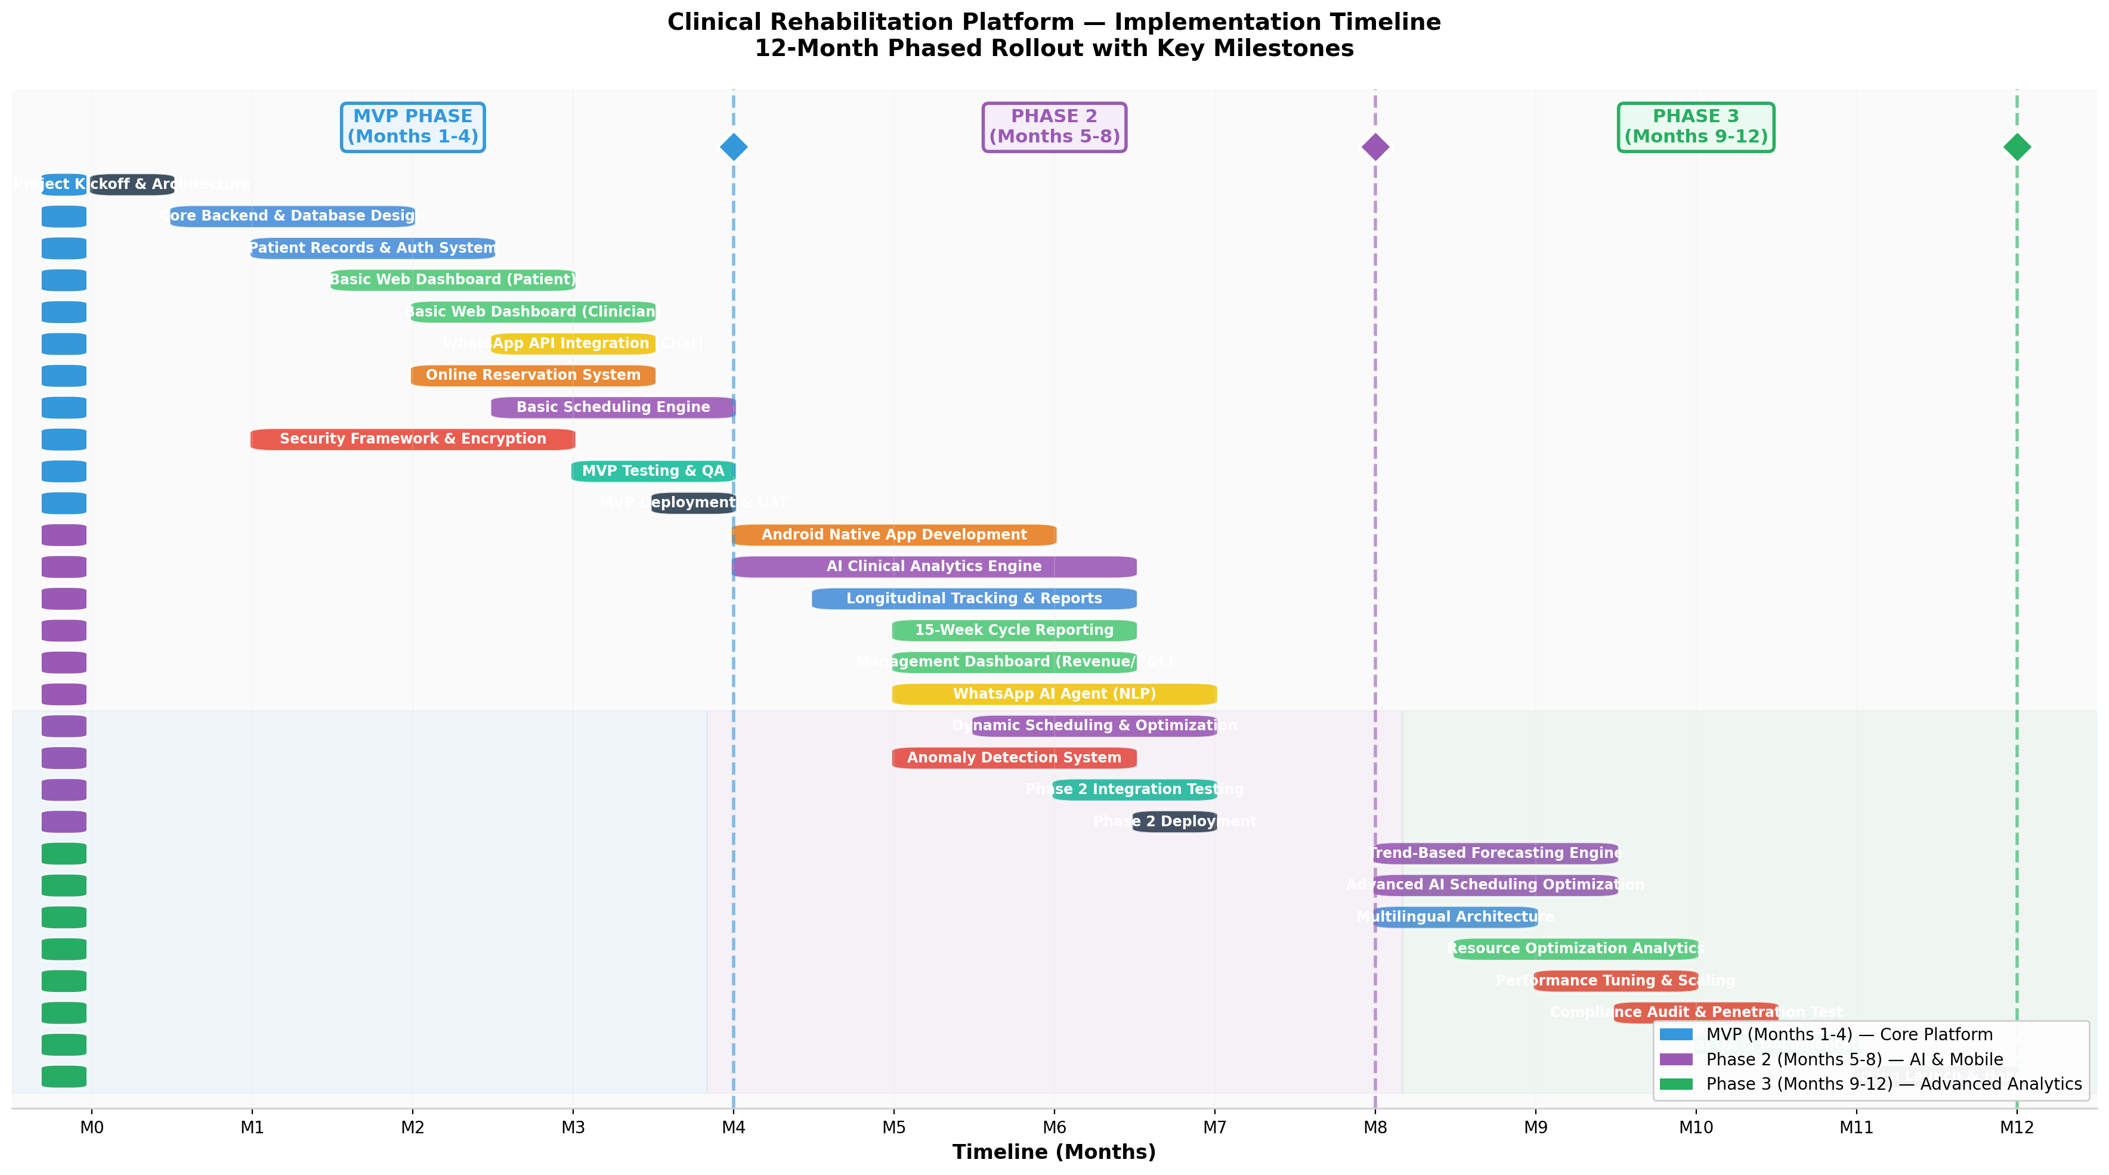

7.1 MVP Phase (Months 1–4) Core Platform
Budget: ~$235,000 | Team: 2 Full-stack, 1 Mobile, 1 DevOps, 1 UI/UX, 1 QA, 0.5 PM
Milestone | Deliverable | Dependencies
Month 1 | Architecture finalization, database schema, CI/CD pipeline | None
Month 2 | Patient records, authentication, basic dashboards | Database schema
Month 3 | Online booking, WhatsApp Chat integration, basic scheduling | Auth system
Month 4 | Security framework, MVP testing, deployment | All core features
MVP Success Criteria: Clinicians can register patients, create rehabilitation plans, book appointments via web and WhatsApp, and view basic progress dashboards.

7.2 Phase 2 (Months 5–8) AI & Mobile
Budget: ~$230,000 | Team: +1 ML Engineer, +1 Backend (scaling team)
Milestone | Deliverable | Dependencies
Month 5 | Android app development begins, longitudinal tracking | MVP APIs
Month 6 | AI Clinical Analytics engine, 15-week reporting | >500 patient records
Month 7 | WhatsApp AI Agent, dynamic scheduling, management dashboards | AI engine v1
Month 8 | Anomaly detection system, Phase 2 integration testing | All Phase 2 features
Phase 2 Success Criteria: Patients use Android app; AI predicts outcomes with >75% accuracy admin receives automated reports.

7.3 Phase 3 (Months 9–12) Advanced Analytics & Scale
Budget: ~$170,000
Milestone | Deliverable | Dependencies
Month 9 | Trend-based forecasting, advanced scheduling optimization | 6+ months historical data
Month 10 | Multilingual rollout, resource optimization analytics | i18n framework
Month 11 | Performance tuning, compliance audit, penetration testing | All features complete
Month 12 | Production launch, documentation, staff training | Audit clearance
Total Timeline: 12 months from kickoff to full production.

8. Cost Estimation
The following charts illustrate development costs by phase and annual ongoing operational expenditures.

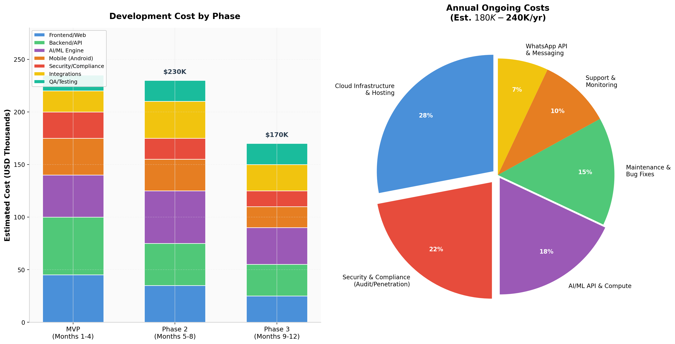

8.1 Development Costs
Phase | Duration | Estimated Cost | Team Composition
MVP | 4 months | $235,000 | 2 Full-stack, 1 Mobile, 1 DevOps, 1 UI/UX, 1 QA, 0.5 PM
Phase 2 | 4 months | $230,000 | + 1 ML Engineer, + 1 Backend
Phase 3 | 4 months | $170,000 | Team stable, focus on optimization
TOTAL DEVELOPMENT | 12 months | $635,000

8.2 Infrastructure & Operating Costs (Annual)
Category | Annual Cost | Notes
Cloud/Server Hosting | $50,000 – $100,000 | Scales with patient volume
Security & Compliance | $40,000 – $60,000 | Audits, penetration testing, certifications
AI/ML API & Compute | $30,000 – $50,000 | Model training, inference, NLP APIs
Maintenance & Bug Fixes | $25,000 – $35,000 | 15–20% of dev cost annually
Support & Monitoring | $15,000 – $25,000 | 24/7 alerting, incident response
WhatsApp API & Messaging | $10,000 – $20,000 | Per-message pricing at scale
TOTAL ANNUAL OPERATING | $170,000 – $290,000

8.3 One-Time Costs
Item | Cost | Purpose
Security Audit & Penetration Test | $15,000 – $25,000 | Pre-launch compliance validation
SOC 2 Type II Certification | $30,000 – $50,000 | If required for enterprise clients
Medical Device/Data Compliance Review | $10,000 – $20,000 | Legal/technical healthcare compliance
TOTAL ONE-TIME | $55,000 – $95,000

9. Risk Assessment
The following risk matrix plots all identified risks by impact severity and probability of occurrence. Bubble size indicates mitigation complexity; color indicates risk category.

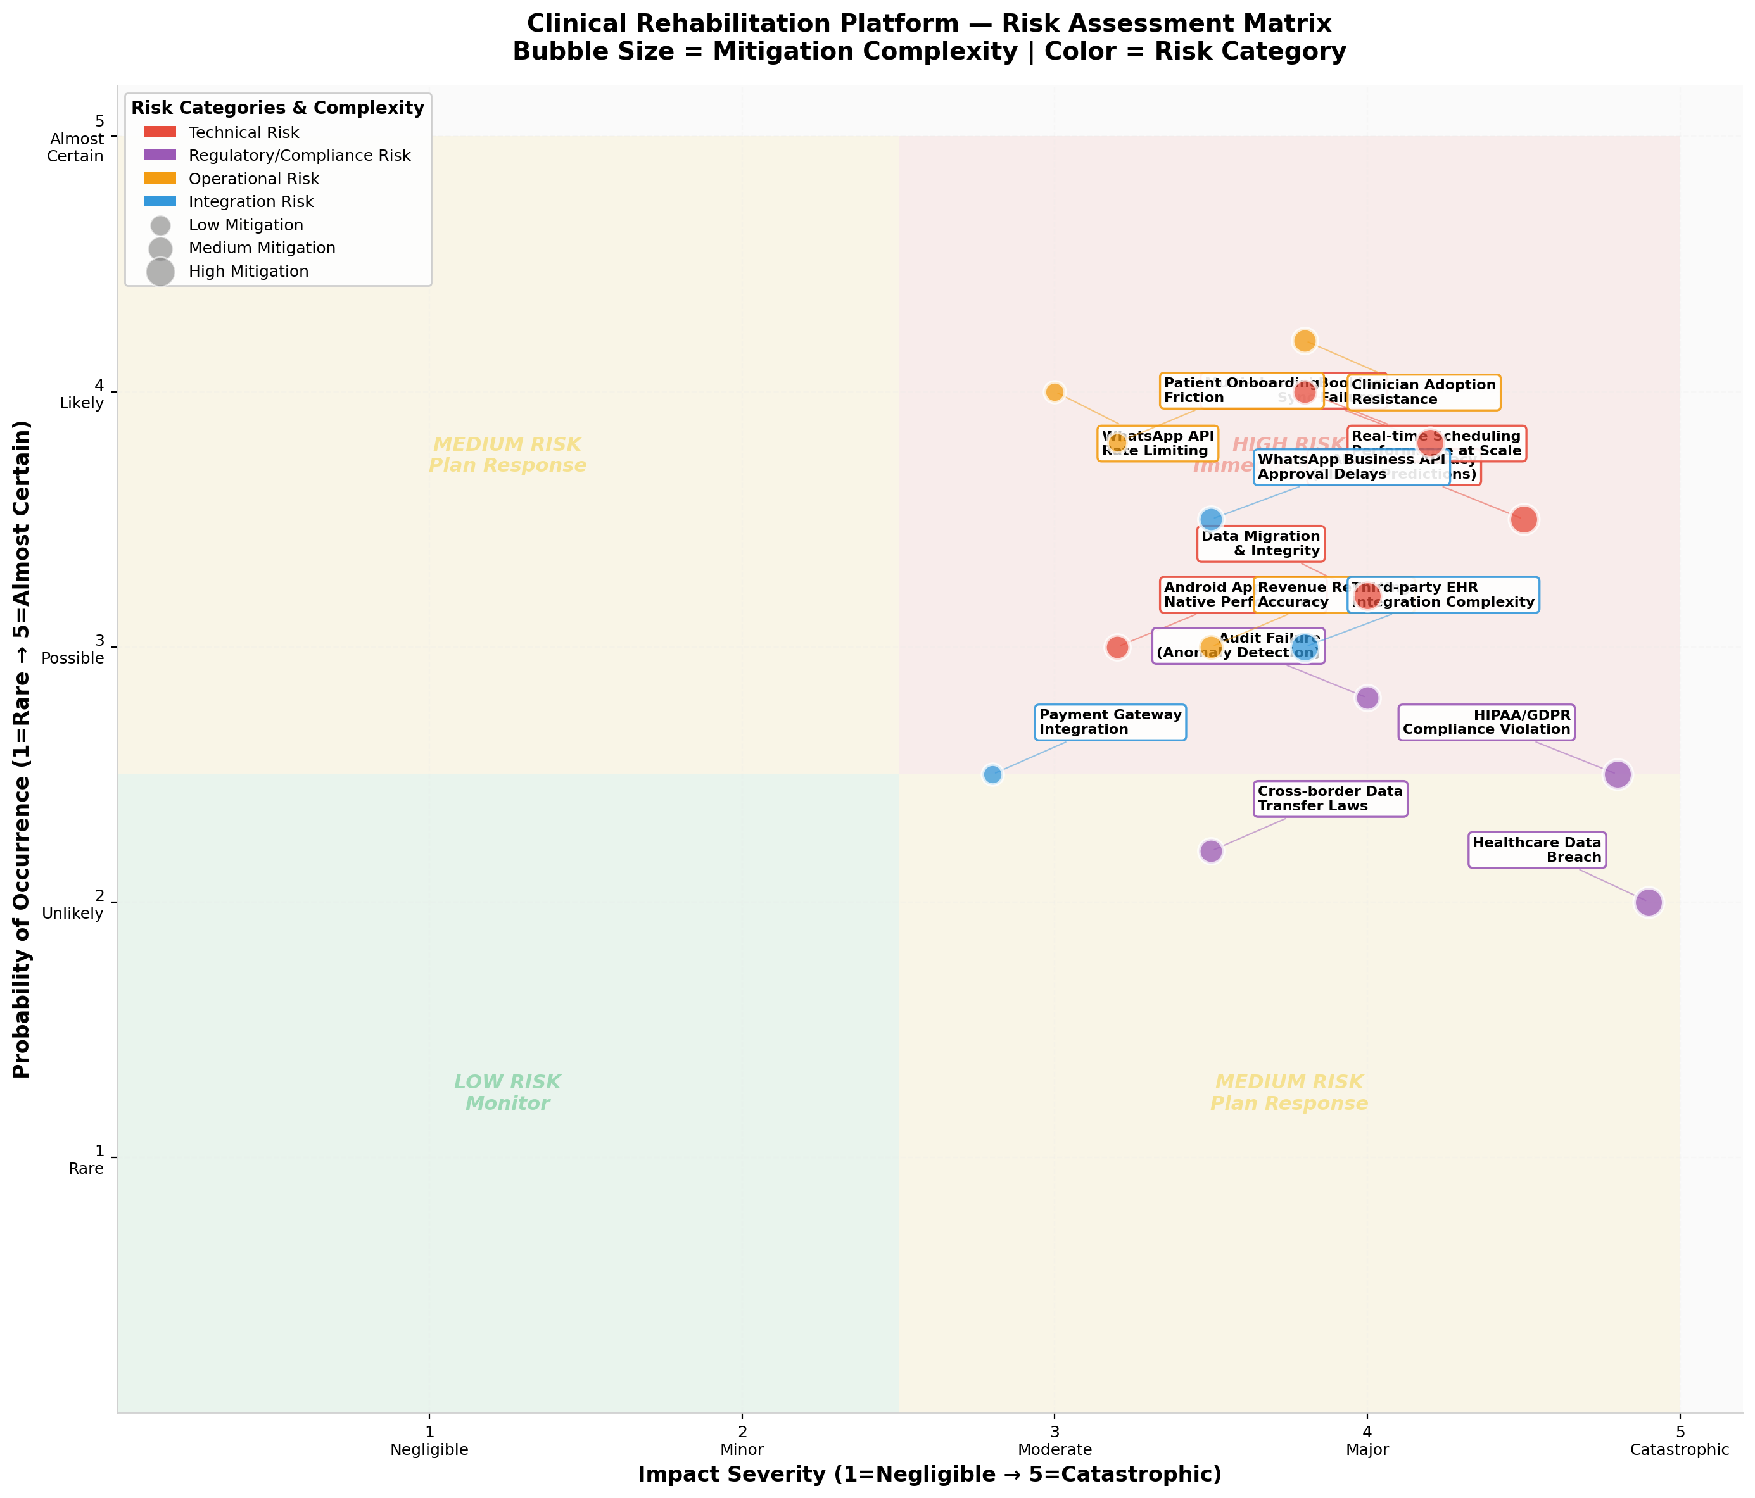

9.1 Critical Risks (Immediate Action Required)
Risk | Impact | Probability | Mitigation
Healthcare Data Breach | Catastrophic | Low | AES-256 encryption, Vault key management, quarterly pen-tests, zero-trust architecture
HIPAA/GDPR Compliance Violation | Catastrophic | Low-Medium | Legal review from Month 1, automated compliance scanning, data residency controls
AI Clinical Prediction Inaccuracy | Major | Medium | Start with decision-support (not autonomous), clinician override always available, continuous model validation

9.2 High-Priority Risks (Plan Response)
Risk | Impact | Probability | Mitigation
Multi-channel Booking Sync Failures | Major | Likely | Redis distributed locks, extensive chaos testing, circuit breakers
Real-time Scheduling at Scale | Major | Likely | Load testing at 10× expected volume, horizontal scaling, caching layers
Clinician Adoption Resistance | Major | Likely | UX research with clinicians, phased rollout, training program, feedback loops
WhatsApp Business API Approval Delays | Moderate | Likely | Apply for verification in Month 1; build fallback SMS channel

9.3 Data Anomaly Detection Requirements
Given the '100% secure system with comprehensive anomaly detection' requirement, the following layered detection model is mandatory:
Detection Layer | Method | Response
Network Layer | DDoS detection, unusual traffic patterns | Auto-block + alert
Application Layer | Unusual API call patterns, failed auth bursts | Rate limit + admin alert
Data Layer | Unusual query patterns, mass exports, off-hours access | Suspend account + audit
Behavioral Layer | Impossible travel, device fingerprint changes | Step-up authentication
Clinical Layer | Impossible patient data combinations, out-of-range values | Flag for clinical review

10. Recommendations

10.1 Technology Partners & Open-Source Solutions
Need | Recommended Solution | Cost Model
Backend Framework | NestJS (Node) or FastAPI (Python) | Open-source
Database | PostgreSQL + TimescaleDB | Open-source
Container Orchestration | K3s (lightweight Kubernetes) | Open-source
Monitoring | Prometheus + Grafana | Open-source
NLP/Chatbot | Rasa Open Source | Open-source (Dialogflow CX for rapid start)
Scheduling Optimization | Google OR-Tools | Open-source
AI/ML Platform | MLflow + ONNX Runtime | Open-source
WhatsApp API | Meta WhatsApp Business API | Pay-per-message
Cloud Hosting | Hetzner Cloud / DigitalOcean | ~$300–$600/month
Security Scanning | OWASP ZAP + Snyk | Open-source + Freemium

10.2 Rapid Deployment Model
For fastest time-to-value, the following hybrid approach is recommended:
- Month 1–2: Use low-code tools (Retool/Appsmith) for internal clinician dashboards while building the patient-facing platform
- Month 2–3: Integrate Dialogflow CX for the WhatsApp AI agent (faster than training Rasa from scratch); migrate to Rasa in Phase 2 for data sovereignty
- Month 3–4: Launch with PostgreSQL + Redis on a single robust server; migrate to microservices only when traffic demands it
- Month 6+: Introduce AI features incrementally start with descriptive analytics, then predictive, then prescriptive

10.3 Key Success Factors
- Start with data quality: AI predictions are only as good as the input data. Invest in data validation pipelines early.
- Clinician co-design: Involve rehabilitation specialists in UX design from Week 1. Adoption is the #1 operational risk.
- Security-first, not security-later: Implement encryption, audit logging, and access controls in the MVP. Retrofitting security is 10× more expensive.
- Measure before predicting: Ensure 3–6 months of structured data exists before deploying AI outcome prediction models.
- Plan for compliance: Budget 15–20% of total project cost for security, compliance, and anomaly detection infrastructure.

Conclusion & Next Steps
The Clinical Rehabilitation Platform is technically feasible and strategically sound. The architecture leverages proven, cost-effective technologies that can run on commodity hardware while scaling to enterprise demands. The 12-month phased approach balances rapid value delivery with risk mitigation.

Immediate Next Steps
Step | Action | Owner | Timeline
1 | Finalize regulatory requirements (HIPAA/GDPR/local) | Compliance/Legal | Week 1–2
2 | Secure WhatsApp Business API verification | Business Dev | Week 1–4
3 | Assemble core development team (6–8 engineers) | HR/Recruitment | Week 2–6
4 | Provision development infrastructure | DevOps | Week 2–3
5 | Conduct clinician workflow research | Product/UX | Week 3–6
6 | Draft data schema and API contracts | Architecture | Week 4–6
7 | Begin MVP sprint 1 (Auth + Patient Records) | Engineering | Week 6

Report Prepared By: Technical Feasibility Analyst
Review Cycle: This report should be revisited at the end of each phase (MVP, Phase 2, Phase 3) to incorporate learnings and adjust timelines/costs.

