CIS 201: Computer Hardware Lab

Name: Mahnoor Bibi

Lab 5.1: Remove and replace a hard drive  
Estimated Completion Time: 45 minutes

Objective:

The goal of this lab is to familiarize you with the process of replacing an old or faulty hard drive. After completing this lab, you will be able to:

* Remove a hard drive
* Install a hard drive
* Configure a new hard drive according to its documentation

Reference:

* Refer to A Guide to Managing and Maintaining a PC: Chapter 4 All About Motherboards

Activity:

1. Open the computer case
2. Locate the hard drive
3. Locate and trace the power and data cable
4. Take a picture of the installed hard drive. Add and label the picture below.

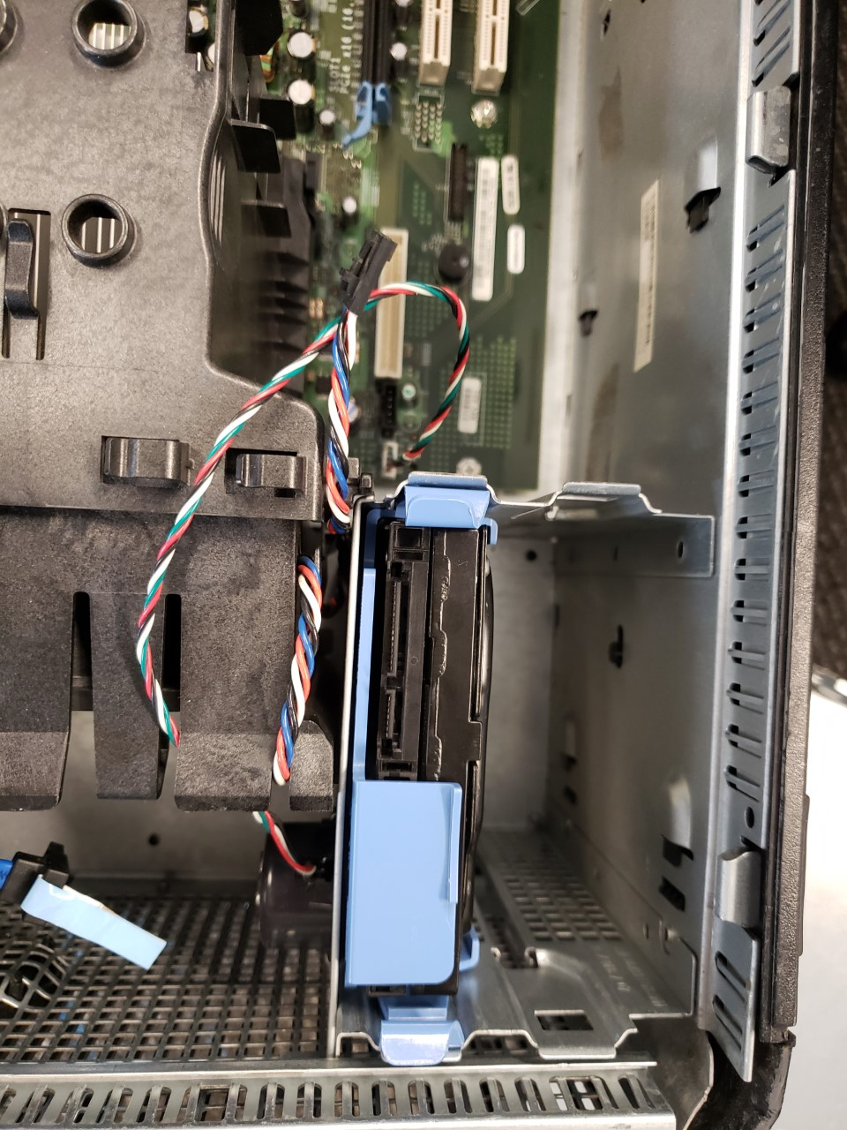

Hard Drive

1. Remove the cables
2. Remove the hard drive. Take a picture of the label on the hard drive. Add the picture below.

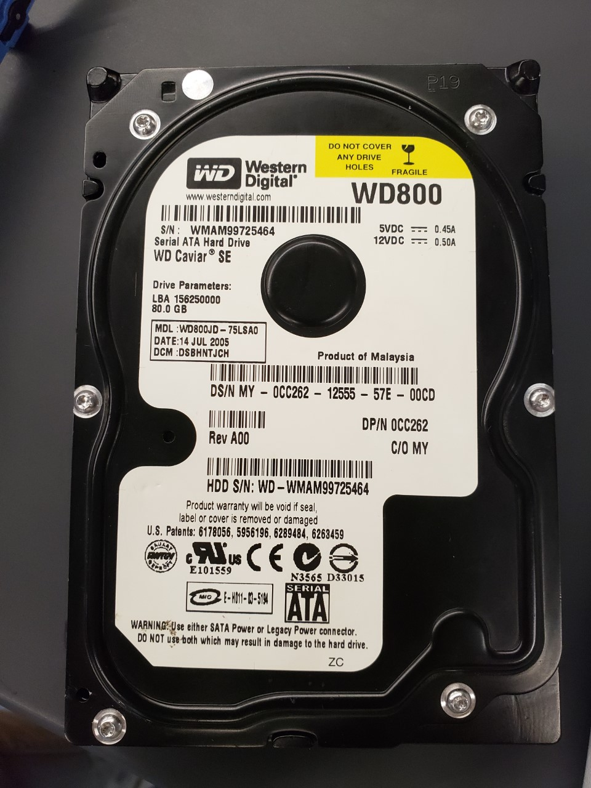

manufacturer

1. Describe the hard drive. Manufacturer. Speed. Capacity. Interface.

West digital, Sata 3.0Gbs, 7200 RPM

1. Replace the hard drive. Describe the steps taken.

It was very easy, but there was a small trick to it, you just had to let the frame rest and not force it

Review Questions

1. How many screws held the hard drive to the case?

*Zero, but there were screws on the disk frame that had to be inserted to the disk itself in order to be installed to the chaise*

1. What are some precautions when removing a computer hard drive?

You don’t want to force it, remove loose jewelry or all to be safe, back up your data

1. Were there jumpers on the hard drive? If yes, what are they used for?

none

1. Research a possible replacement. Name the vendor, manufacturer, price and features of the drive? Why is this a suitable replacement drive?

[WD RE3 750 GB Internal HDD - 3.5" - WD7502ABYS - SATA 3Gb/s - 7,200 rpm](https://www.google.com/aclk?sa=l&ai=DChcSEwiWloCimfvkAhUEeIYKHbkjCicYABAEGgJ2dQ&sig=AOD64_0AuTPZTdd8LVY9G_zaSsB4cemk3w&ctype=5&q=&ved=0ahUKEwiDrvmhmfvkAhUNnlkKHbM8CGgQwzwIMg&adurl=)

This one is also sata interface of 3 gbs and 7200 Rpm and it is from the same manufacturer

Both of them has a 3.5’ Form factor