1. List the user commands and redirect the output to /tmp/commands.list

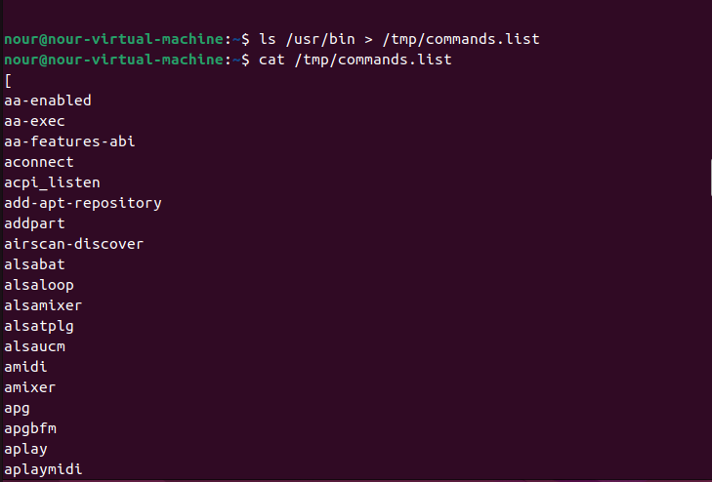

2. Count the number of user commands

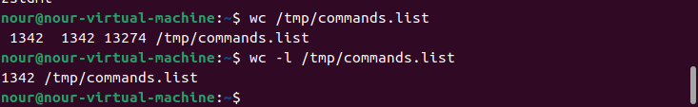

3. Get all the users names whose first character in their login is ‘g’.

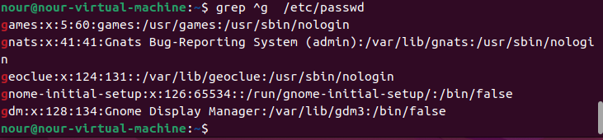

4. Get the logins name and full names (comment) of logins starts with “g”.

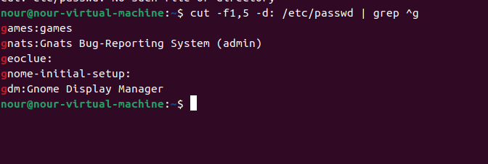

5. Save the output of the last command sorted by their full names in a file.

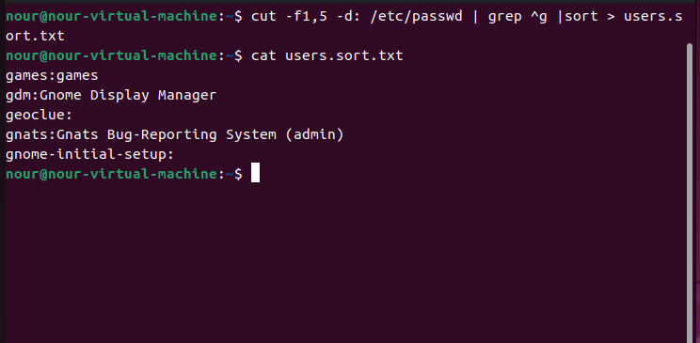

6. Write two commands: first: to search for all files on the system that named .bash_profile. Second: sorts the output of ls command on / recursively, Saving their output and error in 2 different files and sending them to the background.

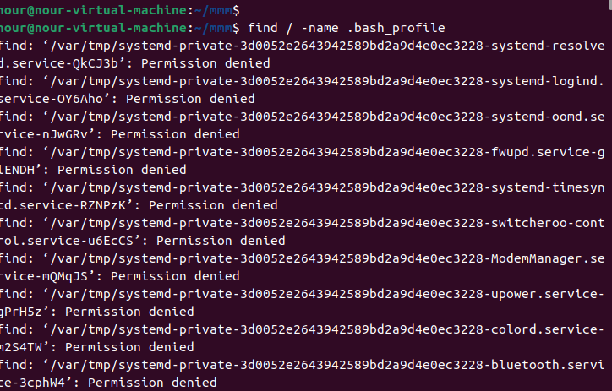

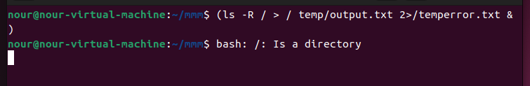

7. Display the number of users who is logged now to the system.

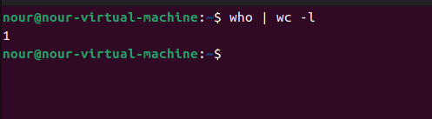

8. Display lines 7 to line 10 of /etc/passwd file

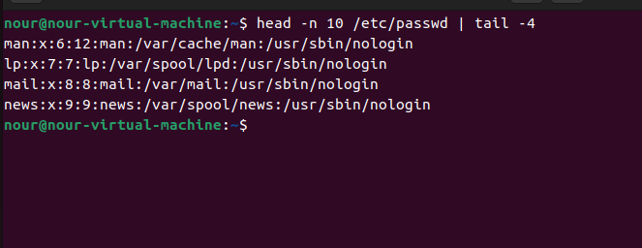

9. What happens if you execute:

• cat filename1 | cat filename2

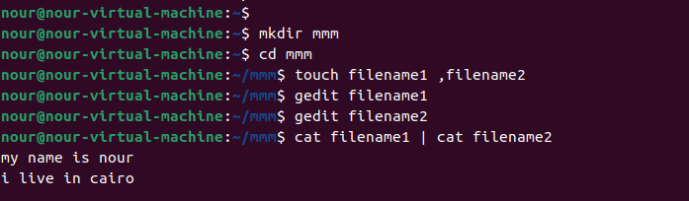

Print the content of filename2

• ls | rm

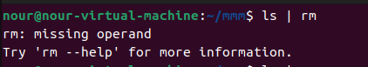

• ls /etc/passwd | wc –l

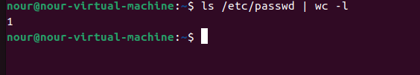

List the content of /etc /passwd

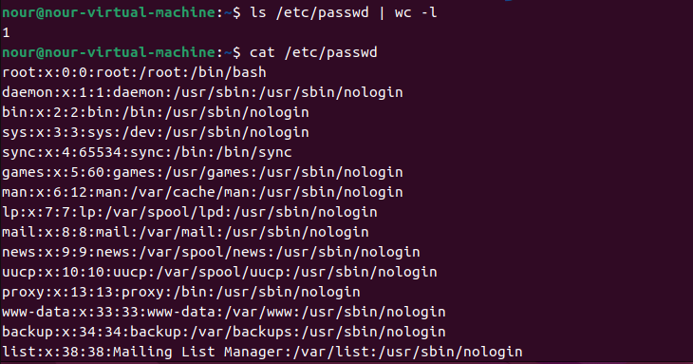

10.Issue the command sleep 100.

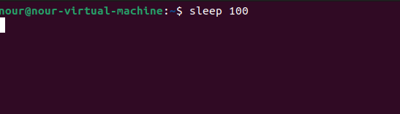

11.Stop the last command.

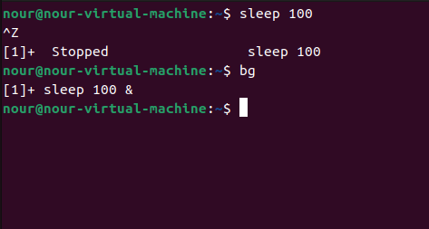

Ctrl + z

12.Resume the last command in the background

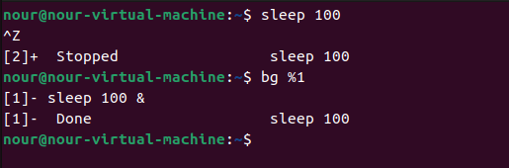

13.Issue the jobs command and see its output.



14.Send the sleep command to the foreground and send it again to the background.

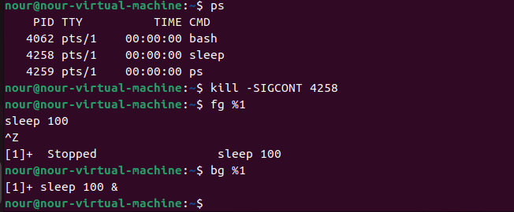

15.Kill the sleep command.

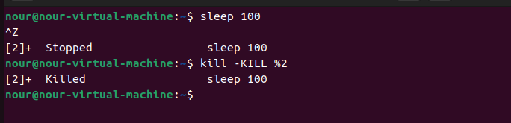

16.Display your processes only

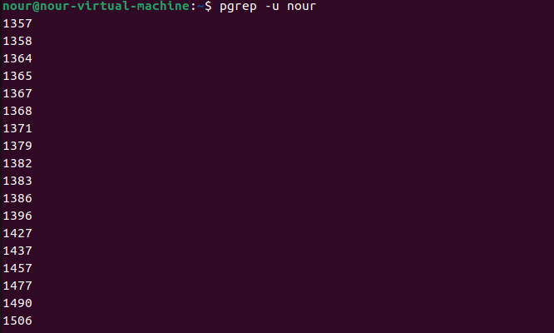

17.Display all processes except yours

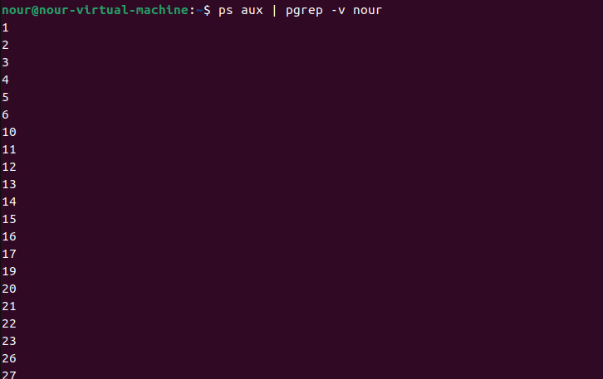

18.Use the pgrep command to list your processes only

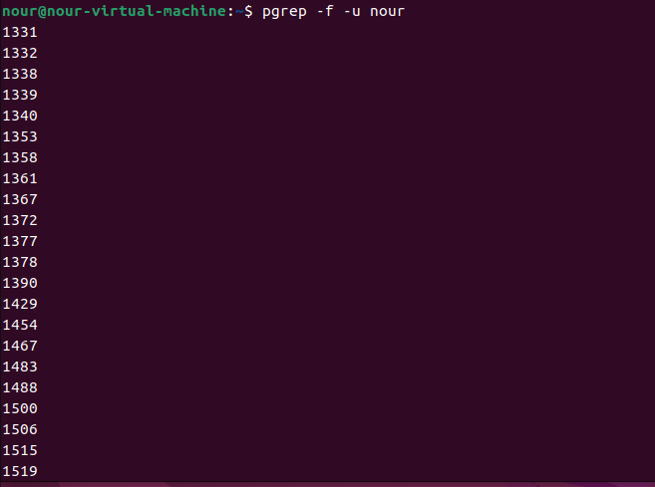

19.Kill your processes only.

