1. Install CentOS /RHEL

DONE

2. What is the difference between cat and more command?

Cat :display the entire content of a file directly to the terminal at once (in one go)

More :display the entire content of a file on screen at a time and allow you to scroll through the content of the file

3. What is the difference between rm and rmdir using man?

rm : used to remove files if I use -r will remove directory

rmdir: To remove empty directories

4. Create the following hierarchy under your home directory: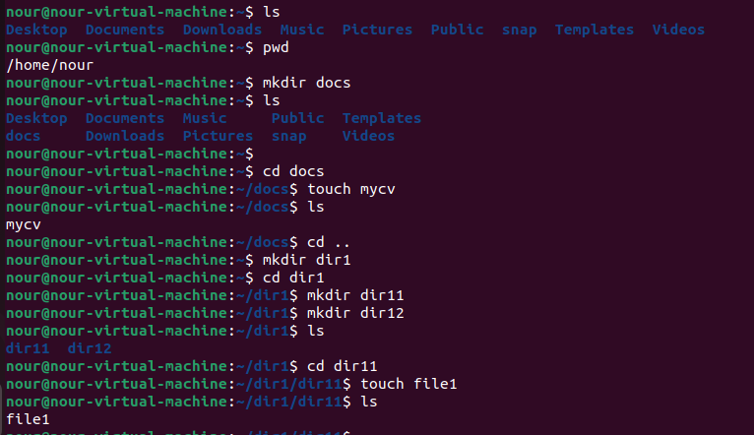

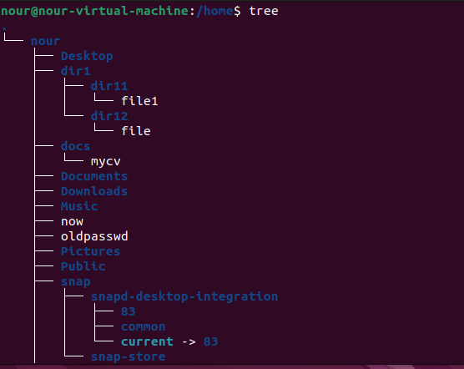

a. Remove dir11 in one-step. What did you notice? And how did you overcome that?



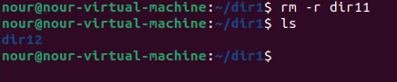

If I use rmdir will encounter error because it designed to remove empty dircetors and dir11 contain file in it so it not empty to overcome that I use rm -r dir11 ,this command will recusively remove the directory and all contents.

b. Then remove dir12 using rmdir –p command. State what happened to the hierarchy (Note: you are in your home directory).

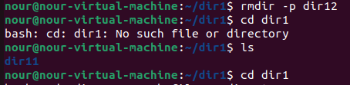

dir 12 is empty so will removed along with its parent directores and the entire hirerarchy .

c. The output of the command pwd was /home/user. Write the absolute and relative path for the file mycv

absolute path for mycv : ’ /home/nour/dir1/dir12/mycv ‘

relative path for mycv: ‘nour/dir1/dir12/mycv ‘

5. Copy the /etc/passwd file to your home directory making its name is mypasswd.

First command will creat a copy of the file in my home

6. Rename this new file to be oldpasswd.

Second command in the image will rename it

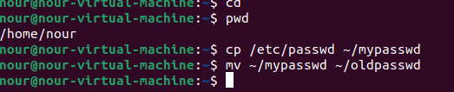

7. You are in /usr/bin, list four ways to go to your home directory

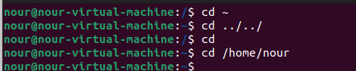

8. List Linux commands in /usr/bin that start with letter w

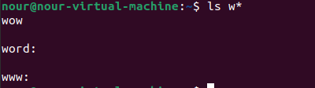

9. Display the first 4 lines of /etc/passwd

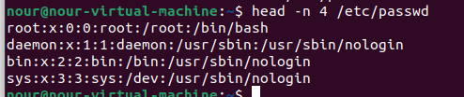

10.Display the last 7 lines of /etc/passwd

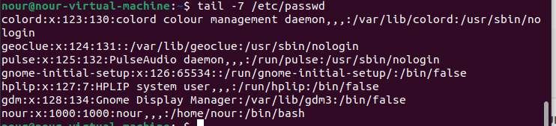

11.Display the man pages of passwd the command and the file sequentially in one command

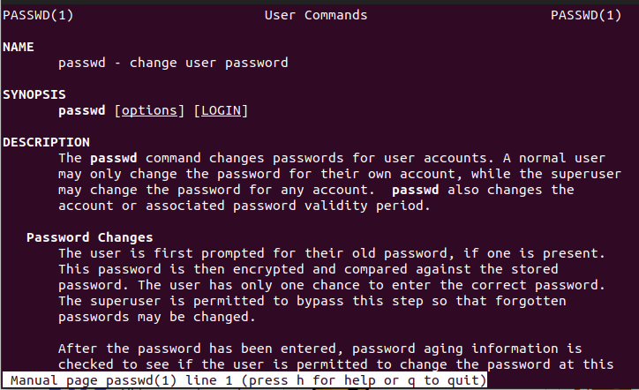

12.Display the man page of the passwd file

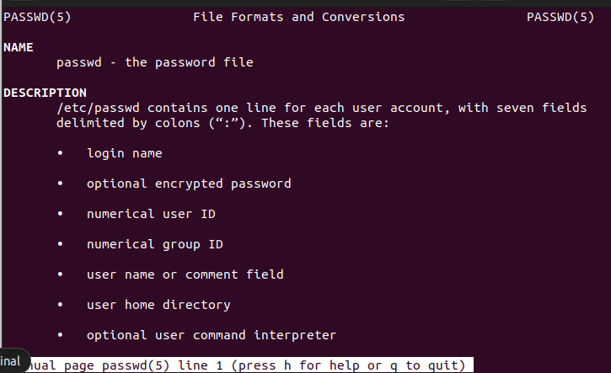

13.Display a list of all the commands that contain the keyword passwd in their man page.

