# 

# Recipe Genie – User Manual

## 1. Account Creation and Login

* Creating an Account

1. Launch the Recipe Genie application.
2. Click the “Sign Up” button on the home page.
3. Fill in the required information: name, email, and password.
4. Click “Create Account”.
5. You’ll be redirected to your personal profile page after successful registration.

* Logging In

1. Click the “Login” button.
2. Enter your email and password.
3. Click “Login” to access your account.

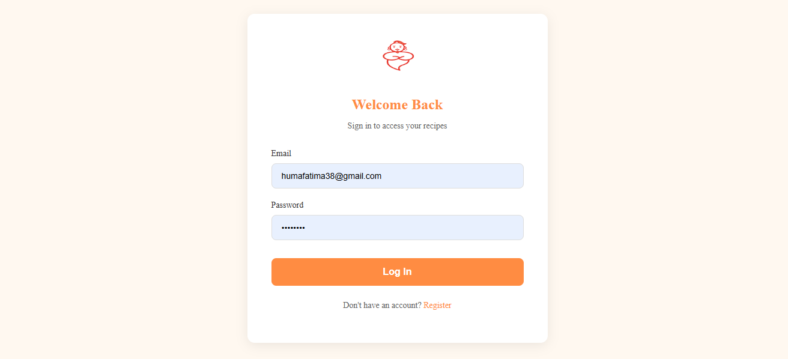

## 2. Posting and Managing Recipes

* Posting a Recipe

1. Navigate to the “Post a Recipe” section.
2. Upload an image of the dish.
3. Enter the recipe name, ingredients, and step-by-step instructions.
4. Click “Submit” to post.

* Managing Recipes

1. Visit your profile page to view recipes you’ve posted.
2. Click “Edit” to update a recipe or “Delete” to remove it.

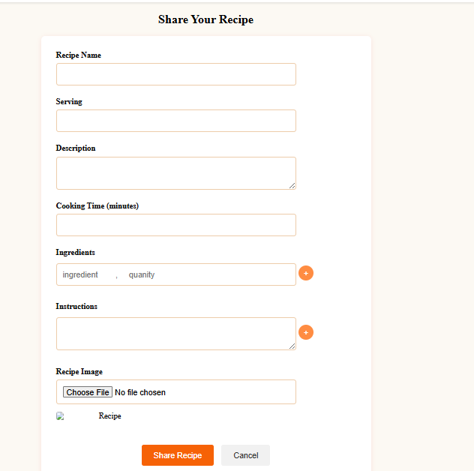

## 3. Subscribing to Other Users

1. Browse through recipes or use search to find other users.
2. Click on a user’s profile.
3. Click the “Subscribe” button to follow them.
4. Subscribed users’ new recipes will appear on your feed.

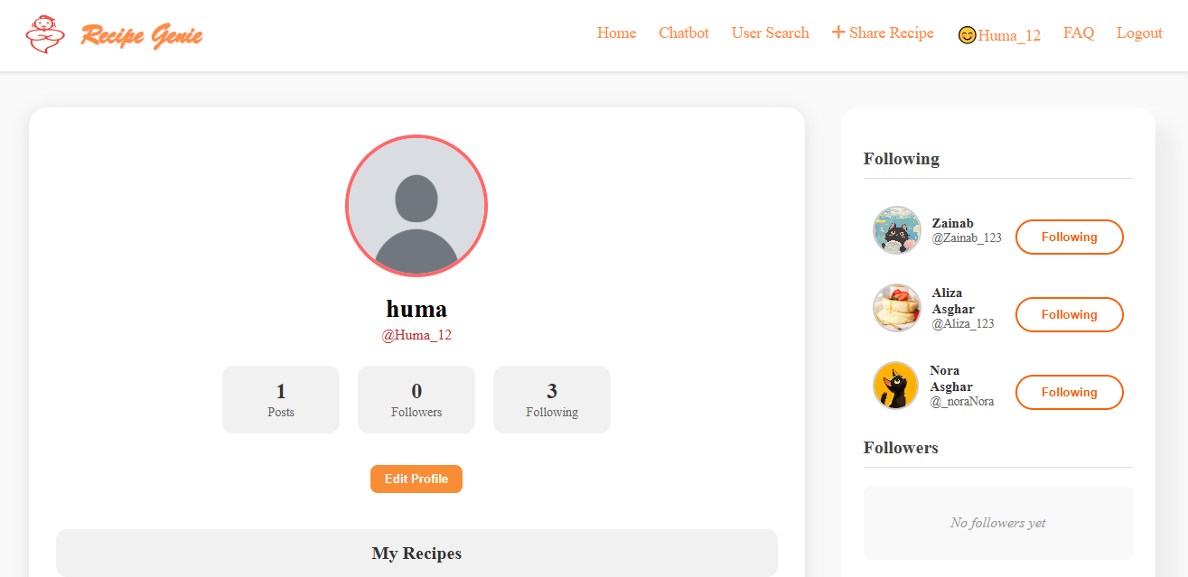

## 4. Liking Recipes

1. Open any recipe.
2. Click the heart icon to like the recipe.
3. Liked recipes help boost visibility and are stored in your “Liked Recipes” section.

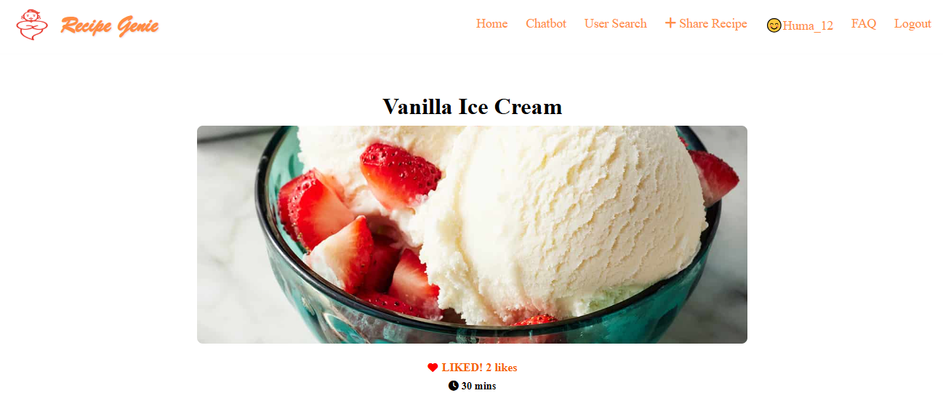

## 5. Using the Built-in Cooking Timer

1. scroll to the “Cooking Timer” section while viewing a recipe.
2. Set the desired time using the slider or input field.
3. Click “Start Timer”.
4. An alert will notify you when the timer ends.



## 6. Interacting with the AI Chatbot

1. Go to the AI Chatbot Page from the navigation bar.
2. Type your query – e.g., “Suggest a vegetarian dinner with tomatoes.”
3. The chatbot will reply with tips, substitutions, or recipe suggestions.
4. You can also ask for ingredient replacements or cooking techniques.

## 6.2. Adjusting Recipe Servings with Chatbot

1. The chatbot will respond with an updated list of ingredients based on the specified number of servings.
2. Type a message like “Adjust this recipe for 4 servings.”
3. Click the chatbot icon or go to the AI Chatbot Page.
4. Open a recipe.
5. Locate the serving size adjustment option.
6. The ingredient list will automatically update to match the new serving size.

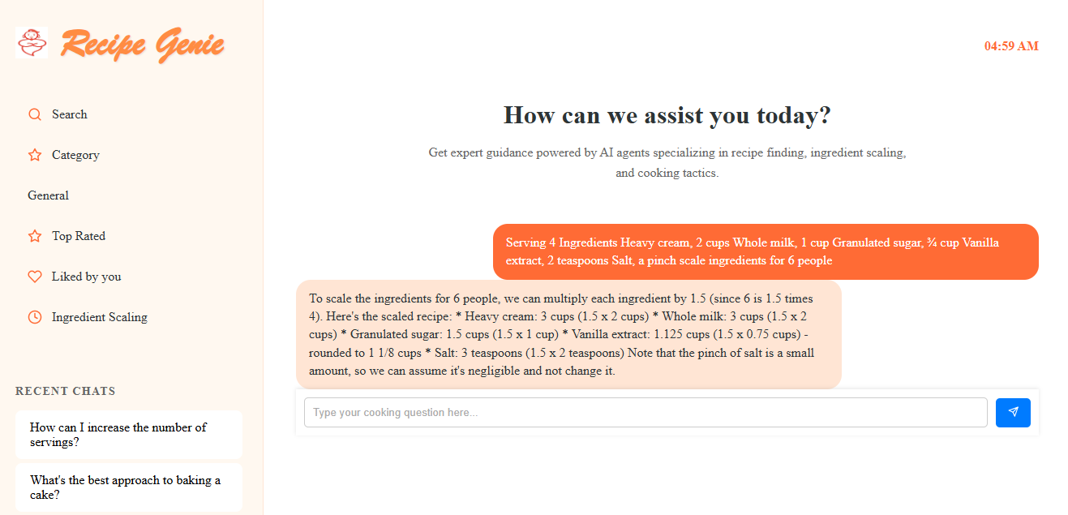

## 8. FAQ Pages

The FAQ (Frequently Asked Questions) section is designed to help users quickly find answers to common queries about using the Recipe Genie app.

* Accessing the FAQ Page

1. Navigate to the Help or Support section from the main menu.
2. Click on “FAQ”.
3. Browse categorized questions about account setup, recipe posting, chatbot usage, and more.

* Using the FAQ

1. Click on a question to expand the answer.
2. Use the search bar at the top of the FAQ page to type in keywords related to your issue.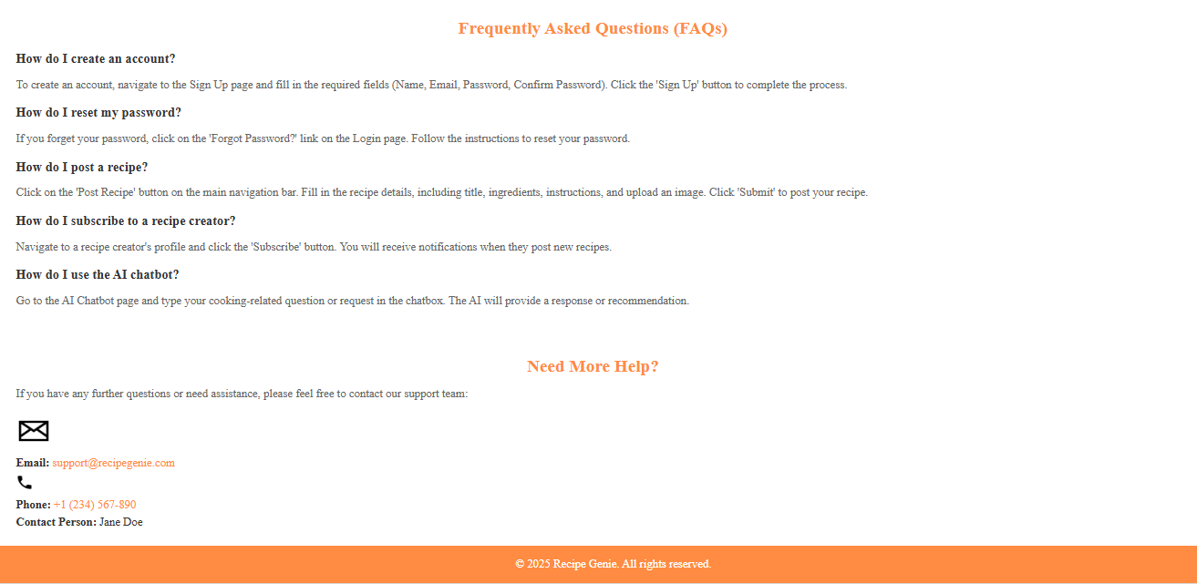

## 9. User Search

The User Search feature allows you to find other recipe creators on the platform.

* How to Search for Users

1. Tap on the search icon in the top navigation bar.
2. Select the “Users” filter from the dropdown menu.
3. Enter a username or keyword related to the type of content they post.
4. Click on the user’s name to visit their profile.
5. You can then subscribe to their profile to stay updated with their latest recipe posts.

