**SQL PROJECT – HIRING ABC COMPANY (Real Question)**

Read the Task Very minutely for all test cases to pass : STRICTLY NO COPY PASTE FROM GOOGLE

Create the following table structure in SNOWFLAKE by creating your own warehouse. Insert some 10 rows using INSERT command (check task 3 and same way insert for all task tables) in the table by trying different values for all the columns and then check using SELECT *

Once data is loaded, performed the below task

**Task 1:**

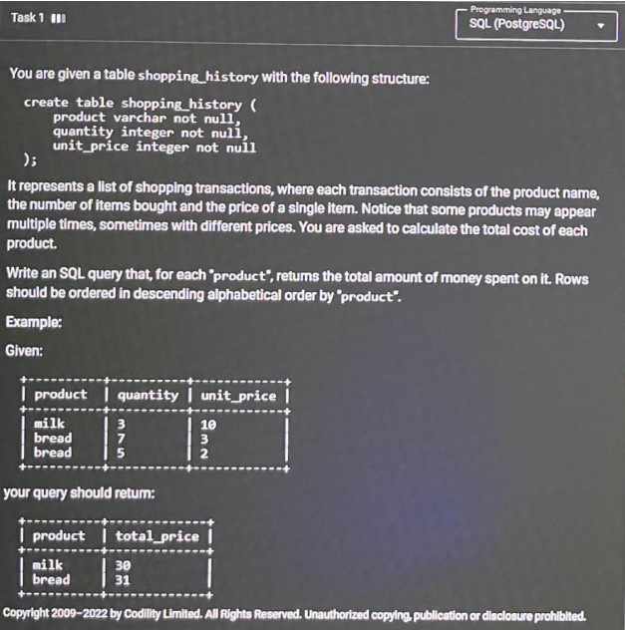

Create database SQL_PROJECT;

USE SQL_PROJECT;

CREATE- TABLE Shopping_history(

Product varchar(30) not null,

Quantity int,

Unit_price int );

insert into Shopping_history (Product, Quantity, Unit_price) values ('tea', 3, 10);

insert into Shopping_history (Product, Quantity, Unit_price) values ('milk', 5 , 3);

insert into Shopping_history (Product, Quantity, Unit_price) values ('bread', 4, 5);

insert into Shopping_history (Product, Quantity, Unit_price) values ('coffee', 2, 4);

insert into Shopping_history (Product, Quantity, Unit_price) values ('tea', 6, 5);

insert into Shopping_history (Product, Quantity, Unit_price) values ('egg', 13, 5);

insert into Shopping_history (Product, Quantity, Unit_price) values ('bread', 6, 5);

insert into Shopping_history (Product, Quantity, Unit_price) values ('coffee', 7, 2);

insert into Shopping_history (Product, Quantity, Unit_price) values ('paneer', 5, 4);

insert into Shopping_history (Product, Quantity, Unit_price) values ('butter', 6,7);

select * from Shopping_history;

**select product,sum(quantity * Unit_price) as total_price from Shopping_history**

**group by product**

**order by product desc;**

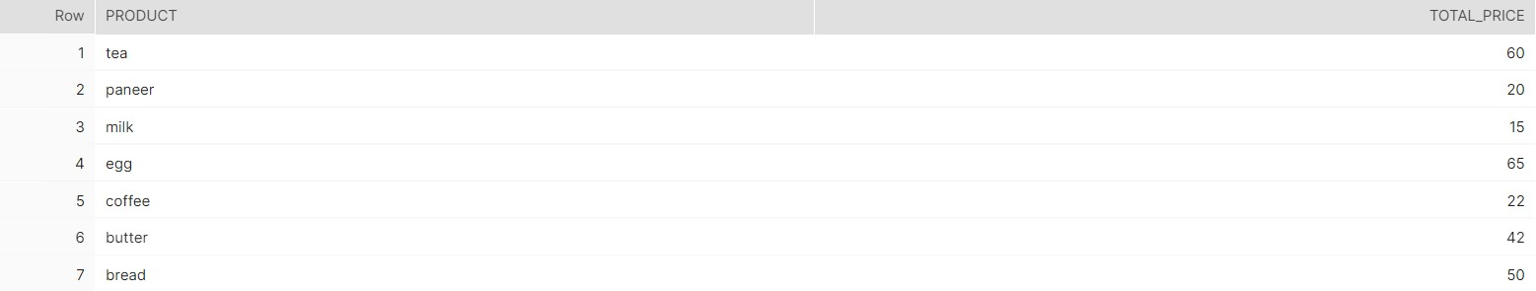

**Task 2 :**

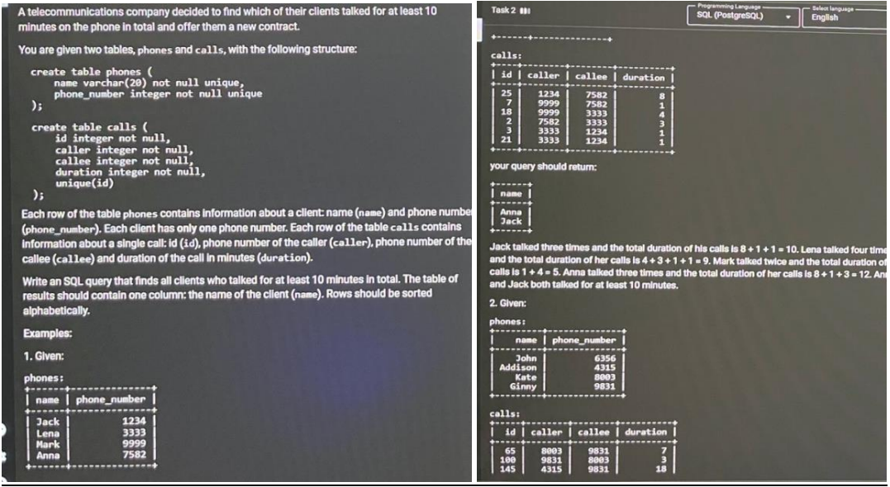

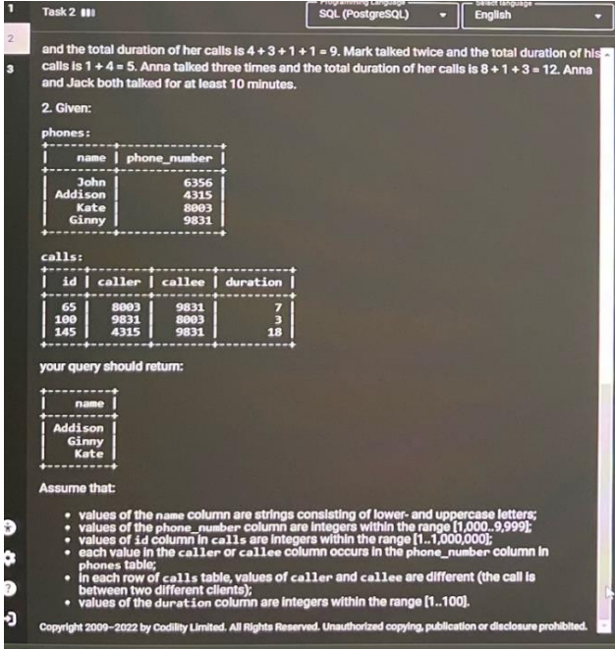

**create table Phones (**

**Name Varchar(20) not null unique,**

**Phone_Number integer not null unique**

**);**

**Create table Calls (**

**ID integer not null,**

**caller integer not null,**

**Callee integer not null,**

**Duration integer not null,**

**Unique(ID)**

**);**

**Insert into Phones Values**

**('Jack' , 1234),**

**('Lena' , 3333),**

**('Mark' , 9999),**

**('Anna' , 7582),**

**('John' , 6356),**

**('Addison' , 4315),**

**('Kate' , 8003),**

**('Ginny' , 9831),**

**('Mike' , 6666),**

**('Stacy' , 0011);**

**Insert into Calls Values**

**(25,1234,7582,8),**

**(7,9999,7582,1),**

**(18,9999,3333,4),**

**(2,7582,3333,3),**

**(3,3333,1234,1),**

**(21,3333,1234,1),**

**(65,8003,9831,7),**

**(100,9821,8003,3),**

**(145,4315,9831,18),**

**(155,6666,0011,5);**

**select * from Phones ;**

**with Call_duration as (**

**select caller as phone_number, Sum(Duration) As Duration from calls group by caller**

**union all**

**select callee as phone_number, Sum(Duration) As Duration from calls group by Callee**

**)**

**select Name**

**FROM phones p join call_duration cd on p.phone_number = cd.phone_number**

**GROUP BY 1**

**HAVING Sum(Duration) >= 10**

**ORDER BY 1;**

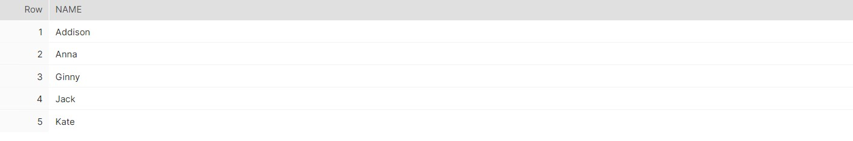

Task – 3Output display is just one column balance

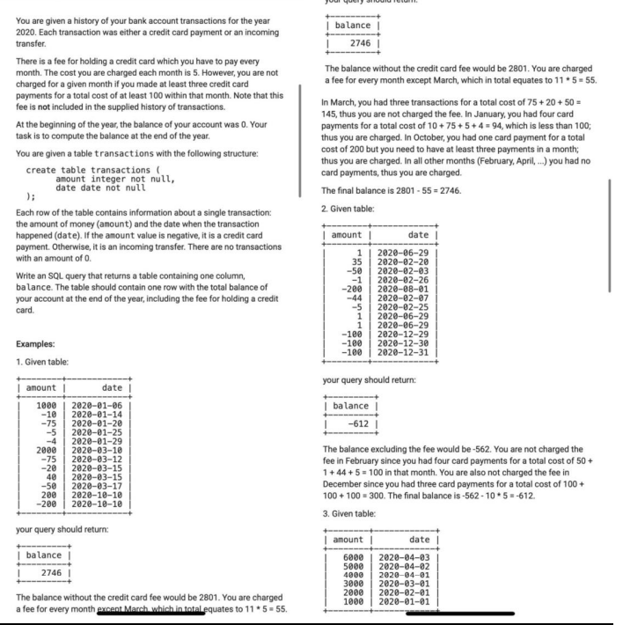

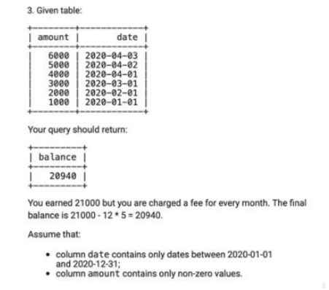

create table Transactions(

Amount Int NOT NULL,

`Date` Date NOT NULL

);

Insert into Transactions Values

(1000, '2020-01-06'),

(-10, '2020-01-14'),

(-75, '2020-01-20'),

(-5, '2020-01-25'),

(-4, '2020-01-29'),

(2000, '2020-03-10'),

(-75, '2020-03-12'),

(-20, '2020-03-15'),

(40, '2020-03-15'),

(-50, '2020-03-17'),

(200, '2020-10-10'),

(-200, '2020-10-10');

**Select ( sum(a.total) - (12- count(b.cnt ))*5 ) as result From**

**(Select sum(amount) as total , 'A' as name from transactions ) as a left join**

**(Select count(amount) as cnt , 'A' as name**

**From transactions**

**where amount <0**

**group by month("`DATE`")**

**having not(count(amount) <3 or sum(amount) >-100) ) as b**

**on a.name = b.name**

