Secure Linux Server Baseline

Noorullah Zaid
Abstract
Linux operating system is increasingly deployed for enterprise environments. Installation and setup, however, is built for conveniency and ease of use and not for enterprise security level. Relying on the initial configuration of the Linux server will leave the system exposed to damaging security threats that can harm the user. Thus, system hardening is needed, as it is an approach to improve system security by implementing and changing configurations and preventing surface level attacks. In this research, a systematic methodology was applied to a Kali Linux server, with SSH configuration enforcement, assigning filesystem permissions depending on users, automated logging analysis and dashboard display with Wazuh, and a concrete rollback and back plan to redo any mistake with deployment in the system change or SSH configurations. When assessing the hardening steps implemented with Lynis scoring tool and Nmap port scanning it has shown that the hardening index has increased from 59% to 67% with a change of SSH port. These finding have demonstrated that with concrete and clear plan to harden the Linux server it can increase the security and making it less vulnerable to attacks.

Keywords
Linux Security, Server Hardening, SSH Hardening, System Auditing, Log Analysis, Wazuh, Lynis, Fail2Ban, Recovery Planning, Intrusion Detection, Cybersecurity.
- Introduction

1.1 Overview
Linux servers are everywhere today. They power enterprise systems, cloud platforms, and national infrastructure. Because these systems handle important data and applications, they have naturally become a target for attackers. Reports show a noticeable increase in threats aimed at Linux, making it clear that proper hardening is important [1]. The thing is, even though Linux is open-source and can be installed by anyone, a fresh installation is not secure by default. Out of the box, there are usually unnecessary services running, file permissions that are too loose and software that hasn’t been patched. All of this gives attackers more room to work with.
Server hardening is the process of locking down a system by removing things that don’t need to be there, restricting who can access what, and configuring security settings properly. It is a key part of any layered security plan [2]. Frameworks like the CIS Benchmarks and NIST SP 800-123 provide solid guidance on how to do this for Linux servers. But in the real world, organizations often have a hard time applying these recommendations in a consistent way. Often, hardening is done manually or partially tied into auditing and recovery processes [3]. This creates issues. If an organization uses random hardening scripts with no audit trail and no way to roll back changes, it is taking a risk. One bad configuration change can take a critical service offline, and without a tested rollback plan, getting things back to normal takes much longer than it should.
Constant security auditing is just as important as initial hardening. Tools like Lynis, OpenSCAP, and Auditd help administrators catch configuration issues, unauthorized changes, and compliance issues over time[4]. But auditing on its own doesn't solve the problem if there is no clear path to fix what it finds or undo changes that went wrong. Hardening, auditing, and rollback planning need to work together as one process, but in reality, organizations treat them separately. This becomes especially problematic in regulated environments like those governed by PCI-DSS or HIPAA, where organizations have to show documented proof that security controls are in place and working.
Tools like Ansible, Chef, and Puppet have helped with the repeatability issues by letting administrators write hardening steps as code that can be reused across systems. However, these tools don’t always handle rollback well on their own. If a hardening step breaks something or a system gets compromised, getting back to a known good state requires snapshot management, filesystem baselines, and careful planning. On top of that, the auditing features built into these tools don’t always produce the kind of evidence that regulators want to see, so additional tooling is usually needed [5].

1.1.1 Main Contributions
The main contributions of this work are as follows:
- We configured a secure baseline for the Linux server, which includes SSH hardening, user access control. Also, we will achieve the correct firewall settings and system logs with the help of Fail2Ban. We have analyzed the logs automatically through Wazuh.
- Comparing the results output from Lynis hardening index and Nmap port scanning before and after hardening to confirm system improvements.
- Rollback and Recovery Procedure: We create a rollback plan so the system can be restored to a known good state if something goes wrong during hardening. This includes configuration backups and step-by-step recovery instructions.
Figure 1 illustrates the Hardening Lifecycle that we will have to go through to achieve a secure Linux server. This lifecycle includes 4 main phases, all done after we deploy a Linux virtual machine; Phase A is simply auditing the system to figure out what security issues are present using different tools such as Lynis, OpenSCAP, or Auditd. Phase B is the real work where we have to do the actual server hardening using multiple techniques, which we will discuss later. We then need to make sure that our hardening process was successful in Phase C by also using auditing tools. Lastly, we must preserve a clear recovery plan in case something goes wrong and we need to restore older versions, which is achieved by using backups and following clear recovery steps, all in Phase D.
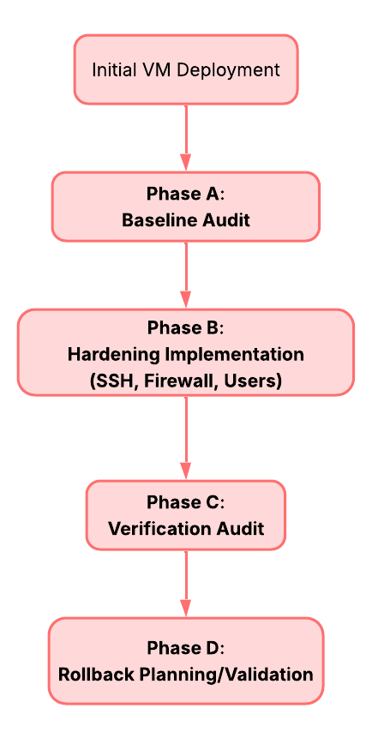
Figure 1. Linux Server Hardening Lifecycle
Though Linux is known for being secure and flexible, it's still considered a popular target for attacks for multiple reasons; first, it is the dominant OS for most servers, cloud infrastructures, and databases, making it subject to attacks because of high reward. Also, many organizations fail to apply even the basics of security rules. We can define some of the areas of a typical Linux operating system that can be exploited by attackers in the following:
1. Network services (SSH)
2.User accounts
3. Files and permissions
Attackers don't need advanced hacking methods to attack the server; they could do that by simply using a trial-and-error approach for weak passwords until they can successfully log in. This mainly happens if the SSH is exposed without protection [6].
By properly hardening (securing) the system, we can reduce the risk of attacks and make the server much safer. It's important to note that the core of a hardening strategy can be built upon two fundamental cybersecurity rules:
1. Defense in Depth [7]
This implies that the security of a system should not rely on merely 1 layer of protection; instead, multiple layers must be present to ensure that if one layer fails, another one will be able to do its job and prevent the hackers.
In our case, we can apply this rule by hardening the server in multiple areas; for example, a firewall blocks unwanted traffic, SSH is securely configured, user permissions are restricted, and logs track suspicious activity.
2. Least Privilege [8]
Each user must only access the minimum amount of access they need, so not many users can have admin permissions, because one compromised service could give full control to an attacker.

Now that we have covered the surface of Linux attacks and the main goals of hardening the server, we must define how to measure the security of a system. Security shouldn't be based on guesswork; it should be measurable [9]. This is why we use auditing tools, which perform a scan on the server's security and produce a quantifiable result. Examples of auditing tools include the Lynis tool, which offers security audit, system security, and vulnerability management [10].

It's crucial to discuss one of the most significant barriers to server hardening in the real world, which is accidentally breaking the system. What we mean by breaking is simply shutting down the main services provided, for example, security settings might block important applications, or admins might get locked out. To prevent this, we must always create a backup, or called a Rollback and Recovery Plan, to ensure that the system will stay secure, usable, and available at all times. We can apply that by saving the system’s state before changes and having clear steps to restore it [11].

Finally, hardening is not a "one-time" event but a continuous process. This is why we use Logging, which basically means monitoring and tracking some events and interactions with the server in order to detect any suspicious activity. Important events to track might include failed login attempts, unauthorized access, or firewall activity. Without logs, it’s impossible to investigate attacks. This is why proper logging will help administrators detect problems and preserve evidence if the system is compromised for continuous monitoring and improvement. [12]

1.2 Literature Review
The subject of Linux server hardening, auditing, and the secure management of configuration has been widely explored in academic research. In this section, we discuss previous studies that focused on improving system security, exploring hardening practices, and reducing vulnerabilities, all providing key contributions relevant to our research.

A foundational study by Nepal [13] provides a practical, hands-on analysis of Linux server hardening. Nepal demonstrated how a default Linux installation (CentOS 5.9 Final) can present a variety of vulnerabilities, such as the absence of a password policy, the installation of unnecessary services that expand the attack surface, and a default SSH configuration that is susceptible to brute-force attacks. Moreover, the built-in firewall (iptables) was found to be disabled. To counter these issues, Nepal examined techniques like securing SSH, tuning kernel security parameters, locking user accounts after multiple failed login attempts, configuring iptables, minimizing services, and deploying the OSSEC intrusion detection system. After analyzing logs, Nepal’s work showed that these measures led to approximately a 80% reduction in SSH brute-force attacks. This clearly indicates the efficacy of these hardening practices.

Building on these implementations, Malaraju [14] presents a structured approach to hardening Red Hat Enterprise Linux (RHEL). He addresses SELinux enforcement, a disk partitioning strategy on installation, and hardening of both the kernel and the user space. He also emphasizes integrating compliance frameworks like CIS Benchmarks and DISA STIG, which are required in enterprise environments. Malaraju also advocated for automation tools such as Ansible for configuration management and OpenSCAP for compliance auditing. Through a case study, it was shown that adopting this approach has significantly improved compliance scores and resulted in a more resilient and stable system.

While Nepal’s and Malaraju’s studies focus on practicalities, Aravindan [15] provides a broader review of Linux system hardening in enterprise environments. Aravindan looked into how frameworks like CIS Benchmarks and ISO 27001 are applied across four different Linux distributions: Oracle Linux, RHEL, SUSE, and Ubuntu. He points out that differing distributions have varying approaches to system hardening, due to their different tools and security frameworks. He also discusses the challenges that most organizations face in enterprise hardening, such as balancing security and usability, operational overhead, and maintaining a consistent hardening baseline across different distributions. Aravindan stresses that hardening shouldn’t be treated as a one-time task, but instead as a continuous process of monitoring and updating.

Moving from implementation to evaluation, Paul and Alsmadi [16] proposed a Unified Compliance Aggregator (UCA), a framework that joins different outputs from multiple auditing tools: Lynis, OpenSCAP, and AIDE, to provide a unified assessment of system security. These auditing tools are used to evaluate three Ubuntu 22.04 nodes configured to baseline, partial, and full hardening levels across 108 audit runs. In the study’s results, OpenSCAP’s compliance score increased from 39.7% to 71.8% after full hardening, thus demonstrating that applying hardening measures can noticeably improve compliance scores. The results also highlight the clarity and consistency of the UCA in comparison to using separate tools.

Implementing the previously discussed security measures manually across many systems is prone to inconsistency and mistakes. Stöckle et al. [17] introduce a DevOps-based framework to manage security configurations through the usage of automated pipelines. Their work is centered around a tool called Scapolite and addresses the challenge of maintaining security in large-scale and dynamic environments. It employs an approach where it treats security configurations as code, which can be version-controlled, automatically tested, and also applied across hundreds or even thousands of servers. This methodology’s main benefit is that it reduces the risk of manual misconfiguration and ensures that hardening standards are continuously checked. This shows that automation is becoming more important in modern system administration.

The need for structured configuration management is discussed by Oppenheimer et al. [18] in their analysis of failures in large-scale internet services. This study is not directly about security, but it provides an important insight: the majority of service outages and failures stem not from hardware or software faults, but from misconfigurations and human errors. This affirms the cruciality of configuration management, validation, and rollback planning. It also shows that a poorly implemented hardening change can become a reason for system failure, thus highlighting the need for reliable and auditable management processes.

Focusing on a specific high-risk component, Bäumer et al. [19] look into vulnerabilities within the SSH protocol, showing that the Binary Packet Protocol (BPP) fails to ensure channel integrity for a number of widely used encryption modes. This allows prefix truncation attacks, where early session packets could be removed without detection. The authors illustrate that such attacks can degrade security during extension negotiation (RFC 8308), therefore weakening authentication methods or disabling protections in newer OpenSSH versions. An internet-wide scan revealed that 71.6% of SSH servers support vulnerable modes, and 63.2% even prefer them. These weaknesses result mainly from unauthenticated handshake messages and improper sequence handling. The authors propose solutions like authenticating extension messages and improving sequence number handling to address these issues.

Expanding to system-level threats, Amarchand, Brown, and Mahoney [20] inspect vulnerabilities that can lead to privilege escalation on Linux systems. Their work examines issues such as memory corruption bugs (e.g., stack clashes) and weaknesses in core components like systemd and journald. They show how attackers can exploit these flaws, usually caused by misconfigurations or unpatched software, in order to gain root-level access. The study also explains that because of delayed updates and insecure default settings, many of these problems persist. To address this, the authors suggested keeping systems regularly patched and properly configuring services, as well as applying least-privilege principles in order to lessen the impact of potential exploits.

On the system level, research on kernel vulnerabilities shows that keeping systems patched and properly configured is really important. Liu et al. [21] showed that even when patches are applied, if they are not written well, they can still leave the system vulnerable. This creates a gap between fixing vulnerabilities and actually making sure the system is secure in practice.

At the same time, intrusion detection systems have been explored to monitor what is happening inside the system during runtime. For example, Abed et al. [22] proposed a container-based intrusion detection system that uses system call monitoring to detect unusual activity in real time. In another study, Abed et al. [23] looked at anomaly detection using system call patterns to identify abnormal process behavior. These methods are useful because they can detect new or unknown attacks, but they also come with challenges like high false positive rates and the need for a lot of training data, which makes them harder to use in real environments without careful tuning.

To help evaluate these systems, Karim et al. [24] provided datasets specifically designed for intrusion detection in Linux environments. Their Linux APT dataset includes realistic attack scenarios, which makes it useful for testing how well detection systems perform. On the other hand, Reshetova et al. [25] focused more on memory safety issues in the Linux kernel. They explain how problems like reference counter overflows and poor pointer checking can lead to serious vulnerabilities. They also suggest practical solutions, such as safer reference counter designs and hardware-assisted pointer checking using Intel MPX. What is interesting is that some of these solutions have already been integrated into the Linux kernel, which shows that improving kernel security is possible without heavily affecting performance.

Diana et al. [26] give an overview of intrusion detection systems (IDS) and their importance in detecting and countering a network-based security threat. It splits the IDS methods into signature-based and anomaly-based methods and elaborates on their strengths, weaknesses, and where they can be applied in various security situations. The authors also show the existing shortcomings in high false positive rates and scalability as well as indicate that more adaptive and intelligent solutions to IDS are needed. These surveys classify the detection methods into signature based, anomaly based and hybrid methods and provide a practical background on monitoring strategies.

More recently, some work has tried to combine hardening and auditing into one process instead of treating them separately. For example, Paul and Alsmadi [16] proposed a FABRIC-based framework that integrates tools like Lynis, OpenSCAP, and AIDE to evaluate system security. The idea is to give a clearer picture of the system’s security and measure improvements in compliance. However, the framework focuses more on evaluation rather than giving clear steps for hardening, and it can be a bit complex to implement, especially for smaller systems.
Table 1. Reference Comparison table
Paper | Approach | Limitations
Nepal [13] | Practical Linux hardening techniques (SSH securing, iptables firewall configuration, service minimization, OSSEC intrusion detection) | Lacks formal experiments or evaluation metrics  No controlled testing or comparison  No rollback or recovery methods
Malaraju [14] | Structured RHEL hardening process using SELinux, service minimization, kernel/user-space hardening, compliance frameworks (CIS, DISA STIG), and automation tools (Ansible, OpenSCAP) | Limited analysis of performance impact  Does not discuss trade-offs or failure handling in automation
Aravindan [15] | Review of Linux hardening frameworks (CIS Benchmarks, ISO 27001) across distributions; emphasizes logging and compliance auditing | Only a high-level review, no experiments or real deployments  No measurable results  Lacks practical implementation details
Paul & Alsmadi [16] | Framework aggregating auditing tools (Lynis, OpenSCAP, AIDE) to evaluate system hardening via compliance scoring | Focus is on evaluation rather than hardening itself  Limited guidance on how to apply fixes
Stöckle et al. [17] | DevOps-based automated pipelines for validating and applying security configurations | Requires complex infrastructure and setup  Not easy to use in small or simple environments  Adds operational overhead
Oppenheimer et al. [18] | Analysis of large-scale system failures caused by misconfigurations and human errors | Not specific to Linux and based on case studies rather than experiments  Limited technical guidance for prevention
Bäumer et al. [19] | Security analysis of SSH protocol vulnerabilities and practical attack demonstrations | Focuses only on SSH and does not cover full system hardening  Limited discussion of defenses
Amarchand et al. [20] | Analysis of system-level vulnerabilities (privilege escalation, memory corruption, kernel/service flaws) | Focuses on vulnerabilities rather than mitigation strategies or hardening frameworks
Liu et al. [21] | An analysis of incomplete security bug fixes in the Linux kernel and talks about the weaknesses in patching and vulnerability mitigation. | Confined to the analysis at the kernel level and has not provided the actual hardening recommendations and recovery measures that can be adopted by system administrators
Abed et al. [22] | Intrusion detection system for Linux containers using system call monitoring and runtime behavior analysis. | Efficient in a dynamic environment, as the given approach is geared towards containerized infrastructures and might not be applicable to the traditional deployment of servers.
Abed et al. [23] | System call–based anomaly detection for identifying abnormal process behavior in Linux systems. | High false positive rates  Requires extensive training data
Karim et al. [24] | Provides a dataset for evaluating intrusion detection systems in Linux environments with realistic attack scenarios. | The dataset is limited in scope and is not representative.
Reshetova et al. [25] | Information leakage and exploitation techniques | Focuses only on offensive techniques, with limited explanation on defensive hardening or system recovery.
Diana et al. [26] | survey of intrusion detection systems, including signature-based and anomaly-based approaches. | High-level and do not provide implementation details specific to Linux server hardening or integration with auditing and rollback processes.
- Preliminary Knowledge
When people talk about hardening a Linux server, they mean decreasing the number of ways an attacker can get in, locking down privileges, and making sure nothing suspicious goes unnoticed. Linux has a solid reputation for security, but fresh installations are rarely ready for the real world. They come loaded with unnecessary services, permissive SSH settings, and access controls that haven't been thought through. Nepal [13] found that out-of-the-box Linux systems are vulnerable to brute-force attacks and weak authentication, which is exactly why hardening is a core part of operational security.
SSH is usually the first thing worth addressing. It's the main entry point into a server, and it's almost always facing the internet. The CIS Benchmarks and NIST SP 800-123 both point to the same essentials: disable root login, change the default port, switch to key-based authentication, cap failed login attempts, and restrict access to authorized users only. Skipping any one of these leaves a door open that should be shut.
Firewalls are the next layer. Tools like iptables, UFW, and nftables control exactly what traffic gets through. Pairing them with Fail2Ban, which watches authentication logs and dynamically blocks IPs after repeated failures, turns passive log files into an active line of defense.
Measuring how secure a system actually is requires proper auditing. Lynis provides a hardening index that gives a rough sense of security posture, OpenSCAP checks compliance against standards like CIS and DISA STIG, and Nmap reveals what ports and services are still exposed. Paul and Alsmadi [16] found that combining multiple audit tools leads to more reliable assessments than relying on any single one.
Recovery planning is something that often gets overlooked. Malaraju [14] makes the point that hardening without tested rollback procedures can cause outages or even lock administrators out of their own systems. Tools like Timeshift let you snapshot the system before making changes, so if something breaks, recovery is straightforward.
Finally, hardening alone isn't enough. Abed et al. [22] argue that real security requires continuous monitoring alongside static configuration changes. Their research on system call–based intrusion detection shows that watching live system behavior can catch privilege escalation and abnormal processes that hardening simply can't prevent. Integrating tools like Wazuh into the stack closes that gap. A hardened server and a monitored server aren't the same thing, and effective protection requires both.
- Proposed Model

This project presents the implementation of a Linux server hardening model that secures a server step by step, measures how much the security improved, and makes sure the system can be restored if something goes wrong.

The main objective of this model is to provide a structured, measurable, and repeatable approach to Linux server hardening that improves system security while maintaining system stability and recoverability. Unlike ad-hoc hardening practices, this model emphasizes a controlled sequence of security enhancements combined with continuous evaluation. By integrating assessment, enforcement, monitoring, and recovery into a single workflow, the model ensures that security improvements are applied, and also validated and reversible in case of failure.

The model starts with a baseline assessment. Before making any changes, the server is scanned using Lynis, which gives a hardening score that shows how secure the system currently is. Nmap is also used to check which ports are open and what services are exposed. We note down these results so that we can compare them later after hardening is done.

The next step is SSH hardening and user access control. SSH is the main way to remotely access the server, so it is the most important thing to secure. A backup of the original SSH configuration file is made before we change anything. Then several settings are applied: the default SSH port is changed, root login is disabled, the number of login attempts is limited, access is restricted to specific users, public key authentication is enabled, password authentication is disabled, and X11 forwarding is turned off.

After that, Fail2Ban and firewall rules are setup. Fail2Ban watches the SSH login logs and automatically blocks any IP address that fails to log in too many times.

The model also includes kernel hardening, where some system settings are changed using sysctl to protect the server from common network attacks like IP spoofing and SYN flood attacks.

Additionally, Wazuh was setup using Docker to provide visibility of system logs and security events. This helps in security monitoring and detecting system events.

Once all the hardening is done, we run Lynis again to get a new hardening index score. The new index is compared to the original one to see how much the security improved. The Nmap results are also compared to check that fewer ports and services are exposed than before.

Throughout the whole process, backups are made before any file is changed. If a step causes a problem, the backup files can be used to restore the system back to how it was before.

3.1 Tools and Technologies

This project was implemented using a set of security tools and system utilities that are commonly used in Linux server hardening. The following tools were used:

3.1.1 Lynis

Lynis is a security auditing tool used to analyze the system and generate a hardening index score. It helps identify vulnerabilities before and after applying security measures.

3.1.2 Nmap

Nmap is a network scanning tool used to detect open ports and running services on the server. We used it before and after hardening to verify that the default port (Port 22), which is a common attack point, was no longer exposed.

3.1.3 OpenSSH

OpenSSH is used to provide secure remote access to the server. We modified its configuration file to disable root login and enable key-based authentication.

3.1.4 Fail2Ban

Fail2Ban is a log monitoring tool that detects repeated failed login attempts and automatically blocks malicious IP addresses using firewall rules.

3.1.5 Wazuh

Wazuh is an open-source security monitoring platform used for log analysis and intrusion detection. We used it to monitor system activity through dashboards, and for logging purposes.

3.1.6 Docker

Docker is used to deploy Wazuh easily and manage it as a containerized service.

3.1.7 Timeshift

We used the Timeshift package to create system snapshots. It allows restoring the system to a previous state in case of a failure during the hardening process.

3.1.8 Linux System Utilities (chmod,usermod,systemctl, etc.)

These commands are used for managing users, permissions, and system services as part of the hardening process.

3.2 System Architecture and Flow of Operations

We now present a breakdown of each phase of the hardening process, from the initial assessment all the way through to recovery planning. Figures 2 and 3 show the system architecture and the flow of operations, including the commands and the technologies used and applied, respectively.
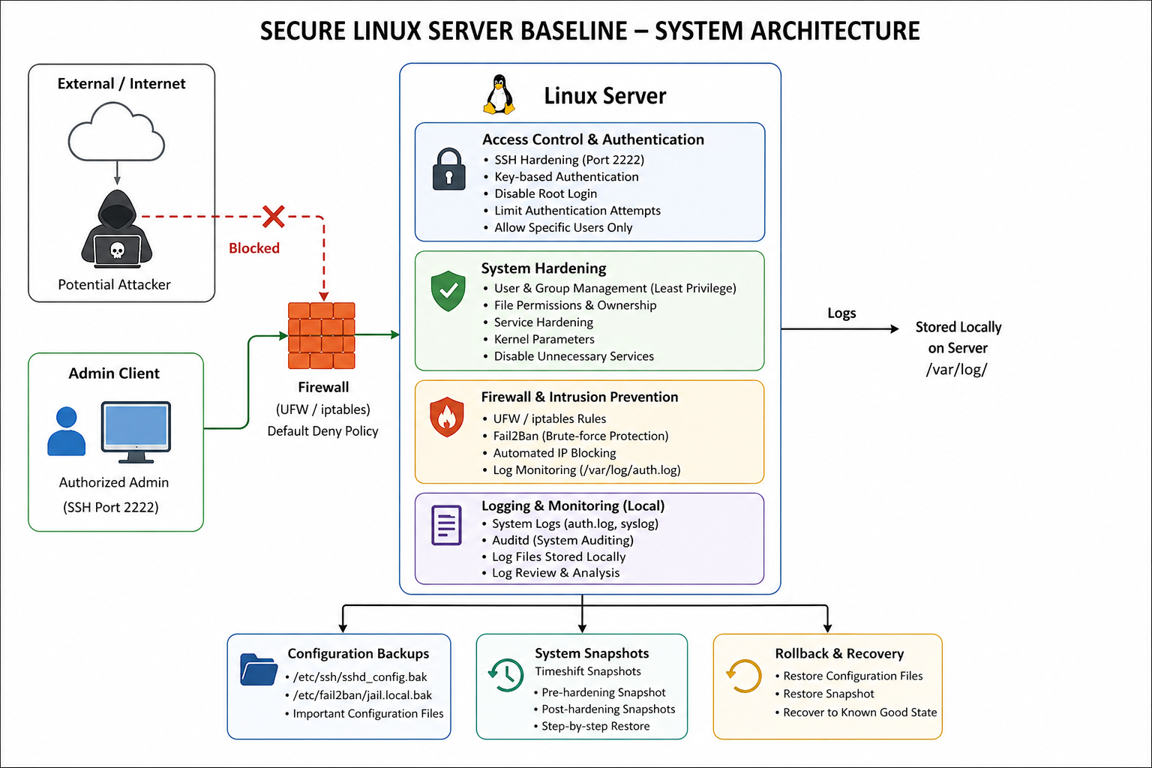
Figure 2. System Architecture

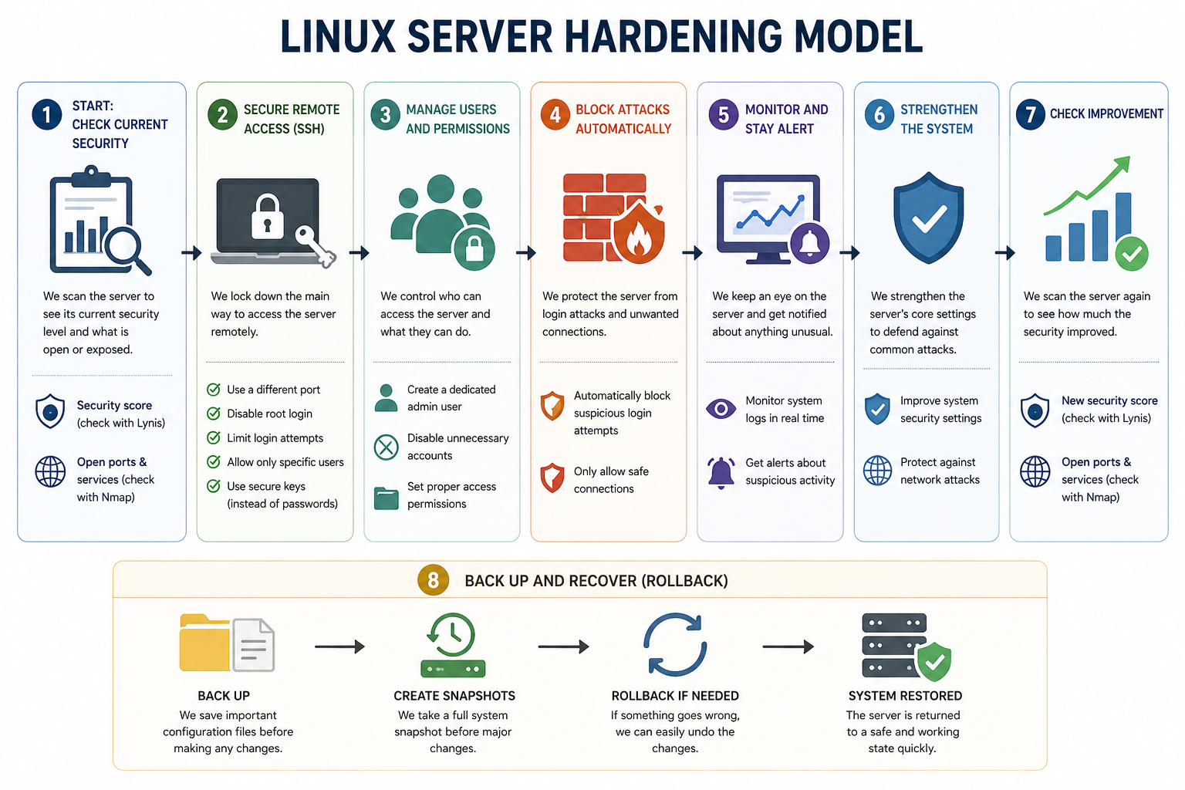Figure 3. Flow of Operations

3.2.1 Baseline Assessment

The system starts with a baseline assessment phase. In this phase, the server is scanned using Lynis to obtain the initial hardening index score. At the same time, Nmap is used to scan the system and identify open ports and running services. These results are recorded as a reference point before applying any security configurations.

3.2.2 SSH Hardening

After the baseline is established, SSH hardening is applied. The SSH service is first verified and enabled if it is not running. A backup of the SSH configuration file is created before making any changes. Then the configuration file is modified by changing the default port, disabling root login, limiting authentication attempts, restricting access to specific users, enabling key-based authentication, and turning off X11 forwarding.

3.2.3 User Access Control

User access control is then implemented. A dedicated administrative user is created and granted sudo privileges instead of using the root account. Unnecessary or inactive users are disabled to reduce security risks. File and directory permissions are configured using chmod and ownership settings to ensure that only authorized users have access.

3.2.4 Fail2Ban and Firewall Rules

Fail2Ban is configured to monitor authentication logs and detect repeated failed login attempts. When suspicious activity is detected, Fail2Ban automatically blocks the attacking IP address by adding firewall rules. The configuration includes settings maximum retry attempts, ban time, and log file path. This ensures protection against brute force attacks.

3.2.5 Log Monitoring and Analysis

To enhance monitoring, a log analysis system is deployed using Wazuh. It is installed using Docker containers and provides a dashboard to monitor system logs and detect suspicious activity. This improves visibility and allows better tracking of security events on the system.

3.2.6 Post Hardening Evaluation

After completing all hardening steps, the system is evaluated again. Lynis is used to generate a new hardening index score, and Nmap is used to scan the system again. The results are compared with the baseline to confirm that the security posture has improved and that fewer services are exposed.

3.2.7 Backup and Recovery

Throughout the process, backup and recovery mechanisms are used. Configuration files were backed up, system snapshots were created using the package Timeshift. If any issue occurs, we can restore the system either by recovering configuration files or by rolling back to a previous snapshot.

3.3 Advantages of Model

The model takes a practical approach to securing a Linux server by applying hardening techniques in a logical order while making sure the system stays functional throughout the process.

One of the clearest benefits is a reduced attack surface. Closing unnecessary ports, disabling unused accounts, and tightening access controls all work together to give attackers fewer ways in.

Brute-force protection is handled by Fail2Ban, which watches authentication logs and automatically blocks IPs that repeatedly fail to log in. It is a simple addition that makes a noticeable difference in practice.

Visibility is another area the model addresses well. Integrating Wazuh for log monitoring means suspicious activity gets flagged rather than going unnoticed, and there is a clear record of what happened and when, which matters both for security and accountability.

For reliability, Timeshift snapshots are used so that if something goes wrong, whether from an attack or a misconfiguration, the system can be rolled back to a previous state without having to start over.

What makes this model different from more traditional hardening approaches is that it does not treat these steps in isolation. Many common guides stop at SSH configuration or firewall rules and leave it at that. This model combines baseline assessment, targeted hardening, active monitoring, and post-hardening evaluation into one structured workflow. The end result is a system that is not only hardened, but also observable and recoverable.

3.4 Performance Measures

In this section, we evaluate the effectiveness of the hardening model by measuring improvements in system security before and after applying the configurations.

3.4.1 Hardening Index Improvement

The primary performance measure is the Lynis hardening index score. This score represents the overall security level of the system.

Hardening Improvement = (New Hardening Index - Original Hardening Index)

After recording the initial hardening index, we got a score of 59 as a baseline. After our hardening measures, the score was increased to 67, a total increase of 8 points.

3.4.2 Hardening Index Improvement

Another important measure is the reduction in exposed ports and services. Nmap scans are performed before and after hardening.

The goal is to minimize the number of open ports to only those necessary for system functionality. For example, the default SSH port (22) was closed and replaced with a different port (2222), to reduce exposure to automated attacks.

3.4.3 Brute Force Attack Mitigation

The effectiveness of Fail2Ban is evaluated based on its ability to detect and block repeated failed login attempts. The configuration limits login retries to 3, and automatically bans malicious IP addresses that fail to login for 3600 seconds (1 Hour). This reduces the risk of brute force attacks.

3.4.4 System Recovery Reliability

System recovery is evaluated based on the ability to restore the system after a failure. This is achieved using configuration backups and Timeshift snapshots. A successful recovery without data loss indicated that the rollback mechanism is effective.
- Simulation Results
This section demonstrates the results we have achieved after hardening the linux server. We will prove the effectiveness and reliability of our proposed hardening steps by using clear metrics and comparing the security before and after the simulation.

4.1 Simulation Setup
The simulation was done in a controlled environment, where we used the following tools and configurations:
- Operating System: Kali Linux, which we ran on a virtual machine using Virtual Box.
- Security Auditing Tools: First, we used Lynis; which acts as security scanner by running tests on the entire system to detect vulnerabilities and gives a “Hardening Index” that is a 0 - 100 numerical score and a measure which shows how many security best practices are implemented, where a higher score indicates a better and more hardened server. Our main goal is to improve this Hardening Index. Nmap is the other auditing tool we used for port scanning when hardening the SSH, which means it shows the port number and service used to access the SSH.
Both tools were run before and after our simulation, to act as measurements of effective hardening.
- Hardening Technologies: OpenSSH was configured for secure remote access. Fail2Ban was installed and configured to monitor logs, detect patterns of failed login attempts, and automatically apply firewall rules based on those patterns. Lastly, we used Wazuh for centralized security monitoring and log analysis.
- Recovery Tools: We installed the Timeshift package which is used to create snapshots of the systems state before and during the hardening process to allow rollbacks at any moment.
- Key Parameters: For parameters related to SSH configuration, SSH was moved from the default port 22 to port 2222, PermitRootLogin, PasswordAuthentication, and X11Forwarding were disabled, and PubkeyAuthentication was enabled. For parameters related to Fail2Ban, maxretry was set to 3, and bantime was set to 3600 seconds.

4.2 Presentation of Results
Our main goal was to improve the Hardening Index provided by the Lynis auditing tool. Figure 4 represents the baseline score, whereas Figure 5 shows the post hardening score.

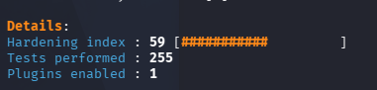
Figure 4. Baseline Hardening Index
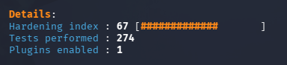
Figure 5. Final Hardening Index

4.3 Analysis and Interpretation
- Score Significance: the Hardening Index increased by 8 points, which is a significant improvement in the overall system security and reflects the successful implementation of our hardening process.
- Mitigation of Brute Force: by disabling PasswordAuthentication and enabling PubkeyAuthentication, we eliminated the main source of credentials based attacks. Furthermore, reducing maxretry in Fail2Ban configuration files ensures that brute force attacks are immediately identified and blocked.
- Reducing Attack Surface: Moving SSH from its default port to a non standard port will reduce the risk of attackers who target default configurations.

4.4 Results and Discussions
The results of applying the hardening model show an improvement in the overall security of the system. The Lynis hardening index increased compared to the baseline (from 59 to 67), indicating that the system became more secure after applying the configurations.
The Nmap scans also showed improvement. Before hardening, the default SSH port 22, which is a very common automated attack target was exposed, while after hardening, it was closed and another port was used in place.
The implementation of Fail2Ban successfully reduced the risk of brute force attacks by limiting login attempts and automatically banning malicious IP addresses. This adds an additional layer of protection on top of SSH hardening.
Log monitoring using Wazuh provided better visibility into system activity. It allows tracking login attempts and detecting suspicious behavior, which improves overall security awareness.
The backup and recovery mechanism also proved to be effective. Using Timeshift snapshots and configuration backups, the system could be restored quickly if any issue occurred during the hardening process or if it was compromised.
Overall, the model achieved its goal of improving system security without affecting normal functionality. The combination of hardening, monitoring, and recovery makes the system more secure, more stable, and easier to manage.
- Conclusions
In this project, our goal was to address a common but usually overlooked problem: default Linux installations are not secure enough for real-world use, and most hardening attempts lack structure, measurement, or a way to recover when something breaks. We proposed a systematic hardening model for a Kali Linux server that combined SSH configuration, user access control, automated log monitoring with Wazuh, Fail2Ban for brute-force protection, and a rollback mechanism using Timeshift. The key findings show that our approach worked, whereas the Lynis hardening index increased from 59% to 67%, Nmap scans confirmed that the default SSH port was closed and moved to a non-standard port, and Fail2Ban successfully blocked IPs after repeated failed login attempts. More importantly, the Timeshift snapshots gave us confidence to make changes knowing we could always revert if something went wrong. These results matter because they show that even basic hardening steps, when applied systematically, can produce measurable security gains without breaking the normal system functionality.
The main contribution of this work is the full hardening lifecycle, following the acts of assess, harden, monitor, and recover, rather than just a list of isolated commands. This advances practice by showing that hardening doesn't have to be risky or irreversible. However, our study has limitations: we only tested on Kali Linux in a virtual machine, not on production servers or other distributions like Ubuntu or RHEL, and the Lynis score still sits at 67%, thus leaving room for improvement. For future work, we plan to apply the same model to other Linux distributions, integrate more CIS controls to push the hardening index higher, and test the setup against real brute-force attacks to better validate the effectiveness of Fail2Ban and Wazuh.
References
[1] CrowdStrike, "2023 CrowdStrike Global Threat Report," CrowdStrike Holdings, Inc., Austin, TX, USA, Tech. Rep., 2023. [Online]. Available: https://www.crowdstrike.com/global-threat-report/
[2] Center for Internet Security (CIS), "CIS Benchmarks: Security Configuration Guidelines," CIS, East Greenbush, NY, USA, 2023. [Online]. Available: https://www.cisecurity.org/cis-benchmarks
[3] National Institute of Standards and Technology (NIST), "Guide to General Server Security," NIST Special Publication 800-123, Gaithersburg, MD, USA, 2008 (updated 2021). [Online]. Available: https://doi.org/10.6028/NIST.SP.800-123
[4] M. Ciampa, Security+ Guide to Network Security Fundamentals, 7th ed. Boston, MA, USA: Cengage Learning, 2021.
[5] National Institute of Standards and Technology (NIST), “Guide for Security-Focused Configuration Management of Information Systems,” NIST Special Publication 800-128 (Errata Upd. 1), Gaithersburg, MD, USA, Aug. 2011, updated Oct. 2019. [Online]. Available: https://doi.org/10.6028/NIST.SP.800-128
[6] M. Hyppönen, "Securing a Linux server against cyber attacks," Master's thesis, Faculty of Information Technology and Communication Sciences, Tampere University, Tampere, Finland, 2021.
[7] R. Alsaqour, A. Majrashi, M. Alreedi, K. Alomar, and M. Abdelhaq, "Defense in depth: Multilayer of security," Int. J. Commun. Netw. Inf. Secur., vol. 13, no. 2, pp. 242–248, Aug. 2021.
[8]E. Billoir, R. Laborde, A. S. Wazan, Y. Rütschlé, and A. Benzekri, "Implementing the principle of least privilege using Linux capabilities: Challenges and perspectives," in Proc. 2023 7th Cyber Secur. Netw. Conf. (CSNet), Montreal, QC, Canada, 2023, pp. 130–136, doi: 10.1109/CSNet59123.2023.10339753.
[9] M. Disi, "Auditing Linux systems for a secure enterprise IT environment," Master's thesis, Dept. Inf. Syst., Iowa State Univ., Ames, IA, USA, 2022.
[10] M. Olenčin and J. Perháč, "Automated configuration of a Linux web server security," in Proc. 2019 IEEE 15th Int. Sci. Conf. Informatics, 2019, pp. 491–496.
[11] Sousa, A.D.C. de and Freitas, H.C. de. (2025) A Performance Analysis of System Rollback Techniques. Anais Estendidos do XXVI Simpósio em Sistemas Computacionais de Alto Desempenho (SSCAD 2025), 9–16.
[12] T. H. Nguyễn, "Cybersecurity logging & monitoring security program," School of Comput. Sci. & Eng., Sacred Heart Univ., Fairfield, CT, USA, 2022.
[13] Nepal, Amit. (2013). Linux Server & Hardening Security. 10.13140/2.1.5079.2329.
[14] Malaraju, Satish Kumar. (2020). Process of OS Security Hardening -Red Hat Enterprise Linux. 10.70528/IJLRP.v1.i2.1474.
[15] Aravindan, S. (2025). A Review of Linux System Hardening Techniques for Enterprise Security and Compliance. International Journal of Scientific Engineering and Research. 12-16. 10.70729/SE251001030219.
[16] Paul, S., & Alsmadi, I. (2026). Security Hardening Using FABRIC: Implementing a Unified Compliance Aggregator for Linux Servers. arXiv preprint arXiv:2601.00909.
[17] Stöckle, Patrick & Pruteanu, Ionut & Grobauer, Bernd & Pretschner, Alexander. (2022). Hardening with Scapolite: a DevOps-based Approach for Improved Authoring and Testing of Security-Configuration Guides in Large-Scale Organizations. 10.48550/arXiv.2209.08824.
[18] Oppenheimer, David & Ganapathi, Archana & Patterson, David. (2003). Why Do Internet Services Fail, and What Can Be Done About It?.
[19] Bäumer, F., Brinkmann, M., & Schwenk, J. (2024). Terrapin attack: Breaking {SSH} channel integrity by sequence number manipulation. In 33rd USENIX Security Symposium (USENIX Security 24) (pp. 7463-7480).
[20] Amarchand,G.;Brown,P.;Mahoney,T. (2023). Linux security. Advances in Engineering Innovation,2,17-20.
[21] Q. Liu, W. Zhang, M. Jiang, L. Wu, and Y. Zhou, "Characteristics, Root Causes, and Detection of Incomplete Security Bug Fixes in the Linux Kernel," arXiv e-prints, Art. no. arXiv:2511.17799, 2025. doi: 10.48550/arXiv.2511.17799.
[22] A. S. Abed, T. Charles Clancy, and D. S. Levy, “Intrusion Detection System for Applications Using Linux Containers,” Lecture Notes in Computer Science, pp. 123–135, Jan. 2015, doi: https://doi.org/10.1007/978-3-319-24858-5_8.
[23] A. S. Abed, T. C. Clancy, and D. S. Levy, “Applying Bag of System Calls for Anomalous Behavior Detection of Applications in Linux Containers,” arXiv (Cornell University), pp. 1–5, Dec. 2015, doi: https://doi.org/10.1109/glocomw.2015.7414047.
[24] Syed Sohaib Karim, M. Afzal, W. Iqbal, and Dawood Al Abri, “Advanced Persistent Threat (APT) and Intrusion Detection Evaluation Dataset for Linux Systems 2024,” Data in brief, vol. 54, pp. 110290–110290, Jun. 2024, doi: https://doi.org/10.1016/j.dib.2024.110290.
[25] E. Reshetova, H. Liljestrand, A. Paverd, and N. Asokan, “Toward Linux kernel memory safety,” Software: Practice and Experience, vol. 48, no. 12, pp. 2237–2256, Sep. 2018, doi: https://doi.org/10.1002/spe.2638.
[26] L. Diana, P. Dini, and D. Paolini, “Overview on Intrusion Detection Systems for Computers Networking Security,” Computers, vol. 14, no. 3, p. 87, Mar. 2025, doi: https://doi.org/10.3390/computers14030087.

Appendix A

A.1 SSH hardening and User Control:
The default configuration of the Secure Shell (SSH) is usually insecure. Proper hardening of the SSH is essential as it could be vulnerable to brute force attacks and unauthorized access.

First we need to check if SSH installed and verify its service status:
Command to check if SSH is installed: ssh -V

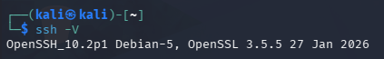
Figure 6. Confirm SSH installed

Command to check that SSH is running: sudo systemctl status ssh

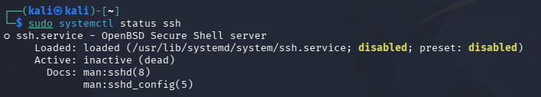
Figure 7. SSH Not Running

The following command will start the SSH: sudo systemctl start ssh && sudo systemctl enable ssh

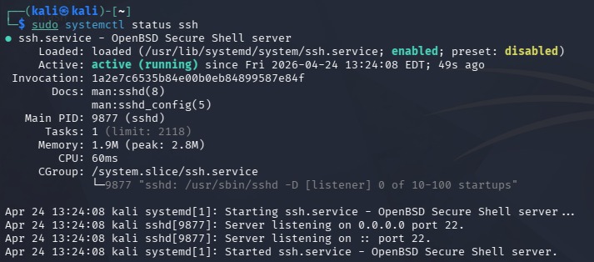
Figure 8. SSH is Running

The original SSH configuration has a lot of vulnerabilities, therefore we need to change the SSH configuration to harden it.

A.2 Configuration back up
First we need to back up the original SSH configuration in case something broke during the hardening process:
sudo cp /etc/ssh/sshd_config /etc/ssh/sshd_config.bak

In case we needed to rollback to the old configuration file we run the following command:
sudo cp /etc/ssh/sshd_config.bak /etc/ssh/sshd_config

Afterwards we have to edit the following SSH configuration file.
SSH configuration file before the hardening:
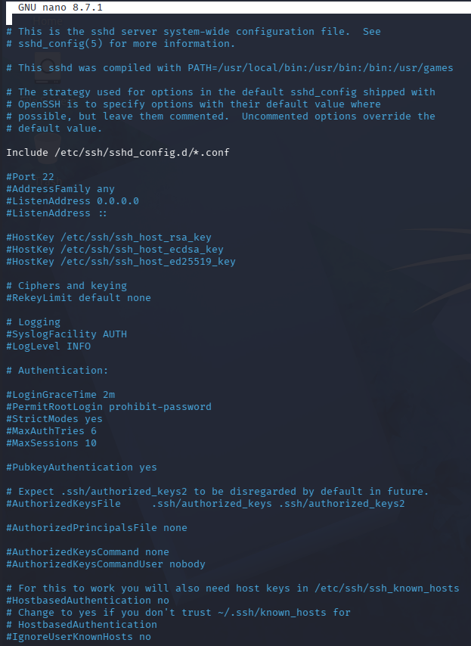
Figure 9. Before SSH Configuration

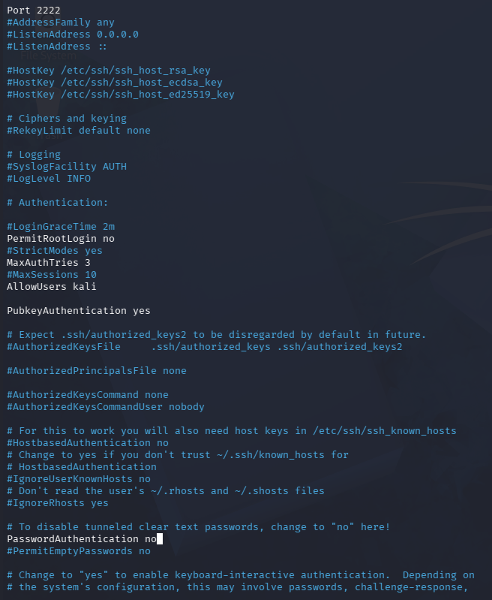
Figure 9 & 10. After SSH Configuration

- Port 22 was changed to port 2222 to prevent attackers scanning port 22 which is the default port.
- PermitRootLogin was disabled in order to stop the attacker from only targeting the root.
- MaxِAuthTries was set to 3 so it limits login attempts and prevents brute force attacks.
- AllowUsers is a setting that restricts access to only specific users. In this case only user “kali” now has access authorization.
- PubkeyAuthentication is enabled as key-based authentication is more powerful than password-based authentication.
- To further enforce key authentication the PasswordAuthentication was set to no.
- X11Forwarding is disabled to prevent GUI to run on remote servers.

To check that changes has taken place:
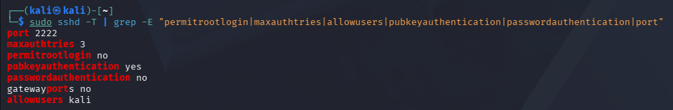
Figure 11. Confirming SSH Configuration Changes

A.2.2 Nmap result before and after:
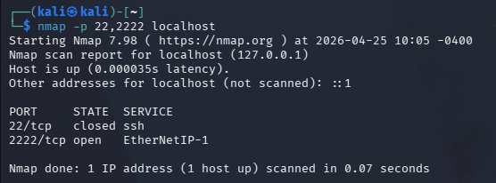
Figure 11. Confirming Port Changes

The figure above shows the output when using the Nmap port scanning tool. Port 22 (the default SSH port) is now closed, preventing automated scanners and attackers that target port 22 by default. SSH has been successfully moved to port 2222, confirmed by the open status on that port.

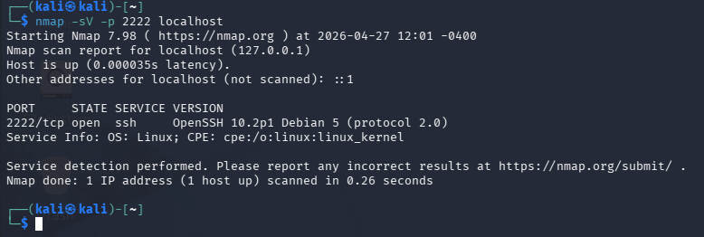
Figure 12. Confirming Port Changes

A.3 Fail2Ban logging and firewall rules:
Fail2Ban is used to monitor logs to spot patterns of authentication failures. It is a log-watching daemon. It sits in the background reading /var/log/auth.log continuously.

First we installed Fail2Ban and made a local configuration file /etc/fail2ban/jail.local
This file was then further edited to contain the following changes:

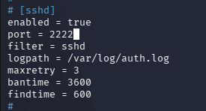
Figure 13. Changing Fail2Ban Configuration

- The enable was set to true in order for the Fail2Ban not to ignore SSH.
- Setting port = 2222 to tell Fail2Ban which port to protect from unauthorized access.
- Filter = sshd: points to a pre-built rule file at /etc/fail2ban/filter.d/sshd.conf that knows what a failed SSH login looks like in the logs.
- logpath = /var/log/auth.log: tells fail2ban where to watch for failed attempts. This is the file that records all authentication events on Kali
- maxretry=3: attacker gets 3 attempts before getting banned. Without this, someone could try thousands of passwords (brute force attack).
- bantime=3600: bans the attacker for 3600 seconds (1 hour). After that the block is lifted automatically.
- findtime

fail2ban's sshd filter knows exactly what that pattern looks like and counts how many times it appears from the same IP within the findtime window. This means your logs become active, they're not just a record of what happened, they're the trigger for defensive action. When the failure count crosses maxretry, fail2ban calls an "action" by default it runs an iptables command that adds a DROP rule for that IP address. This is a real firewall rule, the same as if you had typed it manually.

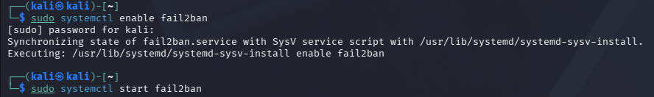
Figure 14. Running Fail2Ban

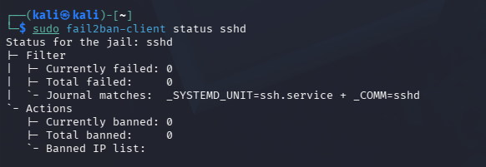
Figure 15. Status of SSH Jail

A.4 User access control
(The following is a demo):

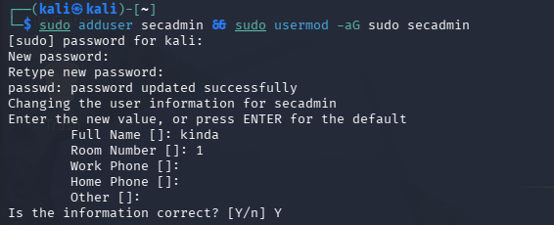
Figure 16. Creating Security Admin
In the above image we created a dedicated secadmin user instead of using root or a personal account to keep administrative actions separate, identifiable, and accountable. -aG: a means append and G means to the group sudo.

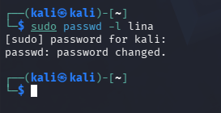
Figure 17. Disabling User

This step is to remove/disable an unwanted or no longer active account. In this case we disabled the user “Lina”. Basically by adding a “!” to the hash password making it impossible to log in.

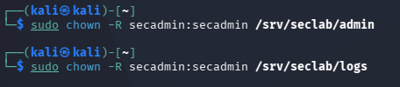
Figure 18. Directory Accessibility

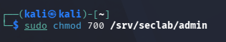

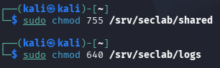
Figure 19 & 20. User Permessions

The chmod commands above show the accessibility permissions for users. The /srv/seclab/admin directory was given permission “chmod 700” meaning only the owner “seclab” can read and write in this directory, however groups and others are blocked.
For the directory /srv/seclab/shared chmod 755 permission was given meaning that the owner can read and write but everyone else can read but cannot write.
As for the /srv/seclab/logs directory: owner can read and write, group can only read and others are blocked.

A.5 Log analysis
To integrate a log analysis with a dashboard we used the wazuh open source security platform to further enhance the security of our system.
To have wazuh running on kali the following steps was done:
Install docer container:
sudo apt install docker.io docker-compose -y
sudo systemctl enable docker --now

Then pull the wazuh github repository with the specified version:
git clone https://github.com/wazuh/wazuh-docker.git -b v4.7.0

Finally start wazuh and access it on https://localhost
docker-compose -f generate-indexer-certs.yml run --rm generator
docker-compose up -d


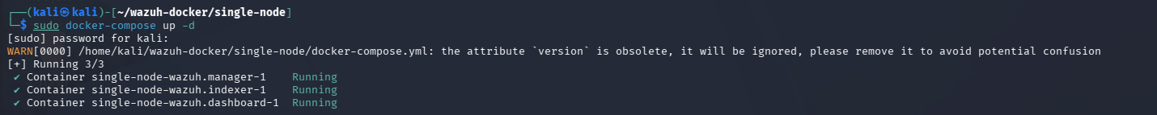
Figure 21& 22. Starting Up Wazuh

And after having the Wazuh dashboard we installed an agent to monitor our system security and display it on the dashboard

A.6 Rollback and Recovery Plan
Aside from backing up the SSH configuration file, we need to take a snapshot of the current system so we can roll back in each step. Therefore we installed the package timeshift to take a snapshot. It takes snapshots of your system so you can roll back to a previous state if something breaks.

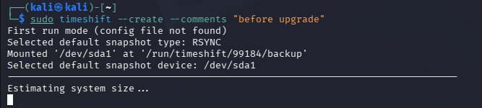
Figure 23. Creating Timeshift Snapshot

The above shows taking a snapshot before any changes, and throughout the changes of the system a new snapshot is taken to enable rollback through every change.


Figure 24. Accessing Timeshift Snapshot List

Restoring a snapshot from that list:
Example: sudo timeshift --restore --snapshot '2026-04-20_10-00-01'

N. Zaid is with the Department of Computing Sciences, Princess Sumaya University for Technology, Amman, Jordan. Email:noo20220370@std.psut.edu.jo

