Meeting Social Agent Project Explanation

1. Project Idea
Meeting Social Agent is a web application that uploads a recorded meeting, transcribes it, summarizes it, creates Facebook and Instagram drafts, generates an Instagram recap image, and waits for human approval before publishing.
2. Main Workflow
1. User uploads an audio or video meeting file.
2. The app stores the file on the server.
3. User chooses Groq/cloud, trained/local, or both.
4. Speech-to-text creates the transcript.
5. Summarization creates title, summary, key points, decisions, action items, risks, and social drafts.
6. The app creates an Instagram recap image.
7. User reviews, edits, and approves.
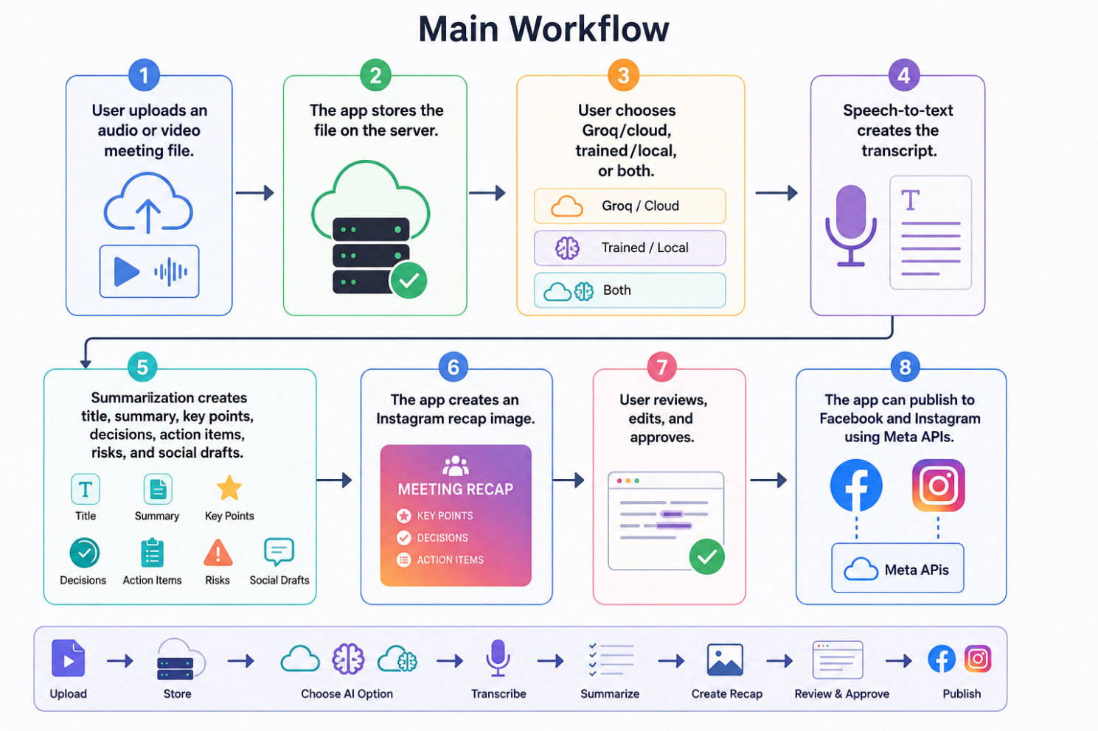
8. The app can publish to Facebook and Instagram using Meta APIs
3. Groq Cloud Pipeline
Groq is used as the cloud AI pipeline. It lets the online Railway app process meetings without storing or loading very large AI models on the server.
Groq transcription settings:
TRANSCRIPTION_BACKEND=groq
TRANSCRIPTION_MODEL=whisper-large-v3-turbo
Groq summarization settings:
SUMMARY_BACKEND=groq
SUMMARY_MODEL=openai/gpt-oss-20b
Why Groq was used: it is lighter for deployment, works online through an API, reduces server memory and disk usage, and is easier to run on Railway.
4. Our Trained Model Pipeline
The trained/local pipeline uses our custom model folders instead of only using Groq. It has a trained ASR model and a trained summarizer model.
Trained ASR model path: models/asr/whisper-ar-meetings
TRAINED_TRANSCRIPTION_BACKEND=transformers_whisper
TRAINED_ASR_MODEL_PATH=models/asr/whisper-ar-meetings
Trained summarizer model path: models/summarizer/meeting-summary-ar
TRAINED_SUMMARY_BACKEND=transformers_seq2seq
TRAINED_SUMMARY_MODEL_PATH=models/summarizer/meeting-summary-ar
5. Hugging Face Model Hosting
The trained model files are large, so we do not push them directly to GitHub. We upload them to Hugging Face model repositories and Railway downloads them at startup.
Hugging Face repositories used:
Nooriso/whisper-ar-meetings
Nooriso/meeting-summary-ar
Railway variables for Hugging Face:
TRAINED_ASR_HF_REPO_ID=Nooriso/whisper-ar-meetings
TRAINED_SUMMARY_HF_REPO_ID=Nooriso/meeting-summary-ar
HUGGINGFACE_TOKEN=your_private_hugging_face_token
6. Railway Deployment
Railway hosts the FastAPI app online. The project uses Docker so Railway can build and run the app in a container.
Important Railway variables:
GROQ_API_KEY=your_groq_key
PUBLIC_BASE_URL=https://meeting-social-agent-production.up.railway.app
TRAINED_TRANSCRIPTION_BACKEND=transformers_whisper
TRAINED_SUMMARY_BACKEND=transformers_seq2seq
Important note: trained local models need much more RAM and disk than Groq cloud mode. If Railway crashes while loading trained models, use Groq/cloud mode or upgrade the Railway plan.
7. Tools Used
Python: main programming language.
FastAPI: backend web framework.
Uvicorn: runs the FastAPI app.
Groq API: cloud transcription and cloud summarization.
Transformers: runs trained Hugging Face models locally.
faster-whisper: optional local Whisper transcription backend.
Hugging Face Hub: stores and downloads trained model files.
Railway: online hosting and deployment.
Docker: packages the app for Railway.
SQLite: stores meeting records and results.
Pillow: generates Instagram recap images.
Meta Graph API: publishes approved posts to Facebook and Instagram.
GitHub: stores project code and connects to Railway.

8. Final Architecture Summary
The final project supports two processing options. Groq/cloud mode is best for online deployment because it is lightweight. Trained/local mode uses our custom models, hosted on Hugging Face and downloaded at startup when Railway has enough resources.

